Readme File for Scientific Investigations Report 2014-5021

**Download the model to the C drive in order to run**
If you run into a Java message error or an issue opening the Models, reference pages 2 and 3 for instructions on how to correct the error.

To RUN the Graphical User Interface (GUI) for PRMS Models
- Open Natural Flows folder
- Select the folder for the river basin of interest
- Select the control folder
- Run gui.bat (if you get a Java error, follow Java instructions.docx instructions )
- Select Run in the header and then Single Run
Obtaining seg_outflow values from Arcmap
- Download the Alabama GIS Data
- Open region of interest geodatabase
- Under the POI layer open the attribute table
- Look under POI_GaSg
- Use the value obtained under POI_GaSg for the seg_outflow value in gui
To display runtime information
- Under the header Graphing Program next to Edit Options for Graph (right hand side of the screen), click the drop down arrow and then select 1.
- To remove variables from the selected variables side, click the variable you wish to remove.
- Under available variables scroll down to seg_outflow, and select it. In order for the variable to appear in selected variables the index value will need to be changed. Change the value to []. Change the value to the POI_GaSg value of interest.
- Select OK.
To extract information out to a text file
- Then under the header File Info, select “Select Statistics Variables.”
- Repeat steps 2,3, and 4 under “to display runtime information.”
- Once desired variables are in the selected variable section, select OK.
- Then once of the MMS Run Control-Single Run page, select “Start” at the bottom of the program.
- Once the model has finished, a “Model Finished” message will appear. Select OK.
- To view the generated text file, select the .starvar file in the output file in the individual river basin model directory.

Java instructions: If you are having difficulty opening the models, follow the java instructions below to correct the java pathway for your computer.

Go to Control Panel -> System
Click "Advanced system settings from the left menu" (you will be prompted for Admin credentials)
Click the "Advanced Tab"
Click "Environment Variables" illustrated here:
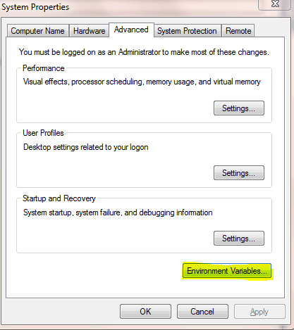
Highlight the "Path" line under System variables and click "Edit"
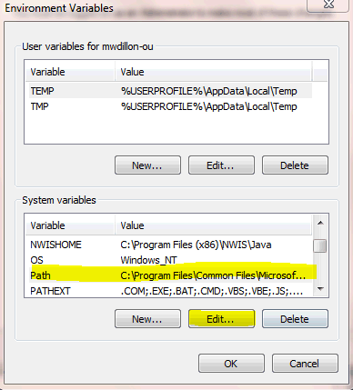
VERY IMPORTANT! Go to the end of the line and append a semi-colon (;) immediately followed by the Path that was retrieved from the first step (i.e. C:\Program Files (x86)\Java\jre6\bin).
DO NOT DELETE what's already in the "Variable value" line. To be safe, you could copy the entire line to an area on wordpad, add the Java path, then copy back the edited line to the "Variable value" line.
Restart and you're done.

