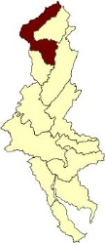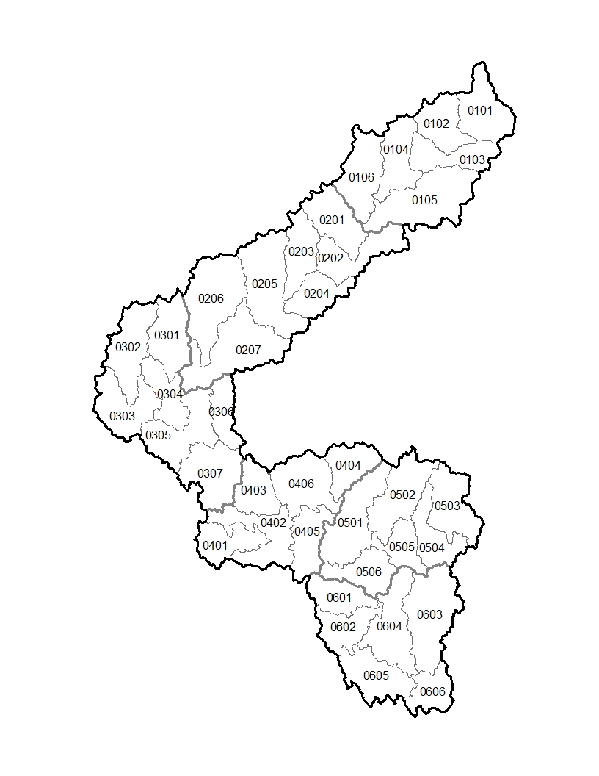
02040101 | Upper Delaware
0204010101 | Upper West Branch Delaware River
020401010101 | Town Brook-Headwaters West Branch Delaware River
020401010102 | Betty Brook-Headwaters West Branch Delaware River
020401010103 | Rose Brook-Headwaters West Branch Delaware River
020401010104 | Elk Creek-Headwaters West Branch Delaware River
020401010105 | Upper Little Delaware River
020401010106 | Wright Brook-Headwaters West Branch Delaware River
0204010102 | Middle West Branch Delaware River
020401010201 | Platner Brook-Upper West Branch Delaware River
020401010202 | Bagley Brook-Upper West Branch Delaware River
020401010203 | East Brook
020401010204 | Mallory Brook-Upper West Branch Delaware River
020401010205 | Beers Brook-Middle West Branch Delaware River
020401010206 | Upper Trout Creek
020401010207 | Cannonsville Reservoir
0204010103 | Lower West Branch Delaware River
020401010301 | East Branch Cold Spring Creek
020401010302 | Upper Oquaga Creek
020401010303 | Lower Oquaga Creek
020401010304 | Big Hollow-Lower West Branch Delaware River
020401010305 | Sherman Creek-Lower West Branch Delaware River
020401010306 | Sands Creek
020401010307 | Balls Creek-Lower West Branch Delaware River
0204010104 | Upper Delaware River
020401010401 | Upper Equinunk Creek
020401010402 | Lower Equinunk Creek
020401010403 | Factory Creek-Delaware River
020401010404 | Basket Creek
020401010405 | Little Equinunk Creek
020401010406 | Pea Brook-Delaware River
0204010105 | Middle Delaware River
020401010501 | Hankins Creek-Delaware River
020401010502 | North Branch Callicoon Creek
020401010503 | Upper East Branch Callicoon Creek
020401010504 | Middle East Branch Callicoon Creek
020401010505 | Lower East Branch Callicoon Creek
020401010506 | Beaverdam Creek-Delaware River
0204010106 | Lower Delaware River
020401010601 | North Branch Calkins Creek
020401010602 | South Branch Calkins Creek
020401010603 | Tenmile River
020401010604 | Peggy Run-Delaware River
020401010605 | Masthope Creek
020401010606 | Westcolang Creek-Delaware River
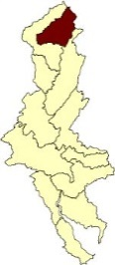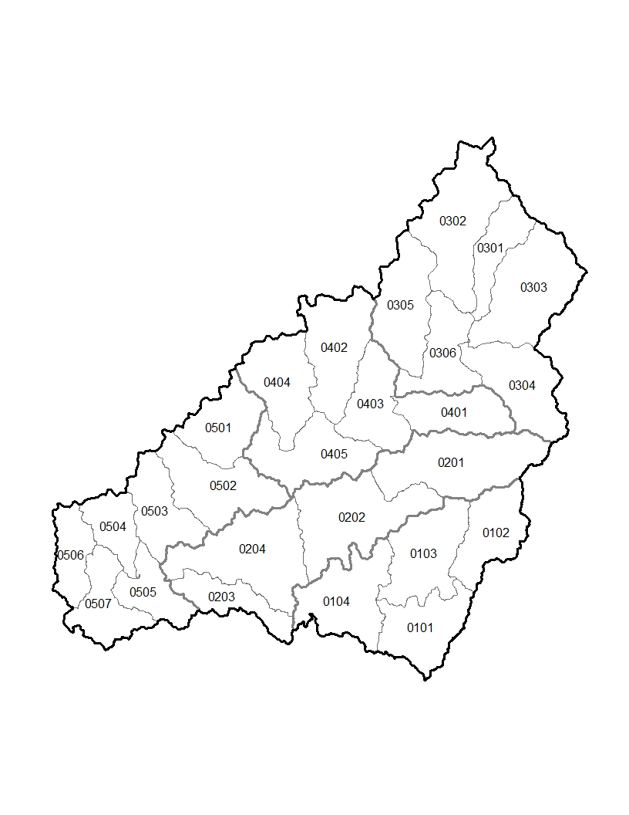
02040102 | East Branch Delaware
0204010201 | Willowemoc Creek
020401020101 | Little Beaver Kill
020401020102 | Upper Willowemoc Creek
020401020103 | Middle Willowemoc Creek
020401020104 | Lower Willowemoc Creek
0204010202 | Beaver Kill
020401020201 | Upper Beaver Kill
020401020202 | Middle Beaver Kill
020401020203 | Tennanah Lake-Trout Brook
020401020204 | Lower Beaver Kill
0204010203 | Upper East Branch Delaware River
020401020301 | Batavia Kill
020401020302 | Pleasant Valley Brook-East Branch Delaware River
020401020303 | Vly Creek-Bush Kill
020401020304 | Dry Brook
020401020305 | Platte Kill
020401020306 | Huckleberry Brook-East Branch Delaware River
0204010204 | Middle East Branch Delaware River
020401020401 | Mill Brook
020401020402 | Tremper Kill-Pepacton Reservoir
020401020403 | Upper Pepacton Reservoir
020401020404 | Murphy Hill Brook-Pepacton Reservoir
020401020405 | Lower Pepacton Reservoir
0204010205 | Lower East Branch Delaware River
020401020501 | Wilson Hollow Brook-Downs Brook
020401020502 | Trout Brook-East Branch Delaware River
020401020503 | Baxter Brook-East Branch Delaware River
020401020504 | Read Creek
020401020505 | Fish Creek-East Branch Delaware River
020401020506 | Cadosia Creek
020401020507 | Peas Eddy Brook-East Branch Delaware River
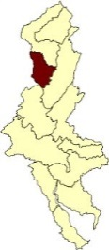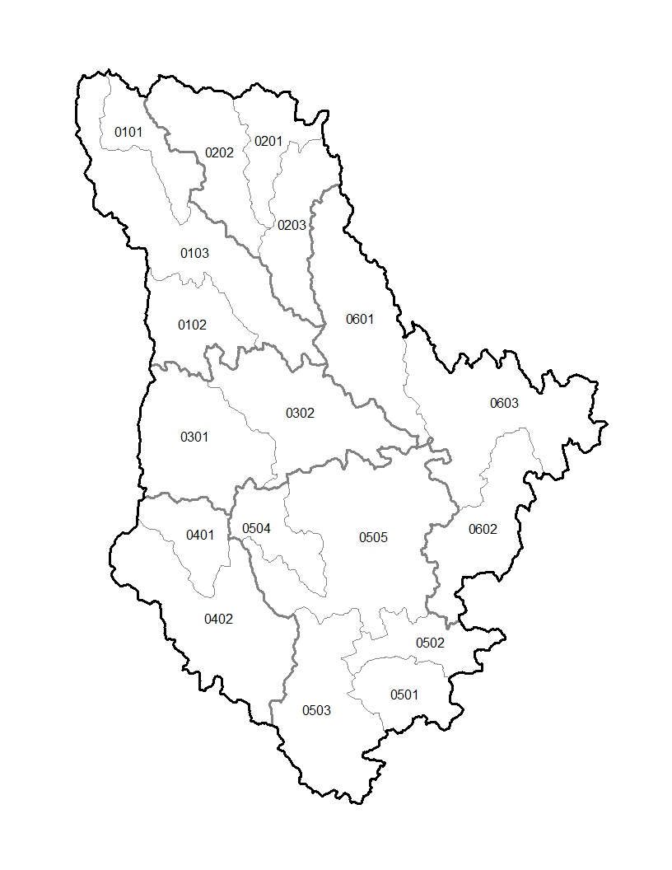
02040103 | Lackawaxen
0204010301 | West Branch Lackawaxen River
020401030101 | Johnson Creek
020401030102 | Van Auken Creek
020401030103 | Belmont Lake-West Branch Lackawaxen River
0204010302 | Dyberry Creek
020401030201 | East Branch Dyberry Creek
020401030202 | West Branch Dyberry Creek
020401030203 | Big Brook-Dyberry Creek
0204010303 | Middle Creek
020401030301 | Upper Middle Creek
020401030302 | Lower Middle Creek
0204010304 | West Branch Wallenpaupack Creek
020401030401 | Jones Creek
020401030402 | Butternut Creek-West Branch Wallenpaupack Creek
0204010305 | Wallenpaupack Creek
020401030501 | Bridge Creek
020401030502 | East Branch Wallenpaupack
020401030503 | Headwaters Wallenpaupack Creek
020401030504 | Ariel Creek
020401030505 | Lake Wallenpaupack-Wallenpaupack Creek
0204010306 | Lackawaxen River
020401030601 | Carley Brook-Lackawaxen River
020401030602 | Blooming Grove Creek
020401030603 | Lackawaxen River-Delaware River
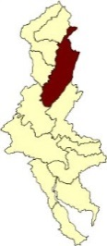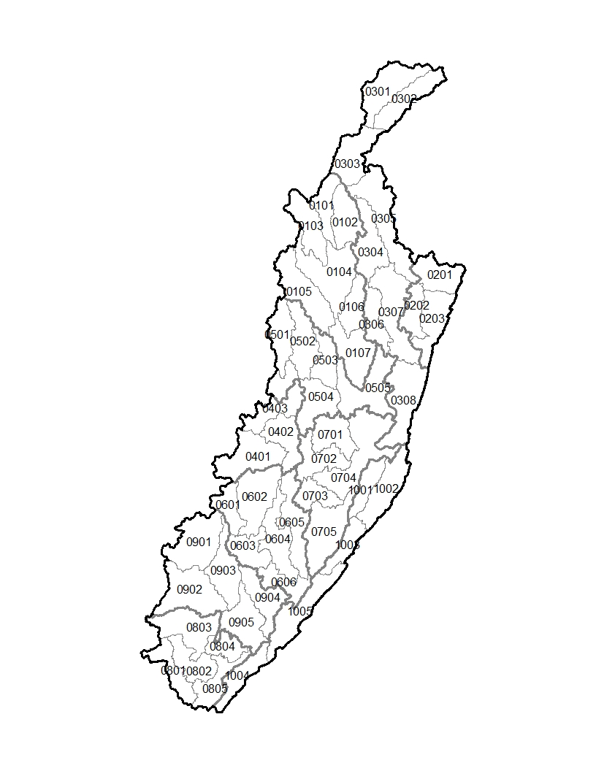
02040104 | Middle Delaware-Mongaup-Brodhead
0204010401 | Mongaup River
020401040101 | Middle Mongaup River
020401040102 | East Mongaup River
020401040103 | West Branch Mongaup River
020401040104 | Swinging Bridge Reservoir-Mongaup River
020401040105 | Black Lake Creek
020401040106 | Black Brook
020401040107 | Rio Reservoir-Mongaup River
0204010402 | Basher Kill
020401040201 | Gumaer Brook-Basher Kill
020401040202 | Pine Kill
020401040203 | Basher Kill
0204010403 | Neversink River
020401040301 | West Branch Neversink River
020401040302 | East Branch Neversink River
020401040303 | Neversink Reservoir
020401040304 | Sheldrake Stream
020401040305 | Upper Neversink River
020401040306 | Turner Brook-Bush Kill
020401040307 | Middle Neversink River
020401040308 | Lower Neversink River
0204010404 | Shahola Creek
020401040401 | Upper Shahola Creek
020401040402 | Middle Shahola Creek
020401040403 | Lower Shohola Creek
0204010405 | Halfway Brook-Delaware River
020401040501 | Beaver Brook
020401040502 | Halfway Brook
020401040503 | Mill Brook
020401040504 | Twin Lakes Creek-Delaware River
020401040505 | Shingle Kill-Delaware River
0204010406 | Bush Kill
020401040601 | Brights Creek
020401040602 | Upper Bush Kill
020401040603 | Middle Bush Kill
020401040604 | Saw Creek
020401040605 | Little Bush Kill
020401040606 | Lower Bush Kill
0204010407 | Raymondskill Creek-Delaware River
020401040701 | Sawkill Creek
020401040702 | Raymondskill Creek
020401040703 | Dingmans Creek
020401040704 | Shimers Brook-Delaware River
020401040705 | Hornbecks Creek-Delaware River
0204010408 | Pocono Creek
020401040801 | Upper McMichael Creek
020401040802 | Appenzell Creek
020401040803 | Upper Pocono Creek
020401040804 | Lower Pocono Creek
020401040805 | Lower McMichael Creek
0204010409 | Broadhead Creek
020401040901 | Upper Broadhead Creek
020401040902 | Paradise Creek
020401040903 | Middle Broadhead Creek
020401040904 | Marshalls Creek
020401040905 | Lower Broadhead Creek
0204010410 | Flat Brook-Delaware River
020401041001 | Little Flat Brook
020401041002 | Big Flat Brook
020401041003 | Flat Brook
020401041004 | Cherry Creek
020401041005 | Vancampens Brook-Delaware River
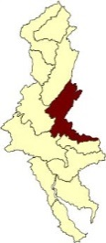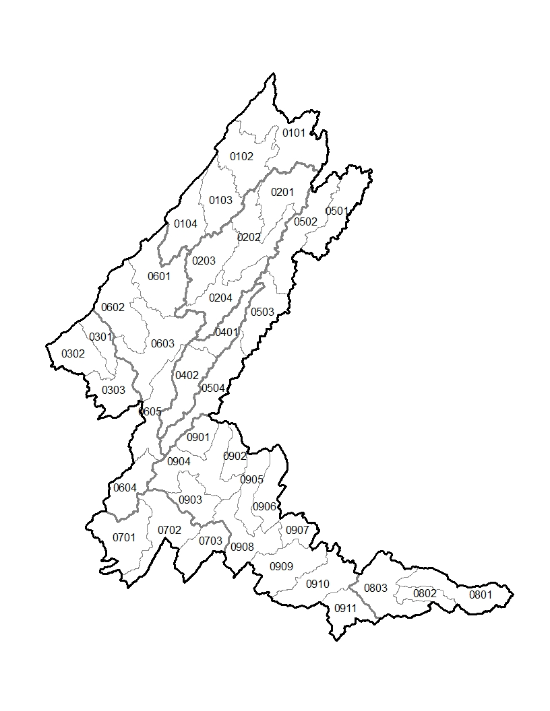
02040105 | Middle Delaware-Musconetcong
0204010501 | Paulins Kill River-Delaware River
020401050101 | Headwaters Paulins Kill River
020401050102 | Upper Paulins Kill River
020401050103 | Middle Paulins Kill River
020401050104 | Lower Paulins Kill River
0204010502 | Pequest River-Delaware River
020401050201 | Upper Pequest River
020401050202 | Middle Pequest River
020401050203 | Beaver Brook
020401050204 | Lower Pequest River
0204010503 | Bushkill Creek-Delaware River
020401050301 | Little Bushkill Creek
020401050302 | Upper Bushkill Creek
020401050303 | Lower Bushkill Creek
0204010504 | Pohatcong Creek-Delaware River
020401050401 | Upper Pohatcong Creek
020401050402 | Lower Pohatcong Creek
0204010505 | Musconetcong River
020401050501 | Lake Hopatcong-Upper Musconetcong River
020401050502 | Lubbers Run-Musconetcong River
020401050503 | Middle Musconetcong River
020401050504 | Lower Musconetcong River
0204010506 | Upper Delaware River
020401050601 | Allegheny Creek-Delaware River
020401050602 | Martins Creek-Delaware River
020401050603 | Buckhorn Creek-Delaware River
020401050604 | Cooks Creek-Delaware River
020401050605 | Lopatcong Creek-Delaware River
0204010507 | Tohickon Creek-Delaware River
020401050701 | Upper Tohickon Creek
020401050702 | Middle Tohickon Creek
020401050703 | Lower Tohickon Creek
0204010508 | Assunpink Creek-Delaware River
020401050801 | Upper Assunpink Creek
020401050802 | Miry Run
020401050803 | Lower Assunpink Creek
0204010509 | Lower Delaware River
020401050901 | Hakihokake Creek-Delaware River
020401050902 | Nishisakawick Creek-Delaware River
020401050903 | Tinicum Creek-Delaware River
020401050904 | Harihokake Creek-Delaware River
020401050905 | Lockatong Creek-Delaware River
020401050906 | Wickecheoke Creek-Delaware River
020401050907 | Alexauken Creek-Delaware River
020401050908 | Paunnacussing Creek-Delaware River
020401050909 | Pidcock Creek-Delaware River
020401050910 | Jacobs Creek-Delaware River
020401050911 | Buck Creek-Delaware River
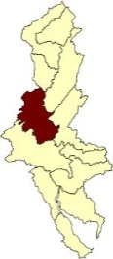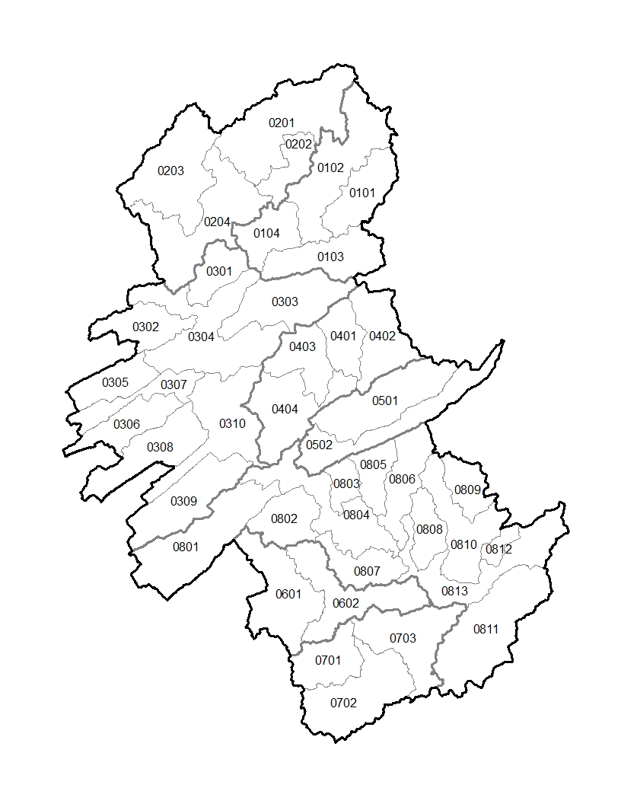
02040106 | Lehigh
0204010601 | Tobyhanna Creek
020401060101 | Stillwater Lake-Upper Tunkhannock Creek
020401060102 | Pocono Lake Dam-Tobyhanna Creek
020401060103 | Tunkhannock Creek
020401060104 | Tobyhanna Creek-Lehigh River
0204010602 | Upper Lehigh River
020401060201 | Headwaters Lehigh River
020401060202 | Brady's Lake-Trout Creek
020401060203 | Bear Creek
020401060204 | Wright Creek-Lehigh River
0204010603 | Middle Lehigh River
020401060301 | Black Creek-East Side of Lehigh River
020401060302 | Sandy Run
020401060303 | Mud Run
020401060304 | Stony Creek-Lehigh River
020401060305 | Hazle Creek
020401060306 | Quakake Creek
020401060307 | Beaver Creek-Black Creek
020401060308 | Nesquehoning Creek
020401060309 | Mahoning Creek
020401060310 | Mauch Chunk Creek-Lehigh River
0204010604 | Pohopoco Creek
020401060401 | Middle Creek
020401060402 | Headwaters Pohopoco Creek
020401060403 | Wild Creek
020401060404 | Beltzville Lake-Pohopoco Creek
0204010605 | Aquashicola Creek
020401060501 | Buckwha Creek
020401060502 | Aquashicola Creek-Lehigh River
0204010606 | Jordan Creek
020401060601 | Upper Jordan Creek
020401060602 | Lower Jordan Creek
0204010607 | Little Lehigh Creek
020401060701 | Spring Creek
020401060702 | Liebert Creek-Little Lehigh Creek
020401060703 | Little Lehigh Creek-Lehigh River
0204010608 | Lower Lehigh River
020401060801 | Lizard Creek
020401060802 | Trout Creek
020401060803 | Bertsch Creek
020401060804 | Fireline Creek-Lehigh River
020401060805 | Indian Creek
020401060806 | Hokendauqua Creek
020401060807 | Coplay Creek
020401060808 | Catasauqua Creek
020401060809 | East Branch Monocacy Creek
020401060810 | Monocacy Creek
020401060811 | Saucon Creek
020401060812 | Nancy Run
020401060813 | Lehigh River-Delaware River
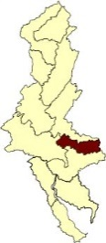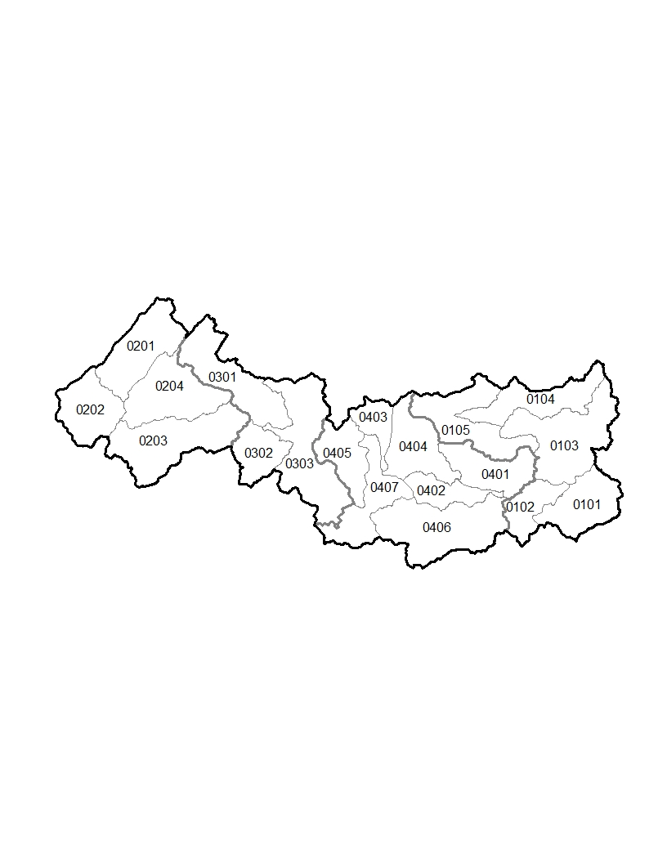
02040201 | Crosswicks-Neshaminy
0204020101 | Crosswicks Creek
020402010101 | Jumping Brook
020402010102 | Upper Crosswicks Creek
020402010103 | Middle Crosswicks Creek
020402010104 | Doctors Creek
020402010105 | Lower Crosswicks Creek
0204020102 | Upper Neshaminy Creek
020402010201 | North Branch Neshaminy Creek
020402010202 | West Branch Neshaminy Creek
020402010203 | LIttle Neshaminy Creek
020402010204 | Cooks Run-Neshaminy Creek
0204020103 | Lower Neshaminy Creek
020402010301 | Mill Creek-Neshaminy Creek
020402010302 | Ironworks Creek-Mill Creek
020402010303 | Core Creek-Neshaminy Creek
0204020104 | Assiscunk Creek-Delaware River
020402010401 | Blacks Creek
020402010402 | Crafts Creek
020402010403 | Martins Creek
020402010404 | Van Sciver Lake-Delaware River
020402010405 | Mill Creek-Silver Lake
020402010406 | Assiscunk Creek
020402010407 | Burlington Island-Delaware River
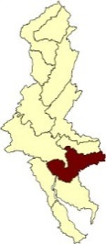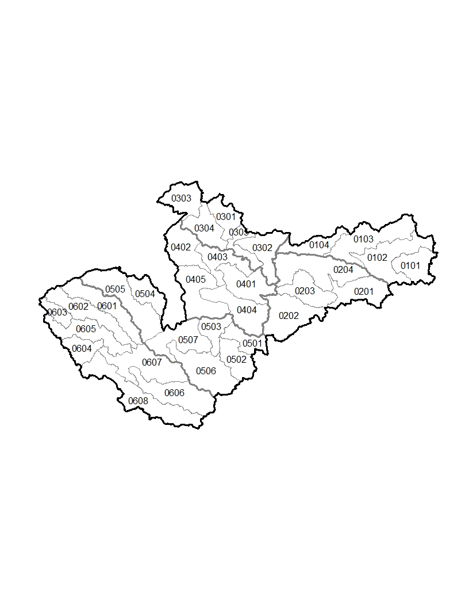
02040202 | Lower Delaware
0204020201 | North Branch Rancocas Creek
020402020101 | Headwaters Mount Misery Brook
020402020102 | Mount Misery Brook
020402020103 | Gaunts Brook-North Branch Rancocas Creek
020402020104 | Powells Run-North Branch Rancocas Creek
0204020202 | South Branch Rancocas Creek
020402020201 | Friendship Creek
020402020202 | Barton Run-Southwest Branch Rancocas Creek
020402020203 | Little Creek-Southwest Branch Rancocas Creek
020402020204 | Jade Run-South Branch Rancocas Creek
0204020203 | Pennypack Creek-Rancocas Creek
020402020301 | Poquessing Creek
020402020302 | Rancocas Creek
020402020303 | Upper Pennypack Creek
020402020304 | Lower Pennypack Creek
020402020305 | Swede Run-Delaware River
0204020204 | Cooper River-Delaware River
020402020401 | Pennsauken Creek
020402020402 | Tacony Creek-Frankford Creek
020402020403 | Pompeston Creek-Delaware River
020402020404 | Cooper River
020402020405 | Petty Island-Delaware River
0204020205 | Darby Creek-Mantua Creek
020402020501 | North Branch Big Timber Creek
020402020502 | South Branch Big Timber Creek
020402020503 | Big Timber Creek
020402020504 | Cobbs Creek
020402020505 | Darby Creek
020402020506 | Manuta Creek
020402020507 | Woodbury Creek-Delaware River
0204020206 | Raccoon Creek-Delaware River
020402020601 | Crum Creek
020402020602 | Ridley Creek
020402020603 | East Branch Chester Creek
020402020604 | West Branch Chester Creek
020402020605 | Chester Creek
020402020606 | Raccoon Creek
020402020607 | Repaupo Creek-Delaware River
020402020608 | Oldmans Creek-Delaware River
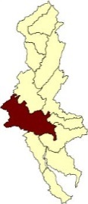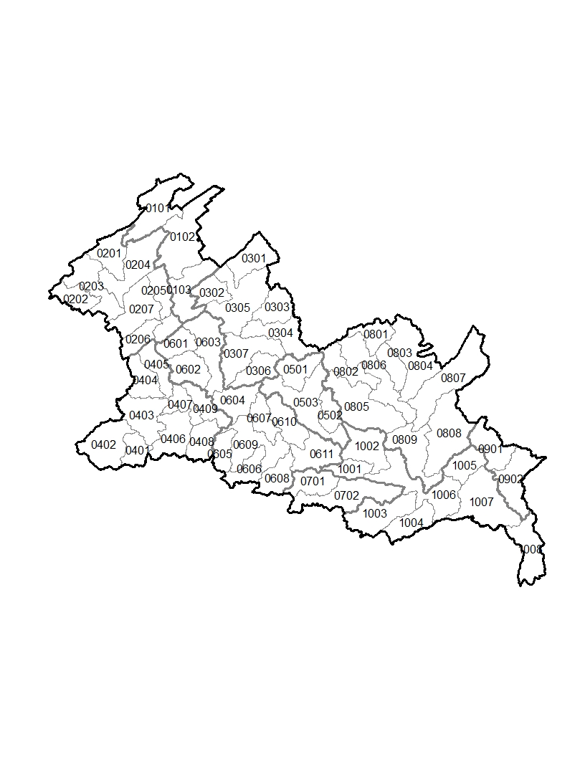
02040203 | Schuylkill
0204020301 | Little Schuylkill River
020402030101 | Headwaters Little Schuylkill River
020402030102 | Upper Little Schuylkill River
020402030103 | Lower Little Schuylkill River
0204020302 | Upper Schuylkill River
020402030201 | Eisenhuth Reservoir-Mill Creek
020402030202 | West Branch Schuylkill River
020402030203 | East Branch Schuylkill River
020402030204 | Headwaters Schuylkill River
020402030205 | Deer Lake-Pine Creek
020402030206 | Bear Creek
020402030207 | Mahannon Creek-Schuylkill River
0204020303 | Maiden Creek
020402030301 | Ontelaunee Creek
020402030302 | Pine Creek
020402030303 | Eagle Point-Mill Creek
020402030304 | Sacony Creek
020402030305 | Upper Maiden Creek
020402030306 | Willow Creek
020402030307 | Lower Maiden Creek
0204020304 | Tulpehocken Creek
020402030401 | Mill Creek
020402030402 | Headwaters Tulpehocken Creek
020402030403 | Upper Tulpehocken Creek
020402030404 | Little Northkill Creek
020402030405 | Northkill Creek
020402030406 | Spring Creek
020402030407 | Middle Tulpehocken Creek
020402030408 | Cacoosing Creek
020402030409 | Lower Tulpehocken Creek
0204020305 | Manatawny Creek
020402030501 | Upper Manatawny Creek
020402030502 | Ironstone Creek
020402030503 | Lower Manatawny Creek
0204020306 | Middle Schuylkill River
020402030601 | Hassler Run-Mill Creek
020402030602 | Irish Creek
020402030603 | Pigeon Creek-Schuylkill River
020402030604 | Laurel Run-Schuylkill River
020402030605 | Wyomissing Creek
020402030606 | Green Hills Lake-Allegheny Creek
020402030607 | Antietam Creek
020402030608 | Hay Creek
020402030609 | Angelica Creek-Schuylkill River
020402030610 | Monocacy Creek
020402030611 | Sixpenny Creek-Schuylkill River
0204020307 | French Creek
020402030701 | Upper French Creek
020402030702 | Lower French Creek
0204020308 | Perkiomen Creek
020402030801 | Hosensack Creek
020402030802 | West Branch Perkiomen Creek
020402030803 | Macoby Creek
020402030804 | Unami Creek
020402030805 | Swamp Creek
020402030806 | Upper Perkiomen Creek
020402030807 | East Branch Perkiomen Creek
020402030808 | Skippack Creek
020402030809 | Lower Perkiomen Creek
0204020309 | Wissahickon Creek
020402030901 | Upper Wissahickon Creek
020402030902 | Lower Wissahickon Creek
0204020310 | Lower Schuylkill River
020402031001 | Pigeon Creek
020402031002 | Sprogles Run-Schuylkill River
020402031003 | Pickering Creek
020402031004 | Little Valley Creek-Valley Creek
020402031005 | Stony Creek
020402031006 | Mingo Creek-Schuylkill River
020402031007 | Plymouth Creek-Schuylkill River
020402031008 | City of Philadelphia-Schuylkill River
020402040000 | Delaware Bay-Deep
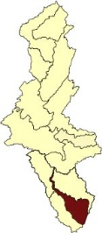
02040204 | Delaware Bay
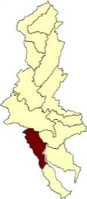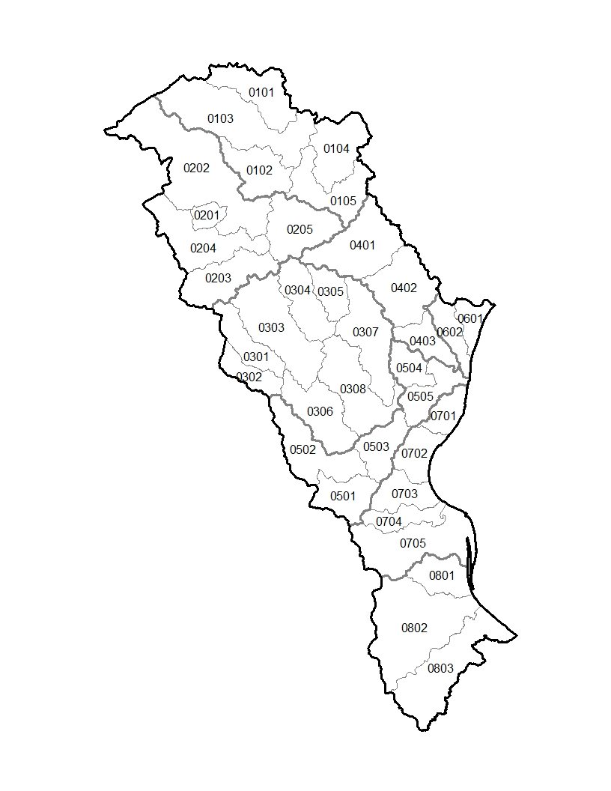
02040205 | Brandywine-Christina
0204020501 | East Branch Brandywine Creek
020402050101 | Marsh Creek
020402050102 | Beaver Creek
020402050103 | Upper East Branch Brandywine Creek
020402050104 | Valley Creek
020402050105 | Lower East Branch Brandywine Creek
0204020502 | West Branch Brandywine Creek
020402050201 | Sucker Run
020402050202 | Upper West Branch Brandywine Creek
020402050203 | Doe Run
020402050204 | Buck Run
020402050205 | Lower West Branch Brandywine Creek
0204020503 | White Clay Creek
020402050301 | Middle Branch White Clay Creek
020402050302 | West Branch White Clay Creek
020402050303 | East Branch White Clay Creek
020402050304 | West Branch Red Clay Creek
020402050305 | East Branch Red Clay Creek
020402050306 | Upper White Clay Creek
020402050307 | Red Clay Creek
020402050308 | Lower White Clay Creek
0204020504 | Brandywine Creek
020402050401 | Upper Brandywine Creek
020402050402 | Middle Brandywine Creek
020402050403 | Lower Brandywine Creek
0204020505 | Christina River
020402050501 | Muddy Run
020402050502 | Upper Christina River
020402050503 | Middle Christina River
020402050504 | Little Mill Creek
020402050505 | Lower Christina River
0204020506 | Shellpot Creek-Delaware River
020402050601 | Stoney Creek
020402050602 | Matson Run-Shellpot Creek
0204020507 | C&D Canal - Red Lion Creek
020402050701 | Broad Duke Canal-Delaware River
020402050702 | Army Creek-Delaware River
020402050703 | Red Lion Creek-Delaware River
020402050704 | Dragon Creek-Delaware River
020402050705 | C&D Canal East-Delaware River
0204020508 | Appoquinimink River-Delaware River
020402050801 | Augustine Creek
020402050802 | Drawyer Creek-Appoquinimink River
020402050803 | Blackbird Creek

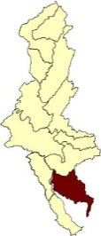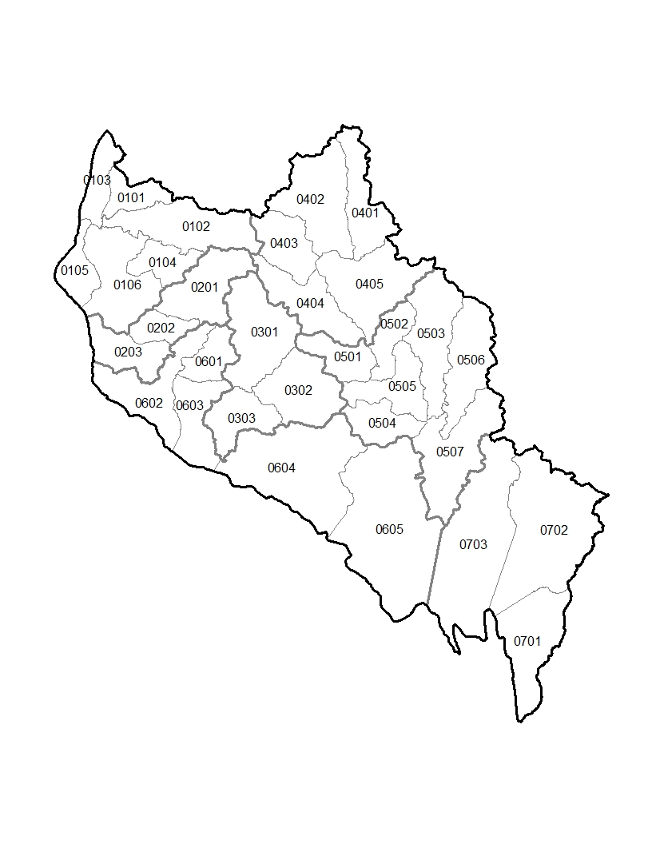
02040206 | Cohansey-Maurice
0204020601 | Salem River-Delaware River
020402060101 | Game Creek
020402060102 | Upper Salem River
020402060103 | Salem Canal-Whooping John Creek
020402060104 | Mannington Creek
020402060105 | Mill Creek-Miles Creek
020402060106 | Lower Salem River
0204020602 | Alloway Creek
020402060201 | Upper Alloway Creek
020402060202 | Middle Alloway Creek
020402060203 | Lower Alloway Creek
0204020603 | Cohansey River
020402060301 | Upper Cohansey River
020402060302 | Middle Cohansey River
020402060303 | Lower Cohansey River
0204020604 | Upper Maurice River
020402060401 | Scotland Run
020402060402 | Reed Branch-Still Run
020402060403 | Upper Muddy Run
020402060404 | Lower Muddy Run
020402060405 | Burnt Mill Branch-Maurice River
0204020605 | Lower Maurice River
020402060501 | Mill Creek
020402060502 | Union Lake-Maurice River
020402060503 | Manantico Creek
020402060504 | Buckshutem Creek
020402060505 | White Marsh Run-Maurice River
020402060506 | Manumuskin River
020402060507 | Muskee Creek-Maurice River
0204020606 | Stow Creek-Delaware Bay
020402060601 | Upper Stow Creek
020402060602 | Mad Horse Creek-Delaware Bay
020402060603 | Lower Stow Creek
020402060604 | Back Creek
020402060605 | Dividing Creek-Oranoaken Creek
0204020607 | Dennis Creek-Delaware Bay
020402060701 | Fishing Creek-Delaware Bay
020402060702 | Dennis Creek
020402060703 | West Creek-Delaware Bay

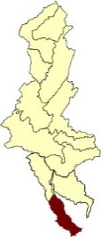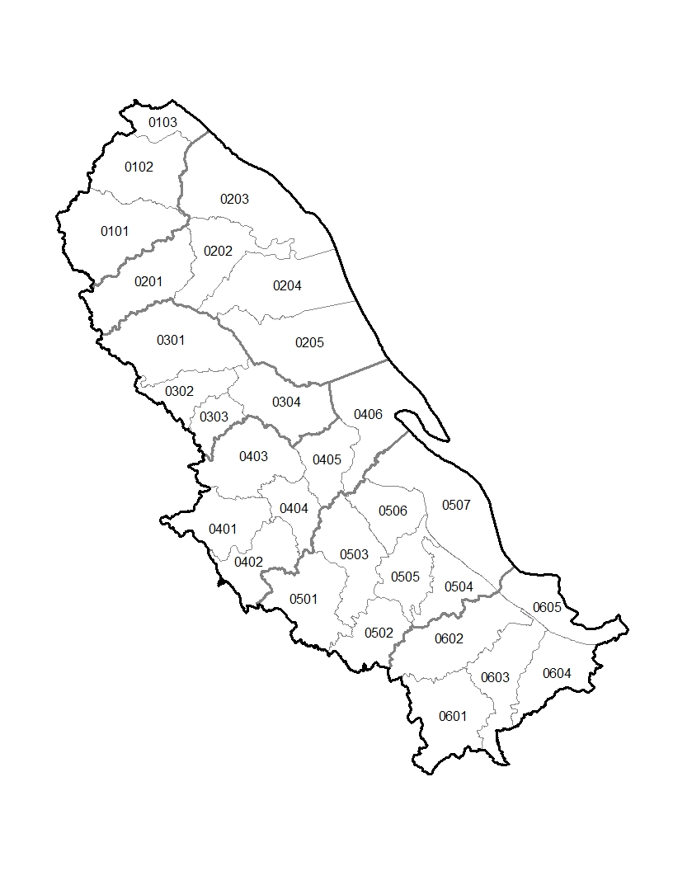
02040207 | Broadkill-Smyrna
0204020701 | Smyrna River-Delaware Bay
020402070101 | Duck Creek
020402070102 | Smryna River
020402070103 | Cedar Swamp-Delaware Bay
0204020702 | Leipsic River-Delaware Bay
020402070201 | Upper Leipsic River
020402070202 | Lower Lepsic River
020402070203 | Duck Creek-Delaware Bay
020402070204 | Simons River-Delaware Bay
020402070205 | Little River-Delaware Bay
0204020703 | Saint Jones River
020402070301 | Upper Saint Jones River
020402070302 | Issac Branch
020402070303 | Tidbury Creek
020402070304 | Lower Saint Jones River
0204020704 | Murderkill River-Delaware Bay
020402070401 | Spring Branch-Murderkill River
020402070402 | Browns Branch
020402070403 | Spring Creek
020402070404 | Ash Gut-Murderkill River
020402070405 | Murderkill River-Town of South Bowers
020402070406 | Brockonbridge Gut-Delaware Bay
0204020705 | Mispillion River-Delaware Bay
020402070501 | Upper Mispillion River
020402070502 | Upper Cedar Creek
020402070503 | Middle Mispillion River
020402070504 | Slaughter Creek
020402070505 | Lower Cedar Creek
020402070506 | Lower Missipillion River
020402070507 | Grecos Canal-Delaware Bay
0204020706 | Broadkill River-Delaware Bay
020402070601 | Round Pole Branch-Broadkill River
020402070602 | Primehook Creek
020402070603 | Beaverdam Creek-Broadkill River
020402070604 | Canary Creek-Broadkill River
020402070605 | Breakwater Harbor-Delaware Bay

