Directions for Converting Analog Sediment Core Description Sheets to Digital, Spreadsheet Format
By James G. Flocks

Before You Start
Associated Publication
Naming Convention
Key Description Sheet
Header File
Directory Path

Digitizing
Software
Calibration
Methods
Symbols-
Curves-
Collective Curves-
Text-

Digitizer Output File

Running the Excel ©* Macro
Editing the Default Paths
‘Run’ vs. ‘Run to cursor’
Problems during Execution
Did not digitize the top and bottom of the core-
Did not digitize the top of the column prior to starting a new attribute-
Inaccurate amount of x,y pairs associated with an attribute-
Did not digitize the stratigraphic interval in the ‘interval’ column-
Processing program could not find appropriate core identification syntax-
Debug Statement
Processing Program Output File
Built-in Program-stop To Check Output
It’s Going to be Alright

Before You Start

Associated Publication
This document describes how to operate the digitizing and processing systems that convert hard-copy sediment Core Description Sheets to a spreadsheet format. The purpose of these systems is described in the paper “Converting analog interpretive data to digital formats for use in database and GIS applications”, which accompanies this file. The user should read this paper before using this document.

Naming Convention
In this document the file that is created by the digitizing program is called the dig_out file. The Microsoft Excel © macro is called the processing program, and the file that it generates is called the output file. The columns of information on the Core Description Sheet are called attributes. The person who is digitizing the Core Description Sheet is called the digitizer.

Key Description Sheet
The Key Description Sheet (fig. 1) is a text file that describes the name and position of each column on the Core Description Sheet (fig. 2). The names are typically located in the column header of the Core Description Sheet (fig. 2A). The position is the distance of the beginning of the column from the left edge of the digitized area (fig. 2B). Once this distance is established, the total distance of all the columns being digitized (Xmax) must be the same for all sheets being digitized using this Key Description Sheet (see Calibration, below). The Key Description Sheet must also contain a word that describes how the information in the column is portrayed. These descriptors are: symbol, curve, collective curve, sample and text (see Methods, below). The Excel macro looks for the descriptors to determine which processing routine to apply to the subsequent data. Each style of Core Description Sheet should have its own Key Description Sheet to coordinate the attribute locations.
The position of the left edge of each column is determined through digitizing. When creating a new Key Description Sheet, it is good practice to digitize the edge of each column several times, through several sheets, and then take an average of the resulting x-values. This reduces any errors than may be produced when determining the position.
Finally, the Key Description Sheet must contain the names of the symbols if a symbol menu is used during digitizing (fig. 1A). The symbol menu is created by the user to represent symbol descriptions on the Core Description Sheet (fig. 2C). No x-positions are necessary for the symbol list. Currently, the Excel macro is set to read twelve symbols; if this number is adjusted, it will need to be reflected in the processing code.

Attribute Name X-position Symbol Name
start 0 (1A) x-beds
clay 99.808 deformed_beds
silt 128.330 planar_beds
fine_sand 156.521 lenticular_beds
med_sand 185.071 organics
coarse_sand 212.728 sand
granule 242.172 burrows
blank 270.846 shell_fragments
interval 308.588 (1B) gray
sand% 365.975 tan
silt% 423.359 brown
color 461.796 black
deformation 488.817
bed_thickness 518.567
%shell 545.433
%organic 574.822
%bioturb 604.764
wavy 631.537
flaser 659.110
lenticular 688.072
cross_bed 714.806
massive_bed 744.359
inclined_bed 772.441
horiz_lam 801.307
blank2 829.705
grain_size 857.333
heavy_minerals 885.636
micro_fossils 914.433
radio 943.770
radio2 972.458
photo 1000.93

Figure 1. Example of Key Description Sheet. Text represents the column headers (attributes), numbers are distance from origin of columns on the Core Description Sheet. The column on the right lists the attributes on the symbol menu (see fig. 2C).

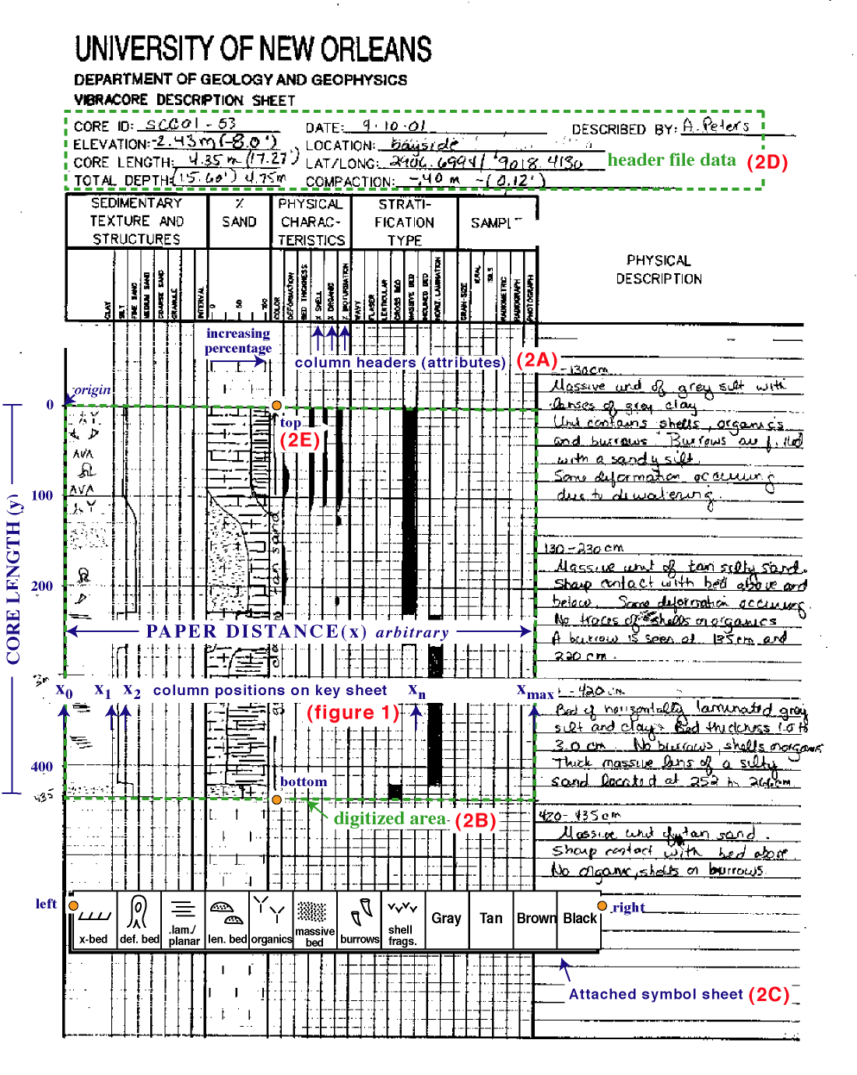
Figure 2. Example sediment Core Description Sheet showing column attributes (A), area being digitized (B), attached symbol menu (C), header information (lat./long., elevations, and so on) (D), and locations of first four digitized points: top and bottom of core, and left and right side of symbol menu (E). Columns are recognized by their distance from origin (x-value); vertical dimension (y) is either core length or depth of core penetration relative to a datum. Attributes are digitized along their left outer edge.

Header File
The header file is a tab-delimited Excel spreadsheet that contains the pertinent information from the header of the Core Description Sheets to be transferred to the output file (fig. 2D). This information is usually already in a spreadsheet format for use in metadata compilation or GIS applications. The header file must contain a column that contains the same text as the file name of the dig_out file. The easiest way to maintain consistency is to make the filename for the dig_out file the same as the sediment core identification name.

Directory Path
All of the dig_out files should be in the same directory. Also in that directory should be another directory named “Edited”. The Excel macro will establish the first directory as the default path and look for the directory named “Edited” within the default path to place the output files. The Excel macro will try to open and process any file within the default directory; any extra files should be removed from the directory prior to running the macro. At times the user might have already processed dig_out files still residing in the default directory. These files can be moved to a temporary folder within the default directory, as the Excel macro only considers files and ignores folders within the default directory. Another common practice is to devote a directory to the processing of the dig_out files. Whenever the user creates dig_out files, they can be placed in this directory. After processing, the dig_out files can be moved to an archive directory. This procedure is similar to the ‘Watched Folders’ method that batch-processing programs use.
The Excel macro will also ask for the names and directory paths to the Key Description Sheet and header file. These files should not reside within the default path (the macro will try to process them). The Key Description Sheet can be placed in a directory with other Key Description Sheets if the user is processing different Core Description Sheet formats. This same argument holds true for the header file.

Digitizing

Software
To provide the proper output format, the digitizing software must be able to produce an ASCII file output of x,y locations. This is a very basic function that most cartographic or CAD digitizing software packages can handle. As such, the least complicated software available is recommended. Consult the software manual for directions on how to achieve the desired output; some additional editing may be necessary to produce the format needed by the processing program (see Digitizer Output File, below). Didger © software by Golden Software © and Digitize © by Waccom © were used while developing this process. If a digitizing tablet is not available, a raster facsimile of the Core Description Sheet can be digitized directly from the computer monitor, using specific software. All that matters is that the digitizing software is capable of providing x,y coordinates in an ASCII format.

Calibration
The digitizing program will require calibration of the area being digitized. This will be the non-text area on the Core Description Sheet (fig. 2B). The calibration values will be the extremes (Ymin, Ymax, Xmin, Xmax) of the area being digitized. Ymin (top of area being digitized) should be zero, Ymax (bottom of area being digitized) should be the core length in the same units as the output intervals (usually centimeters (cm)). Xmin (left edge of area being digitized) should be zero. Xmax is arbitrary but should be a length not too much greater than the typical length of the cores being analyzed. This is because the digitizing program will assume the x and y dimensions are of the same units and scale and will present this scale on the computer screen. If the x distance is far greater or less than the y distance, the resulting image on the screen will be highly skewed and difficult to see. The x distance should also be great enough to ensure that there are many points within each column of the Core Description Sheet, which can sometimes can be very narrow. Most Core Description Sheets processed by this system are vibracores, which typically range in core length from 1,000 to 5,000 cm. Thus, a practical x distance can be 1,000 units. If a Core Description Sheet has 30 columns, this will ensure that each column contains at least 30 points in the x-direction, a suitable number to characterize the information within the column.
The digitizing program may also require the work area to be digitized, which may be confusing to the user. Basically, the calibration points do not necessarily need to be the extremes of the area being digitized. For example, when digitizing contours from a map, you can digitize the latitude and longitude ticks on the map for calibration, but the contours being digitized may extend beyond the tick marks. The digitizing program needs to establish the work area so that it can clip out any erroneous or accidentally digitized points.

Methods
Once the tablet has been calibrated, the data digitizing begins with digitizing key features on the Core Description Sheet: top of core, bottom of core, left side of symbol menu, and right side of symbol menu (fig. 2E). Each dig_out file will begin with these four coordinates (fig. 3A) and provides basic constraint and location information for the processing program.

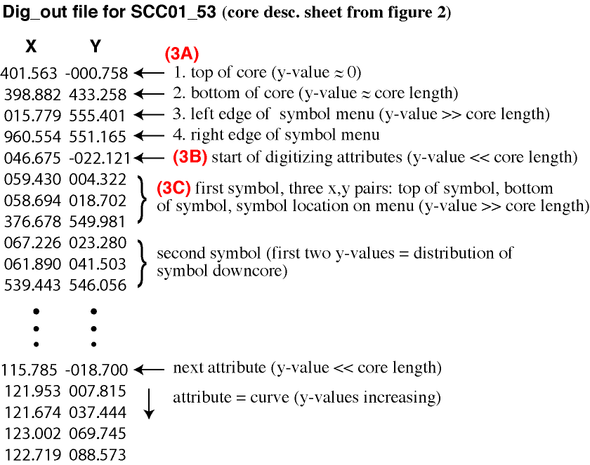
Figure 3. Example output from the digitizing process, showing x,y positions of sediment core and symbol menu (A), indication of new attribute (B), and symbol arrangement (C).

Prior to digitizing an attribute, it is necessary to digitize a point at the top of the column being digitized, above Ymin (core length = 0). Thus, in the dig_out file, the first x,y pair of each digitized attribute should contain a negative y-value (fig. 3B). The negative value will alert the processing program that a new attribute is being digitized.
There are several kinds of attributes on a Core Description Sheet. Features in the core such as shell or cross-beds may be represented as symbols. Color descriptions may cover ranges of the core. Abundance of organic material may be represented by a percent curve, and of course there are text descriptions. These different attributes must be digitized differently, as processing of the data requires different routines. Techniques for digitizing these attributes are listed below.

Symbols-
Symbols represent observations within a core that are common and important descriptions of sedimentary texture and structures (fig. 4A). These symbols are typically placed where they occur in the core profile, or placed sporadically downcore if the feature covers a range within the core. Symbols are digitized by selecting the points where they begin and end in a core. A symbol menu is used to designate the symbol (fig. 4B). Thus, to digitize a symbol, three points are necessary: the start of where the feature occurs in the core, the end of where the feature occurs, and the corresponding symbol for the feature from the symbol menu. As a result, in the dig_out file, there must be three and only three points to represent the distribution of each symbol (fig. 3C). It is up to the user to determine where the textural feature described by the symbol occurs within the core. The user can also rely on other descriptions within the sheet to locate textural changes. For example, if the symbol for laminations occurs in several locations downcore, the user can refer to the laminations column to see if laminations persist throughout the core or if they are sporadic. If laminations are persistent then the user can cover the whole core with one symbol designation (see It’s Going to be Alright, below). Symbols may overlap; if there are other attributes within the same section of core, the program will add (concatenate) the subsequent descriptions without deleting the previous symbols.

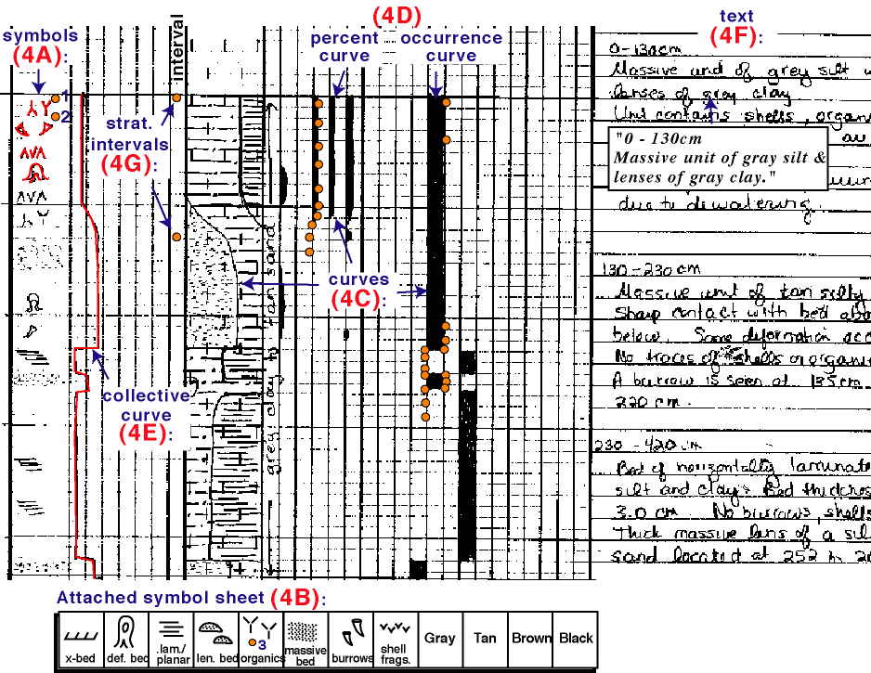

Figure 4. Closeup of Core Description Sheet showing different styles of attributes: Symbols (A), curves (C), and text (F). Orange circles represent digitized points.

Curves-
Curves are lines within columns that represent an abundance or the occurrence of an attribute within the core (fig. 4C). Downcore, a curve may move in one direction within a column if concentration of the attribute increases, or in the other direction if the concentration decreases. Typically, the curve either represents percent with the left side of the column equal to zero and the right side equal to 100. In some cases abundance is not registered; the column simply records the occurrence of the attribute within a core (fig. 4D). Curves used in this case may either fill the whole column (100%) or be completely missing (0%); nevertheless, this can still be considered an abundance curve.
When digitizing a curve, the user follows the line of the curve, typically digitizing points at the inflections of the line. The processing program then interpolates between these digitized points at user-defined intervals. The interpolation provides a smooth representation of the curve, as long as the user-defined intervals are kept small. It is not necessary to start digitizing at the top of the column if there is no curve, or end at the bottom. The program is designed to take the first (or last) digitized point and project that value to the top (or bottom) of the column. It is not necessary to stay within the bounds of the column. If points are digitized outside of the column the program will assume these values to be 0 or 100 percent, depending on which side of the column they occur. This is particularly useful to represent attributes that either exist or do not exist in a core. It is far easier to digitize left or right of the column to designate presence of an attribute as opposed to staying precisely on the 0 or 100 percent line.
Certain habits should be adopted when digitizing a curve. Since the program interpolates points in between the digitized values, a shift from 0 percent abundance to 100 percent will often be processed to include an interval of 50 percent. This may be unavoidable but should be kept to a minimum number of intervals by using small increments when digitizing around these dramatic changes in abundance (fig. 4D). A common interpolation problem occurs when two or more digitized points occur within the same interval, resulting in an averaging of the two values. Thus, if the preceding and subsequent digitized points are at some distance from this averaged set, the interpolated results may not sufficiently characterize the curve. Again, this problem can be minimized by keeping a tight digitizing pattern around these inflection points. If these patterns occur they can be identified at the end of processing and adjusted (see Built-in Program-stop To Check Output, below).

Collective Curve-
The collective curve is a special case of curve data where the lines extend into several columns. An example of this is where several columns represent the presence of clay, silt, and sand in the core (fig. 4E). The abundance of these attributes relative to each other is displayed by moving the curve through the appropriate columns. During processing these curves are treated as any other curve; however, it is necessary to designate them differently since they do cross columns, otherwise any portion of the curve outside the first column would be translated as 100 percent.

Text-
Text information in a Core Description Sheet includes the listing of observations within a core. The text is typically divided into stratigraphic intervals and contains information about texture, color, features, bedding, and so on. For example, an interval from 0 to 130 cm may contain “massive unit of grey silt with lenses of gray clay” (fig. 4F). The words themselves cannot be digitized, but specific words can be characterized either from the attribute descriptions (headers), or the symbol menu. The stratigraphic interval is determined by digitizing the interval extents in a designated column (fig. 4G). A blank column on the Core Description Sheet can be used to represent stratigraphic intervals; this designation is declared in the Key Description Sheet (fig. 1B). This step is important when the processing program encounters the x-value for this column, as it will include any subsequent text description with this stratigraphic until it encounters another interval designation. For the above example the points being digitized would be: “0, 130, clay, silt, gray, massive”. The depths would be digitized in the interval column, and the other attributes are included in the column headers and can be digitized anywhere within their respective columns. Since names of colors are not included in the column headers, the color ‘gray’ must be digitized from the symbol menu. Any text attribute that is digitized is added to previous attributes within certain fields of the processing output file. In this example, “clay” and “silt” will be added together in the ‘sed_texture’ column, and “gray” into a ‘color’ column. “Massive” will be included into the ‘strat_type’ column. This will allow database search engines to find downcore features by specific attributes. The attributes are repeated for each user-defined interval across the entire stratigraphic unit.
Digitizing text is the most user-dependent aspect to the system. It is up to the digitizer to decide what text is necessary to characterize a stratigraphic interval. The system does force consistency in the descriptions. For example, muds will always be characterized as silts and clays, but some text information may be lost. During the processing part of the system, the user is given the opportunity to include extra text that may have been omitted during digitizing. The text is added to an ‘additional _text’ column in the output file. This text should contain information that is not covered by the header attributes or the symbol menu. In the above example the user may decide to include “lenses of gray clay” as additional text since this description is not explicitly covered in the digitized output. If the user does not include additional text, or certain features are not described in the text, these columns will be left blank.

Digitizer Output File
An example of the x,y ASCII file (dig_out) created by the digitizing process is shown in figure 3. These files are tab delimited and contain no text other than the x,y pairs. Some digitizing programs will insert extra characters into the files. For example, the digitizing program may designate the termination of a line (for example, END), or add the value of the computed line length. It may also designate each point with the digitizing type (for example, POINT). Any extra characters need to be avoided or removed prior to running the processing program.
The digitizing software will prompt the user to name the dig_out file. It is recommended this name be the same as the core identification, with some ASCII reference for a suffix (for example, SCC01_53.txt). If the processing program is to locate header information for this core in another file (see Header File, above), it will use the file name as the search keyword. Thus, the core identification and suffix will need to occupy a space in the header file. Once all of the Core Description Sheets have been digitized and stored in a specific directory (see Directory Path, above), the user is ready to proceed to the processing program.

Running the Excel Macro
A macro is a series of commands and functions that are stored in a Visual Basic Module. The commands in a macro can be displayed and edited by the user. To learn about the functionality of macros, consult the documentation that comes with your Microsoft Excel© product. It is recommended that the user know how to execute, stop, and edit macros in Excel before using this system.

Editing the Default Paths
Prior to execution of the processing routine, the Excel macro prompts the user for the directory paths to the dig_out files, the Key Description Sheet and the header file. Within the prompt box a default path and the file names are listed so that the user will not need to type in the directory path or file names every time the macro is run. This default path can be edited in the macro to reflect changes in the directory path. The following procedure outlines how to change the text within the macro:
- Open the Worksheet that contains the macro from within Excel, accept “Enable Macro”.
- From the menu bar, select Tools:Macro:Macros…
- Highlight the macro you wish to edit and select “Edit”
- The default path is within quotations, prefixed by the variable ‘defaultpath’ (fig. 5)
- The default Key Description Sheet filename is within quotations, prefixed by the variable ‘default_descsheet’.
An easy way to change formats is to record a new macro and open the file to be processed. Stop recording, and then replace the 'open file' statement in the Core Description Sheet conversion program with the new 'open file' statement (with the new format specifications) from the new macro recording.

Dim defaultpath As String
'load description variables (key sheet)
'locate file
'default directory paths can be set below:
defaultpath = "Hard_Drive:My_Documents:Data:Core_sheet_dig:"
DirPath = InputBox(prompt:="Directory Path to descriptor Files", _
Default:=defaultpath)
ChDir DirPath
default_descsheet = "UNOsheet_xvalues.txt"
xvalues_file = InputBox("Name of description sheet file", Default:= _
default_descsheet)
Workbooks.OpenText FileName:=DirPath & xvalues_file, Origin:= _
xlMacintosh, StartRow:=1, DataType:=xlDelimited, TextQualifier:= _
xlDoubleQuote, ConsecutiveDelimiter:=False, Tab:=True, Semicolon:=False, _
Comma:=False, Space:=False, Other:=False, FieldInfo:=Array(Array(1, 1), _
Array(2, 1))

Figure 5. Section of Visual Basic code from processing program showing where the default directory path and default Key Description Sheet name are located and can be edited (red text). DirPath variable is set to the default directory path, xvalues_file variable is set to default Key Description Sheet. Open statement then combines DirPath and xvalues_file to locate and open designated Key Description Sheet.

‘Run’ vs. ‘Run to cursor’
The macro can be run in its entirety assuming there are no problems with any of the input files. The user will find that this may not always be the case. Thus, sometimes it is more efficient to use the ‘Run to cursor’ option for at least the initial run of a new set of dig_out files. This simply means that instead of running the macro in its entirety, the user specifies a point within the macro’s code to run to. Once the processing program reaches that point it stops. The advantage to this is the user can monitor the progress of the processing, and if a crash were to occur in the program due to an error in an input file, the user will be able to identify where in the program the error caused the crash. This will provide a clue as to where in the input file the error resides.
Both ‘Run’ and ‘Run to cursor’ are activated by selecting Tools:Macro:Macros… from the menu bar. To ‘Run’ a macro, select the macro in the list and click on the ‘Run’ button. To ‘Run to cursor’, select the macro in the list and then click on the ‘Step Into’ button. This action will bring you into the macro’s code, and a yellow highlight will indicate where in the code the program currently is waiting. Scroll down the code until you reach a spot you wish the program to run to. Click the cursor on that line and under ‘Debug’ on the menu bar select ‘Run to Cursor’. For example, if you want the program to open the Key Description Sheet and then stop, find the Open statement in the macro for the Key Description Sheet (fig. 5) and click on the line. When you select ‘Run to Cursor’, the macro will prompt you for the default path and name of the Key Description Sheet, open the Key Description Sheet and then stop. The line that you selected will be highlighted in yellow. You can advance the ‘Run to cursor’ again, or run the whole macro from where it stopped.

Problems during Execution
The processing program searches for certain x,y values within the dig_out file in order to proceed with its execution of the code. If these values are not located, unexpected results will follow that usually end in the termination of execution (crash). Any resulting error code will be of little use to troubleshoot the crash, although the user can select ‘Debug’ to locate where in the program the offending command is located (see Debug Statement, below). The quickest way to determine where the error occurred is to analyze the x,y output in the dig_out file. Through repetitive execution of the processing program, it is found that most of the problems that lead to a crash are related to the following:

Did not digitize the top and bottom of the core-
The user neglects to digitize the top and bottom of the core, or the left and right sides of the symbol menu. These points are the first four values of the dig_out file (fig. 3A): The first point should have a y-value close to zero, the next point should have a y-value close to the core length. The third and fourth value should have y-values much greater than the core length.

Did not digitize the top of the column prior to starting a new attribute-
The user neglects to first digitize the top of a column prior to proceeding with that column. This error can be debugged in dig_out file by making sure each column starts with a y-value much less than zero. Small negative values can just be the start of the column, inadvertently digitized slightly above the zero line. This small discrepancy is accounted for by the processing program.

Inaccurate amount of x,y pairs associated with an attribute-
While the program is running, the macro will determine which routine to apply to the data using the Key Description Sheet. The routine requires that the data be in a specific format, else the program will crash. For example, if the data being processed are from the texture column (symbols, fig. 4A) from a Core Description Sheet, the routine will be expecting three x,y pairs for each symbol: top, bottom, and symbol identification. If there was an error during digitizing and there are not three points, the program will cease execution and display an error statement. To check the data the user can count the number of points in dig_out file describing symbols and determine whether the total number is divisible by three. The user may also look at the point values themselves; each x,y triplet will have an initial x,y pair with similar x-values, but increasing y-values. These two x,y pairs represent the top and bottom of the symbol location. The third x,y pair will have a y-value much greater than the core length, since its location is on the symbol menu, below the bottom of the core.

Did not digitize the stratigraphic interval in the ‘interval’ column-
When digitizing text information, the user neglects to first digitize two points from the ‘interval’ column (fig. 4G), which designates to which intervals the text information applies. In the dig_out file, the x,y pairs representing the interval column will all have similar x-values and increasing y-values. Thus, the text data in the dig_out file will contain these two x,y pairs, followed by a series of pairs with very different x-values representing text attributes, followed by another pair of similar x-values and increasing y-values.

Processing program could not find appropriate core identification syntax-
The header file that contains the information from the header portion of the Core Description Sheet (fig. 2D) may not contain the exact phrase that the processing program is looking for. To find the appropriate information from the header file, the program uses the filename of the dig_out file. If the program cannot find this phrase when it searches the header file, a null value will be returned and the program will stop. Common errors can be subtle differences in the filename:

phrase processing program is searching for: BSS00_86b.txt
phrases that will not match: BSS_86b.txt, BSS00_86b.dat, BSS00_086b.txt

If the processing program stops at the “Cells.Find” statement in the Visual Basic code, then a phrase mismatch is the most likely cause. The user can change the phrase(s) in the header file to match those of the dig_out filenames and select ’continue’ in the debug window to proceed where the processing program left off.

Debug Statement
If there is an error in any of the input files, the macro may cease execution and a window will display some error code information. In this window, the user will have the option to select the “Debug” button. Selecting this button will highlight the line of code that the program could not execute, causing the stop. If the user can identify why this line of code was not executed and correct the appropriate error in the input files, then selecting “Run” or “Run to cursor” will allow the program to execute the problem line again and, if all is well, continue. If the error in the data still exists, the program will crash again.

Processing Pprogram Output File
Once the processing program successfully completes execution and the user is satisfied with the data (see Built-in Program-stop To Check Output, below), the output file will be saved within the default directory, in the directory titled “Edited”. The output file name will be the same as the dig_out file name, except it will include the additional characters “ed” after the dig_out filename suffix. For example, the file name “BSS00_86b.txt” will output into the “Edited” directory as “BSS00_86b.txted”. Be aware that with some PC computers this suffix is not standard and will not allow the file to open automatically into Microsoft Excel.

Built- in Program-stop To Check Output
In addition to ‘Run to cursor’, there is an optional stop built into the program. This stop occurs after all of the processing has been run, just prior to saving the edited dig_out file. This stop, if chosen by the user, allows the user to check the data for accuracy before the file is saved. The user is prompted by an ‘OK’ button as to whether the macro should continue or stop. The user can scroll around the output data set and check the data and make changes if necessary.
The output data at this point can be treated as any simple Excel spreadsheet. Cells can be edited, formulas can be added, and so on. Keep in mind that once the macro continues, the file will be saved as a text file, so any added formulas or formatting will be lost. This is a good place to check the columns that contain curve data to make sure that the edges of the curves (that is, where attribute occurrence changes from 100% to 0% and vice versa) resemble the actual data. If the user chooses to stop, the program will not continue until ‘Run’ or ‘Run to cursor’ is again selected.

It’s Going to be Alright
It should be mentioned that the macro simply processes the digitized data, it does not authoritatively state how the output data should look. The point of this system is to easily transfer data from an analog state to digital, so the user should feel free to make any changes necessary to the data so that they better resemble the original Core Description Sheet. Alternatively, since the user-defined intervals of the output file can be much smaller than the increments on the original sheet (for example, 5 cm), small-scale departures of the data from the original are acceptable. For example, symbols on the Core Description Sheet are hand-drawn and semiquantitative in nature, yet they are being quantified during the digitizing process. With curve data, if a Core Description Sheet shows that cross-bedding does not exist at 10 cm core depth and does exist at 20 cm, it is sufficient for the processed output data to show 50% cross-bedding in between, since it is such a relatively small interval. Around the terminations of an attribute and at sharp inflection points, the output data may not exactly replicate the original Core Description Sheet. However, the fact that the data are now in digital format extends the usefulness (and life) of the data and justifies a compromise.

Any use of trade, product, or firm names is for descriptive purposes only and dose not imply endorsement by the U. S. Government.

