Regional Geochemical Results from the Analyses of Rock, Water, Soil, Stream Sediment, and Vegetation Samples--Fortymile River Watershed, East-Central, Alaska, 1998 Sampling

By J.G. Crock¹, L.P. Gough², R.B. Wanty¹, W.C. Day¹, B. Wang²,
B.M. Gamble², M. Henning³, Z.A. Brown¹, and A.L. Meier¹
Open-File Report 00-511

This report is preliminary and has not been reviewed for conformity with U.S. Geological Survey editorial standards or with the North American Stratigraphic Code. Any use of trade, firm, or product names is for descriptive purposes only and does not imply endorsement by the U.S. Government.

¹ U.S. Geological Survey, Box 25046, MS 973, DFC, Denver, CO 80225-0046.
² U.S. Geological Survey, 4200 University Dr., Anchorage, AK 99508-4667.
³ Alaska Department of Natural Resources, Division of Mining and Water Management, 550 W. 7th Ave., Suite 900 B, Anchorage, AK 99501-3577.

2000

U.S. DEPARTMENT OF THE INTERIOR
Bruce Babbitt, Secretary
U.S. GEOLOGICAL SURVEY
Charles G. Groat, Director

________________________________________________________________________

For additional information Copies of this report can
write to: be purchased from:
Chief Scientist, Central Region Books and Open-File Reports
Mineral Resources Program U.S. Geological Survey
U.S. Geological Survey Federal Center
Box 25046, Federal Center Box 25046
Denver, CO 80225-0046 Denver, CO 80225-0046

TABLE OF CONTENTS

Page
LIST OF TABLES ………………………………………………………….. 4

LIST OF FIGURES………………………………………………………….. 6

INTRODUCTION…………………………………………………………… 7

Background…………………………………………………………… 7

Geologic and Hydrologic Setting……………………………...……… 9

STUDY METHODS…………………………………………………..……... 9

Study Design and Sample Collection………………………….……… 9

Sample Preparation and Analysis……………………………………... 11

ANALYTICAL RESULTS…………………………………………………… 11

ACKNOWLEDGEMENTS…………………………………………………... 12

REFERENCES………………………………………………………………... 12

LIST OF TABLES

Page
Table 1a. Concentration ranges for major element oxide analyses of rocks by
wavelength dispersive X-ray fluorescence spectrometry…………….……….. 16

Table 1b. Lower limits of determination for elemental analyses of solid samples by
inductively coupled plasma – mass spectrometry……………….…………….. 17

Table 1c. Lower limits of determination for miscellaneous methods of analyses of
solid samples………………………………………………………………….. 19

Table 2a. Field and laboratory methods with lower limits of determination (LLD)
for the analyses of water samples……………………………………………… 20

Table 2b. Lower limits of determination for the elemental analyses of water samples
by inductively coupled plasma-mass spectrometry…………...…………..….... 21

Table 3. Description and location of water sampling sites with selected field
measurements from the Fortymile River watershed, Alaska………………….. 22

Table 4. Rock sample descriptions and location of sampling sites, Fortymile River
watershed, Alaska…………………………………………………………….. 23

Table 5. Description and location of soil, vegetation, and stream sediment collection
sites, Fortymile River watershed, Alaska……………………………………... 25

Table 6. Ion chromatography results for the analyses of water samples from the
Fortymile River watershed, Alaska……………………………………………. 26

Table 7. Chemical results for the analyses of major and minor elements in water
samples from the Fortymile River watershed, Alaska………….…………...… 27

Table 8. Determination of major element concentrations using X-ray fluorescence for
selected rock samples from the Fortymile River watershed, Alaska………….. 34

Table 9. Rare earth and other element determinations (ICP-MS sinter method) for
selected rock samples from the Fortymile River watershed, Alaska………….. 36

Table 10. Miscellaneous analytical results for rock samples from the Fortymile River
watershed, Alaska…………………………………………………………….. 39

Table 11a. Chemical results (dry-weight basis) for soil samples from the Fortymile
River watershed, Alaska……………………………………………………… 59

Page
Table 11b. Chemical results as measured (ash-weight basis, unless noted with *)
For soil samples from the Fortymile River watershed, Alaska……….……….. 74

Table 12a. Chemical results (dry-weight basis) for Alnus crispa (green alder) leaf and
twig samples from the Fortymile River watershed, Alaska……………………. 89

Table 12b. Chemical results as measured (ash-weight basis, unless noted with *) for
Alnus crispa (green alder) leaf and twig samples from the Fortymile River
watershed, Alaska……………………………….……………………………. 98

Table 13a. Chemical results (dry-weight basis) for Salix glauca (grayleaf willow) leaf
and twig samples from the Fortymile River watershed, Alaska………………. 107

Table 13b. Chemical results as measured (ash-weight basis, unless noted with *) for
Salix glauca (grayleaf willow) leaf and twig samples from the Fortymile
River watershed, Alaska…..…………………….……………………………. 117

Table 14a. Chemical results (dry-weight basis) for Hylocomium splendens (feather
moss) samples from the Fortymile River watershed, Alaska………………….. 126

Table 14b. Chemical results as measured (ash-weight basis, unless noted with *) for
Hylocomium splendens (feather moss) samples from the Fortymile River
watershed, Alaska…………………………………………………………….. 132

Table 15a. Chemical results (dry-weight basis) for Peltigera apthosa (green dog lichen)
samples from the Fortymile River watershed, Alaska……………………..….. 137

Table 15b. Chemical results as measured (ash-weight basis, unless noted with *) for
Peltigera apthosa (green dog lichen) samples from the Fortymile River
watershed, Alaska…………………………………………………………….. 142

Table 16a. Chemical results (dry-weight basis) for Picea glauca (white spruce)
samples from the Fortymile River watershed, Alaska……………………….... 147

Table 16b. Chemical results as measured (ash-weight basis, unless noted with *) for
Picea glauca (white spruce) samples from the Fortymile River watershed,
Alaska…………………………………………………………………….…... 150

Table 17. Chemical results for stream sediment samples from the Fortymile River
watershed, Alaska………………………………………..…………………… 153

LIST OF FIGURES

Page

Figure 1. Figure 1. Location of the Big Delta and Eagle quadrangles within which
are located the Goodpaster and Fortymile study areas, respectively.…… 8

Figure 2. Study site locations for water, soil, vegetation, and sediment samples,
Fortymile River watershed. ………………………………..……………..… 15

INTRODUCTION

This report briefly describes and presents geochemical and biogeochemical data for a cooperative study in the Fortymile Mining District, east central Alaska. This study is being funded by the U.S. Geological Survey (USGS) Mineral Resources Program through Fiscal Year 2001. Cooperative funds are being provided from various State of Alaska sources through the Alaska Department of Natural Resources. Results for the first field season completed in June 1997 are presented in Crock and others (1999). The study’s second field season was completed in June 1998 and the results of the sample analyses for this phase of the study are presented here.

Primary objectives of this study are:
• Determine the regional baseline geochemistry (waters, soils, rocks, sediments, and selected terrestrial vegetation) for a section of the Fortymile River watershed currently being mined for placer gold (suction dredge and “cat” or dozer operations).
• Determine regional watershed geochemical fluxes.
• Assess the influence of geology on water-rock signatures, and using these signatures, try to differentiate sources of surface and hyporheic water (shallow groundwater near a streambed).
• Determine the movement of metals through ecosystems of specific interest, such as permafrost muskeg terrain, upland alluvial forests, and riverine floodplain shrub systems.
• Using both a geologic and a hydrologic framework, define the relative contribution of the various natural sources of arsenic and cadmium and other environmentally important metals to the landscape.
• Assist the State of Alaska and the U.S. Environmental Protection Agency (USEPA) in the arsenic risk-assessment process.

Background

The USGS and the Alaska Department of Natural Resources (AK-DNR) are currently investigating the environmental geochemistry of a portion of the Fortymile and Goodpaster River watersheds (fig. 1). The management of the region and its resources is complex due to diverse ownership and the many land-use options. In 1980, the Fortymile River and its major tributaries were designated a Wild and Scenic Corridor by the Alaska National Interest Lands Conservation Act (ANILCA). Jurisdiction of the land bordering the watershed continued to be the responsibility of the U.S. Bureau of Land Management (USBLM). The AK-DNR has jurisdiction over the management of the river’s recreation (rafting, canoeing, and fishing) and mining. The USEPA is also involved because mining discharges require compliance with the National Pollutant Discharge Elimination System (NPDES) of the Clean Water Act. Finally, both sport and subsistence hunting are important in the region and are managed by several Federal and State agencies.

Placer gold was first discovered in the Fortymile River Mining District in 1886 and has been mined there ever since. Yeend (1996) provides a summary of the gold mining history of the placers of the Fortymile River region. Historically from 1886 to 1995, the Fortymile Mining District has produced about 16,640 Kg (534,974 oz) of gold (Swainbank and others, 1998). Along the North Fork of the Fortymile River, and just above its confluence with the South Fork, mining is currently limited to a small number of suction dredges which when combined produce only a few hundred ounces of gold per year.
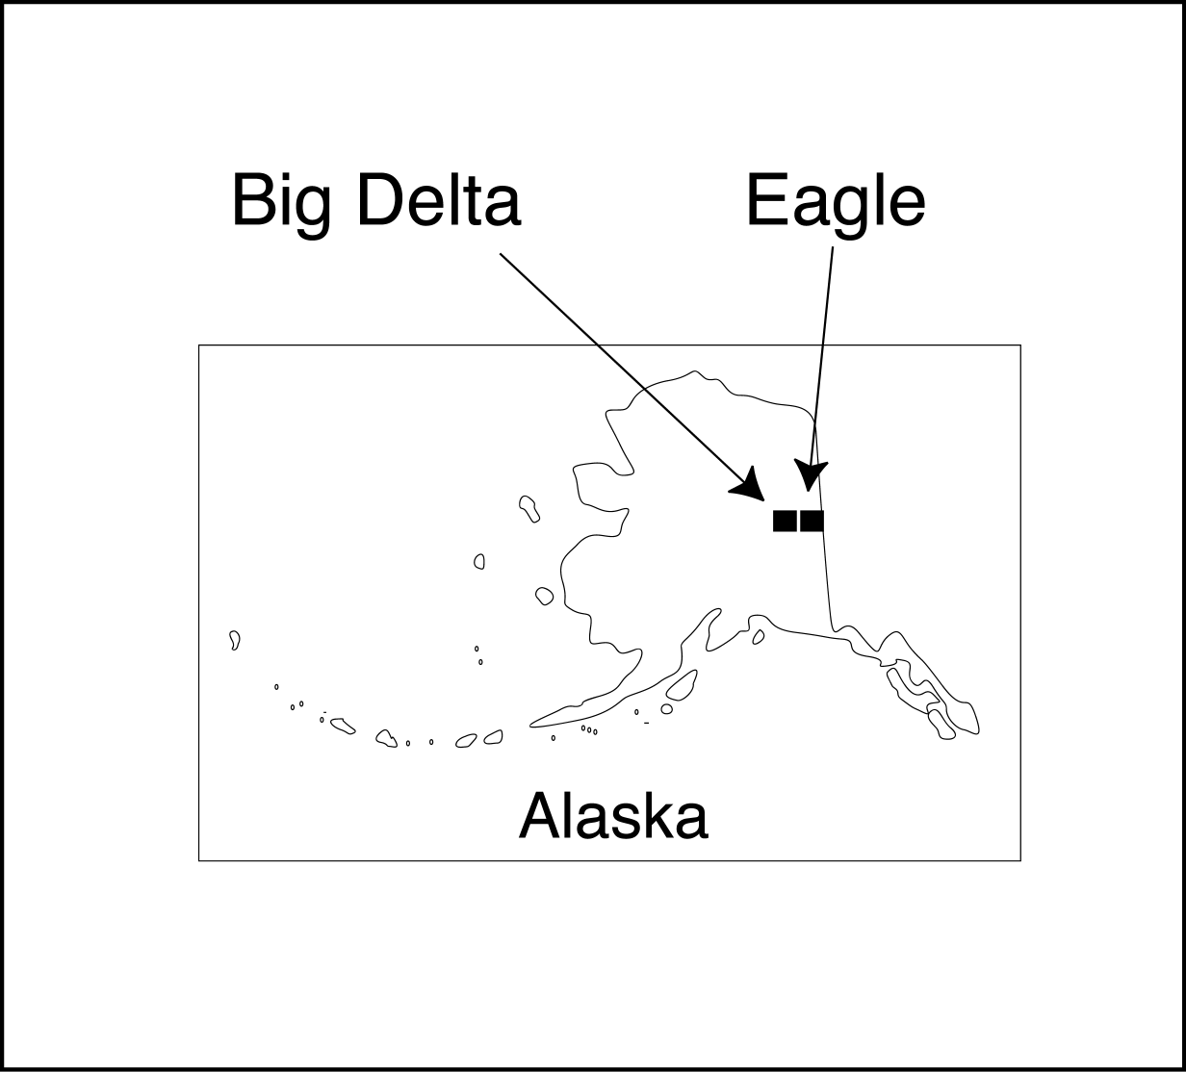

Figure 1. Location of the Big Delta and Eagle quadrangles within which are located the Goodpaster and Fortymile study areas, respectively.

A cooperative effort between the USGS and the AK-DNR was initiated in 1997 to provide data to address water quality concerns, as well as to establish regional baseline geochemical and biogeochemical data (Crock and others, 1999; Wanty and others, 2000). In June 1998, we continued our work of the previous year (Crock and others, 1999) with field measurements of pH, turbidity, electrical conductivity, and stream discharge for the Fortymile River and many of its tributaries. At the same time, samples of soils, rocks, stream sediments, water, and vegetation were collected for chemical analysis, and sent to the USGS laboratories in Denver, Colorado. This report lists the analytical results of the 1998 sampling. Figure 2 depicts the sampling locations for the 1998 sampling efforts in the Fortymile watershed. The analytical results of the 1997 sampling are listed in Crock and others (1999). In addition, similar studies were initiated at and near the new Teck-Pogo gold discovery located about forty miles northeast of Delta Junction, Alaska in the Big Delta quadrangle (fig. 1).

Important to this study’s assessment will be the evaluation of the flux and biogeochemical cycling of arsenic and cadmium between the terrestrial and aquatic phases. In addition to studying water-rock processes that mobilize arsenic and cadmium, this project is also examining other factors that affect their bioavailability to the environment (for example, in sites that are mined verses unmined; vegetated verses barren; saturated (permafrost) verses drained; forested verses muskeg) {Crock, Larison and Gough, 2000; Gough and Crock, 1999; Gough and others, 2001}.
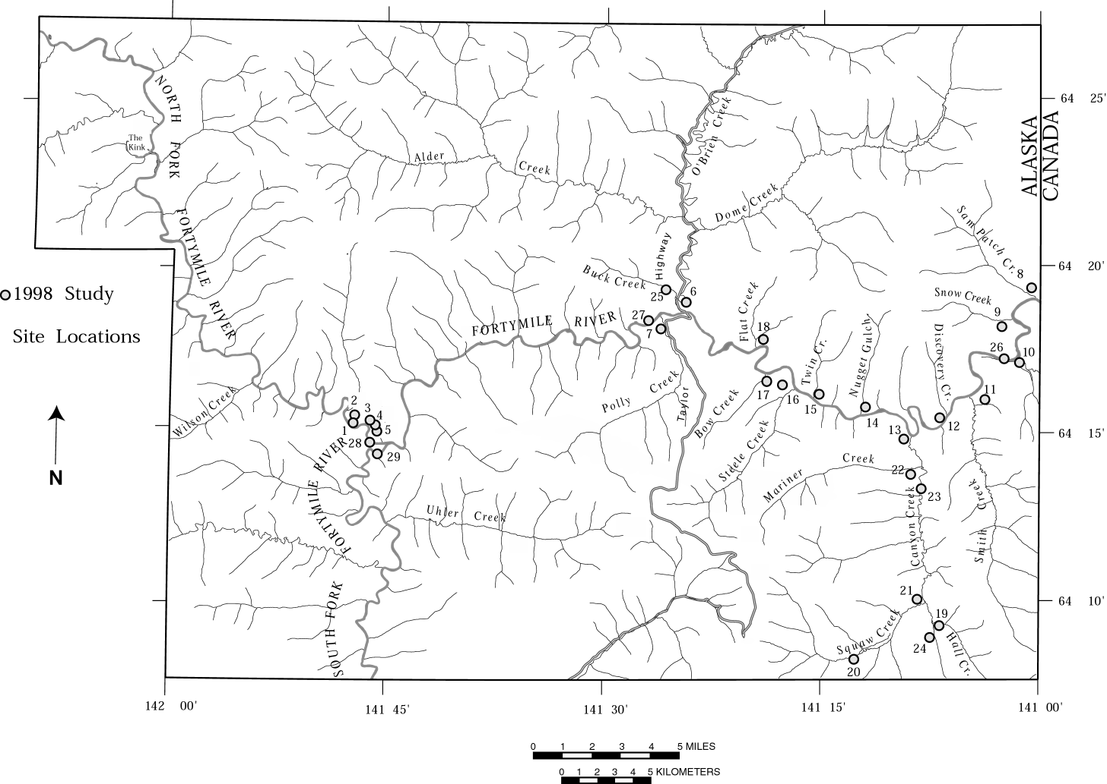

Figure 2. Study site locations for water, soil, vegetation, and sediment samples, Fortymile River watershed.

Geologic and Hydrologic Setting

Bedrock and alluvium control the minerals and chemical elements available to enter the hydrologic and biologic systems. Therefore, understanding the geologic framework of the area is the first step in assessing the effect of past and present mining operations on the Fortymile River. One of the goals of this project is to chemically characterize the bedrock of the area in order to understand its role in determining the composition of the region’s rivers and streams (Day and others, 2000; Gamble and others, 2001). These waters, in turn, flow into the Fortymile River drainage and form the “background” necessary to evaluate the effect of the mining operations on the water chemistry and turbidity (Wanty and others, 2000).

The bedrock of the Fortymile Mining District is composed of volcanic and sedimentary rocks of Paleozoic (?) age that have been intruded by younger granitic rocks (Day and others, 2000; Dusel-Bacon and others, 1995; Foster and Keith, 1969; Foster and others, 1994). The volcanic rocks were originally basalt similar to that formed in modern marine environments. The original sedimentary rocks were variable in composition and are also similar to those seen in modern marine environments. This entire package of rocks experienced regional mountain-building event(s) during Jurassic time in which the rocks were metamorphosed, deformed, and invaded by granite. The regional tectonic mountain-building event(s) caused several periods of folding of the rocks, the latest of which produced regional north-northeast oriented anticlines and synclines (Day and others, 2000; Yeend, 1996).

Recent geologic mapping has outlined several distinct types of alluvial deposits that range in age from Tertiary to Recent. During the Tertiary Epoch, numerous benches were cut into the bedrock by the forces of erosion. These benches have Tertiary-to Quaternary-age gravel deposits upon them, which locally host placer gold (Yeend, 1996). Along the banks of the Fortymile River, Quaternary alluvial gravel, sand, and silt deposits have been the main source of the placer gold mined to date and are the principal target for the dredge mining operations along the river.

The Fortymile River drains mostly subarctic forest and muskeg with discontinuous permafrost. Even the regions that are not underlain by permafrost are commonly frozen to various depths during the growing season. Discharge is highly variable (Kostohrys and others, 1999) and reflects (1) a rapid spring ice-break-up period (April), (2) runoff from storm events (the frozen nature of the terrain accentuates the runoff potential), (3) periodic summer dry periods, and (4) freeze-up (October).

STUDY METHODS

Study Design and Sample Collection

Field sampling was conducted June 17 through June 24, 1998. All sites where water, rock, soil, stream sediment, and vegetation material were collected were located on 1:63,360-scale topographic maps, GPS coordinates recorded, and often photographs were taken.

Geology

In order to meet the objectives of this study, a structural geologic basemap has been compiled (Day and others, 2000). This effort is an extension of the work of Foster and Keith (1969), Foster (1976), Foster and others (1994), and Dusel-Bacon and others (1995). Extensive vegetative cover in the Yukon-Tanana Upland makes outcrop examination difficult; however, both helicopter and river boat support allowed access to ridges, roadcuts, and stream banks and channels. Rock samples were collected for geochemical, thin-section, and petrographic analysis (Gamble and others, 2001). The rock-sampling program was designed to address two specific issues: 1) the need to characterize regional lithologic units that underlie the study area; and 2) the need to characterize any possible mineralized and (or) altered zones that might occur in the study area. Sample sites and sample descriptions for the rock samples are listed in Table 4, and analytical results are listed in Tables 8, 9, and 10. Samples from regional lithologic units were collected at sites thought to best typify the unit being examined. In order to minimize small-scale compositional variations, three to five separate pieces of the rock were collected over a surface exposure of approximately twenty-five square meters. Similarly, altered and (or) mineralized rock samples also consist of multiple pieces of material, but the size of the area sampled was often more restricted due to the smaller size of the target zone.

Hydrology

The hydrology and hydrogeochemistry of the region is being constructed through the examination of integrated flow and chemistry measurements on the mainstem of the Fortymile River and its tributaries (fig. 2). Tributaries were selected for study based on (1) watershed area, (2) geologic terrain, (3) results of past geochemical sampling (Foster and Clark, 1970), (4) results of a reanalysis of archived NURE (National Uranium Resource Evaluation) samples (Hoffman and Buttleman, 1996), and (4) current and past mining activity. Tributaries draining watersheds that met these criteria were then sampled just above their confluence with the Fortymile River. The location, description, and geochemistry of water samples are given in Tables 3, 6, and 7. Also listed in Table 2a and 2b are the references for water sampling protocols used in the study.

Soils, vegetation, and stream sediments

The collection of soils, vegetation, and stream sediments was based on the geologic and hydrologic framework being constructed. Tables 5 (description and location), 11a, 11b (soil), 12a, 12b (green alder), 13a, 13b (grayleaf willow), 14a, 14b (feather moss), 15a, 15b (green dog lichen), 16a, and 16b (white spruce) list the location, description, and analytical results of soil and vegetation samples. Soil and vegetation sampling locations were upslope of the area in the stream where the hydrogeochemical parameters were measured. Selection of the area was based on geology, aspect (south-exposures being preferred), and vegetation community and was usually less than 10 vertical meters above the stream. Vegetation and soil sites were upland conifer stands, usually dominated by white spruce and birch, with an understory of mixed shrubs and a dense ground cover of mosses and scattered lichens. Obvious floodplain and debris flow areas were avoided. Soil pits were dug to the C-horizon or to a depth dictated by the presence of frozen ground. At each site, approximately 1 kg of Oa (surficial organic layer), A1-, B-, and C-soil horizons were collected from the pits and placed in soil-sample paper bags. Vegetation samples (approximately 200 g, dry weight) consisted of the leaf and stem material of the young, growing branches (approximately the terminal-most 10-cm) of Salix glauca (grayleaf willow) and Alnus crispa (green alder). Samples are a composite of the branches from several small individuals in the immediate vicinity of the soil pit. The material was clipped using stainless steel shears, placed in Hubco® bags, and labeled. In addition, a large, integrated sample each of the ubiquitous feather moss (Hylocomium splendens) and green dog lichen (Peltigera aphthosa) as well as a composite sample of the last two year’s growth of white spruce (Picea glauca) twigs and needles was collected. To help assess the local chemical variability, at four sites duplicate stream sediment, soil, and vegetation samples were collected. In the following data tables, these site duplicate samples are designated with an “X” as a suffix to the sample number. Also laboratory-prepared analytical splits are designated in all the tables with a “Y” as a suffix to the sample number.
Stream sediment samples were collected at most of the hydrogeochemical sampling sites (Table 5) and the analytical results for these samples are presented in Table 17. When a stream sediment sample was collected on both the tributary and the main river upstream from the tributary, the sample suffix is “SS1” for the tributary and “SS2” for the upstream main river sample.

Sample Preparation and Analysis

All samples were shipped to the Denver Laboratories of the USGS for analysis. Methods of sample storage, shipping, preservation, drying, preparation for analysis, and analysis are described elsewhere and follow the procedures outlined in Crock and others (1993), Arbogast (1996), Curry (1996), Lichte and others (1986), Gough and Crock (1997), Briggs and Meier (1999), and Lamothe and others (1999). Table 1a lists the concentration ranges for major-element-oxide analysis in rocks by wavelength dispersive x-ray fluorescence spectrometry. Tables 1b and 1c list the lower limits of determination (LLD) for the other methods used in the analyses of the solid samples. Tables 2a and 2b list the LLD’s for both field and laboratory methods used for the analyses of the water samples. The vegetation and soil samples were ashed at 500ºC in a muffle furnace in porcelain dishes prior to the determination of most elements. Except for the determination of gold and FeO% in rock samples (Tables 10) and gold in stream sediments (Table 17), all analytical results reported herein were performed at the Denver, Colorado laboratories of the USGS. Methods used by the contract laboratory are described in Arbogast (1996) – gold by graphite furnace-atomic absorption spectrometry and FeO% by colorimetry. National Institute of Standards and Technology (NIST) and internal USGS reference materials and laboratory-made duplicate sample (designated in the data tables with a suffix of ”Y” to the sample number) were submitted to the laboratories as part of each suite of samples. The results are presented for the duplicate samples in the respective data tables. Quality assurance (QA) and control (QC) practices, for most of the analysis methods used, are provided in more detail in Arbogast (1996).

ANALYTICAL RESULTS

The tables in this report list all chemical analysis results for the samples of water, rock, soil, stream sediment, and vegetation collected in 1998 at the Fortymile River study area. The purpose of this report is the release of these data and the report is not meant to be interpretative. Analytical results for anions and major and minor elements are presented in Tables 6 and 7 for the water samples. Table 8 presents the major element determinations of selected rock samples. Table 9 presents the rare earth element and other selected trace elements for selected rock samples as determined by the sodium peroxide method (Lichte and others, 1986). Table 10 presents the remaining elemental determinations for the rock samples measured by various methods. Due to convention, many of the analyses for soils and vegetation have been converted from a measured ash-weight basis to a dry-weight basis. The data as measured on the samples of vegetation ash and soil ash and raw material are given in Tables 11a (soils), 12a (green alder), 13a (grayleaf willow), 14a (feather moss), 15a (green dog lichen), and 16a (white spruce). The data converted to a dry-weight basis for all the samples of vegetation and soil are given in Tables 11 (soils), 12 (green alder), 13 (grayleaf willow), 14 (feather moss), 15 (green dog lichen), and 16 (white spruce).All data as measured are also presented in Tables 11a (soils), 12a (green alder), 13a (grayleaf willow), 14a (feather moss), 15a (green dog lichen), and 16a (white spruce) for those media where the measured data were converted from an ash-weight basis to a dry weight basis.

ACKNOWLEDGEMENTS

We wish to thank the logistical assistance of Jim Vohden, Alaska Department of Natural Resources, Division of Mining and Water Management, Fairbanks. We are especially grateful to Larry and June Taylor of Eagle, Alaska, for their hospitality and for sharing their knowledge of the river and the region.

REFERENCES

Arbogast, B.F., ed., 1996, Analytical methods manual for the Mineral Resource Surveys Program, U.S. Geological Survey: U.S. Geological Survey Open-File Report 96-525, 248 p.

Briggs, P.H. and Meier, A.L., 1999, The determination of forty-two elements in geological materials by inductively coupled plasma-mass spectrometry: U.S. Geological Survey Open-File Report 99-199, 15 pp.

Crock, J.G., Gough, L.P., Wanty, R.B., Day, W.C., Wang, B., Gamble, B.M., Henning, M., Brown, Z.A., and Meier, A.L., 1999, Regional geochemical results from the analyses of rock, water, soil, stream sediment, and vegetation samples—Fortymile River watershed, east-central, Alaska: U.S. Geological Survey Open-File Report 99-33, 82 pp.

Crock, J.G., Beck, K.A., Fey, D.L., Hageman, P.L., Papp, C.S., and Peacock, T.R., 1993, Element concentrations and baselines for moss, lichen, spruce, and surface soils, in and near Wrangell-Saint Elias National Park and Preserve, Alaska: U.S. Geological Survey Open-File Report 93-14, 98 p.

Crock, J.G., Larison, J.R., and Gough, L.P., 2000, Cadmium accumulation in native vegetation of Alaska and Colorado: in Metal Ions in Biology and Medicine, Volume 6, Proceedings of the Sixth International Symposium on Metal Ions in Biology and Medicine held in San Juan, Puerto Rico, USA, on May 7-10, 2000, J.A. Centeno, Philippe Collery, Guy Vernet, R.B. Finkelman, Herman Gibb, and Jean-Claude Etienne (Editors), John Libby Eurotext, Paris, pp. 177-179.

Curry, K.J., 1996, Total sulfur by combustion, in Arbogast, B.F., ed., 1996, Analytical methods manual for the Mineral Resource Surveys Program, U.S. Geological Survey: U.S. Geological Survey Open-File Report 96-525, p. 177-181.

Day, W.C., Gamble, B.M., Henning, M.W., and Smith, B.R., 2000, Geologic setting of the Fortymile River Area—Polyphase deformational history within part of the eastern Yukon-Tanana Uplands of Alaska, in Kelley, K.D. and Gough, L.P., eds., Geologic studies in Alaska by the U.S. Geological Survey, 1998: U.S. Geological Survey Professional Paper1615, pp. 65-82.

Dusel-Bacon, C., Hansen, V.L., and Scala, J.A., 1995, High-pressure amphibolite facies dynamic metamorphism and the Mesozoic tectonic evolution of an ancient continental margin, east central Alaska: Journal of Metamorphic Geology, v. 13, p. 9-24.

Fishman, M.J., and Friedman, L.C., eds., 1989, Methods for determination of inorganic substances in water and fluvial sediments: Chapter A1, Book 5, Laboratory analysis, Techniques of Water-Resources Investigations of the United States Geological Survey, 545 p.

Fishman, M. J., and Pyen, G., 1979, Determination of selected anions in water by ion chromatography: U.S. Geological Survey Water-Resources Investigations Report 79-101, 30 p.

Foster, H.L., 1976, Geologic map of the Eagle quadrangle, Alaska: U.S. Geological Survey Miscellaneous Investigations Series Map I-922.

Foster, H.L., and Keith, T.E.C., 1969, Geology along the Taylor Highway, Alaska: U.S. Geological Survey Bulletin 1281, 36 p.

Foster, H.L., and Clark, S.H.B., 1970, Geochemical and geologic reconnaissance of a part of the Fortymile Area, Alaska: U.S. Geological Survey Bulletin 1312-M, 29 p.

Foster, H.L., Keith, T.E.C., and Menzie, W.D., 1994, Geology of the Yukon-Tanana area of east-central Alaska, in Plafker, G., and Berg, H.C., eds., The geology of Alaska: Boulder, Colo., The Geological Society of America, p. 205-240.

Gamble, B.M., Day, W.C., and Henning, M., 2001, Geochemistry of lithologic units, Fortymile River watershed, Alaska, in, Gough, L.P. and Wilson, F.H. (eds.), Geological Studies in Alaska by the U.S. Geological Survey, 1999, U.S. Geological Survey Professional Paper (in press).

Gough, L.P. and Crock, J.G., 1997, Distinguishing between natural geologic and anthropogenic trace element sources, Denali National Park and Preserve, in Dumoulin, J.A. and Gray, J.E., eds., Geologic Studies in Alaska by the U.S. Geological Survey, 1995: U.S. Geological Survey Professional Paper 1574, p. 57-71.

Gough, L.P. and Crock, J.G., 1999, Regional biogeochemistry of cadmium and related elements, Fortymile River watershed, east-central Alaska [abs.]: Proc. 3rd Conference on Cadmium in the Environment, Warsaw, Poland, Oct. 26-27, 1999, p. 6.

Gough, L.P., Crock, J.G., Day, W.C., and Vohden, J., 2001, Biogeochemistry of arsenic and cadmium, Fortymile River watershed, east-central Alaska, in, Gough, L.P. and Wilson, F.H. (eds.), Geological Studies in Alaska by the U.S. Geological Survey, 1999, U.S. Geological Survey Professional Paper (in press).

Hoffman, J.D. and Buttleman, K., 1996, National Geochemical Data Base—National Uranium Resource Evaluation (NURE) hydro-geochemical and stream sediment reconnaissance (HSSR) data for Alaska and the conterminous United States: U.S. Geological Survey Digital Data Series DDS-18-B (CD ROM).

Kostohrys, J., Sterin. B.B.G., and Hammond, T., 1999, Water resources of the Fortymile National Wild and Scenic River, Alaska: Bureau of Land Management, BLM – Alaska Open-File Report 75, 64 p.

Lamothe, P.J., Meier, A.L., and Wilson, Stephen, 1999, The determination of forty-four elements in aqueous samples by inductively coupled plasma-mass spectrometry: U.S. Geological Survey Open-File Report 99-151, 14 pp.

Lichte, F.E., Meier, A.L., and Crock, J.G., 1986, Determination of the rare earth elements in geological materials by inductively coupled plasma mass spectrometry: Analytical Chemistry, 59, p. 1150-1157.

Mee, S.J., Siems, D.F., and Taggart, J.E., Jr., 1996, Major element analysis by wavelength dispersive X-ray fluorescence spectrometry, in Arbogast, B.F., ed., 1996, Analytical methods manual for the Mineral Resource Surveys Program, U.S. Geological Survey: U.S. Geological Survey Open-File Report 96-525, p. 236-242.

O’Leary, R.M., Hageman, P.L., and Crock, J.G., 1996, Mercury in water, geologic, and plant materials by continuous flow-cold vapor-atomic absorption spectrometry, in Arbogast, B.F., ed., 1996, Analytical methods manual for the Mineral Resource Surveys Program, U.S. Geological Survey: U.S. Geological Survey Open-File Report 96-525, p. 42-55.

O’Leary, R.M. Meier, A.L., 1996, Gold by flame or graphite furnace atomic absorption spectrometry, in Arbogast, B.F., ed., 1996, Analytical methods manual for the Mineral Resource Surveys Program, U.S. Geological Survey: U.S. Geological Survey Open-File Report 96-525, p. 31-36.

Swainbank, R.C., Clautice, K.H., and Nauman, J.L., 1998, Alaska’s Mineral Industry – 1997: Alaska Department of Natural Resources Division of Geological And Geophysical Surveys Special Report 52, 65 p.

Wanty, R.B., Wang, B., Vohden, J., Briggs, P.H., and Meier, A.L., 2000, Regional baseline geochemistry and environmental effects of gold placer mining operations on the Fortymile River, eastern Alaska, in Kelley, K.D. and Gough, L.P., eds., Geologic studies in Alaska by the U.S. Geological Survey, 1998: U.S. Geological Survey Professional Paper1615, pp. 101-110.

Yeend, W., 1996, Gold placers of the historical Fortymile River region, Alaska: U.S. Geological Survey Bulletin 2125, 75 p.

