FINAL REPORT

on

Data Acquisition and Processing

for the

Airborne Magnetic Survey

of

Death Valley, California

on behalf of the

United States Geological Survey

Brian Schacht P. Geoph.

Ottawa, Ontario, Canada

March, 2001

TABLE OF CONTENTS

1. INTRODUCTION 3

2. TECHNICAL SPECIFICATIONS 4

  - SURVEY LOCATION 4
  - FLIGHT SPECIFICATIONS 4
2.3 TOLERANCES 4
2.4 SURVEY EQUIPMENT 5

3. PERSONNEL 6

4. SURVEY OPERATIONS 7

4.1 GENERAL 7
4.2 DIURNAL CONDITIONS 7
4.3 GENERAL WEATHER CONDITIONS 7
4.4 QUALITY CONTROL AND FIELD PROCESSING 7

5. CALIBRATION AND TEST RESULTS 8
5.1 GPS BASE STATION 8
5.2 MAGNETIC LAG TEST 8
5.3 GPS LAG / ACCURACY TEST 9
5.4 FIGURE OF MERIT 11
  - ALTIMETER CALIBRATION 11

6. FINAL MAGNETIC DATA PROCESSING 12

6.1 NOISE EDITING 12
6.2 NOISE FILTERING 12
6.3 DIURNAL SUBTRACTION 12
6.4 IGRF CORRECTION 12
6.5 UPWARD/DOWNWARD CONTINUATION 13
6.6 LEVELLING 13
6.7 GRIDDING 13
6.8 GRID LEVELLING 13

7. DELIVERABLES 14

  - MAPS 14
7.2 REPORT 14
7.3 DIGITAL ARCHIVES 14

APPENDIX: DIGITAL ARCHIVE FORMAT DESCRIPTION 15

1. INTRODUCTION

An aeromagnetic survey was flown over Death Valley, California, as well as three conjoined areas within western Nevada. The flying was completed between December 5, 2000, and January 14, 2001, by Fugro Airborne Surveys on behalf of the United States Geological Survey (see figure 1). A 1:100,000 scale contour map and digital grid of the total magnetic field were produced, as well as a digital grid of radar altimeter (ground clearance) data.

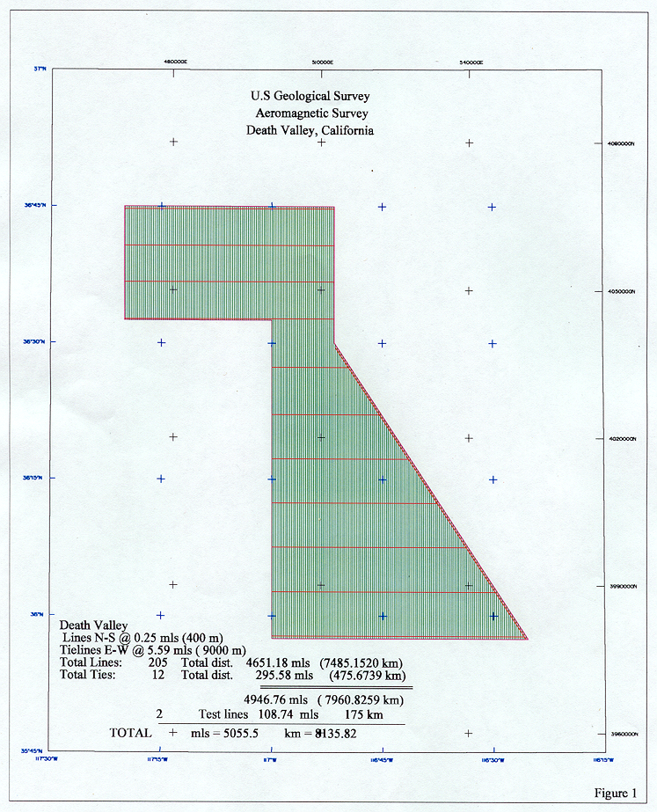

2. TECHNICAL SPECIFICATIONS 4

This section describes in detail the guidelines followed throughout the performance of the project; tolerances and instruments are also presented here.

  - SURVEY LOCATION

The area is bounded by the following co-ordinates (WGS84 UTM and degrees X 1,000,000):
500000.00 3979126.00 35572348 -117000000
552103.00 3979126.00 35571847 -116252002
512687.00 4039215.00 36295343 -116513001
512646.00 4066946.00 36445341 -116513002
470243.00 4066988.00 36445340 -117200003
470163.00 4043879.00 36322342 -117200002
500000.00 4043828.00 36322345 -117000000

2.2 FLIGHT SPECIFICATIONS

Traverse Line Direction E - W
Traverse Line Spacing 400 m
Control Line Direction N - S
Control Line Spacing approximately 7,500 m
Terrain Clearance 117-1217 m+ - see section 2.3 - “Flying Height”
Line kilometers 8135.82 (5055.5 miles)
Average Sampling Interval 7.5 m

2.3 TOLERANCES

Lines (or segments of lines crossing two control lines, or segments of control lines crossing several lines) were re-flown when any of the following tolerances were exceeded:

Navigation
- Nominal line spacing must not be exceeded by more than 50% for a distance of more than 3.2 km.

Flight Height
- In order to maintain similar elevations at all traverse and control line intersections, even when climbing or descending steeply, the Fugro ACCUDRAPE system utilizes a pre-planned digital drape surface which the onboard computer compares with the GPS xyz to feed corrections to the pilot.
- Deviations from the pre-planned drape elevation must not exceed 100 m. The precipitous mountains flanking the survey necessitated a pre-planned drape surface with ground clearance exceeding 1217 m (4000’) over the valley (the radar altimeter maximum is 1217 m). Less than 1% of the data could be flown below 183 m (600’).

Magnetic Diurnal
- Deviations must not be greater than 2 nT from a 2 minute chord. The ground station magnetometer operated during all data acquisition.

Airborne Magnetometer Noise
- “Maneuver” noise must not exceed an envelope of ±0.1 nT over more than 10% of any line. This was monitored on the analog chart with a fourth difference and a high-pass filter.
- A standard Figure of Merit must be less than 1.5 nT.
- Heading errors must be within 1 nT between reciprocal headings.

2.4 SURVEY EQUIPMENT

Table 2.4.a lists major characteristics of the fixed-wing survey aircraft.
Registration | Endurance | Engines | Manufacturer | Type | No. of Seats | Average  Speed
C-FZLK | 6.5 hours | 1  Turbine | Cessna | Caravan 208 | 3 | 75 m/sec

Table 2.4.a Survey Aircraft

Table 2.4.b lists the geophysical equipment installed in C-FZLK throughout the survey.
Equipment | Manufacturer | Model | Type
Data Acquisition System | Fugro Airborne Surveys | GeoDAS | Pentium computer based, real-time,  data synchronization and recording
Magnetometer | Scintrex | CS-2 | Cesium Vapour,10 Hz Sampling,  0.005 nT Sensitivity,0.001 nT Resolution
Compensator | RMS | AADC | 27 Term
Digital Backup | Iomega | Zip Drive | 100 Mb removable hard drive
Analogue Recorder | RMS | GR-33a-1 | Dot Matrix
Radar Altimeter | TRT | AVH-8 | 10 Hz Sampling, Accuracy ±2%
Barometric Altimeter | Rosemount | 1241M | 10 Hz Sampling, Accuracy ±5 m
Omnistar Receiver | Trimble |  | Real-time differential GPS correction
GPS Receiver | Sercel | NR103 | 10 Channel
Video Camera | Panasonic | WVC 1302 | Colour
Video Cassette Recorder | Panasonic | AG2400 | NTSC

Table 2.4.b Airborne Geophysical Equipment

Table 2.4.c lists the components of the ground-based reference station.

Equipment | Manufacturer | Model | Type
Magnetometer | Scintrex | CS-2 | Cesium Vapour, 2 Hz Sampling,  0.005 nT Sensitivity, 0.01 nT Resolution
GPS Receiver | Sercel | NR-103 | 10 Channel

Table 2.4.c Ground Reference Station
The ground magnetometer was mounted in a magnetically quiet area; its clock was synchronized with the GPS time signal. The GPS data logger records all of the raw range data stream. The Trajecto differential correction software matches the output from the airborne GPS system and the ground GPS system during the data reduction process.

Table 2.4.d lists the equipment and software used to perform the field processing.

Equipment | Manufacturer | Model | Type
PC | Dell | Inspiron 7500 | 800 MHz Pentium
Printer | HP | HP950C | A4 Colour
Data Processing Software | Fugro Airborne Surveys | Gmaps | DOS & Windows
Image Processing Software | ERMapper | Version 5.5 | Windows 95/98
GPS Processing Software | Sercel | Trajecto | DOS

Table 2.4.d Field Processing System

3. PERSONNEL

NAME | TITLE | PROJECT POSITION
Robb, Jeff | Aircraft Maintenance Engineer | Aircraft Maintenance
Lamirande, Ken | Electronics Technician | Electronics Operator
Reed, Travis | Electronics Technician | Electronics Operator
Lyall, Ron | Operations Manager | Processor, Logistics
Williston, Mark | Pilot | Survey Pilot
Thomas, Jeff | Pilot | Survey Pilot

Table 3 Field Project Personnel
4. SURVEY OPERATIONS

  - GENERAL

The production phase of the project began in Bishop, California, on December 5th , 2000, and the final production flight was made on January 14th, 2001. The Comfort Inn provided crew accommodation and space for the field processing office.

  - DIURNAL CONDITIONS

Magnetic diurnal variation was exceptionally quiet. Deviations never reached the specification limit.

  - GENERAL WEATHER CONDITIONS

Weather conditions were frequently unfavourable for survey flying due to high turbulence or cloud cover in the mountains. Ten days were lost.

  - QUALITY CONTROL AND FIELD PROCESSING

- To check the data for adherence to contract specifications and move the data closer to the final stage, the following procedures were followed for each flight (details in section 6):

- downloading and verification of aircraft data;
- downloading and verification of GPS and magnetic base station data;
- post-processing of GPS data using SERCEL TRAJECTOGRAPHY software;
- merging of navigation data with geophysical data including transformation of coordinates from WGS84 latitude/longitude to UTM x, y coordinates in the local spheroid;
- creation of flight path plots and evaluation of compliance with contract specifications;
- spike and null value location and removal from the magnetic and altimeter data;
- computing of a drape surface quality control field for evaluation of compliance with the contract specifications;
- computing of magnetic noise channel for evaluation of data quality and compliance with contract specifications;
- evaluation of diurnal data quality, and compliance with contract specifications;
- correction of magnetic data for I.G.R.F. gradient;
- noise filtering of magnetic and altimeter fields;
- correction of magnetic field for altitude deviations;
- backing-up of all field data.

At regular intervals, the corrected magnetic data were levelled and gridded for quality inspection including real-time shade enhancement.
5. CALIBRATION AND TEST RESULTS

5.1 GPS BASE STATION

To apply post-flight differential GPS corrections to the survey data, a GPS base station was installed near the crew’s hotel. The location of the GPS base station antenna was determined by averaging positions over a 24 hour period. The location was 37º 22’ 17.28” N latitude, 118º 22’ 8.46” W longitude, elevation 1,255 m, on the WGS spheroid.

  - MAGNETIC LAG TEST

The camera on-board the aircraft records its position, A, relative to the ground, at time t0. In fact the sensor will arrive over A at time t1 (>t0). Furthermore, because of electronic delays, the reading at time t1 will not be recorded until time t2 (>t1). The difference t2-t0 represents the lag between the actual aircraft position and the x y position tied to the magnetic reading on disk. A lag test was performed by flying the aircraft at survey altitude in opposite directions over a sharp magnetic feature. The position of the magnetic feature was referenced to a visible feature recorded by the video system, in this case a bridge, which was the anomaly source. By superimposing a plot of the east-west anomaly over the west-east anomaly, the video-picked position of the bridge can be transposed onto its counterpart; and one-half the difference between the two video-picked positions equals the magnetic system lag. The lag was 0.7 seconds, or 7 magnetic samples, for aircraft C-FZLK. These values were used to correct for magnetic system lag throughout the survey.

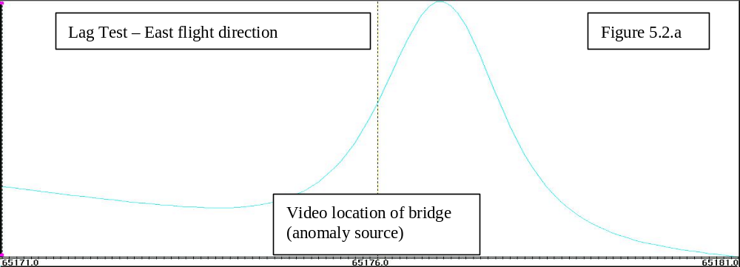
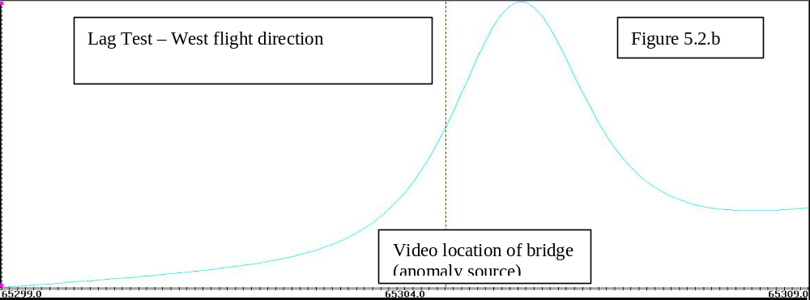
5.3 GPS LAG / ACCURACY.TEST

A cloverleaf flown over the established co-ordinates of the Canadian Geological Survey test site was used to measure the lag in the GPS positioning, with regard to the video camera position. A value of 0.2 seconds resulted in a best fit with the video position. Once the lag is applied (as in figure 5.3) the cloverleaf intersection is used to test the accuracy of the GPS positioning.

Aircraft: |  |  | Cessna Caravan
Registration: |  |  | C-FZLK
Date: |  |  | November 25, 2000
Location: |  |  | Bourget, Ontario, Canada
Altitude: |  |  | 400 ft mean terrain clearance
DIRECTION | FIDUCIAL CLOSEST TO TARGET |  | OFFSET FROM TARGET DUE TO PILOT ERROR | Line # on Video
 | (from video) |  | (estimate in metres & direction)
South | 66216.56 |  | 0 | Line 10
West | 66326.92 |  | 3 N | Line 11
North | 66413.50 |  | 20 E | Line 12
East | 66506.22 |  | 5 N | Line 13
South | 66595.44 |  | 5 W | Line 14
West | 66709.76 |  | 5 N | Line 15
East | 66884.10 |  | 0 | Line 17
North | 66992.44 |  | 15 E | Line 18
TABLE 5.3 GPS LAG / ACCURACY TEST

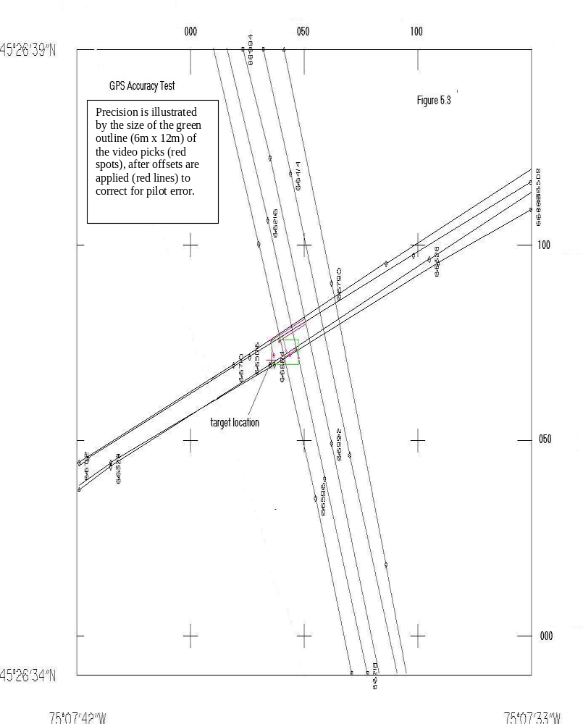
5.4 FIGURE OF MERIT (FOM)

The figure of merit is the measurement of the ability of the compensation system to remove the effects of aircraft maneuvers from the total field data. During the FOM test the aircraft is flown into a quiet magnetic area and put through a series of pitches (±5º), rolls (±10º) and yaws (±5º) to examine the noise remaining in the signal after the 27 term automatic compensation algorithm has been applied to the data.

 | Figure of Merit
Aircraft: |  | Cessna Caravan
Registration: |  | C-FZLK
Magnetometer: |  | Cesium vapor, stinger mounted
Sampling Rate: |  | 10 Hz
Date: |  | December 2, 2000
Location: |  | Bishop, California
HEADING | MANOEUVER | VALUE (nT) | HEADING
 |  |  | TOTAL (nT)
NORTH | PITCH | 0.18
 | ROLL | 0.08
 | YAW | 0.06 | 0.32
EAST | PITCH | 0.12
 | ROLL | 0.07
 | YAW | 0.08 | 0.27
SOUTH | PITCH | 0.08
 | ROLL | 0.06
 | YAW | 0.04 | 0.18
WEST | PITCH | 0.08
 | ROLL | 0.06
 | YAW | 0.06 | 0.20
 |  | FOM VALUE | 0.97 | nT
AVERAGE MANEUVER NOISE ( FOM / 12 ) |  |  |  |  | 0.08 | nT

Table 5.4 C-FZLK Figure of Merit

5.5 ALTIMETER CALIBRATION

On November 24, 2000, the radar, barometric, and GPS altimeters were compared by flying at terrain clearances of 200’, 300’, 400’, 500’, 600’, 800’, and 1000’ over a flat portion of the Ottawa river. The results reconfirmed that all altimeters aboard C-FZLK are functioning normally.

6. FINAL DATA PROCESSING

Final data reduction was undertaken at the Fugro Airborne Surveys processing center in Ottawa, Canada between January and February, 2001. In general, final processing consisted of the following operations:

- final levelling of the total field magnetic data;
- image and 1:100,000 scale map analysis of the total field and levelling compensations by a geophysicist for any levelling, positioning, or gridding errors;
- final gridding and micro-levelling;
- imaging and plotting of magnetic field;
- gridding of radar altimeter data
- archiving of final data.

The final projection was the Universal Transverse Mercator using the NAD83 (WGS84) spheroid, with a false easting of 500,000 m, false northing of 0 m, scale factor of 0.9996 and central meridian of 117º West.

Further details of the magnetic processing are provided below.

6.1 Noise Editing

An automatic editing routine, employing 4th differences of the magnetic field, removed nulls and spikes down to the noise level, and located abrupt level shifts.

6.2 Noise Filtering

We filtered all data in the frequency domain with a cutoff 0.061 (wavelengths per sample interval) rolloff 0.030 (wavelengths per sample interval). This filter approaches 100% removal of anomalies of wavelength 99 metres (13.2 samples x average speed of 7.5 metres/sample) or less. It approaches 0% removal of anomalies of wavelength 163 metres (21.7 samples x average speed of 7.5 metres/sample) or more. This filter should have no effect on any real, geological-source anomalies; or even the narrowest anomaly from cultural sources on the ground surface. The minimum ground clearance is about 150 metres (rarely encountered) and the minimum wavelength produced at 150 metres is roughly 2 x 150 = 300 metres. Thus all real wavelengths are a safe distance from the 163 metre limit of the filter.

6.3 Diurnal Subtraction

A test was made to verify the effectiveness of diurnal subtraction: Long period diurnal variations were subtracted from the air data, as they are more likely to correlate, and the residual magnetic field was leveled. As no improvement was noted in the required levelling compensations, diurnal subtraction was not employed.

6.4 IGRF Correction

The IGRF regional value was calculated using the 1995 model updated to the mid-survey date (2001.0) using the corrected GPS elevations. Using the actual elevations for IGRF correction has the added benefit of correcting for the magnetic effect of altitude variations within the Earth’s primary field. Corrections for vertical movements within the secondary magnetic field induced by the Earth’s crust is discussed in the following section, 6.5.

  - Upward/Downward Continuation

As the terrain clearance drops, the vertical magnetic gradients can become very high; and even minor deviations from the prescribed drape surface may produce significant changes in the measured magnetic field. The Taylor Expansion applies the required upward and downward continuations to the magnetic field to simulate measurements from the prescribed altitude. The resulting magnetic field profiles were input to the levelling process.

  - Levelling

The lines (traverse lines) and tie-lines (control lines) of an aeromagnetic survey form a network, and the points where they cross are called intersections. At each intersection the magnetic values should be identical. In practice they differ as a result of:
- time variations of the magnetic field;
- heading effects;
- altitude differences;
- position errors;
- cultural or instrument noise.

In the levelling process, it is assumed that most of the required level adjustments will vary smoothly along each line or tie-line. The network of line minus tie-line differences at the intersections is analyzed to produce a matrix of misclosures. These misclosures were reduced to zero through an iterative process of tilting the profile baselines and moving the intersection locations. Compensation values applied at adjacent tie-lines were not allowed to differ by more than 5 nT. Intersection movements were restricted to a maximum of 4 samples (about 30 metres). These maximums were very rarely required. None of the 1,121 intersections needed manual corrections.

6.7 Gridding

Gridding was done by the Akima method, using data from all lines and tie-lines. A gridding interval of 1/3 the line spacing was used (133 m).

6.8 Grid Levelling

The final stage of levelling consisted of applying a grid-levelling routine to the gridded data to remove small residual errors that are not properly removed by conventional levelling of the line data
7. DELIVERABLES

7.1 MAPS

Two copies of the magnetic field contour map are presented at 1:100,000 scale with UTM registration plus screened flight path, in black and white, on mylar.

7.2 REPORT

This report covers data acquisition and processing, and is provided in two hard copies plus a digital archive in Microsoft Word format.

7.3 DIGITAL ARCHIVES

Files: raw and final processed profile data, and final magnetic and radar altitude grids;
Format: The ASCII format is used for profiles, and Geosoft binary format is used for grids. A full format description is included in the appendix .
Media: CD-ROM.
Copies: two

We trust this survey will assist your mapping program; and we remain available for questions at any time.

Respectfully Submitted,

Brian Schacht P. Geoph.

APPENDIX

DIGITAL ARCHIVE FORMAT DESCRIPTOR
DIGITAL ARCHIVE DESCRIPTION OF PROFILE DATA

DEATH VALLEY, CALIFORNIA

Digital Archive is Ascii.
Ascii filename: california.profile
250 bytes I 10 format

1-10 Line number X 100 + part number
11-20 Flight number
21-30 Latitude NAD27 (decimal degrees)
31-40 Longitude
41-50 UTM metres NAD27 (CM 117 degrees west)
51-60 UTM metres
61-70 Latitude WGS84 (decimal degrees)
71-80 Longitude
81-90 UTM metres WGS84 (CM 117 degrees west)
91-100 UTM metres
101-110 Fiducial (seconds UTC X 10 increments by 1)
111-120 Date (ddmmyy)
121-130 Radar (m X 100)
131-140 Baro (m X 100)
141-150 GPS elevation (m X 100)
151-160 Diurnal (.001 nT)
161-170 Raw Magnetics (.001 nT) edited, lag applied.
171-180 Filtered Magnetics (.001 nT)
181-190 Filtered Magnetics - I.G.R.F. (.001 nT)
191-200 I.G.R.F. (2000.9)
201-210 Differential Up/Down corr. Magnetics (.001 nT)
211-220 Levelled Magnetics (.001 nT)
221-230 Final Magnetics (.001 nT)
231-240 Compensation (.001 nT) from TL levelling
241-250 Compensation (.001 nT) from micro levelling

Fugro Airborne Survey's direction codes are as follows:

1: Northbound
2: Eastbound
3: Southbound
4: Westbound

The archive file contains the following lines:

ARCHIVE FILE: california.archive
------------
LINE-ID DIR FST-FID LST-FID TAPE BLOCK REC SAMPLES
----------- --- (X10) (X10) ---- ----- --- -------
10101 3 56599 56919 1 1 1 3201
10201 1 57317 57633 1 3202 1 3161
10301 3 57805 58137 1 6363 1 3321
10401 1 58333 58680 1 9684 1 3471
10501 3 58827 59175 1 13155 1 3481
10601 1 59378 59711 1 16636 1 3331
10701 3 59874 60216 1 19967 1 3421
10801 1 60372 60692 1 23388 1 3201
10901 3 60863 61204 1 26589 1 3411
11001 1 61368 61712 1 30000 1 3441
11101 3 62470 62805 1 33441 1 3351
11201 1 62997 63320 1 36792 1 3231
11301 3 63483 63825 1 40023 1 3421
11401 1 63981 64318 1 43444 1 3371
11501 3 64468 64806 1 46815 1 3381
11601 1 64970 65316 1 50196 1 3461
11701 3 65484 65815 1 53657 1 3311
11801 1 65965 66298 1 56968 1 3331
11901 3 66858 67223 1 60299 1 3651
12001 1 67385 67721 1 63950 1 3361
12101 3 68016 68355 1 67311 1 3391
12201 1 68523 68861 1 70702 1 3381
12301 3 69021 69365 1 74083 1 3441
12401 1 69526 69861 1 77524 1 3351
12501 3 70035 70369 1 80875 1 3341
12601 1 70565 70909 1 84216 1 3441
12701 3 71675 72011 1 87657 1 3361
12801 1 72199 72524 1 91018 1 3251
12901 3 72693 73040 1 94269 1 3471
13001 1 73211 73544 1 97740 1 3331
13101 3 56169 56532 1 101071 1 3631
13201 1 56725 57075 1 104702 1 3501
13301 3 57228 57588 1 108203 1 3601
13401 1 57777 58118 1 111804 1 3411
13501 3 58255 58611 1 115215 1 3561
13601 1 58801 59151 1 118776 1 3501
13701 3 59635 59979 1 122277 1 3441
13801 1 60138 60497 1 125718 1 3591
13901 3 60669 61010 1 129309 1 3411
14001 1 61179 61569 1 132720 1 3901
14101 3 61732 62077 1 136621 1 3451
14201 1 62245 62605 1 140072 1 3601
14301 3 62807 63140 1 143673 1 3331
14401 1 63306 63689 1 147004 1 3831
14501 3 63857 64203 1 150835 1 3461
14601 1 64359 64717 1 154296 1 3581
14701 3 65016 65361 1 157877 1 3451
14801 1 65532 65897 1 161328 1 3651
14901 3 66057 66398 1 164979 1 3411
15001 1 66571 66924 1 168390 1 3531
15101 3 67093 67445 1 171921 1 3521
15201 1 67618 67966 1 175442 1 3481
15301 3 68150 68498 1 178923 1 3481
15401 1 68680 69033 1 182404 1 3531
15501 1 70448 70802 1 185935 1 3541
15601 3 69954 70306 1 189476 1 3521
15701 1 69284 69641 1 192997 1 3571
15801 3 68659 69020 1 196568 1 3611
15901 3 67470 67845 1 200179 1 3751
16001 1 68003 68355 1 203930 1 3521
16101 1 66832 67178 1 207451 1 3461
16201 3 66257 66622 1 210912 1 3651
16301 1 65616 65982 1 214563 1 3661
16401 3 65087 65446 1 218224 1 3591
16501 1 64482 64838 1 221815 1 3561
16601 3 63886 64249 1 225376 1 3631
16701 1 63255 63621 1 229007 1 3661
16801 3 62699 63070 1 232668 1 3711
16901 1 86129 86437 1 236379 1 3081
17001 3 85574 85871 1 239460 1 2971
17101 1 85136 85452 1 242431 1 3161
17201 3 84704 85001 1 245592 1 2971
17301 1 67006 67373 1 248563 1 3671
17401 3 66479 66822 1 252234 1 3431
17501 3 83850 85044 1 255665 1 11941
17601 1 85554 86676 1 267606 1 11221
17701 3 57132 58313 1 278827 1 11811
17801 1 58501 59921 1 290638 1 14201
17901 3 60085 60930 1 304839 1 8451
17902 3 61160 61525 1 313290 1 3651
18001 1 61709 63120 1 316941 1 14111
18101 3 63550 64737 1 331052 1 11871
18201 1 64931 66355 1 342923 1 14241
18301 3 73525 74634 1 357164 1 11091
18402 1 75260 76170 1 368255 1 9101
18403 1 72995 73260 1 377356 1 2651
18501 3 76316 76990 1 380007 1 6741
18502 3 77280 77614 1 386748 1 3341
18503 1 73350 73500 1 390089 1 1501
18601 1 77781 78960 1 391590 1 11791
18701 3 79099 80190 1 403381 1 10911
18801 1 80345 81526 1 414292 1 11811
18901 3 81898 82997 1 426103 1 10991
19001 1 83388 84554 1 437094 1 11661
19101 3 56456 57802 1 448755 1 13461
19201 1 57955 59215 1 462216 1 12601
19301 3 59411 60810 1 474817 1 13991
19401 1 61151 62424 1 488808 1 12731
19502 3 57921 59149 1 501539 1 12281
19602 3 63306 64511 1 513820 1 12051
19701 3 58450 59641 1 525871 1 11911
19801 1 72673 74014 1 537782 1 13411
19901 3 57786 58990 1 551193 1 12041
20001 1 72810 74165 1 563234 1 13551
20101 1 71464 72790 1 576785 1 13261
20201 3 71588 72709 1 590046 1 11211
20301 3 63014 64235 1 601257 1 12211
20401 1 72637 73883 1 613468 1 12461
20501 1 72401 73679 1 625929 1 12781
20601 1 68737 70032 1 638710 1 12951
20702 1 59347 60283 1 651661 1 9361
20802 3 60465 61289 1 661022 1 8241
20902 1 61483 62401 1 669263 1 9181
21002 3 62706 63521 1 678444 1 8151
21102 1 63709 64590 1 686595 1 8811
21202 3 64741 65541 1 695406 1 8001
21302 1 65726 66602 1 703407 1 8761
21402 3 66868 67633 1 712168 1 7651
21502 1 67800 68634 1 719819 1 8341
21602 3 68855 69609 1 728160 1 7541
21702 1 64867 65837 1 735701 1 9701
21802 3 66112 66819 1 745402 1 7071
21901 1 67035 67947 1 752473 1 9121
22001 3 68098 68788 1 761594 1 6901
22101 1 59957 60785 1 768495 1 8281
22201 3 61284 61971 1 776776 1 6871
22301 1 62142 62900 1 783647 1 7581
22401 3 63070 63729 1 791228 1 6591
22501 1 63931 64736 1 797819 1 8051
22601 3 64902 65557 1 805870 1 6551
22701 1 65756 66504 1 812421 1 7481
22801 3 66724 67361 1 819902 1 6371
22901 1 67584 68305 1 826273 1 7211
23001 3 68466 69090 1 833484 1 6241
23101 1 69328 70002 1 839725 1 6741
23201 3 70176 70800 1 846466 1 6241
23301 1 70959 71600 1 852707 1 6411
23401 3 71799 72373 1 859118 1 5741
23501 1 59500 59991 1 864859 1 4911
23502 1 64816 64975 1 869770 1 1591
23601 3 60184 60739 1 871361 1 5551
23701 1 60894 61494 1 876912 1 6001
23801 3 61736 62291 1 882913 1 5551
23901 1 62467 63049 1 888464 1 5821
24001 3 63199 63737 1 894285 1 5381
24101 1 63900 64454 1 899666 1 5541
24201 3 64652 65177 1 905207 1 5251
24301 1 65350 65885 1 910458 1 5351
24401 3 66125 66625 1 915809 1 5001
24501 1 67102 67626 1 920810 1 5241
24601 3 67804 68297 1 926051 1 4931
24701 1 68481 68985 1 930982 1 5041
24801 3 69168 69653 1 936023 1 4851
24901 1 69811 70304 1 940874 1 4931
25001 3 70595 71066 1 945805 1 4711
25101 1 71288 71769 1 950516 1 4811
25201 3 71928 72392 1 955327 1 4641
25301 1 70020 70469 1 959968 1 4491
25401 3 70640 71087 1 964459 1 4471
25501 1 59595 60040 1 968930 1 4451
25601 3 60220 60650 1 973381 1 4301
25701 1 60824 61247 1 977682 1 4231
25801 3 61770 62192 1 981913 1 4221
25901 1 62369 62795 1 986134 1 4261
26001 3 62988 63392 1 990395 1 4041
26101 1 63595 63989 1 994436 1 3941
26201 3 64183 64558 1 998377 1 3751
26301 1 64733 65098 1 1002128 1 3651
26401 3 65258 65615 1 1005779 1 3571
26501 1 65790 66143 1 1009350 1 3531
26601 3 66666 67019 1 1012881 1 3531
26701 1 67204 67549 1 1016412 1 3451
26801 3 67737 68070 1 1019863 1 3331
26901 3 68376 68711 1 1023194 1 3351
27001 1 68865 69178 1 1026545 1 3131
27101 3 69315 69634 1 1029676 1 3191
27201 1 69786 70086 1 1032867 1 3001
27301 3 70227 70524 1 1035868 1 2971
27401 1 70669 70961 1 1038839 1 2921
27501 3 71098 71380 1 1041760 1 2821
27601 1 71524 71795 1 1044581 1 2711
27701 3 71939 72193 1 1047292 1 2541
27801 3 65320 65554 1 1049833 1 2341
27901 1 65694 65945 1 1052174 1 2511
28001 3 66094 66302 1 1054685 1 2081
28101 1 66456 66683 1 1056766 1 2271
28201 3 66822 67024 1 1059037 1 2021
28301 1 67173 67378 1 1061058 1 2051
28401 3 67523 67710 1 1063109 1 1871
28501 1 67869 68052 1 1064980 1 1831
28601 3 68401 68573 1 1066811 1 1721
28701 1 68744 68932 1 1068532 1 1881
28801 3 69080 69242 1 1070413 1 1621
28901 1 67499 67657 1 1072034 1 1581
29001 3 67196 67341 1 1073615 1 1451
29101 1 66922 67069 1 1075066 1 1471
29201 3 66623 66757 1 1076537 1 1341
29301 1 66378 66502 1 1077878 1 1241
29401 3 66085 66198 1 1079119 1 1131
29501 1 65859 65964 1 1080250 1 1051
29601 3 65590 65688 1 1081301 1 981
29701 1 65366 65451 1 1082282 1 851
29801 3 65114 65195 1 1083133 1 811
29901 1 64875 64957 1 1083944 1 821
30001 3 64628 64714 1 1084765 1 861
30101 1 64392 64479 1 1085626 1 871
30201 3 64137 64219 1 1086497 1 821
30301 1 63912 63997 1 1087318 1 851
30401 3 63643 63726 1 1088169 1 831
30501 1 63416 63504 1 1089000 1 881
500101 2 69689 70298 1 1089881 1 6091
500201 4 70499 71137 1 1095972 1 6381
500301 2 71287 71903 1 1102353 1 6161
500401 4 72121 72720 1 1108514 1 5991
500501 2 58198 58428 1 1114505 1 2301
500601 4 58676 59021 1 1116806 1 3451
500701 2 59301 59707 1 1120257 1 4061
500801 4 59987 60479 1 1124318 1 4921
500901 2 60702 61280 1 1129239 1 5781
501001 4 61549 62211 1 1135020 1 6621
501101 2 62464 63217 1 1141641 1 7531
501201 1 70083 71005 1 1149172 1 9221

DIGITAL ARCHIVE DESCRIPTION OF GRID DATA

CLIENT U.S.G.S
NAME OF SURVEY AEROMAGNETIC SURVEY of CALIFORNIA
AREA NAME DEATH VALLEY
CONTRACTOR FUGRO AIRBORNE SURVEYS
JOB CODE 655

GRID ARCHIVE NAME CALIF_TF.GRD
FORMAT GEOSOFT BINARY GRID
CONTENT TOTAL MAGNETIC INTENSITY
CREATION DATE February 15, 2001
NUMBER of ROWS and COLUMNS 704 640
PIVOTAL POSITION (X,Y) 470022 3978828
CELL SIZE 133m
UNIT nT
UNIT FACTOR 0.001
MINIMUM VALUE (nT) -540.011
MAXIMUM VALUE (nT) 394.056
MEAN VALUE (nT) -101.347

GRID ARCHIVE NAME CALIF_RADAR.GRD
FORMAT GEOSOFT BINARY GRID
CONTENT RADAR
CREATION DATE March 7, 2001
NUMBER of ROWS and COLUMNS 704 640
PIVOTAL POSITION (X,Y) 470022 3978828
CELL SIZE 133m
UNIT m
UNIT FACTOR 0.01
MINIMUM VALUE (m) 168
MAXIMUM VALUE (m) 1217 (instrument maximum)
MEAN VALUE (m) 869

PROJECTION INFORMATION :

DATUM NAD83
SHEROID WGS84
PROJECTION UTM
CENTRAL MERIDIEN 117 West
FALSE EASTING 500000 m
FALSE NORTHING 0 m
SCALE FACTOR 0.9996

Pilkington, M., and Thurston, J. B., 2001. Draping corrections for aeromagnetic data: line versus grid based approaches; Exploration Geophysics, in press.
Minty, B.R.S., 1991: Simple micro-levelling for aeromagnetic data; Exploration Geophysics, v.22, p. 591-592.

