LOCATION.--Lat 43°18'17.7", long 91°47'43.4" referenced to North American Datum of 1927, in NW 1/4 NE 1/4 SW 1/4 sec.16, T.98 N., R.8 W., Winneshiek County, IA, Hydrologic Unit 07060002, on right bank 600 ft upstream from bridge on College Drive in Decorah, 0.8 mi downstream from Dry Run Creek Cutoff, 3.0 mi upstream from Trout Run, and 57.0 mi upstream from mouth.

DRAINAGE AREA.--511 mi².

PERIOD OF RECORD.--Discharge records from August 1951 to September 1983, October 2002 to current year; annual maximum discharge, water years 1984-1988; stage-only records from October 1999 to September 2002.

GAGE.--Water-stage recorder. Datum of gage is 850.00 ft above National Geodetic Vertical Datum of 1929.

EXTREMES OUTSIDE PERIOD OF RECORD.--Since at least 1913, no flood outside the period of record exceeded that of May 29, 1941, at site of former gaging station near Decorah (station 05388000), 4 mi downstream, discharge 28,500 ft³/s.

A summary of all available data for this streamgage is provided through the USGS National Water Information System web interface (NWISWeb). The following link provides access to current/historical observations, daily data, daily statistics, monthly statistics, annual statistics, peak streamflow, field measurements, field/lab water-quality samples, and the latest water-year summaries. Data can be filtered by parameter and/or dates, and can be output in various tabular and graphical formats.
http://waterdata.usgs.gov/nwis/inventory/?site_no=05387500

The USGS WaterWatch Toolkit is available at:
http://waterwatch.usgs.gov/?id=ww_toolkit
Tools for summarizing streamflow information include the duration hydrograph builder, the cumulative streamflow hydrograph builder, the streamgage statistics retrieval tool, the rating curve builder, the flood tracking chart builder, the National Weather Service Advanced Hydrologic Prediction Service (AHPS) river forecast hydrograph builder, and the raster-hydrograph builder. Entering the above number for this streamgage into these toolkit webpages will provide streamflow information specific to this streamgage.

A description of the statistics presented for this streamgage is available in the main body of the report at:
http://dx.doi.org/10.3133/ofr20151214
A link to other streamgages included in this report, a map showing the location of the streamgages, information on the programs used to compute the statistical analyses, and references are included in the main body of the report.

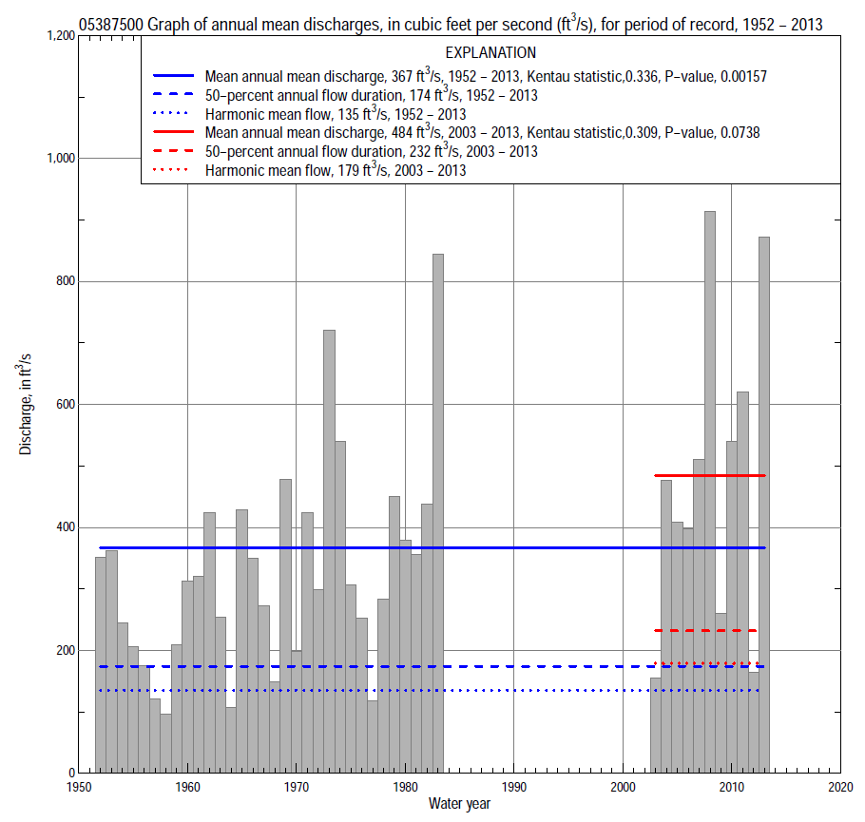

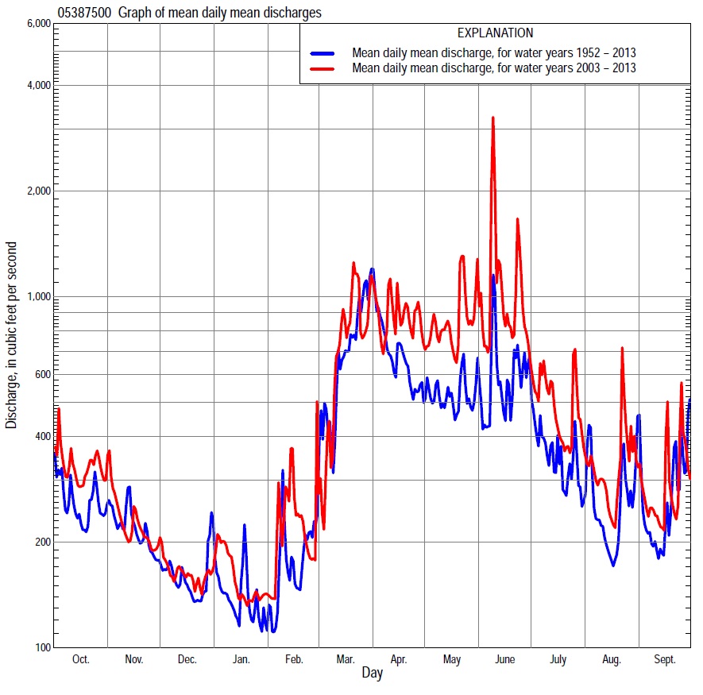

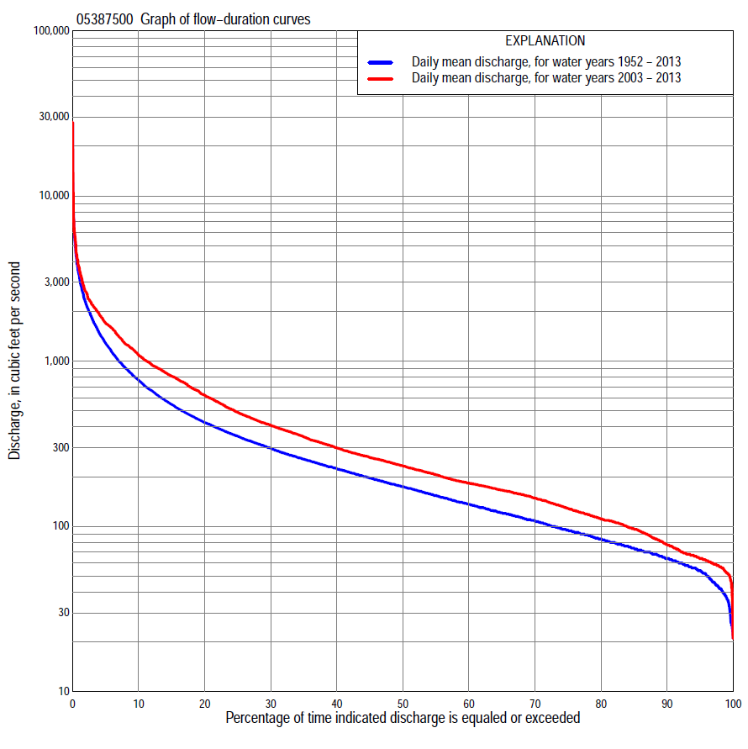

Statistics Based on the Entire Streamflow Period of Record
05387500 Monthly and annual flow durations, based on 1952–83, 2003–13 period of record (43 years)
Percentage of days discharge equaled or exceeded |  |  |  |  | Discharge (cubic feet per second) |  |  |  |  |  |  |  |  | Annual flow durations
 | Oct | Nov | Dec | Jan | Feb | Mar | Apr | May | June | July | Aug | Sept | Annual | Kentau statistic | P-value
99 | 36 | 39 | 37 | 25 | 26 | 34 | 65 | 61 | 59 | 49 | 39 | 38 | 37 | 0.362 | 0.001
98 | 41 | 43 | 40 | 26 | 28 | 42 | 76 | 68 | 61 | 53 | 42 | 43 | 42 | 0.374 | 0.000
95 | 48 | 52 | 45 | 40 | 43 | 58 | 104 | 96 | 84 | 68 | 56 | 57 | 54 | 0.349 | 0.001
90 | 63 | 62 | 51 | 50 | 54 | 70 | 130 | 129 | 114 | 90 | 71 | 63 | 64 | 0.327 | 0.002
85 | 68 | 72 | 59 | 55 | 58 | 81 | 152 | 163 | 133 | 103 | 79 | 68 | 74 | 0.331 | 0.002
80 | 76 | 78 | 67 | 58 | 63 | 96 | 180 | 188 | 153 | 116 | 89 | 74 | 84 | 0.331 | 0.002
75 | 82 | 84 | 74 | 64 | 70 | 112 | 215 | 206 | 171 | 131 | 97 | 82 | 95 | 0.309 | 0.004
70 | 92 | 94 | 83 | 69 | 75 | 134 | 250 | 234 | 188 | 148 | 107 | 91 | 108 | 0.302 | 0.004
65 | 106 | 107 | 94 | 74 | 78 | 154 | 295 | 258 | 207 | 163 | 116 | 102 | 121 | 0.300 | 0.005
60 | 119 | 115 | 100 | 82 | 83 | 192 | 336 | 278 | 226 | 177 | 129 | 114 | 136 | 0.306 | 0.004
55 | 127 | 124 | 108 | 88 | 89 | 224 | 380 | 310 | 250 | 197 | 148 | 134 | 154 | 0.297 | 0.005
50 | 137 | 135 | 116 | 92 | 97 | 272 | 422 | 337 | 277 | 218 | 164 | 146 | 174 | 0.265 | 0.013
45 | 149 | 150 | 122 | 99 | 109 | 321 | 473 | 368 | 310 | 236 | 175 | 157 | 196 | 0.289 | 0.006
40 | 176 | 177 | 134 | 109 | 117 | 386 | 529 | 403 | 347 | 256 | 190 | 170 | 224 | 0.352 | 0.001
35 | 212 | 196 | 145 | 121 | 130 | 460 | 611 | 437 | 388 | 285 | 207 | 186 | 255 | 0.359 | 0.001
30 | 247 | 224 | 165 | 135 | 149 | 580 | 710 | 498 | 429 | 326 | 228 | 205 | 297 | 0.393 | 0.000
25 | 305 | 250 | 188 | 150 | 177 | 718 | 816 | 595 | 495 | 368 | 255 | 238 | 351 | 0.415 | 0.000
20 | 364 | 280 | 217 | 173 | 203 | 964 | 997 | 715 | 605 | 451 | 292 | 300 | 425 | 0.422 | 0.000
15 | 454 | 346 | 250 | 209 | 240 | 1,390 | 1,200 | 874 | 788 | 549 | 347 | 375 | 547 | 0.400 | 0.000
10 | 597 | 442 | 279 | 260 | 308 | 1,870 | 1,520 | 1,100 | 1,050 | 743 | 470 | 517 | 768 | 0.362 | 0.001
5 | 939 | 609 | 330 | 360 | 570 | 2,850 | 2,200 | 1,590 | 1,980 | 1,070 | 675 | 821 | 1,290 | 0.302 | 0.004
2 | 1,350 | 945 | 583 | 523 | 1,100 | 4,080 | 3,330 | 2,310 | 4,140 | 1,780 | 1,380 | 1,460 | 2,240 | 0.213 | 0.046
1 | 1,700 | 1,300 | 914 | 815 | 1,410 | 5,560 | 4,490 | 3,190 | 5,760 | 2,570 | 2,190 | 3,310 | 3,320 | 0.038 | 0.730

05387500 Annual exceedance probability of instantaneous peak discharges, in cubic feet per second (ft³/s), based on the Weighted Independent Estimates method,
Annual exceed-ance probability | Recur-rence interval (years) | Discharge (ft³/s) | 95-percent lower confi-dence interval (ft³/s) | 95-percent upper confi-dence interval (ft³/s)
0.500 | 2 | 6,490 | 5,670 | 7,430
0.200 | 5 | 11,100 | 9,660 | 12,700
0.100 | 10 | 14,300 | 12,300 | 16,700
0.040 | 25 | 18,700 | 15,600 | 22,500
0.020 | 50 | 22,000 | 17,700 | 27,200
0.010 | 100 | 25,300 | 19,800 | 32,400
0.005 | 200 | 28,700 | 21,700 | 38,100
0.002 | 500 | 33,100 | 23,800 | 46,100
and based on the expected moments algorithm/multiple Grubbs-Beck analysis computed using a historical period length of 100 years (1914–2013)ª
0.500 | 2 | 6,500 | 5,610 | 7,500
0.200 | 5 | 11,100 | 9,600 | 12,900
0.100 | 10 | 14,400 | 12,400 | 17,300
0.040 | 25 | 18,800 | 15,800 | 23,900
0.020 | 50 | 22,200 | 18,100 | 29,600
0.010 | 100 | 25,700 | 20,300 | 36,000
0.005 | 200 | 29,200 | 22,300 | 43,300
0.002 | 500 | 34,100 | 24,700 | 54,300
Kentau statistic |  | -0.098
P-value |  | 0.314
Begin year |  | 1952
End year |  | 2013
Number of peaks |  | 51
ªAnalysis includes interval annual-peak discharges (1914, 1919–27, 1933–51) from streamgage 05388000 Upper Iowa River near Decorah.

05387500 Annual exceedance probability of high discharges, based on 1952–83, 2003–13 period of record (43 years)
[ND, not determined]
Annual exceedance probability | Recur-rence interval (years) | Maximum average discharge (ft³/s) for indicated number of consecutive days
 |  | 1 | 3 | 7 | 15 | 30
0.990 | 1.01 | ND | 600 | 448 | 298 | 204
0.950 | 1.05 | ND | 1,030 | 747 | 508 | 352
0.900 | 1.11 | ND | 1,360 | 974 | 666 | 464
0.800 | 1.25 | ND | 1,900 | 1,340 | 915 | 638
0.500 | 2 | ND | 3,550 | 2,400 | 1,620 | 1,120
0.200 | 5 | ND | 6,480 | 4,210 | 2,730 | 1,880
0.100 | 10 | ND | 8,810 | 5,590 | 3,520 | 2,400
0.040 | 25 | ND | 12,100 | 7,510 | 4,570 | 3,080
0.020 | 50 | ND | 14,900 | 9,060 | 5,360 | 3,590
0.010 | 100 | ND | 17,800 | 10,700 | 6,170 | 4,090
0.005 | 200 | ND | 21,000 | 12,400 | 6,980 | 4,590
0.002 | 500 | ND | 25,600 | 14,900 | 8,070 | 5,260
Kentau statistic |  | -0.255 | -0.247 | -0.210 | -0.179 | -0.140
P-value |  | 0.003 | 0.004 | 0.015 | 0.038 | 0.105

 | 05387500 Annual nonexceedance probability of low discharges, based on April 1952 to March 1983, April 2003 to March 2013 period of record (41 years)
Annual nonexceed-ance probability | Recur-rence interval (years) | Minimum average discharge (cubic feet per second) for indicated number of consecutive days
 |  | 1 | 3 | 7 | 14 | 30 | 60 | 90 | 120 | 183
0.01 | 100 | 19 | 20 | 22 | 24 | 27 | 29 | 31 | 31 | 31
0.02 | 50 | 22 | 23 | 25 | 27 | 30 | 33 | 35 | 36 | 36
0.05 | 20 | 27 | 28 | 30 | 33 | 36 | 40 | 43 | 45 | 47
0.10 | 10 | 32 | 33 | 35 | 39 | 43 | 47 | 51 | 55 | 59
0.20 | 5 | 40 | 41 | 44 | 47 | 52 | 58 | 64 | 70 | 78
0.50 | 2 | 60 | 63 | 66 | 71 | 78 | 89 | 100 | 112 | 137
0.80 | 1.25 | 92 | 96 | 102 | 107 | 117 | 139 | 160 | 182 | 248
0.90 | 1.11 | 115 | 120 | 128 | 134 | 146 | 178 | 207 | 235 | 341
0.96 | 1.04 | 146 | 153 | 164 | 170 | 185 | 232 | 272 | 310 | 483
0.98 | 1.02 | 171 | 179 | 193 | 200 | 216 | 278 | 326 | 372 | 608
0.99 | 1.01 | 197 | 207 | 224 | 230 | 248 | 326 | 385 | 438 | 749
Kentau statistic |  | 0.399 | 0.412 | 0.445 | 0.460 | 0.450 | 0.401 | 0.359 | 0.324 | 0.280
P-value |  | 0.000 | 0.000 | 0.000 | 0.000 | 0.000 | 0.000 | 0.001 | 0.003 | 0.010

05387500 Annual nonexceedance probability of seasonal low discharges, based on October 1951 to September 1983, October 2002 to September 2013 period of record (43 years)
Annual nonexceed-ance probability | Recur-rence interval (years) | Minimum average discharge (cubic feet per second) for indicated number of consecutive days
 |  | 1 | 7 | 14 | 30 |  | 1 | 7 | 14 | 30
 |  | January-February-March |  |  |  |  | April-May-June
0.01 | 100 | 19 | 21 | 24 | 30 |  | 40 | 44 | 45 | 62
0.02 | 50 | 22 | 24 | 27 | 33 |  | 46 | 50 | 52 | 71
0.05 | 20 | 27 | 30 | 33 | 39 |  | 56 | 61 | 65 | 86
0.10 | 10 | 33 | 36 | 40 | 46 |  | 69 | 75 | 80 | 104
0.20 | 5 | 42 | 46 | 50 | 56 |  | 89 | 97 | 105 | 134
0.50 | 2 | 66 | 72 | 78 | 86 |  | 153 | 166 | 184 | 228
0.80 | 1.25 | 105 | 117 | 124 | 139 |  | 283 | 307 | 346 | 420
0.90 | 1.11 | 134 | 152 | 160 | 184 |  | 400 | 436 | 495 | 598
0.96 | 1.04 | 173 | 202 | 212 | 252 |  | 593 | 646 | 741 | 894
0.98 | 1.02 | 204 | 243 | 255 | 311 |  | 774 | 845 | 974 | 1,180
0.99 | 1.01 | 237 | 288 | 302 | 380 |  | 991 | 1,080 | 1,250 | 1,520
Kentau statistic |  | 0.288 | 0.327 | 0.354 | 0.343 |  | 0.381 | 0.347 | 0.340 | 0.364
P-value |  | 0.007 | 0.002 | 0.001 | 0.001 |  | 0.000 | 0.001 | 0.001 | 0.001
 |  | July-August-September |  |  |  |  | October-November-December
0.01 | 100 | 29 | 31 | 32 | 35 |  | 24 | 27 | 29 | 33
0.02 | 50 | 34 | 36 | 37 | 40 |  | 27 | 31 | 33 | 37
0.05 | 20 | 42 | 45 | 46 | 51 |  | 34 | 38 | 41 | 44
0.10 | 10 | 51 | 54 | 56 | 62 |  | 41 | 46 | 49 | 53
0.20 | 5 | 64 | 68 | 71 | 78 |  | 51 | 59 | 62 | 67
0.50 | 2 | 98 | 103 | 111 | 123 |  | 82 | 94 | 100 | 110
0.80 | 1.25 | 149 | 158 | 172 | 194 |  | 133 | 153 | 166 | 190
0.90 | 1.11 | 185 | 196 | 215 | 244 |  | 174 | 198 | 219 | 261
0.96 | 1.04 | 233 | 247 | 273 | 313 |  | 232 | 264 | 297 | 372
0.98 | 1.02 | 270 | 287 | 318 | 367 |  | 280 | 318 | 363 | 474
0.99 | 1.01 | 308 | 328 | 364 | 423 |  | 333 | 377 | 437 | 594
Kentau statistic |  | 0.374 | 0.350 | 0.327 | 0.285 |  | 0.245 | 0.260 | 0.251 | 0.212
P-value |  | 0.000 | 0.001 | 0.002 | 0.007 |  | 0.021 | 0.014 | 0.018 | 0.047

Statistics Based on the 1984–2013 Streamflow Period of Record
05387500 Monthly and annual flow durations, based on 2003–13 period of record (11 years)
Percentage of days discharge equaled or exceeded |  |  |  |  | Discharge (cubic feet per second) |  |  |  |  |  |  |  |  | Annual flow durations
 | Oct | Nov | Dec | Jan | Feb | Mar | Apr | May | June | July | Aug | Sept | Annual | Kentau statistic | P-value
99 | 61 | 68 | 50 | 45 | 52 | 30 | 98 | 129 | 140 | 88 | 66 | 61 | 52 | 0.018 | 1.000
98 | 62 | 73 | 53 | 47 | 55 | 42 | 106 | 148 | 151 | 94 | 69 | 62 | 57 | 0.018 | 1.000
95 | 64 | 76 | 57 | 51 | 57 | 59 | 115 | 247 | 161 | 103 | 74 | 63 | 64 | 0.000 | 1.000
90 | 70 | 81 | 66 | 56 | 61 | 111 | 135 | 280 | 205 | 125 | 83 | 67 | 77 | 0.018 | 1.000
85 | 90 | 85 | 69 | 59 | 67 | 145 | 151 | 322 | 254 | 165 | 95 | 69 | 96 | 0.091 | 0.755
80 | 102 | 92 | 74 | 63 | 76 | 159 | 166 | 351 | 309 | 181 | 154 | 106 | 111 | 0.091 | 0.755
75 | 113 | 97 | 81 | 74 | 90 | 177 | 188 | 381 | 343 | 205 | 164 | 119 | 129 | 0.109 | 0.696
70 | 119 | 105 | 98 | 86 | 100 | 196 | 229 | 405 | 366 | 221 | 169 | 136 | 148 | 0.127 | 0.640
65 | 122 | 110 | 109 | 92 | 105 | 215 | 370 | 426 | 399 | 237 | 175 | 145 | 166 | 0.164 | 0.533
60 | 132 | 117 | 118 | 102 | 111 | 235 | 415 | 462 | 435 | 254 | 185 | 153 | 183 | 0.145 | 0.585
55 | 146 | 128 | 125 | 117 | 137 | 254 | 501 | 510 | 473 | 281 | 195 | 159 | 206 | 0.164 | 0.533
50 | 155 | 137 | 135 | 129 | 164 | 307 | 570 | 592 | 553 | 310 | 215 | 166 | 232 | 0.091 | 0.755
45 | 176 | 179 | 153 | 139 | 175 | 353 | 673 | 677 | 605 | 344 | 229 | 184 | 261 | 0.127 | 0.640
40 | 216 | 196 | 174 | 166 | 180 | 418 | 812 | 717 | 702 | 380 | 247 | 195 | 299 | 0.309 | 0.213
35 | 249 | 249 | 190 | 177 | 187 | 468 | 917 | 796 | 806 | 457 | 269 | 208 | 349 | 0.382 | 0.119
30 | 314 | 272 | 220 | 189 | 209 | 633 | 1,060 | 894 | 909 | 516 | 292 | 220 | 409 | 0.309 | 0.213
25 | 374 | 288 | 241 | 217 | 222 | 820 | 1,200 | 994 | 1,030 | 654 | 327 | 268 | 491 | 0.309 | 0.213
20 | 474 | 329 | 255 | 245 | 250 | 1,070 | 1,440 | 1,120 | 1,260 | 743 | 385 | 363 | 623 | 0.309 | 0.213
15 | 589 | 396 | 270 | 275 | 285 | 1,480 | 1,740 | 1,320 | 1,620 | 823 | 513 | 481 | 812 | 0.236 | 0.350
10 | 869 | 467 | 293 | 305 | 452 | 1,850 | 2,090 | 1,650 | 2,140 | 1,030 | 575 | 669 | 1,090 | 0.164 | 0.533
5 | 1,260 | 608 | 312 | 377 | 801 | 2,890 | 2,620 | 2,310 | 2,960 | 1,580 | 692 | 983 | 1,700 | 0.200 | 0.436
2 | 1,630 | 808 | 342 | 450 | 1,180 | 4,080 | 3,460 | 3,320 | 5,280 | 1,900 | 1,970 | 1,270 | 2,620 | 0.200 | 0.436
1 | 1,740 | 945 | 372 | 464 | 1,410 | 4,530 | 4,280 | 6,550 | 12,200 | 2,390 | 2,650 | 2,320 | 3,620 | 0.200 | 0.436

05387500 Annual exceedance probability of high discharges, based on 2003–13 period of record (11 years)
Annual exceedance probability | Recur-rence interval (years) | Maximum average discharge (ft³/s) for indicated number of consecutive days
 |  | 1 | 3 | 7 | 15 | 30
0.990 | 1.01 | 654 | 603 | 492 | 369 | 272
0.950 | 1.05 | 1,060 | 957 | 784 | 591 | 441
0.900 | 1.11 | 1,390 | 1,240 | 1,010 | 761 | 570
0.800 | 1.25 | 1,990 | 1,740 | 1,390 | 1,030 | 775
0.500 | 2 | 4,200 | 3,470 | 2,620 | 1,850 | 1,380
0.200 | 5 | 9,660 | 7,400 | 5,080 | 3,330 | 2,430
0.100 | 10 | 15,500 | 11,300 | 7,270 | 4,520 | 3,250
0.040 | 25 | 26,300 | 18,200 | 10,800 | 6,270 | 4,420
0.020 | 50 | 37,700 | 25,000 | 13,900 | 7,750 | 5,390
0.010 | 100 | 52,600 | 33,500 | 17,600 | 9,380 | 6,420
0.005 | 200 | 72,000 | 44,200 | 21,900 | 11,200 | 7,530
0.002 | 500 | 107,000 | 62,300 | 28,700 | 13,800 | 9,130
Kentau statistic |  | 0.492 | 0.492 | 0.501 | 0.501 | 0.497
P-value |  | 0.000 | 0.000 | 0.000 | 0.000 | 0.000

 | 05387500 Annual nonexceedance probability of low discharges, based on April 2003 to March 2013 period of record (10 years)
Annual nonexceed-ance probability | Recur-rence interval (years) | Minimum average discharge (cubic feet per second) for indicated number of consecutive days
 |  | 1 | 3 | 7 | 14 | 30 | 60 | 90 | 120 | 183
0.01 | 100 | 12 | 14 | 20 | 35 | 35 | 37 | 37 | 37 | 37
0.02 | 50 | 16 | 19 | 25 | 40 | 40 | 43 | 43 | 45 | 45
0.05 | 20 | 25 | 28 | 35 | 48 | 50 | 53 | 55 | 58 | 58
0.10 | 10 | 34 | 38 | 45 | 57 | 60 | 65 | 69 | 73 | 75
0.20 | 5 | 50 | 54 | 61 | 70 | 74 | 82 | 89 | 96 | 105
0.50 | 2 | 91 | 96 | 102 | 105 | 112 | 128 | 142 | 156 | 193
0.80 | 1.25 | 143 | 151 | 158 | 158 | 169 | 198 | 223 | 244 | 339
0.90 | 1.11 | 173 | 181 | 193 | 195 | 210 | 248 | 279 | 303 | 449
0.96 | 1.04 | 205 | 214 | 234 | 244 | 264 | 315 | 353 | 378 | 598
0.98 | 1.02 | 224 | 235 | 262 | 283 | 306 | 367 | 410 | 434 | 716
0.99 | 1.01 | 240 | 253 | 288 | 323 | 349 | 420 | 467 | 489 | 838
Kentau statistic |  | -0.111 | -0.111 | -0.111 | -0.067 | -0.044 | -0.067 | -0.156 | -0.067 | -0.111
P-value |  | 0.721 | 0.721 | 0.721 | 0.858 | 0.928 | 0.858 | 0.592 | 0.858 | 0.721

05387500 Annual nonexceedance probability of seasonal low discharges, based on October 2002 to September 2013 period of record (11 years)
Annual nonexceed-ance probability | Recur-rence interval (years) | Minimum average discharge (cubic feet per second) for indicated number of consecutive days
 |  | 1 | 7 | 14 | 30 |  | 1 | 7 | 14 | 30
 |  | January-February-March |  |  |  |  | April-May-June
0.01 | 100 | 12 | 19 | 30 | 32 |  | 52 | 53 | 58 | 86
0.02 | 50 | 16 | 24 | 35 | 37 |  | 62 | 63 | 68 | 98
0.05 | 20 | 25 | 33 | 44 | 47 |  | 81 | 83 | 89 | 123
0.10 | 10 | 35 | 44 | 54 | 57 |  | 103 | 106 | 113 | 151
0.20 | 5 | 50 | 60 | 68 | 73 |  | 141 | 146 | 155 | 200
0.50 | 2 | 92 | 105 | 109 | 116 |  | 261 | 274 | 295 | 362
0.80 | 1.25 | 151 | 171 | 172 | 184 |  | 504 | 542 | 601 | 719
0.90 | 1.11 | 186 | 217 | 219 | 234 |  | 721 | 788 | 897 | 1,070
0.96 | 1.04 | 226 | 274 | 282 | 302 |  | 1,070 | 1,190 | 1,400 | 1,680
0.98 | 1.02 | 253 | 316 | 332 | 356 |  | 1,390 | 1,570 | 1,900 | 2,290
0.99 | 1.01 | 276 | 358 | 385 | 413 |  | 1,770 | 2,020 | 2,510 | 3,060
Kentau statistic |  | 0.055 | 0.018 | 0.055 | 0.073 |  | 0.382 | 0.382 | 0.382 | 0.382
P-value |  | 0.876 | 1.000 | 0.876 | 0.815 |  | 0.119 | 0.119 | 0.119 | 0.119
 |  | July-August-September |  |  |  |  | October-November-December
0.01 | 100 | 38 | 39 | 39 | 41 |  | 32 | 35 | 36 | 37
0.02 | 50 | 45 | 46 | 47 | 49 |  | 36 | 40 | 41 | 43
0.05 | 20 | 58 | 59 | 61 | 63 |  | 43 | 49 | 51 | 53
0.10 | 10 | 71 | 73 | 75 | 78 |  | 51 | 58 | 62 | 65
0.20 | 5 | 90 | 93 | 97 | 101 |  | 63 | 73 | 77 | 83
0.50 | 2 | 137 | 144 | 151 | 161 |  | 95 | 112 | 120 | 132
0.80 | 1.25 | 199 | 211 | 224 | 248 |  | 144 | 173 | 187 | 213
0.90 | 1.11 | 239 | 254 | 271 | 307 |  | 181 | 218 | 236 | 274
0.96 | 1.04 | 286 | 304 | 328 | 381 |  | 231 | 280 | 303 | 358
0.98 | 1.02 | 320 | 340 | 369 | 436 |  | 271 | 329 | 357 | 427
0.99 | 1.01 | 351 | 373 | 407 | 491 |  | 314 | 380 | 413 | 500
Kentau statistic |  | -0.018 | -0.018 | -0.091 | -0.164 |  | 0.127 | 0.127 | 0.127 | 0.164
P-value |  | 1.000 | 1.000 | 0.756 | 0.533 |  | 0.640 | 0.640 | 0.640 | 0.533

