LOCATION.--Lat 43°25'16", long 91°30'31" referenced to North American Datum of 1927, in SE 1/4 SW 1/4 NW 1/4 sec.01, T.99 N., R.6 W., Allamakee County, IA, Hydrologic Unit 07060002, on right bank 5 ft upstream from bridge on State Highway 76, 3.5 mi south of Dorchester, 650 ft upstream from Mineral Creek, 0.5 mi upstream from Bear Creek, and 18.3 mi upstream from mouth.

DRAINAGE AREA.--770 mi².

PERIOD OF RECORD.--Discharge measurements from September 1936 to September 1938, October 1939 to June 1975; discharge records from October 1938 to September 1939, July 1975 to current year.

GAGE.--Water-stage recorder. Datum of gage is 660.00 ft above National Geodetic Vertical Datum of 1929. Prior to January 6, 1938, non-recording gage at site of old bridge, 0.2 mi upstream, at datum 5.91 ft higher; January 6, 1938, to April 26, 1948, non-recording gage at site of old bridge at datum 60.00 ft lower; April 27, 1948, to August 1963, non-recording gage at site of old bridge at same datum; August 1963 to June 1975, non-recording gage at same site and datum.

EXTREMES OUTSIDE PERIOD OF RECORD.--Flood of May 31, 1941, reached a stage of 21.8 ft, from flood profile, discharge 30,400 ft³/s, on basis of slope-area determination of peak flow, at current datum.

A summary of all available data for this streamgage is provided through the USGS National Water Information System web interface (NWISWeb). The following link provides access to current/historical observations, daily data, daily statistics, monthly statistics, annual statistics, peak streamflow, field measurements, field/lab water-quality samples, and the latest water-year summaries. Data can be filtered by parameter and/or dates, and can be output in various tabular and graphical formats.
http://waterdata.usgs.gov/nwis/inventory/?site_no=05388250

The USGS WaterWatch Toolkit is available at:
http://waterwatch.usgs.gov/?id=ww_toolkit
Tools for summarizing streamflow information include the duration hydrograph builder, the cumulative streamflow hydrograph builder, the streamgage statistics retrieval tool, the rating curve builder, the flood tracking chart builder, the National Weather Service Advanced Hydrologic Prediction Service (AHPS) river forecast hydrograph builder, and the raster-hydrograph builder. Entering the above number for this streamgage into these toolkit webpages will provide streamflow information specific to this streamgage.

A description of the statistics presented for this streamgage is available in the main body of the report at:
http://dx.doi.org/10.3133/ofr20151214
A link to other streamgages included in this report, a map showing the location of the streamgages, information on the programs used to compute the statistical analyses, and references are included in the main body of the report.

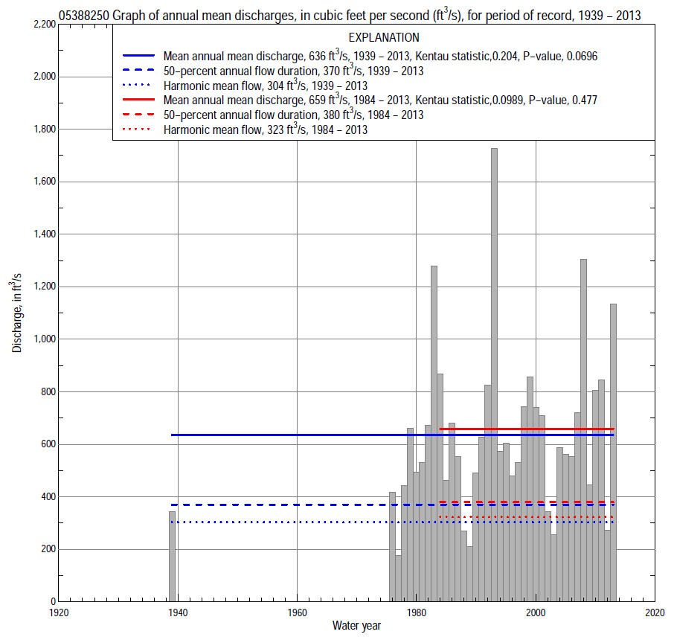

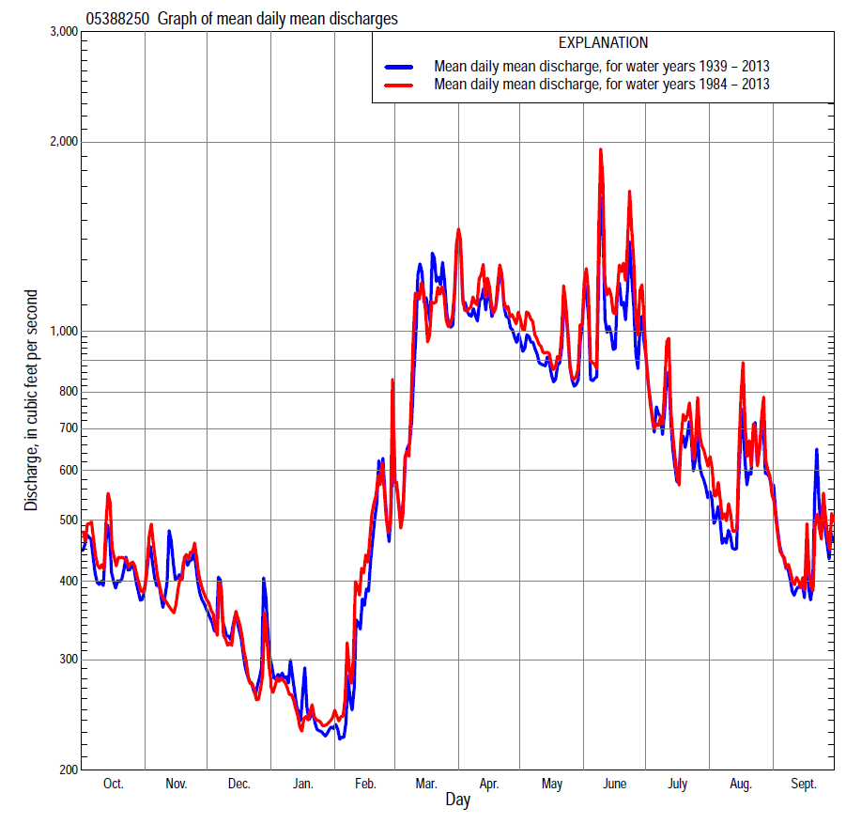

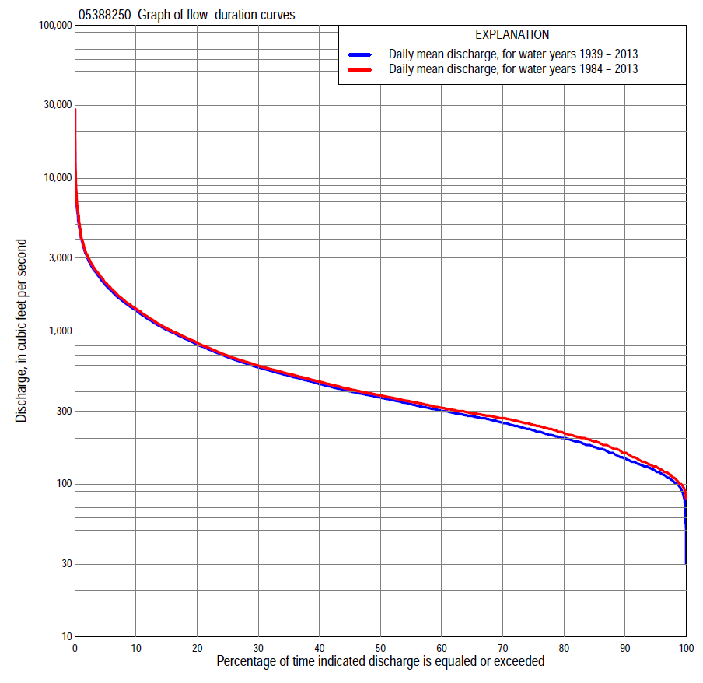

Statistics Based on the Entire Streamflow Period of Record
05388250 Monthly and annual flow durations, based on 1939, 1976–2013 period of record (39 years)
Percentage of days discharge equaled or exceeded |  |  |  |  | Discharge (cubic feet per second) |  |  |  |  |  |  |  |  | Annual flow durations
 | Oct | Nov | Dec | Jan | Feb | Mar | Apr | May | June | July | Aug | Sept | Annual | Kentau statistic | P-value
99 | 113 | 110 | 89 | 87 | 94 | 107 | 180 | 152 | 111 | 83 | 83 | 68 | 95 | 0.190 | 0.090
98 | 118 | 119 | 96 | 92 | 98 | 120 | 191 | 172 | 117 | 105 | 99 | 93 | 103 | 0.173 | 0.124
95 | 130 | 132 | 104 | 100 | 110 | 180 | 216 | 215 | 152 | 127 | 114 | 125 | 122 | 0.193 | 0.085
90 | 140 | 145 | 118 | 110 | 123 | 216 | 249 | 288 | 240 | 183 | 149 | 141 | 147 | 0.165 | 0.143
85 | 174 | 167 | 133 | 125 | 139 | 259 | 284 | 346 | 294 | 227 | 179 | 166 | 175 | 0.135 | 0.231
80 | 187 | 184 | 151 | 132 | 150 | 286 | 356 | 388 | 342 | 276 | 214 | 205 | 200 | 0.134 | 0.236
75 | 201 | 200 | 169 | 144 | 169 | 316 | 441 | 419 | 389 | 305 | 270 | 220 | 225 | 0.120 | 0.287
70 | 216 | 217 | 180 | 156 | 180 | 352 | 496 | 477 | 431 | 339 | 287 | 238 | 251 | 0.104 | 0.358
65 | 240 | 238 | 200 | 168 | 200 | 400 | 548 | 534 | 479 | 360 | 300 | 254 | 279 | 0.109 | 0.333
60 | 264 | 264 | 218 | 178 | 215 | 460 | 616 | 583 | 530 | 382 | 314 | 270 | 301 | 0.123 | 0.276
55 | 281 | 287 | 230 | 190 | 230 | 512 | 699 | 637 | 577 | 405 | 338 | 292 | 333 | 0.126 | 0.266
50 | 302 | 304 | 244 | 200 | 250 | 572 | 788 | 690 | 625 | 435 | 364 | 321 | 368 | 0.116 | 0.304
45 | 318 | 322 | 261 | 213 | 270 | 642 | 870 | 761 | 685 | 467 | 397 | 346 | 405 | 0.142 | 0.208
40 | 338 | 356 | 275 | 234 | 280 | 735 | 971 | 844 | 753 | 499 | 428 | 374 | 452 | 0.155 | 0.168
35 | 355 | 385 | 293 | 258 | 300 | 859 | 1,080 | 937 | 857 | 547 | 472 | 404 | 511 | 0.170 | 0.130
30 | 385 | 425 | 320 | 272 | 330 | 1,020 | 1,220 | 1,030 | 952 | 614 | 514 | 435 | 580 | 0.179 | 0.110
25 | 430 | 493 | 361 | 300 | 370 | 1,210 | 1,380 | 1,160 | 1,070 | 730 | 553 | 475 | 675 | 0.200 | 0.075
20 | 520 | 554 | 396 | 340 | 430 | 1,430 | 1,600 | 1,320 | 1,300 | 865 | 611 | 538 | 817 | 0.186 | 0.097
15 | 629 | 628 | 436 | 394 | 529 | 1,740 | 1,880 | 1,510 | 1,550 | 1,080 | 691 | 633 | 1,020 | 0.197 | 0.079
10 | 781 | 743 | 510 | 475 | 769 | 2,300 | 2,300 | 1,770 | 2,030 | 1,460 | 917 | 865 | 1,360 | 0.190 | 0.090
5 | 1,190 | 988 | 900 | 580 | 1,400 | 3,230 | 3,000 | 2,290 | 3,100 | 2,160 | 1,690 | 1,200 | 1,990 | 0.174 | 0.121
2 | 1,770 | 1,550 | 1,300 | 720 | 2,190 | 4,650 | 3,980 | 2,880 | 5,140 | 3,090 | 2,770 | 1,830 | 3,040 | 0.173 | 0.124
1 | 2,130 | 1,900 | 1,860 | 1,100 | 2,560 | 5,760 | 5,710 | 3,580 | 9,070 | 4,610 | 4,000 | 2,610 | 4,040 | 0.136 | 0.226

05388250 Annual exceedance probability of instantaneous peak discharges, in cubic feet per second (ft³/s), based on the Weighted Independent Estimates method,
Annual exceed-ance probability | Recur-rence interval (years) | Discharge (ft³/s) | 95-percent lower confi-dence interval (ft³/s) | 95-percent upper confi-dence interval (ft³/s)
0.500 | 2 | 6,780 | 5,810 | 7,930
0.200 | 5 | 11,800 | 10,000 | 13,900
0.100 | 10 | 15,600 | 13,000 | 18,700
0.040 | 25 | 20,800 | 16,700 | 26,000
0.020 | 50 | 24,700 | 19,100 | 31,900
0.010 | 100 | 28,800 | 21,500 | 38,600
0.005 | 200 | 33,000 | 23,700 | 45,800
0.002 | 500 | 38,400 | 26,300 | 56,200
and based on the expected moments algorithm/multiple Grubbs-Beck analysis computed using a historical period length of 75 years (1939–2013)
0.500 | 2 | 6,750 | 5,370 | 8,410
0.200 | 5 | 11,700 | 9,350 | 14,800
0.100 | 10 | 15,500 | 12,200 | 20,200
0.040 | 25 | 20,800 | 15,900 | 29,000
0.020 | 50 | 25,100 | 18,600 | 37,300
0.010 | 100 | 29,700 | 21,300 | 47,400
0.005 | 200 | 34,500 | 23,900 | 59,700
0.002 | 500 | 41,400 | 27,300 | 79,900
Kentau statistic |  | 0.030
P-value |  | 0.801
Begin year |  | 1939
End year |  | 2013
Number of peaks |  | 38

05388250 Annual exceedance probability of high discharges, based on 1939, 1976–2013 period of record (39 years)
[ND, not determined]
Annual exceedance probability | Recur-rence interval (years) | Maximum average discharge (ft³/s) for indicated number of consecutive days
 |  | 1 | 3 | 7 | 15 | 30
0.990 | 1.01 | ND | 978 | 762 | 593 | 456
0.950 | 1.05 | ND | 1,460 | 1,120 | 873 | 670
0.900 | 1.11 | ND | 1,820 | 1,380 | 1,070 | 822
0.800 | 1.25 | ND | 2,390 | 1,790 | 1,380 | 1,050
0.500 | 2 | ND | 4,120 | 3,000 | 2,230 | 1,670
0.200 | 5 | ND | 7,280 | 5,100 | 3,600 | 2,640
0.100 | 10 | ND | 9,920 | 6,800 | 4,620 | 3,350
0.040 | 25 | ND | 13,900 | 9,290 | 6,040 | 4,310
0.020 | 50 | ND | 17,400 | 11,400 | 7,190 | 5,070
0.010 | 100 | ND | 21,300 | 13,700 | 8,400 | 5,850
0.005 | 200 | ND | 25,700 | 16,300 | 9,680 | 6,680
0.002 | 500 | ND | 32,400 | 20,200 | 11,500 | 7,830
Kentau statistic |  | 0.498 | 0.502 | 0.517 | 0.526 | 0.527
P-value |  | 0.000 | 0.000 | 0.000 | 0.000 | 0.000

 | 05388250 Annual nonexceedance probability of low discharges, based on April 1976 to March 2013 period of record (37 years)
Annual nonexceed-ance probability | Recur-rence interval (years) | Minimum average discharge (cubic feet per second) for indicated number of consecutive days
 |  | 1 | 3 | 7 | 14 | 30 | 60 | 90 | 120 | 183
0.01 | 100 | 60 | 65 | 65 | 68 | 73 | 78 | 84 | 87 | 87
0.02 | 50 | 64 | 70 | 71 | 75 | 81 | 87 | 94 | 98 | 100
0.05 | 20 | 73 | 79 | 82 | 86 | 94 | 102 | 110 | 117 | 124
0.10 | 10 | 82 | 88 | 93 | 99 | 107 | 118 | 128 | 138 | 149
0.20 | 5 | 95 | 102 | 109 | 116 | 127 | 141 | 153 | 168 | 188
0.50 | 2 | 132 | 140 | 151 | 161 | 177 | 201 | 221 | 245 | 294
0.80 | 1.25 | 191 | 200 | 215 | 227 | 250 | 288 | 325 | 359 | 465
0.90 | 1.11 | 236 | 245 | 262 | 275 | 302 | 349 | 401 | 439 | 592
0.96 | 1.04 | 301 | 308 | 326 | 338 | 370 | 430 | 505 | 545 | 770
0.98 | 1.02 | 356 | 360 | 378 | 388 | 424 | 492 | 588 | 627 | 914
0.99 | 1.01 | 415 | 416 | 433 | 440 | 479 | 557 | 675 | 712 | 1,070
Kentau statistic |  | 0.168 | 0.149 | 0.120 | 0.126 | 0.117 | 0.093 | 0.078 | 0.054 | 0.012
P-value |  | 0.146 | 0.200 | 0.301 | 0.278 | 0.314 | 0.425 | 0.505 | 0.647 | 0.927

05388250 Annual nonexceedance probability of seasonal low discharges, based on October 1938 to September 1939, July 1975 to September 2013 period of record (39–40 years)
Annual nonexceed-ance probability | Recur-rence interval (years) | Minimum average discharge (cubic feet per second) for indicated number of consecutive days
 |  | 1 | 7 | 14 | 30 |  | 1 | 7 | 14 | 30
 |  | January-February-March |  |  |  |  | April-May-June
0.01 | 100 | 58 | 69 | 73 | 80 |  | 62 | 86 | 91 | 106
0.02 | 50 | 63 | 75 | 79 | 87 |  | 78 | 103 | 109 | 126
0.05 | 20 | 73 | 86 | 91 | 100 |  | 111 | 134 | 142 | 164
0.10 | 10 | 83 | 98 | 104 | 114 |  | 148 | 169 | 179 | 207
0.20 | 5 | 98 | 115 | 122 | 135 |  | 206 | 224 | 238 | 275
0.50 | 2 | 138 | 160 | 172 | 190 |  | 365 | 382 | 411 | 477
0.80 | 1.25 | 204 | 232 | 250 | 275 |  | 602 | 644 | 707 | 833
0.90 | 1.11 | 253 | 285 | 307 | 338 |  | 760 | 843 | 940 | 1,120
0.96 | 1.04 | 323 | 361 | 388 | 425 |  | 954 | 1,120 | 1,270 | 1,540
0.98 | 1.02 | 380 | 422 | 453 | 496 |  | 1,090 | 1,340 | 1,550 | 1,890
0.99 | 1.01 | 443 | 489 | 524 | 572 |  | 1,230 | 1,580 | 1,840 | 2,270
Kentau statistic |  | 0.161 | 0.063 | 0.055 | 0.063 |  | 0.200 | 0.188 | 0.182 | 0.231
P-value |  | 0.153 | 0.578 | 0.628 | 0.578 |  | 0.075 | 0.095 | 0.105 | 0.040
 |  | July-August-September |  |  |  |  | October-November-December
0.01 | 100 | 41 | 58 | 70 | 79 |  | 61 | 69 | 76 | 88
0.02 | 50 | 54 | 71 | 82 | 91 |  | 68 | 77 | 85 | 97
0.05 | 20 | 79 | 94 | 105 | 115 |  | 81 | 93 | 101 | 112
0.10 | 10 | 107 | 119 | 129 | 140 |  | 95 | 109 | 117 | 129
0.20 | 5 | 148 | 156 | 165 | 179 |  | 115 | 132 | 141 | 155
0.50 | 2 | 248 | 249 | 258 | 284 |  | 167 | 191 | 203 | 226
0.80 | 1.25 | 359 | 373 | 391 | 450 |  | 246 | 277 | 296 | 345
0.90 | 1.11 | 415 | 451 | 481 | 571 |  | 304 | 336 | 362 | 438
0.96 | 1.04 | 469 | 542 | 595 | 735 |  | 381 | 414 | 450 | 573
0.98 | 1.02 | 500 | 605 | 679 | 865 |  | 443 | 473 | 520 | 687
0.99 | 1.01 | 524 | 664 | 763 | 1,000 |  | 508 | 533 | 592 | 812
Kentau statistic |  | 0.228 | 0.208 | 0.196 | 0.159 |  | 0.061 | 0.065 | 0.049 | 0.050
P-value |  | 0.039 | 0.061 | 0.077 | 0.152 |  | 0.594 | 0.570 | 0.672 | 0.663

Statistics Based on the 1984–2013 Streamflow Period of Record
05388250 Monthly and annual flow durations, based on 1984–2013 period of record (30 years)
Percentage of days discharge equaled or exceeded |  |  |  |  | Discharge (cubic feet per second) |  |  |  |  |  |  |  |  | Annual flow durations
 | Oct | Nov | Dec | Jan | Feb | Mar | Apr | May | June | July | Aug | Sept | Annual | Kentau statistic | P-value
99 | 111 | 115 | 90 | 88 | 100 | 112 | 186 | 208 | 140 | 114 | 99 | 125 | 100 | 0.023 | 0.872
98 | 118 | 127 | 96 | 93 | 109 | 128 | 196 | 222 | 153 | 122 | 103 | 128 | 110 | 0.030 | 0.830
95 | 127 | 135 | 104 | 101 | 119 | 190 | 219 | 270 | 220 | 168 | 135 | 140 | 130 | 0.044 | 0.748
90 | 143 | 156 | 120 | 110 | 131 | 256 | 248 | 340 | 271 | 212 | 160 | 160 | 160 | -0.002 | 1.000
85 | 178 | 179 | 140 | 125 | 150 | 280 | 271 | 384 | 333 | 272 | 197 | 203 | 190 | -0.067 | 0.617
80 | 197 | 191 | 153 | 135 | 170 | 310 | 317 | 412 | 385 | 309 | 274 | 219 | 216 | -0.064 | 0.630
75 | 209 | 205 | 169 | 150 | 189 | 348 | 421 | 466 | 428 | 335 | 287 | 236 | 243 | -0.055 | 0.682
70 | 235 | 224 | 188 | 160 | 204 | 383 | 492 | 521 | 478 | 357 | 298 | 250 | 270 | -0.060 | 0.656
65 | 253 | 242 | 202 | 180 | 220 | 442 | 549 | 564 | 521 | 375 | 311 | 264 | 290 | -0.039 | 0.775
60 | 274 | 269 | 220 | 190 | 240 | 492 | 615 | 622 | 569 | 392 | 327 | 276 | 315 | -0.032 | 0.817
55 | 288 | 294 | 236 | 200 | 260 | 543 | 691 | 663 | 622 | 417 | 352 | 295 | 346 | 0.000 | 1.000
50 | 305 | 310 | 254 | 211 | 270 | 592 | 780 | 722 | 672 | 448 | 371 | 321 | 380 | -0.014 | 0.929
45 | 317 | 336 | 270 | 230 | 280 | 655 | 866 | 798 | 747 | 483 | 403 | 342 | 418 | 0.041 | 0.762
40 | 333 | 368 | 285 | 250 | 300 | 733 | 970 | 889 | 839 | 517 | 438 | 364 | 468 | 0.071 | 0.592
35 | 351 | 397 | 309 | 270 | 320 | 841 | 1,080 | 971 | 938 | 571 | 474 | 391 | 525 | 0.087 | 0.509
30 | 387 | 455 | 340 | 286 | 350 | 989 | 1,250 | 1,080 | 1,050 | 650 | 511 | 418 | 596 | 0.115 | 0.382
25 | 456 | 510 | 378 | 305 | 397 | 1,130 | 1,430 | 1,190 | 1,240 | 753 | 553 | 447 | 692 | 0.140 | 0.284
20 | 553 | 560 | 414 | 351 | 440 | 1,370 | 1,660 | 1,340 | 1,490 | 899 | 619 | 505 | 839 | 0.133 | 0.309
15 | 675 | 628 | 446 | 390 | 560 | 1,650 | 1,970 | 1,510 | 1,820 | 1,110 | 713 | 603 | 1,040 | 0.122 | 0.353
10 | 830 | 740 | 500 | 450 | 830 | 2,100 | 2,420 | 1,830 | 2,380 | 1,490 | 993 | 872 | 1,400 | 0.117 | 0.372
5 | 1,410 | 944 | 796 | 540 | 1,420 | 2,910 | 3,210 | 2,390 | 3,660 | 2,200 | 1,910 | 1,200 | 2,080 | 0.103 | 0.432
2 | 1,940 | 1,510 | 1,080 | 606 | 2,130 | 4,110 | 4,720 | 3,020 | 6,020 | 3,220 | 3,110 | 1,830 | 3,150 | 0.152 | 0.246
1 | 2,270 | 1,840 | 1,400 | 680 | 2,790 | 5,460 | 6,500 | 3,940 | 9,890 | 4,730 | 5,720 | 2,240 | 4,170 | 0.120 | 0.363

05388250 Annual exceedance probability of high discharges, based on 1984–2013 period of record (30 years)
Annual exceedance probability | Recur-rence interval (years) | Maximum average discharge (ft³/s) for indicated number of consecutive days
 |  | 1 | 3 | 7 | 15 | 30
0.990 | 1.01 | 1,060 | 922 | 810 | 597 | 475
0.950 | 1.05 | 1,640 | 1,410 | 1,170 | 894 | 703
0.900 | 1.11 | 2,080 | 1,780 | 1,430 | 1,110 | 865
0.800 | 1.25 | 2,800 | 2,390 | 1,850 | 1,440 | 1,110
0.500 | 2 | 5,090 | 4,260 | 3,110 | 2,360 | 1,780
0.200 | 5 | 9,590 | 7,820 | 5,450 | 3,850 | 2,830
0.100 | 10 | 13,500 | 10,900 | 7,420 | 4,980 | 3,590
0.040 | 25 | 19,800 | 15,600 | 10,400 | 6,530 | 4,630
0.020 | 50 | 25,500 | 19,800 | 13,100 | 7,790 | 5,440
0.010 | 100 | 32,100 | 24,600 | 16,100 | 9,110 | 6,290
0.005 | 200 | 39,800 | 30,100 | 19,600 | 10,500 | 7,180
0.002 | 500 | 51,900 | 38,600 | 25,000 | 12,500 | 8,420
Kentau statistic |  | 0.090 | 0.076 | 0.126 | 0.136 | 0.117
P-value |  | 0.498 | 0.568 | 0.335 | 0.301 | 0.372

 | 05388250 Annual nonexceedance probability of low discharges, based on April 1983 to March 2013 period of record (30 years)
Annual nonexceed-ance probability | Recur-rence interval (years) | Minimum average discharge (cubic feet per second) for indicated number of consecutive days
 |  | 1 | 3 | 7 | 14 | 30 | 60 | 90 | 120 | 183
0.01 | 100 | 62 | 66 | 67 | 70 | 75 | 81 | 88 | 91 | 92
0.02 | 50 | 67 | 71 | 73 | 77 | 83 | 91 | 98 | 103 | 104
0.05 | 20 | 76 | 81 | 85 | 90 | 97 | 107 | 115 | 123 | 129
0.10 | 10 | 86 | 92 | 97 | 102 | 112 | 124 | 133 | 144 | 156
0.20 | 5 | 101 | 107 | 114 | 121 | 133 | 148 | 160 | 174 | 196
0.50 | 2 | 139 | 147 | 158 | 167 | 185 | 209 | 229 | 252 | 304
0.80 | 1.25 | 201 | 210 | 225 | 236 | 259 | 295 | 334 | 365 | 474
0.90 | 1.11 | 247 | 256 | 272 | 283 | 310 | 355 | 409 | 444 | 598
0.96 | 1.04 | 312 | 320 | 336 | 346 | 376 | 431 | 510 | 546 | 768
0.98 | 1.02 | 365 | 371 | 387 | 395 | 426 | 489 | 589 | 625 | 903
0.99 | 1.01 | 422 | 427 | 441 | 446 | 477 | 549 | 673 | 706 | 1,040
Kentau statistic |  | 0.025 | 0.030 | 0.000 | 0.016 | -0.011 | -0.021 | -0.030 | -0.053 | -0.094
P-value |  | 0.858 | 0.830 | 0.000 | 0.915 | 0.943 | 0.887 | 0.830 | 0.695 | 0.695

05388250 Annual nonexceedance probability of seasonal low discharges, based on October 1983 to September 2013 period of record (30 years)
Annual nonexceed-ance probability | Recur-rence interval (years) | Minimum average discharge (cubic feet per second) for indicated number of consecutive days
 |  | 1 | 7 |  | 14 | 30 |  |  |  | 1 | 7 | 14 | 30
 |  | January-February-March |  |  |  |  |  |  |  | April-May-June
0.01 | 100 | 60 | 68 | 72 |  |  | 81 |  |  | 107 | 108 | 114 |  | 134
0.02 | 50 | 67 | 75 | 80 |  |  | 89 |  |  | 123 | 125 | 131 |  | 154
0.05 | 20 | 78 | 88 | 93 |  |  | 104 |  |  | 153 | 157 | 164 |  | 191
0.10 | 10 | 90 | 101 | 107 |  |  | 120 |  |  | 186 | 192 | 202 |  | 233
0.20 | 5 | 107 | 120 | 128 |  |  | 143 |  |  | 236 | 246 | 260 |  | 300
0.50 | 2 | 153 | 171 | 182 |  |  | 202 |  |  | 377 | 403 | 432 |  | 499
0.80 | 1.25 | 223 | 250 | 264 |  |  | 288 |  |  | 610 | 672 | 739 |  | 863
0.90 | 1.11 | 273 | 308 | 324 |  |  | 349 |  |  | 789 | 885 | 990 |  | 1,170
0.96 | 1.04 | 342 | 387 | 405 |  |  | 430 |  |  | 1,040 | 1,190 | 1,360 |  | 1,630
0.98 | 1.02 | 396 | 450 | 469 |  |  | 493 |  |  | 1,250 | 1,450 | 1,690 |  | 2,030
0.99 | 1.01 | 453 | 517 | 537 |  |  | 559 |  |  | 1,480 | 1,740 | 2,050 |  | 2,500
Kentau statistic |  | -0.090 | -0.092 | -0.076 |  |  | -0.094 |  |  | 0.149 | 0.136 | 0.126 |  | 0.209
P-value |  | 0.497 | 0.486 | 0.568 |  |  | 0.475 |  |  | 0.254 | 0.301 | 0.335 |  | 0.108
 |  | July-August-September |  |  |  |  |  |  |  | October-November-December
0.01 | 100 | 89 | 95 | 99 |  |  | 107 |  |  | 60 | 67 | 72 |  | 84
0.02 | 50 | 100 | 106 | 110 |  |  | 118 |  |  | 67 | 76 | 82 |  | 95
0.05 | 20 | 119 | 125 | 130 |  |  | 139 |  |  | 81 | 93 | 100 |  | 113
0.10 | 10 | 139 | 145 | 151 |  |  | 161 |  |  | 96 | 110 | 118 |  | 132
0.20 | 5 | 168 | 175 | 182 |  |  | 195 |  |  | 117 | 135 | 145 |  | 161
0.50 | 2 | 244 | 253 | 266 |  |  | 291 |  |  | 172 | 197 | 211 |  | 234
0.80 | 1.25 | 357 | 376 | 397 |  |  | 452 |  |  | 254 | 282 | 301 |  | 345
0.90 | 1.11 | 438 | 466 | 493 |  |  | 581 |  |  | 312 | 338 | 360 |  | 423
0.96 | 1.04 | 545 | 590 | 627 |  |  | 769 |  |  | 388 | 408 | 434 |  | 528
0.98 | 1.02 | 630 | 689 | 735 |  |  | 930 |  |  | 447 | 459 | 488 |  | 610
0.99 | 1.01 | 718 | 795 | 850 |  |  | 1,110 |  |  | 508 | 510 | 542 |  | 695
Kentau statistic |  | 0.143 | 0.126 | 0.099 |  |  | 0.090 |  |  | -0.032 | -0.025 | -0.053 |  | -0.034
P-value |  | 0.276 | 0.335 | 0.454 |  |  | 0.498 |  |  | 0.816 | 0.858 | 0.695 |  | 0.803

