LOCATION.--Lat 43°12'37", long 91°18'21" referenced to North American Datum of 1927, in NE 1/4 NW 1/4 NW 1/4 sec.22, T.97 N., R.4 W., Allamakee County, IA, Hydrologic Unit 07060001, on right bank 100 ft downstream from bridge on County Highway 132, 0.5 mi northwest of Waterville and 10.0 mi upstream from mouth.

DRAINAGE AREA.--42.8 mi².

PERIOD OF RECORD.--Discharge records from October 1952 to September 1973. Monthly mean discharge for some periods published in WSP 1728.

A summary of all available data for this streamgage is provided through the USGS National Water Information System web interface (NWISWeb). The following link provides access to current/historical observations, daily data, daily statistics, monthly statistics, annual statistics, peak streamflow, field measurements, field/lab water-quality samples, and the latest water-year summaries. Data can be filtered by parameter and/or dates, and can be output in various tabular and graphical formats.
http://waterdata.usgs.gov/nwis/inventory/?site_no=05388500

The USGS WaterWatch Toolkit is available at:
http://waterwatch.usgs.gov/?id=ww_toolkit
Tools for summarizing streamflow information include the duration hydrograph builder, the cumulative streamflow hydrograph builder, the streamgage statistics retrieval tool, the rating curve builder, the flood tracking chart builder, the National Weather Service Advanced Hydrologic Prediction Service (AHPS) river forecast hydrograph builder, and the raster-hydrograph builder. Entering the above number for this streamgage into these toolkit webpages will provide streamflow information specific to this streamgage.

A description of the statistics presented for this streamgage is available in the main body of the report at:
http://dx.doi.org/10.3133/ofr20151214
A link to other streamgages included in this report, a map showing the location of the streamgages, information on the programs used to compute the statistical analyses, and references are included in the main body of the report.

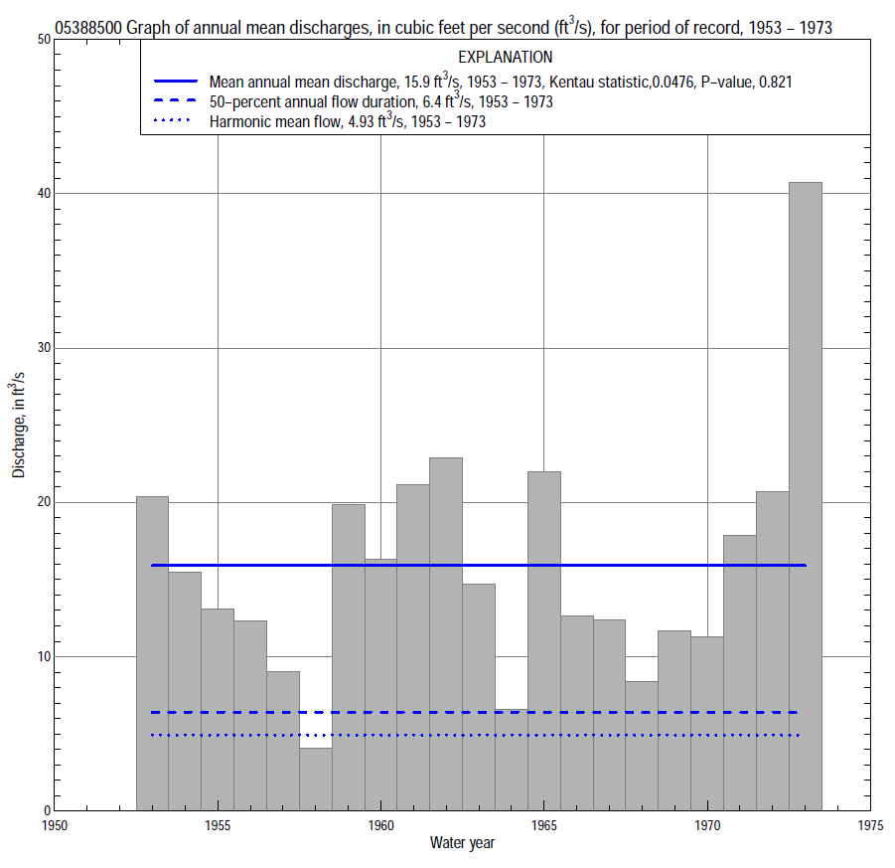

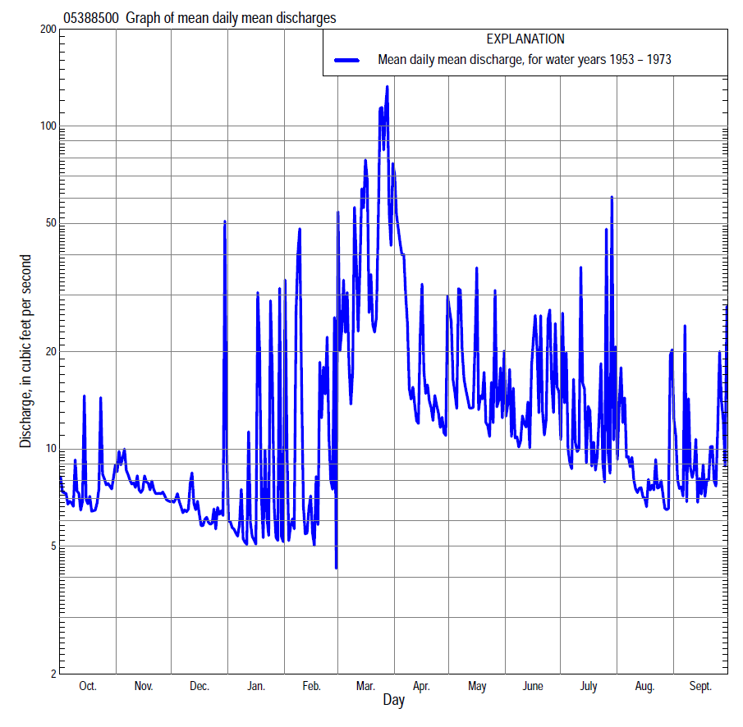

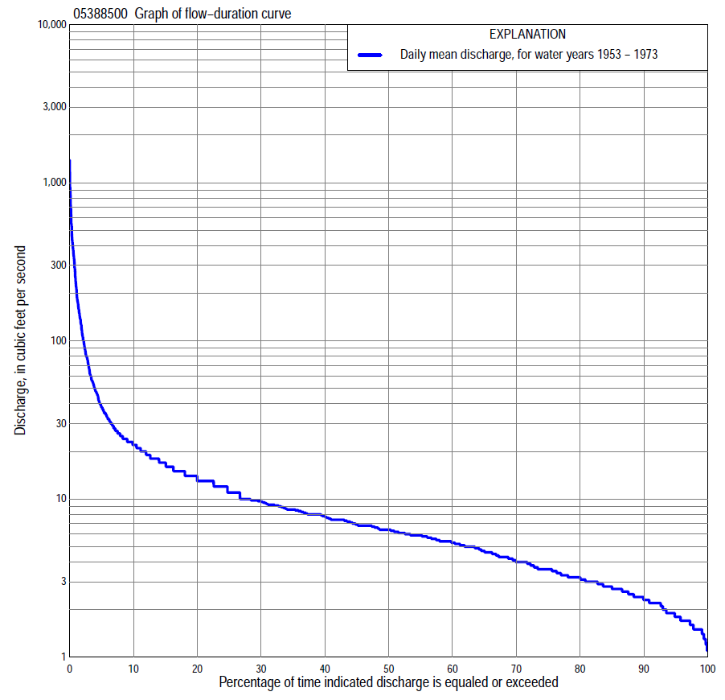
Statistics Based on the Entire Streamflow Period of Record
05388500 Monthly and annual flow durations, based on 1953–73 period of record (21 years)
Percentage of days discharge equaled or exceeded |  |  |  |  | Discharge (cubic feet per second) |  |  |  |  |  |  |  |  | Annual flow durations
 | Oct | Nov | Dec | Jan | Feb | Mar | Apr | May | June | July | Aug | Sept | Annual | Kentau statistic | P-value
99 | 1.6 | 1.5 | 1.5 | 1.2 | 1.5 | 1.4 | 1.8 | 1.9 | 1.9 | 1.7 | 1.3 | 1.3 | 1.5 | -0.076 | 0.640
98 | 1.7 | 1.7 | 1.6 | 1.2 | 1.5 | 1.5 | 2.2 | 2.2 | 2.0 | 1.9 | 1.3 | 1.5 | 1.5 | -0.095 | 0.556
95 | 1.8 | 1.8 | 1.7 | 1.5 | 1.5 | 1.7 | 2.6 | 2.4 | 2.3 | 2.0 | 1.8 | 1.7 | 1.8 | -0.067 | 0.689
90 | 2.4 | 2.2 | 1.8 | 1.9 | 2.2 | 2.5 | 3.6 | 2.9 | 3.1 | 2.6 | 2.3 | 2.1 | 2.3 | -0.067 | 0.690
85 | 2.6 | 2.4 | 2.1 | 2.3 | 2.4 | 3.5 | 4.2 | 3.2 | 3.6 | 2.9 | 2.8 | 2.9 | 2.8 | -0.033 | 0.854
80 | 3.0 | 2.9 | 2.7 | 2.6 | 2.5 | 3.8 | 5.1 | 3.8 | 3.8 | 3.1 | 3.0 | 3.1 | 3.2 | -0.024 | 0.903
75 | 3.2 | 3.2 | 3.0 | 2.7 | 3.0 | 4.5 | 5.8 | 5.0 | 4.1 | 3.6 | 3.4 | 3.6 | 3.6 | -0.067 | 0.692
70 | 3.6 | 3.6 | 3.2 | 3.0 | 3.3 | 5.0 | 6.5 | 5.7 | 4.6 | 4.3 | 3.8 | 4.0 | 4.0 | -0.043 | 0.808
65 | 4.2 | 4.2 | 3.9 | 3.6 | 3.6 | 5.8 | 7.2 | 6.4 | 5.5 | 4.7 | 4.3 | 4.6 | 4.7 | -0.043 | 0.808
60 | 4.6 | 5.2 | 4.6 | 4.2 | 4.0 | 6.3 | 7.6 | 6.8 | 6.0 | 5.4 | 5.0 | 5.4 | 5.3 | -0.024 | 0.903
55 | 5.8 | 5.6 | 5.0 | 4.6 | 4.3 | 7.0 | 8.3 | 7.6 | 6.7 | 5.9 | 5.4 | 5.9 | 5.9 | -0.014 | 0.951
50 | 5.9 | 5.9 | 5.4 | 4.9 | 5.0 | 7.8 | 9.0 | 8.6 | 7.6 | 6.6 | 5.8 | 6.1 | 6.4 | -0.014 | 0.951
45 | 6.4 | 6.8 | 5.9 | 5.2 | 5.3 | 8.6 | 9.8 | 9.8 | 9.5 | 8.0 | 6.4 | 6.8 | 6.9 | 0.005 | 1.000
40 | 7.2 | 7.6 | 6.8 | 5.8 | 5.6 | 10 | 11 | 11 | 11 | 10 | 7.1 | 7.2 | 7.8 | -0.014 | 0.951
35 | 7.6 | 8.4 | 7.2 | 6.3 | 6.0 | 14 | 13 | 13 | 13 | 11 | 8.0 | 7.7 | 8.6 | 0.000 | 1.000
30 | 8.9 | 9.1 | 8.0 | 6.6 | 6.4 | 19 | 17 | 14 | 14 | 12 | 8.3 | 8.4 | 9.6 | -0.014 | 0.951
25 | 9.7 | 9.8 | 8.6 | 6.8 | 7.4 | 26 | 20 | 16 | 15 | 14 | 8.9 | 9.8 | 11 | -0.010 | 0.976
20 | 11 | 12 | 9.3 | 7.4 | 8.6 | 35 | 24 | 18 | 17 | 15 | 9.5 | 12 | 13 | 0.029 | 0.879
15 | 12 | 14 | 9.8 | 8.0 | 12 | 59 | 27 | 22 | 20 | 18 | 12 | 13 | 17 | 0.010 | 0.976
10 | 14 | 18 | 12 | 8.6 | 16 | 106 | 38 | 32 | 30 | 23 | 20 | 17 | 22 | 0.038 | 0.832
5 | 17 | 20 | 15 | 13 | 30 | 260 | 70 | 57 | 46 | 30 | 25 | 23 | 38 | 0.067 | 0.694
2 | 24 | 25 | 22 | 20 | 102 | 551 | 186 | 106 | 96 | 107 | 41 | 47 | 109 | 0.038 | 0.832
1 | 34 | 28 | 26 | 100 | 299 | 728 | 342 | 175 | 171 | 142 | 76 | 97 | 223 | 0.152 | 0.349

05388500 Annual exceedance probability of instantaneous peak discharges, in cubic feet per second (ft³/s), based on the Weighted Independent Estimates method,
Annual exceed-ance probability | Recur-rence interval (years) | Discharge (ft³/s) | 95-percent lower confi-dence interval (ft³/s) | 95-percent upper confi-dence interval (ft³/s)
0.500 | 2 | 2,160 | 1,710 | 2,750
0.200 | 5 | 3,620 | 2,840 | 4,610
0.100 | 10 | 4,720 | 3,630 | 6,130
0.040 | 25 | 6,380 | 4,750 | 8,590
0.020 | 50 | 7,670 | 5,520 | 10,700
0.010 | 100 | 9,100 | 6,340 | 13,100
0.005 | 200 | 10,700 | 7,180 | 15,800
0.002 | 500 | 12,600 | 8,060 | 19,600
and based on the expected moments algorithm/multiple Grubbs-Beck analysis computed using a historical period length of 23 years (1951–1973)
0.500 | 2 | 2,220 | 1,650 | 2,900
0.200 | 5 | 3,600 | 2,760 | 5,050
0.100 | 10 | 4,590 | 3,480 | 7,020
0.040 | 25 | 5,900 | 4,340 | 10,300
0.020 | 50 | 6,920 | 4,930 | 13,400
0.010 | 100 | 7,950 | 5,490 | 17,200
0.005 | 200 | 9,010 | 6,000 | 21,800
0.002 | 500 | 10,500 | 6,630 | 29,500
Kentau statistic |  | 0.033
P-value |  | 0.856
Begin year |  | 1953
End year |  | 1973
Number of peaks |  | 21

05388500 Annual exceedance probability of high discharges, based on 1953–73 period of record (21 years)
Annual exceedance probability | Recur-rence interval (years) | Maximum average discharge (ft³/s) for indicated number of consecutive days
 |  | 1 | 3 | 7 | 15 | 30
0.990 | 1.01 | 117 | 71 | 45 | 24 | 14
0.950 | 1.05 | 201 | 114 | 66 | 36 | 22
0.900 | 1.11 | 262 | 145 | 81 | 46 | 29
0.800 | 1.25 | 357 | 194 | 105 | 60 | 38
0.500 | 2 | 611 | 328 | 174 | 102 | 64
0.200 | 5 | 982 | 538 | 294 | 174 | 105
0.100 | 10 | 1,230 | 688 | 390 | 230 | 133
0.040 | 25 | 1,530 | 886 | 529 | 309 | 171
0.020 | 50 | 1,750 | 1,040 | 646 | 373 | 199
0.010 | 100 | 1,960 | 1,190 | 775 | 443 | 228
0.005 | 200 | 2,170 | 1,350 | 917 | 519 | 258
0.002 | 500 | 2,430 | 1,570 | 1,130 | 628 | 297
Kentau statistic |  | 0.238 | 0.133 | 0.124 | 0.143 | 0.143
P-value |  | 0.139 | 0.415 | 0.450 | 0.381 | 0.381

 | 05388500 Annual nonexceedance probability of low discharges, based on April 1953 to March 1973 period of record (20 years)
Annual nonexceed-ance probability | Recur-rence interval (years) | Minimum average discharge (cubic feet per second) for indicated number of consecutive days
 |  | 1 | 3 | 7 | 14 | 30 | 60 | 90 | 120 | 183
0.01 | 100 | 0.75 | 0.78 | 0.91 | 0.95 | 1.0 | 1.0 | 1.0 | 1.0 | 1.1
0.02 | 50 | 0.88 | 0.90 | 1.0 | 1.1 | 1.2 | 1.2 | 1.3 | 1.3 | 1.4
0.05 | 20 | 1.1 | 1.1 | 1.3 | 1.4 | 1.5 | 1.6 | 1.7 | 1.7 | 1.9
0.10 | 10 | 1.3 | 1.4 | 1.5 | 1.6 | 1.8 | 2.0 | 2.1 | 2.2 | 2.5
0.20 | 5 | 1.7 | 1.7 | 1.9 | 2.0 | 2.2 | 2.5 | 2.8 | 3.0 | 3.4
0.50 | 2 | 2.7 | 2.7 | 2.9 | 3.1 | 3.4 | 4.0 | 4.5 | 5.0 | 5.9
0.80 | 1.25 | 4.1 | 4.2 | 4.4 | 4.7 | 5.1 | 6.1 | 7.0 | 7.9 | 9.5
0.90 | 1.11 | 5.2 | 5.3 | 5.5 | 5.8 | 6.4 | 7.5 | 8.6 | 9.8 | 12
0.96 | 1.04 | 6.6 | 6.7 | 7.0 | 7.3 | 8.0 | 9.2 | 11 | 12 | 15
0.98 | 1.02 | 7.6 | 7.8 | 8.1 | 8.5 | 9.2 | 11 | 12 | 14 | 17
0.99 | 1.01 | 8.8 | 9.0 | 9.3 | 9.6 | 11 | 12 | 13 | 16 | 19
Kentau statistic |  | 0.042 | 0.042 | 0.026 | 0.005 | 0.000 | -0.021 | -0.011 | 0.011 | -0.021
P-value |  | 0.820 | 0.820 | 0.897 | 1.000 | 1.000 | 0.922 | 0.974 | 0.974 | 0.922

05388500 Annual nonexceedance probability of seasonal low discharges, based on October 1952 to September 1973 period of record (21 years)
Annual nonexceed-ance probability | Recur-rence interval (years) | Minimum average discharge (cubic feet per second) for indicated number of consecutive days
 |  | 1 | 7 | 14 | 30 |  | 1 | 7 | 14 | 30
 |  | January-February-March |  |  |  |  | April-May-June
0.01 | 100 | 0.95 | 0.96 | 0.96 | 1.3 |  | 1.0 | 1.1 | 1.3 | 1.7
0.02 | 50 | 1.0 | 1.1 | 1.1 | 1.4 |  | 1.2 | 1.3 | 1.5 | 1.9
0.05 | 20 | 1.3 | 1.4 | 1.4 | 1.7 |  | 1.5 | 1.7 | 1.9 | 2.3
0.10 | 10 | 1.7 | 1.8 | 1.8 | 2.0 |  | 1.9 | 2.1 | 2.3 | 2.8
0.20 | 5 | 2.2 | 2.3 | 2.3 | 2.6 |  | 2.5 | 2.7 | 3.1 | 3.7
0.50 | 2 | 3.5 | 3.7 | 3.8 | 4.1 |  | 4.4 | 4.8 | 5.3 | 6.6
0.80 | 1.25 | 5.7 | 6.0 | 6.2 | 7.0 |  | 8.3 | 9.0 | 10 | 13
0.90 | 1.11 | 7.3 | 7.6 | 8.0 | 9.5 |  | 12 | 13 | 15 | 19
0.96 | 1.04 | 9.6 | 10 | 11 | 13 |  | 17 | 19 | 22 | 30
0.98 | 1.02 | 12 | 12 | 13 | 17 |  | 23 | 25 | 29 | 41
0.99 | 1.01 | 14 | 14 | 15 | 21 |  | 29 | 32 | 37 | 55
Kentau statistic |  | -0.043 | -0.052 | -0.038 | -0.048 |  | 0.067 | 0.057 | 0.038 | 0.076
P-value |  | 0.809 | 0.763 | 0.833 | 0.786 |  | 0.695 | 0.740 | 0.833 | 0.651
 |  | July-August-September |  |  |  |  | October-November-December
0.01 | 100 | 0.74 | 0.92 | 1.0 | 1.2 |  | 0.91 | 0.93 | 0.95 | 0.95
0.02 | 50 | 0.88 | 1.1 | 1.2 | 1.4 |  | 1.1 | 1.1 | 1.1 | 1.2
0.05 | 20 | 1.1 | 1.4 | 1.5 | 1.7 |  | 1.4 | 1.5 | 1.5 | 1.6
0.10 | 10 | 1.5 | 1.7 | 1.9 | 2.2 |  | 1.8 | 1.9 | 1.9 | 2.0
0.20 | 5 | 2.0 | 2.2 | 2.4 | 2.9 |  | 2.4 | 2.5 | 2.6 | 2.7
0.50 | 2 | 3.6 | 3.9 | 4.3 | 5.0 |  | 3.9 | 4.1 | 4.4 | 4.8
0.80 | 1.25 | 7.0 | 7.3 | 7.8 | 8.9 |  | 6.2 | 6.8 | 7.2 | 8.3
0.90 | 1.11 | 9.9 | 10 | 11 | 12 |  | 7.8 | 8.7 | 9.3 | 11
0.96 | 1.04 | 15 | 15 | 16 | 17 |  | 9.9 | 11 | 12 | 15
0.98 | 1.02 | 19 | 20 | 20 | 21 |  | 11 | 13 | 15 | 17
0.99 | 1.01 | 24 | 25 | 25 | 26 |  | 13 | 15 | 17 | 20
Kentau statistic |  | 0.005 | -0.019 | -0.010 | -0.038 |  | -0.019 | -0.048 | -0.048 | -0.048
P-value |  | 1.000 | 0.928 | 0.976 | 0.833 |  | 0.928 | 0.786 | 0.786 | 0.786

