LOCATION.--Lat 43°06'43", long 91°15'54" referenced to North American Datum of 1927, in NW 1/4 SE 1/4 SW 1/4 sec.24, T.96 N., R.4 W., Allamakee County, IA, Hydrologic Unit 07060001, on left bank 5 ft downstream from bridge on County Highway X36, 7.5 mi northwest of McGregor, and 9.7 mi upstream from mouth.

DRAINAGE AREA.--221 mi².

PERIOD OF RECORD.--Discharge records from October 1934 to September 1951, October 2004 to current year; partial-record low-flow measurement site from September 1957 to July 1977.

GAGE.--Water-stage recorder. Datum of gage is 661.87 ft above National Geodetic Vertical Datum of 1929. October 1, 1934, to September 30, 1951, datum of gage was 664.65 ft above Mean Sea Level, general adjustment of 1912.

A summary of all available data for this streamgage is provided through the USGS National Water Information System web interface (NWISWeb). The following link provides access to current/historical observations, daily data, daily statistics, monthly statistics, annual statistics, peak streamflow, field measurements, field/lab water-quality samples, and the latest water-year summaries. Data can be filtered by parameter and/or dates, and can be output in various tabular and graphical formats.
http://waterdata.usgs.gov/nwis/inventory/?site_no=05389000

The USGS WaterWatch Toolkit is available at:
http://waterwatch.usgs.gov/?id=ww_toolkit
Tools for summarizing streamflow information include the duration hydrograph builder, the cumulative streamflow hydrograph builder, the streamgage statistics retrieval tool, the rating curve builder, the flood tracking chart builder, the National Weather Service Advanced Hydrologic Prediction Service (AHPS) river forecast hydrograph builder, and the raster-hydrograph builder. Entering the above number for this streamgage into these toolkit webpages will provide streamflow information specific to this streamgage.

A description of the statistics presented for this streamgage is available in the main body of the report at:
http://dx.doi.org/10.3133/ofr20151214
A link to other streamgages included in this report, a map showing the location of the streamgages, information on the programs used to compute the statistical analyses, and references are included in the main body of the report.

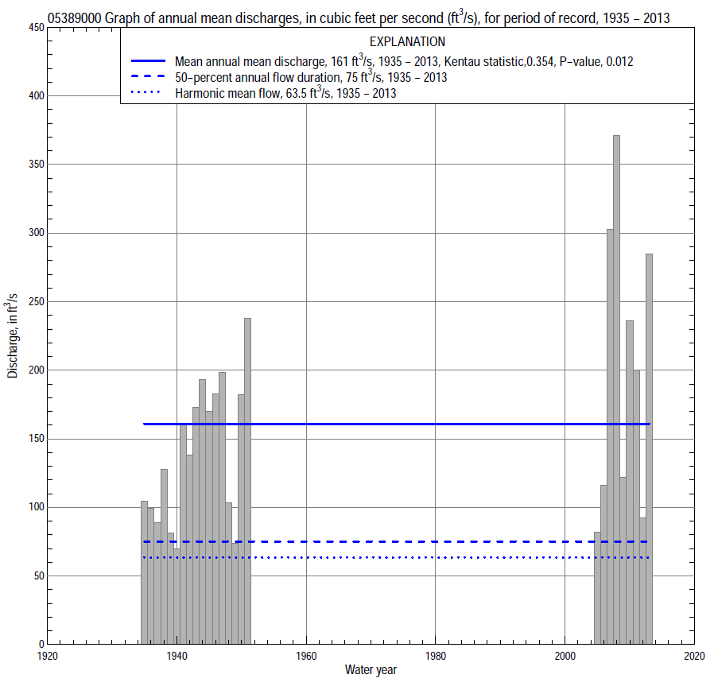

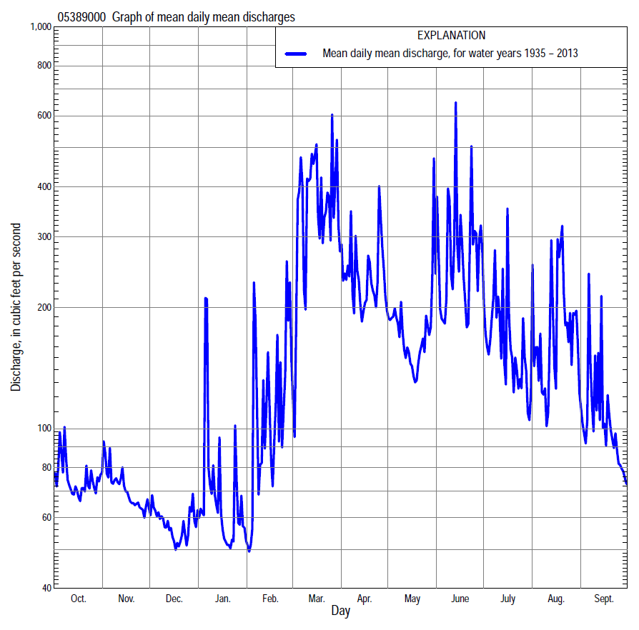

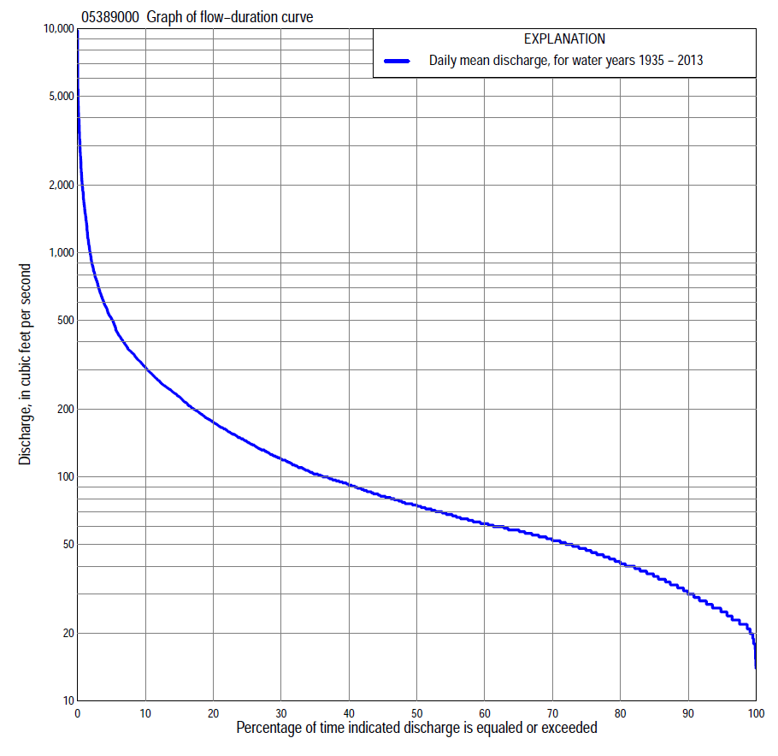

Statistics Based on the Entire Streamflow Period of Record
05389000 Monthly and annual flow durations, based on 1935–51, 2005–13 period of record (26 years)
Percentage of days discharge equaled or exceeded |  |  |  |  | Discharge (cubic feet per second) |  |  |  |  |  |  |  |  | Annual flow durations
 | Oct | Nov | Dec | Jan | Feb | Mar | Apr | May | June | July | Aug | Sept | Annual | Kentau statistic | P-value
99 | 23 | 19 | 18 | 18 | 20 | 20 | 35 | 28 | 23 | 22 | 22 | 22 | 21 | 0.249 | 0.077
98 | 23 | 22 | 19 | 20 | 21 | 23 | 45 | 29 | 26 | 24 | 23 | 22 | 22 | 0.317 | 0.024
95 | 24 | 23 | 22 | 22 | 22 | 39 | 55 | 47 | 36 | 28 | 26 | 26 | 25 | 0.378 | 0.007
90 | 28 | 27 | 25 | 25 | 25 | 57 | 64 | 54 | 43 | 33 | 32 | 34 | 30 | 0.382 | 0.007
85 | 33 | 32 | 28 | 27 | 28 | 70 | 70 | 57 | 48 | 46 | 44 | 39 | 36 | 0.366 | 0.009
80 | 36 | 36 | 31 | 30 | 32 | 78 | 74 | 60 | 53 | 52 | 49 | 41 | 41 | 0.372 | 0.008
75 | 38 | 40 | 35 | 31 | 34 | 89 | 79 | 65 | 63 | 57 | 52 | 45 | 47 | 0.345 | 0.014
70 | 44 | 42 | 37 | 34 | 37 | 100 | 84 | 72 | 72 | 61 | 57 | 51 | 52 | 0.335 | 0.017
65 | 48 | 45 | 40 | 36 | 41 | 112 | 91 | 82 | 81 | 69 | 64 | 59 | 58 | 0.345 | 0.014
60 | 54 | 51 | 42 | 42 | 45 | 123 | 98 | 96 | 96 | 79 | 69 | 63 | 62 | 0.354 | 0.012
55 | 57 | 54 | 45 | 45 | 48 | 139 | 107 | 114 | 111 | 89 | 80 | 66 | 68 | 0.403 | 0.004
50 | 58 | 56 | 48 | 48 | 52 | 155 | 125 | 124 | 127 | 100 | 86 | 71 | 75 | 0.412 | 0.003
45 | 61 | 59 | 51 | 54 | 57 | 180 | 150 | 139 | 162 | 112 | 96 | 76 | 82 | 0.388 | 0.006
40 | 62 | 62 | 55 | 60 | 62 | 210 | 186 | 149 | 180 | 124 | 102 | 83 | 92 | 0.397 | 0.005
35 | 64 | 67 | 58 | 65 | 68 | 248 | 214 | 164 | 203 | 139 | 115 | 88 | 103 | 0.403 | 0.004
30 | 70 | 75 | 62 | 70 | 72 | 280 | 240 | 186 | 229 | 155 | 127 | 98 | 120 | 0.403 | 0.004
25 | 76 | 82 | 70 | 75 | 80 | 355 | 281 | 208 | 257 | 171 | 145 | 103 | 143 | 0.412 | 0.003
20 | 82 | 98 | 79 | 81 | 100 | 450 | 328 | 242 | 317 | 203 | 164 | 112 | 176 | 0.415 | 0.003
15 | 91 | 116 | 89 | 92 | 132 | 600 | 384 | 281 | 377 | 252 | 198 | 130 | 228 | 0.366 | 0.009
10 | 110 | 135 | 97 | 102 | 209 | 812 | 506 | 343 | 519 | 332 | 266 | 166 | 309 | 0.323 | 0.022
5 | 253 | 180 | 147 | 138 | 410 | 1,330 | 755 | 474 | 904 | 517 | 490 | 320 | 510 | 0.274 | 0.052
2 | 364 | 224 | 169 | 196 | 847 | 2,360 | 1,100 | 690 | 1,960 | 822 | 1,670 | 505 | 940 | 0.102 | 0.481
1 | 419 | 259 | 182 | 342 | 1,480 | 2,940 | 1,500 | 829 | 3,170 | 1,420 | 2,240 | 732 | 1,640 | 0.015 | 0.930

05389000 Annual exceedance probability of instantaneous peak discharges, in cubic feet per second (ft³/s), based on the Weighted Independent Estimates method,
Annual exceed-ance probability | Recur-rence interval (years) | Discharge (ft³/s) | 95-percent lower confi-dence interval (ft³/s) | 95-percent upper confi-dence interval (ft³/s)
0.500 | 2 | 6,030 | 4,950 | 7,350
0.200 | 5 | 11,800 | 9,780 | 14,200
0.100 | 10 | 15,900 | 13,000 | 19,400
0.040 | 25 | 21,300 | 16,800 | 26,900
0.020 | 50 | 25,200 | 19,200 | 33,000
0.010 | 100 | 29,000 | 21,300 | 39,600
0.005 | 200 | 32,900 | 23,200 | 46,500
0.002 | 500 | 37,900 | 25,400 | 56,500
and based on the expected moments algorithm/multiple Grubbs-Beck analysis computed using a historical period length of 79 years (1935–2013)
0.500 | 2 | 6,150 | 4,170 | 8,670
0.200 | 5 | 12,200 | 8,660 | 17,700
0.100 | 10 | 16,800 | 11,800 | 25,600
0.040 | 25 | 23,000 | 15,500 | 38,000
0.020 | 50 | 27,800 | 17,900 | 49,200
0.010 | 100 | 32,700 | 19,900 | 62,200
0.005 | 200 | 37,600 | 21,500 | 77,300
0.002 | 500 | 44,200 | 23,300 | 101,000
Kentau statistic |  | -0.037
P-value |  | 0.808
Begin year |  | 1935
End year |  | 2013
Number of peaks |  | 26

05389000 Annual exceedance probability of high discharges, based on 1935–51, 2005–13 period of record (26 years)
Annual exceedance probability | Recur-rence interval (years) | Maximum average discharge (ft³/s) for indicated number of consecutive days
 |  | 1 | 3 | 7 | 15 | 30
0.990 | 1.01 | 328 | 314 | 253 | 200 | 167
0.950 | 1.05 | 728 | 592 | 408 | 288 | 226
0.900 | 1.11 | 1,070 | 804 | 521 | 352 | 267
0.800 | 1.25 | 1,620 | 1,130 | 694 | 449 | 330
0.500 | 2 | 3,250 | 2,020 | 1,160 | 724 | 507
0.200 | 5 | 5,640 | 3,250 | 1,880 | 1,180 | 802
0.100 | 10 | 7,140 | 4,020 | 2,380 | 1,540 | 1,030
0.040 | 25 | 8,860 | 4,910 | 3,020 | 2,040 | 1,360
0.020 | 50 | 10,000 | 5,500 | 3,510 | 2,460 | 1,640
0.010 | 100 | 11,000 | 6,050 | 4,000 | 2,910 | 1,950
0.005 | 200 | 11,900 | 6,550 | 4,490 | 3,400 | 2,280
0.002 | 500 | 13,000 | 7,150 | 5,140 | 4,120 | 2,780
Kentau statistic |  | -0.139 | -0.138 | -0.128 | -0.129 | -0.120
P-value |  | 0.031 | 0.031 | 0.047 | 0.045 | 0.060

 | 05389000 Annual nonexceedance probability of low discharges, based on April 1935 to March 1951, April 2005 to March 2013 period of record (24 years)
Annual nonexceed-ance probability | Recur-rence interval (years) | Minimum average discharge (cubic feet per second) for indicated number of consecutive days
 |  | 1 | 3 | 7 | 14 | 30 | 60 | 90 | 120 | 183
0.01 | 100 | 11 | 12 | 13 | 14 | 15 | 15 | 16 | 17 | 17
0.02 | 50 | 12 | 13 | 15 | 16 | 16 | 17 | 18 | 19 | 20
0.05 | 20 | 14 | 16 | 17 | 18 | 19 | 21 | 22 | 24 | 26
0.10 | 10 | 16 | 18 | 19 | 21 | 23 | 25 | 27 | 29 | 32
0.20 | 5 | 19 | 21 | 23 | 24 | 27 | 30 | 33 | 36 | 41
0.50 | 2 | 26 | 29 | 31 | 33 | 38 | 44 | 48 | 53 | 64
0.80 | 1.25 | 36 | 40 | 43 | 46 | 52 | 61 | 69 | 76 | 99
0.90 | 1.11 | 43 | 47 | 51 | 54 | 61 | 71 | 82 | 91 | 123
0.96 | 1.04 | 53 | 57 | 61 | 65 | 73 | 84 | 98 | 109 | 155
0.98 | 1.02 | 60 | 65 | 69 | 73 | 81 | 93 | 110 | 122 | 179
0.99 | 1.01 | 67 | 73 | 77 | 81 | 89 | 102 | 121 | 134 | 203
Kentau statistic |  | 0.264 | 0.228 | 0.254 | 0.315 | 0.304 | 0.304 | 0.297 | 0.261 | 0.152
P-value |  | 0.073 | 0.124 | 0.087 | 0.033 | 0.040 | 0.040 | 0.045 | 0.078 | 0.309

05389000 Annual nonexceedance probability of seasonal low discharges, based on October 1934 to September 1951, October 2004 to September 2013 period of record (26 years)
Annual nonexceed-ance probability | Recur-rence interval (years) | Minimum average discharge (cubic feet per second) for indicated number of consecutive days
 |  | 1 | 7 | 14 | 30 |  | 1 | 7 | 14 | 30
 |  | January-February-March |  |  |  |  | April-May-June
0.01 | 100 | 13 | 14 | 15 | 19 |  | 18 | 18 | 21 | 22
0.02 | 50 | 14 | 16 | 17 | 20 |  | 21 | 22 | 24 | 26
0.05 | 20 | 16 | 18 | 19 | 23 |  | 26 | 28 | 30 | 34
0.10 | 10 | 18 | 21 | 22 | 26 |  | 33 | 35 | 38 | 44
0.20 | 5 | 21 | 24 | 26 | 31 |  | 43 | 46 | 49 | 59
0.50 | 2 | 29 | 34 | 37 | 44 |  | 71 | 77 | 82 | 102
0.80 | 1.25 | 41 | 48 | 51 | 68 |  | 119 | 131 | 140 | 176
0.90 | 1.11 | 51 | 57 | 61 | 88 |  | 157 | 173 | 188 | 232
0.96 | 1.04 | 64 | 71 | 74 | 119 |  | 210 | 233 | 260 | 313
0.98 | 1.02 | 75 | 81 | 85 | 146 |  | 255 | 283 | 322 | 378
0.99 | 1.01 | 86 | 92 | 95 | 177 |  | 303 | 337 | 390 | 448
Kentau statistic |  | 0.154 | 0.166 | 0.197 | 0.095 |  | 0.458 | 0.455 | 0.474 | 0.422
P-value |  | 0.279 | 0.243 | 0.165 | 0.508 |  | 0.001 | 0.001 | 0.001 | 0.003
 |  | July-August-September |  |  |  |  | October-November-December
0.01 | 100 | 14 | 14 | 17 | 18 |  | 14 | 17 | 18 | 18
0.02 | 50 | 16 | 17 | 20 | 21 |  | 15 | 18 | 19 | 19
0.05 | 20 | 21 | 22 | 25 | 27 |  | 17 | 20 | 21 | 22
0.10 | 10 | 26 | 27 | 30 | 33 |  | 18 | 22 | 24 | 25
0.20 | 5 | 33 | 34 | 38 | 42 |  | 21 | 26 | 27 | 30
0.50 | 2 | 51 | 53 | 57 | 65 |  | 29 | 36 | 38 | 44
0.80 | 1.25 | 75 | 79 | 83 | 97 |  | 46 | 55 | 59 | 69
0.90 | 1.11 | 90 | 95 | 101 | 119 |  | 62 | 72 | 77 | 88
0.96 | 1.04 | 108 | 115 | 122 | 145 |  | 87 | 99 | 105 | 118
0.98 | 1.02 | 121 | 129 | 138 | 165 |  | 111 | 123 | 130 | 143
0.99 | 1.01 | 133 | 143 | 153 | 184 |  | 140 | 153 | 160 | 172
Kentau statistic |  | 0.437 | 0.425 | 0.428 | 0.391 |  | 0.418 | 0.320 | 0.360 | 0.332
P-value |  | 0.002 | 0.003 | 0.002 | 0.005 |  | 0.003 | 0.023 | 0.011 | 0.018

