LOCATION.--Lat 43°02'27", long 91°12'23" referenced to North American Datum of 1927, in SE 1/4 SW 1/4 SW 1/4 sec.16, T.95 N., R.3 W., Clayton County, IA, Hydrologic Unit 07060001, on right bank 50 ft downstream from bridge on State Highway 18, 1.5 mi west of Marquette, and 1.5 mi upstream from mouth.

DRAINAGE AREA.--34.13 mi².

PERIOD OF RECORD.--Discharge records from October 1991 to current year.

GAGE.--Water-stage recorder. Datum of gage is 624.82 ft above National Geodetic Vertical Datum of 1929.

REMARKS.--For records status prior to October 1, 2013, see remarks printed in annual water-data reports.

A summary of all available data for this streamgage is provided through the USGS National Water Information System web interface (NWISWeb). The following link provides access to current/historical observations, daily data, daily statistics, monthly statistics, annual statistics, peak streamflow, field measurements, field/lab water-quality samples, and the latest water-year summaries. Data can be filtered by parameter and/or dates, and can be output in various tabular and graphical formats.
http://waterdata.usgs.gov/nwis/inventory/?site_no=05389400

The USGS WaterWatch Toolkit is available at:
http://waterwatch.usgs.gov/?id=ww_toolkit
Tools for summarizing streamflow information include the duration hydrograph builder, the cumulative streamflow hydrograph builder, the streamgage statistics retrieval tool, the rating curve builder, the flood tracking chart builder, the National Weather Service Advanced Hydrologic Prediction Service (AHPS) river forecast hydrograph builder, and the raster-hydrograph builder. Entering the above number for this streamgage into these toolkit webpages will provide streamflow information specific to this streamgage.

A description of the statistics presented for this streamgage is available in the main body of the report at:
http://dx.doi.org/10.3133/ofr20151214
A link to other streamgages included in this report, a map showing the location of the streamgages, information on the programs used to compute the statistical analyses, and references are included in the main body of the report.

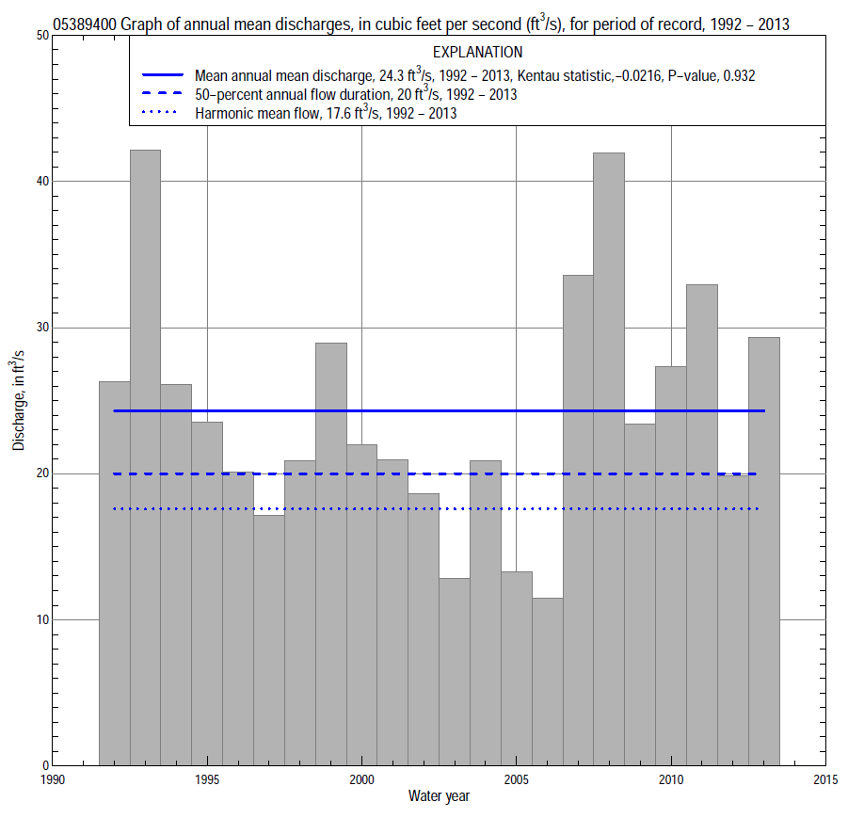

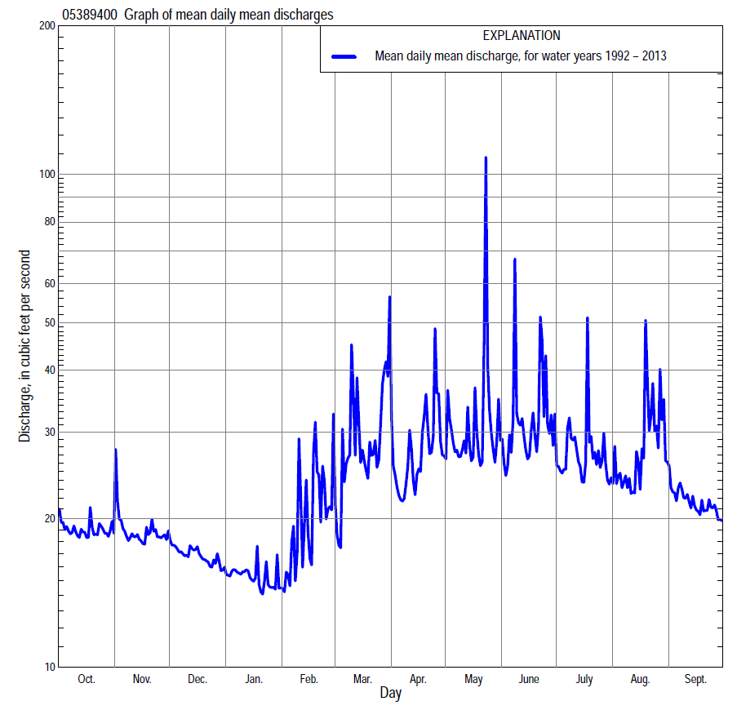

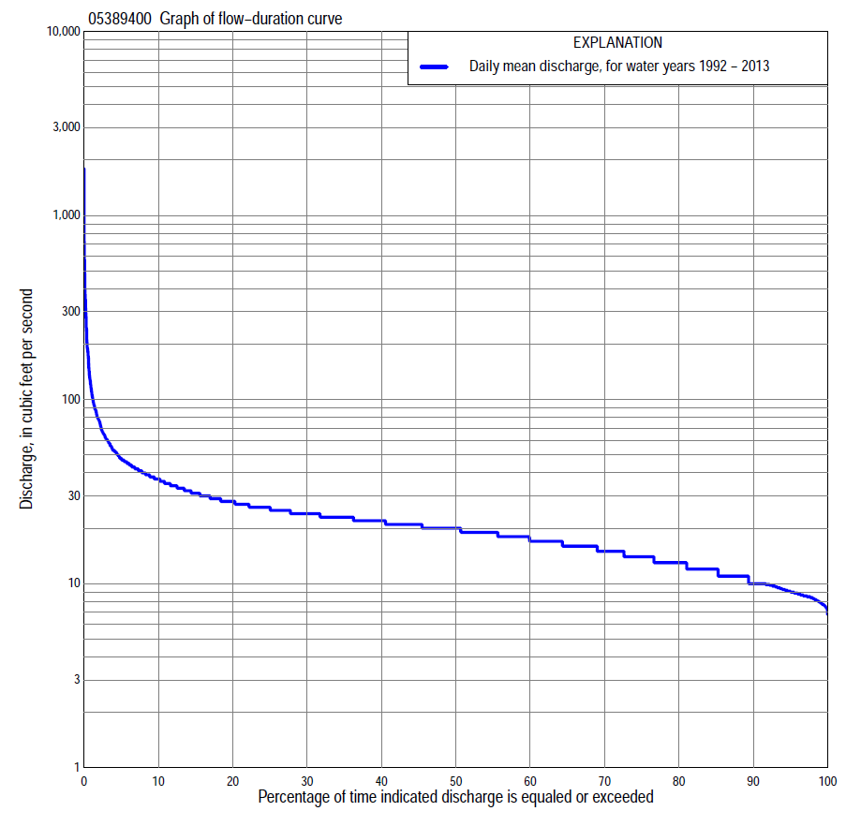
Statistics Based on the Entire Streamflow Period of Record
05389400 Monthly and annual flow durations, based on 1992–2013 period of record (22 years)
Percentage of days discharge equaled or exceeded |  |  |  |  | Discharge (cubic feet per second) |  |  |  |  |  |  |  |  | Annual flow durations
 | Oct | Nov | Dec | Jan | Feb | Mar | Apr | May | June | July | Aug | Sept | Annual | Kentau statistic | P-value
99 | 8.6 | 8.6 | 8.8 | 7.7 | 7.3 | 7.6 | 8.9 | 9.8 | 8.9 | 8.1 | 7.9 | 8.4 | 7.9 | -0.177 | 0.254
98 | 8.6 | 8.8 | 9.0 | 8.1 | 7.5 | 7.7 | 9.3 | 10 | 9.3 | 8.6 | 8.2 | 8.5 | 8.3 | -0.182 | 0.242
95 | 9.0 | 9.2 | 9.5 | 8.5 | 7.7 | 8.3 | 10 | 11 | 10 | 9.6 | 9.4 | 9.0 | 9.1 | -0.190 | 0.221
90 | 10 | 10 | 10 | 9.2 | 8.2 | 11 | 11 | 14 | 12 | 13 | 11 | 10 | 10 | -0.221 | 0.156
85 | 12 | 11 | 11 | 10 | 8.5 | 13 | 13 | 15 | 15 | 14 | 12 | 12 | 12 | -0.173 | 0.268
80 | 13 | 12 | 11 | 11 | 10 | 14 | 15 | 16 | 17 | 16 | 13 | 13 | 13 | -0.190 | 0.224
75 | 14 | 13 | 12 | 11 | 11 | 16 | 16 | 17 | 19 | 18 | 15 | 14 | 14 | -0.190 | 0.222
70 | 14 | 14 | 12 | 12 | 12 | 17 | 17 | 18 | 20 | 20 | 17 | 15 | 15 | -0.199 | 0.202
65 | 16 | 15 | 13 | 12 | 13 | 17 | 17 | 19 | 21 | 21 | 18 | 17 | 16 | -0.190 | 0.223
60 | 17 | 16 | 13 | 13 | 15 | 18 | 18 | 20 | 22 | 22 | 19 | 18 | 17 | -0.160 | 0.308
55 | 17 | 16 | 15 | 14 | 16 | 19 | 19 | 21 | 23 | 23 | 20 | 19 | 19 | -0.156 | 0.322
50 | 18 | 18 | 16 | 15 | 17 | 20 | 21 | 22 | 24 | 24 | 22 | 20 | 20 | -0.134 | 0.395
45 | 20 | 20 | 17 | 16 | 17 | 21 | 22 | 24 | 25 | 24 | 23 | 21 | 21 | -0.126 | 0.427
40 | 21 | 21 | 19 | 16 | 18 | 23 | 23 | 25 | 27 | 26 | 24 | 22 | 22 | -0.065 | 0.692
35 | 22 | 22 | 20 | 17 | 19 | 24 | 25 | 27 | 29 | 27 | 26 | 23 | 23 | -0.069 | 0.671
30 | 23 | 23 | 21 | 18 | 20 | 25 | 26 | 30 | 32 | 29 | 27 | 25 | 24 | -0.095 | 0.552
25 | 23 | 24 | 21 | 19 | 20 | 26 | 30 | 34 | 35 | 32 | 29 | 26 | 26 | -0.048 | 0.777
20 | 24 | 24 | 22 | 19 | 21 | 29 | 36 | 37 | 38 | 34 | 31 | 27 | 28 | -0.061 | 0.714
15 | 26 | 26 | 23 | 20 | 23 | 35 | 40 | 43 | 42 | 36 | 34 | 29 | 31 | -0.035 | 0.843
10 | 27 | 28 | 25 | 21 | 27 | 52 | 47 | 49 | 47 | 42 | 38 | 35 | 37 | -0.017 | 0.932
5 | 30 | 30 | 27 | 23 | 45 | 83 | 65 | 62 | 64 | 49 | 48 | 41 | 48 | 0.013 | 0.955
2 | 33 | 32 | 29 | 26 | 79 | 128 | 102 | 94 | 105 | 77 | 135 | 54 | 77 | 0.203 | 0.195
1 | 35 | 34 | 31 | 29 | 121 | 240 | 129 | 166 | 144 | 98 | 211 | 61 | 112 | 0.108 | 0.499

05389400 Annual exceedance probability of instantaneous peak discharges, in cubic feet per second (ft³/s), based on the Weighted Independent Estimates method,
Annual exceed-ance probability | Recur-rence interval (years) | Discharge (ft³/s) | 95-percent lower confi-dence interval (ft³/s) | 95-percent upper confi-dence interval (ft³/s)
0.500 | 2 | 737 | 496 | 1,090
0.200 | 5 | 1,930 | 1,330 | 2,780
0.100 | 10 | 3,070 | 2,110 | 4,460
0.040 | 25 | 4,890 | 3,270 | 7,310
0.020 | 50 | 6,250 | 4,040 | 9,660
0.010 | 100 | 7,840 | 4,900 | 12,500
0.005 | 200 | 9,580 | 5,800 | 15,800
0.002 | 500 | 11,700 | 6,690 | 20,500
and based on the expected moments algorithm/multiple Grubbs-Beck analysis computed using a historical period length of 22 years (1992–2013)
0.500 | 2 | 608 | 368 | 959
0.200 | 5 | 1,420 | 901 | 2,450
0.100 | 10 | 2,140 | 1,340 | 4,230
0.040 | 25 | 3,250 | 1,950 | 7,960
0.020 | 50 | 4,210 | 2,400 | 12,200
0.010 | 100 | 5,270 | 2,840 | 18,200
0.005 | 200 | 6,430 | 3,250 | 26,500
0.002 | 500 | 8,130 | 3,750 | 42,600
Kentau statistic |  | 0.065
P-value |  | 0.693
Begin year |  | 1992
End year |  | 2013
Number of peaks |  | 22

05389400 Annual exceedance probability of high discharges, based on 1992–2013 period of record (22 years)
Annual exceedance probability | Recur-rence interval (years) | Maximum average discharge (ft³/s) for indicated number of consecutive days
 |  | 1 | 3 | 7 | 15 | 30
0.990 | 1.01 | 21 | 18 | 14 | 13 | 12
0.950 | 1.05 | 40 | 30 | 22 | 19 | 18
0.900 | 1.11 | 56 | 39 | 29 | 24 | 22
0.800 | 1.25 | 85 | 56 | 40 | 31 | 28
0.500 | 2 | 195 | 117 | 78 | 55 | 46
0.200 | 5 | 464 | 260 | 163 | 106 | 77
0.100 | 10 | 742 | 404 | 246 | 153 | 103
0.040 | 25 | 1,240 | 661 | 392 | 233 | 142
0.020 | 50 | 1,730 | 919 | 535 | 309 | 176
0.010 | 100 | 2,350 | 1,240 | 713 | 401 | 213
0.005 | 200 | 3,120 | 1,650 | 935 | 514 | 255
0.002 | 500 | 4,420 | 2,350 | 1,310 | 702 | 319
Kentau statistic |  | -0.013 | -0.004 | 0.030 | 0.048 | 0.065
P-value |  | 0.955 | 1.000 | 0.866 | 0.778 | 0.693

 | 05389400 Annual nonexceedance probability of low discharges, based on April 1992 to March 2013 period of record (21 years)
Annual nonexceed-ance probability | Recur-rence interval (years) | Minimum average discharge (cubic feet per second) for indicated number of consecutive days
 |  | 1 | 3 | 7 | 14 |  | 30 | 60 | 90 | 120 | 183
0.01 | 100 | 5.0 | 5.3 | 5.4 | 5.6 | 5.9 |  | 6.2 | 6.7 | 6.8 | 7.0
0.02 | 50 | 5.5 | 5.8 | 6.0 | 6.1 | 6.5 |  | 6.9 | 7.4 | 7.5 | 7.9
0.05 | 20 | 6.2 | 6.6 | 6.8 | 7.0 | 7.6 |  | 8.1 | 8.5 | 8.8 | 9.2
0.10 | 10 | 7.0 | 7.3 | 7.7 | 7.9 | 8.6 |  | 9.2 | 9.7 | 10 | 11
0.20 | 5 | 8.0 | 8.4 | 8.8 | 9.2 | 10 |  | 11 | 11 | 12 | 12
0.50 | 2 | 11 | 11 | 11 | 12 | 13 |  | 14 | 15 | 15 | 17
0.80 | 1.25 | 14 | 14 | 15 | 15 | 16 |  | 18 | 19 | 20 | 22
0.90 | 1.11 | 16 | 16 | 17 | 17 | 18 |  | 19 | 21 | 23 | 25
0.96 | 1.04 | 18 | 19 | 19 | 20 | 20 |  | 22 | 23 | 26 | 29
0.98 | 1.02 | 20 | 20 | 21 | 21 | 22 |  | 23 | 25 | 28 | 32
0.99 | 1.01 | 22 | 22 | 23 | 23 | 23 |  | 24 | 27 | 30 | 34
Kentau statistic |  | -0.010 | -0.062 | -0.095 | -0.100 | -0.019 |  | -0.067 | -0.090 | -0.105 | -0.143
P-value |  | 0.976 | 0.717 | 0.566 | 0.546 | 0.928 |  | 0.695 | 0.587 | 0.526 | 0.381

05389400 Annual nonexceedance probability of seasonal low discharges, based on October 1991 to September 2013 period of record (21-22 years)
Annual nonexceed-ance probability | Recur-rence interval (years) | Minimum average discharge (cubic feet per second) for indicated number of consecutive days
 |  | 1 | 7 | 14 | 30 |  | 1 | 7 | 14 | 30
 |  | January-February-March |  |  |  |  | April-May-June
0.01 | 100 | 4.9 | 5.4 | 5.6 | 6.0 |  | 7.0 | 7.2 | 7.4 | 8.2
0.02 | 50 | 5.4 | 6.0 | 6.1 | 6.7 |  | 7.7 | 7.9 | 8.2 | 9.0
0.05 | 20 | 6.3 | 6.9 | 7.1 | 7.8 |  | 8.8 | 9.2 | 9.5 | 10
0.10 | 10 | 7.2 | 7.9 | 8.1 | 8.9 |  | 10 | 11 | 11 | 12
0.20 | 5 | 8.3 | 9.2 | 9.5 | 10 |  | 12 | 12 | 13 | 14
0.50 | 2 | 11 | 12 | 13 | 14 |  | 16 | 17 | 18 | 20
0.80 | 1.25 | 15 | 16 | 17 | 18 |  | 22 | 24 | 26 | 29
0.90 | 1.11 | 17 | 18 | 19 | 20 |  | 26 | 29 | 31 | 35
0.96 | 1.04 | 20 | 21 | 22 | 23 |  | 32 | 35 | 38 | 44
0.98 | 1.02 | 22 | 23 | 24 | 24 |  | 36 | 40 | 44 | 52
0.99 | 1.01 | 24 | 25 | 26 | 27 |  | 41 | 45 | 50 | 59
Kentau statistic |  | -0.100 | -0.182 | -0.199 | -0.143 |  | -0.017 | -0.043 | -0.039 | -0.052
P-value |  | 0.534 | 0.247 | 0.204 | 0.367 |  | 0.932 | 0.800 | 0.822 | 0.756
 |  | July-August-September |  |  |  |  | October-November-December
0.01 | 100 | 6.3 | 6.3 | 6.4 | 6.9 |  | 6.6 | 6.7 | 6.9 | 7.1
0.02 | 50 | 7.1 | 7.2 | 7.2 | 7.7 |  | 7.1 | 7.3 | 7.6 | 7.7
0.05 | 20 | 8.4 | 8.6 | 8.8 | 9.1 |  | 8.0 | 8.3 | 8.6 | 8.9
0.10 | 10 | 10 | 10 | 10 | 11 |  | 8.8 | 9.2 | 9.6 | 10
0.20 | 5 | 12 | 12 | 13 | 13 |  | 9.9 | 11 | 11 | 12
0.50 | 2 | 16 | 17 | 18 | 18 |  | 13 | 14 | 14 | 15
0.80 | 1.25 | 22 | 23 | 24 | 27 |  | 16 | 18 | 19 | 20
0.90 | 1.11 | 25 | 27 | 27 | 34 |  | 18 | 20 | 21 | 23
0.96 | 1.04 | 30 | 31 | 31 | 42 |  | 21 | 23 | 24 | 26
0.98 | 1.02 | 33 | 34 | 34 | 49 |  | 22 | 25 | 27 | 29
0.99 | 1.01 | 36 | 37 | 38 | 56 |  | 24 | 28 | 29 | 32
Kentau statistic |  | -0.061 | -0.087 | -0.095 | -0.082 |  | -0.017 | -0.039 | -0.043 | -0.056
P-value |  | 0.713 | 0.592 | 0.554 | 0.612 |  | 0.932 | 0.822 | 0.800 | 0.735

