LOCATION.--Lat 43°01'37.3", long 91°10'21" referenced to North American Datum of 1927, in SE 1/4 NE 1/4 SE 1/4 sec.22, T.95 N., R.3 W., Clayton County, IA, Hydrologic Unit 07060001, on right bank in city park at east end of Main Street in McGregor, 2.6 mi upstream from Wisconsin River, 4.3 mi downstream from Yellow River, and 633.4 mi upstream from Ohio River.

DRAINAGE AREA.--67,500 mi².

PERIOD OF RECORD.--Discharge records from August 1936 to September 2005, October 2007 to September 2013; stage-only records from October 2005 to September 2007, October 2013 to current year.

GAGE.--Water-stage recorder. Datum of gage is 604.84 ft above National Geodetic Vertical Datum of 1929. Auxiliary gage at Lock and Dam 9 (station 05388410), 14.1 mi upstream, at datum 5.30 ft lower. Prior to June 1, 1937, and since June 2, 1939, auxiliary water-stage recorder; June 1, 1937, to June 1, 1939, non-recording auxiliary gage.

REMARKS.--Minor flow regulation caused by navigation dams.

EXTREMES OUTSIDE PERIOD OF RECORD.--Since at least 1828, no flood outside the period of record exceeded that of April 24, 1965, discharge, 276,000 ft³/s, gage height, 25.38 ft.

A summary of all available data for this streamgage is provided through the USGS National Water Information System web interface (NWISWeb). The following link provides access to current/historical observations, daily data, daily statistics, monthly statistics, annual statistics, peak streamflow, field measurements, field/lab water-quality samples, and the latest water-year summaries. Data can be filtered by parameter and/or dates, and can be output in various tabular and graphical formats.
http://waterdata.usgs.gov/nwis/inventory/?site_no=05389500

The USGS WaterWatch Toolkit is available at:
http://waterwatch.usgs.gov/?id=ww_toolkit
Tools for summarizing streamflow information include the duration hydrograph builder, the cumulative streamflow hydrograph builder, the streamgage statistics retrieval tool, the rating curve builder, the flood tracking chart builder, the National Weather Service Advanced Hydrologic Prediction Service (AHPS) river forecast hydrograph builder, and the raster-hydrograph builder. Entering the above number for this streamgage into these toolkit webpages will provide streamflow information specific to this streamgage.

A description of the statistics presented for this streamgage is available in the main body of the report at:
http://dx.doi.org/10.3133/ofr20151214
A link to other streamgages included in this report, a map showing the location of the streamgages, information on the programs used to compute the statistical analyses, and references are included in the main body of the report.

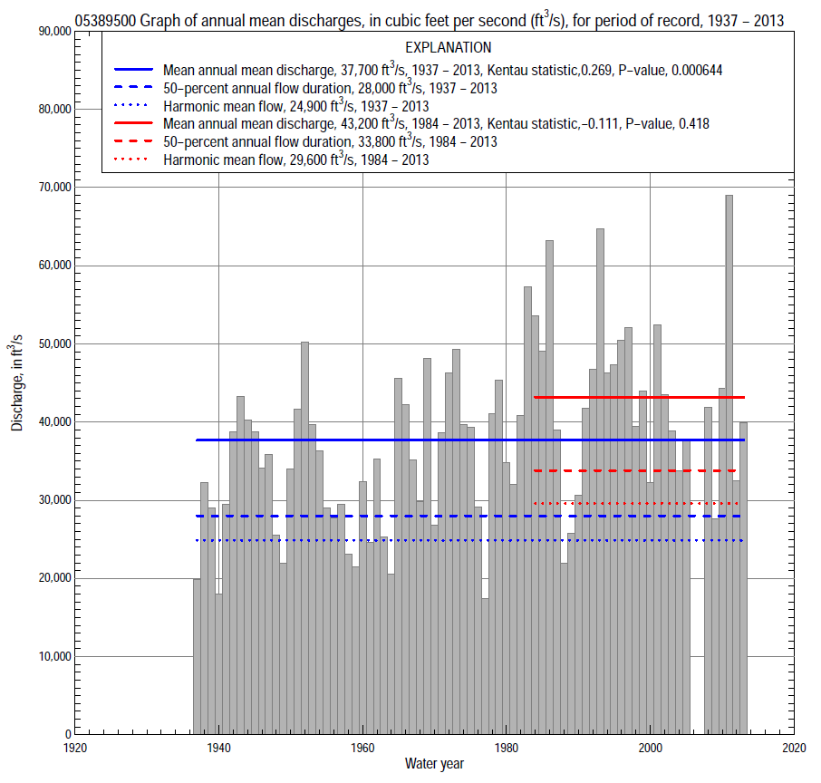

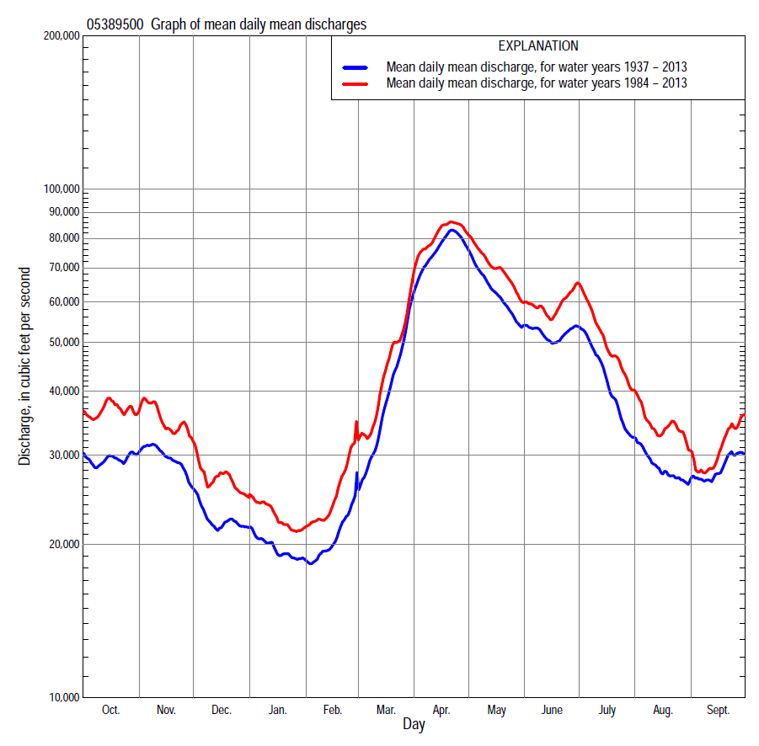

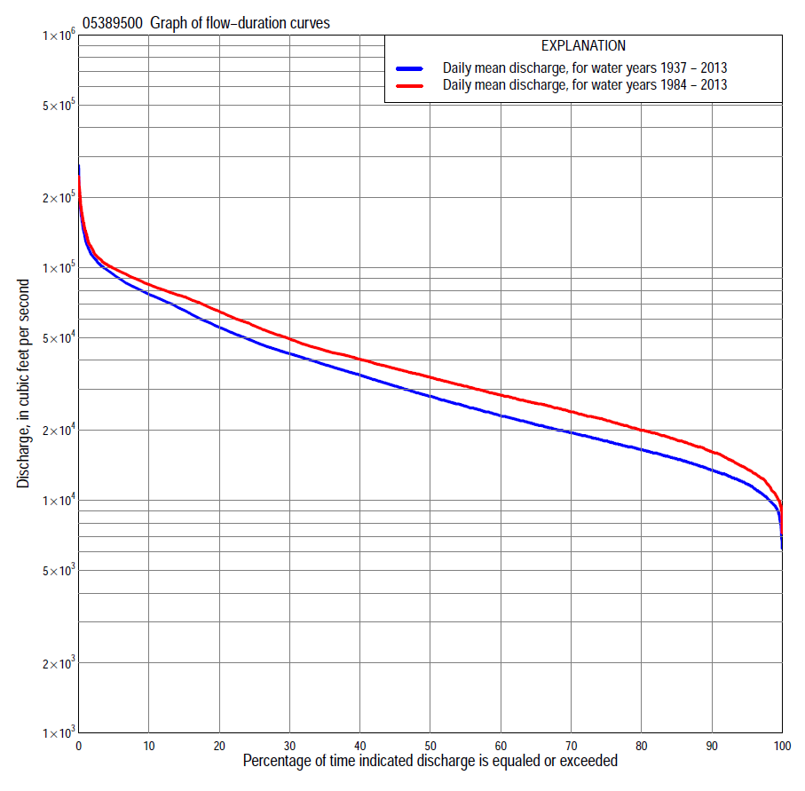

Statistics Based on the Entire Streamflow Period of Record
05389500 Monthly and annual flow durations, based on 1937–2005, 2008–13 period of record (75 years)
Percentage of days discharge equaled or exceeded |  |  |  |  | Discharge (cubic feet per second) |  |  |  |  |  |  |  |  | Annual flow durations
 | Oct | Nov | Dec | Jan | Feb | Mar | Apr | May | June | July | Aug | Sept | Annual | Kentau statistic | P-value
99 | 9,110 | 10,100 | 8,000 | 8,000 | 9,400 | 11,900 | 20,200 | 15,100 | 12,500 | 9,940 | 9,000 | 9,510 | 9,500 | 0.170 | 0.032
98 | 9,660 | 10,700 | 9,000 | 9,000 | 9,700 | 12,800 | 22,800 | 16,500 | 13,600 | 10,600 | 9,740 | 9,920 | 10,100 | 0.186 | 0.018
95 | 11,000 | 11,800 | 10,500 | 10,100 | 10,900 | 14,500 | 28,300 | 20,700 | 16,600 | 12,100 | 11,000 | 10,800 | 11,800 | 0.246 | 0.002
90 | 12,700 | 13,900 | 11,800 | 12,000 | 12,400 | 16,700 | 33,100 | 26,700 | 20,900 | 14,900 | 12,500 | 12,300 | 13,500 | 0.300 | 0.000
85 | 13,800 | 15,700 | 13,400 | 12,700 | 13,000 | 18,500 | 37,400 | 31,700 | 25,900 | 17,200 | 13,900 | 13,600 | 15,100 | 0.301 | 0.000
80 | 14,700 | 17,100 | 14,400 | 13,400 | 13,700 | 20,000 | 42,700 | 35,500 | 30,300 | 19,800 | 15,200 | 14,800 | 16,500 | 0.305 | 0.000
75 | 15,700 | 18,200 | 15,400 | 14,400 | 14,600 | 21,900 | 47,200 | 39,500 | 34,700 | 22,100 | 16,600 | 15,800 | 18,000 | 0.325 | 0.000
70 | 16,800 | 19,400 | 16,000 | 15,100 | 15,500 | 23,500 | 51,800 | 42,600 | 37,600 | 25,000 | 17,900 | 17,000 | 19,600 | 0.328 | 0.000
65 | 17,800 | 20,500 | 17,000 | 16,000 | 16,300 | 25,100 | 57,100 | 45,700 | 40,100 | 28,700 | 19,500 | 18,300 | 21,200 | 0.330 | 0.000
60 | 19,100 | 21,700 | 17,800 | 16,500 | 17,000 | 26,900 | 62,700 | 49,500 | 42,400 | 31,500 | 21,100 | 20,000 | 23,200 | 0.319 | 0.000
55 | 20,600 | 23,000 | 18,900 | 17,400 | 17,700 | 29,000 | 68,600 | 53,300 | 44,700 | 34,500 | 22,700 | 21,500 | 25,500 | 0.293 | 0.000
50 | 22,300 | 24,900 | 19,600 | 18,300 | 18,500 | 31,600 | 72,600 | 58,400 | 47,200 | 37,400 | 24,400 | 23,200 | 28,000 | 0.287 | 0.000
45 | 24,300 | 27,200 | 20,700 | 19,200 | 19,500 | 34,100 | 76,000 | 62,200 | 50,500 | 40,200 | 26,200 | 25,000 | 31,000 | 0.270 | 0.001
40 | 26,500 | 29,600 | 22,000 | 20,300 | 20,000 | 37,000 | 79,600 | 67,100 | 54,100 | 43,400 | 27,800 | 27,500 | 34,700 | 0.274 | 0.001
35 | 29,600 | 32,000 | 23,800 | 21,500 | 21,000 | 40,700 | 83,900 | 72,800 | 58,000 | 48,500 | 29,900 | 29,800 | 38,400 | 0.260 | 0.001
30 | 33,500 | 34,800 | 25,400 | 22,800 | 22,500 | 44,500 | 88,300 | 77,700 | 63,700 | 52,200 | 32,400 | 32,800 | 42,800 | 0.262 | 0.001
25 | 36,800 | 37,800 | 28,000 | 24,000 | 23,900 | 49,200 | 93,200 | 82,600 | 69,100 | 57,900 | 35,300 | 36,500 | 48,200 | 0.242 | 0.002
20 | 41,400 | 40,800 | 30,000 | 25,500 | 25,500 | 56,200 | 99,700 | 88,900 | 73,600 | 62,900 | 38,300 | 40,300 | 55,600 | 0.199 | 0.012
15 | 46,500 | 44,700 | 32,900 | 27,000 | 27,000 | 64,000 | 108,000 | 96,000 | 80,300 | 69,800 | 43,200 | 44,700 | 65,700 | 0.197 | 0.013
10 | 53,900 | 51,000 | 36,400 | 29,000 | 30,800 | 74,900 | 119,000 | 102,000 | 87,500 | 76,100 | 50,600 | 52,100 | 77,000 | 0.188 | 0.017
5 | 70,700 | 63,600 | 42,500 | 33,000 | 37,600 | 92,700 | 151,000 | 113,000 | 97,000 | 86,100 | 66,100 | 61,500 | 93,400 | 0.145 | 0.067
2 | 93,700 | 74,700 | 51,200 | 39,800 | 55,300 | 111,000 | 191,000 | 132,000 | 111,000 | 103,000 | 79,200 | 78,100 | 112,000 | 0.131 | 0.098
1 | 112,000 | 78,500 | 58,000 | 42,200 | 66,000 | 125,000 | 213,000 | 164,000 | 116,000 | 122,000 | 84,900 | 85,000 | 132,000 | 0.138 | 0.080

05389500 Annual exceedance probability of instantaneous peak discharges, in cubic feet per second (ft³/s), based on U.S. Army Corps of Engineers regulated flow frequency studyª, analysis computed using a historical period length of 101 years (1898-1998)
USACE Regulated Flow Frequency Analysis
[ND, not determined]
Annual exceedance probability | Recurrence interval (years) | Discharge (ft³/s) | 95-percent lower confidence interval (ft³/s) | 95-percent upper confidence interval (ft³/s)
0.500 | 2 | 101,000 | 94,100 | 108,000
0.200 | 5 | 141,000 | 131,000 | 154,000
0.100 | 10 | 168,000 | 155,000 | 186,000
0.040 | 25 | 202,000 | ND | ND
0.020 | 50 | 227,000 | 204,000 | 258,000
0.010 | 100 | 251,000 | 224,000 | 289,000
0.005 | 200 | 276,000 | 244,000 | 321,000
0.002 | 500 | 309,000 | 270,000 | 365,000
ªU.S. Army Corps of Engineers, 2004a, Upper Mississippi River System Flow Frequency Study, Hydrology and Hydraulics Appendix B, St. Paul District: U.S. Army Corps of Engineers, 71 p., accessed September 9, 2014, at http://www.mvr.usace.army.mil/Portals/48/docs/FRM/UpperMissFlowFreq/App.%20B%20St.%20Paul%20Dist.%20Hydrology_Hydraulics.pdf.
USGS Kendall's Tau Trend Analysis
Kentau statistic |  | 0.138
P-value |  | 0.081
Begin year |  | 1937^{b}
End year |  | 2013^{b}
Number of peaks |  | 75
^{b}Kendalll's tau trend analysis computed using the regulated period of record which is not the same period of record used to compute the above flow frequency analysis

05389500 Annual exceedance probability of high discharges, based on 1937–2005, 2008–13 period of record (75 years)
[ND, not determined]
Annual exceed-ance probability | Recur-rence interval (years) | Maximum average discharge (cubic feet per second) for indicated number of consecutive days
 |  | 1 | 3 | 7 | 15 | 30
0.990 | 1.01 | ND | ND | ND | 42,300 | 36,400
0.950 | 1.05 | ND | ND | ND | 54,600 | 47,900
0.900 | 1.11 | ND | ND | ND | 62,400 | 55,200
0.800 | 1.25 | ND | ND | ND | 73,400 | 65,200
0.500 | 2 | ND | ND | ND | 99,400 | 88,300
0.200 | 5 | ND | ND | ND | 134,000 | 118,000
0.100 | 10 | ND | ND | ND | 156,000 | 135,000
0.040 | 25 | ND | ND | ND | 183,000 | 157,000
0.020 | 50 | ND | ND | ND | 203,000 | 172,000
0.010 | 100 | ND | ND | ND | 223,000 | 186,000
0.005 | 200 | ND | ND | ND | 242,000 | 200,000
0.002 | 500 | ND | ND | ND | 268,000 | 218,000
Kentau statistic |  | 0.140 | 0.142 | 0.131 | 0.125 | 0.129
P-value |  | 0.076 | 0.072 | 0.097 | 0.113 | 0.102

 | 05389500 Annual nonexceedance probability of low discharges, based on April 1937 to March 2005, April 2008 to March 2013, period of record (73 years)
Annual nonexceed-ance probability | Recur-rence interval (years) | Minimum average discharge (cubic feet per second) for indicated number of consecutive days
 |  | 1 | 3 | 7 | 14 | 30 | 60 | 90 | 120 | 183
0.01 | 100 | 6,370 | 6,920 | 7,040 | 7,260 | 7,860 | 8,480 | 8,900 | 9,290 | 9,470
0.02 | 50 | 6,760 | 7,310 | 7,530 | 7,840 | 8,490 | 9,180 | 9,650 | 10,100 | 10,400
0.05 | 20 | 7,420 | 7,980 | 8,360 | 8,810 | 9,540 | 10,400 | 10,900 | 11,500 | 12,000
0.10 | 10 | 8,120 | 8,680 | 9,210 | 9,800 | 10,600 | 11,500 | 12,200 | 12,900 | 13,700
0.20 | 5 | 9,120 | 9,680 | 10,400 | 11,200 | 12,100 | 13,200 | 14,000 | 14,800 | 16,100
0.50 | 2 | 11,700 | 12,200 | 13,300 | 14,400 | 15,600 | 17,100 | 18,300 | 19,600 | 22,100
0.80 | 1.25 | 15,400 | 15,900 | 17,300 | 18,700 | 20,400 | 22,300 | 24,000 | 26,200 | 30,700
0.90 | 1.11 | 18,100 | 18,500 | 19,900 | 21,500 | 23,500 | 25,700 | 27,800 | 30,500 | 36,700
0.96 | 1.04 | 21,600 | 21,900 | 23,400 | 25,100 | 27,500 | 30,000 | 32,500 | 36,100 | 44,400
0.98 | 1.02 | 24,400 | 24,700 | 26,000 | 27,700 | 30,400 | 33,200 | 36,000 | 40,300 | 50,300
0.99 | 1.01 | 27,400 | 27,500 | 28,700 | 30,300 | 33,400 | 36,300 | 39,600 | 44,600 | 56,400
Kentau statistic |  | 0.166 | 0.200 | 0.242 | 0.239 | 0.226 | 0.219 | 0.237 | 0.251 | 0.246
P-value |  | 0.038 | 0.012 | 0.002 | 0.003 | 0.005 | 0.006 | 0.003 | 0.002 | 0.002

05389500 Annual nonexceedance probability of seasonal low discharges, based on October 1936 to September 2005, October 2007 to September 2013 period of record (75 years)
Annual nonexceed-ance probability | Recur-rence interval (years) | Minimum average discharge (cubic feet per second) for indicated number of consecutive days
 |  | 1 | 7 | 14 | 30 |  | 1 | 7 | 14 | 30
 |  | January-February-March |  |  |  |  | April-May-June
0.01 | 100 | 7,310 | 7,480 | 7,590 | 7,960 |  | 8,210 | 10,300 | 11,700 | 13,000
0.02 | 50 | 7,940 | 8,180 | 8,360 | 8,770 |  | 9,450 | 11,700 | 13,200 | 15,100
0.05 | 20 | 9,000 | 9,350 | 9,620 | 10,100 |  | 11,600 | 14,100 | 15,900 | 18,700
0.10 | 10 | 10,100 | 10,500 | 10,900 | 11,400 |  | 14,000 | 16,700 | 18,800 | 22,400
0.20 | 5 | 11,500 | 12,100 | 12,600 | 13,200 |  | 17,400 | 20,500 | 22,800 | 27,700
0.50 | 2 | 14,800 | 15,700 | 16,400 | 17,300 |  | 26,100 | 29,900 | 33,200 | 40,400
0.80 | 1.25 | 19,100 | 20,200 | 21,100 | 22,300 |  | 38,600 | 43,200 | 47,900 | 57,000
0.90 | 1.11 | 21,800 | 22,900 | 24,000 | 25,400 |  | 47,200 | 52,200 | 57,900 | 67,400
0.96 | 1.04 | 25,000 | 26,200 | 27,300 | 28,900 |  | 58,200 | 63,600 | 70,800 | 79,800
0.98 | 1.02 | 27,400 | 28,600 | 29,600 | 31,500 |  | 66,500 | 72,300 | 80,500 | 88,500
0.99 | 1.01 | 29,700 | 30,800 | 31,900 | 33,800 |  | 74,800 | 80,900 | 90,300 | 96,800
Kentau statistic |  | 0.350 | 0.331 | 0.329 | 0.318 |  | 0.264 | 0.246 | 0.204 | 0.207
P-value |  | 0.000 | 0.000 | 0.000 | 0.000 |  | 0.001 | 0.002 | 0.010 | 0.009
 |  | July-August-September |  |  |  |  | October-November-December
0.01 | 100 | 6,810 | 7,360 | 7,880 | 8,340 |  | 5,980 | 7,040 | 7,610 | 8,360
0.02 | 50 | 7,210 | 7,910 | 8,510 | 9,100 |  | 6,500 | 7,650 | 8,340 | 9,210
0.05 | 20 | 7,950 | 8,880 | 9,610 | 10,400 |  | 7,410 | 8,680 | 9,560 | 10,600
0.10 | 10 | 8,780 | 9,930 | 10,800 | 11,900 |  | 8,350 | 9,730 | 10,800 | 12,100
0.20 | 5 | 10,000 | 11,500 | 12,500 | 14,000 |  | 9,690 | 11,200 | 12,600 | 14,100
0.50 | 2 | 13,700 | 15,700 | 17,200 | 19,600 |  | 13,100 | 14,900 | 16,800 | 19,100
0.80 | 1.25 | 20,000 | 22,600 | 24,600 | 28,600 |  | 17,900 | 20,100 | 22,600 | 25,900
0.90 | 1.11 | 25,200 | 27,900 | 30,200 | 35,300 |  | 21,300 | 23,600 | 26,500 | 30,400
0.96 | 1.04 | 32,900 | 35,400 | 38,100 | 44,700 |  | 25,700 | 28,100 | 31,300 | 36,100
0.98 | 1.02 | 39,700 | 41,700 | 44,700 | 52,400 |  | 29,200 | 31,600 | 35,000 | 40,400
0.99 | 1.01 | 47,400 | 48,500 | 51,700 | 60,700 |  | 32,700 | 35,100 | 38,700 | 44,600
Kentau statistic |  | 0.157 | 0.194 | 0.199 | 0.181 |  | 0.152 | 0.213 | 0.258 | 0.257
P-value |  | 0.046 | 0.014 | 0.012 | 0.022 |  | 0.054 | 0.007 | 0.001 | 0.001

Statistics Based on the 1984–2013 Streamflow Period of Record
05389500 Monthly and annual flow durations, based on 1984–2005, 2008–13 period of record (28 years)
Percentage of days discharge equaled or exceeded |  |  |  |  | Discharge (cubic feet per second) |  |  |  |  |  |  |  |  | Annual flow durations
 | Oct | Nov | Dec | Jan | Feb | Mar | Apr | May | June | July | Aug | Sept | Annual | Kentau statistic | P-value
99 | 9,990 | 11,700 | 9,700 | 10,900 | 11,000 | 13,100 | 22,000 | 18,300 | 11,700 | 10,300 | 9,620 | 10,000 | 10,700 | -0.159 | 0.243
98 | 11,500 | 13,500 | 10,300 | 11,700 | 12,400 | 14,000 | 24,700 | 23,200 | 12,900 | 11,100 | 10,900 | 10,300 | 11,700 | -0.151 | 0.268
95 | 13,100 | 15,500 | 11,800 | 12,700 | 12,900 | 17,100 | 29,400 | 27,400 | 19,300 | 13,700 | 13,000 | 11,200 | 13,700 | -0.159 | 0.244
90 | 14,400 | 17,700 | 14,500 | 13,400 | 15,000 | 19,700 | 34,300 | 33,400 | 26,400 | 19,100 | 15,900 | 13,200 | 16,200 | -0.172 | 0.206
85 | 15,800 | 19,300 | 16,100 | 14,700 | 16,500 | 22,600 | 40,300 | 37,000 | 31,200 | 25,800 | 17,300 | 14,600 | 18,200 | -0.190 | 0.161
80 | 17,100 | 21,000 | 17,500 | 16,300 | 17,100 | 24,200 | 45,400 | 41,100 | 35,900 | 31,000 | 19,000 | 15,700 | 20,000 | -0.198 | 0.144
75 | 18,700 | 22,600 | 18,700 | 18,000 | 18,400 | 26,300 | 50,900 | 43,800 | 39,700 | 33,800 | 20,500 | 16,900 | 22,100 | -0.214 | 0.114
70 | 20,500 | 24,100 | 19,600 | 18,800 | 19,200 | 28,400 | 58,200 | 46,800 | 42,300 | 36,100 | 22,500 | 18,000 | 24,000 | -0.201 | 0.138
65 | 22,100 | 26,400 | 20,900 | 19,500 | 19,900 | 31,000 | 62,800 | 51,300 | 45,500 | 38,800 | 24,400 | 19,900 | 26,200 | -0.196 | 0.149
60 | 23,700 | 28,600 | 22,200 | 20,500 | 20,400 | 33,300 | 71,000 | 56,800 | 49,700 | 41,400 | 25,500 | 21,500 | 28,400 | -0.201 | 0.138
55 | 25,400 | 30,900 | 23,800 | 21,400 | 21,300 | 35,200 | 75,600 | 63,000 | 53,000 | 43,100 | 26,600 | 23,200 | 31,000 | -0.212 | 0.119
50 | 27,200 | 32,800 | 25,400 | 22,500 | 22,500 | 37,500 | 79,000 | 69,200 | 57,100 | 46,000 | 28,300 | 24,900 | 33,800 | -0.233 | 0.086
45 | 29,600 | 34,500 | 27,000 | 23,000 | 23,000 | 41,100 | 82,300 | 75,500 | 61,800 | 49,700 | 30,700 | 26,800 | 36,900 | -0.235 | 0.082
40 | 33,600 | 36,700 | 28,600 | 24,100 | 24,500 | 44,100 | 85,700 | 79,200 | 65,900 | 52,700 | 34,200 | 29,400 | 40,400 | -0.177 | 0.192
35 | 36,600 | 38,200 | 30,000 | 25,500 | 26,000 | 46,200 | 89,300 | 82,900 | 69,900 | 56,900 | 37,300 | 32,200 | 44,100 | -0.188 | 0.167
30 | 40,400 | 40,400 | 31,500 | 26,800 | 26,900 | 51,400 | 92,400 | 88,000 | 73,100 | 59,700 | 40,200 | 35,600 | 49,500 | -0.095 | 0.489
25 | 43,600 | 42,700 | 33,000 | 27,600 | 28,000 | 57,300 | 98,000 | 93,200 | 77,800 | 63,500 | 43,400 | 39,700 | 56,200 | -0.085 | 0.540
20 | 51,400 | 45,700 | 35,000 | 28,300 | 30,100 | 63,100 | 105,000 | 96,700 | 83,000 | 67,100 | 47,800 | 43,500 | 65,000 | -0.040 | 0.782
15 | 57,900 | 51,000 | 37,000 | 30,000 | 32,000 | 70,000 | 113,000 | 100,000 | 89,000 | 74,200 | 52,300 | 48,900 | 75,100 | -0.021 | 0.890
10 | 71,700 | 58,200 | 40,100 | 31,600 | 35,400 | 80,000 | 126,000 | 105,000 | 94,000 | 79,700 | 62,900 | 56,700 | 84,700 | -0.037 | 0.797
5 | 96,000 | 72,000 | 46,400 | 35,800 | 48,700 | 92,800 | 160,000 | 115,000 | 101,000 | 98,700 | 76,600 | 67,000 | 99,400 | -0.063 | 0.650
2 | 122,000 | 77,800 | 58,200 | 40,600 | 68,600 | 102,000 | 197,000 | 129,000 | 113,000 | 142,000 | 83,600 | 82,400 | 120,000 | -0.050 | 0.722
1 | 141,000 | 82,700 | 66,100 | 42,700 | 80,000 | 106,000 | 219,000 | 177,000 | 121,000 | 153,000 | 85,800 | 109,000 | 143,000 | -0.048 | 0.737

05389500 Annual exceedance probability of high discharges, based on 1984–2005, 2008–13 period of record (28 years)
Annual exceed-ance probability | Recur-rence interval (years) | Maximum average discharge (cubic feet per second) for indicated number of consecutive days
 |  | 1 | 3 | 7 | 15 | 30
0.990 | 1.01 | 62,800 | 62,600 | 61,400 | 58,300 | 52,000
0.950 | 1.05 | 74,000 | 73,600 | 71,800 | 67,500 | 60,400
0.900 | 1.11 | 81,300 | 80,800 | 78,600 | 73,600 | 65,900
0.800 | 1.25 | 91,600 | 90,900 | 88,200 | 82,200 | 73,700
0.500 | 2 | 117,000 | 116,000 | 112,000 | 104,000 | 93,400
0.200 | 5 | 153,000 | 151,000 | 146,000 | 136,000 | 122,000
0.100 | 10 | 177,000 | 176,000 | 170,000 | 159,000 | 142,000
0.040 | 25 | 210,000 | 208,000 | 202,000 | 190,000 | 169,000
0.020 | 50 | 234,000 | 232,000 | 226,000 | 213,000 | 189,000
0.010 | 100 | 260,000 | 257,000 | 251,000 | 238,000 | 211,000
0.005 | 200 | 286,000 | 284,000 | 278,000 | 265,000 | 233,000
0.002 | 500 | 323,000 | 320,000 | 315,000 | 302,000 | 265,000
Kentau statistic |  | -0.024 | -0.024 | -0.058 | -0.053 | -0.042
P-value |  | 0.874 | 0.874 | 0.678 | 0.707 | 0.767

 | 05389500 Annual nonexceedance probability of low discharges, based on April 1983 to March 2005, April 2008 to March 2013, period of record (27 years)
Annual nonexceed-ance probability | Recur-rence interval (years) | Minimum average discharge (cubic feet per second) for indicated number of consecutive days
 |  | 1 | 3 | 7 | 14 | 30 | 60 | 90 | 120 | 183
0.01 | 100 | 5,750 | 6,690 | 7,110 | 7,650 | 8,360 | 9,240 | 9,790 | 10,300 | 10,900
0.02 | 50 | 6,320 | 7,250 | 7,800 | 8,420 | 9,180 | 10,100 | 10,800 | 11,400 | 12,100
0.05 | 20 | 7,290 | 8,200 | 8,960 | 9,710 | 10,600 | 11,600 | 12,400 | 13,200 | 14,200
0.10 | 10 | 8,310 | 9,180 | 10,100 | 11,000 | 11,900 | 13,100 | 14,100 | 15,100 | 16,300
0.20 | 5 | 9,750 | 10,600 | 11,700 | 12,800 | 13,800 | 15,100 | 16,400 | 17,600 | 19,300
0.50 | 2 | 13,400 | 14,000 | 15,600 | 16,900 | 18,300 | 19,800 | 21,600 | 23,400 | 26,700
0.80 | 1.25 | 18,500 | 18,900 | 20,600 | 22,300 | 24,000 | 25,900 | 28,400 | 31,000 | 36,800
0.90 | 1.11 | 22,000 | 22,200 | 23,900 | 25,600 | 27,600 | 29,700 | 32,600 | 35,800 | 43,600
0.96 | 1.04 | 26,500 | 26,600 | 27,900 | 29,700 | 31,900 | 34,300 | 37,700 | 41,500 | 52,100
0.98 | 1.02 | 29,900 | 30,000 | 30,900 | 32,600 | 35,100 | 37,600 | 41,400 | 45,700 | 58,600
0.99 | 1.01 | 33,300 | 33,400 | 33,800 | 35,500 | 38,200 | 40,800 | 45,000 | 49,700 | 65,000
Kentau statistic |  | -0.205 | -0.191 | -0.225 | -0.231 | -0.231 | -0.248 | -0.242 | -0.259 | -0.248
P-value |  | 0.139 | 0.169 | 0.104 | 0.095 | 0.095 | 0.073 | 0.080 | 0.061 | 0.073

05389500 Annual nonexceedance probability of seasonal low discharges, based on October 1983 to September 2005, October 2007 to September 2013 period of record (28 years)
Annual nonexceed-ance probability | Recur-rence interval (years) | Minimum average discharge (cubic feet per second) for indicated number of consecutive days
 |  | 1 | 7 | 14 | 30 |  | 1 | 7 | 14 | 30
 |  | January-February-March |  |  |  |  | April-May-June
0.01 | 100 | 8,720 | 9,280 | 9,700 | 10,200 |  | 8,450 | 10,000 | 11,300 | 13,500
0.02 | 50 | 9,540 | 10,200 | 10,600 | 11,200 |  | 10,200 | 12,000 | 13,400 | 16,100
0.05 | 20 | 10,900 | 11,600 | 12,200 | 12,800 |  | 13,200 | 15,400 | 17,100 | 20,600
0.10 | 10 | 12,200 | 13,000 | 13,700 | 14,400 |  | 16,600 | 19,100 | 21,000 | 25,400
0.20 | 5 | 13,900 | 14,900 | 15,600 | 16,400 |  | 21,400 | 24,400 | 26,600 | 32,200
0.50 | 2 | 17,700 | 18,900 | 19,800 | 20,800 |  | 33,300 | 37,300 | 40,600 | 48,200
0.80 | 1.25 | 22,200 | 23,500 | 24,600 | 25,700 |  | 49,000 | 54,100 | 59,100 | 67,700
0.90 | 1.11 | 24,900 | 26,100 | 27,200 | 28,400 |  | 58,700 | 64,200 | 70,800 | 78,900
0.96 | 1.04 | 27,900 | 29,100 | 30,200 | 31,500 |  | 70,100 | 76,000 | 84,700 | 91,500
0.98 | 1.02 | 30,000 | 31,100 | 32,100 | 33,500 |  | 78,000 | 84,100 | 94,500 | 99,800
0.99 | 1.01 | 31,900 | 33,000 | 33,900 | 35,300 |  | 85,400 | 91,600 | 104,000 | 107,000
Kentau statistic |  | -0.116 | -0.119 | -0.116 | -0.132 |  | 0.071 | 0.106 | 0.122 | 0.127
P-value |  | 0.395 | 0.385 | 0.396 | 0.333 |  | 0.607 | 0.441 | 0.374 | 0.353
 |  | July-August-September |  |  |  |  | October-November-December
0.01 | 100 | 6,160 | 7,240 | 7,720 | 8,360 |  | 5,750 | 7,630 | 8,650 | 9,870
0.02 | 50 | 6,800 | 8,020 | 8,600 | 9,360 |  | 6,420 | 8,370 | 9,550 | 11,000
0.05 | 20 | 7,950 | 9,390 | 10,100 | 11,100 |  | 7,560 | 9,640 | 11,100 | 12,800
0.10 | 10 | 9,210 | 10,900 | 11,800 | 13,000 |  | 8,750 | 10,900 | 12,600 | 14,700
0.20 | 5 | 11,100 | 13,000 | 14,200 | 15,800 |  | 10,400 | 12,700 | 14,700 | 17,200
0.50 | 2 | 16,500 | 18,800 | 20,600 | 23,300 |  | 14,700 | 17,100 | 19,700 | 22,900
0.80 | 1.25 | 25,500 | 27,900 | 30,600 | 34,900 |  | 20,600 | 23,100 | 26,300 | 29,900
0.90 | 1.11 | 32,700 | 34,700 | 38,000 | 43,500 |  | 24,700 | 27,000 | 30,600 | 34,200
0.96 | 1.04 | 43,100 | 44,100 | 48,100 | 55,400 |  | 29,800 | 31,900 | 35,800 | 39,100
0.98 | 1.02 | 51,600 | 51,700 | 56,200 | 64,900 |  | 33,800 | 35,600 | 39,600 | 42,600
0.99 | 1.01 | 59,800 | 59,900 | 64,800 | 75,100 |  | 37,700 | 39,300 | 43,300 | 45,900
Kentau statistic |  | -0.127 | -0.148 | -0.196 | -0.206 |  | -0.272 | -0.222 | -0.243 | -0.286
P-value |  | 0.353 | 0.277 | 0.149 | 0.128 |  | 0.044 | 0.101 | 0.072 | 0.035

