LOCATION.--Lat 42°56'55", long 91°11'10" referenced to North American Datum of 1927, in SW 1/4 NE 1/4 NW 1/4 sec.22, T.94 N., R.3 W., Clayton County, IA, Hydrologic Unit 07060003, on right bank 130 ft downstream from bridge on Keystone Road, 0.9 mi upstream from County Highway X56, and 4.9 mi northwest of Clayton.

DRAINAGE AREA.--27.6 mi².

PERIOD OF RECORD.--October 1991 to September 2001.

GAGE.--Water-stage recorder. Datum of gage is 622.70 ft above National Geodetic Vertical Datum of 1929.

REMARKS.--Records good except for winter periods, which are poor due to intermittent snow accumulation and subsequent melting.

A summary of all available data for this streamgage is provided through the USGS National Water Information System web interface (NWISWeb). The following link provides access to current/historical observations, daily data, daily statistics, monthly statistics, annual statistics, peak streamflow, field measurements, field/lab water-quality samples, and the latest water-year summaries. Data can be filtered by parameter and/or dates, and can be output in various tabular and graphical formats.
http://waterdata.usgs.gov/nwis/inventory/?site_no=05411400

The USGS WaterWatch Toolkit is available at:
http://waterwatch.usgs.gov/?id=ww_toolkit
Tools for summarizing streamflow information include the duration hydrograph builder, the cumulative streamflow hydrograph builder, the streamgage statistics retrieval tool, the rating curve builder, the flood tracking chart builder, the National Weather Service Advanced Hydrologic Prediction Service (AHPS) river forecast hydrograph builder, and the raster-hydrograph builder. Entering the above number for this streamgage into these toolkit webpages will provide streamflow information specific to this streamgage.

A description of the statistics presented for this streamgage is available in the main body of the report at:
http://dx.doi.org/10.3133/ofr20151214
A link to other streamgages included in this report, a map showing the location of the streamgages, information on the programs used to compute the statistical analyses, and references are included in the main body of the report.

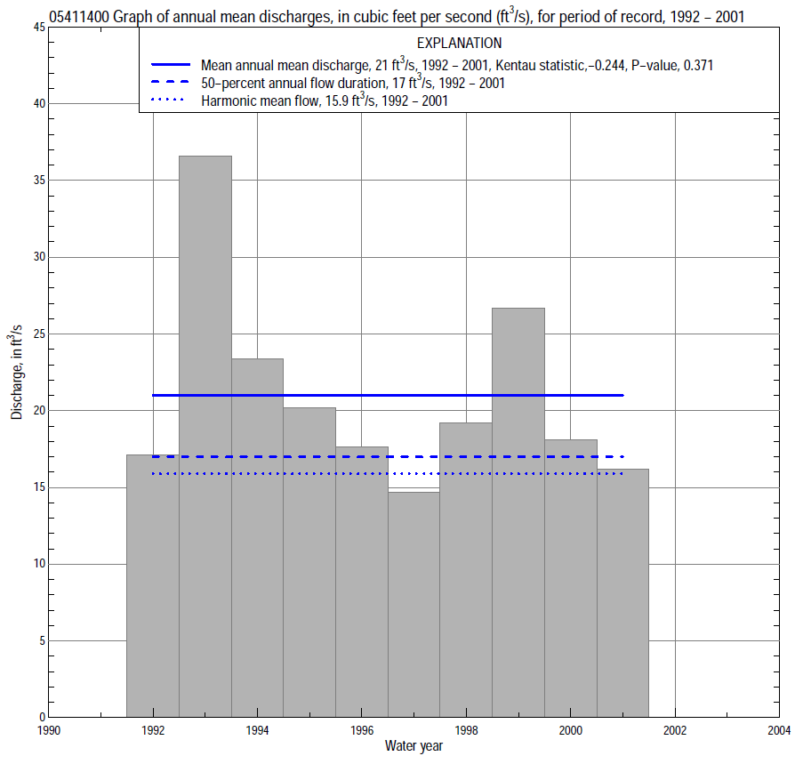

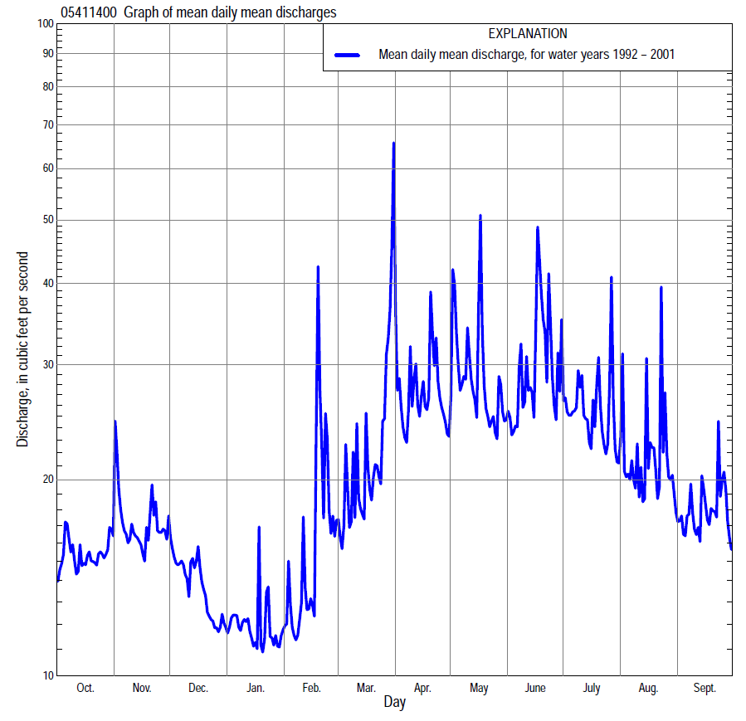

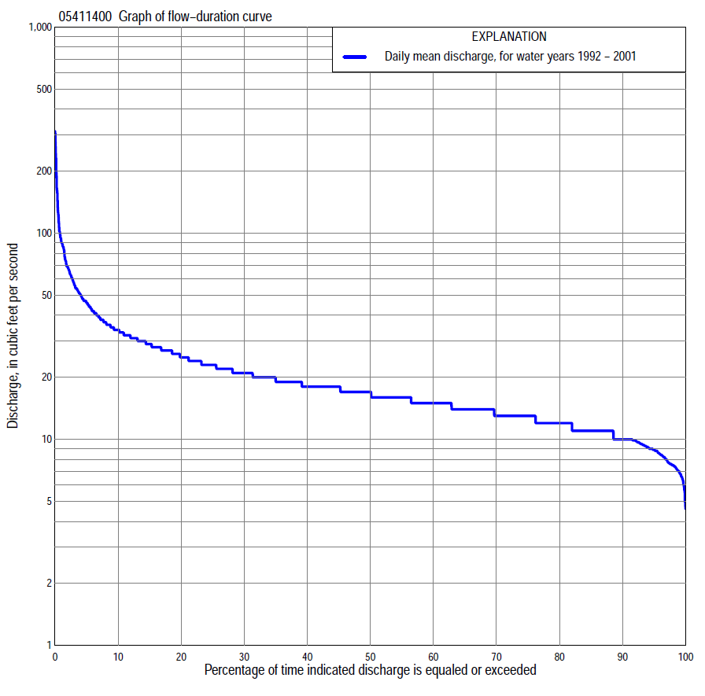
Statistics Based on the Entire Streamflow Period of Record
05411400 Monthly and annual flow durations, based on 1992–2001 period of record (10 years)
Percentage of days discharge equaled or exceeded |  |  |  |  | Discharge (cubic feet per second) |  |  |  |  |  |  |  |  | Annual flow durations
 | Oct | Nov | Dec | Jan | Feb | Mar | Apr | May | June | July | Aug | Sept | Annual | Kentau statistic | P-value
99 | 6.9 | 9.3 | 6.5 | 5.0 | 7.1 | 5.9 | 11 | 11 | 9.3 | 13 | 9.2 | 7.2 | 7.0 | -0.178 | 0.515
98 | 7.1 | 10 | 6.7 | 5.6 | 7.3 | 8.4 | 11 | 11 | 10 | 13 | 9.9 | 7.4 | 7.5 | -0.200 | 0.454
95 | 7.9 | 10 | 7.5 | 6.6 | 7.7 | 10 | 13 | 12 | 12 | 14 | 11 | 8.9 | 8.9 | -0.178 | 0.522
90 | 9.8 | 11 | 8.9 | 7.5 | 8.9 | 12 | 13 | 13 | 14 | 14 | 12 | 10 | 10 | -0.222 | 0.415
85 | 10 | 11 | 9.3 | 8.0 | 9.4 | 14 | 14 | 14 | 15 | 15 | 13 | 11 | 11 | -0.222 | 0.415
80 | 10 | 12 | 9.9 | 8.6 | 10 | 14 | 14 | 16 | 17 | 16 | 14 | 11 | 12 | -0.267 | 0.318
75 | 11 | 12 | 10 | 9.0 | 10 | 14 | 15 | 16 | 18 | 17 | 14 | 12 | 13 | -0.244 | 0.362
70 | 11 | 12 | 11 | 9.6 | 11 | 15 | 16 | 17 | 19 | 18 | 15 | 13 | 13 | -0.311 | 0.239
65 | 12 | 13 | 11 | 11 | 11 | 16 | 17 | 18 | 20 | 19 | 16 | 14 | 14 | -0.244 | 0.362
60 | 13 | 13 | 12 | 11 | 12 | 16 | 19 | 19 | 22 | 19 | 16 | 15 | 15 | -0.222 | 0.415
55 | 13 | 15 | 13 | 12 | 12 | 17 | 20 | 19 | 23 | 21 | 17 | 15 | 16 | -0.244 | 0.362
50 | 14 | 16 | 13 | 12 | 13 | 18 | 21 | 20 | 24 | 22 | 17 | 16 | 17 | -0.200 | 0.471
45 | 15 | 17 | 15 | 13 | 14 | 19 | 23 | 21 | 27 | 22 | 18 | 17 | 18 | -0.200 | 0.471
40 | 16 | 17 | 15 | 13 | 14 | 20 | 25 | 23 | 28 | 24 | 19 | 18 | 18 | -0.156 | 0.580
35 | 16 | 18 | 16 | 13 | 15 | 20 | 26 | 24 | 30 | 25 | 20 | 19 | 19 | -0.178 | 0.530
30 | 18 | 19 | 16 | 14 | 15 | 21 | 30 | 31 | 31 | 26 | 22 | 19 | 21 | -0.111 | 0.718
25 | 18 | 20 | 17 | 14 | 17 | 22 | 32 | 34 | 34 | 28 | 26 | 20 | 23 | -0.111 | 0.718
20 | 19 | 22 | 17 | 14 | 18 | 23 | 36 | 37 | 38 | 29 | 29 | 22 | 25 | -0.156 | 0.584
15 | 21 | 24 | 18 | 15 | 20 | 24 | 43 | 42 | 41 | 35 | 31 | 26 | 29 | -0.156 | 0.589
10 | 25 | 27 | 18 | 15 | 23 | 27 | 52 | 51 | 48 | 42 | 34 | 31 | 34 | -0.156 | 0.589
5 | 27 | 30 | 22 | 16 | 31 | 41 | 67 | 70 | 63 | 56 | 42 | 34 | 46 | -0.178 | 0.525
2 | 30 | 34 | 22 | 17 | 62 | 119 | 82 | 102 | 94 | 84 | 54 | 38 | 69 | -0.244 | 0.367
1 | 31 | 40 | 25 | 18 | 100 | 194 | 90 | 162 | 126 | 88 | 83 | 45 | 90 | -0.178 | 0.530

05411400 Annual exceedance probability of instantaneous peak discharges, in cubic feet per second (ft³/s), based on the Weighted Independent Estimates method,
Annual exceed-ance probability | Recur-rence interval (years) | Discharge (ft³/s) | 95-percent lower confi-dence interval (ft³/s) | 95-percent upper confi-dence interval (ft³/s)
0.500 | 2 | 664 | 481 | 918
0.200 | 5 | 1,210 | 886 | 1,650
0.100 | 10 | 1,710 | 1,230 | 2,370
0.040 | 25 | 2,470 | 1,720 | 3,540
0.020 | 50 | 2,990 | 2,010 | 4,420
0.010 | 100 | 3,610 | 2,360 | 5,520
0.005 | 200 | 4,290 | 2,720 | 6,780
0.002 | 500 | 5,060 | 3,050 | 8,410
and based on the expected moments algorithm/multiple Grubbs-Beck analysis computed using a historical period length of 10 years (1992–2001)
0.500 | 2 | 613 | 396 | 876
0.200 | 5 | 954 | 669 | 1,520
0.100 | 10 | 1,180 | 833 | 2,150
0.040 | 25 | 1,460 | 1,010 | 3,240
0.020 | 50 | 1,660 | 1,130 | 4,280
0.010 | 100 | 1,850 | 1,220 | 5,570
0.005 | 200 | 2,040 | 1,310 | 7,100
0.002 | 500 | 2,280 | 1,400 | 9,670
Kentau statistic |  | 0.067
P-value |  | 0.858
Begin year |  | 1992
End year |  | 2001
Number of peaks |  | 10

05411400 Annual exceedance probability of high discharges, based on 1992–2001 period of record (10 years)
Annual exceedance probability | Recur-rence interval (years) | Maximum average discharge (ft³/s) for indicated number of consecutive days
 |  | 1 | 3 | 7 | 15 |  | 30
0.990 | 1.01 | 57 | 38 | 26 |  | 22 |  | 21
0.950 | 1.05 | 79 | 50 | 34 |  | 27 |  | 24
0.900 | 1.11 | 94 | 58 | 39 |  | 30 |  | 26
0.800 | 1.25 | 115 | 71 | 47 |  | 35 |  | 29
0.500 | 2 | 172 | 106 | 68 |  | 48 |  | 38
0.200 | 5 | 256 | 163 | 105 |  | 70 |  | 54
0.100 | 10 | 314 | 207 | 134 |  | 87 |  | 66
0.040 | 25 | 392 | 269 | 178 |  | 112 |  | 85
0.020 | 50 | 452 | 321 | 214 |  | 134 |  | 102
0.010 | 100 | 513 | 377 | 255 |  | 157 |  | 120
0.005 | 200 | 577 | 438 | 301 |  | 183 |  | 142
0.002 | 500 | 664 | 527 | 370 |  | 223 |  | 174
Kentau statistic |  | -0.156 | -0.244 | -0.333 |  | -0.333 |  | -0.200
P-value |  | 0.592 | 0.371 | 0.211 |  | 0.211 |  | 0.474

(Annual nonexceedance probability of low discharges not determined because only 9 years of annual low-flow data were available for analysis.)

05411400 Annual nonexceedance probability of seasonal low discharges, based on October 1991 to September 2001 period of record (10 years)
Annual nonexceed-ance probability | Recur-rence interval (years) | Minimum average discharge (cubic feet per second) for indicated number of consecutive days
 |  | 1 | 7 | 14 | 30 |  | 1 | 7 | 14 | 30
 |  | January-February-March |  |  |  |  | April-May-June
0.01 | 100 | 3.5 | 4.0 | 4.4 | 5.3 |  | 8.7 | 8.8 | 8.9 | 9.4
0.02 | 50 | 4.0 | 4.5 | 5.0 | 5.8 |  | 9.0 | 9.1 | 9.3 | 10
0.05 | 20 | 4.8 | 5.4 | 5.8 | 6.8 |  | 9.5 | 9.7 | 10 | 11
0.10 | 10 | 5.6 | 6.2 | 6.7 | 7.7 |  | 9.9 | 11 | 11 | 12
0.20 | 5 | 6.7 | 7.3 | 7.8 | 8.8 |  | 11 | 12 | 13 | 14
0.50 | 2 | 8.9 | 10 | 10 | 11 |  | 13 | 15 | 17 | 19
0.80 | 1.25 | 11 | 12 | 13 | 14 |  | 19 | 23 | 24 | 28
0.90 | 1.11 | 12 | 14 | 14 | 15 |  | 24 | 29 | 31 | 36
0.96 | 1.04 | 13 | 15 | 16 | 16 |  | 33 | 39 | 40 | 47
0.98 | 1.02 | 14 | 16 | 17 | 17 |  | 41 | 48 | 49 | 57
0.99 | 1.01 | 15 | 17 | 18 | 18 |  | 51 | 58 | 59 | 69
Kentau statistic |  | -0.111 | -0.044 | -0.178 | -0.244 |  | -0.133 | -0.044 | -0.156 | 0.067
P-value |  | 0.718 | 0.928 | 0.530 | 0.371 |  | 0.642 | 0.928 | 0.592 | 0.858
 |  | July-August-September |  |  |  |  | October-November-December
0.01 | 100 | 5.8 | 7.0 | 7.1 | 8.4 |  | 4.8 | 5.3 | 5.8 | 6.6
0.02 | 50 | 6.1 | 7.2 | 7.4 | 8.7 |  | 5.2 | 5.7 | 6.2 | 7.0
0.05 | 20 | 6.6 | 7.7 | 8.1 | 9.3 |  | 5.8 | 6.4 | 6.8 | 7.7
0.10 | 10 | 7.2 | 8.3 | 8.7 | 10 |  | 6.4 | 7.1 | 7.5 | 8.4
0.20 | 5 | 8.2 | 9.2 | 10 | 11 |  | 7.2 | 8.0 | 8.4 | 9.4
0.50 | 2 | 11 | 12 | 13 | 14 |  | 8.9 | 10 | 11 | 12
0.80 | 1.25 | 16 | 17 | 19 | 20 |  | 11 | 13 | 13 | 15
0.90 | 1.11 | 21 | 22 | 23 | 24 |  | 12 | 14 | 15 | 17
0.96 | 1.04 | 28 | 29 | 30 | 31 |  | 14 | 16 | 18 | 20
0.98 | 1.02 | 34 | 35 | 36 | 37 |  | 15 | 17 | 19 | 22
0.99 | 1.01 | 42 | 42 | 43 | 44 |  | 16 | 19 | 21 | 24
Kentau statistic |  | 0.133 | 0.133 | 0.067 | 0.067 |  | -0.111 | -0.156 | -0.200 | -0.244
P-value |  | 0.653 | 0.653 | 0.858 | 0.858 |  | 0.718 | 0.592 | 0.474 | 0.371

