LOCATION.--Lat 43°03'15.16", long 91°48'32.18" referenced to North American Datum of 1927, in NW 1/4 SE 1/4 SE 1/4 sec.08, T.95 N., R.8 W., Fayette County, IA, Hydrologic Unit 07060004, on left bank 5 ft downstream from bridge on County Highway B40, 1.4 mi east of Eldorado, 3.6 mi downstream from confluence with Little Turkey River, 3.4 mi upstream from Dry Branch Creek, and 83.6 mi upstream from mouth.

DRAINAGE AREA.--641 mi².

PERIOD OF RECORD.--Discharge records from September 2000 to current year.

GAGE.--Water-stage recorder. Datum of gage is 890.00 ft above National Geodetic Vertical Datum of 1929.

EXTREMES OUTSIDE PERIOD OF RECORD.--Flood of June 15, 1991, reached a stage of 18.78 ft, discharge 17,600 ft³/s.

A summary of all available data for this streamgage is provided through the USGS National Water Information System web interface (NWISWeb). The following link provides access to current/historical observations, daily data, daily statistics, monthly statistics, annual statistics, peak streamflow, field measurements, field/lab water-quality samples, and the latest water-year summaries. Data can be filtered by parameter and/or dates, and can be output in various tabular and graphical formats.
http://waterdata.usgs.gov/nwis/inventory/?site_no=05411850

The USGS WaterWatch Toolkit is available at:
http://waterwatch.usgs.gov/?id=ww_toolkit
Tools for summarizing streamflow information include the duration hydrograph builder, the cumulative streamflow hydrograph builder, the streamgage statistics retrieval tool, the rating curve builder, the flood tracking chart builder, the National Weather Service Advanced Hydrologic Prediction Service (AHPS) river forecast hydrograph builder, and the raster-hydrograph builder. Entering the above number for this streamgage into these toolkit webpages will provide streamflow information specific to this streamgage.

A description of the statistics presented for this streamgage is available in the main body of the report at:
http://dx.doi.org/10.3133/ofr20151214
A link to other streamgages included in this report, a map showing the location of the streamgages, information on the programs used to compute the statistical analyses, and references are included in the main body of the report.

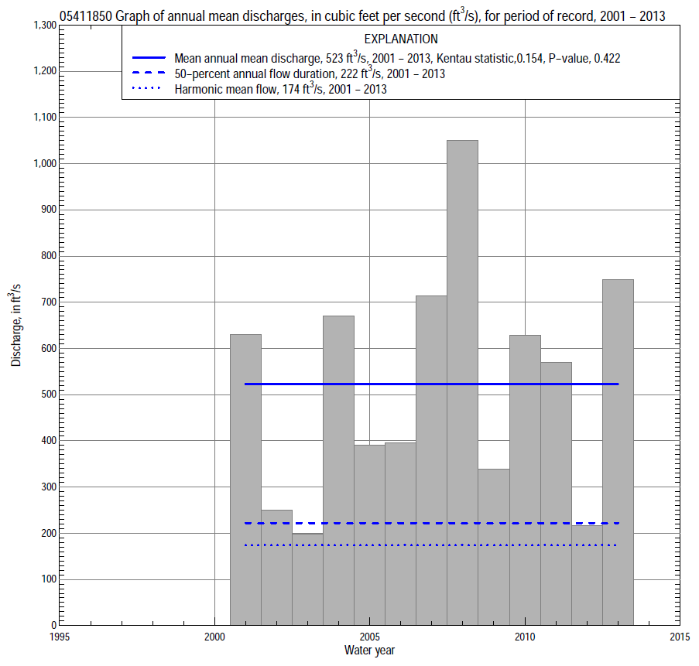

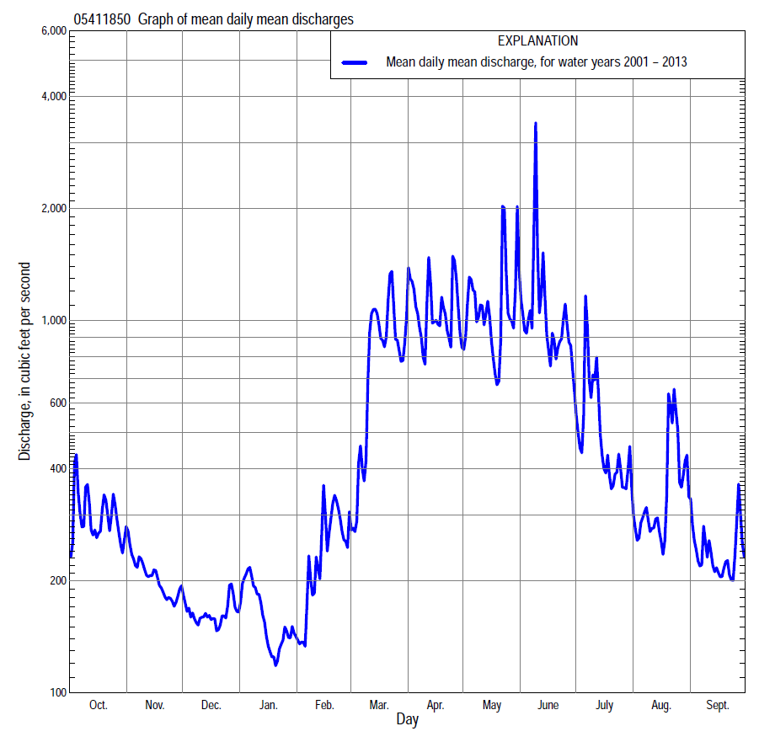

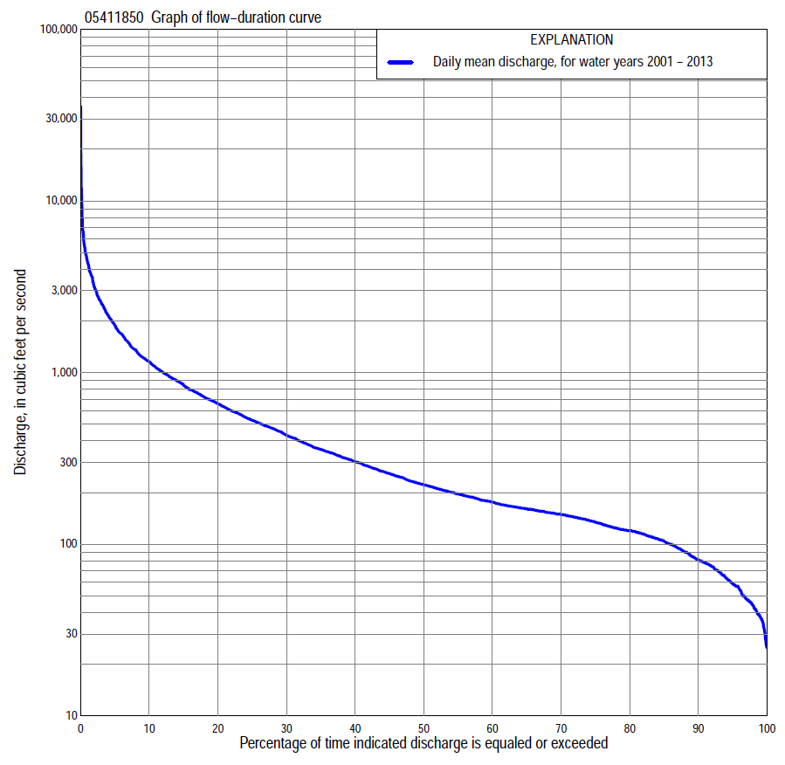

Statistics Based on the Entire Streamflow Period of Record
05411850 Monthly and annual flow durations, based on 2001–2013 period of record (13 years)
Percentage of days discharge equaled or exceeded |  |  |  |  | Discharge (cubic feet per second) |  |  |  |  |  |  |  |  | Annual flow durations
 | Oct | Nov | Dec | Jan | Feb | Mar | Apr | May | June | July | Aug | Sept | Annual | Kentau statistic | P-value
99 | 47 | 61 | 42 | 26 | 31 | 42 | 130 | 202 | 159 | 81 | 59 | 48 | 38 | 0.026 | 0.951
98 | 48 | 63 | 43 | 27 | 32 | 46 | 146 | 244 | 178 | 84 | 63 | 49 | 44 | 0.026 | 0.951
95 | 57 | 68 | 46 | 36 | 37 | 92 | 156 | 287 | 213 | 97 | 69 | 52 | 59 | -0.026 | 0.951
90 | 62 | 75 | 66 | 42 | 45 | 153 | 176 | 336 | 266 | 129 | 81 | 61 | 81 | -0.051 | 0.855
85 | 95 | 88 | 76 | 50 | 72 | 172 | 206 | 390 | 320 | 146 | 127 | 71 | 104 | 0.000 | 1.000
80 | 105 | 101 | 82 | 66 | 85 | 190 | 275 | 451 | 348 | 162 | 141 | 112 | 120 | 0.038 | 0.903
75 | 109 | 107 | 92 | 78 | 96 | 204 | 321 | 491 | 388 | 176 | 144 | 119 | 134 | 0.026 | 0.951
70 | 116 | 115 | 110 | 84 | 108 | 221 | 385 | 538 | 419 | 192 | 150 | 122 | 149 | 0.000 | 1.000
65 | 122 | 120 | 120 | 94 | 122 | 234 | 471 | 580 | 459 | 208 | 160 | 126 | 161 | 0.000 | 1.000
60 | 126 | 132 | 133 | 102 | 136 | 256 | 526 | 634 | 497 | 245 | 176 | 133 | 176 | 0.051 | 0.855
55 | 144 | 149 | 144 | 112 | 145 | 284 | 591 | 683 | 530 | 276 | 193 | 139 | 197 | 0.179 | 0.428
50 | 150 | 155 | 155 | 119 | 151 | 340 | 661 | 732 | 591 | 310 | 215 | 151 | 222 | 0.308 | 0.161
45 | 159 | 171 | 161 | 128 | 161 | 409 | 716 | 813 | 652 | 341 | 230 | 157 | 258 | 0.308 | 0.161
40 | 164 | 182 | 170 | 135 | 170 | 481 | 795 | 899 | 731 | 376 | 254 | 163 | 303 | 0.359 | 0.100
35 | 175 | 197 | 183 | 145 | 182 | 622 | 913 | 966 | 797 | 414 | 269 | 168 | 357 | 0.333 | 0.127
30 | 203 | 214 | 197 | 155 | 200 | 778 | 1,060 | 1,040 | 928 | 492 | 298 | 181 | 432 | 0.256 | 0.246
25 | 251 | 226 | 213 | 180 | 219 | 908 | 1,220 | 1,140 | 1,090 | 570 | 327 | 205 | 528 | 0.179 | 0.428
20 | 297 | 297 | 223 | 206 | 249 | 1,160 | 1,450 | 1,290 | 1,280 | 658 | 360 | 254 | 660 | 0.179 | 0.428
15 | 360 | 345 | 250 | 277 | 275 | 1,600 | 1,960 | 1,550 | 1,600 | 789 | 436 | 348 | 844 | 0.167 | 0.463
10 | 705 | 399 | 276 | 355 | 361 | 2,000 | 2,580 | 1,890 | 2,090 | 1,020 | 529 | 510 | 1,160 | 0.179 | 0.428
5 | 1,390 | 503 | 311 | 450 | 800 | 3,000 | 3,800 | 2,870 | 3,060 | 1,390 | 644 | 916 | 1,880 | 0.179 | 0.428
2 | 2,060 | 626 | 406 | 597 | 1,600 | 4,140 | 4,810 | 4,690 | 4,890 | 2,210 | 2,780 | 1,200 | 3,150 | 0.077 | 0.760
1 | 2,460 | 754 | 467 | 717 | 2,070 | 4,720 | 5,720 | 6,720 | 6,840 | 3,790 | 4,370 | 1,330 | 4,400 | 0.051 | 0.855

05411850 Annual exceedance probability of instantaneous peak discharges, in cubic feet per second (ft³/s), based on the Weighted Independent Estimates method,
Annual exceed-ance probability | Recur-rence interval (years) | Discharge (ft³/s) | 95-percent lower confi-dence interval (ft³/s) | 95-percent upper confi-dence interval (ft³/s)
0.500 | 2 | 6,080 | 5,210 | 7,110
0.200 | 5 | 11,900 | 10,200 | 13,900
0.100 | 10 | 16,500 | 13,900 | 19,500
0.040 | 25 | 22,700 | 18,500 | 27,900
0.020 | 50 | 27,400 | 21,600 | 34,800
0.010 | 100 | 32,300 | 24,400 | 42,600
0.005 | 200 | 37,200 | 27,100 | 51,000
0.002 | 500 | 43,600 | 30,100 | 63,200
and based on the expected moments algorithm/multiple Grubbs-Beck analysis computed using a historical period length of 124 years (1890–2013)
0.500 | 2 | 6,060 | 3,610 | 9,410
0.200 | 5 | 11,900 | 7,580 | 18,200
0.100 | 10 | 16,500 | 10,400 | 25,100
0.040 | 25 | 23,000 | 14,000 | 35,600
0.020 | 50 | 28,200 | 16,800 | 45,100
0.010 | 100 | 33,600 | 19,600 | 56,600
0.005 | 200 | 39,300 | 22,400 | 70,700
0.002 | 500 | 47,200 | 26,000 | 94,300
Kentau statistic |  | 0.141
P-value |  | 0.541
Begin year |  | 2001
End year |  | 2013
Number of peaks |  | 13

05411850 Annual exceedance probability of high discharges, based on 2001–2013 period of record (13 years)
[ND, not determined]
Annual exceed-ance probability | Recur-rence interval (years) | Maximum average discharge (ft³/s) for indicated number of consecutive days
 |  | 1 | 3 | 7 | 15 | 30
0.990 | 1.01 | ND | ND | 565 | 425 | 344
0.950 | 1.05 | ND | ND | 875 | 667 | 537
0.900 | 1.11 | ND | ND | 1,120 | 853 | 682
0.800 | 1.25 | ND | ND | 1,530 | 1,160 | 910
0.500 | 2 | ND | ND | 2,870 | 2,110 | 1,590
0.200 | 5 | ND | ND | 5,680 | 3,960 | 2,770
0.100 | 10 | ND | ND | 8,290 | 5,550 | 3,720
0.040 | 25 | ND | ND | 12,600 | 8,020 | 5,090
0.020 | 50 | ND | ND | 16,700 | 10,200 | 6,230
0.010 | 100 | ND | ND | 21,600 | 12,800 | 7,480
0.005 | 200 | ND | ND | 27,400 | 15,700 | 8,850
0.002 | 500 | ND | ND | 36,900 | 20,100 | 10,800
Kentau statistic |  | 0.051 | 0.154 | 0.128 | 0.051 | 0.179
P-value |  | 0.855 | 0.502 | 0.583 | 0.855 | 0.428

 | 05411850 Annual nonexceedance probability of low discharges, based on April 2001 to March 2013 period of record (12 years)
Annual nonexceed-ance probability | Recur-rence interval (years) | Minimum average discharge (cubic feet per second) for indicated number of consecutive days
 |  | 1 | 3 | 7 | 14 | 30 | 60 | 90 | 120 | 183
0.01 | 100 | 15 | 15 | 16 | 17 | 17 | 22 | 29 | 33 | 34
0.02 | 50 | 19 | 19 | 20 | 21 | 22 | 27 | 35 | 40 | 40
0.05 | 20 | 26 | 26 | 28 | 30 | 32 | 37 | 46 | 51 | 53
0.10 | 10 | 33 | 35 | 36 | 39 | 42 | 49 | 59 | 64 | 68
0.20 | 5 | 44 | 47 | 50 | 54 | 58 | 67 | 78 | 84 | 92
0.50 | 2 | 73 | 78 | 83 | 89 | 100 | 116 | 128 | 136 | 163
0.80 | 1.25 | 109 | 119 | 128 | 135 | 156 | 189 | 203 | 216 | 288
0.90 | 1.11 | 131 | 143 | 155 | 161 | 190 | 237 | 253 | 273 | 388
0.96 | 1.04 | 156 | 171 | 186 | 189 | 229 | 298 | 317 | 346 | 532
0.98 | 1.02 | 173 | 189 | 206 | 208 | 255 | 341 | 364 | 403 | 652
0.99 | 1.01 | 188 | 206 | 224 | 225 | 278 | 383 | 410 | 460 | 783
Kentau statistic |  | 0.030 | 0.030 | 0.030 | 0.061 | 0.121 | 0.121 | 0.000 | 0.030 | 0.000
P-value |  | 0.945 | 0.945 | 0.945 | 0.837 | 0.631 | 0.631 | 1.000 | 0.945 | 1.000

05411850 Annual nonexceedance probability of seasonal low discharges, based on October 2000 to September 2013 period of record (13 years)
Annual nonexceed-ance probability | Recur-rence interval (years) | Minimum average discharge (cubic feet per second) for indicated number of consecutive days
 |  | 1 | 7 | 14 | 30 |  | 1 | 7 | 14 | 30
 |  | January-February-March |  |  |  |  | April-May-June
0.01 | 100 | 16 | 16 | 17 | 19 |  | 80 | 81 | 98 | 187
0.02 | 50 | 20 | 20 | 22 | 24 |  | 92 | 94 | 111 | 201
0.05 | 20 | 27 | 29 | 31 | 34 |  | 113 | 117 | 135 | 228
0.10 | 10 | 34 | 38 | 41 | 45 |  | 136 | 143 | 162 | 257
0.20 | 5 | 45 | 52 | 57 | 62 |  | 170 | 182 | 204 | 304
0.50 | 2 | 74 | 87 | 94 | 106 |  | 263 | 290 | 330 | 447
0.80 | 1.25 | 111 | 132 | 142 | 164 |  | 411 | 468 | 560 | 719
0.90 | 1.11 | 133 | 159 | 170 | 198 |  | 522 | 603 | 752 | 956
0.96 | 1.04 | 159 | 189 | 199 | 236 |  | 674 | 792 | 1,050 | 1,340
0.98 | 1.02 | 176 | 208 | 218 | 262 |  | 796 | 947 | 1,310 | 1,690
0.99 | 1.01 | 192 | 225 | 235 | 284 |  | 926 | 1,110 | 1,600 | 2,100
Kentau statistic |  | 0.077 | 0.026 | 0.026 | 0.077 |  | 0.256 | 0.308 | 0.205 | 0.256
P-value |  | 0.760 | 0.951 | 0.951 | 0.760 |  | 0.246 | 0.161 | 0.360 | 0.246
 |  | July-August-September |  |  |  |  | October-November-December
0.01 | 100 | 34 | 35 | 35 | 37 |  | 22 | 28 | 30 | 38
0.02 | 50 | 40 | 42 | 43 | 45 |  | 27 | 33 | 36 | 45
0.05 | 20 | 52 | 54 | 56 | 58 |  | 37 | 42 | 46 | 56
0.10 | 10 | 64 | 67 | 70 | 73 |  | 47 | 52 | 57 | 67
0.20 | 5 | 80 | 85 | 89 | 96 |  | 61 | 67 | 74 | 84
0.50 | 2 | 119 | 125 | 133 | 153 |  | 96 | 104 | 113 | 126
0.80 | 1.25 | 164 | 171 | 182 | 233 |  | 137 | 150 | 164 | 183
0.90 | 1.11 | 189 | 196 | 209 | 284 |  | 160 | 178 | 196 | 220
0.96 | 1.04 | 217 | 222 | 237 | 346 |  | 185 | 208 | 232 | 265
0.98 | 1.02 | 234 | 238 | 254 | 391 |  | 201 | 228 | 256 | 297
0.99 | 1.01 | 250 | 252 | 268 | 434 |  | 215 | 247 | 279 | 329
Kentau statistic |  | -0.154 | -0.128 | -0.154 | 0.038 |  | 0.077 | 0.077 | 0.103 | 0.077
P-value |  | 0.502 | 0.583 | 0.502 | 0.903 |  | 0.760 | 0.760 | 0.669 | 0.760

