LOCATION.--Lat 42°51'17", long 91°24'13" referenced to North American Datum of 1927, in sec.23, T.93 N., R.5 W., Clayton County, IA, Hydrologic Unit 07060004, in tailrace of power plant in Elkader, and 2.7 mi upstream from Roberts Creek.

DRAINAGE AREA.--891 mi².

PERIOD OF RECORD.--Discharge records from July 1933 to September 1942. Prior to July 1, 1933, discharge records furnished by Central States Power and Light Corporation.

GAGE.--Non-recording gage. Datum of gage is 701.61 ft above North American Vertical Datum of 1929.

COOPERATION.--Gage-height records provided by Central Sates Power and Light Corporation.

REMARKS.--Flow regulated by power plant at site.

EXTREMES OUTSIDE PERIOD OF RECORD.--Flood of June 1916 reached a stage of 34.30 ft, from floodmark, discharge about 30,000 ft³/s.

A summary of all available data for this streamgage is provided through the USGS National Water Information System web interface (NWISWeb). The following link provides access to current/historical observations, daily data, daily statistics, monthly statistics, annual statistics, peak streamflow, field measurements, field/lab water-quality samples, and the latest water-year summaries. Data can be filtered by parameter and/or dates, and can be output in various tabular and graphical formats.
http://waterdata.usgs.gov/nwis/inventory/?site_no=05412000

The USGS WaterWatch Toolkit is available at:
http://waterwatch.usgs.gov/?id=ww_toolkit
Tools for summarizing streamflow information include the duration hydrograph builder, the cumulative streamflow hydrograph builder, the streamgage statistics retrieval tool, the rating curve builder, the flood tracking chart builder, the National Weather Service Advanced Hydrologic Prediction Service (AHPS) river forecast hydrograph builder, and the raster-hydrograph builder. Entering the above number for this streamgage into these toolkit webpages will provide streamflow information specific to this streamgage.

A description of the statistics presented for this streamgage is available in the main body of the report at:
http://dx.doi.org/10.3133/ofr20151214
A link to other streamgages included in this report, a map showing the location of the streamgages, information on the programs used to compute the statistical analyses, and references are included in the main body of the report.

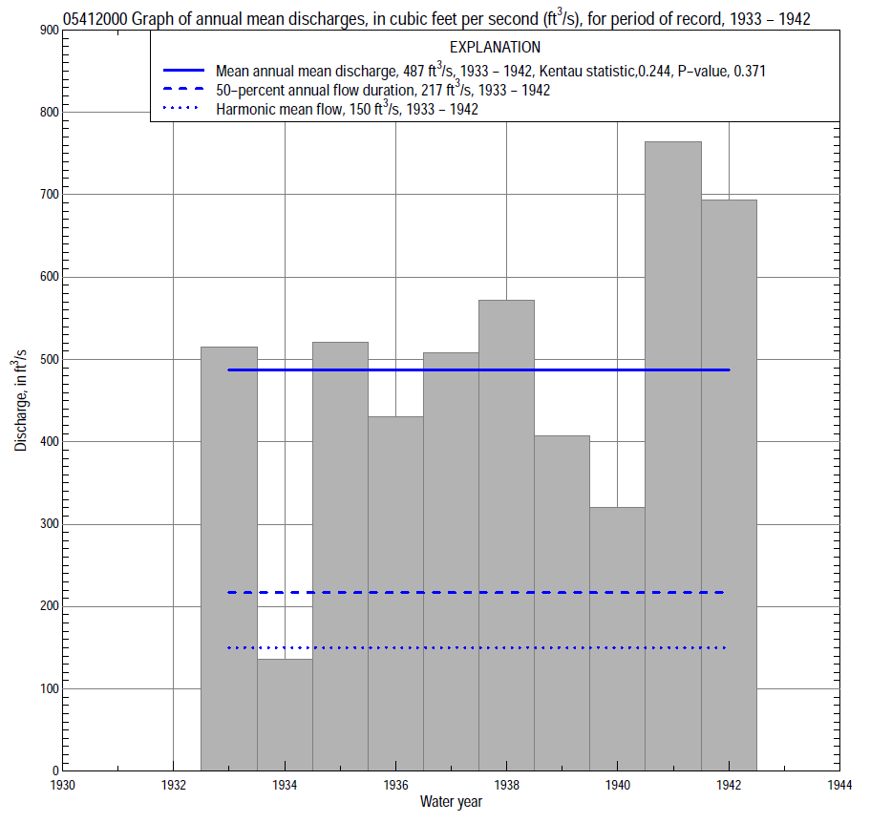

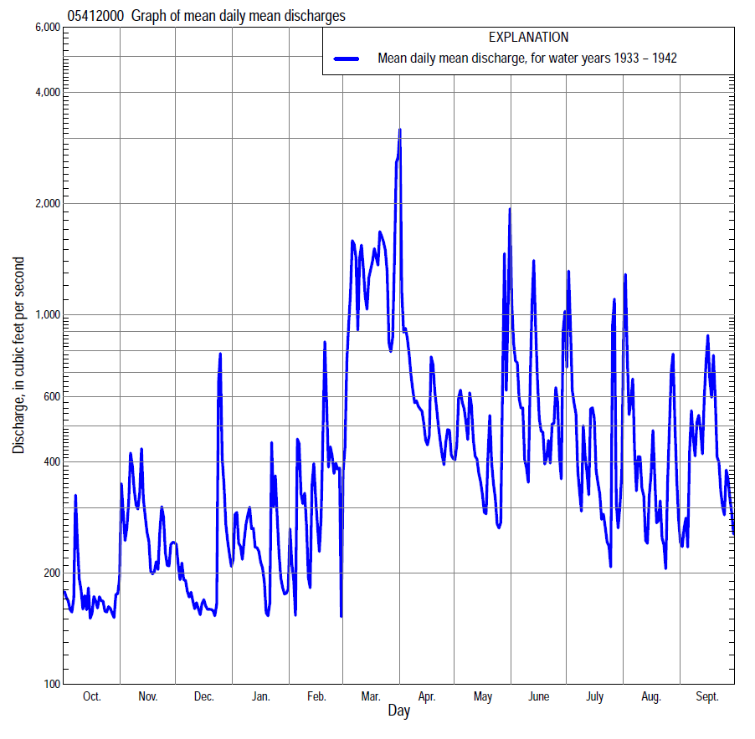

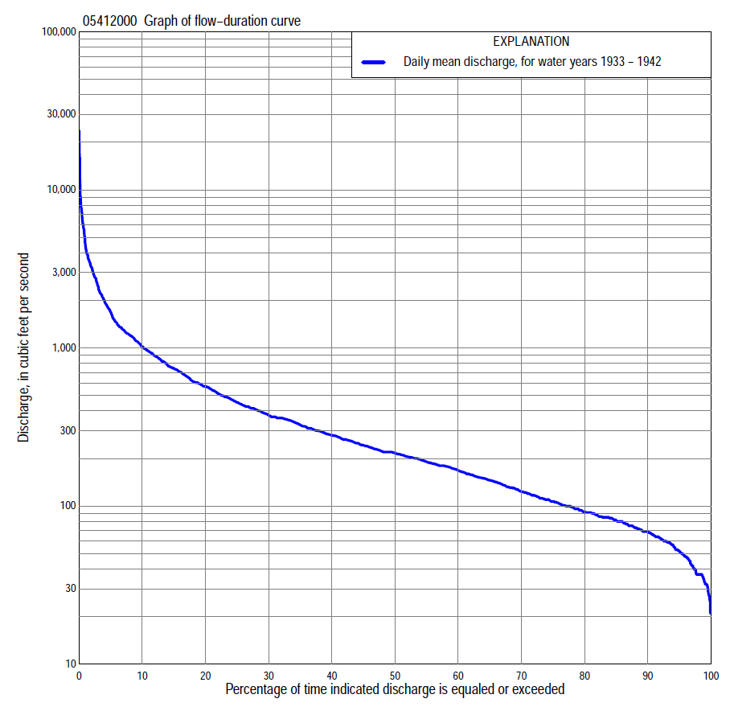

Statistics Based on the Entire Streamflow Period of Record
05412000 Monthly and annual flow durations, based on 1933–42 period of record (10 years)
Percentage of days discharge equaled or exceeded |  |  |  |  | Discharge (cubic feet per second) |  |  |  |  |  |  |  |  | Annual flow durations
 | Oct | Nov | Dec | Jan | Feb | Mar | Apr | May | June | July | Aug | Sept | Annual | Kentau statistic | P-value
99 | 60 | 46 | 34 | 21 | 32 | 64 | 93 | 33 | 25 | 30 | 36 | 53 | 33 | 0.200 | 0.474
98 | 64 | 57 | 36 | 27 | 32 | 69 | 110 | 49 | 30 | 35 | 40 | 60 | 37 | 0.244 | 0.371
95 | 71 | 64 | 42 | 37 | 37 | 82 | 154 | 67 | 43 | 52 | 47 | 63 | 52 | 0.244 | 0.371
90 | 80 | 72 | 56 | 37 | 48 | 96 | 207 | 98 | 69 | 64 | 57 | 71 | 69 | 0.244 | 0.371
85 | 85 | 80 | 64 | 51 | 53 | 145 | 264 | 132 | 91 | 73 | 77 | 77 | 81 | 0.333 | 0.210
80 | 91 | 86 | 68 | 65 | 67 | 182 | 285 | 174 | 130 | 82 | 91 | 84 | 92 | 0.378 | 0.152
75 | 99 | 91 | 80 | 84 | 86 | 239 | 311 | 194 | 150 | 106 | 101 | 87 | 107 | 0.333 | 0.210
70 | 102 | 101 | 85 | 100 | 100 | 311 | 346 | 238 | 178 | 139 | 117 | 92 | 124 | 0.333 | 0.210
65 | 110 | 121 | 94 | 107 | 128 | 376 | 383 | 260 | 206 | 166 | 128 | 102 | 146 | 0.467 | 0.074
60 | 116 | 132 | 105 | 115 | 153 | 449 | 426 | 273 | 220 | 184 | 140 | 117 | 168 | 0.422 | 0.107
55 | 125 | 150 | 114 | 122 | 173 | 528 | 452 | 297 | 233 | 203 | 155 | 132 | 190 | 0.422 | 0.107
50 | 136 | 160 | 140 | 142 | 185 | 652 | 491 | 324 | 279 | 227 | 180 | 148 | 217 | 0.422 | 0.107
45 | 151 | 178 | 164 | 160 | 200 | 767 | 517 | 358 | 309 | 244 | 203 | 180 | 242 | 0.378 | 0.152
40 | 165 | 193 | 189 | 186 | 236 | 954 | 564 | 381 | 349 | 260 | 220 | 215 | 281 | 0.511 | 0.049
35 | 177 | 207 | 205 | 213 | 272 | 1,090 | 588 | 413 | 415 | 301 | 227 | 250 | 327 | 0.467 | 0.074
30 | 188 | 238 | 235 | 230 | 320 | 1,240 | 674 | 442 | 510 | 354 | 285 | 332 | 375 | 0.378 | 0.152
25 | 201 | 294 | 259 | 260 | 361 | 1,400 | 753 | 486 | 603 | 434 | 385 | 415 | 453 | 0.422 | 0.107
20 | 211 | 338 | 282 | 305 | 431 | 1,910 | 872 | 557 | 754 | 528 | 574 | 597 | 571 | 0.378 | 0.152
15 | 248 | 426 | 360 | 350 | 578 | 2,450 | 994 | 657 | 983 | 710 | 673 | 747 | 743 | 0.378 | 0.152
10 | 333 | 610 | 390 | 598 | 757 | 3,240 | 1,160 | 807 | 1,340 | 949 | 1,020 | 1,050 | 1,020 | 0.356 | 0.178
5 | 373 | 1,020 | 462 | 886 | 1,350 | 4,420 | 1,470 | 1,310 | 2,220 | 1,750 | 1,860 | 2,110 | 1,680 | 0.400 | 0.127
2 | 491 | 1,360 | 990 | 1,110 | 1,960 | 6,700 | 1,950 | 2,690 | 4,620 | 3,460 | 3,510 | 2,860 | 3,200 | 0.156 | 0.592
1 | 537 | 1,850 | 1,330 | 1,370 | 2,780 | 9,280 | 2,470 | 3,900 | 6,470 | 4,220 | 5,030 | 3,610 | 4,340 | 0.156 | 0.592

05412000 Annual exceedance probability of instantaneous peak discharges, in cubic feet per second (ft³/s), based on the Weighted Independent Estimates method,
Annual exceed-ance probability | Recur-rence interval (years) | Discharge (ft³/s) | 95-percent lower confi-dence interval (ft³/s) | 95-percent upper confi-dence interval (ft³/s)
0.500 | 2 | 8,560 | 7,450 | 9,850
0.200 | 5 | 15,500 | 13,600 | 17,800
0.100 | 10 | 20,600 | 17,700 | 23,900
0.040 | 25 | 27,100 | 22,600 | 32,500
0.020 | 50 | 31,700 | 25,600 | 39,300
0.010 | 100 | 36,400 | 28,300 | 46,700
0.005 | 200 | 40,900 | 30,700 | 54,400
0.002 | 500 | 46,700 | 33,400 | 65,400
and based on the expected moments algorithm/multiple Grubbs-Beck analysis computed using a historical period length of 124 years (1890–2013)ª
0.500 | 2 | 8,580 | 6,150 | 11,300
0.200 | 5 | 15,700 | 11,800 | 19,900
0.100 | 10 | 20,900 | 15,800 | 26,400
0.040 | 25 | 28,000 | 20,900 | 36,300
0.020 | 50 | 33,400 | 24,700 | 45,500
0.010 | 100 | 39,000 | 28,300 | 56,500
0.005 | 200 | 44,600 | 31,600 | 69,600
0.002 | 500 | 52,200 | 35,600 | 90,500
Kentau statistic |  | 0.389
P-value |  | 0.175
Begin year |  | 1934
End year |  | 1942
Number of peaks |  | 9
ªAnalysis includes interval annual-peak discharges (1991, 2002–13) from streamgage 05412020 Turkey River above French Hollow Creek at Elkader.

05412000 Annual exceedance probability of high discharges, based on 1933–1942 period of record (10 years)
[ND, not determined]
Annual exceedance probability | Recur-rence interval (years) | Maximum average discharge (ft³/s) for indicated number of consecutive days
 |  | 1 | 3 | 7 | 15 | 30
0.990 | 1.01 | ND | 909 | 704 | 341 | 189
0.950 | 1.05 | ND | 1,590 | 1,220 | 780 | 492
0.900 | 1.11 | ND | 2,120 | 1,620 | 1,130 | 751
0.800 | 1.25 | ND | 3,000 | 2,230 | 1,680 | 1,160
0.500 | 2 | ND | 5,680 | 3,970 | 3,030 | 2,120
0.200 | 5 | ND | 10,500 | 6,680 | 4,460 | 3,010
0.100 | 10 | ND | 14,200 | 8,580 | 5,110 | 3,340
0.040 | 25 | ND | 19,600 | 11,000 | 5,670 | 3,580
0.020 | 50 | ND | 24,100 | 12,900 | 5,950 | 3,680
0.010 | 100 | ND | 28,800 | 14,700 | 6,150 | 3,730
0.005 | 200 | ND | 33,900 | 16,500 | 6,290 | 3,770
0.002 | 500 | ND | 41,100 | 19,000 | 6,420 | 3,800
Kentau statistic |  | 0.156 | 0.111 | 0.067 | -0.067 | -0.067
P-value |  | 0.592 | 0.721 | 0.858 | 0.858 | 0.858

(Annual nonexceedance probability of low discharges not determined because only 9 years of annual low-flow data were available for analysis.)

05412000 Annual nonexceedance probability of seasonal low discharges, based on October 1932 to September 1942 period of record (10 years)
Annual nonexceed-ance probability | Recur-rence interval (years) | Minimum average discharge (cubic feet per second) for indicated number of consecutive days
 |  | 1 | 7 | 14 | 30 |  | 1 | 7 | 14 | 30
 |  | January-February-March |  |  |  |  | April-May-June
0.01 | 100 | 10 | 14 | 15 | 17 |  | 11 | 16 | 20 | 23
0.02 | 50 | 13 | 18 | 19 | 22 |  | 17 | 23 | 29 | 34
0.05 | 20 | 19 | 25 | 27 | 33 |  | 30 | 39 | 47 | 56
0.10 | 10 | 27 | 34 | 37 | 47 |  | 47 | 60 | 69 | 84
0.20 | 5 | 39 | 48 | 52 | 69 |  | 75 | 93 | 105 | 129
0.50 | 2 | 74 | 87 | 95 | 134 |  | 154 | 182 | 203 | 255
0.80 | 1.25 | 128 | 147 | 160 | 233 |  | 250 | 292 | 329 | 417
0.90 | 1.11 | 165 | 188 | 205 | 300 |  | 298 | 348 | 398 | 504
0.96 | 1.04 | 211 | 239 | 260 | 382 |  | 342 | 402 | 468 | 590
0.98 | 1.02 | 245 | 277 | 300 | 441 |  | 365 | 431 | 510 | 640
0.99 | 1.01 | 277 | 313 | 338 | 497 |  | 382 | 454 | 544 | 680
Kentau statistic |  | -0.022 | 0.022 | -0.022 | 0.111 |  | 0.067 | 0.022 | 0.022 | 0.200
P-value |  | 1.000 | 1.000 | 1.000 | 0.721 |  | 0.858 | 1.000 | 1.000 | 0.474
 |  | July-August-September |  |  |  |  | October-November-December
0.01 | 100 | 24 | 34 | 37 | 40 |  | 18 | 21 | 28 | 32
0.02 | 50 | 25 | 35 | 38 | 41 |  | 21 | 25 | 33 | 38
0.05 | 20 | 27 | 38 | 42 | 45 |  | 27 | 34 | 42 | 48
0.10 | 10 | 31 | 42 | 48 | 56 |  | 34 | 43 | 51 | 59
0.20 | 5 | 37 | 50 | 57 | 75 |  | 44 | 58 | 65 | 76
0.50 | 2 | 60 | 79 | 93 | 144 |  | 70 | 95 | 103 | 121
0.80 | 1.25 | 124 | 162 | 188 | 313 |  | 107 | 148 | 161 | 192
0.90 | 1.11 | 202 | 262 | 300 | 494 |  | 132 | 183 | 202 | 242
0.96 | 1.04 | 369 | 479 | 531 | 838 |  | 163 | 226 | 258 | 310
0.98 | 1.02 | 572 | 743 | 803 | 1210 |  | 187 | 257 | 301 | 363
0.99 | 1.01 | 876 | 1140 | 1200 | 1700 |  | 209 | 287 | 345 | 418
Kentau statistic |  | 0.267 | 0.422 | 0.511 | 0.511 |  | 0.244 | 0.244 | 0.244 | 0.244
P-value |  | 0.323 | 0.107 | 0.049 | 0.049 |  | 0.371 | 0.371 | 0.371 | 0.371

