LOCATION.--Lat 42°50'36.6", long 91°24'04.1" referenced to North American Datum of 1927, in NW 1/4 SE 1/4 NW 1/4 sec.26, T.93 N., R.5 W., Clayton County, IA, Hydrologic Unit 07060004, on left bank 5 ft downstream from bridge on State Highway 13 in Elkader, 100 ft upstream from French Hollow Creek, and 39.1 mi upstream from mouth.

DRAINAGE AREA.--903 mi².

PERIOD OF RECORD.--Discharge records from August 2001 to current year.

GAGE.--Water-stage recorder. Datum of gage is 694.93 ft above National Geodetic Vertical Datum of 1929.

EXTREMES OUTSIDE PERIOD OF RECORD.--Flood of June 15, 1991, reached a stage of 27.32 ft, discharge 38,300 ft³/s.

A summary of all available data for this streamgage is provided through the USGS National Water Information System web interface (NWISWeb). The following link provides access to current/historical observations, daily data, daily statistics, monthly statistics, annual statistics, peak streamflow, field measurements, field/lab water-quality samples, and the latest water-year summaries. Data can be filtered by parameter and/or dates, and can be output in various tabular and graphical formats.
http://waterdata.usgs.gov/nwis/inventory/?site_no=05412020

The USGS WaterWatch Toolkit is available at:
http://waterwatch.usgs.gov/?id=ww_toolkit
Tools for summarizing streamflow information include the duration hydrograph builder, the cumulative streamflow hydrograph builder, the streamgage statistics retrieval tool, the rating curve builder, the flood tracking chart builder, the National Weather Service Advanced Hydrologic Prediction Service (AHPS) river forecast hydrograph builder, and the raster-hydrograph builder. Entering the above number for this streamgage into these toolkit webpages will provide streamflow information specific to this streamgage.

A description of the statistics presented for this streamgage is available in the main body of the report at:
http://dx.doi.org/10.3133/ofr20151214
A link to other streamgages included in this report, a map showing the location of the streamgages, information on the programs used to compute the statistical analyses, and references are included in the main body of the report.

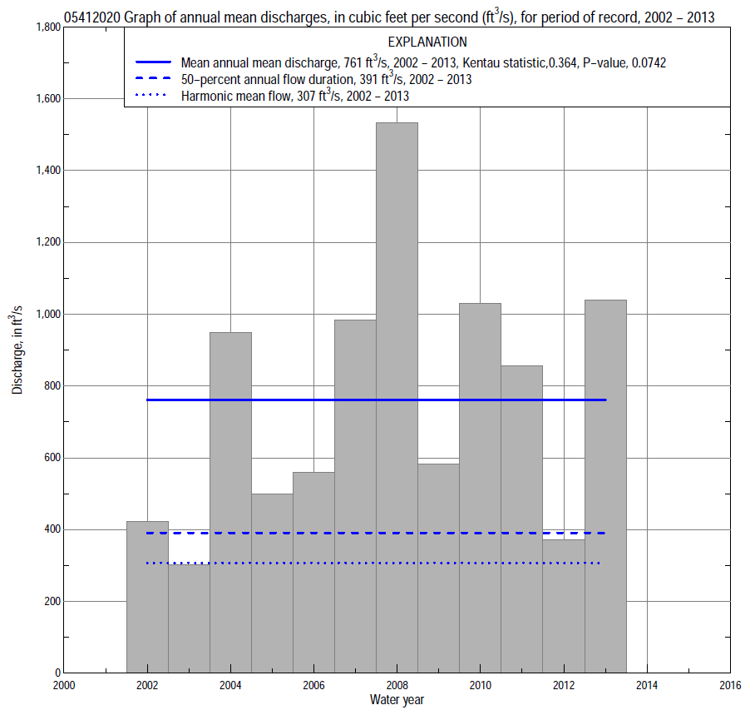

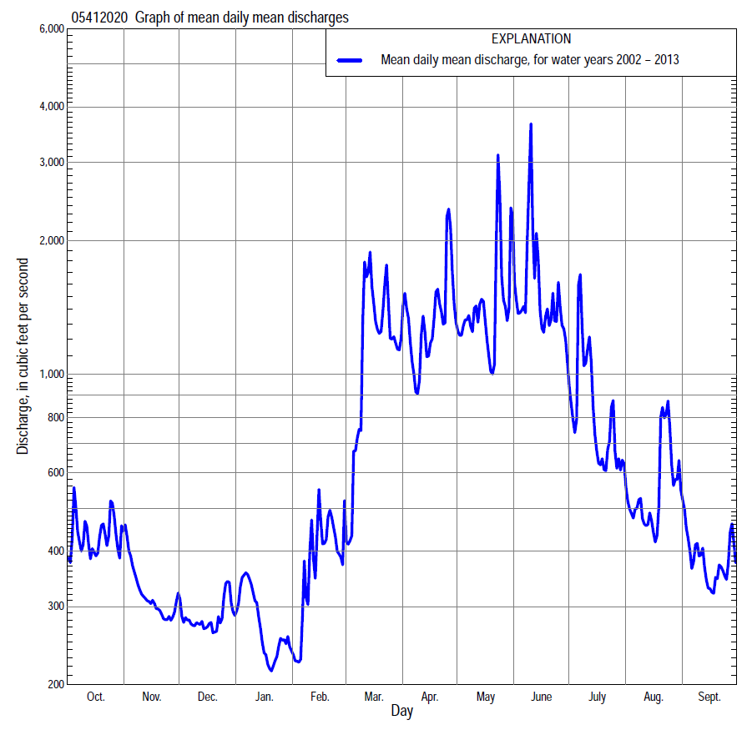

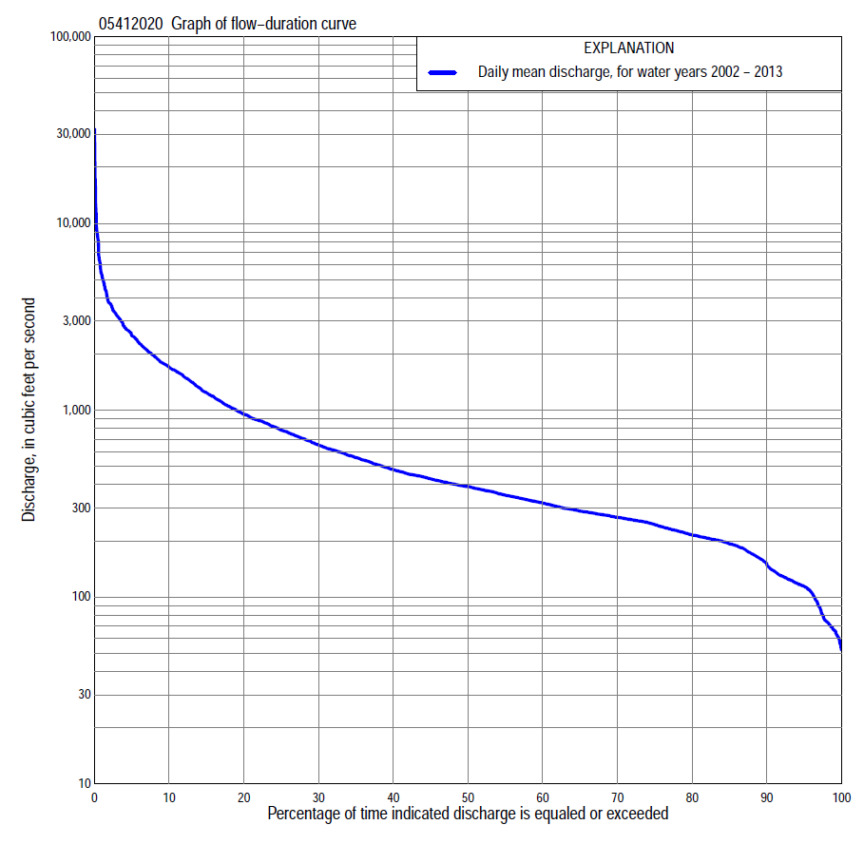

Statistics Based on the Entire Streamflow Period of Record
05412020 Monthly and annual flow durations, based on 2002–2013 period of record (12 years)
Percentage of days discharge equaled or exceeded |  |  |  |  | Discharge (cubic feet per second) |  |  |  |  |  |  |  |  | Annual flow durations
 | Oct | Nov | Dec | Jan | Feb | Mar | Apr | May | June | July | Aug | Sept | Annual | Kentau statistic | P-value
99 | 112 | 107 | 73 | 55 | 62 | 81 | 236 | 297 | 297 | 198 | 127 | 111 | 67 | 0.076 | 0.783
98 | 113 | 108 | 75 | 56 | 64 | 88 | 241 | 318 | 317 | 206 | 130 | 115 | 74 | 0.091 | 0.732
95 | 115 | 113 | 95 | 62 | 68 | 200 | 297 | 404 | 369 | 212 | 143 | 123 | 114 | 0.121 | 0.631
90 | 118 | 130 | 110 | 72 | 72 | 246 | 336 | 543 | 429 | 248 | 173 | 127 | 147 | 0.121 | 0.631
85 | 124 | 147 | 127 | 80 | 105 | 292 | 357 | 624 | 491 | 275 | 202 | 140 | 192 | 0.167 | 0.492
80 | 188 | 168 | 135 | 96 | 171 | 330 | 391 | 675 | 557 | 303 | 243 | 203 | 215 | 0.061 | 0.837
75 | 197 | 179 | 163 | 147 | 188 | 373 | 423 | 742 | 587 | 335 | 267 | 224 | 244 | 0.061 | 0.837
70 | 207 | 197 | 200 | 163 | 202 | 392 | 502 | 797 | 623 | 368 | 291 | 232 | 267 | 0.061 | 0.837
65 | 213 | 214 | 217 | 184 | 217 | 404 | 603 | 851 | 671 | 413 | 315 | 242 | 288 | 0.152 | 0.537
60 | 243 | 230 | 234 | 199 | 228 | 424 | 695 | 911 | 732 | 469 | 340 | 252 | 318 | 0.212 | 0.373
55 | 259 | 253 | 262 | 207 | 246 | 446 | 807 | 975 | 814 | 497 | 377 | 263 | 350 | 0.242 | 0.304
50 | 266 | 261 | 291 | 219 | 270 | 492 | 954 | 1,030 | 875 | 533 | 415 | 280 | 390 | 0.288 | 0.216
45 | 270 | 268 | 319 | 239 | 285 | 561 | 1,050 | 1,130 | 921 | 573 | 446 | 286 | 429 | 0.394 | 0.086
40 | 278 | 275 | 333 | 268 | 302 | 685 | 1,140 | 1,210 | 1,050 | 635 | 463 | 293 | 482 | 0.424 | 0.064
35 | 297 | 288 | 346 | 295 | 330 | 892 | 1,300 | 1,340 | 1,220 | 701 | 494 | 305 | 560 | 0.394 | 0.086
30 | 321 | 322 | 366 | 314 | 370 | 1,140 | 1,520 | 1,460 | 1,440 | 759 | 528 | 327 | 656 | 0.394 | 0.086
25 | 385 | 337 | 372 | 362 | 400 | 1,490 | 1,680 | 1,620 | 1,720 | 856 | 590 | 372 | 785 | 0.333 | 0.150
20 | 425 | 419 | 388 | 395 | 448 | 1,810 | 1,930 | 1,780 | 2,050 | 1,070 | 631 | 445 | 954 | 0.364 | 0.115
15 | 505 | 510 | 399 | 447 | 478 | 2,330 | 2,220 | 2,030 | 2,670 | 1,470 | 707 | 567 | 1,250 | 0.364 | 0.115
10 | 1,080 | 592 | 426 | 556 | 623 | 2,990 | 3,050 | 2,400 | 3,100 | 1,800 | 834 | 800 | 1,710 | 0.303 | 0.193
5 | 1,770 | 803 | 486 | 654 | 1,190 | 3,900 | 3,730 | 3,110 | 3,790 | 2,400 | 1,000 | 1,120 | 2,530 | 0.348 | 0.130
2 | 2,240 | 1,030 | 605 | 844 | 1,970 | 6,100 | 5,030 | 8,070 | 8,120 | 4,270 | 3,850 | 1,550 | 3,750 | 0.303 | 0.193
1 | 2,610 | 1,120 | 672 | 944 | 2,260 | 6,630 | 6,140 | 9,480 | 12,100 | 4,930 | 5,160 | 1,720 | 5,220 | 0.364 | 0.115

05412020 Annual exceedance probability of instantaneous peak discharges, in cubic feet per second (ft³/s), based on the Weighted Independent Estimates method,
Annual exceed-ance probability | Recur-rence interval (years) | Discharge (ft³/s) | 95-percent lower confi-dence interval (ft³/s) | 95-percent upper confi-dence interval (ft³/s)
0.500 | 2 | 8,660 | 7,520 | 9,980
0.200 | 5 | 15,800 | 13,800 | 18,100
0.100 | 10 | 20,900 | 18,000 | 24,300
0.040 | 25 | 27,600 | 23,000 | 33,200
0.020 | 50 | 32,400 | 26,100 | 40,200
0.010 | 100 | 37,100 | 28,900 | 47,700
0.005 | 200 | 41,600 | 31,300 | 55,500
0.002 | 500 | 47,600 | 34,000 | 66,700
and based on the expected moments algorithm/multiple Grubbs-Beck analysis computed using a historical period length of 124 years (1890–2013)ª
0.500 | 2 | 8,680 | 6,230 | 11,400
0.200 | 5 | 15,900 | 12,000 | 20,100
0.100 | 10 | 21,300 | 16,200 | 26,800
0.040 | 25 | 28,600 | 21,500 | 37,000
0.020 | 50 | 34,100 | 25,400 | 46,400
0.010 | 100 | 39,800 | 29,000 | 57,700
0.005 | 200 | 45,500 | 32,400 | 71,100
0.002 | 500 | 53,200 | 36,400 | 92,500
Kentau statistic |  | 0.242
P-value |  | 0.304
Begin year |  | 2002
End year |  | 2013
Number of peaks |  | 12
ªAnalysis includes interval annual-peak discharges (1916, 1929, 1933–42) from streamgage 05412000 Turkey River at Elkader.

05412020 Annual exceedance probability of high discharges, based on 2002–2013 period of record (12 years)
[ND, not determined]
Annual exceedance probability | Recur-rence interval (years) | Maximum average discharge (ft³/s) for indicated number of consecutive days
 |  | 1 | 3 | 7 | 15 | 30
0.990 | 1.01 | ND | ND | ND | 630 | 495
0.950 | 1.05 | ND | ND | ND | 922 | 746
0.900 | 1.11 | ND | ND | ND | 1,140 | 933
0.800 | 1.25 | ND | ND | ND | 1,510 | 1,220
0.500 | 2 | ND | ND | ND | 2,650 | 2,080
0.200 | 5 | ND | ND | ND | 4,930 | 3,580
0.100 | 10 | ND | ND | ND | 6,970 | 4,780
0.040 | 25 | ND | ND | ND | 10,200 | 6,520
0.020 | 50 | ND | ND | ND | 13,300 | 7,990
0.010 | 100 | ND | ND | ND | 16,800 | 9,600
0.005 | 200 | ND | ND | ND | 21,100 | 11,400
0.002 | 500 | ND | ND | ND | 27,800 | 14,000
Kentau statistic |  | 0.273 | 0.242 | 0.273 | 0.212 | 0.273
P-value |  | 0.244 | 0.304 | 0.244 | 0.373 | 0.244

 | 05412020 Annual nonexceedance probability of low discharges, based on April 2002 to March 2013 period of record (11 years)
Annual nonexceed-ance probability | Recur-rence interval (years) | Minimum average discharge (cubic feet per second) for indicated number of consecutive days
 |  | 1 | 3 | 7 | 14 | 30 | 60 | 90 | 120 | 183
0.01 | 100 | 23 | 24 | 25 | 28 | 29 | 37 | 46 | 53 | 62
0.02 | 50 | 30 | 31 | 32 | 36 | 37 | 47 | 57 | 65 | 74
0.05 | 20 | 44 | 46 | 47 | 52 | 54 | 65 | 78 | 87 | 97
0.10 | 10 | 60 | 62 | 64 | 69 | 72 | 86 | 101 | 111 | 123
0.20 | 5 | 84 | 87 | 90 | 96 | 101 | 118 | 135 | 146 | 163
0.50 | 2 | 146 | 152 | 158 | 164 | 174 | 201 | 224 | 239 | 276
0.80 | 1.25 | 226 | 236 | 246 | 252 | 270 | 313 | 342 | 370 | 460
0.90 | 1.11 | 273 | 286 | 298 | 304 | 327 | 382 | 415 | 456 | 596
0.96 | 1.04 | 323 | 339 | 355 | 361 | 390 | 462 | 500 | 560 | 784
0.98 | 1.02 | 355 | 373 | 391 | 398 | 431 | 516 | 557 | 634 | 933
0.99 | 1.01 | 383 | 403 | 422 | 431 | 467 | 565 | 610 | 706 | 1,090
Kentau statistic |  | 0.091 | 0.164 | 0.127 | 0.164 | 0.236 | 0.200 | 0.091 | 0.018 | 0.018
P-value |  | 0.756 | 0.533 | 0.640 | 0.533 | 0.350 | 0.436 | 0.756 | 1.000 | 1.000

05412020 Annual nonexceedance probability of seasonal low discharges, based on October 2001 to September 2013 period of record (12 years)
Annual nonexceed-ance probability | Recur-rence interval (years) | Minimum average discharge (cubic feet per second) for indicated number of consecutive days
 |  | 1 | 7 | 14 | 30 |  | 1 | 7 | 14 | 30
 |  | January-February-March |  |  |  |  | April-May-June
0.01 | 100 | 24 | 25 | 28 | 31 |  | 155 | 156 | 174 | 241
0.02 | 50 | 31 | 33 | 37 | 40 |  | 174 | 175 | 194 | 268
0.05 | 20 | 46 | 49 | 54 | 58 |  | 207 | 211 | 229 | 316
0.10 | 10 | 62 | 67 | 73 | 78 |  | 243 | 250 | 269 | 370
0.20 | 5 | 88 | 95 | 102 | 109 |  | 297 | 310 | 332 | 452
0.50 | 2 | 152 | 167 | 175 | 190 |  | 440 | 476 | 518 | 687
0.80 | 1.25 | 233 | 258 | 267 | 299 |  | 665 | 755 | 861 | 1,100
0.90 | 1.11 | 278 | 309 | 318 | 366 |  | 832 | 972 | 1,150 | 1,430
0.96 | 1.04 | 327 | 364 | 373 | 442 |  | 1,060 | 1,280 | 1,600 | 1,920
0.98 | 1.02 | 357 | 398 | 408 | 492 |  | 1,250 | 1,550 | 2,010 | 2,350
0.99 | 1.01 | 383 | 427 | 437 | 537 |  | 1,450 | 1,830 | 2,480 | 2,830
Kentau statistic |  | 0.061 | 0.121 | 0.091 | 0.121 |  | 0.485 | 0.515 | 0.545 | 0.545
P-value |  | 0.837 | 0.631 | 0.732 | 0.631 |  | 0.034 | 0.024 | 0.016 | 0.016
 |  | July-August-September |  |  |  |  | October-November-December
0.01 | 100 | 74 | 78 | 82 | 86 |  | 34 | 46 | 51 | 63
0.02 | 50 | 86 | 91 | 96 | 100 |  | 44 | 56 | 63 | 75
0.05 | 20 | 108 | 113 | 119 | 124 |  | 63 | 76 | 83 | 95
0.10 | 10 | 130 | 136 | 143 | 150 |  | 85 | 97 | 105 | 117
0.20 | 5 | 160 | 168 | 177 | 187 |  | 116 | 127 | 136 | 148
0.50 | 2 | 229 | 240 | 253 | 277 |  | 188 | 200 | 210 | 227
0.80 | 1.25 | 312 | 325 | 345 | 395 |  | 268 | 289 | 299 | 334
0.90 | 1.11 | 359 | 373 | 398 | 469 |  | 307 | 340 | 350 | 404
0.96 | 1.04 | 411 | 426 | 457 | 557 |  | 344 | 394 | 404 | 488
0.98 | 1.02 | 445 | 460 | 496 | 620 |  | 365 | 429 | 439 | 548
0.99 | 1.01 | 476 | 491 | 531 | 679 |  | 382 | 459 | 469 | 606
Kentau statistic |  | 0.136 | 0.152 | 0.152 | 0.091 |  | 0.045 | 0.091 | 0.091 | 0.030
P-value |  | 0.582 | 0.537 | 0.537 | 0.732 |  | 0.891 | 0.732 | 0.732 | 0.945

