LOCATION.--Lat 42°55'49", long 91°23'03" referenced to North American Datum of 1927, in SW 1/4 NW 1/4 sec.25, T.94 N., R.5 W., Clayton County, IA, Hydrologic Unit 07060004, on left bank on downstream side of bridge on County Highway X28 in Saint Olaf.

DRAINAGE AREA.--70.7 mi².

PERIOD OF RECORD.--Partial-record low-flow measurement site from September 1957 to July 1977; discharge records from March 1986 to September 2001.

GAGE.--Water-stage recorder. Datum of gage is 826.73 ft above National Geodetic Vertical Datum of 1929.

REMARKS.--Records good except for days during the winter period, which are poor and may be affected by intermittent snow accumulation and subsequent melting.

A summary of all available data for this streamgage is provided through the USGS National Water Information System web interface (NWISWeb). The following link provides access to current/historical observations, daily data, daily statistics, monthly statistics, annual statistics, peak streamflow, field measurements, field/lab water-quality samples, and the latest water-year summaries. Data can be filtered by parameter and/or dates, and can be output in various tabular and graphical formats.
http://waterdata.usgs.gov/nwis/inventory/?site_no=05412100

The USGS WaterWatch Toolkit is available at:
http://waterwatch.usgs.gov/?id=ww_toolkit
Tools for summarizing streamflow information include the duration hydrograph builder, the cumulative streamflow hydrograph builder, the streamgage statistics retrieval tool, the rating curve builder, the flood tracking chart builder, the National Weather Service Advanced Hydrologic Prediction Service (AHPS) river forecast hydrograph builder, and the raster-hydrograph builder. Entering the above number for this streamgage into these toolkit webpages will provide streamflow information specific to this streamgage.

A description of the statistics presented for this streamgage is available in the main body of the report at:
http://dx.doi.org/10.3133/ofr20151214
A link to other streamgages included in this report, a map showing the location of the streamgages, information on the programs used to compute the statistical analyses, and references are included in the main body of the report.

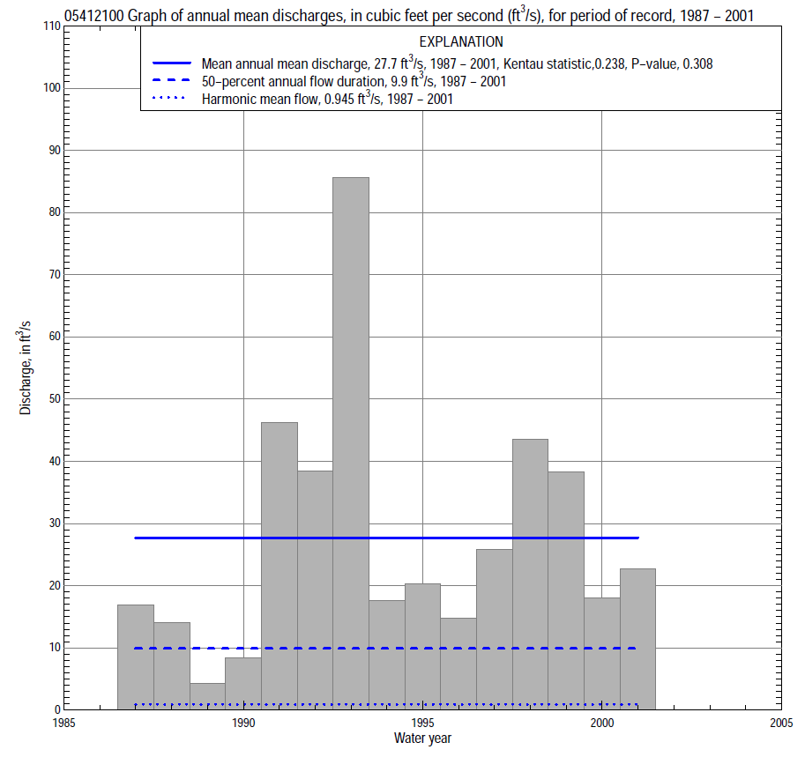

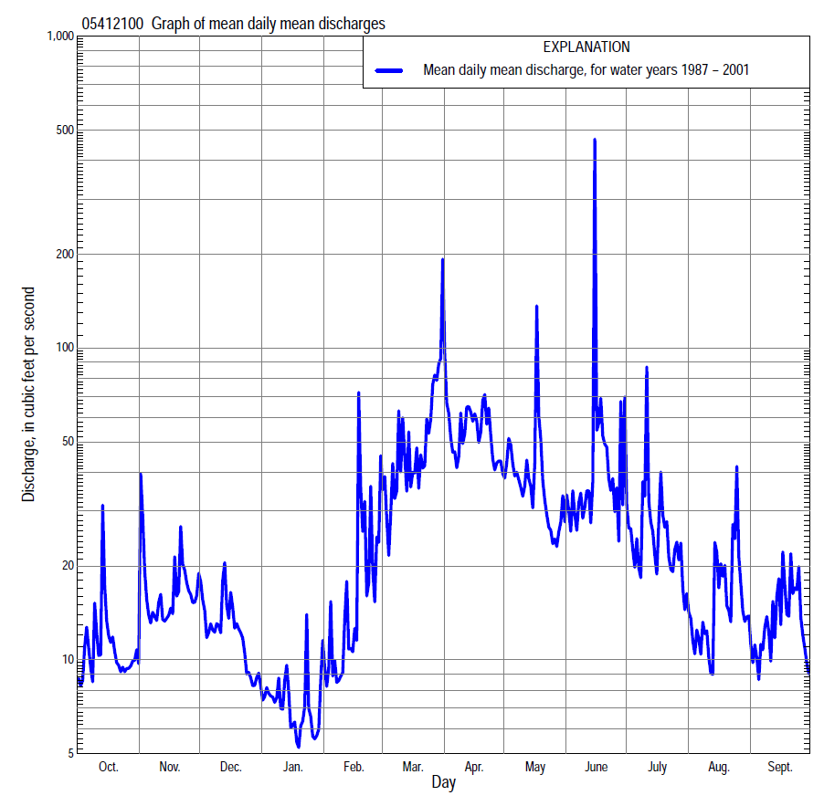

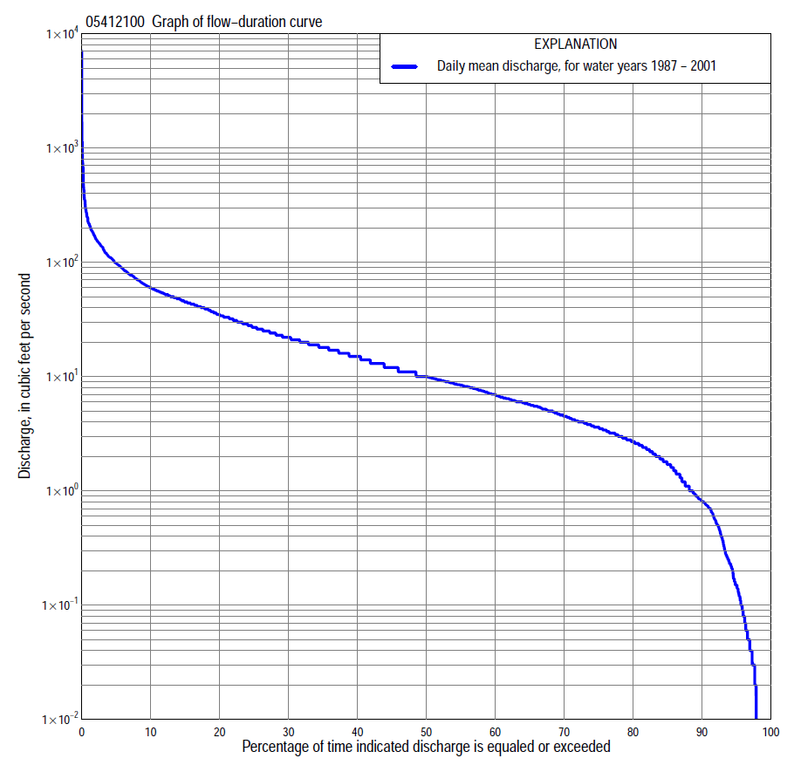

Statistics Based on the Entire Streamflow Period of Record
05412100 Monthly and annual flow durations, based on 1987–2001 period of record (15 years)
Percentage of days discharge equaled or exceeded |  |  |  |  | Discharge (cubic feet per second) |  |  |  |  |  |  |  |  | Annual flow durations
 | Oct | Nov | Dec | Jan | Feb | Mar | Apr | May | June | July | Aug | Sept | Annual | Kentau statistic | P-value
99 | 0.00 | 0.00 | 0.00 | 0.00 | 0.01 | 0.80 | 0.27 | 0.12 | 0.07 | 0.00 | 0.00 | 0.00 | 0.00 | -0.029 | 0.918
98 | 0.00 | 0.00 | 0.00 | 0.00 | 0.03 | 0.88 | 0.43 | 0.15 | 0.09 | 0.02 | 0.00 | 0.02 | 0.00 | 0.010 | 1.000
95 | 0.11 | 0.00 | 0.00 | 0.05 | 0.10 | 2.8 | 1.0 | 0.71 | 0.24 | 0.08 | 0.06 | 0.04 | 0.14 | -0.029 | 0.918
90 | 0.46 | 2.3 | 0.60 | 0.15 | 0.72 | 5.8 | 2.6 | 1.6 | 3.0 | 1.2 | 0.26 | 0.11 | 0.80 | -0.029 | 0.918
85 | 1.5 | 3.0 | 0.85 | 0.56 | 0.94 | 7.3 | 4.0 | 4.9 | 5.2 | 2.1 | 0.43 | 0.57 | 1.7 | -0.067 | 0.764
80 | 2.0 | 3.3 | 1.1 | 0.95 | 1.7 | 8.9 | 10 | 8.8 | 6.7 | 3.1 | 0.87 | 2.0 | 2.7 | -0.019 | 0.960
75 | 2.6 | 3.7 | 1.4 | 1.2 | 2.1 | 11 | 15 | 10 | 9.0 | 4.4 | 2.6 | 2.6 | 3.6 | -0.010 | 1.000
70 | 3.0 | 4.3 | 2.5 | 2.0 | 2.4 | 17 | 17 | 11 | 11 | 6.1 | 3.9 | 3.2 | 4.5 | 0.000 | 1.000
65 | 3.3 | 5.6 | 3.2 | 2.9 | 3.8 | 20 | 20 | 13 | 13 | 7.5 | 4.6 | 3.7 | 5.7 | 0.019 | 0.960
60 | 3.9 | 6.8 | 3.8 | 3.5 | 5.5 | 22 | 22 | 17 | 15 | 8.5 | 5.2 | 4.0 | 6.9 | 0.086 | 0.690
55 | 4.8 | 8.6 | 4.5 | 4.0 | 6.1 | 25 | 26 | 19 | 17 | 9.4 | 6.3 | 4.5 | 8.4 | 0.076 | 0.728
50 | 5.5 | 10 | 5.8 | 4.6 | 7.0 | 29 | 30 | 23 | 20 | 11 | 7.6 | 5.0 | 9.9 | 0.095 | 0.655
45 | 6.4 | 11 | 7.0 | 5.0 | 8.1 | 32 | 34 | 27 | 24 | 12 | 8.6 | 6.1 | 12 | 0.105 | 0.619
40 | 8.1 | 13 | 7.5 | 5.5 | 8.6 | 36 | 43 | 32 | 28 | 13 | 9.9 | 7.2 | 15 | 0.076 | 0.729
35 | 9.6 | 15 | 8.5 | 6.0 | 9.8 | 42 | 52 | 36 | 34 | 15 | 11 | 8.4 | 18 | 0.105 | 0.620
30 | 11 | 18 | 10 | 6.6 | 13 | 48 | 63 | 40 | 40 | 18 | 13 | 10 | 22 | 0.143 | 0.487
25 | 14 | 19 | 12 | 7.6 | 16 | 54 | 77 | 45 | 46 | 22 | 16 | 16 | 27 | 0.200 | 0.321
20 | 16 | 21 | 16 | 9.6 | 20 | 65 | 92 | 51 | 52 | 29 | 19 | 23 | 35 | 0.229 | 0.254
15 | 22 | 24 | 19 | 12 | 27 | 77 | 110 | 58 | 67 | 41 | 25 | 33 | 45 | 0.210 | 0.297
10 | 26 | 42 | 43 | 16 | 39 | 100 | 141 | 78 | 90 | 66 | 43 | 42 | 61 | 0.286 | 0.151
5 | 33 | 58 | 55 | 29 | 76 | 161 | 189 | 136 | 138 | 114 | 77 | 50 | 99 | 0.410 | 0.038
2 | 53 | 80 | 68 | 40 | 131 | 290 | 263 | 201 | 217 | 184 | 112 | 62 | 166 | 0.429 | 0.029
1 | 66 | 108 | 80 | 53 | 160 | 614 | 286 | 225 | 372 | 221 | 137 | 69 | 224 | 0.371 | 0.060

05412100 Annual exceedance probability of instantaneous peak discharges, in cubic feet per second (ft³/s), based on the Weighted Independent Estimates method,
Annual exceed-ance probability | Recur-rence interval (years) | Discharge (ft³/s) | 95-percent lower confi-dence interval (ft³/s) | 95-percent upper confi-dence interval (ft³/s)
0.500 | 2 | 1,430 | 956 | 2,130
0.200 | 5 | 3,810 | 2,620 | 5,540
0.100 | 10 | 5,910 | 4,050 | 8,640
0.040 | 25 | 9,180 | 6,130 | 13,700
0.020 | 50 | 11,700 | 7,540 | 18,000
0.010 | 100 | 14,400 | 9,020 | 22,900
0.005 | 200 | 17,200 | 10,500 | 28,300
0.002 | 500 | 20,800 | 12,000 | 36,200
and based on the expected moments algorithm/multiple Grubbs-Beck analysis computed using a historical period length of 24 years (1980–2003)
0.500 | 2 | 1,190 | 617 | 2,160
0.200 | 5 | 2,990 | 1,650 | 6,100
0.100 | 10 | 4,750 | 2,540 | 11,200
0.040 | 25 | 7,670 | 3,860 | 22,500
0.020 | 50 | 10,400 | 4,920 | 36,800
0.010 | 100 | 13,500 | 6,020 | 58,500
0.005 | 200 | 17,200 | 7,130 | 91,500
0.002 | 500 | 22,800 | 8,600 | 162,000
Kentau statistic |  | 0.132
P-value |  | 0.546
Begin year |  | 1987
End year |  | 2001
Number of peaks |  | 14

05412100 Annual exceedance probability of high discharges, based on 1987–2001 period of record (15 years)
[ND, not determined]
Annual exceedance probability | Recur-rence interval (years) | Maximum average discharge (ft³/s) for indicated number of consecutive days
 |  | 1 | 3 | 7 | 15 | 30
0.990 | 1.01 | ND | 86 | 58 | 38 | 20
0.950 | 1.05 | ND | 103 | 69 | 48 | 30
0.900 | 1.11 | ND | 118 | 79 | 56 | 37
0.800 | 1.25 | ND | 146 | 98 | 69 | 49
0.500 | 2 | ND | 260 | 167 | 116 | 88
0.200 | 5 | ND | 595 | 354 | 224 | 167
0.100 | 10 | ND | 1,020 | 576 | 338 | 240
0.040 | 25 | ND | 2,000 | 1,040 | 549 | 358
0.020 | 50 | ND | 3,230 | 1,590 | 774 | 469
0.010 | 100 | ND | 5,170 | 2,400 | 1,070 | 602
0.005 | 200 | ND | 8,160 | 3,580 | 1,470 | 761
0.002 | 500 | ND | 14,800 | 6,000 | 2,210 | 1,020
Kentau statistic |  | 0.181 | 0.219 | 0.314 | 0.371 | 0.352
P-value |  | 0.373 | 0.276 | 0.113 | 0.060 | 0.075

 | 05412100 Annual nonexceedance probability of low discharges, based on April 1986 to March 2001 period of record (15 years)
Annual nonexceed-ance probability | Recur-rence interval (years) | Minimum average discharge (cubic feet per second) for indicated number of consecutive days
 |  | 1 | 3 | 7 | 14 | 30 | 60 | 90 | 120 | 183
0.01 | 100 | 0.00 | 0.00 | 0.00 | 0.00 | 0.00 | 0.00 | 0.00 | 0.01 | 0.18
0.02 | 50 | 0.00 | 0.00 | 0.00 | 0.00 | 0.00 | 0.00 | 0.01 | 0.03 | 0.31
0.05 | 20 | 0.00 | 0.00 | 0.00 | 0.00 | 0.00 | 0.01 | 0.06 | 0.15 | 0.69
0.10 | 10 | 0.00 | 0.00 | 0.01 | 0.02 | 0.04 | 0.05 | 0.25 | 0.50 | 1.3
0.20 | 5 | 0.00 | 0.05 | 0.09 | 0.16 | 0.30 | 0.40 | 0.96 | 1.6 | 2.6
0.50 | 2 | 1.0 | 1.0 | 1.2 | 1.5 | 2.0 | 4.3 | 5.3 | 6.8 | 7.9
0.80 | 1.25 | 4.1 | 5.4 | 5.4 | 5.8 | 6.3 | 9.7 | 12 | 13 | 18
0.90 | 1.11 | 5.3 | 9.0 | 9.2 | 9.4 | 9.4 | 11 | 14 | 15 | 25
0.96 | 1.04 | 6.2 | 9.2 | 9.3 | 9.5 | 9.5 | 11 | 15 | 16 | 34
0.98 | 1.02 | 6.5 | 9.3 | 9.5 | 10 | 10 | 11 | 15 | 16 | 39
0.99 | 1.01 | 6.7 | 10 | 10 | 10 | 11 | 12 | 15 | 16 | 44
Kentau statistic |  | 0.057 | 0.095 | 0.105 | 0.086 | 0.048 | 0.010 | 0.010 | -0.010 | -0.010
P-value |  | 0.804 | 0.656 | 0.621 | 0.692 | 0.843 | 1.000 | 1.000 | 1.000 | 1.000

05412100 Annual nonexceedance probability of seasonal low discharges, based on October 1986 to September 2001 period of record (14–16 years)
Annual nonexceed-ance probability | Recur-rence interval (years) | Minimum average discharge (cubic feet per second) for indicated number of consecutive days
 |  | 1 | 7 | 14 | 30 |  | 1 | 7 | 14 | 30
 |  | January-February-March |  |  |  |  | April-May-June
0.01 | 100 | 0.00 | 0.00 | 0.00 | 0.01 |  | 0.02 | 0.04 | 0.05 | 0.12
0.02 | 50 | 0.00 | 0.00 | 0.01 | 0.03 |  | 0.05 | 0.09 | 0.11 | 0.26
0.05 | 20 | 0.00 | 0.00 | 0.03 | 0.10 |  | 0.20 | 0.31 | 0.37 | 0.75
0.10 | 10 | 0.00 | 0.03 | 0.10 | 0.26 |  | 0.54 | 0.81 | 0.94 | 1.7
0.20 | 5 | 0.36 | 0.37 | 0.39 | 0.75 |  | 1.6 | 2.2 | 2.5 | 4.1
0.50 | 2 | 2.4 | 3.3 | 3.4 | 3.7 |  | 6.7 | 8.9 | 10 | 15
0.80 | 1.25 | 5.9 | 8.3 | 10 | 11 |  | 16 | 21 | 26 | 35
0.90 | 1.11 | 8.9 | 10 | 15 | 16 |  | 21 | 27 | 36 | 47
0.96 | 1.04 | 10 | 11 | 21 | 22 |  | 24 | 32 | 45 | 59
0.98 | 1.02 | 11 | 12 | 24 | 26 |  | 26 | 35 | 50 | 66
0.99 | 1.01 | 12 | 12 | 26 | 28 |  | 27 | 36 | 54 | 70
Kentau statistic |  | -0.133 | -0.124 | -0.124 | -0.143 |  | 0.042 | 0.200 | 0.250 | 0.317
P-value |  | 0.520 | 0.553 | 0.553 | 0.488 |  | 0.857 | 0.300 | 0.192 | 0.096
 |  | July-August-September |  |  |  |  | October-November-December
0.01 | 100 | 0.00 | 0.00 | 0.00 | 0.02 |  | 0.00 | 0.00 | 0.00 | 0.00
0.02 | 50 | 0.00 | 0.00 | 0.00 | 0.05 |  | 0.00 | 0.00 | 0.00 | 0.00
0.05 | 20 | 0.00 | 0.00 | 0.00 | 0.12 |  | 0.00 | 0.00 | 0.00 | 0.00
0.10 | 10 | 0.00 | 0.02 | 0.07 | 0.28 |  | 0.14 | 0.19 | 0.24 | 0.44
0.20 | 5 | 0.16 | 0.22 | 0.39 | 0.70 |  | 0.52 | 0.69 | 0.82 | 1.4
0.50 | 2 | 2.1 | 2.3 | 2.8 | 3.3 |  | 2.2 | 2.8 | 3.1 | 4.6
0.80 | 1.25 | 7.8 | 10 | 11 | 12 |  | 6.0 | 7.1 | 8.0 | 10
0.90 | 1.11 | 13 | 17 | 18 | 22 |  | 9.1 | 10 | 12 | 14
0.96 | 1.04 | 19 | 26 | 29 | 39 |  | 14 | 15 | 17 | 19
0.98 | 1.02 | 23 | 33 | 37 | 53 |  | 17 | 17 | 21 | 22
0.99 | 1.01 | 26 | 38 | 45 | 70 |  | 19 | 20 | 24 | 25
Kentau statistic |  | 0.108 | 0.150 | 0.133 | 0.067 |  | -0.114 | -0.105 | -0.086 | -0.010
P-value |  | 0.589 | 0.444 | 0.499 | 0.753 |  | 0.586 | 0.621 | 0.692 | 1.000

