LOCATION.--Lat 42°45'14", long 91°22'08" referenced to North American Datum of 1927, in NE 1/4 NE 1/4 SE 1/4 sec.25, T.92 N., R.5 W., Clayton County, IA, Hydrologic Unit 07060004, on left bank 10 ft downstream from bridge on County Highway X21 in Littleport, 9.3 mi upstream from confluence with Turkey River, and 8.0 mi southeast of Elkader.

DRAINAGE AREA.--348 mi².

PERIOD OF RECORD.--Partial-record low-flow measurement site from September 1957 to July 1977; discharge records from September 1999 to current year.

GAGE.--Water-stage recorder. Datum of gage is 677.00 ft above National Geodetic Vertical Datum of 1929.

EXTREMES OUTSIDE PERIOD OF RECORD.--Flood of May 17, 1999, reached a stage of 25.36 ft, discharge about 30,000 ft³/s, from indirect measurement at Mederville, 2.5 mi upstream from Littleport.

A summary of all available data for this streamgage is provided through the USGS National Water Information System web interface (NWISWeb). The following link provides access to current/historical observations, daily data, daily statistics, monthly statistics, annual statistics, peak streamflow, field measurements, field/lab water-quality samples, and the latest water-year summaries. Data can be filtered by parameter and/or dates, and can be output in various tabular and graphical formats.
http://waterdata.usgs.gov/nwis/inventory/?site_no=05412400

The USGS WaterWatch Toolkit is available at:
http://waterwatch.usgs.gov/?id=ww_toolkit
Tools for summarizing streamflow information include the duration hydrograph builder, the cumulative streamflow hydrograph builder, the streamgage statistics retrieval tool, the rating curve builder, the flood tracking chart builder, the National Weather Service Advanced Hydrologic Prediction Service (AHPS) river forecast hydrograph builder, and the raster-hydrograph builder. Entering the above number for this streamgage into these toolkit webpages will provide streamflow information specific to this streamgage.

A description of the statistics presented for this streamgage is available in the main body of the report at:
http://dx.doi.org/10.3133/ofr20151214
A link to other streamgages included in this report, a map showing the location of the streamgages, information on the programs used to compute the statistical analyses, and references are included in the main body of the report.

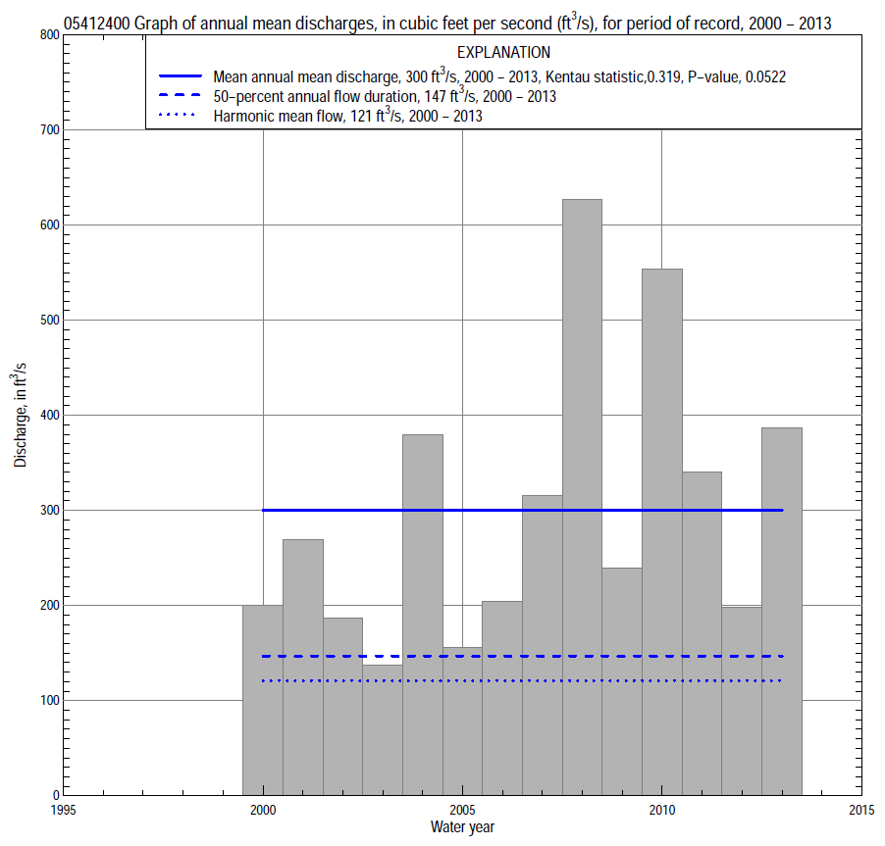

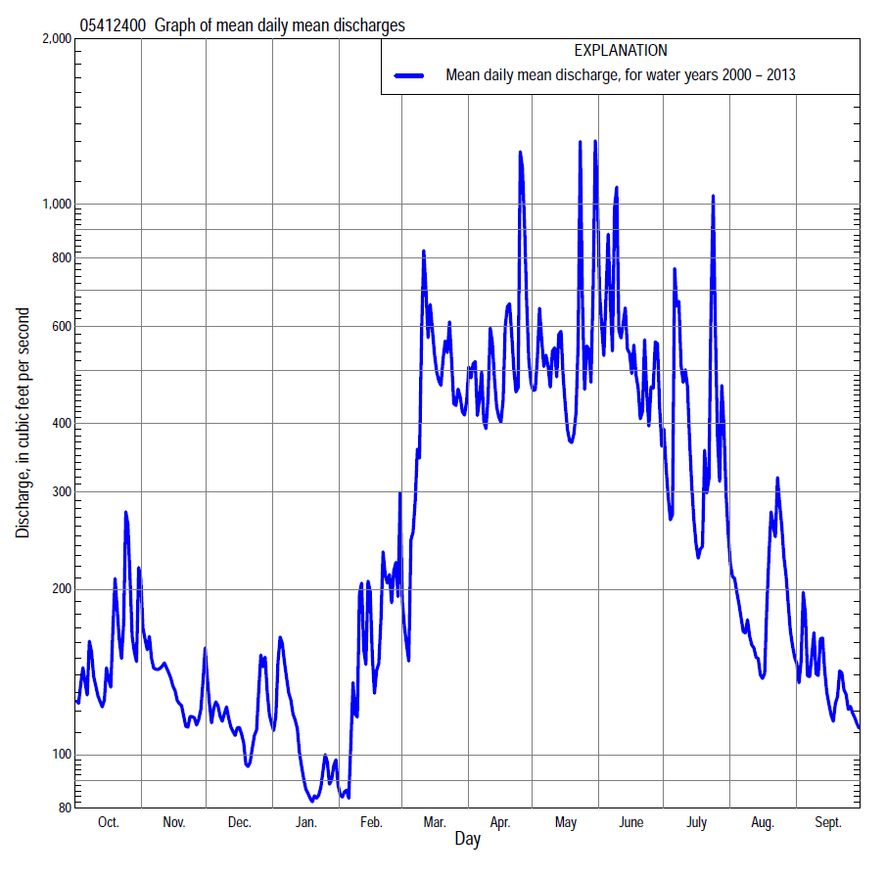

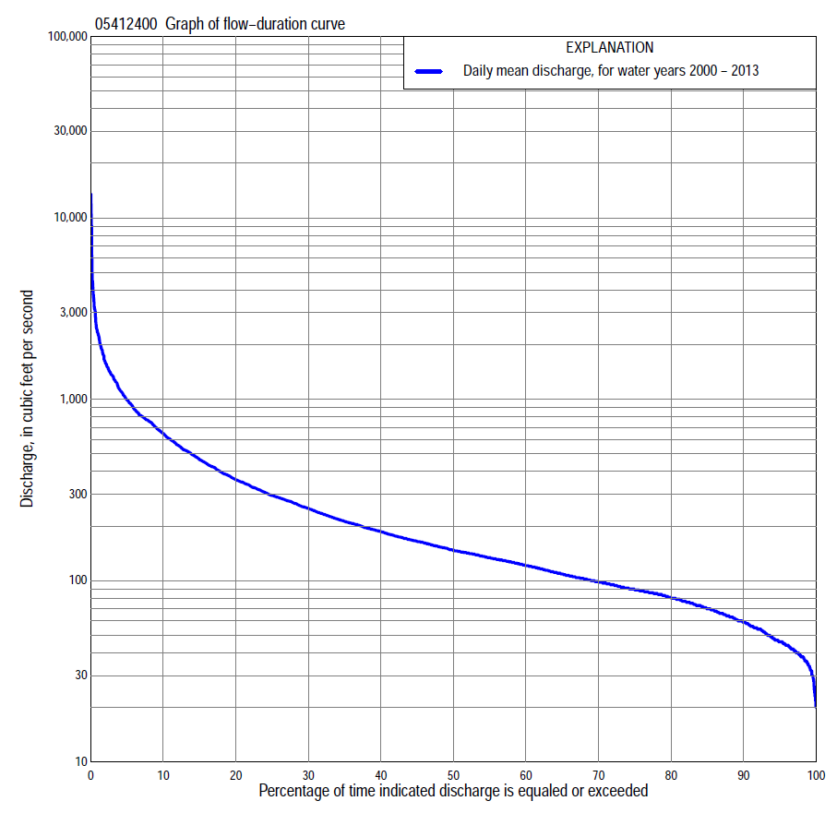

Statistics Based on the Entire Streamflow Period of Record
05412400 Monthly and annual flow durations, based on 2000–2013 period of record (14 years)
Percentage of days discharge equaled or exceeded |  |  |  |  | Discharge (cubic feet per second) |  |  |  |  |  |  |  |  | Annual flow durations
 | Oct | Nov | Dec | Jan | Feb | Mar | Apr | May | June | July | Aug | Sept | Annual | Kentau statistic | P-value
99 | 45 | 44 | 32 | 23 | 32 | 37 | 69 | 118 | 64 | 77 | 53 | 47 | 34 | 0.264 | 0.206
98 | 46 | 52 | 33 | 24 | 34 | 42 | 78 | 137 | 85 | 80 | 56 | 49 | 38 | 0.308 | 0.139
95 | 48 | 60 | 37 | 30 | 37 | 63 | 110 | 156 | 117 | 89 | 59 | 53 | 46 | 0.264 | 0.207
90 | 54 | 65 | 42 | 38 | 43 | 79 | 131 | 181 | 147 | 100 | 70 | 55 | 59 | 0.352 | 0.088
85 | 66 | 69 | 46 | 41 | 47 | 106 | 144 | 204 | 177 | 112 | 76 | 60 | 70 | 0.341 | 0.099
80 | 71 | 74 | 52 | 43 | 57 | 121 | 157 | 227 | 205 | 127 | 82 | 68 | 80 | 0.374 | 0.070
75 | 77 | 80 | 59 | 47 | 65 | 134 | 175 | 253 | 224 | 134 | 90 | 76 | 89 | 0.407 | 0.049
70 | 84 | 86 | 64 | 51 | 70 | 153 | 194 | 274 | 245 | 144 | 97 | 82 | 98 | 0.363 | 0.080
65 | 88 | 89 | 75 | 60 | 77 | 175 | 219 | 291 | 262 | 154 | 104 | 85 | 109 | 0.363 | 0.080
60 | 95 | 92 | 85 | 66 | 81 | 198 | 259 | 315 | 278 | 164 | 112 | 88 | 121 | 0.297 | 0.155
55 | 101 | 97 | 92 | 75 | 87 | 210 | 298 | 339 | 293 | 174 | 120 | 91 | 134 | 0.341 | 0.099
50 | 105 | 102 | 97 | 84 | 91 | 232 | 343 | 365 | 320 | 191 | 135 | 97 | 147 | 0.319 | 0.125
45 | 109 | 113 | 101 | 93 | 98 | 259 | 375 | 396 | 350 | 216 | 144 | 107 | 165 | 0.319 | 0.125
40 | 115 | 125 | 108 | 102 | 109 | 297 | 424 | 428 | 422 | 250 | 154 | 116 | 187 | 0.330 | 0.112
35 | 123 | 132 | 122 | 114 | 116 | 357 | 480 | 463 | 491 | 284 | 166 | 129 | 213 | 0.363 | 0.080
30 | 134 | 144 | 134 | 124 | 127 | 434 | 580 | 507 | 549 | 334 | 182 | 143 | 251 | 0.407 | 0.049
25 | 144 | 163 | 146 | 132 | 136 | 563 | 688 | 578 | 651 | 383 | 208 | 169 | 295 | 0.407 | 0.049
20 | 156 | 175 | 166 | 145 | 157 | 671 | 777 | 663 | 772 | 449 | 230 | 187 | 362 | 0.385 | 0.063
15 | 171 | 207 | 188 | 160 | 232 | 799 | 933 | 781 | 913 | 551 | 266 | 205 | 465 | 0.319 | 0.125
10 | 244 | 234 | 208 | 179 | 312 | 1,040 | 1,160 | 1,000 | 1,100 | 817 | 327 | 242 | 648 | 0.220 | 0.298
5 | 463 | 295 | 278 | 232 | 560 | 1,500 | 1,570 | 1,460 | 1,630 | 1,270 | 535 | 327 | 992 | 0.231 | 0.274
2 | 852 | 408 | 371 | 377 | 853 | 2,130 | 2,350 | 3,090 | 2,840 | 2,310 | 811 | 480 | 1,600 | 0.231 | 0.274
1 | 1,450 | 539 | 457 | 577 | 1,390 | 2,480 | 2,810 | 4,360 | 3,170 | 3,690 | 1,460 | 651 | 2,310 | 0.176 | 0.411

05412400 Annual exceedance probability of instantaneous peak discharges, in cubic feet per second (ft³/s), based on the Weighted Independent Estimates method,
Annual exceed-ance probability | Recur-rence interval (years) | Discharge (ft³/s) | 95-percent lower confi-dence interval (ft³/s) | 95-percent upper confi-dence interval (ft³/s)
0.500 | 2 | 4,920 | 3,990 | 6,060
0.200 | 5 | 9,750 | 7,920 | 12,000
0.100 | 10 | 13,500 | 10,800 | 16,900
0.040 | 25 | 18,700 | 14,300 | 24,300
0.020 | 50 | 22,500 | 16,600 | 30,400
0.010 | 100 | 26,500 | 18,900 | 37,300
0.005 | 200 | 30,600 | 21,000 | 44,700
0.002 | 500 | 36,000 | 23,300 | 55,600
and based on the expected moments algorithm/multiple Grubbs-Beck analysis computed using a historical period length of 66 years (1948–2013)
0.500 | 2 | 4,910 | 3,110 | 6,920
0.200 | 5 | 9,740 | 6,580 | 13,200
0.100 | 10 | 13,600 | 9,270 | 18,700
0.040 | 25 | 19,200 | 13,000 | 28,500
0.020 | 50 | 23,800 | 15,800 | 38,600
0.010 | 100 | 28,600 | 18,600 | 51,700
0.005 | 200 | 33,800 | 21,200 | 68,500
0.002 | 500 | 41,000 | 24,400 | 97,900
Kentau statistic |  | 0.187
P-value |  | 0.381
Begin year |  | 2000
End year |  | 2013
Number of peaks |  | 14

05412400 Annual exceedance probability of high discharges, based on 2000–2013 period of record (14 years)
[ND, not determined]
Annual exceedance probability | Recur-rence interval (years) | Maximum average discharge (ft³/s) for indicated number of consecutive days
 |  | 1 | 3 | 7 | 15 | 30
0.990 | 1.01 | ND | 548 | 428 | 375 | 278
0.950 | 1.05 | ND | 786 | 591 | 477 | 365
0.900 | 1.11 | ND | 971 | 714 | 554 | 428
0.800 | 1.25 | ND | 1,280 | 910 | 676 | 528
0.500 | 2 | ND | 2,280 | 1,520 | 1,060 | 825
0.200 | 5 | ND | 4,420 | 2,690 | 1,820 | 1,370
0.100 | 10 | ND | 6,450 | 3,730 | 2,520 | 1,840
0.040 | 25 | ND | 9,900 | 5,380 | 3,660 | 2,570
0.020 | 50 | ND | 13,200 | 6,900 | 4,750 | 3,220
0.010 | 100 | ND | 17,400 | 8,700 | 6,070 | 3,980
0.005 | 200 | ND | 22,500 | 10,800 | 7,670 | 4,870
0.002 | 500 | ND | 31,000 | 14,200 | 10,300 | 6,260
Kentau statistic |  | 0.110 | 0.165 | 0.165 | 0.165 | 0.121
P-value |  | 0.622 | 0.443 | 0.443 | 0.443 | 0.584

 | 05412400 Annual nonexceedance probability of low discharges, based on April 2000 to March 2013 period of record (13 years)
Annual nonexceed-ance probability | Recur-rence interval (years) | Minimum average discharge (cubic feet per second) for indicated number of consecutive days
 |  | 1 | 3 | 7 | 14 | 30 | 60 | 90 | 120 | 183
0.01 | 100 | 14 | 17 | 17 | 19 | 23 | 24 | 27 | 31 | 33
0.02 | 50 | 15 | 19 | 19 | 22 | 26 | 29 | 32 | 36 | 39
0.05 | 20 | 19 | 22 | 24 | 26 | 31 | 36 | 40 | 45 | 50
0.10 | 10 | 22 | 26 | 28 | 31 | 37 | 44 | 49 | 54 | 61
0.20 | 5 | 27 | 32 | 35 | 38 | 45 | 55 | 61 | 67 | 78
0.50 | 2 | 40 | 46 | 51 | 56 | 65 | 81 | 91 | 99 | 119
0.80 | 1.25 | 61 | 67 | 75 | 80 | 92 | 112 | 132 | 140 | 175
0.90 | 1.11 | 76 | 82 | 90 | 96 | 109 | 131 | 157 | 166 | 210
0.96 | 1.04 | 96 | 101 | 110 | 116 | 131 | 152 | 187 | 197 | 251
0.98 | 1.02 | 113 | 117 | 125 | 130 | 147 | 166 | 208 | 218 | 281
0.99 | 1.01 | 130 | 132 | 140 | 144 | 163 | 179 | 228 | 239 | 309
Kentau statistic |  | 0.308 | 0.410 | 0.385 | 0.385 | 0.410 | 0.462 | 0.410 | 0.385 | 0.333
P-value |  | 0.159 | 0.059 | 0.077 | 0.077 | 0.059 | 0.033 | 0.059 | 0.077 | 0.127

05412400 Annual nonexceedance probability of seasonal low discharges, based on September 1999 to September 2013 period of record (13–14 years)
Annual nonexceed-ance probability | Recur-rence interval (years) | Minimum average discharge (cubic feet per second) for indicated number of consecutive days
 |  | 1 | 7 | 14 | 30 |  | 1 | 7 | 14 | 30
 |  | January-February-March |  |  |  |  | April-May-June
0.01 | 100 | 14 | 17 | 19 | 23 |  | 41 | 45 | 58 | 78
0.02 | 50 | 16 | 19 | 22 | 26 |  | 49 | 53 | 66 | 88
0.05 | 20 | 19 | 23 | 27 | 32 |  | 62 | 67 | 80 | 106
0.10 | 10 | 22 | 28 | 32 | 38 |  | 77 | 84 | 96 | 127
0.20 | 5 | 27 | 34 | 39 | 46 |  | 98 | 108 | 121 | 159
0.50 | 2 | 40 | 51 | 57 | 67 |  | 157 | 175 | 196 | 256
0.80 | 1.25 | 60 | 74 | 82 | 94 |  | 246 | 281 | 335 | 438
0.90 | 1.11 | 74 | 90 | 98 | 112 |  | 309 | 357 | 452 | 595
0.96 | 1.04 | 94 | 111 | 118 | 133 |  | 393 | 460 | 632 | 839
0.98 | 1.02 | 109 | 127 | 133 | 149 |  | 457 | 540 | 792 | 1,060
0.99 | 1.01 | 126 | 143 | 147 | 164 |  | 523 | 623 | 976 | 1,320
Kentau statistic |  | 0.330 | 0.418 | 0.407 | 0.451 |  | 0.319 | 0.385 | 0.319 | 0.341
P-value |  | 0.112 | 0.042 | 0.049 | 0.029 |  | 0.125 | 0.063 | 0.125 | 0.101
 |  | July-August-September |  |  |  |  | October-November-December
0.01 | 100 | 39 | 40 | 42 | 45 |  | 17 | 22 | 25 | 32
0.02 | 50 | 42 | 43 | 45 | 48 |  | 19 | 25 | 28 | 35
0.05 | 20 | 46 | 47 | 50 | 54 |  | 23 | 30 | 33 | 41
0.10 | 10 | 50 | 52 | 56 | 61 |  | 28 | 36 | 39 | 47
0.20 | 5 | 56 | 60 | 64 | 71 |  | 35 | 44 | 48 | 57
0.50 | 2 | 73 | 80 | 86 | 98 |  | 53 | 64 | 69 | 80
0.80 | 1.25 | 104 | 114 | 120 | 142 |  | 82 | 94 | 101 | 116
0.90 | 1.11 | 129 | 141 | 147 | 176 |  | 104 | 114 | 123 | 142
0.96 | 1.04 | 167 | 179 | 184 | 224 |  | 134 | 140 | 152 | 176
0.98 | 1.02 | 200 | 211 | 214 | 266 |  | 158 | 160 | 174 | 204
0.99 | 1.01 | 238 | 247 | 248 | 311 |  | 180 | 181 | 197 | 232
Kentau statistic |  | 0.275 | 0.242 | 0.242 | 0.187 |  | 0.231 | 0.275 | 0.319 | 0.275
P-value |  | 0.188 | 0.250 | 0.250 | 0.381 |  | 0.274 | 0.189 | 0.125 | 0.189

