LOCATION.--Lat 42°33'18", long 90°44'46" referenced to North American Datum of 1927, in NW 1/4 NE 1/4 sec.05, T.89 N., R.2 E., Dubuque County, IA, Hydrologic Unit 07060003, on left bank 10 ft upstream from bridge on Access Road, 1.7 mi east of Durango, 300 ft upstream from Cloie Branch, and 6.4 mi upstream from mouth.

DRAINAGE AREA.--130 mi².

PERIOD OF RECORD.--Discharge records from October 1934 to February 1982; annual maximum discharge, water years 1983, 1986-1992, 1994, 1997-1999.

GAGE.--Water-stage recorder. Datum of gage is 612.03 ft above National Geodetic Vertical Datum of 1929. Prior to January 5, 1939, nonrecording gage at same site and datum.

EXTREMES OUTSIDE PERIOD OF RECORD.--Flood of June 15, 1925, reached a stage of about 22.10 ft, discharge about 29,000 ft³/s, from information by U.S. Army Corps of Engineers. Flood of July 28, 2011, reached a stage of 22.94 ft, discharge about 34,800 ft³/s.

A summary of all available data for this streamgage is provided through the USGS National Water Information System web interface (NWISWeb). The following link provides access to current/historical observations, daily data, daily statistics, monthly statistics, annual statistics, peak streamflow, field measurements, field/lab water-quality samples, and the latest water-year summaries. Data can be filtered by parameter and/or dates, and can be output in various tabular and graphical formats.
http://waterdata.usgs.gov/nwis/inventory/?site_no=05414500

The USGS WaterWatch Toolkit is available at:
http://waterwatch.usgs.gov/?id=ww_toolkit
Tools for summarizing streamflow information include the duration hydrograph builder, the cumulative streamflow hydrograph builder, the streamgage statistics retrieval tool, the rating curve builder, the flood tracking chart builder, the National Weather Service Advanced Hydrologic Prediction Service (AHPS) river forecast hydrograph builder, and the raster-hydrograph builder. Entering the above number for this streamgage into these toolkit webpages will provide streamflow information specific to this streamgage.

A description of the statistics presented for this streamgage is available in the main body of the report at:
http://dx.doi.org/10.3133/ofr20151214
A link to other streamgages included in this report, a map showing the location of the streamgages, information on the programs used to compute the statistical analyses, and references are included in the main body of the report.

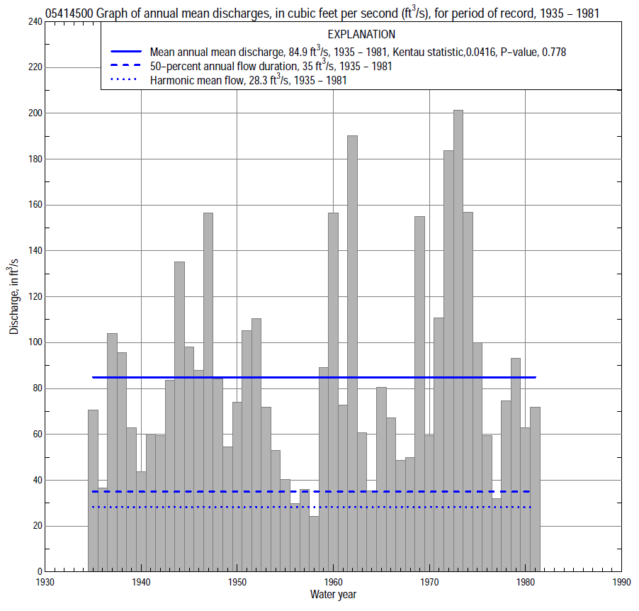

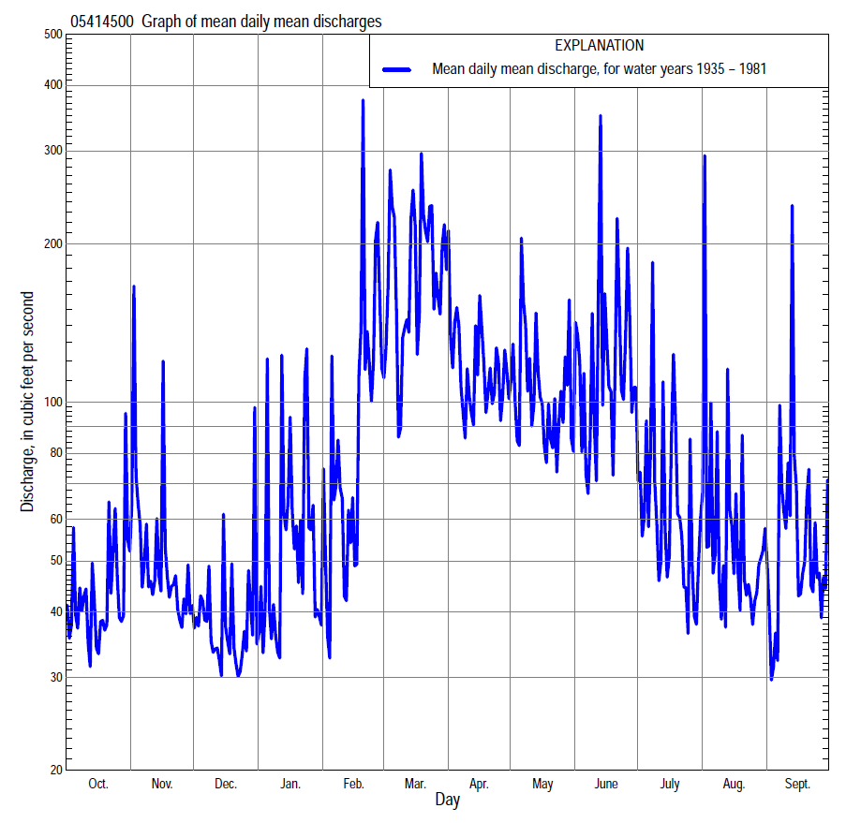

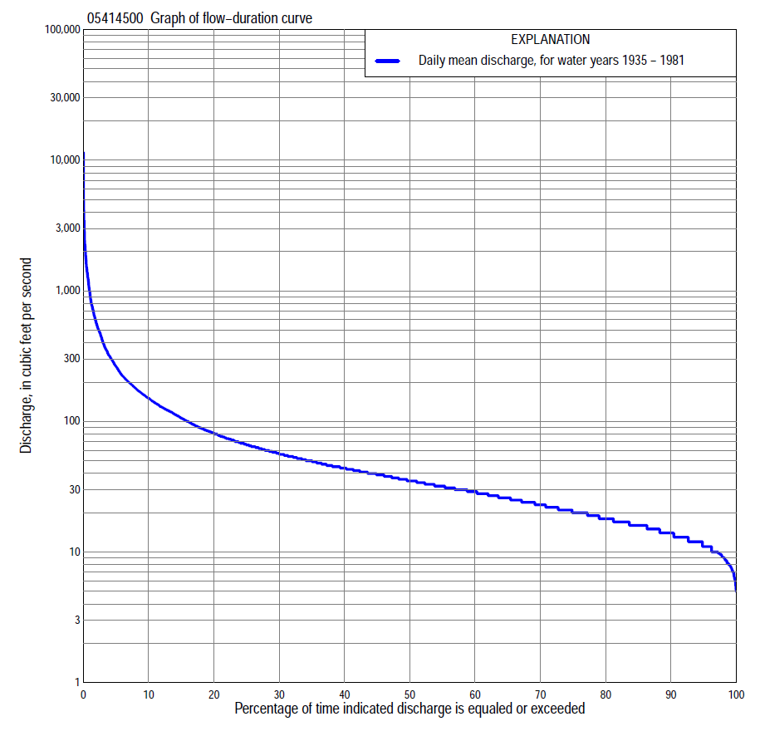

Statistics Based on the Entire Streamflow Period of Record
05414500 Monthly and annual flow durations, based on 1935–81 period of record (47 years)
Percentage of days discharge equaled or exceeded |  |  |  |  | Discharge (cubic feet per second) |  |  |  |  |  |  |  |  | Annual flow durations
 | Oct | Nov | Dec | Jan | Feb | Mar | Apr | May | June | July | Aug | Sept | Annual | Kentau statistic | P-value
99 | 8.0 | 8.6 | 8.6 | 7.6 | 7.8 | 14 | 14 | 12 | 10 | 7.0 | 6.0 | 7.2 | 8.0 | 0.251 | 0.013
98 | 8.6 | 11 | 9.1 | 8.0 | 9.8 | 16 | 17 | 14 | 11 | 7.4 | 7.6 | 7.7 | 9.1 | 0.240 | 0.018
95 | 11 | 12 | 10 | 9.6 | 11 | 17 | 21 | 17 | 14 | 9.8 | 9.2 | 10 | 11 | 0.220 | 0.029
90 | 13 | 14 | 12 | 11 | 13 | 22 | 29 | 25 | 18 | 14 | 12 | 12 | 14 | 0.194 | 0.055
85 | 14 | 15 | 14 | 12 | 16 | 26 | 35 | 29 | 22 | 16 | 13 | 13 | 16 | 0.185 | 0.067
80 | 16 | 17 | 15 | 14 | 18 | 31 | 39 | 33 | 26 | 18 | 15 | 15 | 18 | 0.171 | 0.091
75 | 17 | 18 | 16 | 15 | 20 | 36 | 43 | 36 | 28 | 20 | 17 | 16 | 20 | 0.153 | 0.132
70 | 18 | 20 | 18 | 18 | 22 | 41 | 47 | 40 | 32 | 22 | 18 | 17 | 23 | 0.139 | 0.171
65 | 20 | 23 | 20 | 19 | 24 | 49 | 51 | 43 | 36 | 24 | 20 | 19 | 26 | 0.129 | 0.205
60 | 22 | 26 | 22 | 21 | 26 | 56 | 57 | 47 | 40 | 26 | 21 | 21 | 28 | 0.108 | 0.287
55 | 24 | 29 | 25 | 23 | 29 | 63 | 63 | 53 | 44 | 28 | 24 | 24 | 32 | 0.095 | 0.349
50 | 26 | 31 | 26 | 25 | 32 | 69 | 70 | 58 | 48 | 31 | 26 | 26 | 35 | 0.080 | 0.435
45 | 28 | 33 | 29 | 27 | 36 | 81 | 78 | 64 | 54 | 34 | 29 | 28 | 39 | 0.062 | 0.545
40 | 30 | 36 | 31 | 30 | 40 | 97 | 87 | 70 | 60 | 37 | 33 | 32 | 44 | 0.031 | 0.762
35 | 32 | 40 | 33 | 33 | 45 | 118 | 97 | 77 | 68 | 41 | 38 | 35 | 49 | 0.032 | 0.755
30 | 35 | 43 | 36 | 37 | 50 | 139 | 112 | 86 | 78 | 47 | 43 | 39 | 56 | 0.027 | 0.797
25 | 40 | 46 | 40 | 41 | 56 | 168 | 126 | 102 | 90 | 57 | 49 | 43 | 66 | 0.042 | 0.686
20 | 47 | 52 | 45 | 49 | 70 | 208 | 148 | 120 | 114 | 68 | 56 | 48 | 81 | 0.039 | 0.707
15 | 56 | 61 | 53 | 58 | 98 | 281 | 179 | 151 | 142 | 83 | 67 | 60 | 106 | 0.043 | 0.673
10 | 73 | 81 | 66 | 76 | 153 | 404 | 226 | 194 | 198 | 108 | 93 | 88 | 150 | 0.043 | 0.673
5 | 122 | 147 | 86 | 143 | 357 | 764 | 328 | 295 | 390 | 195 | 173 | 176 | 265 | 0.068 | 0.503
2 | 209 | 221 | 130 | 354 | 996 | 1,320 | 566 | 554 | 852 | 411 | 355 | 368 | 565 | 0.003 | 0.985
1 | 320 | 358 | 163 | 707 | 1,500 | 1,780 | 822 | 779 | 1,720 | 594 | 601 | 610 | 964 | -0.003 | 0.985

05414500 Annual exceedance probability of instantaneous peak discharges, in cubic feet per second (ft³/s), based on the Weighted Independent Estimates method,
Annual exceed-ance probability | Recur-rence interval (years) | Discharge (ft³/s) | 95-percent lower confi-dence interval (ft³/s) | 95-percent upper confi-dence interval (ft³/s)
0.500 | 2 | 6,510 | 5,750 | 7,380
0.200 | 5 | 11,600 | 10,200 | 13,300
0.100 | 10 | 15,500 | 13,400 | 18,000
0.040 | 25 | 20,900 | 17,400 | 25,100
0.020 | 50 | 25,100 | 20,200 | 31,200
0.010 | 100 | 29,600 | 23,000 | 38,000
0.005 | 200 | 34,200 | 25,700 | 45,500
0.002 | 500 | 40,700 | 29,100 | 56,800
and based on the expected moments algorithm/multiple Grubbs-Beck analysis computed using a historical period length of 137 years (1877–2013)
0.500 | 2 | 6,610 | 5,480 | 7,930
0.200 | 5 | 11,900 | 9,880 | 14,400
0.100 | 10 | 16,100 | 13,200 | 19,800
0.040 | 25 | 22,100 | 17,700 | 28,300
0.020 | 50 | 27,100 | 21,300 | 36,600
0.010 | 100 | 32,500 | 24,800 | 46,900
0.005 | 200 | 38,200 | 28,400 | 59,600
0.002 | 500 | 46,500 | 33,100 | 81,100
Kentau statistic |  | -0.026
P-value |  | 0.783
Begin year |  | 1935
End year |  | 1999
Number of peaks |  | 57

05414500 Annual exceedance probability of high discharges, based on 1935–81 period of record (47 years)
Annual exceedance probability | Recur-rence interval (years) | Maximum average discharge (ft³/s) for indicated number of consecutive days
 |  | 1 | 3 | 7 | 15 | 30
0.990 | 1.01 | 456 | 235 | 149 | 87 | 56
0.950 | 1.05 | 721 | 380 | 228 | 137 | 91
0.900 | 1.11 | 919 | 487 | 286 | 174 | 117
0.800 | 1.25 | 1,230 | 656 | 376 | 231 | 157
0.500 | 2 | 2,160 | 1,140 | 634 | 398 | 273
0.200 | 5 | 3,760 | 1,930 | 1,060 | 678 | 461
0.100 | 10 | 5,030 | 2,520 | 1,390 | 894 | 601
0.040 | 25 | 6,840 | 3,330 | 1,860 | 1,200 | 791
0.020 | 50 | 8,350 | 3,970 | 2,230 | 1,440 | 940
0.010 | 100 | 9,980 | 4,640 | 2,640 | 1,710 | 1,100
0.005 | 200 | 11,700 | 5,350 | 3,070 | 1,990 | 1,260
0.002 | 500 | 14,300 | 6,330 | 3,690 | 2,400 | 1,480
Kentau statistic |  | 0.043 | 0.029 | 0.043 | 0.029 | 0.025
P-value |  | 0.673 | 0.783 | 0.680 | 0.783 | 0.812

 | 05414500 Annual nonexceedance probability of low discharges, based on April 1935 to March 1981 period of record (46 years)
Annual nonexceed-ance probability | Recur-rence interval (years) | Minimum average discharge (cubic feet per second) for indicated number of consecutive days
 |  | 1 | 3 | 7 | 14 | 30 | 60 | 90 | 120 | 183
0.01 | 100 | 4.1 | 4.3 | 4.7 | 4.9 | 5.6 | 6.5 | 8.1 | 9.1 | 10.0
0.02 | 50 | 4.6 | 4.8 | 5.3 | 5.6 | 6.3 | 7.4 | 9.0 | 10.0 | 11
0.05 | 20 | 5.5 | 5.8 | 6.3 | 6.8 | 7.7 | 8.9 | 11 | 12 | 13
0.10 | 10 | 6.5 | 6.9 | 7.5 | 8.0 | 9.2 | 11 | 12 | 14 | 16
0.20 | 5 | 7.9 | 8.5 | 9.2 | 9.9 | 11 | 13 | 15 | 17 | 20
0.50 | 2 | 12 | 13 | 14 | 15 | 17 | 20 | 23 | 25 | 31
0.80 | 1.25 | 18 | 20 | 21 | 22 | 26 | 32 | 38 | 41 | 53
0.90 | 1.11 | 23 | 25 | 26 | 28 | 32 | 41 | 50 | 55 | 71
0.96 | 1.04 | 30 | 32 | 33 | 35 | 41 | 54 | 67 | 76 | 100
0.98 | 1.02 | 35 | 37 | 39 | 41 | 47 | 64 | 83 | 95 | 126
0.99 | 1.01 | 41 | 43 | 45 | 47 | 54 | 76 | 101 | 117 | 156
Kentau statistic |  | 0.164 | 0.186 | 0.168 | 0.152 | 0.139 | 0.121 | 0.085 | 0.086 | 0.117
P-value |  | 0.109 | 0.069 | 0.101 | 0.140 | 0.176 | 0.240 | 0.410 | 0.405 | 0.256

05414500 Annual nonexceedance probability of seasonal low discharges, based on October 1934 to December 1981 period of record (47–48 years)
Annual nonexceed-ance probability | Recur-rence interval (years) | Minimum average discharge (cubic feet per second) for indicated number of consecutive days
 |  | 1 | 7 | 14 | 30 |  | 1 | 7 | 14 | 30
 |  | January-February-March |  |  |  |  | April-May-June
0.01 | 100 | 2.3 | 3.1 | 4.0 | 5.1 |  | 3.0 | 4.0 | 4.0 | 4.5
0.02 | 50 | 3.4 | 4.3 | 5.0 | 5.8 |  | 5.6 | 5.6 | 5.9 | 5.7
0.05 | 20 | 5.4 | 6.2 | 6.7 | 7.3 |  | 7.8 | 8.5 | 9.5 | 11
0.10 | 10 | 7.4 | 8.3 | 9.3 | 9.6 |  | 11 | 12 | 14 | 17
0.20 | 5 | 10 | 11 | 13 | 14 |  | 15 | 17 | 20 | 26
0.50 | 2 | 17 | 19 | 21 | 27 |  | 27 | 31 | 36 | 50
0.80 | 1.25 | 26 | 29 | 32 | 51 |  | 44 | 51 | 60 | 84
0.90 | 1.11 | 31 | 35 | 38 | 67 |  | 56 | 63 | 75 | 107
0.96 | 1.04 | 38 | 43 | 45 | 88 |  | 71 | 79 | 93 | 134
0.98 | 1.02 | 42 | 48 | 50 | 104 |  | 82 | 90 | 106 | 154
0.99 | 1.01 | 46 | 53 | 55 | 119 |  | 92 | 101 | 119 | 173
Kentau statistic |  | 0.113 | 0.080 | 0.031 | -0.044 |  | 0.080 | 0.046 | 0.000 | -0.008
P-value |  | 0.266 | 0.436 | 0.769 | 0.666 |  | 0.435 | 0.653 | 1.000 | 0.942
 |  | July-August-September |  |  |  |  | October-November-December
0.01 | 100 | 1.3 | 1.9 | 4.8 | 7.6 |  | 5.8 | 6.4 | 7.2 | 8.4
0.02 | 50 | 2.4 | 3.1 | 5.4 | 8.1 |  | 6.1 | 6.8 | 7.6 | 8.9
0.05 | 20 | 4.4 | 5.1 | 6.5 | 9.2 |  | 6.9 | 7.8 | 8.6 | 10
0.10 | 10 | 6.4 | 7.2 | 8.1 | 11 |  | 7.9 | 9.2 | 10 | 12
0.20 | 5 | 9.4 | 10 | 11 | 14 |  | 10 | 12 | 13 | 15
0.50 | 2 | 17 | 18 | 19 | 23 |  | 16 | 19 | 20 | 24
0.80 | 1.25 | 26 | 28 | 31 | 39 |  | 27 | 31 | 33 | 39
0.90 | 1.11 | 32 | 34 | 40 | 50 |  | 34 | 39 | 42 | 50
0.96 | 1.04 | 39 | 41 | 51 | 64 |  | 44 | 50 | 54 | 63
0.98 | 1.02 | 44 | 47 | 59 | 74 |  | 51 | 58 | 62 | 73
0.99 | 1.01 | 48 | 52 | 67 | 84 |  | 58 | 65 | 71 | 83
Kentau statistic |  | 0.250 | 0.231 | 0.208 | 0.181 |  | 0.183 | 0.231 | 0.228 | 0.165
P-value |  | 0.014 | 0.022 | 0.040 | 0.074 |  | 0.068 | 0.021 | 0.023 | 0.100

