LOCATION.--Lat 42°28'12.0", long 91°26'54.84" referenced to North American Datum of 1927, in SW 1/4 SW 1/4 SW 1/4 sec.33, T.89 N., R.5 W., Delaware County, IA, Hydrologic Unit 07060006, on right bank 10 ft downstream from east-bound bridge of U.S. Highway 20, 1.5 mi downstream from dam in Manchester, 1.5 mi upstream from Sand Creek, and 113.3 mi upstream from mouth.

DRAINAGE AREA.--275 mi².

PERIOD OF RECORD.--Discharge records from April 2000 to December 2002, June 2003 to current year.

GAGE.--Water-stage recorder. Datum of gage is 900.41 ft above National Geodetic Vertical Datum of 1929.

A summary of all available data for this streamgage is provided through the USGS National Water Information System web interface (NWISWeb). The following link provides access to current/historical observations, daily data, daily statistics, monthly statistics, annual statistics, peak streamflow, field measurements, field/lab water-quality samples, and the latest water-year summaries. Data can be filtered by parameter and/or dates, and can be output in various tabular and graphical formats.
http://waterdata.usgs.gov/nwis/inventory/?site_no=05416900

The USGS WaterWatch Toolkit is available at:
http://waterwatch.usgs.gov/?id=ww_toolkit
Tools for summarizing streamflow information include the duration hydrograph builder, the cumulative streamflow hydrograph builder, the streamgage statistics retrieval tool, the rating curve builder, the flood tracking chart builder, the National Weather Service Advanced Hydrologic Prediction Service (AHPS) river forecast hydrograph builder, and the raster-hydrograph builder. Entering the above number for this streamgage into these toolkit webpages will provide streamflow information specific to this streamgage.

A description of the statistics presented for this streamgage is available in the main body of the report at:
http://dx.doi.org/10.3133/ofr20151214
A link to other streamgages included in this report, a map showing the location of the streamgages, information on the programs used to compute the statistical analyses, and references are included in the main body of the report.

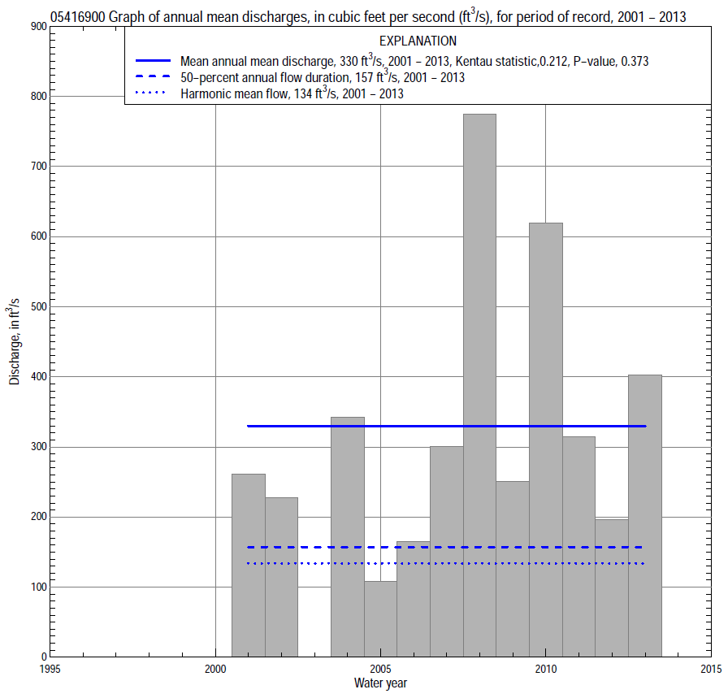

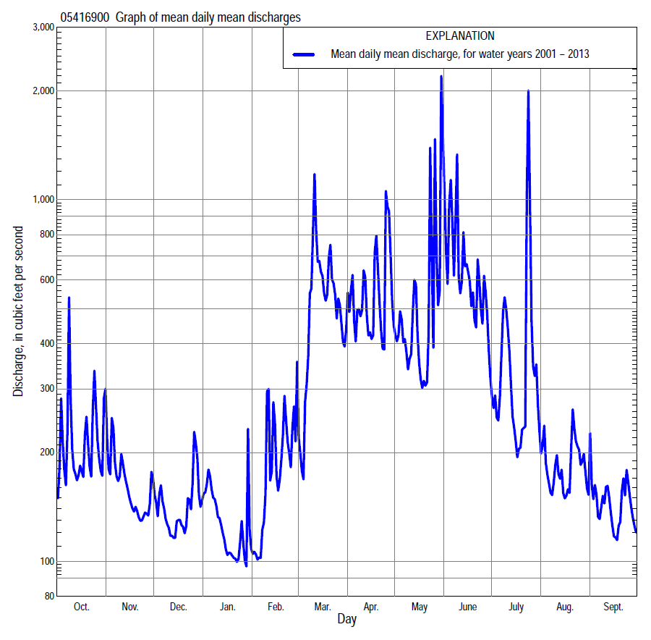

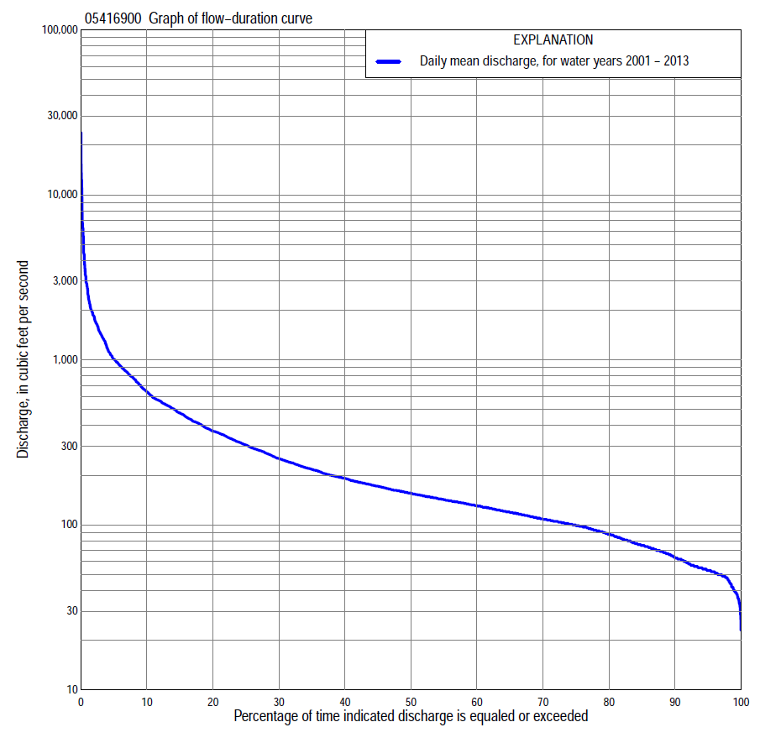

Statistics Based on the Entire Streamflow Period of Record
05416900 Monthly and annual flow durations, based on 2001–02, 2004–2013 period of record (12 years)
Percentage of days discharge equaled or exceeded |  |  |  |  | Discharge (cubic feet per second) |  |  |  |  |  |  |  |  | Annual flow durations
 | Oct | Nov | Dec | Jan | Feb | Mar | Apr | May | June | July | Aug | Sept | Annual | Kentau statistic | P-value
99 | 47 | 48 | 32 | 33 | 52 | 65 | 108 | 101 | 84 | 75 | 54 | 48 | 40 | 0.106 | 0.680
98 | 49 | 50 | 35 | 34 | 57 | 68 | 111 | 104 | 89 | 78 | 56 | 49 | 46 | 0.091 | 0.730
95 | 49 | 51 | 39 | 39 | 63 | 100 | 120 | 123 | 101 | 81 | 60 | 51 | 53 | 0.091 | 0.732
90 | 52 | 54 | 44 | 44 | 69 | 117 | 134 | 144 | 126 | 88 | 70 | 55 | 63 | 0.121 | 0.631
85 | 57 | 63 | 52 | 54 | 74 | 128 | 151 | 158 | 148 | 99 | 74 | 56 | 74 | 0.121 | 0.631
80 | 62 | 72 | 54 | 62 | 81 | 140 | 182 | 181 | 166 | 107 | 81 | 62 | 87 | 0.061 | 0.837
75 | 66 | 80 | 57 | 70 | 90 | 154 | 200 | 197 | 185 | 122 | 88 | 67 | 99 | 0.076 | 0.783
70 | 73 | 93 | 68 | 82 | 97 | 169 | 220 | 215 | 215 | 132 | 93 | 72 | 108 | 0.091 | 0.732
65 | 78 | 98 | 75 | 88 | 105 | 181 | 242 | 234 | 234 | 140 | 103 | 77 | 118 | 0.136 | 0.582
60 | 92 | 102 | 94 | 94 | 110 | 205 | 266 | 254 | 253 | 148 | 108 | 91 | 130 | 0.121 | 0.631
55 | 101 | 108 | 114 | 100 | 115 | 268 | 290 | 281 | 306 | 156 | 117 | 98 | 141 | 0.152 | 0.537
50 | 104 | 125 | 124 | 106 | 122 | 295 | 317 | 305 | 334 | 165 | 123 | 113 | 154 | 0.152 | 0.537
45 | 107 | 144 | 131 | 116 | 130 | 337 | 358 | 334 | 368 | 175 | 130 | 120 | 170 | 0.167 | 0.492
40 | 113 | 151 | 143 | 123 | 139 | 375 | 415 | 356 | 410 | 195 | 137 | 124 | 189 | 0.152 | 0.537
35 | 121 | 160 | 150 | 131 | 144 | 451 | 472 | 382 | 459 | 225 | 149 | 133 | 214 | 0.242 | 0.304
30 | 161 | 178 | 162 | 136 | 154 | 521 | 535 | 418 | 532 | 263 | 162 | 156 | 248 | 0.303 | 0.193
25 | 181 | 193 | 172 | 143 | 169 | 569 | 654 | 482 | 611 | 314 | 184 | 176 | 297 | 0.303 | 0.193
20 | 199 | 217 | 186 | 156 | 180 | 705 | 800 | 568 | 758 | 378 | 222 | 198 | 364 | 0.273 | 0.244
15 | 239 | 240 | 200 | 182 | 219 | 915 | 954 | 677 | 906 | 505 | 314 | 222 | 468 | 0.303 | 0.193
10 | 411 | 282 | 242 | 227 | 318 | 1,220 | 1,150 | 858 | 1,290 | 670 | 430 | 271 | 622 | 0.273 | 0.244
5 | 866 | 367 | 347 | 292 | 528 | 1,710 | 1,650 | 1,400 | 2,040 | 1,070 | 565 | 392 | 1,000 | 0.242 | 0.304
2 | 1,570 | 639 | 513 | 386 | 1,080 | 2,890 | 2,910 | 4,400 | 3,590 | 1,840 | 790 | 582 | 1,830 | 0.242 | 0.304
1 | 2,170 | 794 | 547 | 436 | 1,440 | 3,250 | 3,350 | 6,800 | 5,410 | 2,760 | 895 | 704 | 2,700 | 0.212 | 0.373

05416900 Annual exceedance probability of instantaneous peak discharges, in cubic feet per second (ft³/s), based on the Weighted Independent Estimates method,
Annual exceed-ance probability | Recur-rence interval (years) | Discharge (ft³/s) | 95-percent lower confi-dence interval (ft³/s) | 95-percent upper confi-dence interval (ft³/s)
0.500 | 2 | 4,620 | 3,860 | 5,540
0.200 | 5 | 9,070 | 7,590 | 10,800
0.100 | 10 | 12,700 | 10,500 | 15,300
0.040 | 25 | 17,900 | 14,400 | 22,200
0.020 | 50 | 21,900 | 17,100 | 28,000
0.010 | 100 | 25,900 | 19,600 | 34,200
0.005 | 200 | 31,500 | 22,900 | 43,400
0.002 | 500 | 36,200 | 25,000 | 52,400
and based on the expected moments algorithm/multiple Grubbs-Beck analysis computed using a historical period length of 89 years (1925–2013)ª
0.500 | 2 | 4,620 | 3,710 | 5,700
0.200 | 5 | 9,140 | 7,400 | 11,400
0.100 | 10 | 12,800 | 10,200 | 16,400
0.040 | 25 | 18,100 | 14,000 | 25,000
0.020 | 50 | 22,400 | 16,900 | 33,200
0.010 | 100 | 27,000 | 19,500 | 43,100
0.005 | 200 | 31,900 | 22,100 | 55,200
0.002 | 500 | 38,900 | 25,300 | 74,800
Kentau statistic |  | 0.051
P-value |  | 0.855
Begin year |  | 2001
End year |  | 2013
Number of peaks |  | 13
ªAnalysis includes interval annual-peak discharges (1925, 1928–30, 1933–73, 1976–83) from streamgage 05417000 Maquoketa River near Manchester.

05416900 Annual exceedance probability of high discharges, based on 2001–2002, 2004–2013 period of record (12 years)
[ND, not determined]
Annual exceedance probability | Recur-rence interval (years) | Maximum average discharge (ft³/s) for indicated number of consecutive days
 |  | 1 | 3 | 7 | 15 | 30
0.990 | 1.01 | ND | ND | 316 | 250 | 195
0.950 | 1.05 | ND | ND | 515 | 378 | 300
0.900 | 1.11 | ND | ND | 675 | 480 | 380
0.800 | 1.25 | ND | ND | 947 | 651 | 511
0.500 | 2 | ND | ND | 1,870 | 1,220 | 924
0.200 | 5 | ND | ND | 3,830 | 2,460 | 1,720
0.100 | 10 | ND | ND | 5,680 | 3,640 | 2,420
0.040 | 25 | ND | ND | 8,750 | 5,640 | 3,510
0.020 | 50 | ND | ND | 11,700 | 7,580 | 4,490
0.010 | 100 | ND | ND | 15,200 | 9,970 | 5,620
0.005 | 200 | ND | ND | 19,400 | 12,900 | 6,930
0.002 | 500 | ND | ND | 26,200 | 17,800 | 8,960
Kentau statistic |  | 0.128 | 0.103 | 0.154 | 0.090 | 0.154
P-value |  | 0.583 | 0.669 | 0.502 | 0.714 | 0.502

 | 05416900 Annual nonexceedance probability of low discharges, based on April 2001 to March 2002, April 2004 to March 2013 period of record ( 10 years)
Annual nonexceed-ance probability | Recur-rence interval (years) | Minimum average discharge (cubic feet per second) for indicated number of consecutive days
 |  | 1 | 3 | 7 | 14 | 30 | 60 | 90 | 120 | 183
0.01 | 100 | 17 | 19 | 22 | 25 | 25 | 25 | 26 | 27 | 29
0.02 | 50 | 21 | 23 | 26 | 31 | 31 | 31 | 32 | 33 | 36
0.05 | 20 | 27 | 29 | 32 | 38 | 38 | 41 | 43 | 44 | 48
0.10 | 10 | 33 | 35 | 39 | 44 | 47 | 52 | 55 | 56 | 61
0.20 | 5 | 42 | 44 | 48 | 53 | 58 | 67 | 71 | 73 | 82
0.50 | 2 | 62 | 65 | 69 | 73 | 82 | 101 | 111 | 116 | 141
0.80 | 1.25 | 87 | 90 | 93 | 95 | 108 | 137 | 159 | 172 | 235
0.90 | 1.11 | 102 | 104 | 106 | 108 | 121 | 156 | 186 | 205 | 302
0.96 | 1.04 | 117 | 119 | 121 | 121 | 135 | 175 | 215 | 243 | 392
0.98 | 1.02 | 127 | 129 | 130 | 130 | 143 | 186 | 233 | 268 | 461
0.99 | 1.01 | 136 | 138 | 139 | 139 | 151 | 195 | 249 | 291 | 532
Kentau statistic |  | 0.133 | 0.156 | 0.067 | 0.067 | 0.156 | 0.111 | 0.067 | 0.156 | 0.067
P-value |  | 0.653 | 0.592 | 0.858 | 0.858 | 0.592 | 0.721 | 0.858 | 0.592 | 0.858

05416900 Annual nonexceedance probability of seasonal low discharges, based on April 2001 to September 2002, July 2003 to September 2013 period of record (12–14 years)
Annual nonexceed-ance probability | Recur-rence interval (years) | Minimum average discharge (cubic feet per second) for indicated number of consecutive days
 |  | 1 | 7 | 14 | 30 |  | 1 | 7 | 14 | 30
 |  | January-February-March |  |  |  |  | April-May-June
0.01 | 100 | 18 | 23 | 29 | 39 |  | 63 | 64 | 65 | 81
0.02 | 50 | 21 | 27 | 33 | 43 |  | 70 | 71 | 72 | 89
0.05 | 20 | 27 | 33 | 38 | 51 |  | 82 | 84 | 86 | 105
0.10 | 10 | 33 | 39 | 45 | 58 |  | 94 | 98 | 103 | 123
0.20 | 5 | 41 | 48 | 53 | 68 |  | 111 | 117 | 128 | 152
0.50 | 2 | 62 | 70 | 75 | 91 |  | 155 | 167 | 200 | 245
0.80 | 1.25 | 90 | 97 | 104 | 119 |  | 217 | 242 | 327 | 432
0.90 | 1.11 | 107 | 114 | 123 | 137 |  | 260 | 295 | 430 | 604
0.96 | 1.04 | 127 | 135 | 148 | 157 |  | 316 | 365 | 582 | 892
0.98 | 1.02 | 141 | 149 | 166 | 171 |  | 359 | 420 | 713 | 1,170
0.99 | 1.01 | 155 | 163 | 184 | 185 |  | 403 | 478 | 860 | 1,500
Kentau statistic |  | 0.121 | 0.061 | 0.121 | 0.424 |  | 0.045 | 0.061 | 0.182 | 0.091
P-value |  | 0.631 | 0.837 | 0.631 | 0.064 |  | 0.891 | 0.837 | 0.451 | 0.732
 |  | July-August-September |  |  |  |  | October-November-December
0.01 | 100 | 39 | 40 | 41 | 42 |  | 18 | 22 | 24 | 26
0.02 | 50 | 42 | 42 | 43 | 45 |  | 22 | 26 | 28 | 30
0.05 | 20 | 46 | 48 | 49 | 50 |  | 29 | 33 | 35 | 37
0.10 | 10 | 51 | 53 | 54 | 56 |  | 37 | 41 | 43 | 45
0.20 | 5 | 58 | 61 | 63 | 66 |  | 48 | 51 | 54 | 58
0.50 | 2 | 78 | 83 | 87 | 95 |  | 74 | 78 | 81 | 90
0.80 | 1.25 | 109 | 117 | 125 | 148 |  | 110 | 116 | 120 | 138
0.90 | 1.11 | 134 | 142 | 155 | 194 |  | 132 | 140 | 146 | 172
0.96 | 1.04 | 168 | 176 | 196 | 266 |  | 158 | 170 | 179 | 217
0.98 | 1.02 | 197 | 205 | 230 | 331 |  | 175 | 192 | 203 | 252
0.99 | 1.01 | 229 | 235 | 268 | 408 |  | 192 | 214 | 227 | 287
Kentau statistic |  | 0.198 | 0.143 | 0.143 | 0.187 |  | 0.136 | 0.091 | 0.121 | 0.091
P-value |  | 0.351 | 0.511 | 0.511 | 0.381 |  | 0.582 | 0.732 | 0.631 | 0.732

