LOCATION.--Lat 42°27'22", long 91°25'56" referenced to North American Datum of 1927, in NW 1/4 NW 1/4 NE 1/4 sec.09, T.88 N., R.5 W., Delaware County, IA, Hydrologic Unit 07060006, on left bank 2.2 mi downstream from bridge on U.S. Highway 20, 1.2 mi southeast of Manchester, 0.7 mi downstream from Sand Creek, 1.5 mi upstream from Spring Branch, and 111 mi upstream from mouth.

DRAINAGE AREA.--305 mi².

PERIOD OF RECORD.--Discharge records from April 1933 to September 1973.

GAGE.--Water-stage recorder. Concrete control since June 1, 1935. Datum of gage is 895.06 ft above mean sea level, adjustment of 1912.

EXTREMES OUTSIDE PERIOD OF RECORD.--Flood of June 15, 1925, discharge 25,400 ft³/s.

A summary of all available data for this streamgage is provided through the USGS National Water Information System web interface (NWISWeb). The following link provides access to current/historical observations, daily data, daily statistics, monthly statistics, annual statistics, peak streamflow, field measurements, field/lab water-quality samples, and the latest water-year summaries. Data can be filtered by parameter and/or dates, and can be output in various tabular and graphical formats.
http://waterdata.usgs.gov/nwis/inventory/?site_no=05417000

The USGS WaterWatch Toolkit is available at:
http://waterwatch.usgs.gov/?id=ww_toolkit
Tools for summarizing streamflow information include the duration hydrograph builder, the cumulative streamflow hydrograph builder, the streamgage statistics retrieval tool, the rating curve builder, the flood tracking chart builder, the National Weather Service Advanced Hydrologic Prediction Service (AHPS) river forecast hydrograph builder, and the raster-hydrograph builder. Entering the above number for this streamgage into these toolkit webpages will provide streamflow information specific to this streamgage.

A description of the statistics presented for this streamgage is available in the main body of the report at:
http://dx.doi.org/10.3133/ofr20151214
A link to other streamgages included in this report, a map showing the location of the streamgages, information on the programs used to compute the statistical analyses, and references are included in the main body of the report.

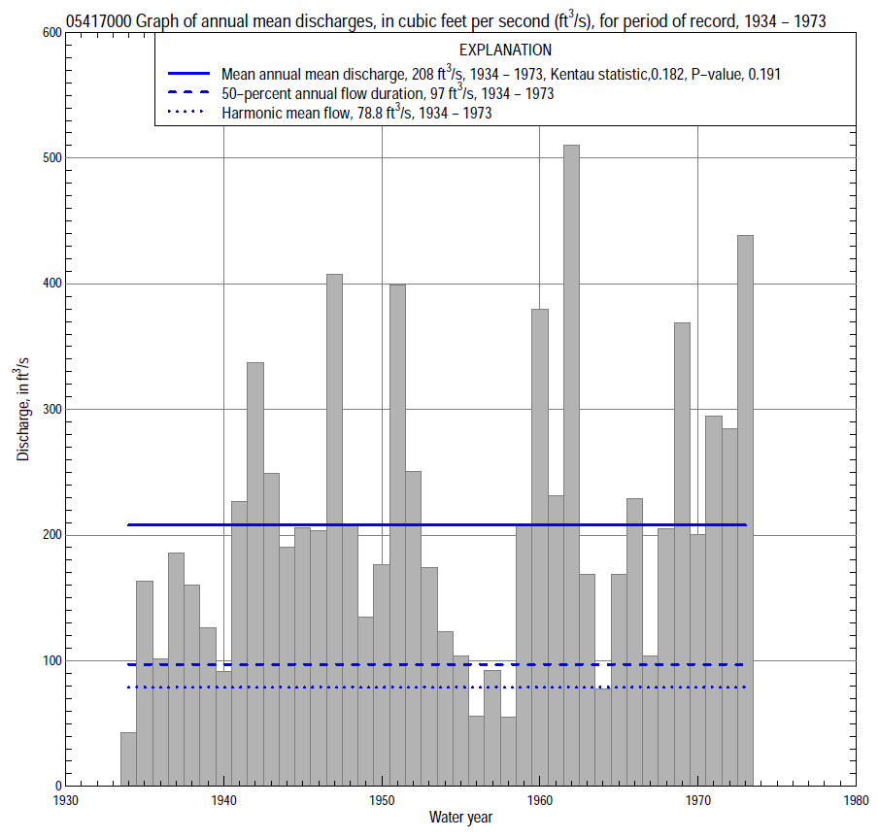

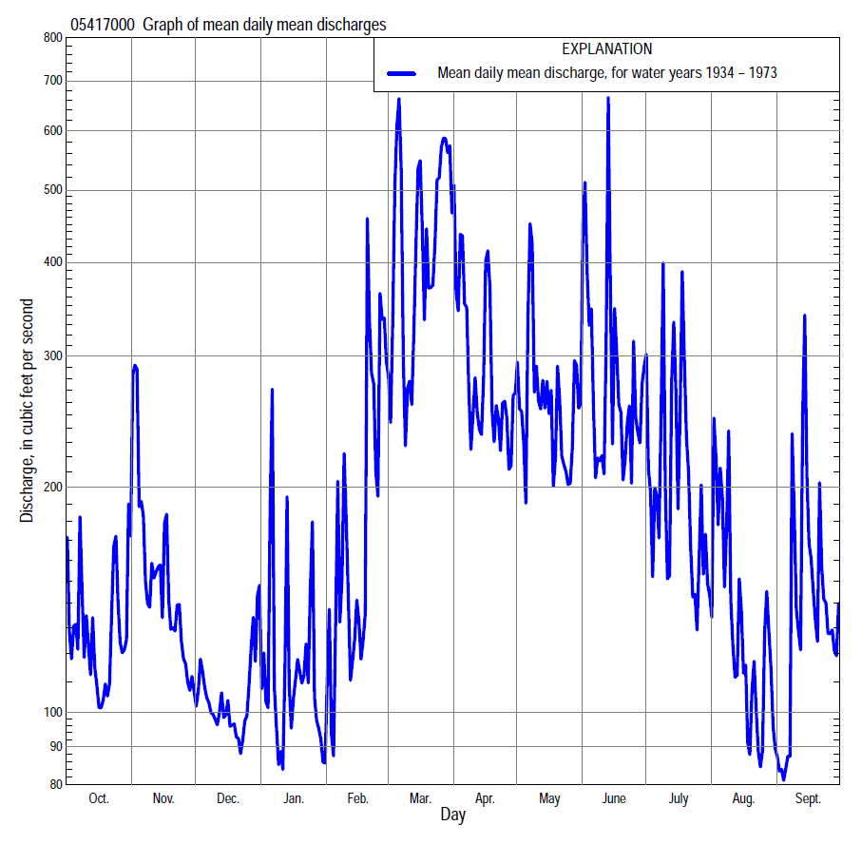

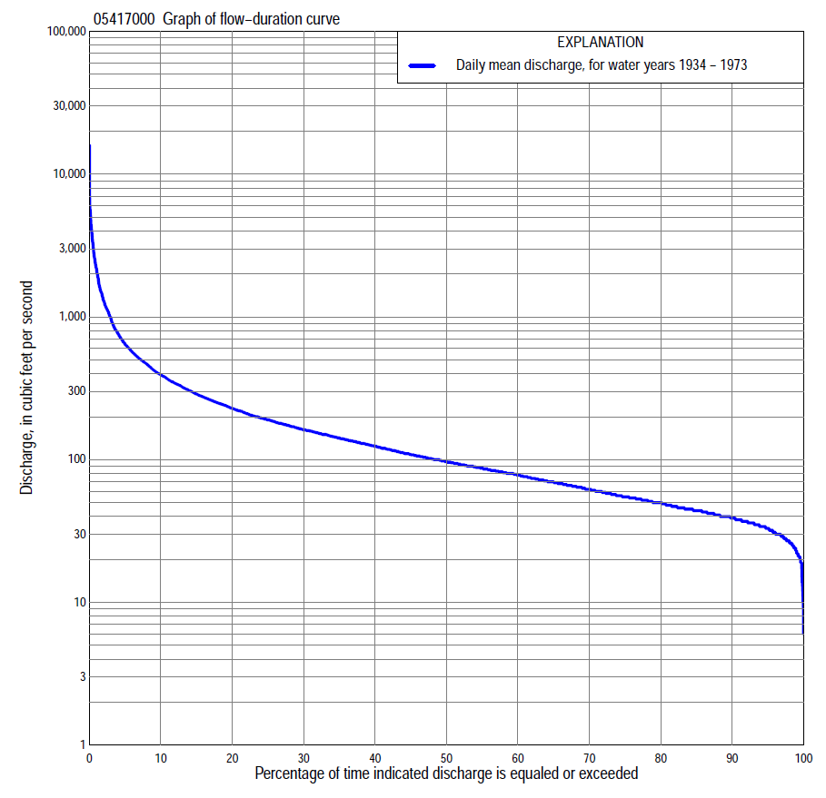

Statistics Based on the Entire Streamflow Period of Record
05417000 Monthly and annual flow durations, based on 1934–73 period of record (40 years)
Percentage of days discharge equaled or exceeded |  |  |  |  | Discharge (cubic feet per second) |  |  |  |  |  |  |  |  | Annual flow durations
 | Oct | Nov | Dec | Jan | Feb | Mar | Apr | May | June | July | Aug | Sept | Annual | Kentau statistic | P-value
99 | 25 | 27 | 24 | 21 | 19 | 31 | 27 | 21 | 11 | 27 | 26 | 26 | 23 | 0.263 | 0.017
98 | 29 | 28 | 26 | 21 | 21 | 34 | 31 | 25 | 13 | 30 | 28 | 29 | 27 | 0.282 | 0.011
95 | 31 | 34 | 31 | 27 | 27 | 42 | 46 | 37 | 39 | 36 | 30 | 34 | 33 | 0.264 | 0.017
90 | 36 | 38 | 35 | 34 | 36 | 50 | 62 | 55 | 55 | 45 | 39 | 38 | 39 | 0.215 | 0.052
85 | 40 | 43 | 39 | 36 | 40 | 56 | 80 | 71 | 66 | 52 | 43 | 41 | 44 | 0.201 | 0.069
80 | 43 | 47 | 42 | 39 | 44 | 70 | 98 | 82 | 74 | 58 | 46 | 44 | 50 | 0.173 | 0.118
75 | 47 | 52 | 45 | 41 | 46 | 87 | 113 | 90 | 84 | 65 | 50 | 47 | 55 | 0.195 | 0.078
70 | 52 | 57 | 50 | 45 | 51 | 101 | 124 | 98 | 93 | 70 | 54 | 53 | 62 | 0.196 | 0.076
65 | 56 | 63 | 55 | 50 | 56 | 120 | 136 | 107 | 105 | 76 | 59 | 59 | 70 | 0.185 | 0.096
60 | 61 | 68 | 60 | 53 | 64 | 137 | 147 | 118 | 116 | 83 | 64 | 65 | 79 | 0.199 | 0.073
55 | 65 | 73 | 65 | 56 | 70 | 160 | 159 | 131 | 128 | 90 | 71 | 72 | 87 | 0.200 | 0.071
50 | 71 | 82 | 72 | 61 | 77 | 180 | 175 | 146 | 144 | 98 | 80 | 80 | 97 | 0.181 | 0.103
45 | 76 | 92 | 82 | 70 | 84 | 204 | 196 | 162 | 160 | 108 | 87 | 87 | 109 | 0.174 | 0.116
40 | 85 | 104 | 91 | 79 | 94 | 250 | 215 | 179 | 186 | 119 | 95 | 94 | 125 | 0.203 | 0.067
35 | 94 | 122 | 101 | 88 | 110 | 300 | 246 | 197 | 206 | 140 | 102 | 106 | 142 | 0.204 | 0.066
30 | 106 | 144 | 116 | 100 | 125 | 360 | 271 | 223 | 242 | 159 | 116 | 117 | 163 | 0.192 | 0.083
25 | 124 | 165 | 135 | 115 | 145 | 434 | 311 | 261 | 282 | 184 | 130 | 132 | 191 | 0.188 | 0.089
20 | 165 | 195 | 150 | 133 | 170 | 513 | 356 | 314 | 343 | 221 | 152 | 157 | 229 | 0.179 | 0.105
15 | 208 | 242 | 169 | 160 | 220 | 660 | 439 | 384 | 440 | 287 | 178 | 186 | 289 | 0.182 | 0.100
10 | 290 | 303 | 195 | 210 | 350 | 930 | 550 | 504 | 605 | 410 | 230 | 244 | 394 | 0.172 | 0.121
5 | 388 | 432 | 257 | 290 | 697 | 1,650 | 875 | 834 | 934 | 630 | 330 | 382 | 648 | 0.187 | 0.091
2 | 587 | 762 | 349 | 518 | 1,500 | 3,200 | 1,550 | 1,520 | 1,580 | 1,420 | 670 | 736 | 1,300 | 0.129 | 0.244
1 | 879 | 1,170 | 483 | 800 | 2,540 | 4,320 | 2,420 | 2,210 | 2,340 | 2,250 | 1,180 | 1,380 | 2,170 | 0.124 | 0.263

05417000 Annual exceedance probability of instantaneous peak discharges, in cubic feet per second (ft³/s), based on the Weighted Independent Estimates method,
Annual exceed-ance probability | Recur-rence interval (years) | Discharge (ft³/s) | 95-percent lower confi-dence interval (ft³/s) | 95-percent upper confi-dence interval (ft³/s)
0.500 | 2 | 4,750 | 4,030 | 5,590
0.200 | 5 | 9,000 | 7,580 | 10,700
0.100 | 10 | 12,600 | 10,400 | 15,300
0.040 | 25 | 18,100 | 14,500 | 22,600
0.020 | 50 | 22,400 | 17,400 | 28,800
0.010 | 100 | 26,700 | 20,100 | 35,600
0.005 | 200 | 33,000 | 23,800 | 45,700
0.002 | 500 | 38,300 | 26,300 | 56,000
and based on the expected moments algorithm/multiple Grubbs-Beck analysis computed using a historical period length of 89 years (1925–2013)ª
0.500 | 2 | 4,740 | 3,890 | 5,760
0.200 | 5 | 9,000 | 7,330 | 11,200
0.100 | 10 | 12,600 | 10,100 | 16,300
0.040 | 25 | 18,000 | 13,900 | 25,500
0.020 | 50 | 22,600 | 17,000 | 35,000
0.010 | 100 | 27,900 | 20,200 | 47,500
0.005 | 200 | 33,700 | 23,400 | 64,100
0.002 | 500 | 42,400 | 27,800 | 94,000
Kentau statistic |  | -0.044
P-value |  | 0.660
Begin year |  | 1933
End year |  | 1983
Number of peaks |  | 49
ªAnalysis includes interval annual-peak discharges (2001–13) from streamgage 05416900 Maquoketa River at Manchester.

05417000 Annual exceedance probability of high discharges, based on 1934–73 period of record (40 years)
Annual exceedance probability | Recur-rence interval (years) | Maximum average discharge (ft³/s) for indicated number of consecutive days
 |  | 1 | 3 | 7 | 15 | 30
0.990 | 1.01 | 478 | 334 | 198 | 126 | 86
0.950 | 1.05 | 998 | 670 | 399 | 249 | 175
0.900 | 1.11 | 1,420 | 934 | 558 | 346 | 246
0.800 | 1.25 | 2,090 | 1,350 | 808 | 499 | 358
0.500 | 2 | 3,930 | 2,480 | 1,480 | 923 | 659
0.200 | 5 | 6,460 | 4,030 | 2,400 | 1,530 | 1,070
0.100 | 10 | 7,980 | 4,970 | 2,960 | 1,910 | 1,310
0.040 | 25 | 9,660 | 6,020 | 3,570 | 2,340 | 1,570
0.020 | 50 | 10,700 | 6,710 | 3,970 | 2,640 | 1,740
0.010 | 100 | 11,700 | 7,320 | 4,320 | 2,910 | 1,890
0.005 | 200 | 12,500 | 7,860 | 4,630 | 3,160 | 2,020
0.002 | 500 | 13,500 | 8,490 | 5,000 | 3,450 | 2,170
Kentau statistic |  | 0.122 | 0.123 | 0.146 | 0.121 | 0.136
P-value |  | 0.273 | 0.268 | 0.188 | 0.279 | 0.221

 | 05417000 Annual nonexceedance probability of low discharges, based on April 1934 to March 1973 period of record (39 years)
Annual nonexceed-ance probability | Recur-rence interval (years) | Minimum average discharge (cubic feet per second) for indicated number of consecutive days
 |  | 1 | 3 | 7 | 14 | 30 | 60 | 90 | 120 | 183
0.01 | 100 | 8.6 | 10 | 12 | 13 | 15 | 19 | 22 | 24 | 25
0.02 | 50 | 10 | 12 | 14 | 15 | 17 | 21 | 25 | 27 | 26
0.05 | 20 | 13 | 16 | 17 | 19 | 21 | 25 | 28 | 31 | 32
0.10 | 10 | 16 | 19 | 21 | 23 | 25 | 29 | 33 | 36 | 39
0.20 | 5 | 21 | 25 | 27 | 29 | 32 | 36 | 40 | 44 | 50
0.50 | 2 | 33 | 38 | 41 | 44 | 49 | 55 | 62 | 69 | 84
0.80 | 1.25 | 50 | 56 | 61 | 66 | 75 | 86 | 104 | 117 | 150
0.90 | 1.11 | 62 | 68 | 75 | 82 | 94 | 111 | 141 | 160 | 207
0.96 | 1.04 | 76 | 83 | 92 | 101 | 119 | 148 | 201 | 230 | 297
0.98 | 1.02 | 87 | 94 | 105 | 116 | 139 | 179 | 257 | 296 | 380
0.99 | 1.01 | 97 | 104 | 117 | 132 | 159 | 213 | 324 | 374 | 476
Kentau statistic |  | 0.300 | 0.266 | 0.259 | 0.244 | 0.247 | 0.233 | 0.142 | 0.136 | 0.117
P-value |  | 0.007 | 0.018 | 0.021 | 0.029 | 0.028 | 0.037 | 0.208 | 0.226 | 0.298

05417000 Annual nonexceedance probability of seasonal low discharges, based on April 1933 to September 1973 period of record (40–41 years)
Annual nonexceed-ance probability | Recur-rence interval (years) | Minimum average discharge (cubic feet per second) for indicated number of consecutive days
 |  | 1 | 7 | 14 | 30 |  | 1 | 7 | 14 | 30
 |  | January-February-March |  |  |  |  | April-May-June
0.01 | 100 | 16 | 17 | 18 | 20 |  | 7.9 | 13 | 15 | 16
0.02 | 50 | 17 | 18 | 19 | 22 |  | 11 | 17 | 19 | 21
0.05 | 20 | 20 | 22 | 23 | 27 |  | 16 | 25 | 27 | 32
0.10 | 10 | 23 | 25 | 27 | 32 |  | 22 | 34 | 37 | 46
0.20 | 5 | 27 | 31 | 33 | 39 |  | 33 | 48 | 52 | 67
0.50 | 2 | 39 | 47 | 50 | 62 |  | 64 | 87 | 95 | 128
0.80 | 1.25 | 59 | 73 | 80 | 103 |  | 111 | 143 | 162 | 218
0.90 | 1.11 | 75 | 93 | 102 | 138 |  | 142 | 179 | 209 | 275
0.96 | 1.04 | 98 | 122 | 134 | 191 |  | 180 | 222 | 267 | 343
0.98 | 1.02 | 117 | 146 | 161 | 238 |  | 207 | 252 | 310 | 389
0.99 | 1.01 | 139 | 172 | 190 | 292 |  | 232 | 280 | 352 | 432
Kentau statistic |  | 0.190 | 0.153 | 0.131 | 0.117 |  | 0.176 | 0.221 | 0.215 | 0.236
P-value |  | 0.086 | 0.169 | 0.239 | 0.294 |  | 0.113 | 0.046 | 0.052 | 0.033
 |  | July-August-September |  |  |  |  | October-November-December
0.01 | 100 | 14 | 20 | 21 | 23 |  | 13 | 21 | 23 | 24
0.02 | 50 | 15 | 22 | 23 | 25 |  | 14 | 23 | 25 | 25
0.05 | 20 | 19 | 26 | 27 | 30 |  | 17 | 26 | 28 | 30
0.10 | 10 | 22 | 30 | 32 | 35 |  | 20 | 30 | 32 | 35
0.20 | 5 | 27 | 36 | 39 | 43 |  | 25 | 36 | 39 | 43
0.50 | 2 | 41 | 53 | 57 | 66 |  | 41 | 54 | 58 | 66
0.80 | 1.25 | 62 | 79 | 88 | 106 |  | 71 | 89 | 95 | 112
0.90 | 1.11 | 79 | 98 | 111 | 138 |  | 99 | 119 | 128 | 151
0.96 | 1.04 | 101 | 125 | 146 | 185 |  | 144 | 169 | 180 | 214
0.98 | 1.02 | 119 | 147 | 174 | 225 |  | 186 | 214 | 229 | 272
0.99 | 1.01 | 138 | 170 | 205 | 271 |  | 237 | 269 | 286 | 341
Kentau statistic |  | 0.266 | 0.278 | 0.271 | 0.198 |  | 0.255 | 0.242 | 0.219 | 0.228
P-value |  | 0.015 | 0.011 | 0.013 | 0.071 |  | 0.021 | 0.028 | 0.048 | 0.039

