LOCATION.--Lat 42°02'22", long 90°52'57" referenced to North American Datum of 1927, in NE 1/4 SE 1/4 sec.31, T.84 N., R.1 E., Jackson County, IA, Hydrologic Unit 07060006, on right bank 15 ft downstream from bridge on 4th Street, 2.8 mi south of Monmouth, 1.6 mi upstream from Rat Run, and 8.2 mi upstream from mouth.

DRAINAGE AREA.--61.3 mi².

PERIOD OF RECORD.--Discharge records from October 1957 to September 1976.

GAGE.--Water-stage recorder and concrete control. Datum of gage is 728.80 ft above National Geodetic Vertical Datum of 1929.

EXTREMES OUTSIDE PERIOD OF RECORD.--Flood of June 1944 reached a stage of about 21.50 ft, from floodmark, from information by local residents, discharge not determined.

A summary of all available data for this streamgage is provided through the USGS National Water Information System web interface (NWISWeb). The following link provides access to current/historical observations, daily data, daily statistics, monthly statistics, annual statistics, peak streamflow, field measurements, field/lab water-quality samples, and the latest water-year summaries. Data can be filtered by parameter and/or dates, and can be output in various tabular and graphical formats.
http://waterdata.usgs.gov/nwis/inventory/?site_no=05417700

The USGS WaterWatch Toolkit is available at:
http://waterwatch.usgs.gov/?id=ww_toolkit
Tools for summarizing streamflow information include the duration hydrograph builder, the cumulative streamflow hydrograph builder, the streamgage statistics retrieval tool, the rating curve builder, the flood tracking chart builder, the National Weather Service Advanced Hydrologic Prediction Service (AHPS) river forecast hydrograph builder, and the raster-hydrograph builder. Entering the above number for this streamgage into these toolkit webpages will provide streamflow information specific to this streamgage.

A description of the statistics presented for this streamgage is available in the main body of the report at:
http://dx.doi.org/10.3133/ofr20151214
A link to other streamgages included in this report, a map showing the location of the streamgages, information on the programs used to compute the statistical analyses, and references are included in the main body of the report.

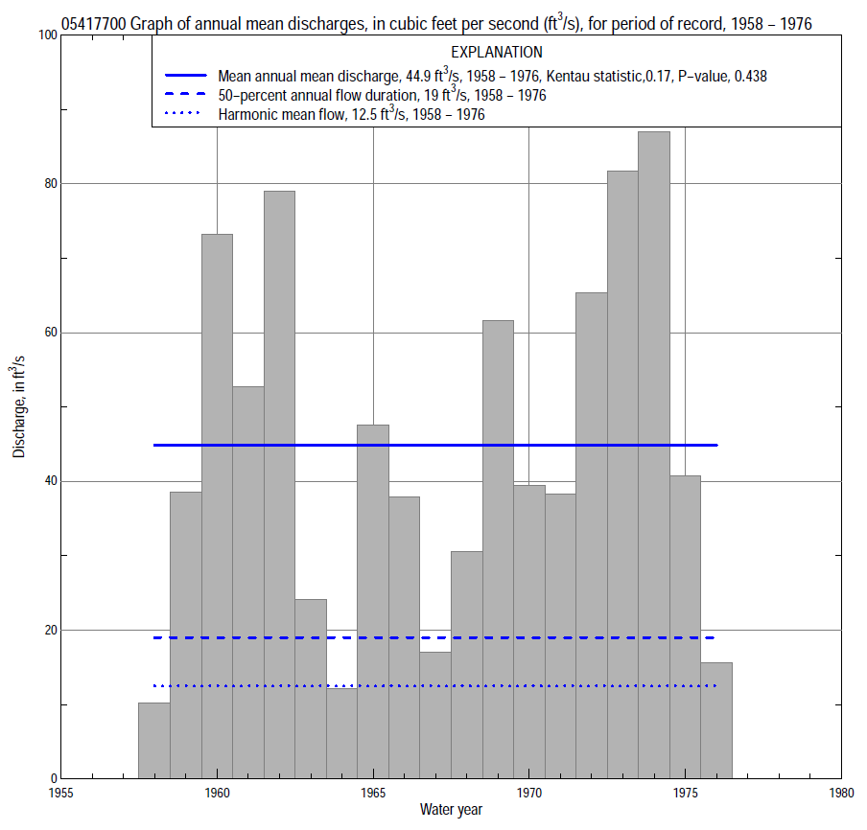

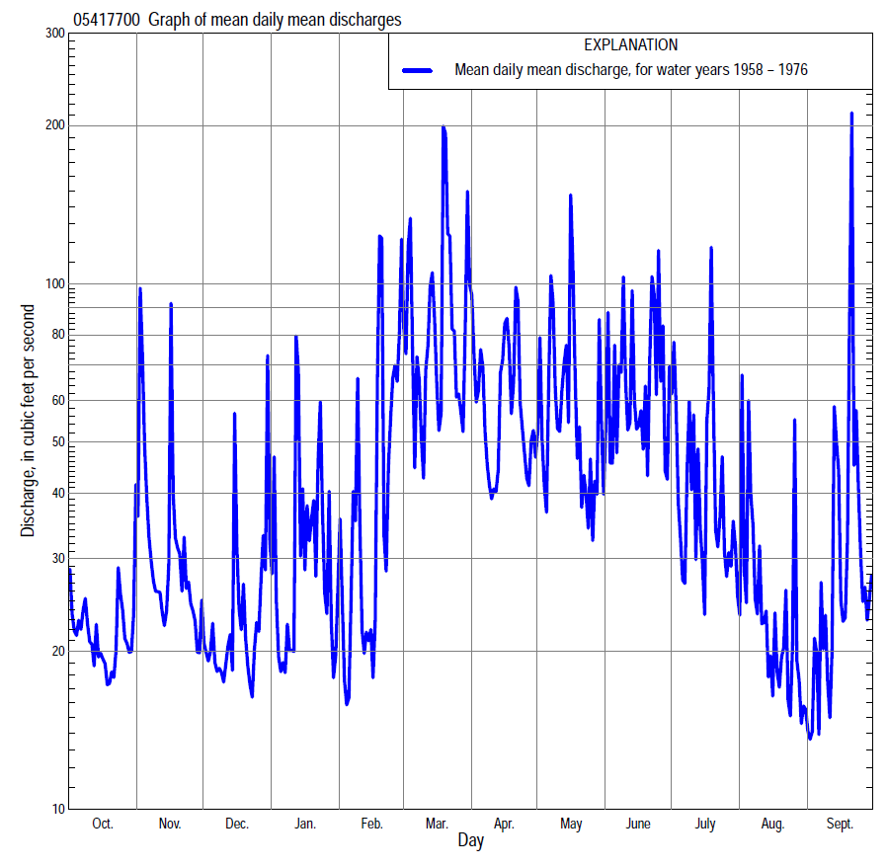

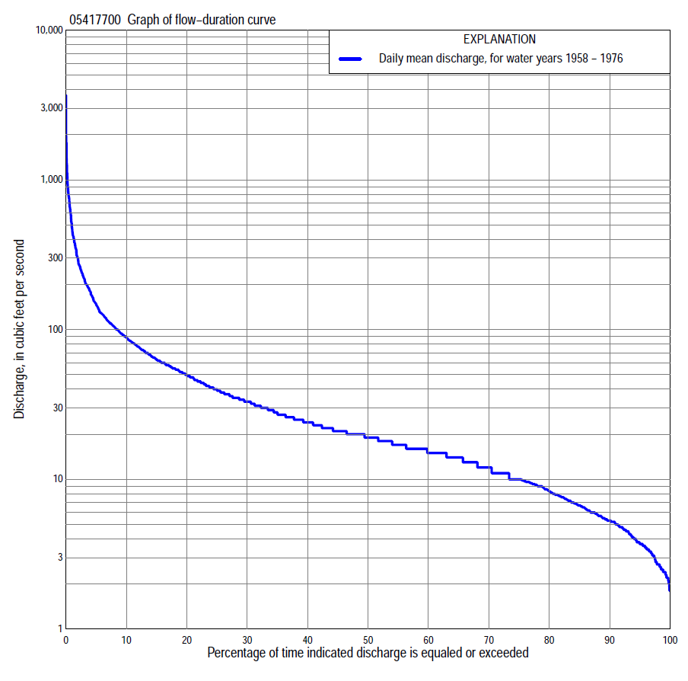

Statistics Based on the Entire Streamflow Period of Record
05417700 Monthly and annual flow durations, based on 1958–76 period of record (19 years)
Percentage of days discharge equaled or exceeded |  |  |  |  | Discharge (cubic feet per second) |  |  |  |  |  |  |  |  | Annual flow durations
 | Oct | Nov | Dec | Jan | Feb | Mar | Apr | May | June | July | Aug | Sept | Annual | Kentau statistic | P-value
99 | 2.2 | 2.7 | 1.9 | 2.1 | 2.2 | 7.9 | 10 | 4.9 | 5.7 | 3.8 | 3.1 | 2.2 | 2.4 | 0.181 | 0.289
98 | 2.5 | 2.7 | 2.2 | 2.3 | 2.4 | 8.1 | 12 | 5.9 | 5.9 | 4.5 | 3.3 | 2.4 | 2.7 | 0.181 | 0.289
95 | 2.8 | 3.5 | 2.8 | 2.7 | 2.7 | 9.3 | 13 | 8.1 | 7.2 | 5.2 | 3.6 | 3.1 | 3.7 | 0.164 | 0.343
90 | 3.7 | 4.6 | 3.6 | 3.6 | 5.3 | 12 | 15 | 11 | 9.0 | 5.8 | 4.9 | 3.8 | 5.3 | 0.175 | 0.307
85 | 4.6 | 5.3 | 4.6 | 4.5 | 6.2 | 15 | 17 | 13 | 9.6 | 6.5 | 6.5 | 4.8 | 6.7 | 0.193 | 0.260
80 | 5.2 | 6.2 | 6.0 | 5.2 | 7.0 | 17 | 18 | 14 | 11 | 7.9 | 7.2 | 5.8 | 8.3 | 0.199 | 0.246
75 | 6.5 | 8.9 | 7.4 | 6.0 | 9.0 | 19 | 20 | 15 | 13 | 9.5 | 7.9 | 6.6 | 10 | 0.187 | 0.276
70 | 7.6 | 11 | 9.2 | 7.0 | 10 | 21 | 22 | 17 | 15 | 11 | 9.3 | 7.4 | 12 | 0.216 | 0.206
65 | 9.3 | 14 | 10 | 8.4 | 12 | 23 | 24 | 19 | 18 | 14 | 10 | 9.2 | 14 | 0.222 | 0.195
60 | 13 | 15 | 12 | 9.8 | 13 | 25 | 27 | 20 | 21 | 15 | 11 | 10 | 15 | 0.216 | 0.207
55 | 15 | 16 | 14 | 11 | 15 | 27 | 31 | 22 | 24 | 16 | 12 | 12 | 17 | 0.199 | 0.247
50 | 16 | 17 | 15 | 12 | 17 | 31 | 34 | 26 | 29 | 18 | 13 | 14 | 19 | 0.187 | 0.277
45 | 18 | 19 | 17 | 15 | 20 | 39 | 37 | 30 | 34 | 20 | 15 | 15 | 21 | 0.187 | 0.277
40 | 20 | 20 | 19 | 18 | 22 | 49 | 44 | 34 | 38 | 24 | 16 | 15 | 24 | 0.175 | 0.310
35 | 21 | 21 | 21 | 22 | 25 | 58 | 51 | 41 | 48 | 28 | 19 | 16 | 28 | 0.164 | 0.344
30 | 24 | 25 | 24 | 26 | 27 | 68 | 58 | 48 | 56 | 34 | 21 | 18 | 33 | 0.170 | 0.327
25 | 27 | 34 | 27 | 30 | 32 | 85 | 64 | 59 | 70 | 41 | 23 | 22 | 40 | 0.164 | 0.345
20 | 31 | 42 | 31 | 35 | 37 | 104 | 77 | 72 | 82 | 50 | 26 | 31 | 50 | 0.170 | 0.327
15 | 39 | 56 | 37 | 43 | 46 | 134 | 98 | 92 | 104 | 62 | 33 | 40 | 63 | 0.175 | 0.309
10 | 48 | 70 | 44 | 60 | 80 | 206 | 125 | 126 | 129 | 86 | 41 | 54 | 88 | 0.175 | 0.310
5 | 62 | 106 | 63 | 100 | 150 | 354 | 201 | 202 | 218 | 124 | 65 | 89 | 148 | 0.111 | 0.529
2 | 90 | 173 | 104 | 200 | 250 | 600 | 319 | 348 | 477 | 290 | 145 | 200 | 293 | 0.053 | 0.780
1 | 109 | 258 | 152 | 380 | 550 | 877 | 428 | 520 | 745 | 581 | 210 | 353 | 480 | 0.076 | 0.675

05417700 Annual exceedance probability of instantaneous peak discharges, in cubic feet per second (ft³/s), based on the Weighted Independent Estimates method,
Annual exceed-ance probability | Recur-rence interval (years) | Discharge (ft³/s) | 95-percent lower confi-dence interval (ft³/s) | 95-percent upper confi-dence interval (ft³/s)
0.500 | 2 | 1,720 | 1,270 | 2,320
0.200 | 5 | 2,990 | 2,280 | 3,930
0.100 | 10 | 4,090 | 3,120 | 5,350
0.040 | 25 | 5,720 | 4,320 | 7,580
0.020 | 50 | 6,840 | 5,040 | 9,280
0.010 | 100 | 7,940 | 5,660 | 11,100
0.005 | 200 | 9,670 | 6,630 | 14,100
0.002 | 500 | 10,600 | 6,920 | 16,300
and based on the expected moments algorithm/multiple Grubbs-Beck analysis computed using a historical period length of 19 years (1958–1976)
0.500 | 2 | 1,710 | 1,180 | 2,350
0.200 | 5 | 2,960 | 2,160 | 4,370
0.100 | 10 | 3,870 | 2,810 | 6,290
0.040 | 25 | 5,050 | 3,560 | 9,580
0.020 | 50 | 5,940 | 4,070 | 12,700
0.010 | 100 | 6,840 | 4,510 | 16,500
0.005 | 200 | 7,740 | 4,890 | 21,100
0.002 | 500 | 8,950 | 5,330 | 28,700
Kentau statistic |  | -0.053
P-value |  | 0.780
Begin year |  | 1958
End year |  | 1976
Number of peaks |  | 19

05417700 Annual exceedance probability of high discharges, based on 1958–76 period of record (19 years)
Annual exceedance probability | Recur-rence interval (years) | Maximum average discharge (ft³/s) for indicated number of consecutive days
 |  | 1 | 3 | 7 | 15 | 30
0.990 | 1.01 | 105 | 77 | 40 | 26 | 15
0.950 | 1.05 | 227 | 144 | 78 | 52 | 33
0.900 | 1.11 | 329 | 198 | 110 | 72 | 48
0.800 | 1.25 | 497 | 286 | 161 | 105 | 73
0.500 | 2 | 988 | 550 | 316 | 201 | 146
0.200 | 5 | 1,730 | 992 | 567 | 347 | 256
0.100 | 10 | 2,210 | 1,320 | 747 | 444 | 326
0.040 | 25 | 2,780 | 1,750 | 978 | 561 | 407
0.020 | 50 | 3,170 | 2,090 | 1,150 | 645 | 461
0.010 | 100 | 3,530 | 2,430 | 1,320 | 723 | 511
0.005 | 200 | 3,860 | 2,770 | 1,490 | 797 | 555
0.002 | 500 | 4,260 | 3,230 | 1,710 | 890 | 608
Kentau statistic |  | 0.041 | 0.076 | 0.146 | 0.158 | 0.193
P-value |  | 0.834 | 0.675 | 0.401 | 0.363 | 0.263

 | 05417700 Annual nonexceedance probability of low discharges, based on April 1958 to March 1976 period of record (18 years)
Annual nonexceed-ance probability | Recur-rence interval (years) | Minimum average discharge (cubic feet per second) for indicated number of consecutive days
 |  | 1 | 3 | 7 | 14 | 30 | 60 | 90 | 120 | 183
0.01 | 100 | 1.3 | 1.4 | 1.5 | 1.6 | 1.7 | 1.9 | 2.0 | 2.0 | 2.1
0.02 | 50 | 1.5 | 1.6 | 1.8 | 1.9 | 2.1 | 2.3 | 2.5 | 2.6 | 2.8
0.05 | 20 | 1.9 | 2.0 | 2.2 | 2.4 | 2.7 | 3.2 | 3.5 | 3.6 | 4.3
0.10 | 10 | 2.3 | 2.4 | 2.8 | 3.0 | 3.5 | 4.2 | 4.7 | 5.0 | 6.2
0.20 | 5 | 2.9 | 3.1 | 3.6 | 4.0 | 4.7 | 5.8 | 6.6 | 7.3 | 9.4
0.50 | 2 | 4.8 | 5.1 | 6.0 | 6.5 | 8.1 | 10 | 12 | 14 | 19
0.80 | 1.25 | 8.2 | 8.8 | 9.8 | 11 | 13 | 18 | 22 | 26 | 36
0.90 | 1.11 | 11 | 12 | 13 | 14 | 17 | 23 | 29 | 35 | 48
0.96 | 1.04 | 15 | 17 | 17 | 18 | 22 | 30 | 38 | 47 | 64
0.98 | 1.02 | 19 | 20 | 21 | 22 | 25 | 36 | 45 | 56 | 77
0.99 | 1.01 | 22 | 23 | 24 | 26 | 29 | 41 | 53 | 66 | 89
Kentau statistic |  | 0.209 | 0.203 | 0.183 | 0.209 | 0.163 | 0.137 | 0.111 | 0.124 | 0.098
P-value |  | 0.240 | 0.256 | 0.306 | 0.240 | 0.363 | 0.449 | 0.544 | 0.495 | 0.596

05417700 Annual nonexceedance probability of seasonal low discharges, based on October 1957 to September 1976 period of record (19 years)
Annual nonexceed-ance probability | Recur-rence interval (years) | Minimum average discharge (cubic feet per second) for indicated number of consecutive days
 |  | 1 | 7 | 14 | 30 |  | 1 | 7 | 14 | 30
 |  | January-February-March |  |  |  |  | April-May-June
0.01 | 100 | 1.1 | 1.3 | 1.4 | 1.5 |  | 2.6 | 2.9 | 3.6 | 4.7
0.02 | 50 | 1.4 | 1.6 | 1.7 | 2.0 |  | 3.2 | 3.5 | 4.2 | 5.4
0.05 | 20 | 1.8 | 2.2 | 2.4 | 2.9 |  | 4.2 | 4.7 | 5.3 | 6.9
0.10 | 10 | 2.4 | 2.9 | 3.2 | 4.0 |  | 5.3 | 6.0 | 6.7 | 8.7
0.20 | 5 | 3.3 | 4.1 | 4.7 | 5.9 |  | 7.2 | 8.2 | 9.1 | 12
0.50 | 2 | 6.0 | 7.7 | 9.1 | 13 |  | 13 | 15 | 17 | 22
0.80 | 1.25 | 11 | 14 | 17 | 27 |  | 24 | 29 | 35 | 44
0.90 | 1.11 | 15 | 20 | 23 | 41 |  | 33 | 41 | 52 | 67
0.96 | 1.04 | 21 | 28 | 31 | 63 |  | 46 | 60 | 82 | 106
0.98 | 1.02 | 26 | 35 | 38 | 82 |  | 58 | 77 | 111 | 146
0.99 | 1.01 | 31 | 43 | 45 | 105 |  | 71 | 96 | 148 | 196
Kentau statistic |  | 0.170 | 0.152 | 0.146 | 0.205 |  | 0.228 | 0.251 | 0.275 | 0.181
P-value |  | 0.327 | 0.381 | 0.401 | 0.234 |  | 0.184 | 0.142 | 0.108 | 0.294
 |  | July-August-September |  |  |  |  | October-November-December
0.01 | 100 | 1.6 | 1.8 | 1.9 | 2.2 |  | 1.1 | 1.0 | 1.1 | 1.4
0.02 | 50 | 1.9 | 2.2 | 2.3 | 2.6 |  | 1.4 | 1.4 | 1.5 | 1.9
0.05 | 20 | 2.5 | 2.9 | 3.0 | 3.4 |  | 2.0 | 2.1 | 2.3 | 2.8
0.10 | 10 | 3.1 | 3.6 | 3.8 | 4.4 |  | 2.8 | 3.0 | 3.3 | 3.9
0.20 | 5 | 4.1 | 4.7 | 4.9 | 5.9 |  | 4.0 | 4.5 | 5.0 | 5.8
0.50 | 2 | 6.8 | 7.6 | 8.1 | 10 |  | 7.7 | 9.2 | 10 | 12
0.80 | 1.25 | 11 | 12 | 13 | 17 |  | 14 | 17 | 19 | 22
0.90 | 1.11 | 14 | 15 | 16 | 22 |  | 18 | 24 | 25 | 30
0.96 | 1.04 | 18 | 19 | 20 | 28 |  | 23 | 32 | 33 | 41
0.98 | 1.02 | 22 | 22 | 23 | 34 |  | 27 | 38 | 40 | 49
0.99 | 1.01 | 25 | 25 | 26 | 39 |  | 32 | 45 | 46 | 58
Kentau statistic |  | 0.129 | 0.193 | 0.170 | 0.076 |  | 0.234 | 0.193 | 0.205 | 0.193
P-value |  | 0.462 | 0.263 | 0.327 | 0.675 |  | 0.172 | 0.263 | 0.234 | 0.263

