LOCATION.--Lat 42°08'48", long 90°40'33" referenced to North American Datum of 1927, in SE 1/4 NE 1/4 NW 1/4 sec.25, T.85 N., R.2 E., Jackson County, IA, Hydrologic Unit 07060006, on right bank on downstream side of bridge on State Highway 61, 0.5 mi south of Fulton, and 7.8 mi upstream from mouth.

DRAINAGE AREA.--516 mi².

PERIOD OF RECORD.--July 1977 to September 1991.

GAGE.--Water-stage recorder. Datum of gage is 666.19 ft above National Geodetic Vertical Datum of 1929. Prior to September 23, 1977, non-recording gage at same site and datum.

EXTREMES OUTSIDE PERIOD OF RECORD.--Flood of May 18, 1974, reached a stage of 16.00 ft, from floodmark, discharge 10,000 ft³/s.

A summary of all available data for this streamgage is provided through the USGS National Water Information System web interface (NWISWeb). The following link provides access to current/historical observations, daily data, daily statistics, monthly statistics, annual statistics, peak streamflow, field measurements, field/lab water-quality samples, and the latest water-year summaries. Data can be filtered by parameter and/or dates, and can be output in various tabular and graphical formats.
http://waterdata.usgs.gov/nwis/inventory/?site_no=05418450

The USGS WaterWatch Toolkit is available at:
http://waterwatch.usgs.gov/?id=ww_toolkit
Tools for summarizing streamflow information include the duration hydrograph builder, the cumulative streamflow hydrograph builder, the streamgage statistics retrieval tool, the rating curve builder, the flood tracking chart builder, the National Weather Service Advanced Hydrologic Prediction Service (AHPS) river forecast hydrograph builder, and the raster-hydrograph builder. Entering the above number for this streamgage into these toolkit webpages will provide streamflow information specific to this streamgage.

A description of the statistics presented for this streamgage is available in the main body of the report at:
http://dx.doi.org/10.3133/ofr20151214
A link to other streamgages included in this report, a map showing the location of the streamgages, information on the programs used to compute the statistical analyses, and references are included in the main body of the report.

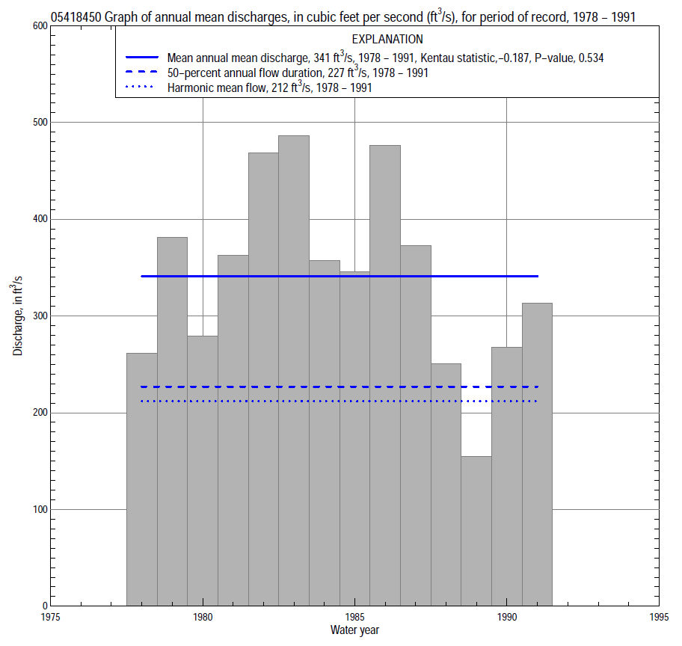

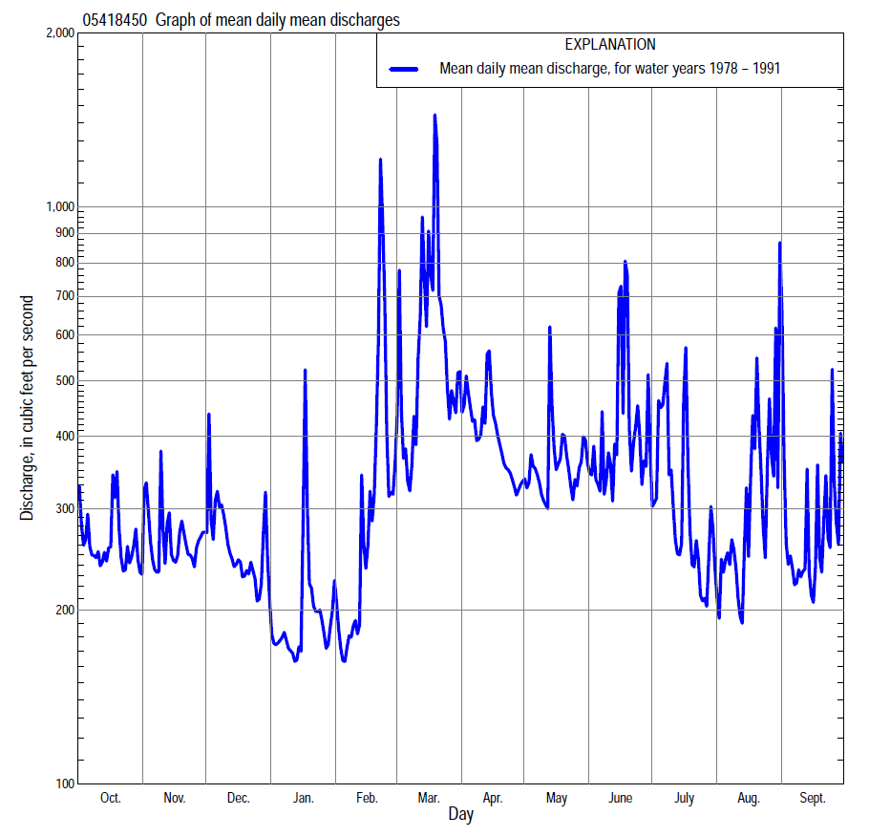

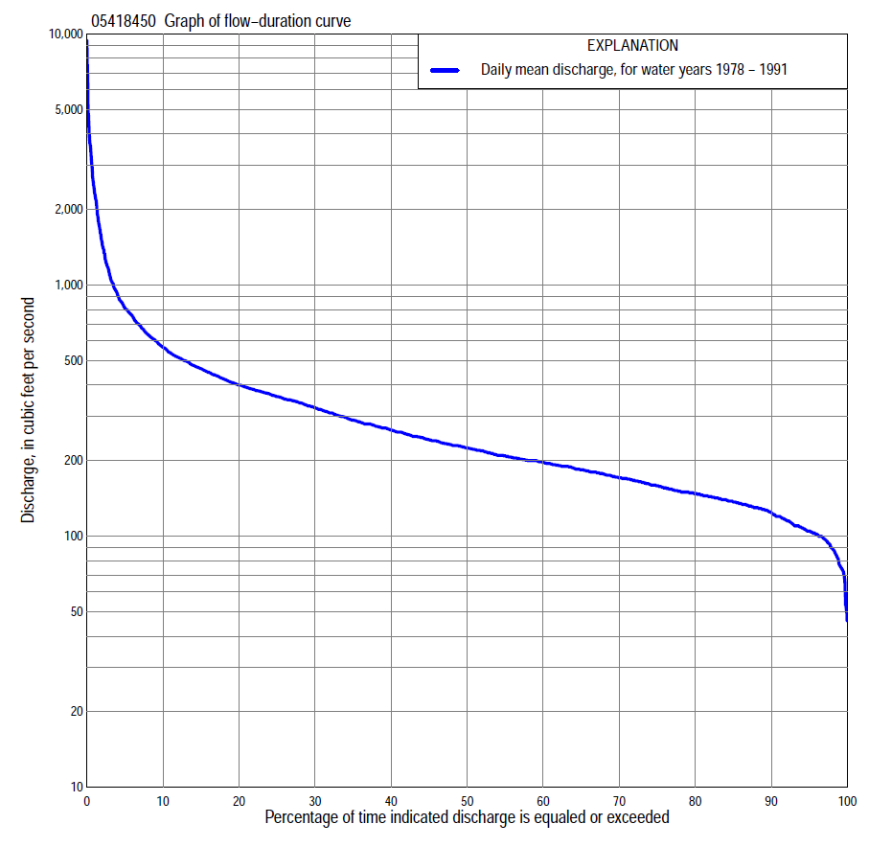

Statistics Based on the Entire Streamflow Period of Record
05418450 Monthly and annual flow durations, based on 1978–91 period of record (14 years)
Percentage of days discharge equaled or exceeded |  |  |  |  | Discharge (cubic feet per second) |  |  |  |  |  |  |  |  | Annual flow durations
 | Oct | Nov | Dec | Jan | Feb | Mar | Apr | May | June | July | Aug | Sept | Annual | Kentau statistic | P-value
99 | 100 | 105 | 50 | 69 | 72 | 90 | 116 | 132 | 109 | 99 | 95 | 103 | 78 | -0.110 | 0.622
98 | 103 | 107 | 52 | 74 | 74 | 96 | 125 | 134 | 116 | 103 | 100 | 105 | 93 | -0.099 | 0.661
95 | 104 | 114 | 84 | 85 | 83 | 116 | 132 | 137 | 149 | 110 | 115 | 116 | 105 | -0.143 | 0.511
90 | 120 | 133 | 101 | 95 | 100 | 152 | 146 | 153 | 163 | 134 | 133 | 129 | 127 | -0.132 | 0.546
85 | 137 | 139 | 110 | 105 | 110 | 175 | 188 | 170 | 172 | 147 | 141 | 134 | 138 | -0.099 | 0.661
80 | 146 | 147 | 127 | 119 | 118 | 191 | 241 | 187 | 189 | 154 | 145 | 144 | 149 | -0.121 | 0.583
75 | 154 | 160 | 135 | 125 | 130 | 215 | 261 | 208 | 207 | 170 | 151 | 157 | 160 | -0.132 | 0.546
70 | 164 | 172 | 149 | 136 | 140 | 244 | 280 | 242 | 225 | 180 | 159 | 169 | 173 | -0.077 | 0.743
65 | 173 | 180 | 155 | 143 | 150 | 263 | 303 | 256 | 238 | 190 | 171 | 173 | 185 | -0.055 | 0.827
60 | 185 | 185 | 169 | 150 | 170 | 278 | 323 | 277 | 260 | 196 | 183 | 186 | 199 | -0.099 | 0.661
55 | 192 | 195 | 180 | 156 | 180 | 314 | 345 | 303 | 279 | 202 | 198 | 194 | 210 | -0.121 | 0.584
50 | 195 | 204 | 200 | 162 | 195 | 350 | 365 | 331 | 298 | 212 | 216 | 204 | 227 | -0.099 | 0.661
45 | 200 | 223 | 220 | 178 | 205 | 378 | 380 | 344 | 331 | 226 | 223 | 211 | 244 | -0.121 | 0.584
40 | 204 | 243 | 240 | 190 | 223 | 404 | 401 | 358 | 353 | 242 | 232 | 222 | 268 | -0.132 | 0.546
35 | 209 | 281 | 270 | 200 | 239 | 435 | 423 | 377 | 373 | 261 | 243 | 233 | 292 | -0.099 | 0.661
30 | 217 | 300 | 280 | 210 | 260 | 478 | 455 | 397 | 399 | 291 | 268 | 248 | 328 | -0.099 | 0.661
25 | 229 | 317 | 315 | 230 | 300 | 557 | 484 | 428 | 445 | 320 | 290 | 271 | 363 | -0.099 | 0.661
20 | 255 | 350 | 359 | 240 | 360 | 684 | 521 | 470 | 487 | 350 | 326 | 289 | 402 | -0.077 | 0.743
15 | 364 | 403 | 402 | 260 | 449 | 838 | 576 | 517 | 560 | 393 | 380 | 338 | 467 | -0.033 | 0.913
10 | 528 | 460 | 482 | 285 | 620 | 1,290 | 657 | 574 | 715 | 448 | 551 | 440 | 570 | -0.121 | 0.584
5 | 762 | 538 | 616 | 350 | 1,040 | 2,110 | 835 | 716 | 976 | 698 | 800 | 672 | 814 | -0.011 | 1.000
2 | 1,020 | 707 | 750 | 465 | 2,250 | 3,000 | 1,070 | 860 | 1,890 | 1,280 | 1,750 | 1,220 | 1,480 | -0.253 | 0.228
1 | 1,390 | 969 | 1,050 | 900 | 2,720 | 4,510 | 1,400 | 951 | 3,100 | 3,600 | 3,080 | 2,400 | 2,370 | -0.385 | 0.063

05418450 Annual exceedance probability of instantaneous peak discharges, in cubic feet per second (ft³/s), based on the Weighted Independent Estimates method,
Annual exceed-ance probability | Recur-rence interval (years) | Discharge (ft³/s) | 95-percent lower confi-dence interval (ft³/s) | 95-percent upper confi-dence interval (ft³/s)
0.500 | 2 | 6,870 | 5,740 | 8,220
0.200 | 5 | 11,700 | 9,910 | 13,900
0.100 | 10 | 15,300 | 12,800 | 18,300
0.040 | 25 | 20,300 | 16,600 | 24,800
0.020 | 50 | 23,900 | 19,000 | 30,000
0.010 | 100 | 27,300 | 21,000 | 35,500
0.005 | 200 | 32,200 | 23,900 | 43,400
0.002 | 500 | 35,800 | 25,300 | 50,600
and based on the expected moments algorithm/multiple Grubbs-Beck analysis computed using a historical period length of 60 years (1954–2013)ª
0.500 | 2 | 6,880 | 4,470 | 8,630
0.200 | 5 | 11,900 | 9,310 | 15,300
0.100 | 10 | 15,400 | 11,900 | 20,900
0.040 | 25 | 19,900 | 15,000 | 30,100
0.020 | 50 | 23,200 | 17,100 | 38,500
0.010 | 100 | 26,600 | 19,100 | 48,100
0.005 | 200 | 29,900 | 21,000 | 58,700
0.002 | 500 | 34,200 | 23,200 | 74,500
Kentau statistic |  | -0.181
P-value |  | 0.373
Begin year |  | 1977
End year |  | 1991
Number of peaks |  | 15
ªAnalysis includes interval annual-peak discharges (1999–2001, 2003–13) from streamgage 05418400 North Fork Maquoketa River near Fulton.

05418450 Annual exceedance probability of high discharges, based on 1978–91 period of record (14 years)
Annual exceedance probability | Recur-rence interval (years) | Maximum average discharge (ft³/s) for indicated number of consecutive days
 |  | 1 | 3 | 7 | 15 | 30
0.990 | 1.01 | 591 | 570 | 434 | 314 | 242
0.950 | 1.05 | 1,330 | 1,060 | 753 | 520 | 394
0.900 | 1.11 | 1,920 | 1,420 | 977 | 661 | 494
0.800 | 1.25 | 2,830 | 1,940 | 1,300 | 864 | 634
0.500 | 2 | 5,070 | 3,220 | 2,060 | 1,340 | 941
0.200 | 5 | 7,520 | 4,720 | 2,930 | 1,890 | 1,270
0.100 | 10 | 8,670 | 5,510 | 3,400 | 2,200 | 1,430
0.040 | 25 | 9,680 | 6,320 | 3,880 | 2,520 | 1,590
0.020 | 50 | 10,200 | 6,790 | 4,160 | 2,720 | 1,690
0.010 | 100 | 10,600 | 7,180 | 4,400 | 2,890 | 1,760
0.005 | 200 | 10,900 | 7,510 | 4,610 | 3,040 | 1,820
0.002 | 500 | 11,100 | 7,860 | 4,830 | 3,210 | 1,890
Kentau statistic |  | -0.319 | -0.319 | -0.363 | -0.275 | -0.187
P-value |  | 0.125 | 0.125 | 0.080 | 0.189 | 0.381

 | 05418450 Annual nonexceedance probability of low discharges, based on April 1978 to March 1991 period of record (13 years)
Annual nonexceed-ance probability | Recur-rence interval (years) | Minimum average discharge (cubic feet per second) for indicated number of consecutive days
 |  | 1 | 3 | 7 | 14 | 30 | 60 | 90 | 120 | 183
0.01 | 100 | 34 | 34 | 36 | 38 | 50 | 68 | 73 | 74 | 83
0.02 | 50 | 40 | 41 | 43 | 45 | 58 | 76 | 83 | 83 | 93
0.05 | 20 | 50 | 52 | 54 | 57 | 71 | 88 | 97 | 99 | 110
0.10 | 10 | 61 | 63 | 66 | 70 | 84 | 101 | 111 | 115 | 129
0.20 | 5 | 76 | 79 | 82 | 87 | 101 | 118 | 131 | 138 | 155
0.50 | 2 | 109 | 113 | 119 | 125 | 140 | 157 | 177 | 192 | 220
0.80 | 1.25 | 149 | 151 | 159 | 168 | 182 | 205 | 235 | 263 | 314
0.90 | 1.11 | 170 | 171 | 181 | 191 | 206 | 233 | 271 | 309 | 378
0.96 | 1.04 | 194 | 195 | 203 | 214 | 231 | 267 | 313 | 365 | 462
0.98 | 1.02 | 210 | 211 | 217 | 229 | 247 | 290 | 342 | 405 | 525
0.99 | 1.01 | 223 | 224 | 229 | 241 | 261 | 312 | 371 | 445 | 590
Kentau statistic |  | -0.090 | -0.115 | 0.000 | 0.000 | -0.026 | -0.051 | -0.026 | -0.128 | -0.154
P-value |  | 0.714 | 0.625 | 1.000 | 1.000 | 0.951 | 0.855 | 0.951 | 0.583 | 0.502

05418450 Annual nonexceedance probability of seasonal low discharges, based on July 1977 to September 1991 period of record (14–15 years)
Annual nonexceed-ance probability | Recur-rence interval (years) | Minimum average discharge (cubic feet per second) for indicated number of consecutive days
 |  | 1 | 7 | 14 | 30 |  | 1 | 7 | 14 | 30
 |  | January-February-March |  |  |  |  | April-May-June
0.01 | 100 | 43 | 51 | 53 | 73 |  | 81 | 90 | 90 | 93
0.02 | 50 | 48 | 57 | 59 | 80 |  | 90 | 99 | 100 | 105
0.05 | 20 | 56 | 66 | 69 | 90 |  | 104 | 114 | 118 | 125
0.10 | 10 | 65 | 76 | 79 | 101 |  | 119 | 130 | 136 | 146
0.20 | 5 | 78 | 90 | 94 | 116 |  | 140 | 152 | 162 | 176
0.50 | 2 | 108 | 123 | 130 | 154 |  | 193 | 207 | 224 | 247
0.80 | 1.25 | 151 | 170 | 181 | 207 |  | 267 | 282 | 309 | 340
0.90 | 1.11 | 179 | 201 | 216 | 244 |  | 317 | 332 | 364 | 399
0.96 | 1.04 | 215 | 241 | 261 | 291 |  | 382 | 397 | 434 | 470
0.98 | 1.02 | 242 | 271 | 295 | 328 |  | 431 | 445 | 485 | 522
0.99 | 1.01 | 269 | 301 | 330 | 365 |  | 481 | 494 | 536 | 572
Kentau statistic |  | -0.022 | 0.143 | 0.143 | 0.231 |  | -0.209 | -0.187 | -0.209 | -0.187
P-value |  | 0.956 | 0.511 | 0.511 | 0.274 |  | 0.324 | 0.381 | 0.324 | 0.381
 |  | July-August-September |  |  |  |  | October-November-December
0.01 | 100 | 58 | 63 | 67 | 98 |  | 36 | 39 | 41 | 65
0.02 | 50 | 66 | 71 | 75 | 104 |  | 42 | 48 | 50 | 74
0.05 | 20 | 80 | 85 | 89 | 116 |  | 52 | 62 | 67 | 90
0.10 | 10 | 93 | 98 | 103 | 128 |  | 64 | 77 | 84 | 106
0.20 | 5 | 111 | 116 | 122 | 144 |  | 80 | 98 | 109 | 129
0.50 | 2 | 149 | 156 | 165 | 182 |  | 120 | 147 | 163 | 183
0.80 | 1.25 | 192 | 202 | 215 | 233 |  | 176 | 203 | 220 | 256
0.90 | 1.11 | 215 | 229 | 244 | 266 |  | 211 | 234 | 248 | 302
0.96 | 1.04 | 240 | 259 | 278 | 308 |  | 255 | 266 | 276 | 358
0.98 | 1.02 | 256 | 279 | 300 | 339 |  | 285 | 286 | 292 | 399
0.99 | 1.01 | 270 | 297 | 321 | 369 |  | 303 | 304 | 305 | 438
Kentau statistic |  | 0.000 | -0.010 | -0.010 | -0.162 |  | -0.011 | 0.055 | 0.077 | 0.011
P-value |  | 1.000 | 1.000 | 1.000 | 0.428 |  | 1.000 | 0.827 | 0.743 | 1.000

