LOCATION.--Lat 41°46'50", long 90°15'07" referenced to North American Datum of 1927, in SW 1/4 SE 1/4 NW 1/4 sec.34, T.81 N., R.6 E., Clinton County, IA, Hydrologic Unit 07080101, on right bank near end of 8th Avenue in Camanche, 5.0 mi upstream from Wapsipinicon River, 6.4 mi downstream from Clinton, 10.6 mi downstream from Lock and Dam 13, and 511.8 mi upstream from Ohio River.

DRAINAGE AREA.--85,600 mi².

PERIOD OF RECORD.--Discharge records from June to August 1873 (fragmentary), October 1873 to current year. October 1932 to September 1939, published as "at Le Claire". June 1873 to December 1932, published in the Iowa State Planning Board report "Stream-flow records of Iowa, 1873-1932".

GAGE.--Water-stage recorder. Datum of gage is 562.68 ft above National Geodetic Vertical Datum of 1929. June 1873 to May 31, 1934, non-recording gage, and June 1, 1934, to September 30, 1939, water-stage recorder, both at site 14.8 mi downstream at Le Claire at datum 0.07 ft lower; October 1, 1939, to September 30, 1955, water-stage recorder at site 10.6 mi upstream at Lock and Dam 13 at datum 5.48 ft higher; October 1, 1955, to June 5, 1969, water-stage recorder at same site and datum; June 6, 1969, to September 16, 1988, water-stage recorder at site 400 ft upstream at same datum; since October 1, 1958, auxiliary water-stage recorder at site 10.6 mi upstream at Lock and Dam 13 at datum 5.48 ft higher.

REMARKS.--Minor flow regulation caused by navigation dams.

EXTREMES OUTSIDE PERIOD OF RECORD.--Since at least 1828, no flood outside the period of record exceeded the April 28, 1965, stage of 24.65 ft.

A summary of all available data for this streamgage is provided through the USGS National Water Information System web interface (NWISWeb). The following link provides access to current/historical observations, daily data, daily statistics, monthly statistics, annual statistics, peak streamflow, field measurements, field/lab water-quality samples, and the latest water-year summaries. Data can be filtered by parameter and/or dates, and can be output in various tabular and graphical formats.
http://waterdata.usgs.gov/nwis/inventory/?site_no=05420500

The USGS WaterWatch Toolkit is available at:
http://waterwatch.usgs.gov/?id=ww_toolkit
Tools for summarizing streamflow information include the duration hydrograph builder, the cumulative streamflow hydrograph builder, the streamgage statistics retrieval tool, the rating curve builder, the flood tracking chart builder, the National Weather Service Advanced Hydrologic Prediction Service (AHPS) river forecast hydrograph builder, and the raster-hydrograph builder. Entering the above number for this streamgage into these toolkit webpages will provide streamflow information specific to this streamgage.

A description of the statistics presented for this streamgage is available in the main body of the report at:
http://dx.doi.org/10.3133/ofr20151214
A link to other streamgages included in this report, a map showing the location of the streamgages, information on the programs used to compute the statistical analyses, and references are included in the main body of the report.

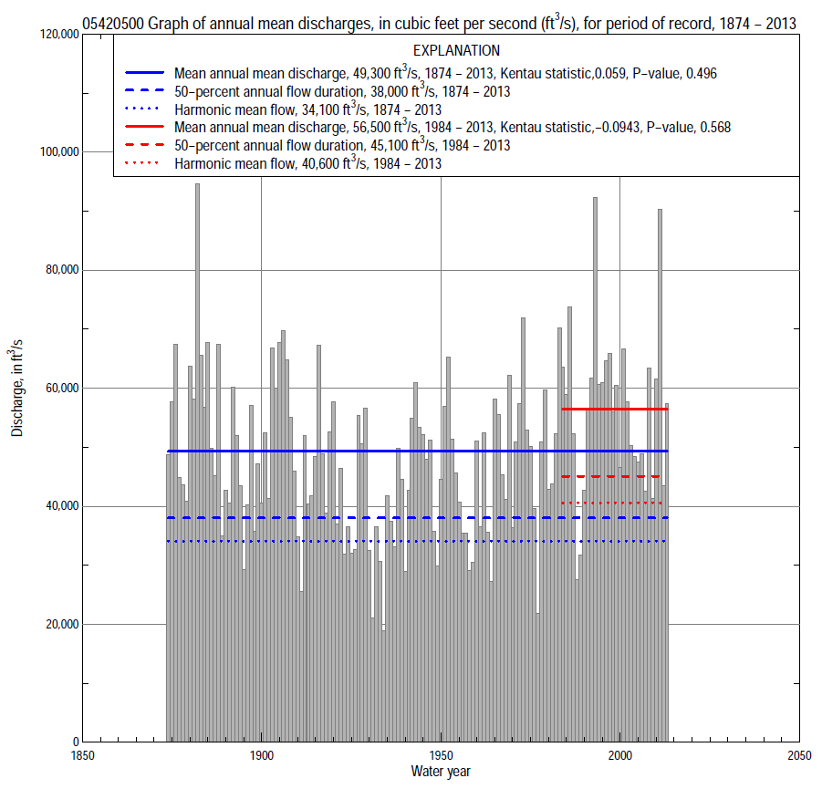

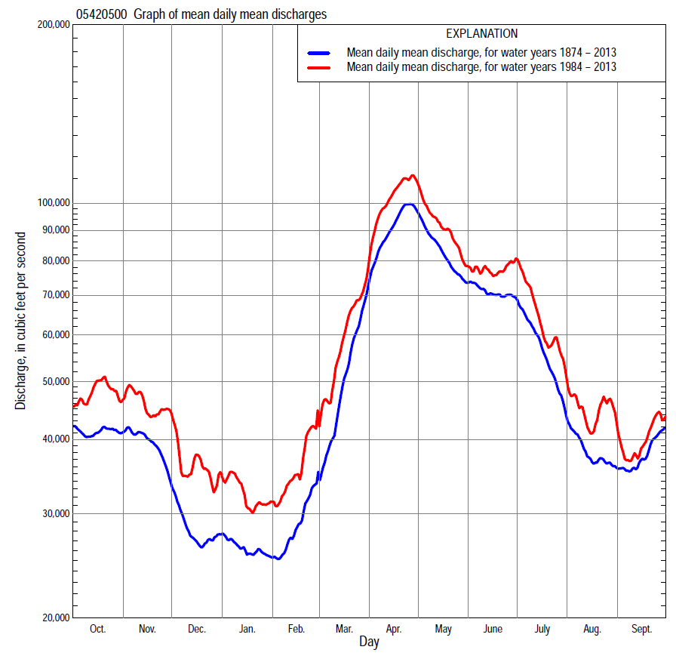

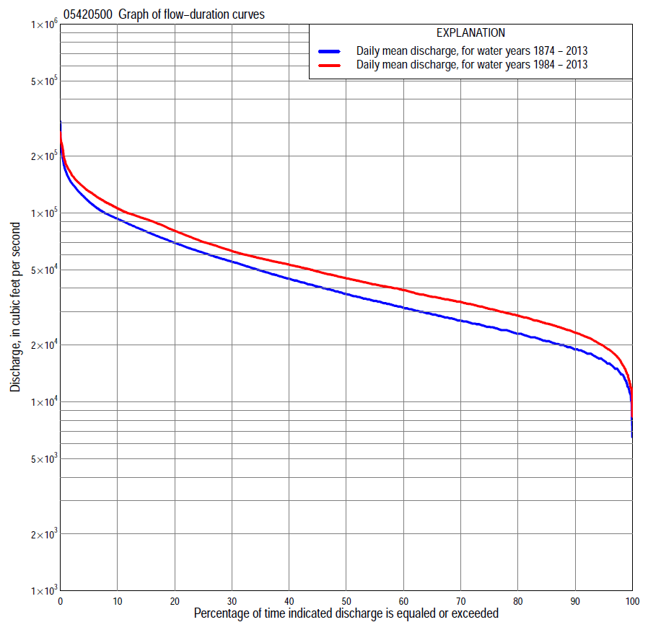

Statistics Based on the Entire Streamflow Period of Record
05420500 Monthly and annual flow durations, based on 1874–2013 period of record (140 years)
Percentage of days discharge equaled or exceeded |  |  |  |  | Discharge (cubic feet per second) |  |  |  |  |  |  |  |  | Annual flow durations
 | Oct | Nov | Dec | Jan | Feb | Mar | Apr | May | June | July | Aug | Sept | Annual | Kentau statistic | P-value
99 | 13,900 | 12,600 | 9,440 | 10,800 | 12,300 | 15,900 | 24,400 | 21,100 | 16,400 | 15,200 | 11,700 | 13,400 | 12,500 | 0.256 | 0.000
98 | 15,300 | 14,200 | 10,700 | 12,200 | 13,000 | 17,600 | 27,400 | 24,100 | 19,200 | 16,300 | 13,100 | 15,000 | 14,000 | 0.244 | 0.000
95 | 17,000 | 16,700 | 12,700 | 14,300 | 15,100 | 20,400 | 35,100 | 30,600 | 24,600 | 19,400 | 15,800 | 16,500 | 16,400 | 0.153 | 0.007
90 | 19,500 | 19,800 | 15,000 | 16,000 | 16,500 | 23,500 | 41,400 | 38,300 | 31,400 | 22,800 | 18,800 | 19,100 | 19,300 | 0.137 | 0.017
85 | 21,100 | 22,100 | 16,500 | 17,200 | 17,900 | 26,200 | 47,400 | 44,200 | 37,300 | 26,300 | 21,000 | 20,700 | 21,400 | 0.137 | 0.016
80 | 22,800 | 24,100 | 17,900 | 18,400 | 19,200 | 28,900 | 53,300 | 49,300 | 42,100 | 29,900 | 23,200 | 22,400 | 23,500 | 0.131 | 0.022
75 | 24,300 | 25,700 | 19,400 | 19,400 | 20,300 | 31,400 | 58,600 | 54,200 | 45,700 | 33,500 | 25,000 | 23,900 | 25,500 | 0.098 | 0.086
70 | 25,700 | 27,400 | 20,600 | 20,300 | 21,400 | 33,800 | 63,800 | 58,400 | 49,100 | 36,900 | 26,700 | 25,300 | 27,600 | 0.073 | 0.198
65 | 27,100 | 29,200 | 21,900 | 21,200 | 22,500 | 36,500 | 69,800 | 62,500 | 52,500 | 40,000 | 28,500 | 26,800 | 30,100 | 0.061 | 0.284
60 | 28,800 | 31,000 | 23,200 | 22,000 | 23,600 | 39,300 | 76,200 | 66,900 | 56,400 | 43,200 | 30,200 | 28,300 | 32,600 | 0.053 | 0.354
55 | 30,800 | 32,800 | 24,400 | 22,900 | 24,800 | 42,200 | 82,200 | 72,100 | 60,300 | 46,800 | 31,900 | 30,300 | 35,200 | 0.051 | 0.375
50 | 32,800 | 34,600 | 25,600 | 24,200 | 26,000 | 45,500 | 86,700 | 77,300 | 64,200 | 50,500 | 33,600 | 32,200 | 38,600 | 0.037 | 0.518
45 | 34,800 | 36,900 | 26,800 | 25,600 | 27,200 | 49,000 | 91,300 | 82,600 | 68,700 | 54,300 | 35,400 | 34,200 | 42,000 | 0.040 | 0.479
40 | 37,700 | 39,300 | 28,100 | 27,000 | 28,700 | 52,500 | 95,800 | 87,800 | 73,800 | 58,900 | 38,000 | 36,600 | 46,400 | 0.040 | 0.487
35 | 40,600 | 41,800 | 30,200 | 28,600 | 30,600 | 56,500 | 101,000 | 93,100 | 78,900 | 63,400 | 40,500 | 39,400 | 51,200 | 0.032 | 0.580
30 | 43,900 | 44,900 | 32,300 | 30,500 | 32,500 | 60,700 | 107,000 | 98,400 | 84,500 | 68,300 | 43,100 | 42,200 | 57,000 | 0.024 | 0.679
25 | 49,000 | 48,600 | 34,300 | 32,400 | 34,400 | 64,900 | 114,000 | 106,000 | 90,400 | 73,600 | 47,300 | 46,400 | 63,500 | 0.014 | 0.801
20 | 54,600 | 52,300 | 37,600 | 34,400 | 37,100 | 70,600 | 122,000 | 114,000 | 96,400 | 78,900 | 51,400 | 51,300 | 72,100 | 0.008 | 0.885
15 | 61,600 | 58,600 | 41,500 | 37,300 | 40,300 | 77,000 | 135,000 | 124,000 | 105,000 | 86,900 | 57,500 | 57,700 | 82,500 | 0.015 | 0.795
10 | 71,900 | 65,600 | 47,400 | 40,900 | 44,100 | 86,300 | 148,000 | 138,000 | 118,000 | 96,700 | 64,900 | 64,800 | 96,100 | 0.020 | 0.731
5 | 95,300 | 79,000 | 56,300 | 47,100 | 52,800 | 102,000 | 177,000 | 158,000 | 141,000 | 114,000 | 78,600 | 77,100 | 119,000 | 0.036 | 0.533
2 | 138,000 | 94,500 | 65,400 | 54,000 | 67,900 | 125,000 | 207,000 | 186,000 | 168,000 | 142,000 | 95,800 | 95,400 | 148,000 | 0.058 | 0.311
1 | 169,000 | 103,000 | 77,000 | 61,100 | 78,900 | 143,000 | 224,000 | 215,000 | 184,000 | 170,000 | 107,000 | 114,000 | 176,000 | 0.058 | 0.313

05420500 Annual exceedance probability of instantaneous peak discharges, in cubic feet per second (ft³/s), based on U.S. Army Corps of Engineers flow frequency studyª, analysis computed using a systematic record length of 101 years (1898–1998)
USACE Flow Frequency Analysis
[ND, not determined]
Annual exceed-ance probability | Recurrence interval (years) | Discharge (ft³/s) | 95-percent lower confi-dence interval (ft³/s) | 95-percent upper confi-dence interval (ft³/s)
0.500 | 2 | 131,000 | 124,000 | 138,000
0.200 | 5 | 174,000 | 164,000 | 187,000
0.100 | 10 | 202,000 | 188,000 | 219,000
0.040 | 25 | 235,000 | ND | ND
0.020 | 50 | 259,000 | 237,000 | 289,000
0.010 | 100 | 283,000 | 257,000 | 319,000
0.005 | 200 | 306,000 | 276,000 | 348,000
0.002 | 500 | 337,000 | 301,000 | 387,000
ªU.S. Army Corps of Engineers, 2004b, Upper Mississippi River System Flow Frequency Study, Hydrology and Hydraulics Appendix C Mississippi River, Rock Island District: U.S. Army Corps of Engineers, 50 p., accessed September 9, 2014, at http://www.mvr.usace.army.mil/Portals/48/docs/FRM/UpperMissFlowFreq/App.%20C%20Rock%20Island%20Dist.%20Mississippi%20River%20Hydrology_Hydraulics.pdf.
USGS Kendall's Tau Trend Analysis
Kentau statistic |  | 0.154 | 0.079 | -0.211 | 0.124
P-value |  | 0.023 | 0.167 | 0.012 | 0.119
Begin year |  | 1898 | ^{b}1874 | ^{c}1874 | ^{d}1940
End year |  | 1998 | ^{b}2013 | ^{c}1939 | ^{d}2013
Number of peaks |  | 101 | 140 | 66 | 74
^{b}Kendall's tau trend analysis computed using the entire period of record which is not the same period of record used to compute the above flow frequency analysis
^{c}Kendall's tau trend analysis computed using the pre-regulated period of record which is not the same period of record used to compute the above flow frequency analysis
^{d}Kendall's tau trend analysis computed using the regulated period of record which is not the same period of record used to compute the above flow frequency analysis.

05420500 Annual exceedance probability of high discharges, based on 1874–2013 period of record (140 years)
[ND, not determined]
Annual exceed-ance probability | Recur-rence interval (years) | Maximum average discharge (cubic feet per second) for indicated number of consecutive days
 |  | 1 | 3 | 7 | 15 | 30
0.990 | 1.01 | ND | ND | 49,300 | 46,000 | 41,900
0.950 | 1.05 | ND | ND | 68,200 | 63,600 | 57,400
0.900 | 1.11 | ND | ND | 80,200 | 74,700 | 67,200
0.800 | 1.25 | ND | ND | 96,500 | 89,800 | 80,400
0.500 | 2 | ND | ND | 133,000 | 124,000 | 110,000
0.200 | 5 | ND | ND | 177,000 | 165,000 | 146,000
0.100 | 10 | ND | ND | 202,000 | 188,000 | 167,000
0.040 | 25 | ND | ND | 230,000 | 215,000 | 190,000
0.020 | 50 | ND | ND | 248,000 | 233,000 | 205,000
0.010 | 100 | ND | ND | 265,000 | 249,000 | 220,000
0.005 | 200 | ND | ND | 281,000 | 264,000 | 233,000
0.002 | 500 | ND | ND | ª292000 | ª276000 | ª247000
Kentau statistic |  | 0.062 | 0.059 | 0.057 | 0.045 | 0.034
P-value |  | 0.277 | 0.302 | 0.315 | 0.433 | 0.556
ªBased on 1881–2013 period of record (133 years).

 | 05420500 Annual nonexceedance probability of low discharges, based on April 1874 to March 2013 period of record (139 years)
Annual nonexceed-ance probability | Recur-rence interval (years) | Minimum average discharge (cubic feet per second) for indicated number of consecutive days
 |  | 1 | 3 | 7 | 14 | 30 | 60 | 90 | 120 | 183
0.01 | 100 | 6,400 | 6,580 | 7,130 | 8,590 | 10,200 | 11,300 | 12,100 | 13,000 | 14,000
0.02 | 50 | 7,160 | 7,350 | 7,900 | 9,360 | 11,100 | 12,200 | 13,100 | 14,100 | 15,200
0.05 | 20 | 8,440 | 8,640 | 9,210 | 10,600 | 12,500 | 13,700 | 14,700 | 15,900 | 17,200
0.10 | 10 | 9,700 | 9,920 | 10,500 | 11,900 | 13,900 | 15,300 | 16,400 | 17,700 | 19,300
0.20 | 5 | 11,400 | 11,700 | 12,300 | 13,700 | 15,800 | 17,400 | 18,700 | 20,200 | 22,300
0.50 | 2 | 15,300 | 15,700 | 16,400 | 17,900 | 20,400 | 22,500 | 24,200 | 26,300 | 29,700
0.80 | 1.25 | 19,900 | 20,500 | 21,600 | 23,400 | 26,300 | 29,200 | 31,500 | 34,400 | 40,400
0.90 | 1.11 | 22,600 | 23,400 | 24,900 | 26,900 | 30,100 | 33,600 | 36,300 | 39,800 | 47,800
0.96 | 1.04 | 25,700 | 26,800 | 28,700 | 31,200 | 34,800 | 39,100 | 42,400 | 46,600 | 57,500
0.98 | 1.02 | 27,800 | 29,200 | 31,400 | 34,400 | 38,200 | 43,200 | 46,900 | 51,600 | 65,000
0.99 | 1.01 | 29,800 | 31,400 | 34,000 | 37,500 | 41,600 | 47,200 | 51,400 | 56,700 | 72,800
Kentau statistic |  | 0.258 | 0.293 | 0.311 | 0.275 | 0.194 | 0.195 | 0.205 | 0.168 | 0.098
P-value |  | 0.000 | 0.000 | 0.000 | 0.000 | 0.001 | 0.001 | 0.000 | 0.003 | 0.088

05420500 Annual nonexceedance probability of seasonal low discharges, based on October 1873 to September 2013 period of record (140 years)
Annual nonexceed-ance probability | Recur-rence interval (years) | Minimum average discharge (cubic feet per second) for indicated number of consecutive days
 |  | 1 | 7 | 14 | 30 |  | 1 | 7 | 14 | 30
 |  | January-February-March |  |  |  |  | April-May-June
0.01 | 100 | 7,790 | 8,650 | 10,000 | 11,100 |  | 13,200 | 14,700 | 15,900 | 17,800
0.02 | 50 | 8,770 | 9,620 | 11,000 | 12,100 |  | 15,200 | 16,900 | 18,200 | 20,500
0.05 | 20 | 10,400 | 11,200 | 12,500 | 13,700 |  | 18,600 | 20,700 | 22,200 | 25,300
0.10 | 10 | 12,000 | 12,800 | 14,000 | 15,300 |  | 22,200 | 24,500 | 26,400 | 30,300
0.20 | 5 | 14,200 | 15,000 | 16,100 | 17,600 |  | 27,200 | 30,000 | 32,300 | 37,400
0.50 | 2 | 19,000 | 19,800 | 20,800 | 22,700 |  | 39,400 | 43,000 | 46,700 | 54,600
0.80 | 1.25 | 24,500 | 25,700 | 26,900 | 29,300 |  | 55,400 | 60,000 | 65,700 | 77,400
0.90 | 1.11 | 27,600 | 29,100 | 30,600 | 33,400 |  | 65,500 | 70,700 | 77,800 | 91,800
0.96 | 1.04 | 31,000 | 33,000 | 35,100 | 38,400 |  | 77,700 | 83,400 | 92,500 | 109,000
0.98 | 1.02 | 33,300 | 35,700 | 38,300 | 42,000 |  | 86,300 | 92,400 | 103,000 | 121,000
0.99 | 1.01 | 35,400 | 38,300 | 41,400 | 45,600 |  | 94,600 | 101,000 | 113,000 | 133,000
Kentau statistic |  | 0.222 | 0.239 | 0.234 | 0.211 |  | -0.079 | -0.043 | -0.040 | -0.023
P-value |  | 0.000 | 0.000 | 0.000 | 0.000 |  | 0.164 | 0.449 | 0.486 | 0.691
 |  | July-August-September |  |  |  |  | October-November-December
0.01 | 100 | 9,590 | 10,900 | 11,500 | 12,400 |  | 7,000 | 7,700 | 9,110 | 11,500
0.02 | 50 | 10,600 | 12,000 | 12,600 | 13,600 |  | 7,760 | 8,490 | 9,960 | 12,500
0.05 | 20 | 12,400 | 13,700 | 14,500 | 15,600 |  | 9,050 | 9,840 | 11,400 | 14,200
0.10 | 10 | 14,200 | 15,600 | 16,400 | 17,700 |  | 10,400 | 11,200 | 12,900 | 15,900
0.20 | 5 | 16,700 | 18,100 | 19,000 | 20,700 |  | 12,200 | 13,200 | 15,000 | 18,300
0.50 | 2 | 22,900 | 24,500 | 25,700 | 28,200 |  | 16,500 | 18,100 | 20,300 | 24,300
0.80 | 1.25 | 31,300 | 33,300 | 35,200 | 39,000 |  | 22,300 | 24,900 | 27,900 | 32,900
0.90 | 1.11 | 36,900 | 39,300 | 41,700 | 46,400 |  | 26,000 | 29,500 | 33,100 | 38,800
0.96 | 1.04 | 43,900 | 46,900 | 50,100 | 56,100 |  | 30,600 | 35,300 | 39,800 | 46,500
0.98 | 1.02 | 49,100 | 52,700 | 56,600 | 63,600 |  | 34,000 | 39,800 | 45,000 | 52,500
0.99 | 1.01 | 54,300 | 58,600 | 63,200 | 71,300 |  | 37,300 | 44,300 | 50,400 | 58,600
Kentau statistic |  | -0.201 | -0.114 | -0.092 | -0.051 |  | 0.283 | 0.325 | 0.325 | 0.243
P-value |  | 0.000 | 0.046 | 0.108 | 0.373 |  | 0.000 | 0.000 | 0.000 | 0.000

Statistics Based on the 1984–2013 Streamflow Period of Record
05420500 Monthly and annual flow durations, based on 1984–2013 period of record (30 years)
Percentage of days discharge equaled or exceeded |  |  |  |  | Discharge (cubic feet per second) |  |  |  |  |  |  |  |  | Annual flow durations
 | Oct | Nov | Dec | Jan | Feb | Mar | Apr | May | June | July | Aug | Sept | Annual | Kentau statistic | P-value
99 | 14,900 | 18,800 | 12,200 | 15,000 | 17,200 | 20,300 | 30,400 | 31,000 | 12,700 | 11,800 | 12,600 | 12,500 | 14,200 | -0.133 | 0.309
98 | 16,000 | 20,000 | 13,900 | 15,500 | 18,300 | 21,400 | 35,800 | 34,400 | 14,600 | 14,000 | 13,700 | 14,100 | 16,300 | -0.156 | 0.232
95 | 17,700 | 21,800 | 17,400 | 17,800 | 19,500 | 26,000 | 40,300 | 39,100 | 28,300 | 20,000 | 17,900 | 16,500 | 19,800 | -0.200 | 0.125
90 | 19,800 | 24,000 | 20,000 | 20,000 | 23,300 | 30,900 | 48,700 | 44,500 | 39,100 | 24,400 | 21,300 | 20,700 | 23,300 | -0.189 | 0.148
85 | 22,700 | 26,300 | 22,500 | 21,900 | 24,400 | 34,500 | 54,300 | 49,900 | 43,400 | 28,700 | 23,300 | 22,600 | 26,000 | -0.179 | 0.169
80 | 24,800 | 28,800 | 24,000 | 23,500 | 25,500 | 37,300 | 59,200 | 54,100 | 46,400 | 35,500 | 26,800 | 24,500 | 28,700 | -0.168 | 0.199
75 | 27,200 | 31,400 | 25,600 | 25,400 | 26,600 | 40,400 | 64,200 | 58,500 | 49,600 | 41,200 | 29,000 | 26,000 | 31,100 | -0.163 | 0.212
70 | 29,500 | 33,400 | 26,900 | 27,000 | 27,800 | 43,000 | 72,900 | 62,800 | 53,100 | 44,900 | 30,900 | 27,200 | 33,800 | -0.154 | 0.239
65 | 31,500 | 35,800 | 28,000 | 28,400 | 29,000 | 45,200 | 80,800 | 68,000 | 56,500 | 48,800 | 32,500 | 28,400 | 36,100 | -0.152 | 0.246
60 | 33,100 | 38,500 | 29,700 | 29,600 | 30,000 | 47,300 | 86,400 | 73,300 | 60,400 | 52,100 | 34,000 | 29,800 | 39,100 | -0.182 | 0.164
55 | 34,600 | 40,900 | 32,500 | 31,000 | 31,000 | 50,600 | 91,200 | 82,100 | 64,200 | 56,700 | 35,900 | 31,500 | 41,900 | -0.159 | 0.225
50 | 36,000 | 43,000 | 34,300 | 32,500 | 32,500 | 52,900 | 95,500 | 91,400 | 69,200 | 59,900 | 37,700 | 33,400 | 45,100 | -0.228 | 0.080
45 | 39,200 | 45,700 | 35,600 | 34,000 | 34,000 | 55,500 | 99,300 | 94,900 | 75,900 | 62,500 | 40,600 | 36,300 | 49,100 | -0.232 | 0.074
40 | 43,200 | 47,700 | 37,400 | 35,000 | 36,000 | 59,000 | 104,000 | 100,000 | 81,600 | 65,900 | 44,500 | 38,900 | 53,300 | -0.221 | 0.090
35 | 49,100 | 49,600 | 40,000 | 36,000 | 37,000 | 62,400 | 111,000 | 106,000 | 88,700 | 69,400 | 48,300 | 41,900 | 57,600 | -0.184 | 0.159
30 | 53,900 | 52,700 | 41,500 | 37,100 | 39,000 | 67,600 | 117,000 | 113,000 | 94,500 | 73,600 | 52,500 | 45,500 | 63,000 | -0.101 | 0.443
25 | 57,500 | 57,000 | 44,000 | 39,000 | 40,500 | 71,100 | 124,000 | 119,000 | 101,000 | 78,400 | 55,400 | 51,300 | 70,300 | -0.085 | 0.521
20 | 64,000 | 60,200 | 46,500 | 40,700 | 41,900 | 75,600 | 133,000 | 128,000 | 109,000 | 88,000 | 59,500 | 55,700 | 80,700 | -0.046 | 0.735
15 | 72,300 | 67,000 | 50,600 | 42,000 | 45,100 | 82,600 | 146,000 | 136,000 | 119,000 | 96,400 | 69,000 | 60,300 | 92,900 | 0.030 | 0.830
10 | 84,500 | 74,800 | 54,800 | 44,500 | 50,700 | 92,800 | 166,000 | 146,000 | 129,000 | 105,000 | 82,800 | 68,200 | 106,000 | 0.087 | 0.509
5 | 113,000 | 85,300 | 59,800 | 48,900 | 61,700 | 103,000 | 188,000 | 157,000 | 145,000 | 136,000 | 96,700 | 82,200 | 130,000 | 0.039 | 0.775
2 | 162,000 | 91,900 | 81,300 | 56,700 | 74,600 | 118,000 | 223,000 | 186,000 | 169,000 | 189,000 | 112,000 | 99,000 | 160,000 | 0.005 | 0.986
1 | 180,000 | 94,700 | 86,000 | 57,900 | 87,500 | 127,000 | 237,000 | 236,000 | 178,000 | 225,000 | 121,000 | 106,000 | 181,000 | 0.044 | 0.748

05420500 Annual exceedance probability of high discharges, based on 1984–2013 period of record (30 years)
[ND, not determined]
Annual exceed-ance probability | Recur-rence interval (years) | Maximum average discharge (cubic feet per second) for indicated number of consecutive days
 |  | 1 | 3 | 7 | 15 | 30
0.990 | 1.01 | ND | 68,900 | 68,300 | 65,500 | 60,000
0.950 | 1.05 | ND | 88,800 | 86,900 | 81,900 | 73,900
0.900 | 1.11 | ND | 101,000 | 98,200 | 92,100 | 82,600
0.800 | 1.25 | ND | 117,000 | 113,000 | 106,000 | 94,400
0.500 | 2 | ND | 152,000 | 147,000 | 137,000 | 122,000
0.200 | 5 | ND | 193,000 | 187,000 | 175,000 | 156,000
0.100 | 10 | ND | 217,000 | 211,000 | 198,000 | 178,000
0.040 | 25 | ND | 244,000 | 238,000 | 225,000 | 204,000
0.020 | 50 | ND | 262,000 | 257,000 | 245,000 | 223,000
0.010 | 100 | ND | 278,000 | 275,000 | 263,000 | 242,000
0.005 | 200 | ND | 294,000 | 291,000 | 281,000 | 260,000
0.002 | 500 | ND | 313,000 | 312,000 | 304,000 | 283,000
Kentau statistic |  | 0.041 | 0.051 | 0.037 | 0.016 | 0.053
P-value |  | 0.762 | 0.708 | 0.789 | 0.915 | 0.695

 | 05420500 Annual nonexceedance probability of low discharges, based on April 1983 to March 2013 period of record (30 years)
Annual nonexceed-ance probability | Recur-rence interval (years) | Minimum average discharge (cubic feet per second) for indicated number of consecutive days
 |  | 1 | 3 | 7 | 14 | 30 | 60 | 90 | 120 | 183
0.01 | 100 | 8,380 | 9,670 | 10,500 | 10,600 | 10,900 | 12,900 | 13,300 | 13,800 | 15,000
0.02 | 50 | 9,390 | 10,600 | 11,500 | 11,700 | 12,400 | 14,500 | 15,100 | 15,700 | 16,800
0.05 | 20 | 11,000 | 12,100 | 13,200 | 13,800 | 14,900 | 17,000 | 18,100 | 18,800 | 20,000
0.10 | 10 | 12,600 | 13,600 | 14,900 | 15,800 | 17,300 | 19,400 | 20,900 | 21,800 | 23,100
0.20 | 5 | 14,700 | 15,600 | 17,000 | 18,400 | 20,400 | 22,600 | 24,600 | 25,800 | 27,300
0.50 | 2 | 19,100 | 19,900 | 21,800 | 23,900 | 26,700 | 29,200 | 32,000 | 34,100 | 37,100
0.80 | 1.25 | 23,900 | 25,100 | 27,300 | 30,000 | 33,100 | 36,200 | 39,400 | 42,800 | 49,100
0.90 | 1.11 | 26,500 | 28,200 | 30,400 | 33,300 | 36,300 | 39,900 | 43,100 | 47,300 | 56,300
0.96 | 1.04 | 29,200 | 31,600 | 33,900 | 36,800 | 39,500 | 43,700 | 46,600 | 51,900 | 64,700
0.98 | 1.02 | 31,000 | 34,000 | 36,300 | 39,100 | 41,300 | 46,100 | 48,800 | 54,700 | 70,500
0.99 | 1.01 | 32,500 | 36,300 | 38,500 | 41,100 | 42,900 | 48,200 | 50,500 | 57,100 | 76,000
Kentau statistic |  | -0.110 | -0.076 | -0.113 | -0.182 | -0.195 | -0.182 | -0.223 | -0.255 | -0.223
P-value |  | 0.402 | 0.568 | 0.392 | 0.164 | 0.134 | 0.164 | 0.087 | 0.050 | 0.087

05420500 Annual nonexceedance probability of seasonal low discharges, based on October 1983 to September 2013 period of record (30 years)
Annual nonexceed-ance probability | Recur-rence interval (years) | Minimum average discharge (cubic feet per second) for indicated number of consecutive days
 |  | 1 | 7 | 14 | 30 |  | 1 | 7 | 14 | 30
 |  | January-February-March |  |  |  |  | April-May-June
0.01 | 100 | 11,500 | 13,000 | 13,900 | 14,900 |  | 11,800 | 13,300 | 14,400 | 17,700
0.02 | 50 | 12,700 | 14,200 | 15,200 | 16,400 |  | 14,300 | 16,200 | 17,400 | 21,100
0.05 | 20 | 14,700 | 16,200 | 17,300 | 18,800 |  | 18,600 | 21,100 | 22,700 | 27,200
0.10 | 10 | 16,700 | 18,200 | 19,300 | 21,000 |  | 23,100 | 26,300 | 28,200 | 33,500
0.20 | 5 | 19,200 | 20,700 | 21,900 | 23,900 |  | 29,500 | 33,600 | 35,900 | 42,500
0.50 | 2 | 24,300 | 26,100 | 27,500 | 29,700 |  | 44,100 | 49,800 | 53,800 | 63,500
0.80 | 1.25 | 29,900 | 32,100 | 33,700 | 35,800 |  | 61,100 | 67,800 | 74,600 | 89,100
0.90 | 1.11 | 33,000 | 35,300 | 37,200 | 38,900 |  | 70,500 | 77,300 | 86,100 | 104,000
0.96 | 1.04 | 36,200 | 38,900 | 41,000 | 42,300 |  | 80,400 | 87,100 | 98,300 | 120,000
0.98 | 1.02 | 38,200 | 41,300 | 43,500 | 44,400 |  | 86,700 | 93,000 | 106,000 | 131,000
0.99 | 1.01 | 40,100 | 43,400 | 45,700 | 46,200 |  | 92,100 | 98,000 | 113,000 | 141,000
Kentau statistic |  | -0.037 | -0.076 | -0.090 | -0.140 |  | 0.018 | 0.039 | 0.062 | 0.113
P-value |  | 0.789 | 0.568 | 0.498 | 0.284 |  | 0.901 | 0.775 | 0.643 | 0.392
 |  | July-August-September |  |  |  |  | October-November-December
0.01 | 100 | 8,300 | 10,700 | 11,700 | 12,900 |  | 10,300 | 10,800 | 11,300 | 13,700
0.02 | 50 | 9,280 | 11,800 | 12,800 | 14,200 |  | 11,200 | 12,000 | 12,800 | 15,400
0.05 | 20 | 11,000 | 13,700 | 14,800 | 16,500 |  | 12,800 | 14,000 | 15,300 | 18,100
0.10 | 10 | 12,900 | 15,700 | 17,000 | 18,900 |  | 14,300 | 16,000 | 17,800 | 20,800
0.20 | 5 | 15,600 | 18,700 | 20,100 | 22,500 |  | 16,300 | 18,600 | 21,100 | 24,400
0.50 | 2 | 23,000 | 26,500 | 28,400 | 31,700 |  | 20,800 | 24,200 | 28,200 | 32,200
0.80 | 1.25 | 34,700 | 38,600 | 41,100 | 46,000 |  | 26,200 | 30,700 | 36,100 | 41,200
0.90 | 1.11 | 43,300 | 47,500 | 50,500 | 56,400 |  | 29,500 | 34,400 | 40,400 | 46,300
0.96 | 1.04 | 55,300 | 59,700 | 63,300 | 70,600 |  | 33,300 | 38,600 | 45,100 | 52,000
0.98 | 1.02 | 65,000 | 69,600 | 73,600 | 82,100 |  | 36,000 | 41,300 | 48,100 | 55,800
0.99 | 1.01 | 75,300 | 80,100 | 84,500 | 94,200 |  | 38,600 | 43,800 | 50,800 | 59,300
Kentau statistic |  | -0.062 | -0.103 | -0.131 | -0.149 |  | -0.092 | -0.099 | -0.131 | -0.182
P-value |  | 0.643 | 0.432 | 0.318 | 0.254 |  | 0.486 | 0.454 | 0.318 | 0.164

