LOCATION.--Lat 43°14'29.9", long 92°31'58.5" referenced to North American Datum of 1927, in NW 1/4 NW 1/4 sec.08, T.97 N., R.14 W., Howard County, IA, Hydrologic Unit 07080102, on right bank 10 ft downstream from bridge on County Highway B17, 4.1 mi west of Elma, and 251 mi upstream from mouth.

DRAINAGE AREA.--95.2 mi².

PERIOD OF RECORD.--Discharge records from October 1958 to September 1992.

GAGE.--Water-stage recorder. Datum of gage is 1,130.05 ft above North American Vertical Datum of 1929.

A summary of all available data for this streamgage is provided through the USGS National Water Information System web interface (NWISWeb). The following link provides access to current/historical observations, daily data, daily statistics, monthly statistics, annual statistics, peak streamflow, field measurements, field/lab water-quality samples, and the latest water-year summaries. Data can be filtered by parameter and/or dates, and can be output in various tabular and graphical formats.
http://waterdata.usgs.gov/nwis/inventory/?site_no=05420560

The USGS WaterWatch Toolkit is available at:
http://waterwatch.usgs.gov/?id=ww_toolkit
Tools for summarizing streamflow information include the duration hydrograph builder, the cumulative streamflow hydrograph builder, the streamgage statistics retrieval tool, the rating curve builder, the flood tracking chart builder, the National Weather Service Advanced Hydrologic Prediction Service (AHPS) river forecast hydrograph builder, and the raster-hydrograph builder. Entering the above number for this streamgage into these toolkit webpages will provide streamflow information specific to this streamgage.

A description of the statistics presented for this streamgage is available in the main body of the report at:
http://dx.doi.org/10.3133/ofr20151214
A link to other streamgages included in this report, a map showing the location of the streamgages, information on the programs used to compute the statistical analyses, and references are included in the main body of the report.

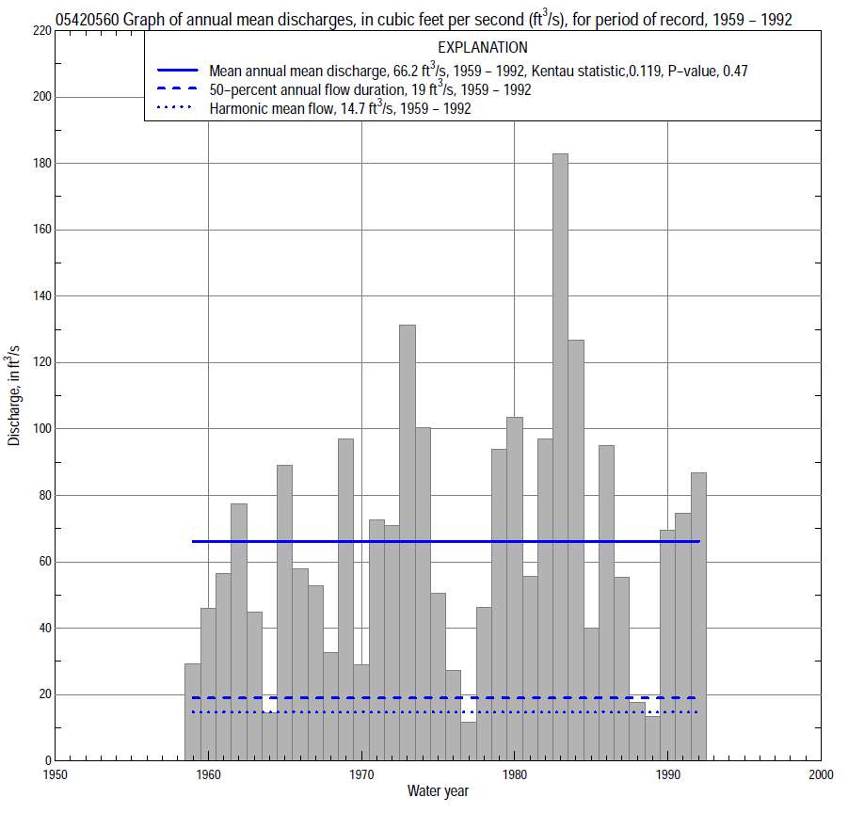

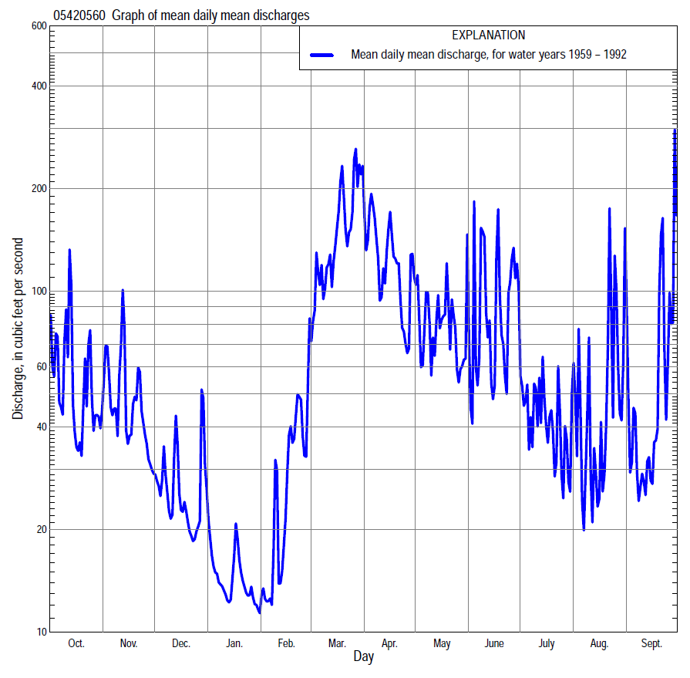

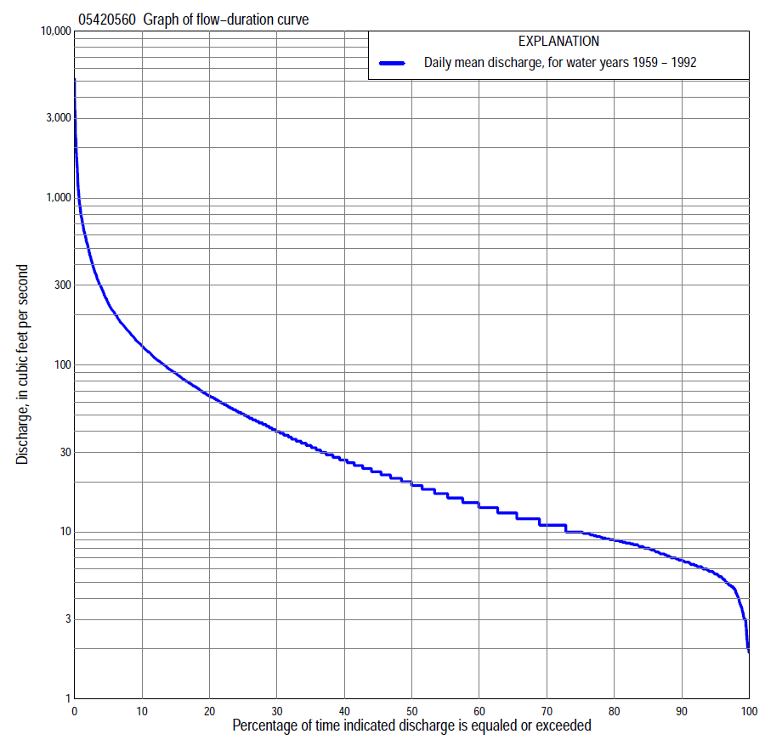

Statistics Based on the Entire Streamflow Period of Record
05420560 Monthly and annual flow durations, based on 1959–92 period of record (34 years)
Percentage of days discharge equaled or exceeded |  |  |  |  | Discharge (cubic feet per second) |  |  |  |  |  |  |  |  | Annual flow durations
 | Oct | Nov | Dec | Jan | Feb | Mar | Apr | May | June | July | Aug | Sept | Annual | Kentau statistic | P-value
99 | 5.2 | 5.0 | 3.6 | 2.3 | 2.0 | 2.9 | 6.9 | 8.6 | 5.6 | 4.6 | 3.8 | 3.7 | 3.3 | 0.153 | 0.203
98 | 5.4 | 5.5 | 4.0 | 2.7 | 2.0 | 4.5 | 9.1 | 8.9 | 5.8 | 4.9 | 4.3 | 4.3 | 4.4 | 0.169 | 0.161
95 | 6.0 | 6.2 | 4.8 | 3.3 | 4.5 | 6.6 | 13 | 10 | 6.8 | 5.8 | 5.3 | 5.4 | 5.6 | 0.194 | 0.107
90 | 6.6 | 7.4 | 6.0 | 4.9 | 5.2 | 9.6 | 20 | 14 | 8.0 | 6.8 | 6.2 | 6.2 | 6.8 | 0.194 | 0.107
85 | 7.5 | 8.2 | 7.0 | 5.8 | 6.7 | 11 | 27 | 18 | 9.6 | 7.9 | 6.8 | 6.6 | 8.0 | 0.232 | 0.054
80 | 8.2 | 8.9 | 8.2 | 6.4 | 7.1 | 13 | 31 | 21 | 11 | 9.1 | 7.6 | 7.9 | 8.9 | 0.216 | 0.073
75 | 9.4 | 9.8 | 9.0 | 7.2 | 8.0 | 17 | 36 | 23 | 12 | 10 | 8.5 | 8.7 | 10 | 0.232 | 0.055
70 | 10 | 12 | 10 | 8.2 | 8.4 | 23 | 42 | 25 | 15 | 12 | 9.1 | 9.5 | 11 | 0.226 | 0.061
65 | 11 | 13 | 11 | 8.7 | 9.0 | 31 | 47 | 28 | 18 | 13 | 9.6 | 11 | 13 | 0.239 | 0.048
60 | 13 | 15 | 12 | 9.0 | 9.6 | 41 | 53 | 32 | 22 | 15 | 11 | 12 | 14 | 0.244 | 0.043
55 | 14 | 18 | 14 | 9.8 | 10 | 47 | 60 | 35 | 25 | 17 | 12 | 13 | 17 | 0.251 | 0.038
50 | 17 | 21 | 16 | 11 | 11 | 54 | 66 | 39 | 29 | 19 | 13 | 15 | 19 | 0.271 | 0.025
45 | 20 | 24 | 17 | 11 | 12 | 70 | 74 | 45 | 33 | 21 | 14 | 16 | 23 | 0.271 | 0.025
40 | 24 | 26 | 18 | 12 | 13 | 90 | 82 | 51 | 37 | 24 | 15 | 20 | 27 | 0.264 | 0.029
35 | 30 | 29 | 20 | 13 | 14 | 108 | 94 | 56 | 44 | 27 | 16 | 24 | 33 | 0.266 | 0.028
30 | 38 | 35 | 21 | 14 | 16 | 128 | 106 | 67 | 51 | 32 | 19 | 29 | 40 | 0.287 | 0.018
25 | 51 | 45 | 24 | 16 | 18 | 150 | 123 | 80 | 61 | 37 | 22 | 36 | 51 | 0.289 | 0.017
20 | 63 | 60 | 28 | 17 | 21 | 197 | 148 | 94 | 74 | 43 | 26 | 48 | 65 | 0.264 | 0.029
15 | 85 | 78 | 36 | 19 | 27 | 253 | 183 | 124 | 96 | 56 | 35 | 63 | 89 | 0.251 | 0.038
10 | 119 | 101 | 48 | 25 | 35 | 358 | 239 | 179 | 151 | 77 | 65 | 93 | 130 | 0.194 | 0.109
5 | 210 | 153 | 76 | 39 | 76 | 600 | 370 | 269 | 301 | 141 | 160 | 174 | 235 | 0.102 | 0.406
2 | 408 | 291 | 140 | 68 | 260 | 971 | 778 | 501 | 792 | 325 | 426 | 621 | 509 | 0.002 | 1.000
1 | 582 | 480 | 244 | 92 | 482 | 1,210 | 1,220 | 631 | 1,820 | 454 | 662 | 1,350 | 777 | -0.021 | 0.870

05420560 Annual exceedance probability of instantaneous peak discharges, in cubic feet per second (ft³/s), based on the Weighted Independent Estimates method,
Annual exceed-ance probability | Recur-rence interval (years) | Discharge (ft³/s) | 95-percent lower confi-dence interval (ft³/s) | 95-percent upper confi-dence interval (ft³/s)
0.500 | 2 | 3,020 | 2,480 | 3,690
0.200 | 5 | 4,930 | 4,090 | 5,950
0.100 | 10 | 6,340 | 5,210 | 7,700
0.040 | 25 | 8,350 | 6,710 | 10,400
0.020 | 50 | 9,800 | 7,680 | 12,500
0.010 | 100 | 11,200 | 8,530 | 14,800
0.005 | 200 | 13,300 | 9,730 | 18,200
0.002 | 500 | 14,700 | 10,300 | 21,100
and based on the expected moments algorithm/multiple Grubbs-Beck analysis computed using a historical period length of 41 years (1959–1999)
0.500 | 2 | 3,060 | 1,430 | 3,690
0.200 | 5 | 5,070 | 3,790 | 6,570
0.100 | 10 | 6,450 | 5,230 | 9,410
0.040 | 25 | 8,190 | 6,210 | 14,300
0.020 | 50 | 9,470 | 6,850 | 19,800
0.010 | 100 | 10,700 | 7,450 | 28,200
0.005 | 200 | 12,000 | 8,030 | 40,000
0.002 | 500 | 13,600 | 8,740 | 54,700
Kentau statistic |  | -0.023
P-value |  | 0.859
Begin year |  | 1959
End year |  | 1992
Number of peaks |  | 34

05420560 Annual exceedance probability of high discharges, based on 1959–92 period of record (34 years)
Annual exceedance probability | Recur-rence interval (years) | Maximum average discharge (ft³/s) for indicated number of consecutive days
 |  | 1 | 3 | 7 | 15 | 30
0.990 | 1.01 | 51 | 44 | 39 | 30 | 24
0.950 | 1.05 | 175 | 139 | 106 | 73 | 56
0.900 | 1.11 | 312 | 238 | 168 | 112 | 83
0.800 | 1.25 | 585 | 426 | 280 | 180 | 129
0.500 | 2 | 1,570 | 1,050 | 627 | 381 | 256
0.200 | 5 | 3,280 | 2,030 | 1,150 | 679 | 427
0.100 | 10 | 4,410 | 2,630 | 1,460 | 862 | 525
0.040 | 25 | 5,680 | 3,270 | 1,810 | 1,060 | 627
0.020 | 50 | 6,490 | 3,650 | 2,020 | 1,190 | 688
0.010 | 100 | 7,190 | 3,970 | 2,200 | 1,300 | 740
0.005 | 200 | 7,780 | 4,240 | 2,360 | 1,400 | 782
0.002 | 500 | 8,430 | 4,520 | 2,530 | 1,510 | 828
Kentau statistic |  | -0.077 | -0.020 | -0.066 | -0.037 | 0.037
P-value |  | 0.534 | 0.882 | 0.594 | 0.767 | 0.767

 | 05420560 Annual nonexceedance probability of low discharges, based on April 1959 to March 1992 period of record (33 years)
Annual nonexceed-ance probability | Recur-rence interval (years) | Minimum average discharge (cubic feet per second) for indicated number of consecutive days
 |  | 1 | 3 | 7 | 14 | 30 | 60 | 90 | 120 | 183
0.01 | 100 | 1.9 | 2.1 | 2.2 | 2.4 | 2.7 | 3.3 | 4.0 | 4.2 | 4.3
0.02 | 50 | 2.2 | 2.5 | 2.6 | 2.7 | 3.0 | 3.8 | 4.4 | 4.7 | 4.8
0.05 | 20 | 2.8 | 3.1 | 3.2 | 3.4 | 3.7 | 4.6 | 5.2 | 5.6 | 5.7
0.10 | 10 | 3.4 | 3.7 | 3.9 | 4.1 | 4.5 | 5.4 | 6.2 | 6.7 | 6.9
0.20 | 5 | 4.3 | 4.6 | 4.8 | 5.1 | 5.5 | 6.8 | 7.7 | 8.5 | 9.9
0.50 | 2 | 6.4 | 6.6 | 6.9 | 7.4 | 8.3 | 10 | 12 | 14 | 20
0.80 | 1.25 | 9.0 | 9.2 | 9.7 | 11 | 13 | 16 | 21 | 26 | 45
0.90 | 1.11 | 11 | 11 | 11 | 13 | 15 | 21 | 30 | 36 | 70
0.96 | 1.04 | 12 | 13 | 13 | 15 | 19 | 27 | 43 | 54 | 113
0.98 | 1.02 | 14 | 14 | 15 | 17 | 22 | 32 | 55 | 71 | 156
0.99 | 1.01 | 15 | 15 | 16 | 19 | 25 | 37 | 70 | 92 | 211
Kentau statistic |  | 0.131 | 0.127 | 0.153 | 0.182 | 0.170 | 0.129 | 0.091 | 0.110 | 0.072
P-value |  | 0.292 | 0.306 | 0.215 | 0.141 | 0.168 | 0.299 | 0.466 | 0.377 | 0.566

05420560 Annual nonexceedance probability of seasonal low discharges, based on October 1958 to September 1992 period of record (34 years)
Annual nonexceed-ance probability | Recur-rence interval (years) | Minimum average discharge (cubic feet per second) for indicated number of consecutive days
 |  | 1 | 7 | 14 | 30 |  | 1 | 7 | 14 | 30
 |  | January-February-March |  |  |  |  | April-May-June
0.01 | 100 | 2.0 | 2.0 | 2.1 | 2.3 |  | 3.2 | 3.4 | 3.5 | 4.4
0.02 | 50 | 2.3 | 2.4 | 2.5 | 2.7 |  | 3.8 | 4.1 | 4.2 | 5.5
0.05 | 20 | 3.0 | 3.1 | 3.2 | 3.5 |  | 4.9 | 5.3 | 5.7 | 7.6
0.10 | 10 | 3.7 | 3.9 | 4.0 | 4.4 |  | 6.2 | 6.8 | 7.5 | 10
0.20 | 5 | 4.8 | 5.0 | 5.2 | 5.7 |  | 8.2 | 9.1 | 10 | 14
0.50 | 2 | 7.6 | 8.1 | 8.5 | 9.5 |  | 14 | 16 | 19 | 27
0.80 | 1.25 | 12 | 12 | 14 | 16 |  | 24 | 28 | 35 | 50
0.90 | 1.11 | 14 | 15 | 17 | 20 |  | 32 | 38 | 49 | 70
0.96 | 1.04 | 18 | 19 | 22 | 26 |  | 43 | 52 | 69 | 98
0.98 | 1.02 | 21 | 22 | 26 | 31 |  | 53 | 63 | 86 | 122
0.99 | 1.01 | 23 | 25 | 29 | 37 |  | 63 | 76 | 105 | 148
Kentau statistic |  | 0.201 | 0.219 | 0.235 | 0.184 |  | 0.171 | 0.203 | 0.175 | 0.112
P-value |  | 0.097 | 0.071 | 0.052 | 0.131 |  | 0.159 | 0.094 | 0.150 | 0.358
 |  | July-August-September |  |  |  |  | October-November-December
0.01 | 100 | 2.0 | 2.5 | 2.8 | 3.3 |  | 2.6 | 3.3 | 3.4 | 3.8
0.02 | 50 | 2.4 | 2.9 | 3.2 | 3.7 |  | 2.9 | 3.6 | 3.8 | 4.3
0.05 | 20 | 3.2 | 3.7 | 3.9 | 4.5 |  | 3.5 | 4.2 | 4.5 | 5.1
0.10 | 10 | 3.9 | 4.4 | 4.8 | 5.4 |  | 4.2 | 4.9 | 5.4 | 6.1
0.20 | 5 | 5.1 | 5.6 | 6.0 | 6.8 |  | 5.3 | 6.1 | 6.8 | 7.8
0.50 | 2 | 8.0 | 8.6 | 9.4 | 11 |  | 8.9 | 9.9 | 11 | 13
0.80 | 1.25 | 12 | 13 | 15 | 19 |  | 16 | 18 | 20 | 26
0.90 | 1.11 | 14 | 16 | 19 | 27 |  | 23 | 25 | 29 | 38
0.96 | 1.04 | 17 | 20 | 24 | 39 |  | 35 | 38 | 43 | 59
0.98 | 1.02 | 19 | 23 | 28 | 50 |  | 46 | 50 | 56 | 81
0.99 | 1.01 | 21 | 26 | 33 | 63 |  | 59 | 66 | 73 | 109
Kentau statistic |  | 0.232 | 0.228 | 0.248 | 0.305 |  | 0.203 | 0.212 | 0.180 | 0.139
P-value |  | 0.055 | 0.060 | 0.041 | 0.012 |  | 0.094 | 0.080 | 0.138 | 0.254

