LOCATION.--Lat 42°50'10", long 92°15'26" referenced to North American Datum of 1927, in NW 1/4 SW 1/4 SW 1/4 sec.27, T.93 N., R.12 W., Bremer County, IA, Hydrologic Unit 07080102, on right bank 10 ft downstream from bridge on State Highway 93, 2.0 mi north of Tripoli, 1.0 mi upstream from mouth of East Fork Wapsipinicon River, and 208 mi upstream from mouth.

DRAINAGE AREA.--346 mi².

PERIOD OF RECORD.--Partial-record low-flow measurement site from September 1957 to July 1977; stage-only records from May to September 2000, October 2004 to September 2006; discharge records from April 1996 to September 1998, October 2000 to September 2004, October 2006 to current year.

GAGE.--Water stage recorder. Datum of gage is 986.42 ft above National Geodetic Vertical Datum of 1929.

EXTREMES OUTSIDE PERIOD OF RECORD.--Flood of July 1, 1969, discharge about 18,900 ft³/s, gage height 17.26 ft. Flood of July 21, 1999, discharge 19,400 ft³/s, gage height 18.50 ft.

A summary of all available data for this streamgage is provided through the USGS National Water Information System web interface (NWISWeb). The following link provides access to current/historical observations, daily data, daily statistics, monthly statistics, annual statistics, peak streamflow, field measurements, field/lab water-quality samples, and the latest water-year summaries. Data can be filtered by parameter and/or dates, and can be output in various tabular and graphical formats.
http://waterdata.usgs.gov/nwis/inventory/?site_no=05420680

The USGS WaterWatch Toolkit is available at:
http://waterwatch.usgs.gov/?id=ww_toolkit
Tools for summarizing streamflow information include the duration hydrograph builder, the cumulative streamflow hydrograph builder, the streamgage statistics retrieval tool, the rating curve builder, the flood tracking chart builder, the National Weather Service Advanced Hydrologic Prediction Service (AHPS) river forecast hydrograph builder, and the raster-hydrograph builder. Entering the above number for this streamgage into these toolkit webpages will provide streamflow information specific to this streamgage.

A description of the statistics presented for this streamgage is available in the main body of the report at:
http://dx.doi.org/10.3133/ofr20151214
A link to other streamgages included in this report, a map showing the location of the streamgages, information on the programs used to compute the statistical analyses, and references are included in the main body of the report.

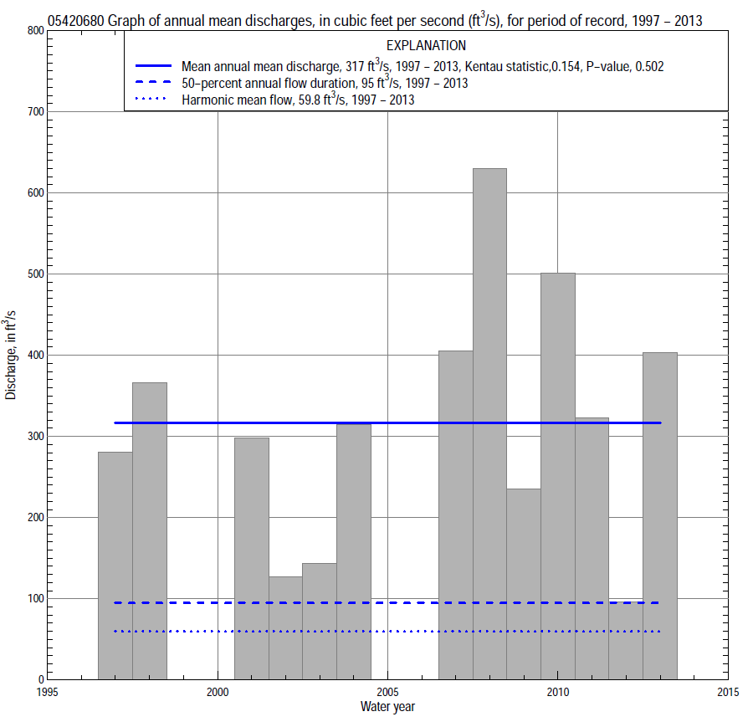

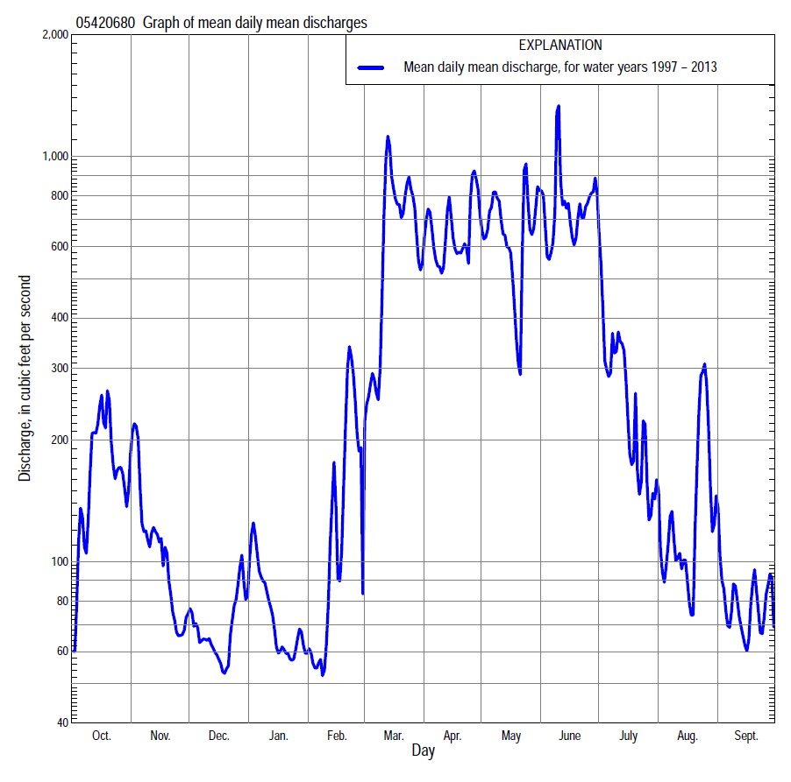

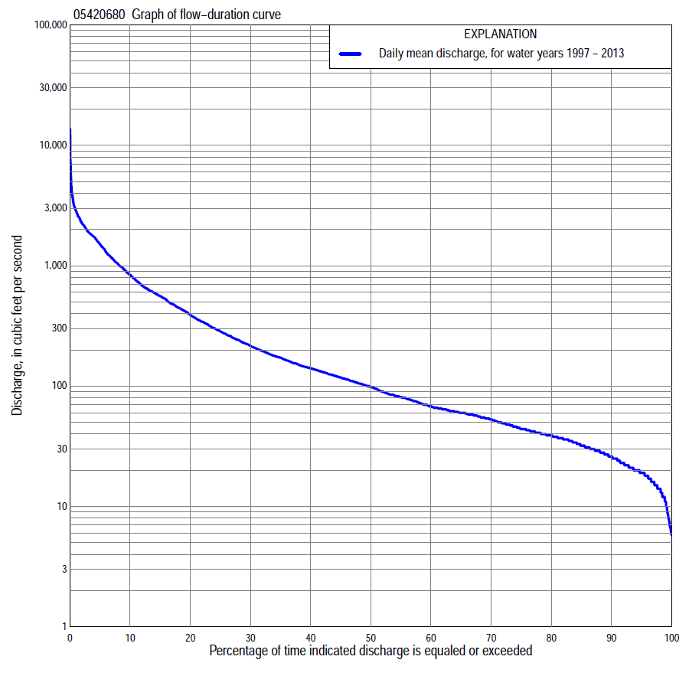

Statistics Based on the Entire Streamflow Period of Record
05420680 Monthly and annual flow durations, based on 1997–98, 2001–04, 2007–13 period of record (13 years)
Percentage of days discharge equaled or exceeded |  |  |  |  | Discharge (cubic feet per second) |  |  |  |  |  |  |  |  | Annual flow durations
 | Oct | Nov | Dec | Jan | Feb | Mar | Apr | May | June | July | Aug | Sept | Annual | Kentau statistic | P-value
99 | 6.1 | 18 | 19 | 12 | 12 | 26 | 56 | 109 | 48 | 14 | 10 | 6.7 | 11 | -0.179 | 0.426
98 | 6.8 | 19 | 19 | 12 | 12 | 30 | 60 | 112 | 57 | 17 | 11 | 7.1 | 14 | -0.141 | 0.541
95 | 15 | 21 | 20 | 15 | 13 | 54 | 66 | 133 | 81 | 19 | 15 | 8.4 | 19 | -0.115 | 0.625
90 | 18 | 25 | 22 | 17 | 17 | 63 | 92 | 163 | 132 | 51 | 25 | 16 | 26 | -0.205 | 0.352
85 | 21 | 31 | 25 | 19 | 28 | 70 | 110 | 186 | 155 | 60 | 33 | 23 | 32 | -0.205 | 0.358
80 | 27 | 34 | 28 | 22 | 35 | 80 | 148 | 205 | 177 | 70 | 40 | 27 | 39 | -0.205 | 0.358
75 | 31 | 37 | 31 | 24 | 41 | 90 | 169 | 224 | 208 | 81 | 44 | 30 | 44 | -0.218 | 0.328
70 | 36 | 38 | 33 | 29 | 44 | 106 | 188 | 245 | 230 | 91 | 48 | 33 | 53 | -0.167 | 0.463
65 | 39 | 40 | 36 | 32 | 49 | 120 | 228 | 278 | 252 | 101 | 53 | 36 | 60 | -0.141 | 0.541
60 | 40 | 43 | 41 | 38 | 56 | 145 | 276 | 321 | 277 | 113 | 57 | 37 | 68 | -0.154 | 0.502
55 | 42 | 45 | 46 | 46 | 59 | 200 | 306 | 360 | 306 | 125 | 61 | 39 | 81 | -0.128 | 0.582
50 | 45 | 51 | 48 | 55 | 61 | 261 | 353 | 409 | 348 | 137 | 66 | 43 | 98 | -0.090 | 0.714
45 | 50 | 57 | 52 | 60 | 65 | 381 | 426 | 441 | 411 | 150 | 73 | 48 | 118 | 0.064 | 0.807
40 | 56 | 63 | 55 | 64 | 68 | 472 | 538 | 509 | 476 | 165 | 80 | 59 | 142 | 0.051 | 0.855
35 | 61 | 78 | 69 | 68 | 78 | 558 | 615 | 566 | 561 | 189 | 87 | 67 | 174 | 0.077 | 0.760
30 | 68 | 105 | 81 | 75 | 85 | 664 | 681 | 688 | 633 | 218 | 98 | 76 | 220 | 0.026 | 0.951
25 | 81 | 124 | 88 | 87 | 103 | 818 | 850 | 914 | 785 | 270 | 115 | 89 | 289 | 0.026 | 0.951
20 | 129 | 147 | 100 | 110 | 119 | 1,020 | 1,180 | 1,120 | 954 | 333 | 139 | 106 | 394 | 0.051 | 0.855
15 | 211 | 178 | 115 | 125 | 131 | 1,210 | 1,650 | 1,300 | 1,210 | 441 | 165 | 137 | 560 | 0.128 | 0.583
10 | 490 | 227 | 133 | 156 | 353 | 1,700 | 1,860 | 1,710 | 1,780 | 656 | 211 | 186 | 847 | 0.231 | 0.300
5 | 989 | 328 | 155 | 230 | 671 | 2,450 | 2,250 | 2,000 | 2,690 | 1,110 | 345 | 327 | 1,550 | 0.256 | 0.246
2 | 1,380 | 561 | 277 | 303 | 1,040 | 2,930 | 3,000 | 2,570 | 3,810 | 1,900 | 1,040 | 455 | 2,280 | 0.179 | 0.428
1 | 1,800 | 1,180 | 342 | 421 | 1,570 | 3,250 | 3,330 | 3,660 | 5,490 | 2,320 | 2,460 | 557 | 2,890 | 0.064 | 0.807

05420680 Annual exceedance probability of instantaneous peak discharges, in cubic feet per second (ft³/s), based on the Weighted Independent Estimates method,
Annual exceed-ance probability | Recur-rence interval (years) | Discharge (ft³/s) | 95-percent lower confi-dence interval (ft³/s) | 95-percent upper confi-dence interval (ft³/s)
0.500 | 2 | 4,390 | 3,420 | 5,640
0.200 | 5 | 8,400 | 6,600 | 10,700
0.100 | 10 | 11,400 | 8,920 | 14,600
0.040 | 25 | 15,500 | 11,900 | 20,200
0.020 | 50 | 18,300 | 13,700 | 24,600
0.010 | 100 | 21,200 | 15,300 | 29,400
0.005 | 200 | 25,900 | 17,900 | 37,500
0.002 | 500 | 28,500 | 18,600 | 43,600
and based on the expected moments algorithm/multiple Grubbs-Beck analysis computed using a historical period length of 45 years (1969–2013)
0.500 | 2 | 4,320 | 2,750 | 6,550
0.200 | 5 | 8,710 | 5,750 | 13,700
0.100 | 10 | 12,400 | 7,970 | 20,500
0.040 | 25 | 17,700 | 10,900 | 32,400
0.020 | 50 | 22,200 | 13,100 | 44,400
0.010 | 100 | 27,000 | 15,200 | 59,900
0.005 | 200 | 32,300 | 17,300 | 79,900
0.002 | 500 | 39,900 | 19,900 | 115,000
Kentau statistic |  | -0.033
P-value |  | 0.893
Begin year |  | 1997
End year |  | 2013
Number of peaks |  | 16

05420680 Annual exceedance probability of high discharges, based on 1997–98, 2001–2004, 2007–2013 period of record (13 years)
[ND, not determined]
Annual exceedance probability | Recur-rence interval (years) | Maximum average discharge (ft³/s) for indicated number of consecutive days
 |  | 1 | 3 | 7 | 15 | 30
0.990 | 1.01 | ND | 684 | 554 | 356 | 275
0.950 | 1.05 | ND | 1,020 | 850 | 619 | 479
0.900 | 1.11 | ND | 1,280 | 1,070 | 813 | 624
0.800 | 1.25 | ND | 1,680 | 1,410 | 1,110 | 834
0.500 | 2 | ND | 2,920 | 2,380 | 1,880 | 1,340
0.200 | 5 | ND | 5,250 | 4,010 | 2,950 | 1,930
0.100 | 10 | ND | 7,210 | 5,270 | 3,630 | 2,260
0.040 | 25 | ND | 10,200 | 7,060 | 4,430 | 2,590
0.020 | 50 | ND | 12,900 | 8,520 | 4,980 | 2,800
0.010 | 100 | ND | 15,900 | 10,100 | 5,490 | 2,980
0.005 | 200 | ND | 19,400 | 11,800 | 5,980 | 3,130
0.002 | 500 | ND | 24,700 | 14,200 | 6,570 | 3,290
Kentau statistic |  | 0.162 | 0.132 | 0.162 | 0.162 | 0.147
P-value |  | 0.383 | 0.481 | 0.383 | 0.383 | 0.430

 | 05420680 Annual nonexceedance probability of low discharges, based on April 1997 to March 1998, April 2001 to March 2004, April 2007 to March 2013 period of record (10 years)
Annual nonexceed-ance probability | Recur-rence interval (years) | Minimum average discharge (cubic feet per second) for indicated number of consecutive days
 |  | 1 | 3 | 7 | 14 | 30 | 60 | 90 | 120 | 183
0.01 | 100 | 3.4 | 3.5 | 3.6 | 3.9 | 4.4 | 5.8 | 7.5 | 8.2 | 8.7
0.02 | 50 | 4.4 | 4.5 | 4.6 | 4.9 | 5.6 | 7.2 | 9.1 | 10 | 10
0.05 | 20 | 6.4 | 6.5 | 6.7 | 7.0 | 7.8 | 9.9 | 12 | 14 | 14
0.10 | 10 | 8.4 | 8.7 | 9.1 | 9.4 | 10 | 13 | 16 | 18 | 18
0.20 | 5 | 12 | 12 | 13 | 13 | 15 | 18 | 21 | 24 | 26
0.50 | 2 | 20 | 21 | 23 | 25 | 27 | 34 | 38 | 45 | 55
0.80 | 1.25 | 33 | 34 | 37 | 42 | 50 | 61 | 69 | 81 | 128
0.90 | 1.11 | 41 | 42 | 47 | 55 | 68 | 83 | 93 | 110 | 208
0.96 | 1.04 | 51 | 52 | 58 | 72 | 93 | 115 | 129 | 152 | 358
0.98 | 1.02 | 58 | 59 | 65 | 84 | 113 | 141 | 159 | 187 | 519
0.99 | 1.01 | 65 | 66 | 72 | 97 | 134 | 170 | 191 | 225 | 731
Kentau statistic |  | -0.089 | -0.067 | 0.000 | 0.022 | -0.111 | -0.111 | -0.156 | -0.200 | -0.200
P-value |  | 0.788 | 0.858 | 1.000 | 1.000 | 0.721 | 0.721 | 0.592 | 0.474 | 0.474

05420680 Annual nonexceedance probability of seasonal low discharges, based on October 1996 to September 1998, October 2000 to September 2004, October 2006 to September 2013 period of record (13–14 years)
Annual nonexceed-ance probability | Recur-rence interval (years) | Minimum average discharge (cubic feet per second) for indicated number of consecutive days
 |  | 1 | 7 | 14 | 30 |  | 1 | 7 | 14 | 30
 |  | January-February-March |  |  |  |  | April-May-June
0.01 | 100 | 6.0 | 6.2 | 6.7 | 6.9 |  | 28 | 37 | 49 | 65
0.02 | 50 | 7.2 | 7.9 | 8.4 | 8.9 |  | 34 | 43 | 54 | 76
0.05 | 20 | 10 | 11 | 12 | 13 |  | 45 | 53 | 64 | 96
0.10 | 10 | 12 | 14 | 15 | 17 |  | 57 | 64 | 75 | 119
0.20 | 5 | 17 | 20 | 21 | 24 |  | 74 | 80 | 93 | 154
0.50 | 2 | 29 | 35 | 37 | 43 |  | 117 | 127 | 152 | 261
0.80 | 1.25 | 49 | 57 | 63 | 72 |  | 171 | 206 | 274 | 456
0.90 | 1.11 | 64 | 72 | 80 | 91 |  | 204 | 267 | 388 | 617
0.96 | 1.04 | 85 | 91 | 103 | 116 |  | 241 | 354 | 582 | 859
0.98 | 1.02 | 102 | 104 | 120 | 134 |  | 266 | 427 | 770 | 1,070
0.99 | 1.01 | 116 | 117 | 137 | 152 |  | 290 | 505 | 1,000 | 1,310
Kentau statistic |  | -0.154 | -0.154 | -0.154 | -0.154 |  | 0.192 | 0.128 | 0.051 | 0.333
P-value |  | 0.502 | 0.501 | 0.502 | 0.502 |  | 0.392 | 0.583 | 0.855 | 0.127
 |  | July-August-September |  |  |  |  | October-November-December
0.01 | 100 | 4.2 | 4.9 | 5.4 | 5.9 |  | 4.4 | 4.5 | 7.0 | 12
0.02 | 50 | 5.7 | 6.5 | 7.1 | 7.7 |  | 5.6 | 5.8 | 8.4 | 13
0.05 | 20 | 8.7 | 9.6 | 11 | 11 |  | 7.9 | 8.4 | 11 | 16
0.10 | 10 | 12 | 13 | 14 | 16 |  | 11 | 11 | 14 | 19
0.20 | 5 | 18 | 19 | 21 | 23 |  | 15 | 16 | 19 | 24
0.50 | 2 | 32 | 35 | 38 | 44 |  | 26 | 30 | 32 | 38
0.80 | 1.25 | 51 | 56 | 62 | 82 |  | 43 | 52 | 55 | 67
0.90 | 1.11 | 61 | 68 | 77 | 111 |  | 54 | 66 | 73 | 93
0.96 | 1.04 | 72 | 83 | 94 | 151 |  | 68 | 85 | 98 | 134
0.98 | 1.02 | 79 | 92 | 106 | 182 |  | 78 | 98 | 118 | 173
0.99 | 1.01 | 84 | 100 | 117 | 215 |  | 87 | 111 | 140 | 219
Kentau statistic |  | -0.132 | -0.121 | -0.099 | -0.121 |  | 0.128 | 0.077 | 0.000 | 0.000
P-value |  | 0.546 | 0.584 | 0.661 | 0.584 |  | 0.582 | 0.760 | 1.000 | 1.000

