LOCATION.--Lat 42°27'49", long 91°53'42" referenced to North American Datum of 1927, in NW 1/4 NE 1/4 SE 1/4 sec.04, T.88 N., R.9 W., Buchanan County, IA, Hydrologic Unit 07080102, on right bank at end of 6th Street in Independence, 1,800 ft downstream from dam at abandoned hydroelectric plant, 4.9 mi downstream from Otter Creek, 9.7 mi upstream from Pine Creek, and 158 mi upstream from mouth.

DRAINAGE AREA.--1,048 mi².

PERIOD OF RECORD.--Discharge records from July 1933 to current year.

GAGE.--Water-stage recorder and concrete control. Datum of gage is 882.85 ft above National Geodetic Vertical Datum of 1929. Prior to May 24, 1941, non-recording gage in tailrace of power plant, 1,800 ft upstream, at datum 80.00 ft lower.

EXTREMES OUTSIDE PERIOD OF RECORD.--Since at least 1901, no flood outside the period of record exceeded the June 14, 1947, stage of 18.74 ft.

A summary of all available data for this streamgage is provided through the USGS National Water Information System web interface (NWISWeb). The following link provides access to current/historical observations, daily data, daily statistics, monthly statistics, annual statistics, peak streamflow, field measurements, field/lab water-quality samples, and the latest water-year summaries. Data can be filtered by parameter and/or dates, and can be output in various tabular and graphical formats.
http://waterdata.usgs.gov/nwis/inventory/?site_no=05421000

The USGS WaterWatch Toolkit is available at:
http://waterwatch.usgs.gov/?id=ww_toolkit
Tools for summarizing streamflow information include the duration hydrograph builder, the cumulative streamflow hydrograph builder, the streamgage statistics retrieval tool, the rating curve builder, the flood tracking chart builder, the National Weather Service Advanced Hydrologic Prediction Service (AHPS) river forecast hydrograph builder, and the raster-hydrograph builder. Entering the above number for this streamgage into these toolkit webpages will provide streamflow information specific to this streamgage.

A description of the statistics presented for this streamgage is available in the main body of the report at:
http://dx.doi.org/10.3133/ofr20151214
A link to other streamgages included in this report, a map showing the location of the streamgages, information on the programs used to compute the statistical analyses, and references are included in the main body of the report.

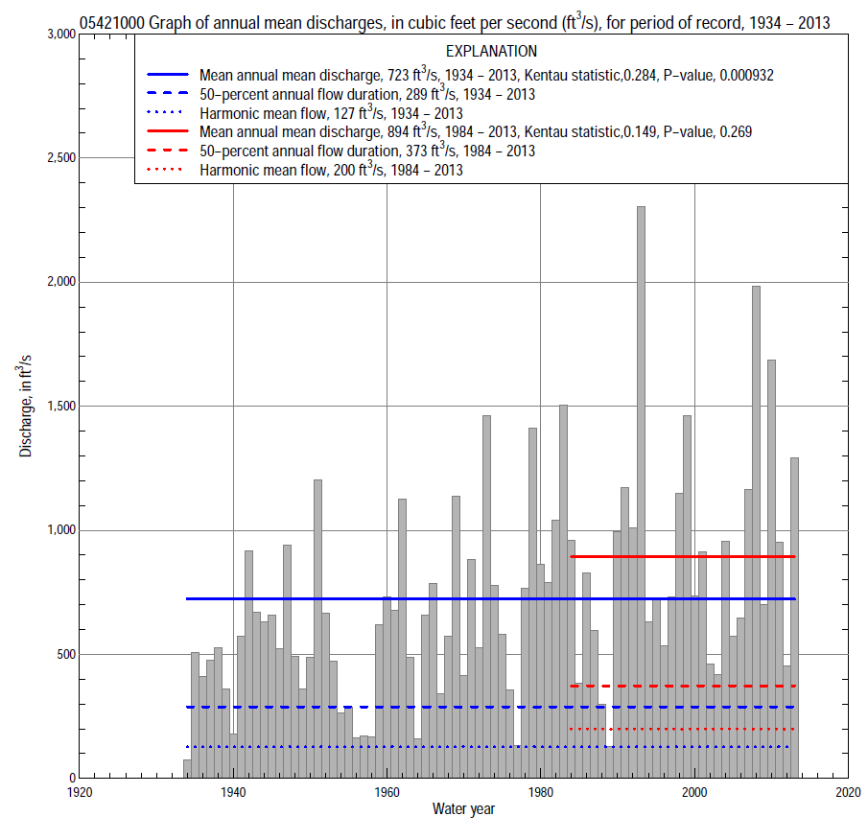

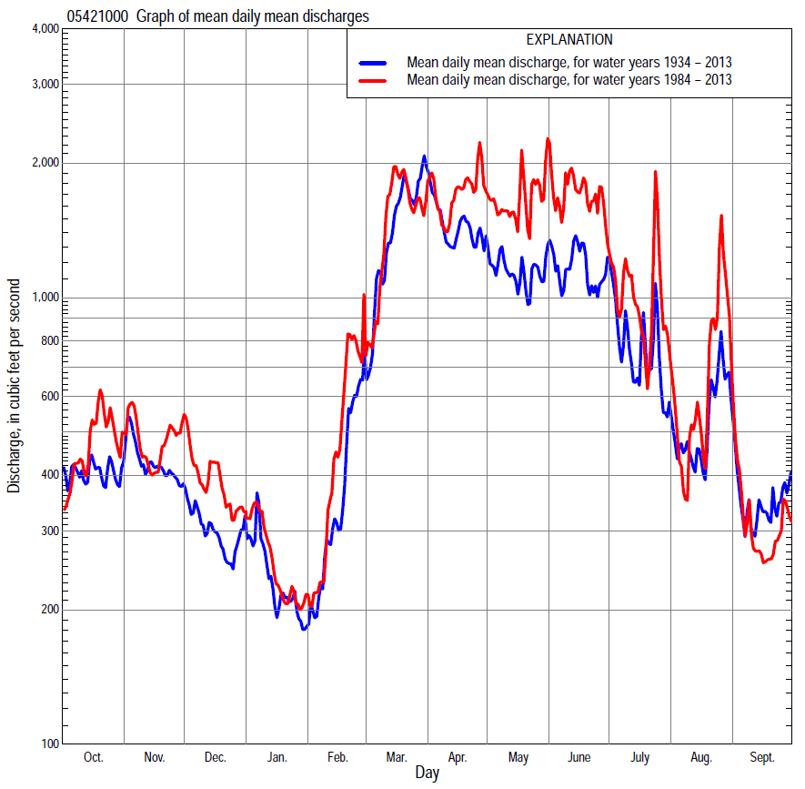

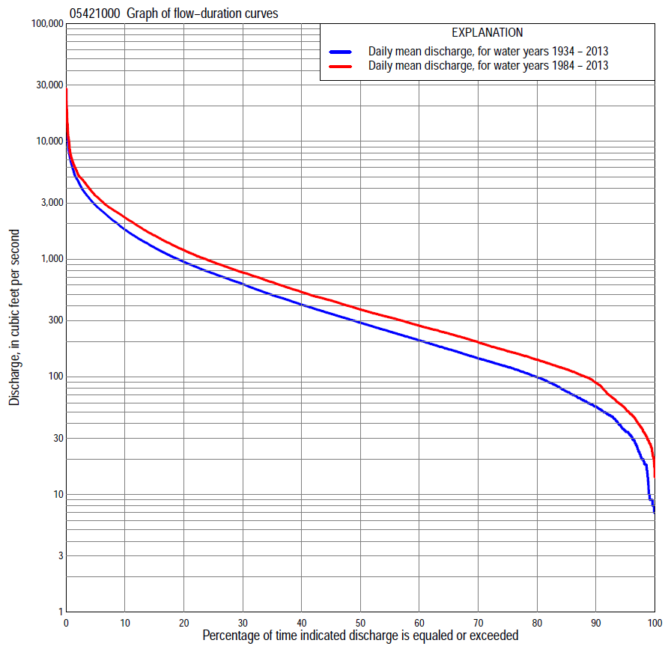

Statistics Based on the Entire Streamflow Period of Record
05421000 Monthly and annual flow durations, based on 1934–2013 period of record (80 years)
Percentage of days discharge equaled or exceeded |  |  |  |  | Discharge (cubic feet per second) |  |  |  |  |  |  |  |  | Annual flow durations
 | Oct | Nov | Dec | Jan | Feb | Mar | Apr | May | June | July | Aug | Sept | Annual | Kentau statistic | P-value
99 | 15 | 17 | 16 | 9.0 | 10 | 36 | 111 | 43 | 10 | 9.0 | 8.0 | 13 | 10 | 0.429 | 0.000
98 | 19 | 28 | 20 | 16 | 18 | 42 | 147 | 59 | 34 | 10 | 9.0 | 18 | 20 | 0.431 | 0.000
95 | 29 | 39 | 33 | 23 | 28 | 84 | 198 | 118 | 61 | 36 | 25 | 23 | 35 | 0.383 | 0.000
90 | 47 | 58 | 48 | 39 | 38 | 133 | 280 | 182 | 122 | 60 | 39 | 39 | 56 | 0.322 | 0.000
85 | 56 | 73 | 65 | 50 | 50 | 189 | 346 | 244 | 166 | 91 | 55 | 57 | 76 | 0.294 | 0.000
80 | 64 | 96 | 83 | 58 | 66 | 270 | 398 | 295 | 209 | 118 | 71 | 68 | 100 | 0.279 | 0.000
75 | 74 | 121 | 100 | 73 | 81 | 339 | 460 | 357 | 257 | 143 | 92 | 82 | 122 | 0.263 | 0.001
70 | 93 | 138 | 114 | 88 | 95 | 412 | 520 | 412 | 315 | 174 | 106 | 93 | 144 | 0.266 | 0.000
65 | 111 | 154 | 129 | 100 | 115 | 489 | 601 | 472 | 384 | 210 | 121 | 105 | 172 | 0.252 | 0.001
60 | 126 | 180 | 146 | 111 | 129 | 575 | 694 | 534 | 463 | 237 | 138 | 119 | 205 | 0.238 | 0.002
55 | 140 | 204 | 170 | 129 | 150 | 682 | 775 | 609 | 542 | 274 | 160 | 132 | 243 | 0.248 | 0.001
50 | 161 | 235 | 197 | 145 | 168 | 793 | 875 | 681 | 632 | 321 | 181 | 148 | 289 | 0.268 | 0.000
45 | 193 | 263 | 228 | 160 | 189 | 928 | 996 | 762 | 722 | 371 | 204 | 176 | 345 | 0.266 | 0.000
40 | 232 | 305 | 258 | 174 | 218 | 1,110 | 1,140 | 861 | 847 | 422 | 235 | 209 | 411 | 0.278 | 0.000
35 | 287 | 364 | 290 | 191 | 252 | 1,350 | 1,270 | 991 | 980 | 498 | 270 | 242 | 497 | 0.277 | 0.000
30 | 364 | 435 | 320 | 215 | 295 | 1,610 | 1,470 | 1,130 | 1,160 | 604 | 311 | 295 | 615 | 0.294 | 0.000
25 | 484 | 507 | 355 | 250 | 363 | 1,890 | 1,770 | 1,330 | 1,380 | 730 | 363 | 353 | 757 | 0.305 | 0.000
20 | 614 | 618 | 404 | 300 | 460 | 2,230 | 2,110 | 1,570 | 1,640 | 924 | 453 | 444 | 950 | 0.311 | 0.000
15 | 748 | 773 | 478 | 364 | 611 | 2,620 | 2,620 | 2,010 | 2,130 | 1,290 | 655 | 600 | 1,260 | 0.316 | 0.000
10 | 986 | 957 | 596 | 490 | 928 | 3,410 | 3,380 | 2,600 | 2,790 | 1,840 | 984 | 840 | 1,780 | 0.300 | 0.000
5 | 1,600 | 1,410 | 870 | 747 | 1,590 | 4,840 | 4,880 | 3,720 | 3,880 | 3,020 | 1,940 | 1,300 | 2,860 | 0.214 | 0.005
2 | 2,590 | 2,530 | 1,530 | 1,260 | 2,420 | 7,390 | 6,430 | 5,030 | 5,660 | 5,280 | 5,250 | 2,310 | 4,640 | 0.178 | 0.020
1 | 3,160 | 3,210 | 1,970 | 1,730 | 3,580 | 9,650 | 7,880 | 6,770 | 7,240 | 7,720 | 7,380 | 3,160 | 6,170 | 0.154 | 0.044

05421000 Annual exceedance probability of instantaneous peak discharges, in cubic feet per second (ft³/s), based on the Weighted Independent Estimates method,
Annual exceed-ance probability | Recur-rence interval (years) | Discharge (ft³/s) | 95-percent lower confi-dence interval (ft³/s) | 95-percent upper confi-dence interval (ft³/s)
0.500 | 2 | 6,790 | 5,860 | 7,870
0.200 | 5 | 12,500 | 10,900 | 14,500
0.100 | 10 | 17,000 | 14,500 | 19,800
0.040 | 25 | 23,100 | 19,300 | 27,700
0.020 | 50 | 27,600 | 22,500 | 34,000
0.010 | 100 | 32,100 | 25,200 | 40,700
0.005 | 200 | 37,900 | 28,700 | 49,900
0.002 | 500 | 42,700 | 30,900 | 59,000
and based on the expected moments algorithm/multiple Grubbs-Beck analysis computed using a historical period length of 113 years (1901–2013)
0.500 | 2 | 6,710 | 5,600 | 7,990
0.200 | 5 | 12,400 | 10,400 | 14,700
0.100 | 10 | 16,600 | 13,900 | 20,200
0.040 | 25 | 22,400 | 18,300 | 28,700
0.020 | 50 | 26,900 | 21,400 | 36,300
0.010 | 100 | 31,500 | 24,300 | 45,000
0.005 | 200 | 36,200 | 26,900 | 54,900
0.002 | 500 | 42,700 | 30,000 | 70,200
Kentau statistic |  | 0.068
P-value |  | 0.372
Begin year |  | 1934
End year |  | 2013
Number of peaks |  | 80

05421000 Annual exceedance probability of high discharges, based on 1934–2013 period of record (80 years)
Annual exceedance probability | Recur-rence interval (years) | Maximum average discharge (ft³/s) for indicated number of consecutive days
 |  | 1 | 3 | 7 | 15 | 30
0.990 | 1.01 | 736 | 652 | 571 | 438 | 300
0.950 | 1.05 | 1,470 | 1,320 | 1,140 | 871 | 631
0.900 | 1.11 | 2,090 | 1,880 | 1,610 | 1,220 | 898
0.800 | 1.25 | 3,120 | 2,810 | 2,360 | 1,770 | 1,320
0.500 | 2 | 6,320 | 5,600 | 4,530 | 3,300 | 2,470
0.200 | 5 | 11,900 | 10,200 | 7,830 | 5,530 | 4,020
0.100 | 10 | 16,000 | 13,400 | 10,000 | 6,950 | 4,930
0.040 | 25 | 21,600 | 17,600 | 12,700 | 8,630 | 5,900
0.020 | 50 | 25,900 | 20,700 | 14,600 | 9,770 | 6,520
0.010 | 100 | 30,200 | 23,700 | 16,300 | 10,800 | 7,050
0.005 | 200 | 34,600 | 26,600 | 18,000 | 11,800 | 7,510
0.002 | 500 | 40,500 | 30,400 | 20,100 | 13,000 | 8,030
Kentau statistic |  | 0.074 | 0.111 | 0.161 | 0.162 | 0.212
P-value |  | 0.333 | 0.147 | 0.035 | 0.034 | 0.005

 | 05421000 Annual nonexceedance probability of low discharges, based on April 1934 to March 2013 period of record (79 years)
Annual nonexceed-ance probability | Recur-rence interval (years) | Minimum average discharge (ft³/s) for indicated number of consecutive days
 |  | 1 | 3 | 7 | 14 | 30 | 60 | 90 | 120 | 183
0.01 | 100 | 3.6 | 5.7 | 6.4 | 7.4 | 8.7 | 12 | 16 | 19 | 21
0.02 | 50 | 5.0 | 7.9 | 8.8 | 10 | 12 | 16 | 21 | 25 | 28
0.05 | 20 | 8.1 | 12 | 14 | 16 | 19 | 24 | 32 | 37 | 43
0.10 | 10 | 12 | 18 | 20 | 23 | 27 | 35 | 45 | 53 | 63
0.20 | 5 | 20 | 27 | 31 | 34 | 41 | 52 | 66 | 79 | 97
0.50 | 2 | 45 | 56 | 64 | 70 | 83 | 104 | 133 | 161 | 210
0.80 | 1.25 | 95 | 105 | 116 | 127 | 150 | 193 | 250 | 308 | 428
0.90 | 1.11 | 135 | 139 | 151 | 167 | 196 | 259 | 338 | 421 | 605
0.96 | 1.04 | 181 | 182 | 194 | 217 | 254 | 346 | 457 | 576 | 860
0.98 | 1.02 | 213 | 214 | 225 | 254 | 296 | 413 | 551 | 699 | 1,070
0.99 | 1.01 | 244 | 245 | 253 | 289 | 336 | 480 | 646 | 826 | 1,290
Kentau statistic |  | 0.488 | 0.367 | 0.298 | 0.288 | 0.279 | 0.261 | 0.220 | 0.202 | 0.186
P-value |  | 0.000 | 0.000 | 0.000 | 0.000 | 0.000 | 0.001 | 0.004 | 0.008 | 0.015

05421000 Annual nonexceedance probability of seasonal low discharges, based on July 1933 to September 2013 period of record (80–81 years)
Annual nonexceed-ance probability | Recur-rence interval (years) | Minimum average discharge (cubic feet per second) for indicated number of consecutive days
 |  | 1 | 7 | 14 | 30 |  | 1 | 7 | 14 | 30
 |  | January-February-March |  |  |  |  | April-May-June
0.01 | 100 | 4.1 | 9.9 | 11 | 13 |  | 5.4 | 17 | 23 | 29
0.02 | 50 | 6.0 | 13 | 15 | 18 |  | 9.2 | 26 | 34 | 43
0.05 | 20 | 10 | 21 | 22 | 26 |  | 19 | 46 | 57 | 76
0.10 | 10 | 16 | 29 | 31 | 37 |  | 35 | 73 | 88 | 122
0.20 | 5 | 27 | 44 | 46 | 55 |  | 68 | 121 | 143 | 205
0.50 | 2 | 67 | 89 | 94 | 114 |  | 194 | 275 | 328 | 481
0.80 | 1.25 | 144 | 163 | 176 | 222 |  | 433 | 517 | 656 | 951
0.90 | 1.11 | 205 | 215 | 237 | 308 |  | 601 | 673 | 895 | 1,270
0.96 | 1.04 | 281 | 282 | 318 | 429 |  | 803 | 851 | 1,200 | 1,670
0.98 | 1.02 | 330 | 331 | 380 | 528 |  | 939 | 968 | 1,430 | 1,940
0.99 | 1.01 | 377 | 378 | 442 | 632 |  | 1,060 | 1,070 | 1,650 | 2,190
Kentau statistic |  | 0.470 | 0.291 | 0.275 | 0.225 |  | 0.416 | 0.337 | 0.330 | 0.335
P-value |  | 0.000 | 0.000 | 0.000 | 0.003 |  | 0.000 | 0.000 | 0.000 | 0.000
 |  | July-August-September |  |  |  |  | October-November-December
0.01 | 100 | 4.3 | 8.5 | 11 | 13 |  | 3.3 | 12 | 15 | 20
0.02 | 50 | 6.0 | 11 | 14 | 17 |  | 5.1 | 15 | 19 | 25
0.05 | 20 | 9.6 | 17 | 20 | 25 |  | 9.2 | 24 | 28 | 36
0.10 | 10 | 14 | 24 | 28 | 35 |  | 15 | 34 | 40 | 49
0.20 | 5 | 24 | 37 | 42 | 53 |  | 27 | 51 | 59 | 71
0.50 | 2 | 57 | 79 | 89 | 116 |  | 72 | 106 | 118 | 143
0.80 | 1.25 | 134 | 164 | 187 | 254 |  | 166 | 201 | 224 | 280
0.90 | 1.11 | 204 | 235 | 274 | 384 |  | 245 | 273 | 305 | 393
0.96 | 1.04 | 316 | 340 | 408 | 598 |  | 357 | 370 | 418 | 562
0.98 | 1.02 | 416 | 430 | 527 | 797 |  | 443 | 444 | 507 | 704
0.99 | 1.01 | 526 | 527 | 661 | 1,030 |  | 519 | 520 | 599 | 861
Kentau statistic |  | 0.434 | 0.248 | 0.234 | 0.192 |  | 0.357 | 0.183 | 0.197 | 0.187
P-value |  | 0.000 | 0.001 | 0.002 | 0.011 |  | 0.000 | 0.017 | 0.010 | 0.014

Statistics Based on the 1984–2013 Streamflow Period of Record
05421000 Monthly and annual flow durations, based on 1984–2013 period of record (30 years)
Percentage of days discharge equaled or exceeded |  |  |  |  | Discharge (cubic feet per second) |  |  |  |  |  |  |  |  | Annual flow durations
 | Oct | Nov | Dec | Jan | Feb | Mar | Apr | May | June | July | Aug | Sept | Annual | Kentau statistic | P-value
99 | 21 | 42 | 36 | 34 | 36 | 37 | 156 | 124 | 43 | 25 | 20 | 21 | 28 | 0.083 | 0.532
98 | 27 | 56 | 41 | 43 | 38 | 40 | 198 | 153 | 56 | 28 | 23 | 24 | 35 | 0.087 | 0.509
95 | 46 | 69 | 53 | 51 | 47 | 203 | 297 | 235 | 85 | 44 | 29 | 34 | 54 | 0.071 | 0.592
90 | 61 | 117 | 86 | 65 | 69 | 279 | 357 | 344 | 164 | 73 | 48 | 56 | 89 | 0.060 | 0.656
85 | 87 | 135 | 102 | 91 | 95 | 350 | 414 | 450 | 236 | 121 | 70 | 71 | 116 | 0.039 | 0.775
80 | 104 | 148 | 116 | 103 | 116 | 420 | 471 | 525 | 370 | 171 | 100 | 88 | 140 | 0.039 | 0.775
75 | 118 | 171 | 132 | 115 | 143 | 475 | 540 | 609 | 470 | 216 | 117 | 101 | 165 | 0.021 | 0.886
70 | 126 | 195 | 164 | 130 | 159 | 540 | 597 | 690 | 551 | 250 | 134 | 110 | 197 | 0.030 | 0.830
65 | 135 | 214 | 192 | 145 | 174 | 625 | 708 | 763 | 644 | 286 | 156 | 124 | 233 | -0.018 | 0.901
60 | 148 | 239 | 228 | 156 | 198 | 713 | 812 | 847 | 756 | 331 | 183 | 136 | 271 | -0.025 | 0.858
55 | 160 | 254 | 259 | 165 | 218 | 820 | 910 | 929 | 866 | 375 | 203 | 157 | 320 | -0.030 | 0.830
50 | 176 | 276 | 288 | 174 | 236 | 906 | 1,030 | 1,010 | 997 | 415 | 231 | 175 | 373 | -0.007 | 0.972
45 | 213 | 307 | 314 | 188 | 258 | 1,030 | 1,190 | 1,100 | 1,130 | 475 | 255 | 197 | 445 | 0.025 | 0.858
40 | 259 | 355 | 339 | 212 | 295 | 1,180 | 1,340 | 1,230 | 1,320 | 551 | 284 | 219 | 525 | 0.039 | 0.775
35 | 321 | 430 | 363 | 238 | 344 | 1,410 | 1,560 | 1,410 | 1,540 | 653 | 322 | 243 | 637 | 0.064 | 0.630
30 | 410 | 479 | 400 | 269 | 400 | 1,660 | 1,870 | 1,640 | 1,870 | 764 | 358 | 284 | 768 | 0.103 | 0.432
25 | 540 | 550 | 450 | 306 | 484 | 1,850 | 2,170 | 1,970 | 2,390 | 935 | 413 | 330 | 941 | 0.126 | 0.335
20 | 664 | 637 | 522 | 350 | 609 | 2,180 | 2,610 | 2,400 | 2,730 | 1,240 | 485 | 411 | 1,190 | 0.152 | 0.246
15 | 846 | 792 | 604 | 412 | 848 | 2,510 | 3,280 | 2,820 | 3,240 | 1,600 | 714 | 549 | 1,590 | 0.168 | 0.199
10 | 1,140 | 1,020 | 761 | 566 | 1,270 | 3,130 | 4,180 | 3,590 | 3,850 | 2,500 | 1,200 | 782 | 2,250 | 0.221 | 0.090
5 | 2,010 | 1,630 | 1,140 | 732 | 1,960 | 4,670 | 5,290 | 4,830 | 5,000 | 3,910 | 3,280 | 1,180 | 3,450 | 0.216 | 0.097
2 | 2,980 | 2,710 | 1,790 | 1,140 | 2,520 | 6,400 | 6,910 | 6,660 | 6,950 | 7,390 | 6,800 | 1,600 | 5,250 | 0.200 | 0.125
1 | 3,430 | 3,060 | 2,300 | 1,350 | 3,640 | 8,100 | 8,570 | 11,600 | 10,400 | 9,290 | 9,350 | 2,010 | 6,960 | 0.221 | 0.090

05421000 Annual exceedance probability of high discharges, based on 1984–2013 period of record (30 years)
Annual exceed-ance probability | Recur-rence interval (years) | Maximum average discharge (ft³/s) for indicated number of consecutive days
 |  | 1 | 3 | 7 | 15 | 30
0.990 | 1.01 | 1,220 | 1,040 | 799 | 722 | 547
0.950 | 1.05 | 1,880 | 1,700 | 1,420 | 1,220 | 956
0.900 | 1.11 | 2,410 | 2,220 | 1,910 | 1,580 | 1,260
0.800 | 1.25 | 3,290 | 3,080 | 2,690 | 2,160 | 1,720
0.500 | 2 | 6,190 | 5,790 | 5,020 | 3,760 | 2,940
0.200 | 5 | 12,300 | 11,000 | 8,940 | 6,270 | 4,660
0.100 | 10 | 17,900 | 15,500 | 11,900 | 8,050 | 5,750
0.040 | 25 | 27,300 | 22,400 | 15,900 | 10,400 | 7,050
0.020 | 50 | 36,100 | 28,500 | 19,000 | 12,100 | 7,960
0.010 | 100 | 46,800 | 35,400 | 22,200 | 13,900 | 8,810
0.005 | 200 | 59,600 | 43,300 | 25,600 | 15,700 | 9,610
0.002 | 500 | 80,400 | 55,200 | 30,200 | 18,100 | 10,600
Kentau statistic |  | 0.218 | 0.218 | 0.232 | 0.177 | 0.223
P-value |  | 0.094 | 0.094 | 0.074 | 0.175 | 0.087

 | 05421000 Annual nonexceedance probability of low discharges, based on April 1983 to March 2013 period of record (30 years)
Annual nonexceed-ance probability | Recur-rence interval (years) | Minimum average discharge (ft³/s) for indicated number of consecutive days
 |  | 1 | 3 | 7 | 14 | 30 | 60 | 90 | 120 | 183
0.01 | 100 | 9.2 | 10 | 10 | 12 | 14 | 15 | 18 | 24 | 29
0.02 | 50 | 13 | 14 | 14 | 16 | 19 | 21 | 26 | 33 | 40
0.05 | 20 | 21 | 22 | 23 | 25 | 30 | 34 | 42 | 52 | 62
0.10 | 10 | 30 | 31 | 33 | 36 | 42 | 49 | 62 | 75 | 90
0.20 | 5 | 44 | 46 | 48 | 52 | 62 | 75 | 94 | 113 | 137
0.50 | 2 | 81 | 84 | 89 | 97 | 113 | 143 | 183 | 216 | 278
0.80 | 1.25 | 122 | 129 | 137 | 151 | 174 | 232 | 299 | 355 | 501
0.90 | 1.11 | 142 | 152 | 163 | 181 | 205 | 281 | 363 | 437 | 653
0.96 | 1.04 | 160 | 174 | 187 | 210 | 235 | 332 | 429 | 524 | 839
0.98 | 1.02 | 170 | 187 | 201 | 228 | 252 | 362 | 468 | 579 | 971
0.99 | 1.01 | 177 | 197 | 212 | 242 | 265 | 386 | 500 | 626 | 1,100
Kentau statistic |  | 0.115 | 0.110 | 0.094 | 0.080 | 0.094 | 0.099 | 0.048 | 0.021 | -0.025
P-value |  | 0.382 | 0.402 | 0.475 | 0.544 | 0.475 | 0.454 | 0.721 | 0.887 | 0.858

05421000 Annual nonexceedance probability of seasonal low discharges, based on October 1983 to September 2013 period of record (30 years)
Annual nonexceed-ance probability | Recur-rence interval (years) | Minimum average discharge (cubic feet per second) for indicated number of consecutive days
 |  | 1 | 7 | 14 | 30 |  | 1 | 7 | 14 | 30
 |  | January-February-March |  |  |  |  | April-May-June
0.01 | 100 | 22 | 24 | 28 | 30 |  | 27 | 32 | 36 | 48
0.02 | 50 | 28 | 30 | 34 | 37 |  | 39 | 46 | 52 | 70
0.05 | 20 | 39 | 42 | 45 | 50 |  | 66 | 78 | 86 | 119
0.10 | 10 | 52 | 54 | 57 | 65 |  | 101 | 119 | 133 | 185
0.20 | 5 | 70 | 74 | 77 | 88 |  | 160 | 189 | 215 | 303
0.50 | 2 | 120 | 127 | 132 | 151 |  | 336 | 400 | 483 | 699
0.80 | 1.25 | 190 | 205 | 221 | 250 |  | 588 | 715 | 948 | 1,400
0.90 | 1.11 | 235 | 256 | 286 | 321 |  | 738 | 911 | 1,280 | 1,910
0.96 | 1.04 | 287 | 320 | 374 | 413 |  | 901 | 1,130 | 1,700 | 2,570
0.98 | 1.02 | 324 | 367 | 443 | 483 |  | 1,000 | 1,270 | 2,010 | 3,040
0.99 | 1.01 | 358 | 412 | 514 | 554 |  | 1,090 | 1,400 | 2,300 | 3,500
Kentau statistic |  | 0.025 | 0.039 | 0.039 | 0.071 |  | 0.269 | 0.232 | 0.232 | 0.274
P-value |  | 0.858 | 0.775 | 0.775 | 0.592 |  | 0.038 | 0.074 | 0.074 | 0.035
 |  | July-August-September |  |  |  |  | October-November-December
0.01 | 100 | 15 | 16 | 17 | 19 |  | 12 | 14 | 18 | 25
0.02 | 50 | 18 | 19 | 21 | 23 |  | 17 | 19 | 24 | 33
0.05 | 20 | 24 | 26 | 28 | 32 |  | 28 | 31 | 37 | 48
0.10 | 10 | 32 | 34 | 37 | 43 |  | 41 | 46 | 54 | 67
0.20 | 5 | 45 | 49 | 53 | 63 |  | 62 | 70 | 80 | 97
0.50 | 2 | 88 | 97 | 107 | 138 |  | 120 | 137 | 154 | 185
0.80 | 1.25 | 178 | 200 | 226 | 318 |  | 194 | 228 | 256 | 325
0.90 | 1.11 | 260 | 297 | 340 | 504 |  | 234 | 281 | 318 | 422
0.96 | 1.04 | 394 | 456 | 532 | 839 |  | 273 | 337 | 387 | 546
0.98 | 1.02 | 518 | 606 | 716 | 1,180 |  | 296 | 372 | 431 | 636
0.99 | 1.01 | 664 | 786 | 940 | 1,610 |  | 315 | 402 | 470 | 724
Kentau statistic |  | 0.115 | 0.067 | 0.085 | 0.090 |  | -0.076 | -0.076 | -0.080 | -0.136
P-value |  | 0.382 | 0.617 | 0.521 | 0.498 |  | 0.568 | 0.568 | 0.544 | 0.301

