LOCATION.--Lat 42°05'00", long 91°16'02" referenced to North American Datum of 1927, in SW 1/4 NW 1/4 SW 1/4 sec.13, T.84 N., R.4 W., Jones County, IA, Hydrologic Unit 07080103, on left bank 6 ft upstream from bridge on Shaw Road, 2.2 mi downstream from dam in Anamosa, 1.1 mi downstream from mouth of Dutch Creek and Fawn Creek, and 92.7 mi upstream from mouth.

DRAINAGE AREA.--1,575 mi².

PERIOD OF RECORD.--Discharge records from July 2002 to current year.

GAGE.--Water-stage recorder. Datum of gage is 755.00 ft above National Geodetic Vertical Datum of 1929.

REMARKS.--Minor diurnal fluctuations during periods of low flow due to operations of hydroelectric dam located 2.2 mi upstream.

EXTREMES OUTSIDE PERIOD OF RECORD.--Flood of July 21, 1968, discharge about 20,000 ft³/s, gage height 22.90 ft. Flood of May 18, 1999, gage height and discharge not determined.

A summary of all available data for this streamgage is provided through the USGS National Water Information System web interface (NWISWeb). The following link provides access to current/historical observations, daily data, daily statistics, monthly statistics, annual statistics, peak streamflow, field measurements, field/lab water-quality samples, and the latest water-year summaries. Data can be filtered by parameter and/or dates, and can be output in various tabular and graphical formats.
http://waterdata.usgs.gov/nwis/inventory/?site_no=05421740

The USGS WaterWatch Toolkit is available at:
http://waterwatch.usgs.gov/?id=ww_toolkit
Tools for summarizing streamflow information include the duration hydrograph builder, the cumulative streamflow hydrograph builder, the streamgage statistics retrieval tool, the rating curve builder, the flood tracking chart builder, the National Weather Service Advanced Hydrologic Prediction Service (AHPS) river forecast hydrograph builder, and the raster-hydrograph builder. Entering the above number for this streamgage into these toolkit webpages will provide streamflow information specific to this streamgage.

A description of the statistics presented for this streamgage is available in the main body of the report at:
http://dx.doi.org/10.3133/ofr20151214
A link to other streamgages included in this report, a map showing the location of the streamgages, information on the programs used to compute the statistical analyses, and references are included in the main body of the report.

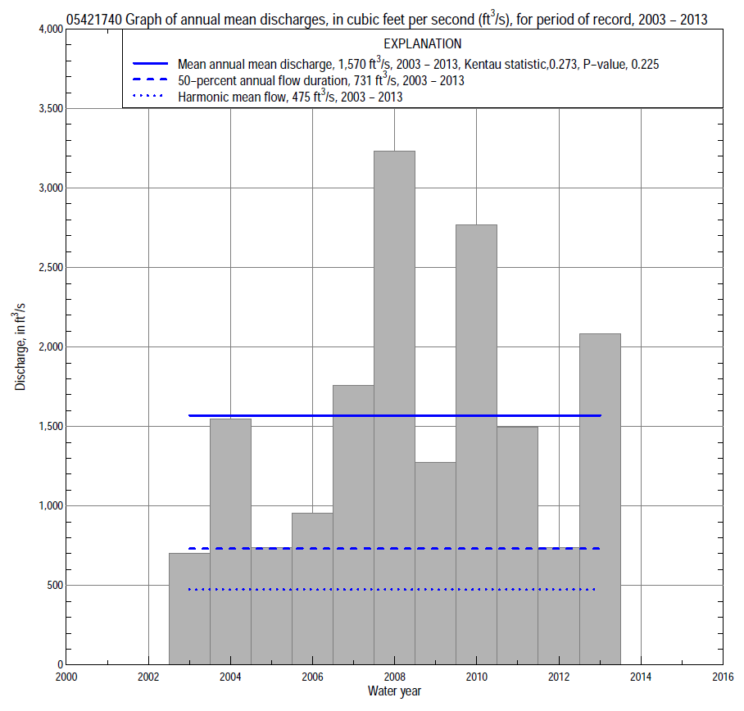

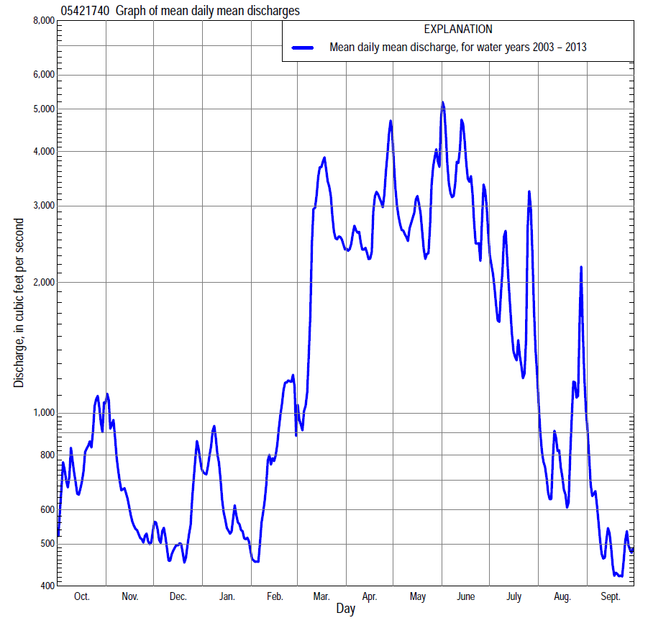

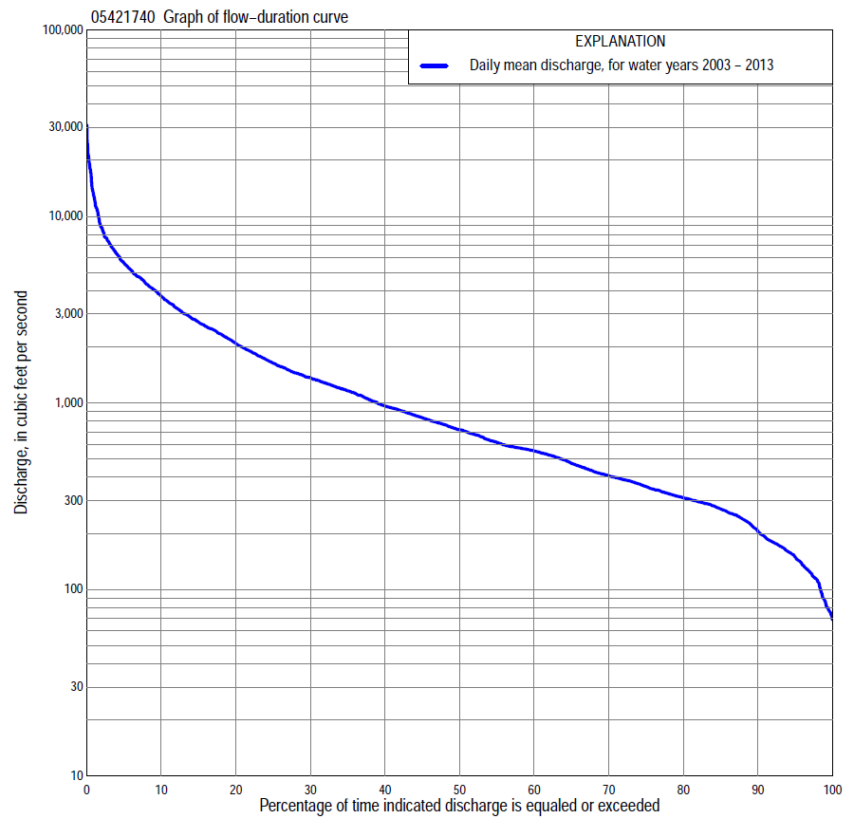

Statistics Based on the Entire Streamflow Period of Record
05421740 Monthly and annual flow durations, based on 2003–2013 period of record (11 years)
Percentage of days discharge equaled or exceeded |  |  |  |  | Discharge (cubic feet per second) |  |  |  |  |  |  |  |  | Annual flow durations
 | Oct | Nov | Dec | Jan | Feb | Mar | Apr | May | June | July | Aug | Sept | Annual | Kentau statistic | P-value
99 | 71 | 146 | 123 | 105 | 73 | 76 | 321 | 677 | 306 | 125 | 125 | 84 | 86 | 0.164 | 0.533
98 | 76 | 167 | 129 | 110 | 76 | 78 | 324 | 724 | 382 | 154 | 140 | 89 | 110 | 0.200 | 0.436
95 | 117 | 180 | 157 | 115 | 83 | 222 | 458 | 803 | 576 | 183 | 157 | 107 | 147 | 0.236 | 0.350
90 | 134 | 237 | 176 | 141 | 178 | 352 | 659 | 965 | 744 | 339 | 181 | 130 | 201 | 0.236 | 0.350
85 | 174 | 265 | 190 | 161 | 217 | 533 | 793 | 1,120 | 843 | 415 | 214 | 146 | 270 | 0.236 | 0.350
80 | 225 | 281 | 277 | 237 | 297 | 620 | 847 | 1,300 | 967 | 488 | 264 | 172 | 311 | 0.164 | 0.533
75 | 242 | 292 | 300 | 296 | 433 | 835 | 951 | 1,450 | 1,080 | 581 | 307 | 208 | 358 | 0.091 | 0.755
70 | 255 | 300 | 318 | 313 | 473 | 929 | 1,020 | 1,550 | 1,210 | 684 | 344 | 253 | 407 | 0.055 | 0.876
65 | 269 | 317 | 347 | 347 | 520 | 972 | 1,240 | 1,630 | 1,330 | 746 | 384 | 289 | 477 | 0.127 | 0.640
60 | 286 | 341 | 387 | 384 | 547 | 1,170 | 1,470 | 1,760 | 1,420 | 825 | 432 | 315 | 558 | 0.273 | 0.276
55 | 300 | 366 | 399 | 424 | 558 | 1,210 | 1,740 | 1,920 | 1,510 | 944 | 469 | 343 | 625 | 0.236 | 0.350
50 | 320 | 390 | 406 | 534 | 573 | 1,280 | 2,040 | 2,120 | 1,700 | 1,100 | 511 | 369 | 731 | 0.164 | 0.533
45 | 345 | 424 | 422 | 589 | 583 | 1,400 | 2,300 | 2,300 | 1,870 | 1,220 | 546 | 389 | 851 | 0.200 | 0.436
40 | 373 | 460 | 484 | 638 | 594 | 1,860 | 2,510 | 2,580 | 2,100 | 1,450 | 595 | 421 | 984 | 0.164 | 0.533
35 | 463 | 507 | 539 | 721 | 620 | 2,270 | 2,960 | 2,750 | 2,400 | 1,750 | 645 | 462 | 1,180 | 0.309 | 0.213
30 | 550 | 581 | 571 | 778 | 692 | 2,810 | 3,400 | 3,020 | 3,080 | 2,060 | 715 | 551 | 1,380 | 0.382 | 0.119
25 | 661 | 663 | 680 | 863 | 781 | 3,270 | 3,830 | 3,480 | 3,860 | 2,500 | 833 | 674 | 1,670 | 0.418 | 0.087
20 | 796 | 783 | 753 | 938 | 952 | 4,000 | 4,510 | 4,140 | 4,560 | 2,730 | 1,090 | 844 | 2,130 | 0.345 | 0.161
15 | 1,030 | 1,120 | 903 | 1,100 | 1,270 | 4,850 | 4,920 | 4,770 | 6,170 | 3,040 | 1,450 | 1,060 | 2,750 | 0.291 | 0.241
10 | 2,200 | 1,370 | 1,060 | 1,320 | 1,510 | 6,180 | 6,190 | 5,620 | 8,230 | 3,660 | 1,890 | 1,220 | 3,820 | 0.236 | 0.350
5 | 4,210 | 1,710 | 1,410 | 1,710 | 2,690 | 7,530 | 8,460 | 7,260 | 12,800 | 5,800 | 3,160 | 1,520 | 5,700 | 0.236 | 0.350
2 | 5,300 | 3,190 | 1,930 | 2,040 | 4,760 | 11,700 | 10,800 | 12,000 | 19,600 | 9,480 | 6,430 | 1,940 | 8,740 | 0.091 | 0.755
1 | 5,770 | 4,590 | 2,860 | 2,500 | 5,270 | 13,100 | 17,100 | 19,200 | 23,900 | 17,300 | 9,020 | 2,790 | 12,800 | 0.055 | 0.876

05421740 Annual exceedance probability of instantaneous peak discharges, in cubic feet per second (ft³/s), based on the Weighted Independent Estimates method,
Annual exceed-ance probability | Recur-rence interval (years) | Discharge (ft³/s) | 95-percent lower confi-dence interval (ft³/s) | 95-percent upper confi-dence interval (ft³/s)
0.500 | 2 | 9,470 | 8,290 | 10,800
0.200 | 5 | 16,100 | 14,200 | 18,300
0.100 | 10 | 20,800 | 18,200 | 23,800
0.040 | 25 | 26,900 | 22,900 | 31,600
0.020 | 50 | 31,100 | 25,800 | 37,600
0.010 | 100 | 35,200 | 28,200 | 43,800
0.005 | 200 | 40,400 | 31,400 | 52,100
0.002 | 500 | 44,600 | 33,100 | 60,200
and based on the expected moments algorithm/multiple Grubbs-Beck analysis computed using a historical period length of 80 years (1934–2013)
0.500 | 2 | 9,390 | 5,930 | 13,400
0.200 | 5 | 16,100 | 10,900 | 22,200
0.100 | 10 | 20,900 | 14,000 | 28,500
0.040 | 25 | 27,000 | 17,800 | 37,400
0.020 | 50 | 31,500 | 20,500 | 45,300
0.010 | 100 | 36,000 | 23,200 | 54,600
0.005 | 200 | 40,400 | 25,800 | 65,400
0.002 | 500 | 46,200 | 28,800 | 82,800
Kentau statistic |  | 0.091
P-value |  | 0.755
Begin year |  | 2003
End year |  | 2013
Number of peaks |  | 11

05421740 Annual exceedance probability of high discharges, based on 2003–2013 period of record (11 years)
[ND, not determined]
Annual exceedance probability | Recur-rence interval (years) | Maximum average discharge (ft³/s) for indicated number of consecutive days
 |  | 1 | 3 | 7 | 15 | 30
0.990 | 1.01 | ND | ND | ND | 1,280 | 994
0.950 | 1.05 | ND | ND | ND | 1,990 | 1,590
0.900 | 1.11 | ND | ND | ND | 2,520 | 2,040
0.800 | 1.25 | ND | ND | ND | 3,360 | 2,730
0.500 | 2 | ND | ND | ND | 5,870 | 4,700
0.200 | 5 | ND | ND | ND | 10,400 | 7,940
0.100 | 10 | ND | ND | ND | 14,000 | 10,400
0.040 | 25 | ND | ND | ND | 19,300 | 13,700
0.020 | 50 | ND | ND | ND | 23,800 | 16,300
0.010 | 100 | ND | ND | ND | 28,800 | 19,000
0.005 | 200 | ND | ND | ND | 34,300 | 21,900
0.002 | 500 | ND | ND | ND | 42,500 | 25,900
Kentau statistic |  | 0.091 | 0.055 | 0.055 | 0.091 | 0.127
P-value |  | 0.756 | 0.876 | 0.876 | 0.756 | 0.640

 | 05421740 Annual nonexceedance probability of low discharges, based on April 2003 to March 2013 period of record (10 years)
Annual nonexceed-ance probability | Recur-rence interval (years) | Minimum average discharge (cubic feet per second) for indicated number of consecutive days
 |  | 1 | 3 | 7 | 14 | 30 | 60 | 90 | 120 | 183
0.01 | 100 | 44 | 43 | 43 | 46 | 52 | 67 | 87 | 119 | 109
0.02 | 50 | 55 | 55 | 56 | 59 | 66 | 83 | 104 | 138 | 131
0.05 | 20 | 74 | 77 | 79 | 83 | 92 | 112 | 135 | 172 | 173
0.10 | 10 | 95 | 102 | 106 | 110 | 121 | 145 | 170 | 210 | 221
0.20 | 5 | 127 | 138 | 144 | 151 | 166 | 196 | 223 | 266 | 297
0.50 | 2 | 205 | 225 | 238 | 255 | 281 | 334 | 372 | 419 | 517
0.80 | 1.25 | 307 | 327 | 349 | 389 | 438 | 544 | 608 | 659 | 889
0.90 | 1.11 | 368 | 380 | 408 | 468 | 535 | 689 | 781 | 834 | 1,180
0.96 | 1.04 | 436 | 435 | 469 | 554 | 648 | 873 | 1,020 | 1,070 | 1,580
0.98 | 1.02 | 482 | 468 | 506 | 611 | 725 | 1,010 | 1,200 | 1,260 | 1,910
0.99 | 1.01 | 523 | 495 | 536 | 660 | 795 | 1,150 | 1,390 | 1,460 | 2,260
Kentau statistic |  | 0.244 | 0.200 | 0.200 | 0.156 | 0.156 | 0.200 | 0.200 | 0.156 | 0.200
P-value |  | 0.371 | 0.474 | 0.474 | 0.592 | 0.592 | 0.474 | 0.474 | 0.592 | 0.474

05421740 Annual nonexceedance probability of seasonal low discharges, based on October 2002 to September 2013 period of record (11 years)
Annual nonexceed-ance probability | Recur-rence interval (years) | Minimum average discharge (cubic feet per second) for indicated number of consecutive days
 |  | 1 | 7 | 14 | 30 |  | 1 | 7 | 14 | 30
 |  | January-February-March |  |  |  |  | April-May-June
0.01 | 100 | 36 | 37 | 39 | 41 |  | 159 | 188 | 199 | 325
0.02 | 50 | 52 | 52 | 55 | 59 |  | 192 | 225 | 239 | 377
0.05 | 20 | 78 | 83 | 88 | 95 |  | 254 | 294 | 315 | 474
0.10 | 10 | 109 | 119 | 128 | 140 |  | 325 | 373 | 404 | 586
0.20 | 5 | 157 | 178 | 192 | 212 |  | 437 | 498 | 546 | 767
0.50 | 2 | 285 | 332 | 360 | 396 |  | 768 | 861 | 976 | 1,330
0.80 | 1.25 | 455 | 522 | 568 | 609 |  | 1,340 | 1,480 | 1,760 | 2,410
0.90 | 1.11 | 554 | 624 | 677 | 714 |  | 1,790 | 1,970 | 2,400 | 3,360
0.96 | 1.04 | 661 | 726 | 785 | 811 |  | 2,430 | 2,660 | 3,360 | 4,840
0.98 | 1.02 | 730 | 785 | 846 | 863 |  | 2,960 | 3,240 | 4,170 | 6,200
0.99 | 1.01 | 789 | 832 | 896 | 903 |  | 3,530 | 3,850 | 5,080 | 7,770
Kentau statistic |  | 0.055 | 0.164 | 0.236 | 0.309 |  | 0.309 | 0.309 | 0.345 | 0.527
P-value |  | 0.876 | 0.533 | 0.350 | 0.213 |  | 0.213 | 0.213 | 0.161 | 0.029
 |  | July-August-September |  |  |  |  | October-November-December
0.01 | 100 | 51 | 56 | 59 | 63 |  | 46 | 48 | 55 | 97
0.02 | 50 | 61 | 67 | 72 | 79 |  | 56 | 59 | 67 | 107
0.05 | 20 | 79 | 89 | 95 | 109 |  | 75 | 80 | 89 | 126
0.10 | 10 | 100 | 113 | 121 | 144 |  | 96 | 105 | 113 | 147
0.20 | 5 | 131 | 149 | 162 | 199 |  | 128 | 142 | 151 | 181
0.50 | 2 | 218 | 248 | 276 | 355 |  | 218 | 247 | 257 | 282
0.80 | 1.25 | 354 | 400 | 456 | 603 |  | 356 | 412 | 425 | 473
0.90 | 1.11 | 452 | 506 | 585 | 780 |  | 454 | 529 | 547 | 638
0.96 | 1.04 | 582 | 644 | 757 | 1,010 |  | 583 | 682 | 709 | 900
0.98 | 1.02 | 683 | 749 | 890 | 1,190 |  | 681 | 799 | 835 | 1,140
0.99 | 1.01 | 787 | 854 | 1,030 | 1,370 |  | 780 | 916 | 965 | 1,420
Kentau statistic |  | 0.164 | 0.091 | 0.127 | 0.164 |  | 0.127 | 0.200 | 0.273 | 0.345
P-value |  | 0.533 | 0.756 | 0.640 | 0.533 |  | 0.640 | 0.436 | 0.276 | 0.161

