LOCATION.--Lat 41°46'01", long 90°32'05" referenced to North American Datum of 1927, in NE 1/4 SW 1/4 NE 1/4 sec.06, T.80 N., R.4 E., Clinton County, IA, Hydrologic Unit 07080103, on left bank 5 ft upstream from bridge on State Highway 956, 4.0 mi south of water tower in De Witt, 0.9 mi downstream from Silver Creek, 6.2 mi upstream from Brophy Creek, and 18.2 mi upstream from mouth.

DRAINAGE AREA.--2,336 mi².

PERIOD OF RECORD.--Discharge records from July 1934 to current year.

GAGE.--Water-stage recorder. Datum of gage is 598.81 ft above National Geodetic Vertical Datum of 1929.

A summary of all available data for this streamgage is provided through the USGS National Water Information System web interface (NWISWeb). The following link provides access to current/historical observations, daily data, daily statistics, monthly statistics, annual statistics, peak streamflow, field measurements, field/lab water-quality samples, and the latest water-year summaries. Data can be filtered by parameter and/or dates, and can be output in various tabular and graphical formats.
http://waterdata.usgs.gov/nwis/inventory/?site_no=05422000

The USGS WaterWatch Toolkit is available at:
http://waterwatch.usgs.gov/?id=ww_toolkit
Tools for summarizing streamflow information include the duration hydrograph builder, the cumulative streamflow hydrograph builder, the streamgage statistics retrieval tool, the rating curve builder, the flood tracking chart builder, the National Weather Service Advanced Hydrologic Prediction Service (AHPS) river forecast hydrograph builder, and the raster-hydrograph builder. Entering the above number for this streamgage into these toolkit webpages will provide streamflow information specific to this streamgage.

A description of the statistics presented for this streamgage is available in the main body of the report at:
http://dx.doi.org/10.3133/ofr20151214
A link to other streamgages included in this report, a map showing the location of the streamgages, information on the programs used to compute the statistical analyses, and references are included in the main body of the report.

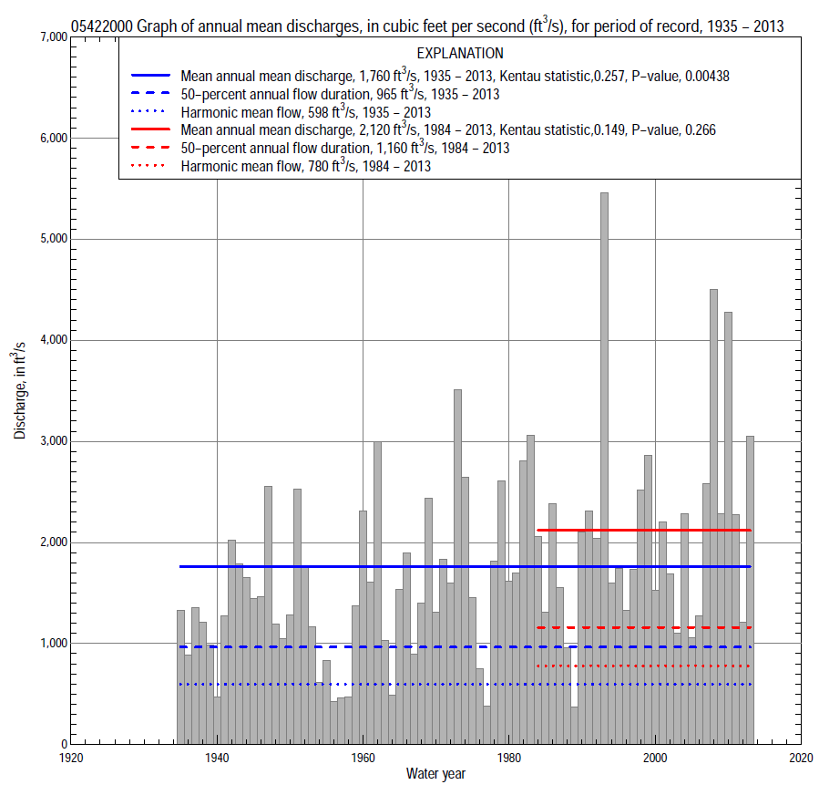

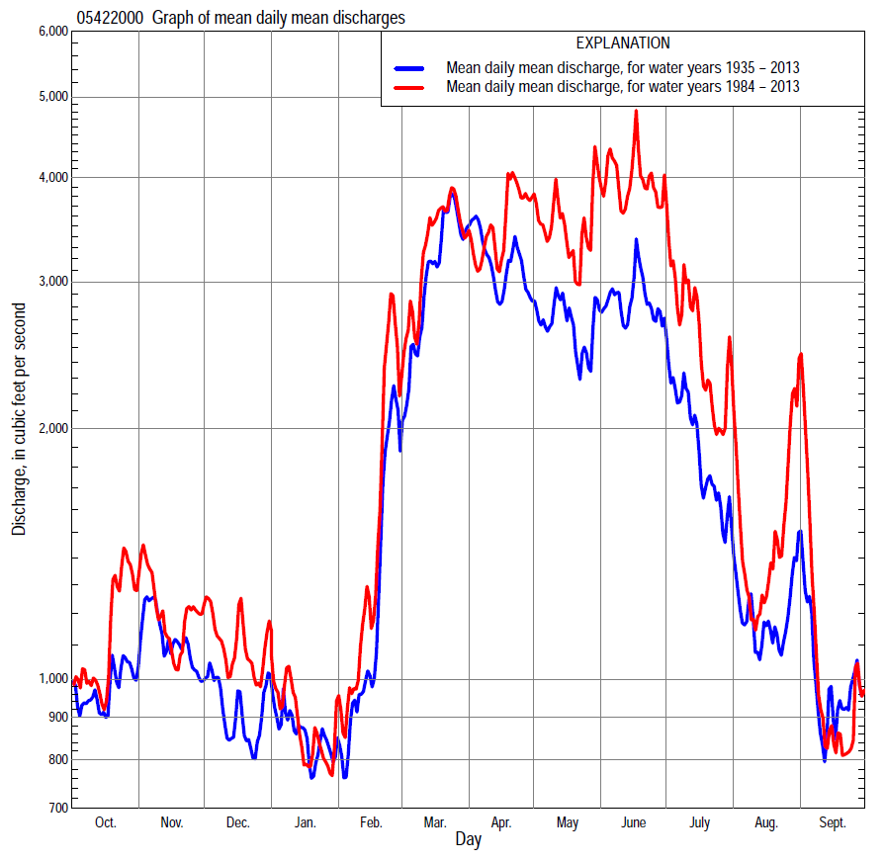

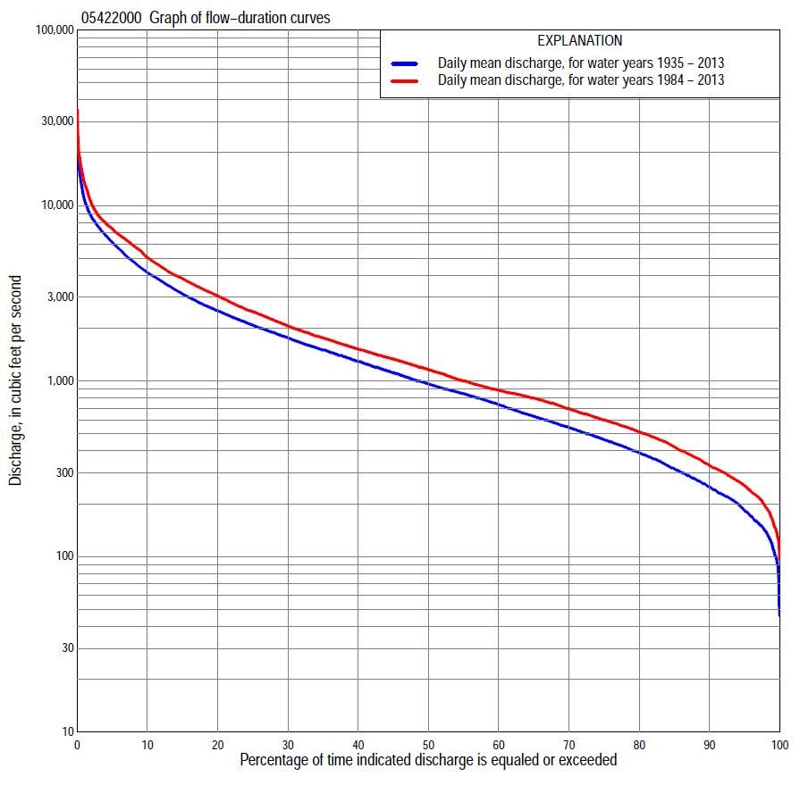

Statistics Based on the Entire Streamflow Period of Record
05422000 Monthly and annual flow durations, based on 1935–2013 period of record (79 years)
Percentage of days discharge equaled or exceeded |  |  |  |  | Discharge (cubic feet per second) |  |  |  |  |  |  |  |  | Annual flow durations
 | Oct | Nov | Dec | Jan | Feb | Mar | Apr | May | June | July | Aug | Sept | Annual | Kentau statistic | P-value
99 | 128 | 140 | 93 | 65 | 100 | 286 | 418 | 307 | 208 | 155 | 104 | 120 | 114 | 0.286 | 0.000
98 | 141 | 155 | 102 | 85 | 110 | 341 | 446 | 347 | 231 | 178 | 136 | 131 | 140 | 0.281 | 0.000
95 | 158 | 175 | 130 | 120 | 160 | 429 | 587 | 459 | 386 | 227 | 180 | 162 | 183 | 0.288 | 0.000
90 | 189 | 216 | 162 | 170 | 240 | 600 | 828 | 684 | 532 | 324 | 231 | 214 | 250 | 0.261 | 0.001
85 | 216 | 255 | 230 | 220 | 300 | 800 | 990 | 821 | 621 | 400 | 286 | 253 | 318 | 0.269 | 0.000
80 | 235 | 301 | 270 | 261 | 348 | 980 | 1,160 | 944 | 765 | 498 | 331 | 282 | 392 | 0.261 | 0.001
75 | 278 | 382 | 320 | 300 | 395 | 1,180 | 1,310 | 1,090 | 947 | 612 | 396 | 312 | 466 | 0.247 | 0.001
70 | 319 | 454 | 390 | 360 | 475 | 1,370 | 1,460 | 1,220 | 1,140 | 689 | 450 | 342 | 546 | 0.241 | 0.002
65 | 373 | 510 | 436 | 410 | 535 | 1,550 | 1,620 | 1,360 | 1,290 | 780 | 499 | 377 | 633 | 0.252 | 0.001
60 | 430 | 569 | 487 | 470 | 600 | 1,770 | 1,800 | 1,520 | 1,450 | 875 | 550 | 416 | 740 | 0.235 | 0.002
55 | 485 | 634 | 567 | 520 | 720 | 1,980 | 2,010 | 1,690 | 1,620 | 990 | 610 | 455 | 850 | 0.216 | 0.005
50 | 554 | 707 | 650 | 570 | 800 | 2,200 | 2,230 | 1,890 | 1,810 | 1,140 | 665 | 506 | 965 | 0.228 | 0.003
45 | 616 | 802 | 750 | 620 | 870 | 2,500 | 2,510 | 2,090 | 2,070 | 1,280 | 730 | 566 | 1,120 | 0.230 | 0.003
40 | 701 | 888 | 845 | 700 | 953 | 2,790 | 2,770 | 2,290 | 2,310 | 1,450 | 816 | 642 | 1,300 | 0.223 | 0.004
35 | 825 | 1,000 | 915 | 800 | 1,100 | 3,170 | 3,090 | 2,550 | 2,620 | 1,630 | 894 | 750 | 1,510 | 0.241 | 0.002
30 | 985 | 1,170 | 1,000 | 900 | 1,300 | 3,700 | 3,550 | 2,890 | 2,960 | 1,900 | 1,000 | 897 | 1,770 | 0.245 | 0.001
25 | 1,160 | 1,340 | 1,150 | 1,000 | 1,510 | 4,130 | 4,030 | 3,300 | 3,480 | 2,180 | 1,140 | 1,080 | 2,090 | 0.251 | 0.001
20 | 1,440 | 1,590 | 1,310 | 1,150 | 1,800 | 4,740 | 4,690 | 3,910 | 4,110 | 2,550 | 1,320 | 1,310 | 2,520 | 0.248 | 0.001
15 | 1,830 | 1,900 | 1,500 | 1,400 | 2,200 | 5,590 | 5,660 | 4,760 | 4,940 | 3,130 | 1,690 | 1,610 | 3,130 | 0.243 | 0.002
10 | 2,340 | 2,340 | 1,900 | 1,840 | 3,000 | 6,700 | 6,950 | 5,900 | 6,090 | 4,040 | 2,480 | 2,030 | 4,160 | 0.231 | 0.003
5 | 3,300 | 3,350 | 2,660 | 2,500 | 4,400 | 8,640 | 8,770 | 7,330 | 8,280 | 6,440 | 4,810 | 3,200 | 6,180 | 0.176 | 0.022
2 | 4,560 | 5,520 | 4,000 | 3,800 | 6,620 | 10,800 | 11,400 | 9,010 | 13,900 | 10,300 | 7,360 | 6,250 | 8,680 | 0.238 | 0.002
1 | 6,110 | 7,000 | 4,770 | 4,540 | 8,300 | 12,400 | 14,200 | 11,700 | 17,200 | 14,700 | 10,000 | 9,150 | 10,900 | 0.219 | 0.004

05422000 Annual exceedance probability of instantaneous peak discharges, in cubic feet per second (ft³/s), based on the Weighted Independent Estimates method,
Annual exceed-ance probability | Recur-rence interval (years) | Discharge (ft³/s) | 95-percent lower confi-dence interval (ft³/s) | 95-percent upper confi-dence interval (ft³/s)
0.500 | 2 | 10,900 | 9,490 | 12,500
0.200 | 5 | 17,600 | 15,300 | 20,200
0.100 | 10 | 22,300 | 19,200 | 26,000
0.040 | 25 | 28,500 | 23,800 | 34,100
0.020 | 50 | 32,800 | 26,600 | 40,400
0.010 | 100 | 37,000 | 29,200 | 47,000
0.005 | 200 | 42,600 | 32,400 | 56,100
0.002 | 500 | 47,000 | 34,100 | 64,800
and based on the expected moments algorithm/multiple Grubbs-Beck analysis computed using a historical period length of 79 years (1935–2013)
0.500 | 2 | 10,800 | 9,340 | 12,400
0.200 | 5 | 17,600 | 15,300 | 20,500
0.100 | 10 | 22,400 | 19,300 | 27,000
0.040 | 25 | 28,800 | 24,100 | 36,900
0.020 | 50 | 33,600 | 27,500 | 45,500
0.010 | 100 | 38,600 | 30,600 | 55,200
0.005 | 200 | 43,600 | 33,400 | 66,100
0.002 | 500 | 50,500 | 36,900 | 82,700
Kentau statistic |  | 0.168
P-value |  | 0.029
Begin year |  | 1935
End year |  | 2013
Number of peaks |  | 79

05422000 Annual exceedance probability of high discharges, based on 1935–2013 period of record (79 years)
Annual exceed-ance probability | Recur-rence interval (years) | Maximum average discharge (ft³/s) for indicated number of consecutive days
 |  | 1 | 3 | 7 | 15 | 30
0.990 | 1.01 | 2,200 | 1,910 | 1,440 | 1,090 | 878
0.950 | 1.05 | 3,530 | 3,140 | 2,520 | 1,970 | 1,590
0.900 | 1.11 | 4,500 | 4,040 | 3,330 | 2,640 | 2,120
0.800 | 1.25 | 5,980 | 5,410 | 4,560 | 3,650 | 2,920
0.500 | 2 | 10,000 | 9,140 | 7,850 | 6,310 | 5,000
0.200 | 5 | 16,200 | 14,800 | 12,600 | 9,970 | 7,800
0.100 | 10 | 20,600 | 18,700 | 15,600 | 12,200 | 9,500
0.040 | 25 | 26,300 | 23,600 | 19,300 | 14,800 | 11,400
0.020 | 50 | 30,600 | 27,400 | 22,000 | 16,600 | 12,700
0.010 | 100 | 35,000 | 31,100 | 24,400 | 18,200 | 13,900
0.005 | 200 | 39,400 | 34,800 | 26,800 | 19,700 | 15,000
0.002 | 500 | 45,300 | 39,600 | 29,800 | 21,500 | 16,200
Kentau statistic |  | 0.179 | 0.198 | 0.198 | 0.207 | 0.218
P-value |  | 0.020 | 0.010 | 0.010 | 0.007 | 0.004

 | 05422000 Annual nonexceedance probability of low discharges, based on April 1935 to March 2013 period of record (78 years)
Annual nonexceed-ance probability | Recur-rence interval (years) | Minimum average discharge (ft³/s) for indicated number of consecutive days
 |  | 1 | 3 | 7 | 14 | 30 | 60 | 90 | 120 | 183
0.01 | 100 | 54 | 54 | 54 | 56 | 60 | 73 | 83 | 88 | 99
0.02 | 50 | 65 | 66 | 66 | 69 | 75 | 90 | 103 | 111 | 126
0.05 | 20 | 87 | 88 | 90 | 94 | 102 | 122 | 143 | 156 | 180
0.10 | 10 | 112 | 114 | 116 | 122 | 134 | 159 | 188 | 209 | 245
0.20 | 5 | 150 | 153 | 158 | 166 | 184 | 219 | 262 | 294 | 350
0.50 | 2 | 256 | 263 | 274 | 291 | 326 | 391 | 477 | 544 | 668
0.80 | 1.25 | 425 | 437 | 458 | 489 | 555 | 679 | 841 | 958 | 1,210
0.90 | 1.11 | 547 | 562 | 589 | 631 | 721 | 895 | 1,120 | 1,260 | 1,630
0.96 | 1.04 | 709 | 729 | 761 | 819 | 942 | 1,190 | 1,490 | 1,670 | 2,200
0.98 | 1.02 | 836 | 857 | 894 | 964 | 1,110 | 1,430 | 1,800 | 1,990 | 2,650
0.99 | 1.01 | 965 | 988 | 1,030 | 1,110 | 1,290 | 1,670 | 2,110 | 2,320 | 3,120
Kentau statistic |  | 0.315 | 0.326 | 0.322 | 0.309 | 0.281 | 0.257 | 0.203 | 0.188 | 0.194
P-value |  | 0.000 | 0.000 | 0.000 | 0.000 | 0.000 | 0.001 | 0.009 | 0.015 | 0.012

05422000 Annual nonexceedance probability of seasonal low discharges, based on October 1934 to September 2013 period of record (79 years)
Annual nonexceed-ance probability | Recur-rence interval (years) | Minimum average discharge (cubic feet per second) for indicated number of consecutive days
 |  | 1 | 7 | 14 | 30 |  | 1 | 7 | 14 | 30
 |  | January-February-March |  |  |  |  | April-May-June
0.01 | 100 | 54 | 55 | 56 | 63 |  | 144 | 161 | 180 | 221
0.02 | 50 | 69 | 71 | 74 | 84 |  | 181 | 201 | 224 | 276
0.05 | 20 | 99 | 104 | 108 | 126 |  | 253 | 278 | 310 | 383
0.10 | 10 | 134 | 142 | 150 | 177 |  | 335 | 368 | 410 | 508
0.20 | 5 | 190 | 205 | 218 | 262 |  | 465 | 510 | 571 | 712
0.50 | 2 | 353 | 391 | 422 | 521 |  | 832 | 918 | 1,040 | 1,330
0.80 | 1.25 | 620 | 693 | 756 | 950 |  | 1,410 | 1,580 | 1,840 | 2,400
0.90 | 1.11 | 814 | 910 | 997 | 1,260 |  | 1,810 | 2,060 | 2,450 | 3,240
0.96 | 1.04 | 1,070 | 1,190 | 1,310 | 1,670 |  | 2,330 | 2,690 | 3,280 | 4,410
0.98 | 1.02 | 1,260 | 1,410 | 1,550 | 1,970 |  | 2,720 | 3,180 | 3,940 | 5,360
0.99 | 1.01 | 1,460 | 1,620 | 1,780 | 2,270 |  | 3,110 | 3,680 | 4,630 | 6,380
Kentau statistic |  | 0.289 | 0.273 | 0.259 | 0.157 |  | 0.278 | 0.246 | 0.250 | 0.229
P-value |  | 0.000 | 0.000 | 0.001 | 0.040 |  | 0.000 | 0.001 | 0.001 | 0.003
 |  | July-August-September |  |  |  |  | October-November-December
0.01 | 100 | 89 | 92 | 99 | 116 |  | 67 | 67 | 68 | 75
0.02 | 50 | 101 | 105 | 113 | 131 |  | 81 | 82 | 85 | 94
0.05 | 20 | 124 | 130 | 139 | 159 |  | 107 | 112 | 117 | 131
0.10 | 10 | 151 | 159 | 170 | 193 |  | 137 | 147 | 154 | 175
0.20 | 5 | 193 | 204 | 219 | 249 |  | 185 | 202 | 215 | 247
0.50 | 2 | 322 | 344 | 370 | 431 |  | 325 | 364 | 396 | 469
0.80 | 1.25 | 569 | 614 | 663 | 818 |  | 565 | 641 | 711 | 868
0.90 | 1.11 | 784 | 849 | 920 | 1,190 |  | 750 | 853 | 954 | 1,190
0.96 | 1.04 | 1,120 | 1,220 | 1,330 | 1,820 |  | 1,010 | 1,150 | 1,290 | 1,640
0.98 | 1.02 | 1,430 | 1,560 | 1,700 | 2,430 |  | 1,220 | 1,390 | 1,570 | 2,020
0.99 | 1.01 | 1,790 | 1,960 | 2,140 | 3,200 |  | 1,450 | 1,640 | 1,860 | 2,430
Kentau statistic |  | 0.285 | 0.272 | 0.263 | 0.226 |  | 0.188 | 0.180 | 0.179 | 0.185
P-value |  | 0.000 | 0.000 | 0.001 | 0.003 |  | 0.015 | 0.019 | 0.020 | 0.016

Statistics Based on the 1984–2013 Streamflow Period of Record
05422000 Monthly and annual flow durations, based on 1984–2013 period of record (30 years)
Percentage of days discharge equaled or exceeded |  |  |  |  | Discharge (cubic feet per second) |  |  |  |  |  |  |  |  | Annual flow durations
 | Oct | Nov | Dec | Jan | Feb | Mar | Apr | May | June | July | Aug | Sept | Annual | Kentau statistic | P-value
99 | 146 | 206 | 113 | 150 | 215 | 327 | 488 | 402 | 225 | 174 | 130 | 137 | 160 | 0.186 | 0.153
98 | 163 | 232 | 138 | 180 | 240 | 341 | 624 | 522 | 265 | 192 | 153 | 146 | 191 | 0.163 | 0.212
95 | 211 | 261 | 190 | 215 | 277 | 700 | 775 | 796 | 411 | 235 | 192 | 205 | 253 | 0.159 | 0.225
90 | 257 | 313 | 260 | 280 | 325 | 911 | 883 | 1,020 | 581 | 334 | 260 | 279 | 331 | 0.138 | 0.292
85 | 298 | 387 | 320 | 320 | 380 | 1,100 | 1,120 | 1,190 | 717 | 468 | 369 | 304 | 421 | 0.136 | 0.301
80 | 336 | 483 | 424 | 391 | 500 | 1,240 | 1,290 | 1,380 | 944 | 689 | 453 | 330 | 513 | 0.117 | 0.372
75 | 388 | 553 | 481 | 437 | 635 | 1,400 | 1,440 | 1,520 | 1,290 | 855 | 509 | 349 | 600 | 0.106 | 0.422
70 | 434 | 601 | 544 | 494 | 712 | 1,540 | 1,620 | 1,730 | 1,500 | 1,010 | 565 | 389 | 696 | 0.071 | 0.592
65 | 472 | 650 | 614 | 533 | 780 | 1,740 | 1,810 | 1,910 | 1,740 | 1,140 | 618 | 437 | 799 | 0.090 | 0.498
60 | 521 | 707 | 700 | 573 | 834 | 1,880 | 1,960 | 2,230 | 2,100 | 1,280 | 676 | 493 | 887 | 0.101 | 0.443
55 | 576 | 777 | 809 | 620 | 880 | 2,030 | 2,230 | 2,450 | 2,420 | 1,390 | 726 | 536 | 1,000 | 0.071 | 0.592
50 | 630 | 830 | 860 | 696 | 947 | 2,210 | 2,480 | 2,670 | 2,650 | 1,540 | 799 | 585 | 1,160 | 0.085 | 0.521
45 | 691 | 887 | 916 | 787 | 1,010 | 2,510 | 2,720 | 2,900 | 3,040 | 1,660 | 856 | 630 | 1,330 | 0.110 | 0.402
40 | 771 | 954 | 1,010 | 850 | 1,120 | 2,920 | 2,990 | 3,260 | 3,560 | 1,860 | 923 | 686 | 1,520 | 0.122 | 0.354
35 | 878 | 1,050 | 1,120 | 903 | 1,300 | 3,360 | 3,340 | 3,600 | 3,970 | 2,130 | 1,010 | 780 | 1,760 | 0.179 | 0.169
30 | 1,020 | 1,230 | 1,240 | 976 | 1,460 | 3,800 | 4,000 | 4,100 | 4,500 | 2,400 | 1,130 | 919 | 2,060 | 0.175 | 0.181
25 | 1,190 | 1,410 | 1,380 | 1,080 | 1,600 | 4,150 | 4,680 | 4,680 | 5,140 | 2,920 | 1,270 | 1,120 | 2,490 | 0.177 | 0.175
20 | 1,570 | 1,640 | 1,530 | 1,240 | 1,800 | 4,830 | 5,580 | 5,250 | 5,740 | 3,380 | 1,560 | 1,330 | 3,060 | 0.182 | 0.164
15 | 2,130 | 1,970 | 1,740 | 1,470 | 2,200 | 6,030 | 6,400 | 6,100 | 7,050 | 4,040 | 2,160 | 1,540 | 3,830 | 0.156 | 0.232
10 | 2,790 | 2,410 | 2,180 | 1,800 | 3,400 | 7,080 | 7,860 | 7,000 | 8,280 | 5,810 | 3,620 | 1,980 | 5,050 | 0.154 | 0.239
5 | 3,680 | 3,350 | 3,200 | 2,270 | 5,580 | 8,690 | 9,400 | 8,060 | 12,300 | 8,510 | 6,880 | 3,420 | 7,370 | 0.159 | 0.225
2 | 6,090 | 5,000 | 4,100 | 2,700 | 8,360 | 12,000 | 12,100 | 10,600 | 17,300 | 15,500 | 10,200 | 7,100 | 10,300 | 0.136 | 0.301
1 | 7,310 | 6,700 | 4,720 | 3,390 | 9,600 | 14,300 | 15,700 | 16,400 | 22,800 | 19,100 | 12,900 | 10,900 | 13,700 | 0.117 | 0.372

05422000 Annual exceedance probability of high discharges, based on 1984–2013 period of record (30 years)
Annual exceed-ance probability | Recur-rence interval (years) | Maximum average discharge (ft³/s) for indicated number of consecutive days
 |  | 1 | 3 | 7 | 15 | 30
0.990 | 1.01 | 1,960 | 1,850 | 1,640 | 1,370 | 1,150
0.950 | 1.05 | 3,630 | 3,370 | 2,960 | 2,460 | 2,050
0.900 | 1.11 | 4,900 | 4,520 | 3,950 | 3,270 | 2,710
0.800 | 1.25 | 6,900 | 6,310 | 5,460 | 4,490 | 3,690
0.500 | 2 | 12,300 | 11,100 | 9,480 | 7,630 | 6,110
0.200 | 5 | 20,100 | 18,000 | 15,100 | 11,800 | 9,150
0.100 | 10 | 25,100 | 22,400 | 18,600 | 14,300 | 10,900
0.040 | 25 | 31,000 | 27,700 | 22,700 | 17,200 | 12,700
0.020 | 50 | 35,100 | 31,400 | 25,500 | 19,100 | 13,900
0.010 | 100 | 38,900 | 34,800 | 28,200 | 20,800 | 15,000
0.005 | 200 | 42,500 | 38,000 | 30,600 | 22,300 | 15,900
0.002 | 500 | 46,900 | 42,000 | 33,600 | 24,200 | 16,900
Kentau statistic |  | 0.085 | 0.108 | 0.117 | 0.122 | 0.113
P-value |  | 0.521 | 0.412 | 0.372 | 0.354 | 0.392

 | 05422000 Annual nonexceedance probability of low discharges, based on April 1983 to March 2013 period of record (30 years)
Annual nonexceed-ance probability | Recur-rence interval (years) | Minimum average discharge (ft³/s) for indicated number of consecutive days
 |  | 1 | 3 | 7 | 14 | 30 | 60 | 90 | 120 | 183
0.01 | 100 | 90 | 93 | 97 | 104 | 118 | 126 | 138 | 145 | 159
0.02 | 50 | 106 | 109 | 113 | 121 | 136 | 147 | 164 | 176 | 196
0.05 | 20 | 133 | 137 | 143 | 152 | 168 | 186 | 213 | 232 | 265
0.10 | 10 | 164 | 168 | 175 | 185 | 204 | 229 | 266 | 296 | 345
0.20 | 5 | 209 | 215 | 224 | 235 | 258 | 295 | 348 | 392 | 468
0.50 | 2 | 329 | 338 | 352 | 370 | 404 | 480 | 573 | 653 | 811
0.80 | 1.25 | 513 | 524 | 544 | 578 | 637 | 783 | 925 | 1,050 | 1,350
0.90 | 1.11 | 643 | 656 | 678 | 728 | 809 | 1,010 | 1,180 | 1,320 | 1,730
0.96 | 1.04 | 815 | 830 | 854 | 929 | 1,040 | 1,330 | 1,520 | 1,670 | 2,230
0.98 | 1.02 | 949 | 964 | 989 | 1,090 | 1,230 | 1,590 | 1,780 | 1,930 | 2,600
0.99 | 1.01 | 1,090 | 1,100 | 1,130 | 1,250 | 1,430 | 1,870 | 2,060 | 2,200 | 2,990
Kentau statistic |  | 0.172 | 0.182 | 0.191 | 0.168 | 0.186 | 0.168 | 0.117 | 0.094 | 0.039
P-value |  | 0.187 | 0.164 | 0.143 | 0.199 | 0.154 | 0.199 | 0.372 | 0.475 | 0.775

05422000 Annual nonexceedance probability of seasonal low discharges, based on October 1983 to September 2013 period of record (30 years)
Annual nonexceed-ance probability | Recur-rence interval (years) | Minimum average discharge (cubic feet per second) for indicated number of consecutive days
 |  | 1 | 7 | 14 | 30 |  | 1 | 7 | 14 | 30
 |  | January-February-March |  |  |  |  | April-May-June
0.01 | 100 | 98 | 107 | 120 | 143 |  | 176 | 187 | 188 | 234
0.02 | 50 | 121 | 132 | 147 | 173 |  | 228 | 244 | 245 | 302
0.05 | 20 | 164 | 180 | 197 | 227 |  | 328 | 350 | 360 | 438
0.10 | 10 | 213 | 233 | 252 | 288 |  | 444 | 473 | 498 | 603
0.20 | 5 | 286 | 314 | 337 | 380 |  | 624 | 666 | 720 | 875
0.50 | 2 | 482 | 528 | 561 | 628 |  | 1,100 | 1,200 | 1,360 | 1,710
0.80 | 1.25 | 764 | 835 | 890 | 1,000 |  | 1,770 | 1,970 | 2,370 | 3,140
0.90 | 1.11 | 950 | 1,040 | 1,110 | 1,270 |  | 2,180 | 2,470 | 3,070 | 4,230
0.96 | 1.04 | 1,180 | 1,290 | 1,390 | 1,600 |  | 2,660 | 3,070 | 3,950 | 5,710
0.98 | 1.02 | 1,340 | 1,460 | 1,590 | 1,860 |  | 2,980 | 3,490 | 4,590 | 6,870
0.99 | 1.01 | 1,500 | 1,630 | 1,790 | 2,120 |  | 3,270 | 3,890 | 5,210 | 8,070
Kentau statistic |  | 0.101 | 0.113 | 0.117 | 0.067 |  | 0.297 | 0.264 | 0.255 | 0.255
P-value |  | 0.443 | 0.392 | 0.372 | 0.617 |  | 0.022 | 0.042 | 0.050 | 0.050
 |  | July-August-September |  |  |  |  | October-November-December
0.01 | 100 | 127 | 128 | 132 | 149 |  | 88 | 94 | 95 | 112
0.02 | 50 | 140 | 142 | 147 | 164 |  | 105 | 116 | 117 | 138
0.05 | 20 | 165 | 169 | 177 | 194 |  | 136 | 153 | 158 | 188
0.10 | 10 | 194 | 201 | 211 | 231 |  | 172 | 195 | 206 | 245
0.20 | 5 | 241 | 253 | 267 | 294 |  | 226 | 258 | 279 | 334
0.50 | 2 | 394 | 420 | 449 | 517 |  | 382 | 433 | 478 | 584
0.80 | 1.25 | 714 | 768 | 830 | 1,060 |  | 638 | 703 | 781 | 978
0.90 | 1.11 | 1,020 | 1,100 | 1,190 | 1,640 |  | 831 | 894 | 989 | 1,260
0.96 | 1.04 | 1,540 | 1,650 | 1,810 | 2,750 |  | 1,100 | 1,140 | 1,260 | 1,630
0.98 | 1.02 | 2,050 | 2,200 | 2,410 | 3,960 |  | 1,320 | 1,330 | 1,450 | 1,910
0.99 | 1.01 | 2,680 | 2,870 | 3,150 | 5,600 |  | 1,520 | 1,530 | 1,650 | 2,190
Kentau statistic |  | 0.177 | 0.172 | 0.154 | 0.159 |  | 0.069 | 0.011 | -0.021 | -0.062
P-value |  | 0.175 | 0.187 | 0.239 | 0.225 |  | 0.605 | 0.943 | 0.887 | 0.643

