LOCATION.--Lat 41°32'46", long 90°31'26" referenced to North American Datum of 1927, in SW 1/4 SE 1/4 NW 1/4 sec.20, T.78 N., R.4 E., Scott County, IA, Hydrologic Unit 07080101, on right bank 500 ft upstream from Kimberly Road in Davenport, 100 ft upstream from golf cart bridge, 0.5 mi downstream from Pheasant Creek, and 4.45 mi upstream from mouth.

DRAINAGE AREA.--57.3 mi².

PERIOD OF RECORD.--Discharge records from November 1993 to current year.

GAGE.--Water stage recorder. Datum of gage is 597.00 ft above National Geodetic Vertical Datum of 1929.

A summary of all available data for this streamgage is provided through the USGS National Water Information System web interface (NWISWeb). The following link provides access to current/historical observations, daily data, daily statistics, monthly statistics, annual statistics, peak streamflow, field measurements, field/lab water-quality samples, and the latest water-year summaries. Data can be filtered by parameter and/or dates, and can be output in various tabular and graphical formats.
http://waterdata.usgs.gov/nwis/inventory/?site_no=05422600

The USGS WaterWatch Toolkit is available at:
http://waterwatch.usgs.gov/?id=ww_toolkit
Tools for summarizing streamflow information include the duration hydrograph builder, the cumulative streamflow hydrograph builder, the streamgage statistics retrieval tool, the rating curve builder, the flood tracking chart builder, the National Weather Service Advanced Hydrologic Prediction Service (AHPS) river forecast hydrograph builder, and the raster-hydrograph builder. Entering the above number for this streamgage into these toolkit webpages will provide streamflow information specific to this streamgage.

A description of the statistics presented for this streamgage is available in the main body of the report at:
http://dx.doi.org/10.3133/ofr20151214
A link to other streamgages included in this report, a map showing the location of the streamgages, information on the programs used to compute the statistical analyses, and references are included in the main body of the report.

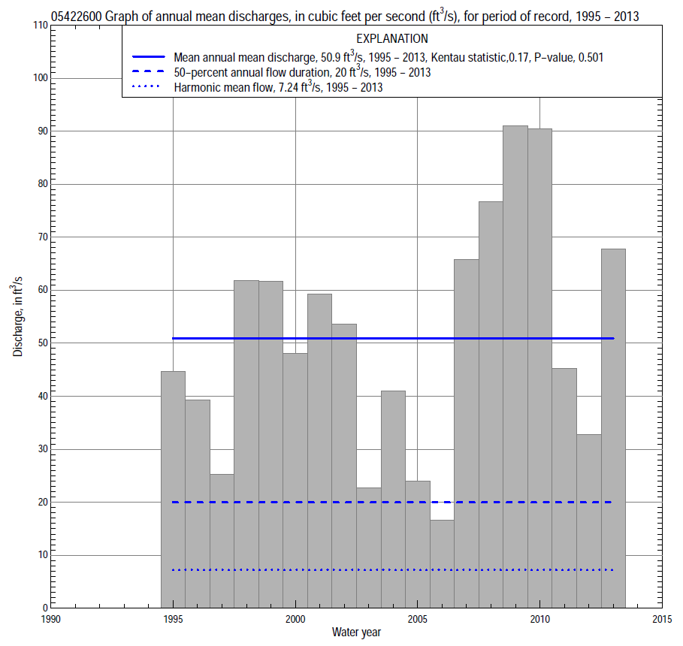

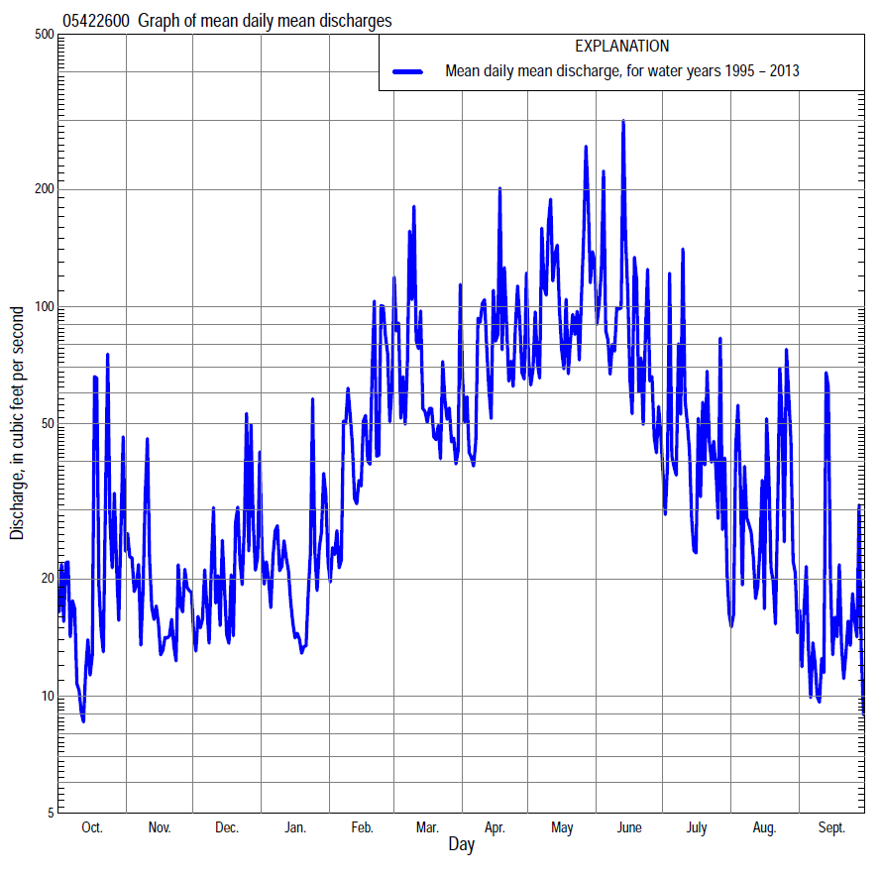

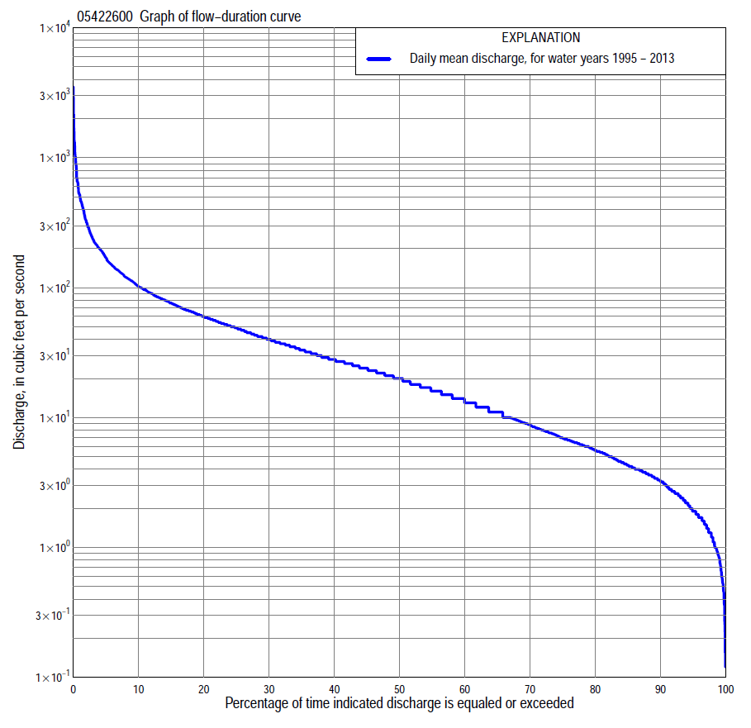

Statistics Based on the Entire Streamflow Period of Record
05422600 Monthly and annual flow durations, based on 1995–2013 period of record (19 years)
Percentage of days discharge equaled or exceeded |  |  |  |  | Discharge (cubic feet per second) |  |  |  |  |  |  |  |  | Annual flow durations
 | Oct | Nov | Dec | Jan | Feb | Mar | Apr | May | June | July | Aug | Sept | Annual | Kentau statistic | P-value
99 | 0.56 | 1.4 | 0.87 | 0.52 | 1.3 | 4.5 | 7.1 | 12 | 6.0 | 2.2 | 0.72 | 0.21 | 0.83 | 0.023 | 0.913
98 | 0.65 | 1.7 | 1.0 | 0.80 | 1.6 | 5.6 | 8.3 | 14 | 6.7 | 2.5 | 1.3 | 0.26 | 1.2 | -0.018 | 0.943
95 | 0.94 | 2.4 | 1.7 | 2.4 | 3.2 | 7.8 | 11 | 17 | 9.0 | 3.4 | 1.7 | 0.92 | 1.9 | 0.035 | 0.857
90 | 1.3 | 3.2 | 3.2 | 3.2 | 4.5 | 12 | 15 | 24 | 13 | 5.2 | 2.4 | 1.6 | 3.3 | 0.064 | 0.723
85 | 1.6 | 3.8 | 3.8 | 3.8 | 5.5 | 17 | 18 | 29 | 17 | 8.4 | 3.2 | 2.0 | 4.3 | 0.082 | 0.645
80 | 1.9 | 4.2 | 4.6 | 4.4 | 6.5 | 20 | 21 | 33 | 24 | 11 | 4.0 | 2.5 | 5.6 | 0.070 | 0.697
75 | 2.2 | 4.7 | 5.5 | 5.0 | 8.0 | 22 | 22 | 38 | 29 | 13 | 5.0 | 2.8 | 6.8 | 0.135 | 0.436
70 | 2.6 | 5.3 | 6.2 | 6.0 | 9.7 | 25 | 25 | 42 | 32 | 15 | 5.5 | 3.3 | 8.5 | 0.146 | 0.397
65 | 3.4 | 6.0 | 6.7 | 6.8 | 13 | 27 | 29 | 47 | 36 | 16 | 6.4 | 3.7 | 11 | 0.158 | 0.361
60 | 4.8 | 6.5 | 7.5 | 7.6 | 16 | 29 | 35 | 51 | 42 | 18 | 7.1 | 4.1 | 13 | 0.135 | 0.440
55 | 5.9 | 7.5 | 8.3 | 9.0 | 20 | 33 | 39 | 55 | 47 | 19 | 8.0 | 4.5 | 16 | 0.123 | 0.482
50 | 7.0 | 8.4 | 9.5 | 11 | 23 | 36 | 45 | 60 | 53 | 21 | 9.4 | 5.2 | 20 | 0.099 | 0.575
45 | 8.1 | 9.8 | 11 | 13 | 26 | 40 | 53 | 66 | 59 | 23 | 11 | 6.4 | 24 | 0.129 | 0.462
40 | 9.6 | 11 | 12 | 14 | 29 | 47 | 60 | 72 | 66 | 26 | 14 | 7.8 | 28 | 0.152 | 0.381
35 | 12 | 13 | 14 | 17 | 35 | 53 | 68 | 85 | 74 | 31 | 17 | 10 | 34 | 0.117 | 0.505
30 | 14 | 15 | 17 | 20 | 41 | 61 | 78 | 96 | 83 | 37 | 21 | 14 | 41 | 0.117 | 0.506
25 | 18 | 18 | 21 | 24 | 49 | 69 | 90 | 114 | 96 | 43 | 27 | 17 | 50 | 0.152 | 0.381
20 | 24 | 25 | 29 | 28 | 64 | 79 | 102 | 133 | 113 | 52 | 35 | 22 | 61 | 0.123 | 0.484
15 | 31 | 37 | 32 | 38 | 80 | 94 | 121 | 155 | 138 | 61 | 49 | 28 | 78 | 0.111 | 0.529
10 | 49 | 50 | 38 | 50 | 108 | 120 | 153 | 214 | 191 | 84 | 74 | 38 | 104 | 0.117 | 0.506
5 | 89 | 69 | 73 | 79 | 173 | 202 | 255 | 362 | 290 | 170 | 145 | 60 | 175 | 0.088 | 0.624
2 | 185 | 97 | 139 | 129 | 348 | 348 | 464 | 653 | 484 | 310 | 289 | 115 | 331 | 0.123 | 0.484
1 | 227 | 118 | 258 | 160 | 497 | 690 | 520 | 1,020 | 871 | 459 | 482 | 207 | 523 | 0.199 | 0.248

05422600 Annual exceedance probability of instantaneous peak discharges, in cubic feet per second (ft³/s), based on the Weighted Independent Estimates method,
Annual exceed-ance probability | Recur-rence interval (years) | Discharge (ft³/s) | 95-percent lower confi-dence interval (ft³/s) | 95-percent upper confi-dence interval (ft³/s)
0.500 | 2 | 2,900 | 2,260 | 3,710
0.200 | 5 | 4,430 | 3,500 | 5,620
0.100 | 10 | 5,600 | 4,400 | 7,130
0.040 | 25 | 7,430 | 5,740 | 9,620
0.020 | 50 | 8,770 | 6,610 | 11,600
0.010 | 100 | 10,100 | 7,380 | 13,800
0.005 | 200 | 12,200 | 8,570 | 17,300
0.002 | 500 | 13,500 | 9,040 | 20,100
and based on the expected moments algorithm/multiple Grubbs-Beck analysis computed using a historical period length of 20 years (1994–2013)
0.500 | 2 | 3,030 | 2,260 | 3,940
0.200 | 5 | 4,820 | 3,720 | 6,640
0.100 | 10 | 6,050 | 4,630 | 9,010
0.040 | 25 | 7,630 | 5,690 | 12,900
0.020 | 50 | 8,800 | 6,380 | 16,400
0.010 | 100 | 9,960 | 6,990 | 20,500
0.005 | 200 | 11,100 | 7,530 | 25,300
0.002 | 500 | 12,700 | 8,150 | 33,100
Kentau statistic |  | 0.274
P-value |  | 0.098
Begin year |  | 1994
End year |  | 2013
Number of peaks |  | 20

05422600 Annual exceedance probability of high discharges, based on 1995–2013 period of record (19 years)
Annual exceedance probability | Recur-rence interval (years) | Maximum average discharge (ft³/s) for indicated number of consecutive days
 |  | 1 | 3 | 7 | 15 | 30
0.990 | 1.01 | 156 | 107 | 71 | 55 | 38
0.950 | 1.05 | 324 | 201 | 130 | 95 | 68
0.900 | 1.11 | 462 | 272 | 173 | 123 | 88
0.800 | 1.25 | 684 | 381 | 236 | 163 | 117
0.500 | 2 | 1,300 | 662 | 386 | 251 | 180
0.200 | 5 | 2,190 | 1,030 | 561 | 345 | 244
0.100 | 10 | 2,740 | 1,250 | 653 | 391 | 273
0.040 | 25 | 3,370 | 1,490 | 745 | 434 | 299
0.020 | 50 | 3,780 | 1,640 | 800 | 458 | 313
0.010 | 100 | 4,160 | 1,780 | 845 | 477 | 323
0.005 | 200 | 4,490 | 1,900 | 882 | 493 | 331
0.002 | 500 | 4,890 | 2,040 | 922 | 508 | 338
Kentau statistic |  | 0.135 | 0.064 | 0.146 | 0.111 | -0.006
P-value |  | 0.441 | 0.726 | 0.401 | 0.529 | 1.000

 | 05422600 Annual nonexceedance probability of low discharges, based on April 1994 to March 2013 period of record (19 years)
Annual nonexceed-ance probability | Recur-rence interval (years) | Minimum average discharge (cubic feet per second) for indicated number of consecutive days
 |  | 1 | 3 | 7 | 14 | 30 | 60 | 90 | 120 | 183
0.01 | 100 | 0.10 | 0.16 | 0.39 | 0.53 | 0.91 | 1.7 | 2.8 | 2.9 | 3.7
0.02 | 50 | 0.15 | 0.22 | 0.46 | 0.63 | 1.1 | 2.0 | 3.2 | 3.3 | 4.3
0.05 | 20 | 0.25 | 0.34 | 0.62 | 0.83 | 1.4 | 2.4 | 4.0 | 4.1 | 5.2
0.10 | 10 | 0.40 | 0.50 | 0.81 | 1.1 | 1.8 | 3.0 | 4.6 | 5.0 | 6.4
0.20 | 5 | 0.69 | 0.80 | 1.2 | 1.5 | 2.5 | 3.9 | 5.6 | 6.5 | 8.3
0.50 | 2 | 1.9 | 2.0 | 2.5 | 3.1 | 4.8 | 7.2 | 9.2 | 12 | 14
0.80 | 1.25 | 5.0 | 5.2 | 5.8 | 6.9 | 9.7 | 15 | 18 | 23 | 27
0.90 | 1.11 | 8.2 | 8.5 | 9.5 | 11 | 14 | 23 | 28 | 33 | 39
0.96 | 1.04 | 14 | 15 | 17 | 18 | 22 | 39 | 46 | 52 | 59
0.98 | 1.02 | 19 | 21 | 24 | 26 | 30 | 55 | 66 | 70 | 78
0.99 | 1.01 | 25 | 28 | 35 | 36 | 39 | 76 | 94 | 94 | 102
Kentau statistic |  | 0.164 | 0.181 | 0.181 | 0.158 | 0.228 | 0.380 | 0.368 | 0.333 | 0.345
P-value |  | 0.345 | 0.293 | 0.294 | 0.363 | 0.184 | 0.025 | 0.030 | 0.050 | 0.042

05422600 Annual nonexceedance probability of seasonal low discharges, based on January 1994 to September 2013 period of record (19–20 years)
Annual nonexceed-ance probability | Recur-rence interval (years) | Minimum average discharge (cubic feet per second) for indicated number of consecutive days
 |  | 1 | 7 | 14 | 30 |  | 1 | 7 | 14 | 30
 |  | January-February-March |  |  |  |  | April-May-June
0.01 | 100 | 0.34 | 0.62 | 0.76 | 1.3 |  | 2.7 | 3.7 | 4.9 | 6.5
0.02 | 50 | 0.51 | 0.85 | 1.1 | 1.7 |  | 3.4 | 4.7 | 6.2 | 8.3
0.05 | 20 | 0.90 | 1.4 | 1.7 | 2.6 |  | 4.9 | 6.5 | 8.7 | 12
0.10 | 10 | 1.5 | 2.0 | 2.4 | 3.8 |  | 6.7 | 8.6 | 11 | 16
0.20 | 5 | 2.5 | 3.2 | 3.8 | 5.7 |  | 9.5 | 12 | 16 | 22
0.50 | 2 | 5.9 | 7.0 | 8.2 | 12 |  | 17 | 21 | 27 | 41
0.80 | 1.25 | 12 | 14 | 16 | 23 |  | 29 | 35 | 43 | 70
0.90 | 1.11 | 16 | 20 | 22 | 32 |  | 36 | 44 | 53 | 90
0.96 | 1.04 | 21 | 28 | 30 | 44 |  | 45 | 56 | 66 | 117
0.98 | 1.02 | 25 | 35 | 37 | 53 |  | 52 | 65 | 74 | 136
0.99 | 1.01 | 28 | 41 | 43 | 63 |  | 58 | 73 | 83 | 156
Kentau statistic |  | 0.195 | 0.211 | 0.211 | 0.137 |  | 0.142 | 0.158 | 0.095 | 0.147
P-value |  | 0.243 | 0.206 | 0.206 | 0.417 |  | 0.398 | 0.347 | 0.581 | 0.381
 |  | July-August-September |  |  |  |  | October-November-December
0.01 | 100 | 0.06 | 0.20 | 0.80 | 1.7 |  | 0.17 | 0.33 | 0.52 | 0.83
0.02 | 50 | 0.10 | 0.28 | 0.95 | 1.9 |  | 0.24 | 0.41 | 0.66 | 1.0
0.05 | 20 | 0.19 | 0.45 | 1.2 | 2.4 |  | 0.38 | 0.59 | 0.93 | 1.5
0.10 | 10 | 0.33 | 0.68 | 1.6 | 2.9 |  | 0.57 | 0.83 | 1.3 | 2.0
0.20 | 5 | 0.64 | 1.1 | 2.2 | 3.7 |  | 0.94 | 1.3 | 1.9 | 3.0
0.50 | 2 | 2.0 | 2.9 | 4.3 | 6.7 |  | 2.5 | 3.1 | 4.3 | 6.5
0.80 | 1.25 | 5.9 | 7.4 | 8.9 | 14 |  | 6.9 | 8.1 | 10 | 15
0.90 | 1.11 | 10 | 12 | 14 | 21 |  | 12 | 14 | 16 | 24
0.96 | 1.04 | 16 | 20 | 22 | 34 |  | 21 | 25 | 27 | 40
0.98 | 1.02 | 22 | 27 | 30 | 47 |  | 30 | 36 | 38 | 55
0.99 | 1.01 | 29 | 36 | 40 | 64 |  | 42 | 49 | 51 | 75
Kentau statistic |  | 0.021 | 0.021 | 0.016 | 0.147 |  | 0.158 | 0.158 | 0.170 | 0.170
P-value |  | 0.922 | 0.922 | 0.948 | 0.381 |  | 0.362 | 0.362 | 0.327 | 0.327

