LOCATION.--Lat 42°57'54.6", long 93°42'20.6" referenced to North American Datum of 1927, in SE 1/4 SE 1/4 SW 1/4 sec.08, T.94 N., R.24 W., Hancock County, IA, Hydrologic Unit 07080207, on downstream side of bridge on 140th Street, 5.6 mi southwest of Klemme, and 18.4 mi upstream from confluence with East Branch Iowa River.

DRAINAGE AREA.--112 mi².

PERIOD OF RECORD.--Discharge records from April 1948 to September 1958.

GAGE.--Non-recording gage. Datum of gage is 1,180.83 ft above National Geodetic Vertical Datum of 1929. Prior to June 13, 1948, at datum 1.00 ft higher.

A summary of all available data for this streamgage is provided through the USGS National Water Information System web interface (NWISWeb). The following link provides access to current/historical observations, daily data, daily statistics, monthly statistics, annual statistics, peak streamflow, field measurements, field/lab water-quality samples, and the latest water-year summaries. Data can be filtered by parameter and/or dates, and can be output in various tabular and graphical formats.
http://waterdata.usgs.gov/nwis/inventory/?site_no=05448500

The USGS WaterWatch Toolkit is available at:
http://waterwatch.usgs.gov/?id=ww_toolkit
Tools for summarizing streamflow information include the duration hydrograph builder, the cumulative streamflow hydrograph builder, the streamgage statistics retrieval tool, the rating curve builder, the flood tracking chart builder, the National Weather Service Advanced Hydrologic Prediction Service (AHPS) river forecast hydrograph builder, and the raster-hydrograph builder. Entering the above number for this streamgage into these toolkit webpages will provide streamflow information specific to this streamgage.

A description of the statistics presented for this streamgage is available in the main body of the report at:
http://dx.doi.org/10.3133/ofr20151214
A link to other streamgages included in this report, a map showing the location of the streamgages, information on the programs used to compute the statistical analyses, and references are included in the main body of the report.

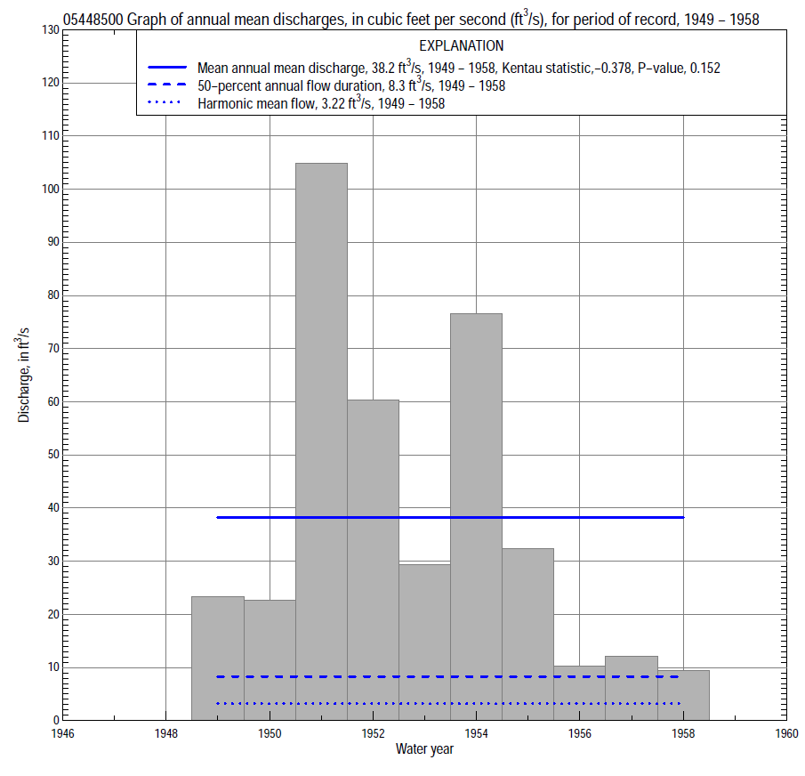

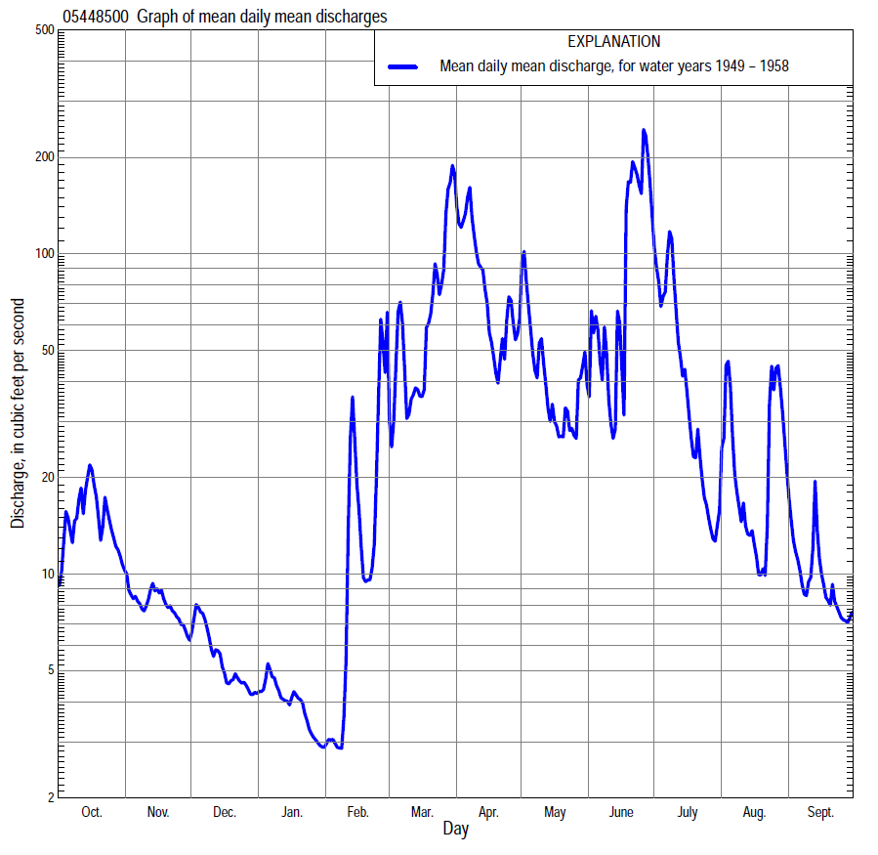

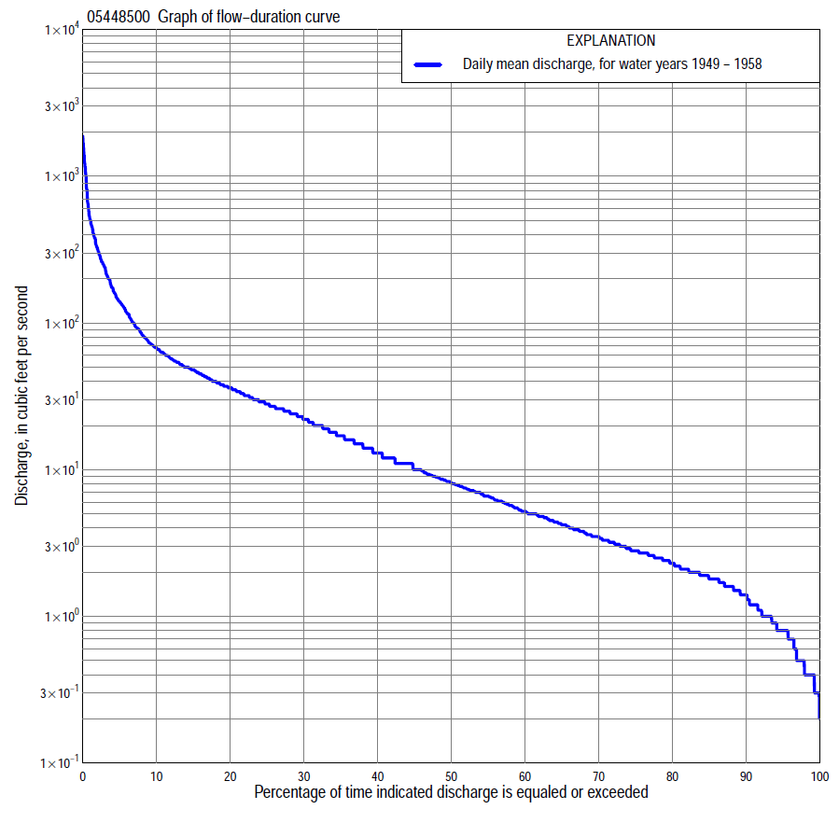

Statistics Based on the Entire Streamflow Period of Record
05448500 Monthly and annual flow durations, based on 1949–58 period of record (10 years)
Percentage of days discharge equaled or exceeded |  |  |  |  | Discharge (cubic feet per second) |  |  |  |  |  |  |  |  | Annual flow durations
 | Oct | Nov | Dec | Jan | Feb | Mar | Apr | May | June | July | Aug | Sept | Annual | Kentau statistic | P-value
99 | 1.0 | 1.1 | 0.40 | 0.30 | 0.30 | 0.80 | 6.1 | 3.8 | 4.4 | 2.5 | 0.60 | 0.30 | 0.40 | -0.111 | 0.683
98 | 1.1 | 1.2 | 0.40 | 0.30 | 0.30 | 1.8 | 6.2 | 4.8 | 4.6 | 3.4 | 0.70 | 0.40 | 0.40 | -0.111 | 0.683
95 | 1.2 | 1.5 | 0.50 | 0.40 | 0.30 | 2.7 | 6.6 | 5.2 | 4.8 | 4.0 | 1.0 | 0.50 | 0.80 | -0.244 | 0.335
90 | 1.7 | 1.8 | 0.90 | 0.50 | 0.40 | 3.5 | 7.7 | 6.5 | 5.2 | 4.8 | 1.4 | 0.80 | 1.4 | -0.178 | 0.510
85 | 2.0 | 2.0 | 1.6 | 0.60 | 0.70 | 7.0 | 8.6 | 7.9 | 9.0 | 5.8 | 2.1 | 1.2 | 1.8 | -0.044 | 0.926
80 | 2.3 | 2.2 | 1.6 | 0.80 | 0.80 | 7.4 | 9.5 | 9.8 | 12 | 6.6 | 3.0 | 2.5 | 2.3 | -0.067 | 0.853
75 | 2.5 | 2.5 | 1.8 | 0.90 | 0.80 | 8.6 | 11 | 12 | 14 | 7.7 | 3.8 | 2.8 | 2.8 | 0.022 | 1.000
70 | 2.8 | 2.8 | 1.8 | 1.1 | 1.0 | 13 | 12 | 14 | 16 | 8.6 | 4.4 | 3.2 | 3.5 | -0.067 | 0.855
65 | 3.1 | 3.0 | 2.0 | 1.4 | 1.0 | 16 | 16 | 18 | 18 | 10 | 5.0 | 3.3 | 4.3 | -0.044 | 0.928
60 | 3.3 | 3.3 | 2.2 | 1.6 | 1.4 | 19 | 20 | 24 | 20 | 12 | 5.7 | 3.6 | 5.2 | -0.044 | 0.927
55 | 3.7 | 3.5 | 2.5 | 1.8 | 1.5 | 24 | 26 | 26 | 22 | 13 | 6.4 | 3.9 | 6.6 | -0.156 | 0.584
50 | 4.5 | 3.8 | 2.7 | 1.9 | 1.8 | 30 | 27 | 29 | 25 | 16 | 7.8 | 4.3 | 8.3 | -0.244 | 0.362
45 | 5.0 | 4.0 | 2.8 | 2.0 | 2.2 | 36 | 31 | 33 | 30 | 19 | 8.9 | 4.7 | 11 | -0.200 | 0.458
40 | 5.1 | 4.2 | 3.1 | 2.1 | 2.4 | 43 | 39 | 36 | 35 | 24 | 10 | 5.2 | 13 | -0.133 | 0.650
35 | 6.1 | 4.6 | 3.5 | 2.4 | 2.9 | 48 | 49 | 40 | 39 | 29 | 12 | 6.6 | 17 | -0.267 | 0.314
30 | 7.6 | 5.4 | 4.0 | 2.8 | 6.1 | 57 | 58 | 46 | 48 | 36 | 15 | 7.3 | 22 | -0.356 | 0.178
25 | 10 | 6.0 | 5.9 | 7.0 | 7.2 | 68 | 73 | 52 | 54 | 44 | 18 | 9.5 | 28 | -0.400 | 0.127
20 | 17 | 10 | 10 | 9.0 | 12 | 90 | 107 | 57 | 63 | 58 | 28 | 20 | 37 | -0.511 | 0.049
15 | 26 | 20 | 12 | 11 | 15 | 117 | 136 | 70 | 81 | 80 | 36 | 25 | 50 | -0.400 | 0.127
10 | 47 | 26 | 16 | 12 | 40 | 200 | 206 | 91 | 162 | 151 | 50 | 28 | 70 | -0.422 | 0.107
5 | 69 | 31 | 22 | 13 | 90 | 315 | 379 | 146 | 806 | 245 | 92 | 38 | 144 | -0.467 | 0.074
2 | 124 | 37 | 24 | 15 | 180 | 474 | 772 | 225 | 1,410 | 390 | 326 | 62 | 328 | -0.511 | 0.049
1 | 140 | 38 | 26 | 16 | 250 | 560 | 1,000 | 270 | 1,580 | 464 | 378 | 83 | 507 | -0.467 | 0.074

05448500 Annual exceedance probability of instantaneous peak discharges, in cubic feet per second (ft³/s), based on the Weighted Independent Estimates method,
Annual exceed-ance probability | Recur-rence interval (years) | Discharge (ft³/s) | 95-percent lower confi-dence interval (ft³/s) | 95-percent upper confi-dence interval (ft³/s)
0.500 | 2 | 611 | 399 | 935
0.200 | 5 | 1,310 | 874 | 1,970
0.100 | 10 | 1,930 | 1,260 | 2,960
0.040 | 25 | 2,810 | 1,750 | 4,490
0.020 | 50 | 3,480 | 2,090 | 5,810
0.010 | 100 | 4,220 | 2,430 | 7,340
0.005 | 200 | 4,980 | 2,730 | 9,070
0.002 | 500 | 6,000 | 3,090 | 11,700
and based on the expected moments algorithm/multiple Grubbs-Beck analysis computed using a historical period length of 10 years (1949–1958)
0.500 | 2 | 507 | 274 | 871
0.200 | 5 | 985 | 581 | 2,040
0.100 | 10 | 1,370 | 806 | 3,520
0.040 | 25 | 1,920 | 1,090 | 6,710
0.020 | 50 | 2,370 | 1,300 | 10,500
0.010 | 100 | 2,850 | 1,490 | 16,000
0.005 | 200 | 3,360 | 1,670 | 23,800
0.002 | 500 | 4,090 | 1,890 | 39,400
Kentau statistic |  | -0.511
P-value |  | 0.049
Begin year |  | 1949
End year |  | 1958
Number of peaks |  | 10

05448500 Annual exceedance probability of high discharges, based on 1949–58 period of record (10 years)
[ND, not determined]
Annual exceedance probability | Recur-rence interval (years) | Maximum average discharge (ft³/s) for indicated number of consecutive days
 |  | 1 | 3 | 7 | 15 | 30
0.990 | 1.01 | 83 | 76 | 55 | 40 | 23
0.950 | 1.05 | 126 | 107 | 76 | 54 | 34
0.900 | 1.11 | 160 | 133 | 93 | 66 | 43
0.800 | 1.25 | 219 | 178 | 125 | 87 | 59
0.500 | 2 | 424 | 342 | 247 | 173 | 120
0.200 | 5 | 896 | 752 | 587 | 419 | 285
0.100 | 10 | 1,370 | 1,200 | 999 | 724 | 476
0.040 | 25 | 2,220 | 2,070 | 1,870 | 1,390 | 864
0.020 | 50 | 3,090 | 3,020 | 2,910 | 2,200 | 1,310
0.010 | 100 | 4,190 | 4,320 | 4,430 | 3,410 | 1,930
0.005 | 200 | 5,590 | 6,070 | 6,640 | 5,210 | 2,800
0.002 | 500 | 8,020 | 9,350 | 11,100 | 8,960 | 4,490
Kentau statistic |  | -0.467 | -0.467 | -0.511 | -0.467 | -0.511
P-value |  | 0.074 | 0.074 | 0.049 | 0.074 | 0.049

 | 05448500 Annual nonexceedance probability of low discharges, based on April 1948 to March 1958 period of record (10 years)
Annual nonexceed-ance probability | Recur-rence interval (years) | Minimum average discharge (cubic feet per second) for indicated number of consecutive days
 |  | 1 | 3 | 7 | 14 | 30 | 60 | 90 | 120 | 183
0.01 | 100 | 0.12 | 0.13 | 0.14 | 0.15 | 0.20 | 0.26 | 0.32 | 0.72 | 1.0
0.02 | 50 | 0.15 | 0.16 | 0.17 | 0.18 | 0.24 | 0.31 | 0.38 | 0.78 | 1.1
0.05 | 20 | 0.22 | 0.23 | 0.24 | 0.25 | 0.31 | 0.42 | 0.52 | 0.91 | 1.3
0.10 | 10 | 0.29 | 0.30 | 0.31 | 0.33 | 0.41 | 0.56 | 0.70 | 1.1 | 1.5
0.20 | 5 | 0.42 | 0.44 | 0.46 | 0.49 | 0.60 | 0.81 | 1.0 | 1.4 | 1.9
0.50 | 2 | 0.97 | 1.0 | 1.1 | 1.2 | 1.4 | 1.8 | 2.3 | 2.7 | 3.7
0.80 | 1.25 | 2.9 | 3.0 | 3.2 | 3.3 | 3.7 | 4.7 | 6.1 | 6.8 | 9.6
0.90 | 1.11 | 5.6 | 5.8 | 6.0 | 6.2 | 6.7 | 8.1 | 11 | 12 | 18
0.96 | 1.04 | 11 | 12 | 12 | 13 | 13 | 15 | 20 | 25 | 40
0.98 | 1.02 | 19 | 20 | 20 | 21 | 21 | 23 | 31 | 42 | 70
0.99 | 1.01 | 31 | 32 | 32 | 33 | 33 | 35 | 46 | 68 | 121
Kentau statistic |  | -0.067 | -0.044 | -0.067 | -0.067 | 0.022 | 0.067 | 0.022 | -0.022 | -0.022
P-value |  | 0.857 | 0.928 | 0.857 | 0.858 | 1.000 | 0.858 | 1.000 | 1.000 | 1.000

05448500 Annual nonexceedance probability of seasonal low discharges, based on April 1948 to September 1958 period of record (10–11 years)
Annual nonexceed-ance probability | Recur-rence interval (years) | Minimum average discharge (cubic feet per second) for indicated number of consecutive days
 |  | 1 | 7 | 14 | 30 |  | 1 | 7 | 14 | 30
 |  | January-February-March |  |  |  |  | April-May-June
0.01 | 100 | 0.15 | 0.16 | 0.17 | 0.20 |  | 2.0 | 2.3 | 2.4 | 2.5
0.02 | 50 | 0.18 | 0.19 | 0.20 | 0.24 |  | 2.3 | 2.6 | 2.7 | 2.9
0.05 | 20 | 0.24 | 0.25 | 0.26 | 0.31 |  | 2.9 | 3.2 | 3.3 | 3.9
0.10 | 10 | 0.32 | 0.33 | 0.34 | 0.41 |  | 3.5 | 3.9 | 4.1 | 5.0
0.20 | 5 | 0.47 | 0.48 | 0.50 | 0.6 |  | 4.5 | 5.0 | 5.5 | 7.0
0.50 | 2 | 1.1 | 1.2 | 1.2 | 1.4 |  | 7.7 | 8.7 | 10 | 14
0.80 | 1.25 | 3.2 | 3.3 | 3.4 | 3.8 |  | 14 | 16 | 20 | 29
0.90 | 1.11 | 6.0 | 6.1 | 6.3 | 6.9 |  | 21 | 23 | 30 | 43
0.96 | 1.04 | 12 | 13 | 13 | 14 |  | 31 | 35 | 45 | 67
0.98 | 1.02 | 20 | 21 | 21 | 23 |  | 40 | 46 | 61 | 90
0.99 | 1.01 | 32 | 33 | 33 | 36 |  | 52 | 59 | 80 | 119
Kentau statistic |  | -0.111 | -0.089 | -0.067 | 0.022 |  | -0.164 | -0.273 | -0.200 | -0.236
P-value |  | 0.718 | 0.788 | 0.858 | 1.000 |  | 0.533 | 0.276 | 0.436 | 0.350
 |  | July-August-September |  |  |  |  | October-November-December
0.01 | 100 | 0.08 | 0.17 | 0.21 | 0.26 |  | 0.25 | 0.26 | 0.28 | 0.43
0.02 | 50 | 0.12 | 0.24 | 0.28 | 0.36 |  | 0.31 | 0.32 | 0.35 | 0.50
0.05 | 20 | 0.24 | 0.40 | 0.46 | 0.58 |  | 0.41 | 0.44 | 0.48 | 0.66
0.10 | 10 | 0.44 | 0.62 | 0.71 | 0.88 |  | 0.54 | 0.61 | 0.66 | 0.87
0.20 | 5 | 0.85 | 1.1 | 1.2 | 1.5 |  | 0.79 | 0.91 | 1.0 | 1.3
0.50 | 2 | 2.7 | 2.9 | 3.3 | 4.2 |  | 1.8 | 2.2 | 2.3 | 2.8
0.80 | 1.25 | 7.6 | 7.9 | 9.0 | 12 |  | 5.0 | 5.7 | 6.0 | 7.1
0.90 | 1.11 | 12 | 13 | 15 | 21 |  | 9.0 | 9.9 | 10 | 12
0.96 | 1.04 | 20 | 23 | 27 | 38 |  | 17 | 18 | 19 | 23
0.98 | 1.02 | 27 | 32 | 40 | 57 |  | 27 | 28 | 28 | 36
0.99 | 1.01 | 34 | 43 | 55 | 82 |  | 39 | 40 | 41 | 55
Kentau statistic |  | -0.127 | -0.091 | -0.127 | -0.164 |  | 0.133 | 0.156 | 0.200 | 0.156
P-value |  | 0.640 | 0.756 | 0.640 | 0.533 |  | 0.653 | 0.592 | 0.474 | 0.592

