LOCATION.--Lat 43°00'34", long 93°37'40" referenced to North American Datum of 1927, in NE 1/4 NW 1/4 sec.36, T.95 N., R.24 W., Hancock County, IA, Hydrologic Unit 07080207, on left bank 15 ft upstream from bridge on County Highway B55, 1.2 mi west of Chicago, Rock Island and Pacific Railroad crossing in Klemme, 1.5 mi upstream from Drainage Ditch 9, and 18.2 mi upstream from confluence with West Branch Iowa River.

DRAINAGE AREA.--133 mi².

PERIOD OF RECORD.--Discharge records from April 1948 to September 1976, June 1977 to November 1995. Prior to October 1958, published as "East Fork Iowa River near Klemme."

GAGE.--Water-stage recorder. Datum of gage is 1,179.33 ft above National Geodetic Vertical Datum of 1929. April 1, 1948, to September 30, 1955, non-recording gage at site 0.6 mi upstream at datum 0.80 ft higher; October 1, 1955, to September 30, 1969, at same site at datum 0.31 ft lower.

EXTREMES OUTSIDE PERIOD OF RECORD.--Flood in June 1944 reached a stage of about 10 ft, from information by local residents, at site and datum in use in 1948.

A summary of all available data for this streamgage is provided through the USGS National Water Information System web interface (NWISWeb). The following link provides access to current/historical observations, daily data, daily statistics, monthly statistics, annual statistics, peak streamflow, field measurements, field/lab water-quality samples, and the latest water-year summaries. Data can be filtered by parameter and/or dates, and can be output in various tabular and graphical formats.
http://waterdata.usgs.gov/nwis/inventory/?site_no=05449000

The USGS WaterWatch Toolkit is available at:
http://waterwatch.usgs.gov/?id=ww_toolkit
Tools for summarizing streamflow information include the duration hydrograph builder, the cumulative streamflow hydrograph builder, the streamgage statistics retrieval tool, the rating curve builder, the flood tracking chart builder, the National Weather Service Advanced Hydrologic Prediction Service (AHPS) river forecast hydrograph builder, and the raster-hydrograph builder. Entering the above number for this streamgage into these toolkit webpages will provide streamflow information specific to this streamgage.

A description of the statistics presented for this streamgage is available in the main body of the report at:
http://dx.doi.org/10.3133/ofr20151214
A link to other streamgages included in this report, a map showing the location of the streamgages, information on the programs used to compute the statistical analyses, and references are included in the main body of the report.

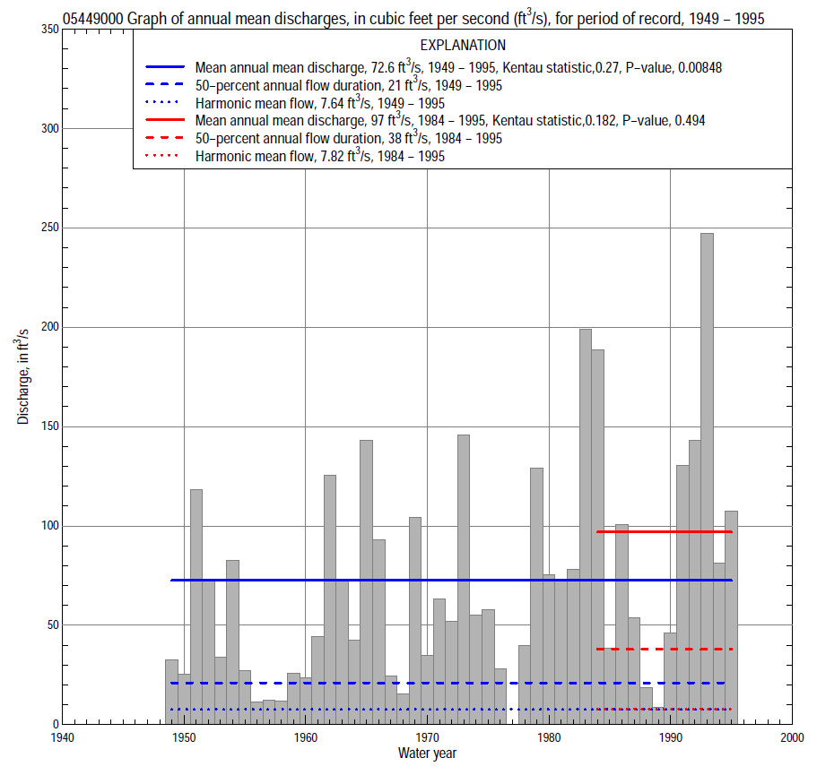

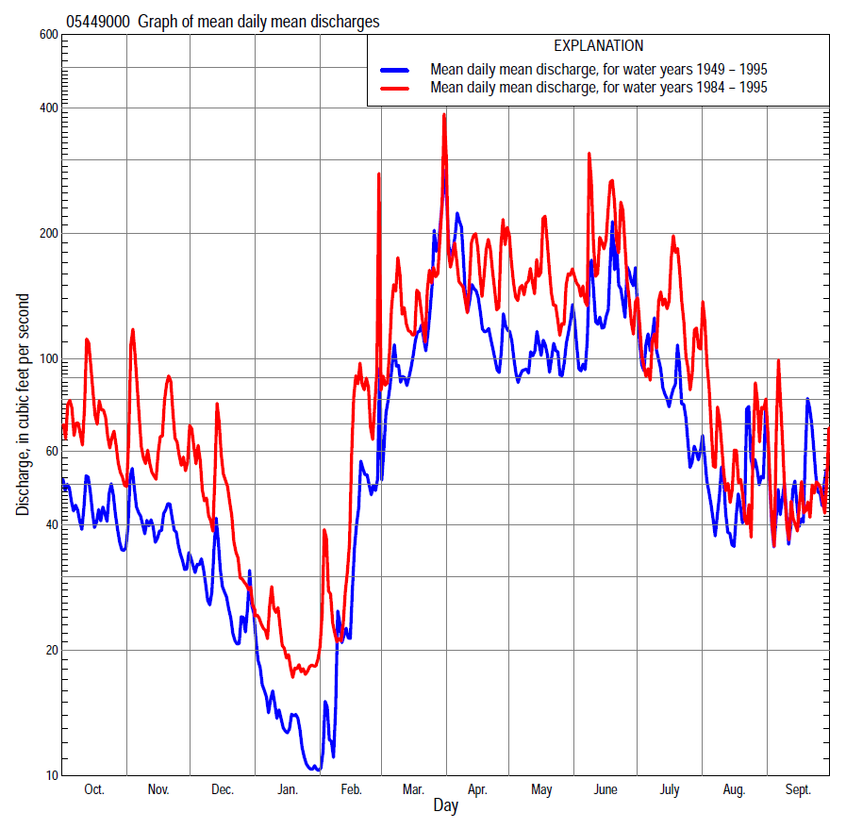

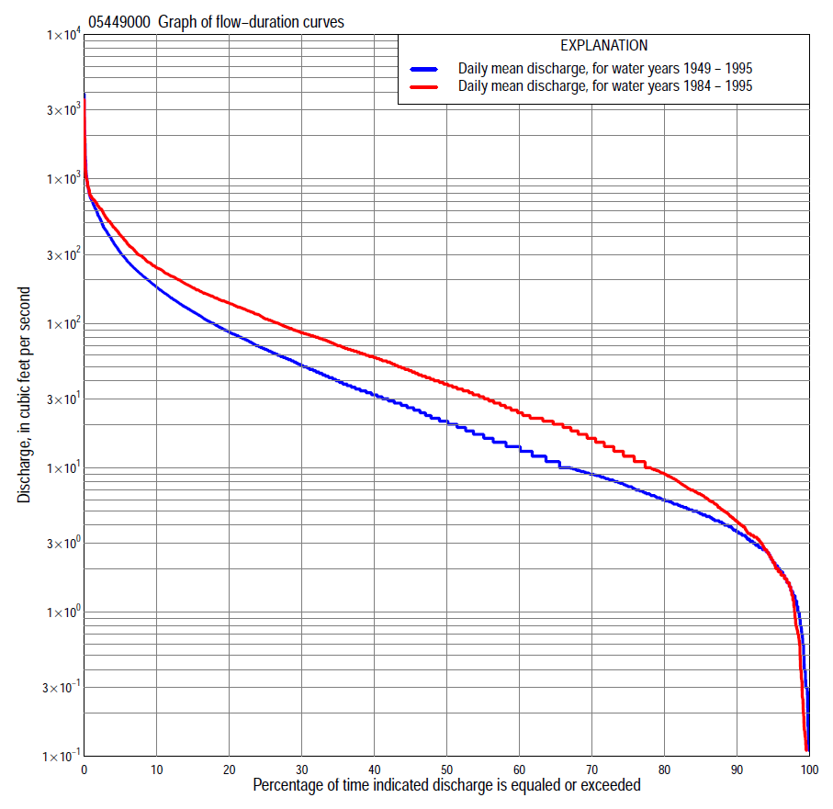

Statistics Based on the Entire Streamflow Period of Record
05449000 Monthly and annual flow durations, based on 1949–76, 1978–95 period of record (46 years)
Percentage of days discharge equaled or exceeded |  |  |  |  | Discharge (cubic feet per second) |  |  |  |  |  |  |  |  | Annual flow durations
 | Oct | Nov | Dec | Jan | Feb | Mar | Apr | May | June | July | Aug | Sept | Annual | Kentau statistic | P-value
99 | 1.8 | 1.5 | 0.19 | 0.13 | 0.30 | 0.60 | 5.3 | 4.7 | 3.1 | 2.2 | 2.8 | 2.5 | 0.70 | 0.282 | 0.005
98 | 2.0 | 1.8 | 0.80 | 0.30 | 0.30 | 1.4 | 6.7 | 5.9 | 4.0 | 3.3 | 3.4 | 2.8 | 1.3 | 0.292 | 0.004
95 | 2.8 | 3.1 | 1.8 | 0.50 | 0.78 | 3.8 | 9.2 | 7.9 | 7.7 | 5.8 | 4.3 | 3.4 | 2.3 | 0.282 | 0.006
90 | 4.1 | 4.2 | 2.7 | 1.4 | 1.3 | 5.3 | 12 | 13 | 11 | 7.4 | 5.4 | 4.3 | 3.7 | 0.282 | 0.006
85 | 4.7 | 5.0 | 3.2 | 1.8 | 1.7 | 7.5 | 17 | 16 | 13 | 8.9 | 6.1 | 5.0 | 4.9 | 0.341 | 0.001
80 | 5.2 | 5.7 | 3.7 | 2.4 | 2.1 | 9.4 | 25 | 20 | 17 | 10 | 6.7 | 5.4 | 6.0 | 0.355 | 0.001
75 | 6.2 | 6.5 | 4.5 | 2.9 | 2.7 | 12 | 32 | 27 | 20 | 12 | 7.8 | 6.0 | 7.5 | 0.357 | 0.000
70 | 6.9 | 7.7 | 5.6 | 3.2 | 3.3 | 17 | 38 | 31 | 25 | 14 | 8.8 | 7.0 | 9.0 | 0.342 | 0.001
65 | 7.8 | 9.0 | 7.0 | 3.8 | 3.9 | 24 | 47 | 36 | 28 | 16 | 9.8 | 8.2 | 11 | 0.334 | 0.001
60 | 8.8 | 10 | 8.6 | 4.4 | 4.5 | 30 | 57 | 42 | 35 | 20 | 11 | 9.0 | 14 | 0.319 | 0.002
55 | 10 | 13 | 11 | 5.0 | 5.6 | 35 | 65 | 48 | 44 | 26 | 12 | 9.9 | 17 | 0.330 | 0.001
50 | 14 | 16 | 13 | 6.2 | 6.8 | 44 | 78 | 57 | 51 | 30 | 14 | 11 | 21 | 0.341 | 0.001
45 | 19 | 21 | 16 | 7.6 | 8.2 | 55 | 90 | 67 | 60 | 37 | 16 | 14 | 26 | 0.317 | 0.002
40 | 25 | 27 | 18 | 9.0 | 9.6 | 66 | 104 | 78 | 72 | 44 | 18 | 15 | 32 | 0.306 | 0.003
35 | 32 | 32 | 21 | 11 | 12 | 84 | 123 | 91 | 87 | 53 | 21 | 19 | 40 | 0.313 | 0.002
30 | 43 | 37 | 25 | 14 | 17 | 105 | 143 | 106 | 107 | 65 | 26 | 27 | 52 | 0.318 | 0.002
25 | 56 | 44 | 30 | 16 | 20 | 145 | 168 | 126 | 135 | 85 | 33 | 37 | 67 | 0.331 | 0.001
20 | 71 | 60 | 34 | 21 | 23 | 189 | 204 | 154 | 176 | 114 | 44 | 51 | 88 | 0.319 | 0.002
15 | 92 | 74 | 45 | 23 | 33 | 238 | 250 | 191 | 241 | 165 | 59 | 74 | 122 | 0.289 | 0.005
10 | 118 | 107 | 61 | 29 | 56 | 335 | 349 | 251 | 357 | 240 | 104 | 104 | 180 | 0.272 | 0.008
5 | 160 | 150 | 94 | 47 | 131 | 480 | 542 | 378 | 587 | 408 | 220 | 195 | 312 | 0.205 | 0.046
2 | 250 | 239 | 189 | 85 | 358 | 696 | 723 | 555 | 900 | 678 | 438 | 461 | 554 | 0.157 | 0.125
1 | 334 | 303 | 292 | 116 | 605 | 820 | 1,040 | 701 | 1,280 | 776 | 666 | 825 | 725 | 0.113 | 0.272

05449000 Annual exceedance probability of instantaneous peak discharges, in cubic feet per second (ft³/s), based on the Weighted Independent Estimates method,
Annual exceed-ance probability | Recur-rence interval (years) | Discharge (ft³/s) | 95-percent lower confi-dence interval (ft³/s) | 95-percent upper confi-dence interval (ft³/s)
0.500 | 2 | 942 | 747 | 1,190
0.200 | 5 | 1,890 | 1,490 | 2,400
0.100 | 10 | 2,680 | 2,060 | 3,500
0.040 | 25 | 3,820 | 2,790 | 5,220
0.020 | 50 | 4,730 | 3,300 | 6,770
0.010 | 100 | 5,700 | 3,800 | 8,550
0.005 | 200 | 6,740 | 4,280 | 10,600
0.002 | 500 | 8,100 | 4,810 | 13,600
and based on the expected moments algorithm/multiple Grubbs-Beck analysis computed using a historical period length of 52 years (1944–1995)
0.500 | 2 | 943 | 724 | 1,220
0.200 | 5 | 1,900 | 1,470 | 2,560
0.100 | 10 | 2,710 | 2,050 | 3,890
0.040 | 25 | 3,920 | 2,850 | 6,320
0.020 | 50 | 4,940 | 3,460 | 8,830
0.010 | 100 | 6,070 | 4,060 | 12,100
0.005 | 200 | 7,320 | 4,650 | 16,200
0.002 | 500 | 9,130 | 5,410 | 23,500
Kentau statistic |  | 0.003
P-value |  | 0.985
Begin year |  | 1949
End year |  | 1995
Number of peaks |  | 46

05449000 Annual exceedance probability of high discharges, based on 1949–76, 1978–1995 period of record (46 years)
Annual exceedance probability | Recur-rence interval (years) | Maximum average discharge (ft³/s) for indicated number of consecutive days
 |  | 1 | 3 | 7 | 15 | 30
0.990 | 1.01 | 109 | 82 | 64 | 44 | 29
0.950 | 1.05 | 202 | 162 | 120 | 82 | 56
0.900 | 1.11 | 277 | 228 | 166 | 114 | 78
0.800 | 1.25 | 404 | 339 | 242 | 165 | 115
0.500 | 2 | 809 | 686 | 479 | 329 | 231
0.200 | 5 | 1,560 | 1,300 | 906 | 626 | 433
0.100 | 10 | 2,180 | 1,770 | 1,240 | 862 | 587
0.040 | 25 | 3,060 | 2,400 | 1,710 | 1,200 | 798
0.020 | 50 | 3,800 | 2,910 | 2,090 | 1,470 | 963
0.010 | 100 | 4,590 | 3,420 | 2,490 | 1,760 | 1,130
0.005 | 200 | 5,450 | 3,950 | 2,910 | 2,070 | 1,310
0.002 | 500 | 6,670 | 4,670 | 3,490 | 2,500 | 1,550
Kentau statistic |  | 0.039 | 0.074 | 0.143 | 0.117 | 0.158
P-value |  | 0.707 | 0.469 | 0.158 | 0.252 | 0.119

 | 05449000 Annual nonexceedance probability of low discharges, based on April 1948 to March 1976, April 1978 to March 1995 period of record (45 years)
Annual nonexceed-ance probability | Recur-rence interval (years) | Minimum average discharge (cubic feet per second) for indicated number of consecutive days
 |  | 1 | 3 | 7 | 14 | 30 | 60 | 90 | 120 | 183
0.01 | 100 | 0.00 | 0.00 | 0.00 | 0.00 | 0.10 | 0.23 | 0.37 | 0.58 | 0.89
0.02 | 50 | 0.00 | 0.00 | 0.00 | 0.00 | 0.17 | 0.37 | 0.56 | 0.84 | 1.2
0.05 | 20 | 0.31 | 0.32 | 0.37 | 0.39 | 0.40 | 0.71 | 1.0 | 1.4 | 2.0
0.10 | 10 | 0.62 | 0.66 | 0.73 | 0.78 | 0.79 | 1.2 | 1.7 | 2.2 | 3.2
0.20 | 5 | 1.2 | 1.3 | 1.4 | 1.5 | 1.6 | 2.3 | 3.0 | 3.8 | 5.4
0.50 | 2 | 3.4 | 3.6 | 3.8 | 4.1 | 5.2 | 6.6 | 8.5 | 10 | 15
0.80 | 1.25 | 8.0 | 8.4 | 8.8 | 9.6 | 12 | 16 | 22 | 27 | 41
0.90 | 1.11 | 12 | 12 | 13 | 14 | 17 | 24 | 34 | 43 | 69
0.96 | 1.04 | 17 | 18 | 19 | 21 | 23 | 34 | 54 | 70 | 121
0.98 | 1.02 | 21 | 22 | 24 | 26 | 27 | 42 | 71 | 96 | 174
0.99 | 1.01 | 25 | 27 | 29 | 30 | 31 | 50 | 90 | 126 | 240
Kentau statistic |  | 0.271 | 0.262 | 0.266 | 0.275 | 0.293 | 0.309 | 0.339 | 0.345 | 0.349
P-value |  | 0.009 | 0.012 | 0.010 | 0.008 | 0.005 | 0.003 | 0.001 | 0.001 | 0.001

05449000 Annual nonexceedance probability of seasonal low discharges, based on April 1948 to September 1976, July 1977 to September 1995 period of record (46–48 years)
Annual nonexceed-ance probability | Recur-rence interval (years) | Minimum average discharge (cubic feet per second) for indicated number of consecutive days
 |  | 1 | 7 | 14 | 30 |  | 1 | 7 | 14 | 30
 |  | January-February-March |  |  |  |  | April-May-June
0.01 | 100 | 0.00 | 0.00 | 0.11 | 0.19 |  | 1.6 | 2.1 | 2.3 | 2.8
0.02 | 50 | 0.00 | 0.00 | 0.18 | 0.29 |  | 2.1 | 2.8 | 3.1 | 3.8
0.05 | 20 | 0.33 | 0.39 | 0.44 | 0.53 |  | 3.1 | 4.2 | 4.8 | 6.0
0.10 | 10 | 0.65 | 0.73 | 9.8 | 0.90 |  | 4.5 | 6.1 | 7.0 | 9.0
0.20 | 5 | 1.3 | 1.4 | 1.5 | 1.7 |  | 7.0 | 9.5 | 11 | 15
0.50 | 2 | 3.9 | 4.0 | 4.6 | 5.2 |  | 17 | 22 | 27 | 37
0.80 | 1.25 | 11 | 11 | 13 | 15 |  | 41 | 51 | 64 | 93
0.90 | 1.11 | 19 | 20 | 22 | 25 |  | 67 | 80 | 100 | 150
0.96 | 1.04 | 32 | 34 | 35 | 43 |  | 113 | 128 | 163 | 250
0.98 | 1.02 | 45 | 50 | 54 | 59 |  | 159 | 173 | 223 | 347
0.99 | 1.01 | 61 | 68 | 74 | 80 |  | 217 | 227 | 295 | 466
Kentau statistic |  | 0.225 | 0.236 | 0.244 | 0.237 |  | 0.266 | 0.307 | 0.307 | 0.290
P-value |  | 0.028 | 0.021 | 0.017 | 0.021 |  | 0.008 | 0.002 | 0.002 | 0.004
 |  | July-August-September |  |  |  |  | October-November-December
0.01 | 100 | 0.89 | 1.2 | 1.3 | 1.7 |  | 0.00 | 0.00 | 0.30 | 0.58
0.02 | 50 | 1.2 | 1.5 | 1.7 | 2.0 |  | 0.00 | 0.00 | 0.40 | 0.84
0.05 | 20 | 1.7 | 2.1 | 2.3 | 2.7 |  | 0.7 | 1.0 | 1.2 | 1.4
0.10 | 10 | 2.4 | 2.8 | 3.1 | 3.6 |  | 1.3 | 1.8 | 2.0 | 2.3
0.20 | 5 | 3.5 | 4.1 | 4.4 | 5.1 |  | 2.3 | 3.0 | 3.5 | 4.0
0.50 | 2 | 7.3 | 8.2 | 8.8 | 11 |  | 6.3 | 7.7 | 9.0 | 11
0.80 | 1.25 | 14 | 16 | 18 | 25 |  | 16 | 19 | 25 | 29
0.90 | 1.11 | 20 | 23 | 25 | 39 |  | 26 | 31 | 39 | 47
0.96 | 1.04 | 29 | 33 | 38 | 66 |  | 43 | 50 | 63 | 77
0.98 | 1.02 | 36 | 42 | 49 | 94 |  | 59 | 70 | 87 | 104
0.99 | 1.01 | 43 | 52 | 61 | 129 |  | 79 | 93 | 115 | 137
Kentau statistic |  | 0.189 | 0.219 | 0.244 | 0.277 |  | 0.316 | 0.360 | 0.362 | 0.376
P-value |  | 0.059 | 0.029 | 0.015 | 0.006 |  | 0.002 | 0.000 | 0.000 | 0.000

Statistics Based on the 1984–2013 Streamflow Period of Record
05449000 Monthly and annual flow durations, based on 1984–95 period of record (12 years)
Percentage of days discharge equaled or exceeded |  |  |  |  | Discharge (cubic feet per second) |  |  |  |  |  |  |  |  | Annual flow durations
 | Oct | Nov | Dec | Jan | Feb | Mar | Apr | May | June | July | Aug | Sept | Annual | Kentau statistic | P-value
99 | 1.7 | 1.4 | 0.00 | 0.00 | 0.50 | 0.94 | 7.9 | 4.7 | 2.7 | 1.8 | 3.2 | 3.0 | 0.26 | 0.212 | 0.370
98 | 1.9 | 1.7 | 0.00 | 0.00 | 0.62 | 2.8 | 8.6 | 5.1 | 2.9 | 2.0 | 3.4 | 3.0 | 0.94 | 0.167 | 0.490
95 | 2.6 | 1.8 | 0.40 | 0.15 | 0.74 | 12 | 9.5 | 6.4 | 3.6 | 2.3 | 4.7 | 3.4 | 2.2 | 0.167 | 0.492
90 | 3.5 | 4.0 | 4.1 | 0.86 | 1.5 | 17 | 11 | 9.2 | 7.3 | 6.0 | 5.4 | 4.6 | 4.2 | 0.121 | 0.630
85 | 4.4 | 5.2 | 5.2 | 1.6 | 2.2 | 25 | 21 | 17 | 9.9 | 7.0 | 5.8 | 5.6 | 6.5 | 0.061 | 0.837
80 | 6.8 | 6.8 | 7.8 | 1.9 | 2.8 | 28 | 31 | 27 | 12 | 8.9 | 6.5 | 8.7 | 9.0 | 0.091 | 0.730
75 | 7.7 | 11 | 11 | 3.3 | 3.4 | 33 | 40 | 31 | 15 | 10 | 8.5 | 9.7 | 12 | 0.091 | 0.732
70 | 13 | 14 | 16 | 4.8 | 9.2 | 38 | 55 | 38 | 19 | 14 | 9.5 | 11 | 16 | 0.121 | 0.631
65 | 18 | 16 | 20 | 6.6 | 12 | 44 | 70 | 42 | 30 | 23 | 12 | 13 | 20 | 0.091 | 0.732
60 | 21 | 19 | 23 | 10 | 15 | 50 | 85 | 55 | 51 | 41 | 15 | 14 | 24 | 0.106 | 0.680
55 | 27 | 38 | 26 | 15 | 17 | 60 | 101 | 67 | 63 | 49 | 17 | 17 | 30 | 0.197 | 0.409
50 | 45 | 46 | 30 | 19 | 19 | 79 | 116 | 82 | 75 | 57 | 21 | 26 | 37 | 0.212 | 0.373
45 | 59 | 59 | 34 | 21 | 20 | 98 | 129 | 118 | 87 | 65 | 26 | 32 | 46 | 0.212 | 0.373
40 | 70 | 62 | 36 | 21 | 21 | 115 | 143 | 135 | 107 | 82 | 31 | 36 | 58 | 0.152 | 0.537
35 | 83 | 68 | 40 | 22 | 22 | 142 | 166 | 154 | 140 | 95 | 40 | 43 | 70 | 0.152 | 0.537
30 | 93 | 77 | 45 | 23 | 26 | 160 | 195 | 170 | 166 | 115 | 48 | 51 | 87 | 0.152 | 0.537
25 | 106 | 92 | 49 | 25 | 35 | 181 | 215 | 205 | 215 | 144 | 60 | 63 | 108 | 0.152 | 0.537
20 | 119 | 110 | 58 | 28 | 44 | 218 | 250 | 251 | 297 | 184 | 87 | 78 | 139 | 0.152 | 0.537
15 | 129 | 130 | 74 | 31 | 66 | 240 | 315 | 300 | 396 | 243 | 137 | 89 | 177 | 0.182 | 0.451
10 | 165 | 154 | 92 | 41 | 92 | 300 | 434 | 397 | 542 | 334 | 206 | 119 | 243 | 0.182 | 0.451
5 | 211 | 234 | 146 | 76 | 293 | 423 | 556 | 538 | 749 | 566 | 286 | 162 | 410 | 0.152 | 0.537
2 | 334 | 374 | 269 | 88 | 660 | 692 | 700 | 711 | 1,010 | 728 | 443 | 287 | 643 | 0.091 | 0.732
1 | 392 | 411 | 292 | 116 | 715 | 748 | 793 | 751 | 1,160 | 776 | 569 | 368 | 749 | 0.091 | 0.732

05449000 Annual exceedance probability of high discharges, based on 1984–1995 period of record (12 years)
Annual exceedance probability | Recur-rence interval (years) | Maximum average discharge (ft³/s) for indicated number of consecutive days
 |  | 1 | 3 | 7 | 15 | 30
0.990 | 1.01 | 87 | 56 | 43 | 41 | 27
0.950 | 1.05 | 178 | 137 | 105 | 87 | 61
0.900 | 1.11 | 255 | 210 | 160 | 126 | 90
0.800 | 1.25 | 386 | 337 | 254 | 190 | 139
0.500 | 2 | 805 | 723 | 537 | 385 | 287
0.200 | 5 | 1,560 | 1,310 | 959 | 701 | 523
0.100 | 10 | 2,140 | 1,690 | 1,220 | 921 | 682
0.040 | 25 | 2,940 | 2,120 | 1,510 | 1,200 | 876
0.020 | 50 | 3,560 | 2,400 | 1,700 | 1,400 | 1,010
0.010 | 100 | 4,210 | 2,650 | 1,870 | 1,590 | 1,140
0.005 | 200 | 4,870 | 2,870 | 2,010 | 1,770 | 1,260
0.002 | 500 | 5,770 | 3,120 | 2,180 | 2,010 | 1,400
Kentau statistic |  | -0.121 | 0.000 | 0.091 | 0.121 | 0.182
P-value |  | 0.631 | 1.000 | 0.732 | 0.631 | 0.451

 | 05449000 Annual nonexceedance probability of low discharges, based on April 1983 to March 1995 period of record (12 years)
Annual nonexceed-ance probability | Recur-rence interval (years) | Minimum average discharge (cubic feet per second) for indicated number of consecutive days
 |  | 1 | 3 | 7 | 14 | 30 | 60 | 90 | 120 | 183
0.01 | 100 | 0.00 | 0.00 | 0.00 | 0.00 | 0.01 | 0.06 | 0.13 | 0.25 | 0.38
0.02 | 50 | 0.00 | 0.00 | 0.00 | 0.00 | 0.04 | 0.14 | 0.29 | 0.50 | 0.73
0.05 | 20 | 0.00 | 0.00 | 0.00 | 0.00 | 0.17 | 0.47 | 0.87 | 1.3 | 1.9
0.10 | 10 | 0.19 | 0.23 | 0.36 | 0.54 | 0.89 | 1.2 | 2.1 | 2.8 | 3.9
0.20 | 5 | 1.4 | 1.5 | 1.8 | 2.2 | 2.6 | 3.2 | 5.0 | 6.2 | 8.9
0.50 | 2 | 5.8 | 6.1 | 6.5 | 7.1 | 10 | 13 | 18 | 21 | 32
0.80 | 1.25 | 13 | 14 | 14 | 15 | 23 | 29 | 41 | 50 | 84
0.90 | 1.11 | 17 | 18 | 18 | 20 | 30 | 38 | 53 | 68 | 123
0.96 | 1.04 | 21 | 22 | 23 | 26 | 34 | 46 | 64 | 88 | 172
0.98 | 1.02 | 22 | 24 | 26 | 30 | 36 | 49 | 70 | 100 | 205
0.99 | 1.01 | 24 | 26 | 28 | 34 | 37 | 52 | 73 | 109 | 234
Kentau statistic |  | 0.182 | 0.182 | 0.167 | 0.182 | 0.152 | 0.061 | 0.030 | 0.030 | 0.030
P-value |  | 0.449 | 0.451 | 0.492 | 0.451 | 0.537 | 0.837 | 0.945 | 0.945 | 0.945

05449000 Annual nonexceedance probability of seasonal low discharges, based on October 1983 to September 1995 period of record (12 years)
Annual nonexceed-ance probability | Recur-rence interval (years) | Minimum average discharge (cubic feet per second) for indicated number of consecutive days
 |  | 1 | 7 | 14 | 30 |  | 1 | 7 | 14 | 30
 |  | January-February-March |  |  |  |  | April-May-June
0.01 | 100 | 0.00 | 0.00 | 0.01 | 0.04 |  | 0.81 | 0.93 | 1.0 | 1.2
0.02 | 50 | 0.00 | 0.00 | 0.04 | 0.09 |  | 1.3 | 1.5 | 1.6 | 2.0
0.05 | 20 | 0.00 | 0.00 | 0.16 | 0.29 |  | 2.5 | 2.9 | 3.3 | 4.2
0.10 | 10 | 0.17 | 0.31 | 0.51 | 0.75 |  | 4.3 | 5.2 | 6.0 | 7.7
0.20 | 5 | 1.4 | 1.9 | 2.0 | 2.1 |  | 8.3 | 10 | 12 | 16
0.50 | 2 | 8.4 | 9.0 | 10 | 11 |  | 27 | 33 | 40 | 55
0.80 | 1.25 | 26 | 27 | 33 | 36 |  | 80 | 91 | 114 | 169
0.90 | 1.11 | 41 | 44 | 50 | 57 |  | 135 | 149 | 186 | 291
0.96 | 1.04 | 60 | 67 | 69 | 84 |  | 228 | 243 | 302 | 502
0.98 | 1.02 | 73 | 86 | 87 | 103 |  | 317 | 327 | 404 | 701
0.99 | 1.01 | 86 | 105 | 106 | 119 |  | 420 | 421 | 518 | 933
Kentau statistic |  | -0.061 | -0.061 | -0.030 | -0.030 |  | 0.061 | 0.061 | 0.091 | 0.182
P-value |  | 0.837 | 0.837 | 0.945 | 0.945 |  | 0.837 | 0.837 | 0.732 | 0.451
 |  | July-August-September |  |  |  |  | October-November-December
0.01 | 100 | 1.3 | 1.5 | 1.7 | 1.8 |  | 0.00 | 0.00 | 0.01 | 0.18
0.02 | 50 | 1.5 | 1.8 | 2.0 | 2.1 |  | 0.00 | 0.00 | 0.03 | 0.40
0.05 | 20 | 2.1 | 2.5 | 2.7 | 2.8 |  | 0.00 | 0.00 | 0.23 | 1.2
0.10 | 10 | 2.9 | 3.3 | 3.6 | 4.0 |  | 1.8 | 2.2 | 1.0 | 2.9
0.20 | 5 | 4.2 | 4.7 | 5.2 | 6.5 |  | 5.0 | 6.7 | 4.2 | 7.0
0.50 | 2 | 8.9 | 10 | 11 | 17 |  | 13 | 17 | 24 | 26
0.80 | 1.25 | 20 | 22 | 25 | 42 |  | 27 | 33 | 47 | 57
0.90 | 1.11 | 31 | 35 | 39 | 69 |  | 37 | 42 | 53 | 75
0.96 | 1.04 | 51 | 58 | 65 | 115 |  | 50 | 53 | 55 | 90
0.98 | 1.02 | 70 | 81 | 91 | 161 |  | 60 | 61 | 62 | 98
0.99 | 1.01 | 94 | 111 | 125 | 218 |  | 67 | 68 | 69 | 103
Kentau statistic |  | 0.364 | 0.333 | 0.333 | 0.333 |  | -0.030 | 0.000 | 0.061 | 0.061
P-value |  | 0.115 | 0.150 | 0.150 | 0.150 |  | 0.945 | 1.000 | 0.837 | 0.837

