LOCATION.--Lat 42°03'57", long 92°54'27" referenced to North American Datum of 1927, in NW 1/4 SE 1/4 SE 1/4 sec.23, T.84 N., R.18 W., Marshall County, IA, Hydrologic Unit 07080208, on right bank 10 ft downstream from bridge on State Highway 14 in Marshalltown, 1,500 ft upstream from Burnett Creek, 2.2 mi upstream from Linn Creek, and 212.7 mi upstream from mouth.

DRAINAGE AREA.--1,532 mi².

PERIOD OF RECORD.--Discharge records from October 1902 to September 1903, October 1914 to September 1927, October 1932 to current year. Prior to February 1933, monthly mean discharge for some periods published in WSP 1308.

GAGE.--Water-stage recorder. Datum of gage is 853.10 ft above National Geodetic Vertical Datum of 1929. October 25, 1902, to August 8, 1903, non-recording gage at site 1 mi upstream at different datum; May 21, 1915, to September 30, 1927, and February 1, 1933, to September 1, 1934, non-recording gage at site 1,000 ft upstream at same datum; September 2-20, 1934, non-recording gage at site 1,000 ft downstream at different datum; September 21, 1934, to June 8, 1973, water-stage recorder at site 900 ft downstream at same datum.

A summary of all available data for this streamgage is provided through the USGS National Water Information System web interface (NWISWeb). The following link provides access to current/historical observations, daily data, daily statistics, monthly statistics, annual statistics, peak streamflow, field measurements, field/lab water-quality samples, and the latest water-year summaries. Data can be filtered by parameter and/or dates, and can be output in various tabular and graphical formats.
http://waterdata.usgs.gov/nwis/inventory/?site_no=05451500

The USGS WaterWatch Toolkit is available at:
http://waterwatch.usgs.gov/?id=ww_toolkit
Tools for summarizing streamflow information include the duration hydrograph builder, the cumulative streamflow hydrograph builder, the streamgage statistics retrieval tool, the rating curve builder, the flood tracking chart builder, the National Weather Service Advanced Hydrologic Prediction Service (AHPS) river forecast hydrograph builder, and the raster-hydrograph builder. Entering the above number for this streamgage into these toolkit webpages will provide streamflow information specific to this streamgage.

A description of the statistics presented for this streamgage is available in the main body of the report at:
http://dx.doi.org/10.3133/ofr20151214
A link to other streamgages included in this report, a map showing the location of the streamgages, information on the programs used to compute the statistical analyses, and references are included in the main body of the report.

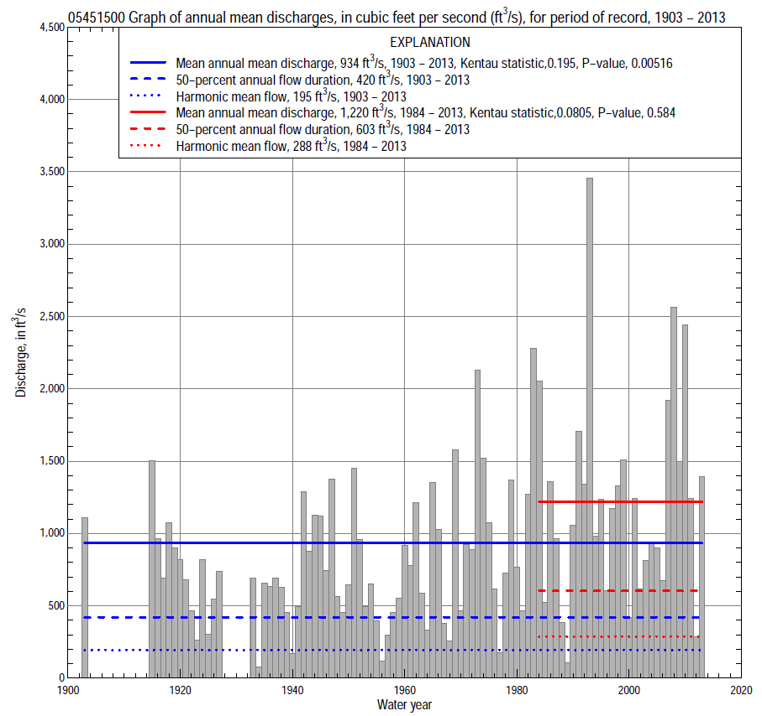

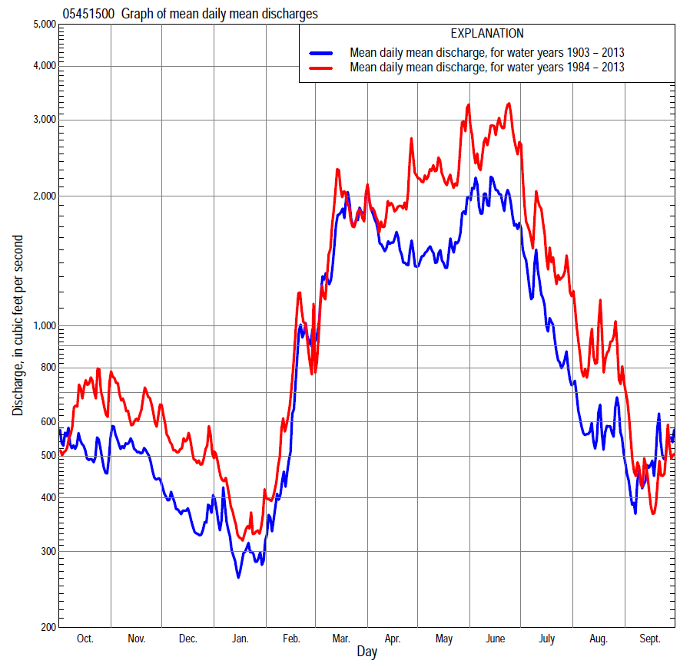

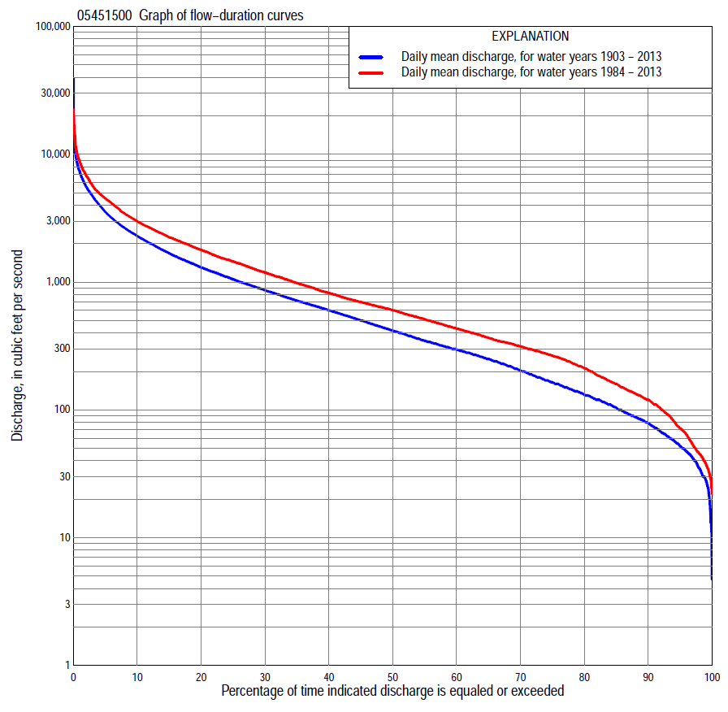

Statistics Based on the Entire Streamflow Period of Record
05451500 Monthly and annual flow durations, based on 1903, 1915–27, 1933–2013 period of record (95 years)
Percentage of days discharge equaled or exceeded |  |  |  |  | Discharge (cubic feet per second) |  |  |  |  |  |  |  |  | Annual flow durations
 | Oct | Nov | Dec | Jan | Feb | Mar | Apr | May | June | July | Aug | Sept | Annual | Kentau statistic | P-value
99 | 35 | 45 | 25 | 12 | 20 | 60 | 104 | 73 | 23 | 30 | 29 | 28 | 28 | 0.260 | 0.000
98 | 40 | 49 | 30 | 17 | 27 | 90 | 120 | 91 | 46 | 40 | 38 | 35 | 35 | 0.259 | 0.000
95 | 49 | 59 | 40 | 30 | 37 | 130 | 152 | 135 | 113 | 60 | 52 | 46 | 52 | 0.255 | 0.000
90 | 68 | 75 | 54 | 40 | 58 | 185 | 236 | 192 | 183 | 100 | 70 | 64 | 80 | 0.236 | 0.001
85 | 81 | 90 | 67 | 56 | 84 | 270 | 315 | 265 | 277 | 154 | 94 | 83 | 105 | 0.218 | 0.002
80 | 91 | 119 | 84 | 70 | 100 | 340 | 420 | 354 | 380 | 210 | 117 | 96 | 133 | 0.209 | 0.003
75 | 111 | 137 | 100 | 85 | 120 | 410 | 520 | 458 | 490 | 265 | 136 | 113 | 165 | 0.211 | 0.003
70 | 130 | 163 | 124 | 100 | 140 | 500 | 611 | 561 | 592 | 325 | 158 | 130 | 205 | 0.198 | 0.005
65 | 158 | 202 | 150 | 120 | 165 | 600 | 690 | 667 | 710 | 384 | 182 | 149 | 250 | 0.192 | 0.006
60 | 197 | 242 | 180 | 146 | 203 | 700 | 782 | 761 | 850 | 460 | 208 | 176 | 300 | 0.174 | 0.012
55 | 238 | 271 | 210 | 160 | 250 | 814 | 895 | 872 | 1,010 | 535 | 241 | 211 | 350 | 0.193 | 0.006
50 | 271 | 306 | 240 | 180 | 300 | 947 | 1,020 | 986 | 1,180 | 614 | 280 | 240 | 420 | 0.202 | 0.004
45 | 305 | 340 | 277 | 210 | 350 | 1,100 | 1,170 | 1,110 | 1,330 | 735 | 325 | 282 | 505 | 0.207 | 0.003
40 | 348 | 400 | 303 | 242 | 417 | 1,270 | 1,320 | 1,280 | 1,530 | 854 | 370 | 331 | 605 | 0.213 | 0.002
35 | 425 | 480 | 340 | 280 | 494 | 1,500 | 1,510 | 1,480 | 1,800 | 982 | 420 | 375 | 720 | 0.224 | 0.001
30 | 507 | 563 | 380 | 315 | 600 | 1,750 | 1,730 | 1,690 | 2,110 | 1,120 | 480 | 437 | 868 | 0.230 | 0.001
25 | 604 | 680 | 470 | 379 | 708 | 2,100 | 1,990 | 1,970 | 2,450 | 1,270 | 569 | 502 | 1,050 | 0.238 | 0.001
20 | 780 | 797 | 596 | 450 | 850 | 2,480 | 2,380 | 2,310 | 2,890 | 1,510 | 692 | 608 | 1,300 | 0.220 | 0.002
15 | 952 | 926 | 690 | 540 | 1,060 | 2,980 | 2,800 | 2,790 | 3,530 | 1,830 | 858 | 743 | 1,690 | 0.217 | 0.002
10 | 1,260 | 1,170 | 838 | 674 | 1,500 | 3,740 | 3,540 | 3,490 | 4,470 | 2,260 | 1,160 | 1,060 | 2,300 | 0.197 | 0.005
5 | 1,840 | 1,560 | 1,140 | 981 | 2,420 | 5,380 | 4,930 | 4,880 | 6,750 | 3,500 | 2,150 | 1,790 | 3,530 | 0.180 | 0.010
2 | 2,750 | 2,260 | 1,580 | 1,500 | 4,280 | 7,560 | 6,540 | 6,540 | 9,410 | 5,960 | 4,260 | 2,700 | 5,580 | 0.131 | 0.060
1 | 3,840 | 3,040 | 2,100 | 2,220 | 5,540 | 8,850 | 8,230 | 8,020 | 11,600 | 8,540 | 5,900 | 4,100 | 7,320 | 0.103 | 0.140

05451500 Annual exceedance probability of instantaneous peak discharges, in cubic feet per second (ft³/s), based on the Weighted Independent Estimates method,
Annual exceed-ance probability | Recur-rence interval (years) | Discharge (ft³/s) | 95-percent lower confi-dence interval (ft³/s) | 95-percent upper confi-dence interval (ft³/s)
0.500 | 2 | 8,290 | 7,350 | 9,350
0.200 | 5 | 14,200 | 12,600 | 15,900
0.100 | 10 | 18,100 | 15,900 | 20,500
0.040 | 25 | 23,400 | 20,100 | 27,300
0.020 | 50 | 27,300 | 22,800 | 32,600
0.010 | 100 | 31,000 | 25,200 | 38,200
0.005 | 200 | 35,800 | 28,100 | 45,500
0.002 | 500 | 40,000 | 30,100 | 53,200
and based on the expected moments algorithm/multiple Grubbs-Beck analysis computed using a historical period length of 132 years (1882–2013)
0.500 | 2 | 8,270 | 7,150 | 9,520
0.200 | 5 | 14,100 | 12,300 | 16,300
0.100 | 10 | 18,200 | 15,700 | 21,500
0.040 | 25 | 23,600 | 19,900 | 29,100
0.020 | 50 | 27,600 | 22,700 | 35,400
0.010 | 100 | 31,700 | 25,100 | 42,400
0.005 | 200 | 35,700 | 27,300 | 50,100
0.002 | 500 | 41,100 | 29,900 | 61,400
Kentau statistic |  | -0.002
P-value |  | 0.983
Begin year |  | 1903
End year |  | 2013
Number of peaks |  | 97

05451500 Annual exceedance probability of high discharges, based on 1903, 1915-27, 1933-2013 period of record (95 years)
Annual exceedance probability | Recur-rence interval (years) | Maximum average discharge (ft³/s) for indicated number of consecutive days
 |  | 1 | 3 | 7 | 15 | 30
0.990 | 1.01 | 1,050 | 739 | 518 | 398 | 285
0.950 | 1.05 | 1,980 | 1,530 | 1,170 | 894 | 672
0.900 | 1.11 | 2,710 | 2,180 | 1,710 | 1,310 | 1,000
0.800 | 1.25 | 3,890 | 3,230 | 2,610 | 1,990 | 1,540
0.500 | 2 | 7,290 | 6,240 | 5,130 | 3,910 | 2,980
0.200 | 5 | 12,600 | 10,700 | 8,610 | 6,540 | 4,820
0.100 | 10 | 16,400 | 13,500 | 10,700 | 8,090 | 5,800
0.040 | 25 | 21,100 | 16,800 | 12,900 | 9,760 | 6,780
0.020 | 50 | 24,600 | 19,100 | 14,300 | 10,800 | 7,340
0.010 | 100 | 28,000 | 21,200 | 15,500 | 11,700 | 7,780
0.005 | 200 | 31,300 | 23,100 | 16,500 | 12,500 | 8,140
0.002 | 500 | 35,700 | 25,400 | 17,700 | 13,300 | 8,510
KENTAU statistic |  | 0.255 | 0.271 | 0.285 | 0.311 | 0.331
P-level |  | 0.000 | 0.000 | 0.000 | 0.000 | 0.000

 | 05451500 Annual nonexceedance probability of low discharges, based on April 1915 to March 1927, April 1933 to March 2013 period of record (92 years)
Annual nonexceed-ance probability | Recur-rence interval (years) |  | Minimum average discharge (ft³/s) for indicated number of consecutive days
 |  |  | 1 |  | 3 |  | 7 |  | 14 |  | 30 |  | 60 |  | 90 |  | 120 |  |  | 183
0.01 | 100 |  | 7.1 |  | 7.2 |  | 7.7 |  | 8.6 |  | 12 |  | 15 |  | 20 |  | 23 |  |  | 27
0.02 | 50 |  | 10 |  | 10 |  | 11 |  | 12 |  | 15 |  | 20 |  | 26 |  | 30 |  |  | 36
0.05 | 20 |  | 15 |  | 16 |  | 17 |  | 19 |  | 24 |  | 30 |  | 38 |  | 45 |  |  | 56
0.10 | 10 |  | 23 |  | 24 |  | 25 |  | 28 |  | 34 |  | 43 |  | 54 |  | 64 |  |  | 81
0.20 | 5 |  | 36 |  | 37 |  | 40 |  | 43 |  | 52 |  | 65 |  | 81 |  | 98 |  |  | 126
0.50 | 2 |  | 79 |  | 83 |  | 88 |  | 95 |  | 110 |  | 140 |  | 174 |  | 212 |  |  | 279
0.80 | 1.25 |  | 160 |  | 167 |  | 176 |  | 190 |  | 219 |  | 286 |  | 364 |  | 447 |  |  | 583
0.90 | 1.11 |  | 224 |  | 232 |  | 244 |  | 264 |  | 306 |  | 409 |  | 530 |  | 653 |  |  | 839
0.96 | 1.04 |  | 313 |  | 321 |  | 336 |  | 365 |  | 429 |  | 588 |  | 785 |  | 969 |  |  | 1,220
0.98 | 1.02 |  | 384 |  | 391 |  | 407 |  | 444 |  | 529 |  | 739 |  | 1,010 |  | 1,250 |  |  | 1,530
0.99 | 1.01 |  | 458 |  | 463 |  | 479 |  | 524 |  | 633 |  | 902 |  | 1,260 |  | 1,560 |  |  | 1,880
Kentau statistic |  |  | 0.450 |  | 0.448 |  | 0.455 |  | 0.461 |  | 0.454 |  | 0.422 |  | 0.406 |  | 0.380 |  |  | 0.366
P-value |  |  | 0.000 |  | 0.000 |  | 0.000 |  | 0.000 |  | 0.000 |  | 0.000 |  | 0.000 |  | 0.000 |  |  | 0.000
05451500 Annual nonexceedance probability of seasonal low discharges, based on October 1902 to September 1903, October 1914 to September 1927, October 1932 to September 2013 period of record (95 years)
Annual nonexceed-ance probability |  | Recur-rence interval (years) |  | Minimum average discharge (cubic feet per second) for indicated number of consecutive days
 |  |  |  | 1 |  | 7 |  | 14 |  | 30 |  |  |  | 1 |  | 7 |  | 14 |  |  | 30
 |  |  |  | January-February-March |  |  |  |  |  |  |  |  |  | April-May-June
0.01 |  | 100 |  | 8.5 |  | 9.0 |  | 9.7 |  | 13 |  |  |  | 21 |  | 25 |  | 27 |  |  | 34
0.02 |  | 50 |  | 12 |  | 13 |  | 14 |  | 19 |  |  |  | 31 |  | 37 |  | 41 |  |  | 52
0.05 |  | 20 |  | 20 |  | 21 |  | 23 |  | 30 |  |  |  | 54 |  | 65 |  | 72 |  |  | 93
0.10 |  | 10 |  | 30 |  | 32 |  | 35 |  | 44 |  |  |  | 86 |  | 103 |  | 116 |  |  | 151
0.20 |  | 5 |  | 48 |  | 52 |  | 56 |  | 71 |  |  |  | 146 |  | 174 |  | 199 |  |  | 261
0.50 |  | 2 |  | 113 |  | 123 |  | 133 |  | 168 |  |  |  | 359 |  | 422 |  | 494 |  |  | 665
0.80 |  | 1.25 |  | 241 |  | 264 |  | 288 |  | 373 |  |  |  | 763 |  | 878 |  | 1,050 |  |  | 1,470
0.90 |  | 1.11 |  | 346 |  | 380 |  | 417 |  | 554 |  |  |  | 1,070 |  | 1,220 |  | 1,480 |  |  | 2,110
0.96 |  | 1.04 |  | 495 |  | 545 |  | 602 |  | 829 |  |  |  | 1,480 |  | 1,650 |  | 2,050 |  |  | 2,980
0.98 |  | 1.02 |  | 616 |  | 679 |  | 753 |  | 1,070 |  |  |  | 1,790 |  | 1,980 |  | 2,470 |  |  | 3,650
0.99 |  | 1.01 |  | 742 |  | 820 |  | 914 |  | 1,330 |  |  |  | 2,100 |  | 2,290 |  | 2,880 |  |  | 4,320
Kentau statistic |  |  |  | 0.196 |  | 0.201 |  | 0.192 |  | 0.131 |  |  |  | 0.310 |  | 0.284 |  | 0.278 |  |  | 0.255
P-value |  |  |  | 0.005 |  | 0.004 |  | 0.006 |  | 0.060 |  |  |  | 0.000 |  | 0.000 |  | 0.000 |  |  | 0.000
 |  |  |  | July-August-September |  |  |  |  |  |  |  |  |  | October-November-December
0.01 |  | 100 |  | 14 |  | 18 |  | 21 |  | 27 |  |  |  | 14 |  | 15 |  | 17 |  |  | 22
0.02 |  | 50 |  | 17 |  | 22 |  | 25 |  | 33 |  |  |  | 19 |  | 20 |  | 22 |  |  | 28
0.05 |  | 20 |  | 25 |  | 31 |  | 35 |  | 44 |  |  |  | 27 |  | 30 |  | 33 |  |  | 41
0.10 |  | 10 |  | 35 |  | 41 |  | 47 |  | 58 |  |  |  | 38 |  | 42 |  | 46 |  |  | 58
0.20 |  | 5 |  | 52 |  | 60 |  | 68 |  | 83 |  |  |  | 57 |  | 63 |  | 70 |  |  | 86
0.50 |  | 2 |  | 111 |  | 123 |  | 138 |  | 170 |  |  |  | 121 |  | 137 |  | 154 |  |  | 186
0.80 |  | 1.25 |  | 236 |  | 260 |  | 289 |  | 368 |  |  |  | 252 |  | 291 |  | 328 |  |  | 397
0.90 |  | 1.11 |  | 350 |  | 388 |  | 430 |  | 563 |  |  |  | 366 |  | 427 |  | 482 |  |  | 587
0.96 |  | 1.04 |  | 533 |  | 598 |  | 661 |  | 901 |  |  |  | 541 |  | 638 |  | 723 |  |  | 886
0.98 |  | 1.02 |  | 698 |  | 794 |  | 877 |  | 1,230 |  |  |  | 696 |  | 825 |  | 936 |  |  | 1,160
0.99 |  | 1.01 |  | 891 |  | 1,030 |  | 1,130 |  | 1,650 |  |  |  | 869 |  | 1,040 |  | 1,180 |  |  | 1,460
Kentau statistic |  |  |  | 0.211 |  | 0.210 |  | 0.198 |  | 0.175 |  |  |  | 0.191 |  | 0.185 |  | 0.188 |  |  | 0.179
P-value |  |  |  | 0.002 |  | 0.003 |  | 0.004 |  | 0.012 |  |  |  | 0.006 |  | 0.008 |  | 0.007 |  |  | 0.010

Statistics Based on the 1984–2013 Streamflow Period of Record
05451500 Monthly and annual flow durations, based on 1984–2013 period of record (30 years)
Percentage of days discharge equaled or exceeded |  |  |  |  | Discharge (cubic feet per second) |  |  |  |  |  |  |  |  | Annual flow durations
 | Oct | Nov | Dec | Jan | Feb | Mar | Apr | May | June | July | Aug | Sept | Annual | Kentau statistic | P-value
99 | 39 | 49 | 25 | 30 | 40 | 88 | 132 | 104 | 98 | 54 | 37 | 34 | 38 | -0.016 | 0.915
98 | 40 | 52 | 30 | 32 | 50 | 130 | 141 | 122 | 115 | 60 | 41 | 39 | 45 | -0.025 | 0.858
95 | 46 | 69 | 62 | 44 | 72 | 183 | 211 | 190 | 183 | 76 | 56 | 46 | 72 | -0.016 | 0.915
90 | 80 | 117 | 77 | 85 | 101 | 320 | 299 | 416 | 313 | 142 | 74 | 75 | 120 | -0.011 | 0.943
85 | 110 | 147 | 108 | 108 | 138 | 379 | 437 | 586 | 497 | 314 | 130 | 114 | 160 | -0.028 | 0.844
80 | 123 | 189 | 149 | 130 | 178 | 415 | 597 | 732 | 717 | 431 | 182 | 128 | 212 | -0.030 | 0.830
75 | 160 | 225 | 200 | 150 | 245 | 493 | 670 | 922 | 924 | 521 | 228 | 141 | 265 | -0.002 | 1.000
70 | 191 | 254 | 232 | 170 | 292 | 593 | 793 | 1,070 | 1,110 | 595 | 270 | 160 | 314 | -0.028 | 0.844
65 | 255 | 289 | 269 | 200 | 336 | 670 | 988 | 1,260 | 1,230 | 686 | 302 | 179 | 367 | -0.025 | 0.858
60 | 280 | 320 | 303 | 230 | 380 | 764 | 1,130 | 1,460 | 1,400 | 811 | 337 | 202 | 433 | -0.021 | 0.887
55 | 306 | 361 | 340 | 264 | 410 | 859 | 1,310 | 1,610 | 1,590 | 930 | 371 | 222 | 512 | -0.023 | 0.872
50 | 335 | 450 | 380 | 290 | 450 | 984 | 1,460 | 1,770 | 1,900 | 1,040 | 404 | 251 | 603 | 0.002 | 1.000
45 | 374 | 510 | 459 | 310 | 500 | 1,120 | 1,640 | 1,970 | 2,200 | 1,160 | 442 | 297 | 700 | 0.021 | 0.887
40 | 454 | 589 | 525 | 350 | 560 | 1,370 | 1,820 | 2,160 | 2,430 | 1,300 | 490 | 349 | 823 | 0.016 | 0.915
35 | 557 | 706 | 609 | 400 | 620 | 1,540 | 2,100 | 2,410 | 2,730 | 1,500 | 557 | 391 | 983 | 0.018 | 0.901
30 | 649 | 811 | 660 | 450 | 700 | 1,830 | 2,410 | 2,730 | 3,060 | 1,680 | 629 | 444 | 1,190 | 0.021 | 0.887
25 | 785 | 912 | 701 | 511 | 750 | 2,150 | 2,670 | 3,120 | 3,470 | 1,870 | 732 | 518 | 1,450 | 0.062 | 0.643
20 | 952 | 1,000 | 802 | 576 | 900 | 2,580 | 2,950 | 3,560 | 3,990 | 2,080 | 894 | 620 | 1,790 | 0.083 | 0.532
15 | 1,220 | 1,210 | 924 | 664 | 1,150 | 3,000 | 3,370 | 4,200 | 4,800 | 2,450 | 1,160 | 761 | 2,240 | 0.136 | 0.301
10 | 1,530 | 1,410 | 1,100 | 790 | 1,480 | 3,830 | 4,260 | 4,910 | 6,710 | 3,150 | 1,840 | 1,000 | 2,990 | 0.145 | 0.269
5 | 2,170 | 1,820 | 1,430 | 1,020 | 2,230 | 5,320 | 5,160 | 6,240 | 8,660 | 5,070 | 4,020 | 1,680 | 4,510 | 0.152 | 0.246
2 | 3,840 | 2,430 | 1,910 | 1,300 | 4,140 | 7,560 | 6,700 | 8,120 | 11,200 | 8,700 | 6,940 | 2,510 | 6,820 | 0.166 | 0.205
1 | 4,720 | 3,130 | 2,200 | 1,510 | 5,200 | 9,110 | 9,180 | 9,870 | 14,500 | 10,700 | 8,430 | 3,130 | 8,720 | 0.154 | 0.239

05451500 Annual exceedance probability of high discharges, based on 1984–2013 period of record (30 years)
Annual exceed-ance probability | Recur-rence interval (years) | Maximum average discharge (ft³/s) for indicated number of consecutive days
 |  | 1 | 3 | 7 | 15 | 30
0.990 | 1.01 | 860 | 609 | 424 | 393 | 348
0.950 | 1.05 | 1,780 | 1,430 | 1,090 | 943 | 802
0.900 | 1.11 | 2,540 | 2,130 | 1,680 | 1,420 | 1,190
0.800 | 1.25 | 3,780 | 3,310 | 2,710 | 2,230 | 1,810
0.500 | 2 | 7,360 | 6,660 | 5,700 | 4,550 | 3,550
0.200 | 5 | 12,800 | 11,300 | 9,850 | 7,800 | 5,850
0.100 | 10 | 16,300 | 14,100 | 12,200 | 9,710 | 7,160
0.040 | 25 | 20,600 | 17,000 | 14,700 | 11,800 | 8,520
0.020 | 50 | 23,500 | 18,800 | 16,200 | 13,000 | 9,340
0.010 | 100 | 26,200 | 20,400 | 17,400 | 14,100 | 10,000
0.005 | 200 | 28,800 | 21,700 | 18,400 | 15,000 | 10,600
0.002 | 500 | 31,900 | 23,200 | 19,500 | 16,000 | 11,200
KENTAU statistic |  | 0.080 | 0.117 | 0.140 | 0.103 | 0.117
P-level |  | 0.544 | 0.372 | 0.284 | 0.432 | 0.372

 | 05451500 Annual nonexceedance probability of low discharges, based on April 1983 to March 2013 period of record (30 years)
Annual nonexceed-ance probability | Recur-rence interval (years) | Minimum average discharge (ft³/s) for indicated number of consecutive days
 |  | 1 | 3 | 7 | 14 | 30 | 60 | 90 | 120 | 183
0.01 | 100 | 14 | 15 | 16 | 17 | 20 | 23 | 24 | 27 | 27
0.02 | 50 | 20 | 21 | 22 | 24 | 28 | 32 | 35 | 39 | 40
0.05 | 20 | 31 | 33 | 35 | 38 | 44 | 51 | 58 | 64 | 70
0.10 | 10 | 44 | 47 | 51 | 56 | 64 | 76 | 87 | 98 | 109
0.20 | 5 | 67 | 71 | 77 | 85 | 97 | 117 | 137 | 155 | 179
0.50 | 2 | 134 | 139 | 151 | 167 | 191 | 235 | 287 | 332 | 407
0.80 | 1.25 | 235 | 242 | 255 | 281 | 323 | 410 | 512 | 611 | 786
0.90 | 1.11 | 302 | 307 | 319 | 348 | 402 | 519 | 655 | 795 | 1,040
0.96 | 1.04 | 382 | 385 | 390 | 421 | 491 | 644 | 818 | 1,010 | 1,360
0.98 | 1.02 | 433 | 434 | 435 | 468 | 548 | 726 | 926 | 1,160 | 1,570
0.99 | 1.01 | 474 | 475 | 476 | 507 | 597 | 799 | 1,020 | 1,290 | 1,770
KENTAU statistic |  | -0.046 | -0.051 | -0.053 | -0.062 | -0.044 | 0.002 | -0.016 | -0.007 | -0.071
P-level |  | 0.735 | 0.708 | 0.695 | 0.643 | 0.748 | 1.000 | 0.915 | 0.972 | 0.592

05451500 Annual nonexceedance probability of seasonal low discharges, based on October 1983 to September 2013 period of record (30 years)
Annual nonexceed-ance probability | Recur-rence interval (years) | Minimum average discharge (cubic feet per second) for indicated number of consecutive days
 |  | 1 | 7 |  | 14 |  | 30 |  | 1 | 7 | 14 | 30
 |  | January-February-March |  |  |  |  |  |  | April-May-June
0.01 | 100 | 16 | 17 | 19 |  | 24 |  |  | 50 | 54 | 55 | 71
0.02 | 50 | 23 | 24 | 26 |  | 33 |  |  | 71 | 77 | 81 | 103
0.05 | 20 | 36 | 40 | 43 |  | 53 |  |  | 118 | 128 | 139 | 176
0.10 | 10 | 54 | 60 | 65 |  | 78 |  |  | 180 | 196 | 218 | 276
0.20 | 5 | 86 | 95 | 103 |  | 122 |  |  | 288 | 315 | 361 | 459
0.50 | 2 | 188 | 208 | 226 |  | 259 |  |  | 629 | 697 | 836 | 1,110
0.80 | 1.25 | 372 | 404 | 436 |  | 495 |  |  | 1,200 | 1,340 | 1,660 | 2,360
0.90 | 1.11 | 511 | 546 | 587 |  | 666 |  |  | 1,590 | 1,800 | 2,250 | 3,350
0.96 | 1.04 | 696 | 728 | 779 |  | 886 |  |  | 2,070 | 2,360 | 2,980 | 4,710
0.98 | 1.02 | 836 | 861 | 920 |  | 1,050 |  |  | 2,400 | 2,760 | 3,510 | 5,770
0.99 | 1.01 | 977 | 990 | 1,060 |  | 1,210 |  |  | 2,720 | 3,150 | 4,010 | 6,840
Kentau statistic |  | -0.032 | -0.039 | -0.044 |  | -0.048 |  |  | 0.124 | 0.101 | 0.108 | 0.163
P-value |  | 0.817 | 0.775 | 0.748 |  | 0.721 |  |  | 0.344 | 0.443 | 0.412 | 0.212
 |  | July-August-September |  |  |  |  |  |  | October-November-December
0.01 | 100 | 26 | 32 | 33 |  | 38 |  |  | 15 | 17 | 18 |  | 24
0.02 | 50 | 31 | 37 | 39 |  | 45 |  |  | 22 | 24 | 26 |  | 33
0.05 | 20 | 41 | 47 | 51 |  | 59 |  |  | 36 | 40 | 44 |  | 54
0.10 | 10 | 52 | 60 | 66 |  | 76 |  |  | 55 | 61 | 68 |  | 81
0.20 | 5 | 73 | 81 | 91 |  | 107 |  |  | 89 | 98 | 109 |  | 128
0.50 | 2 | 144 | 158 | 180 |  | 217 |  |  | 197 | 219 | 243 |  | 282
0.80 | 1.25 | 314 | 345 | 386 |  | 488 |  |  | 381 | 429 | 473 |  | 553
0.90 | 1.11 | 489 | 542 | 596 |  | 776 |  |  | 512 | 580 | 636 |  | 752
0.96 | 1.04 | 805 | 908 | 972 |  | 1,310 |  |  | 676 | 772 | 839 |  | 1,010
0.98 | 1.02 | 1,130 | 1,290 | 1,350 |  | 1,880 |  |  | 794 | 913 | 986 |  | 1,200
0.99 | 1.01 | 1,550 | 1,800 | 1,840 |  | 2,630 |  |  | 906 | 1,050 | 1,130 |  | 1,400
Kentau statistic |  | -0.011 | -0.011 | -0.048 |  | -0.085 |  |  | -0.041 | -0.023 | -0.009 |  | -0.044
P-value |  | 0.943 | 0.943 | 0.721 |  | 0.521 |  |  | 0.762 | 0.872 | 0.957 |  | 0.748

