LOCATION.--Lat 41°53'58", long 92°28'27" referenced to North American Datum of 1927, in SE 1/4 SE 1/4 NE 1/4 sec.21, T.82 N., R.14 W., Tama County, IA, Hydrologic Unit 07080208, on right bank 5 ft upstream from bridge on P Avenue, 0.5 mi northeast of Haven, and 3.0 mi upstream from mouth.

DRAINAGE AREA.--56.1 mi².

PERIOD OF RECORD.--Discharge records from October 1949 to current year.

GAGE.--Water-stage recorder. Datum of gage is 788.69 ft above National Geodetic Vertical Datum of 1929. Prior to October 1, 1971, at datum 10.00 ft higher.

EXTREMES OUTSIDE PERIOD OF RECORD.--Flood in June 1918 reached a stage of 24.3 ft, at current datum, discharge not determined.

A summary of all available data for this streamgage is provided through the USGS National Water Information System web interface (NWISWeb). The following link provides access to current/historical observations, daily data, daily statistics, monthly statistics, annual statistics, peak streamflow, field measurements, field/lab water-quality samples, and the latest water-year summaries. Data can be filtered by parameter and/or dates, and can be output in various tabular and graphical formats.
http://waterdata.usgs.gov/nwis/inventory/?site_no=05451900

The USGS WaterWatch Toolkit is available at:
http://waterwatch.usgs.gov/?id=ww_toolkit
Tools for summarizing streamflow information include the duration hydrograph builder, the cumulative streamflow hydrograph builder, the streamgage statistics retrieval tool, the rating curve builder, the flood tracking chart builder, the National Weather Service Advanced Hydrologic Prediction Service (AHPS) river forecast hydrograph builder, and the raster-hydrograph builder. Entering the above number for this streamgage into these toolkit webpages will provide streamflow information specific to this streamgage.

A description of the statistics presented for this streamgage is available in the main body of the report at:
http://dx.doi.org/10.3133/ofr20151214
A link to other streamgages included in this report, a map showing the location of the streamgages, information on the programs used to compute the statistical analyses, and references are included in the main body of the report.

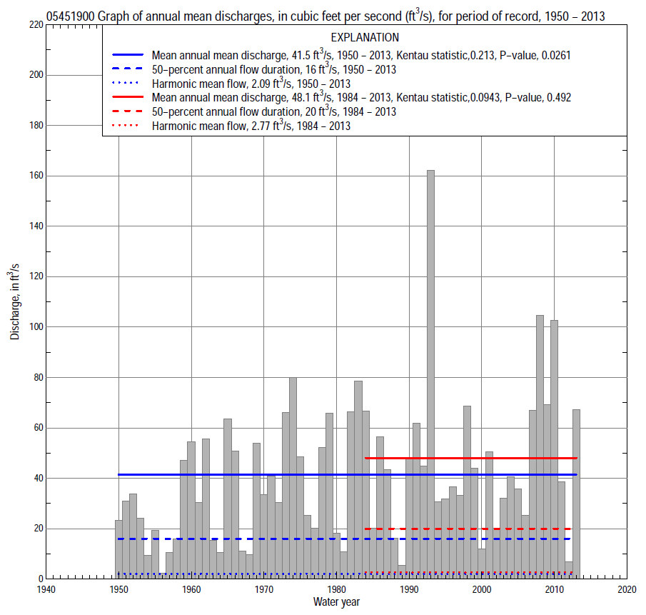

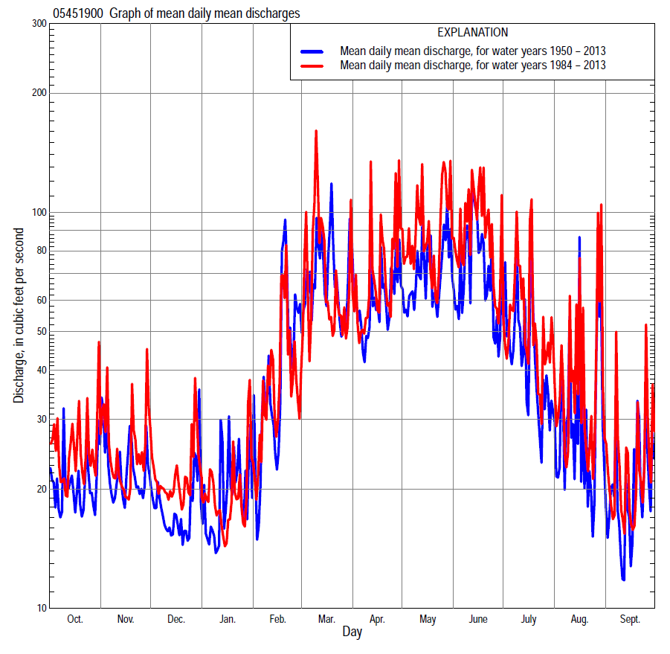

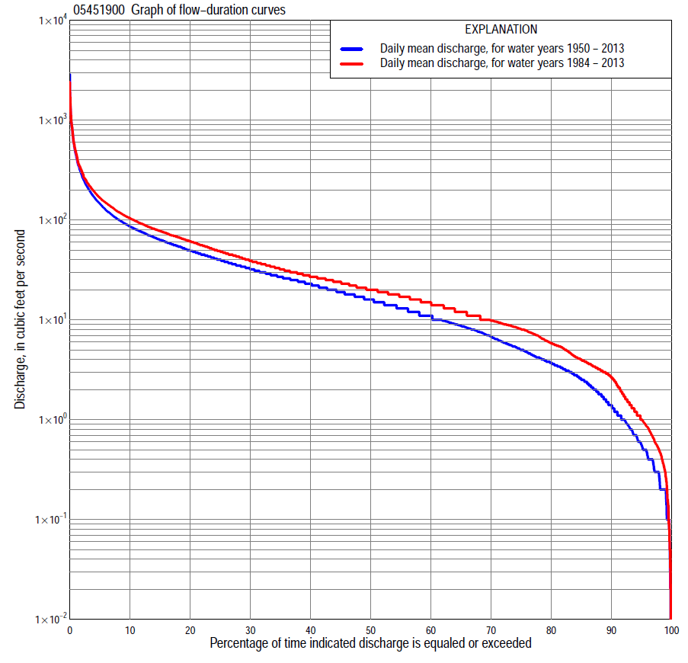

Statistics Based on the Entire Streamflow Period of Record
05451900 Monthly and annual flow durations, based on 1950–2013 period of record (64 years)
Percentage of days discharge equaled or exceeded |  |  |  |  | Discharge (cubic feet per second) |  |  |  |  |  |  |  |  | Annual flow durations
 | Oct | Nov | Dec | Jan | Feb | Mar | Apr | May | June | July | Aug | Sept | Annual | Kentau statistic | P-value
99 | 0.10 | 0.30 | 0.20 | 0.02 | 0.11 | 0.50 | 0.50 | 0.40 | 0.20 | 0.10 | 0.34 | 0.06 | 0.20 | 0.261 | 0.002
98 | 0.20 | 0.30 | 0.20 | 0.10 | 0.20 | 0.60 | 0.80 | 0.57 | 0.31 | 0.20 | 0.43 | 0.20 | 0.26 | 0.250 | 0.003
95 | 0.30 | 0.50 | 0.30 | 0.20 | 0.50 | 2.0 | 1.7 | 2.4 | 2.1 | 0.95 | 0.70 | 0.40 | 0.56 | 0.249 | 0.003
90 | 0.68 | 1.0 | 0.66 | 0.70 | 1.9 | 3.5 | 5.5 | 4.9 | 4.8 | 2.5 | 1.0 | 0.79 | 1.4 | 0.279 | 0.001
85 | 1.3 | 1.4 | 1.1 | 1.5 | 2.6 | 6.3 | 8.7 | 8.6 | 7.5 | 4.1 | 2.0 | 1.4 | 2.5 | 0.272 | 0.001
80 | 1.9 | 2.4 | 1.8 | 2.1 | 3.6 | 8.4 | 11 | 13 | 11 | 6.1 | 3.2 | 2.2 | 3.7 | 0.274 | 0.001
75 | 2.6 | 3.4 | 2.9 | 3.2 | 5.4 | 11 | 14 | 16 | 16 | 8.9 | 4.1 | 2.9 | 5.0 | 0.270 | 0.002
70 | 3.4 | 4.2 | 3.8 | 4.0 | 8.0 | 14 | 17 | 19 | 20 | 12 | 5.2 | 3.4 | 6.8 | 0.288 | 0.001
65 | 4.1 | 5.6 | 5.0 | 5.0 | 9.3 | 16 | 21 | 24 | 24 | 14 | 6.0 | 4.0 | 8.7 | 0.284 | 0.001
60 | 4.9 | 7.0 | 6.2 | 6.2 | 11 | 21 | 25 | 30 | 28 | 16 | 7.3 | 4.7 | 11 | 0.267 | 0.002
55 | 6.2 | 8.9 | 7.6 | 8.0 | 12 | 24 | 28 | 37 | 33 | 18 | 8.6 | 5.6 | 13 | 0.250 | 0.004
50 | 8.0 | 11 | 8.9 | 9.4 | 15 | 27 | 33 | 43 | 37 | 21 | 9.8 | 7.1 | 16 | 0.242 | 0.005
45 | 9.5 | 13 | 12 | 11 | 18 | 31 | 38 | 50 | 43 | 24 | 11 | 8.6 | 19 | 0.229 | 0.007
40 | 11 | 17 | 15 | 13 | 21 | 37 | 45 | 57 | 49 | 27 | 13 | 9.7 | 23 | 0.221 | 0.010
35 | 14 | 19 | 18 | 16 | 25 | 43 | 52 | 65 | 57 | 30 | 14 | 11 | 27 | 0.203 | 0.018
30 | 17 | 24 | 20 | 18 | 29 | 49 | 60 | 74 | 65 | 34 | 17 | 14 | 32 | 0.205 | 0.017
25 | 22 | 29 | 23 | 21 | 33 | 58 | 70 | 83 | 75 | 39 | 21 | 16 | 40 | 0.230 | 0.007
20 | 27 | 36 | 27 | 25 | 40 | 73 | 84 | 96 | 87 | 47 | 25 | 19 | 49 | 0.243 | 0.005
15 | 37 | 42 | 32 | 31 | 50 | 94 | 101 | 113 | 105 | 57 | 33 | 26 | 63 | 0.252 | 0.003
10 | 54 | 51 | 41 | 41 | 80 | 147 | 129 | 142 | 142 | 78 | 48 | 39 | 86 | 0.232 | 0.007
5 | 81 | 72 | 58 | 60 | 180 | 290 | 192 | 208 | 234 | 156 | 104 | 84 | 146 | 0.187 | 0.030
2 | 125 | 123 | 87 | 100 | 387 | 580 | 313 | 352 | 483 | 295 | 273 | 158 | 284 | 0.109 | 0.207
1 | 193 | 187 | 116 | 186 | 530 | 824 | 499 | 521 | 846 | 487 | 456 | 262 | 458 | 0.042 | 0.626

05451900 Annual exceedance probability of instantaneous peak discharges, in cubic feet per second (ft³/s), based on the Weighted Independent Estimates method,
Annual exceed-ance probability | Recur-rence interval (years) | Discharge (ft³/s) | 95-percent lower confi-dence interval (ft³/s) | 95-percent upper confi-dence interval (ft³/s)
0.500 | 2 | 1,670 | 1,410 | 1,980
0.200 | 5 | 2,990 | 2,510 | 3,570
0.100 | 10 | 4,160 | 3,430 | 5,040
0.040 | 25 | 6,010 | 4,820 | 7,500
0.020 | 50 | 7,450 | 5,800 | 9,570
0.010 | 100 | 8,910 | 6,710 | 11,800
0.005 | 200 | 11,000 | 7,940 | 15,100
0.002 | 500 | 12,700 | 8,760 | 18,400
and based on the expected moments algorithm/multiple Grubbs-Beck analysis computed using a historical period length of 64 years (1950–2013)
0.500 | 2 | 1,660 | 1,390 | 1,990
0.200 | 5 | 2,930 | 2,440 | 3,610
0.100 | 10 | 3,920 | 3,210 | 5,080
0.040 | 25 | 5,320 | 4,220 | 7,580
0.020 | 50 | 6,470 | 4,980 | 10,000
0.010 | 100 | 7,710 | 5,720 | 13,000
0.005 | 200 | 9,040 | 6,450 | 16,700
0.002 | 500 | 11,000 | 7,380 | 22,800
Kentau statistic |  | 0.077
P-value |  | 0.372
Begin year |  | 1950
End year |  | 2013
Number of peaks |  | 64

05451900 Annual exceedance probability of high discharges, based on 1950–2013 period of record (64 years)
Annual exceedance probability | Recur-rence interval (years) | Maximum average discharge (ft³/s) for indicated number of consecutive days
 |  | 1 | 3 | 7 | 15 | 30
0.990 | 1.01 | 97 | 71 | 44 | 27 | 18
0.950 | 1.05 | 210 | 138 | 83 | 53 | 35
0.900 | 1.11 | 304 | 190 | 113 | 73 | 49
0.800 | 1.25 | 456 | 272 | 161 | 105 | 71
0.500 | 2 | 880 | 499 | 293 | 193 | 133
0.200 | 5 | 1,470 | 826 | 490 | 323 | 225
0.100 | 10 | 1,820 | 1,040 | 619 | 406 | 284
0.040 | 25 | 2,210 | 1,280 | 777 | 505 | 355
0.020 | 50 | 2,460 | 1,450 | 888 | 574 | 403
0.010 | 100 | 2,670 | 1,610 | 994 | 638 | 448
0.005 | 200 | 2,860 | 1,750 | 1,090 | 698 | 490
0.002 | 500 | 3,070 | 1,930 | 1,220 | 771 | 541
Kentau statistic |  | 0.017 | 0.018 | 0.081 | 0.108 | 0.139
P-value |  | 0.844 | 0.839 | 0.345 | 0.211 | 0.106

 | 05451900 Annual nonexceedance probability of low discharges, based on April 1950 to March 2013 period of record (63 years)
Annual nonexceed-ance probability | Recur-rence interval (years) | Minimum average discharge (ft³/s) for indicated number of consecutive days
 |  | 1 | 3 | 7 | 14 | 30 | 60 | 90 | 120 | 183
0.01 | 100 | 0.00 | 0.00 | 0.00 | 0.00 | 0.02 | 0.08 | 0.14 | 0.16 | 0.30
0.02 | 50 | 0.00 | 0.00 | 0.01 | 0.01 | 0.04 | 0.14 | 0.24 | 0.28 | 0.50
0.05 | 20 | 0.02 | 0.05 | 0.06 | 0.06 | 0.13 | 0.34 | 0.52 | 0.61 | 1.0
0.10 | 10 | 0.11 | 0.15 | 0.20 | 0.20 | 0.33 | 0.69 | 1.0 | 1.2 | 1.9
0.20 | 5 | 0.40 | 0.46 | 0.56 | 0.65 | 0.90 | 1.5 | 2.0 | 2.4 | 3.7
0.50 | 2 | 2.2 | 2.3 | 2.6 | 3.4 | 4.0 | 5.3 | 6.7 | 8.0 | 11
0.80 | 1.25 | 6.5 | 7.0 | 7.5 | 9.0 | 11 | 14 | 18 | 21 | 29
0.90 | 1.11 | 10 | 11 | 11 | 12 | 16 | 21 | 27 | 33 | 43
0.96 | 1.04 | 13 | 15 | 16 | 17 | 21 | 31 | 40 | 50 | 64
0.98 | 1.02 | 16 | 18 | 19 | 20 | 24 | 38 | 51 | 62 | 80
0.99 | 1.01 | 18 | 20 | 22 | 23 | 26 | 44 | 61 | 75 | 96
Kentau statistic |  | 0.299 | 0.307 | 0.311 | 0.296 | 0.300 | 0.240 | 0.206 | 0.194 | 0.172
P-value |  | 0.001 | 0.000 | 0.000 | 0.001 | 0.001 | 0.006 | 0.017 | 0.025 | 0.048

05451900 Annual nonexceedance probability of seasonal low discharges, based on October 1949 to September 2013 period of record (64 years)
Annual nonexceed-ance probability | Recur-rence interval (years) | Minimum average discharge (cubic feet per second) for indicated number of consecutive days
 |  | 1 | 7 | 14 | 30 |  | 1 | 7 | 14 | 30
 |  | January-February-March |  |  |  |  | April-May-June
0.01 | 100 | 0.00 | 0.00 | 0.01 | 0.03 |  | 0.05 | 0.16 | 0.21 | 0.36
0.02 | 50 | 0.01 | 0.02 | 0.02 | 0.09 |  | 0.12 | 0.32 | 0.42 | 0.70
0.05 | 20 | 0.12 | 0.16 | 0.20 | 0.33 |  | 0.41 | 0.8 | 1.1 | 1.7
0.10 | 10 | 0.33 | 0.35 | 0.37 | 0.90 |  | 1.1 | 1.8 | 2.4 | 3.6
0.20 | 5 | 0.92 | 1.1 | 1.3 | 2.5 |  | 2.8 | 4.1 | 5.3 | 7.7
0.50 | 2 | 4.1 | 4.8 | 6.6 | 10 |  | 12 | 14 | 18 | 25
0.80 | 1.25 | 12 | 14 | 17 | 22 |  | 31 | 34 | 40 | 57
0.90 | 1.11 | 19 | 21 | 22 | 27 |  | 42 | 47 | 54 | 78
0.96 | 1.04 | 25 | 27 | 31 | 33 |  | 54 | 61 | 68 | 100
0.98 | 1.02 | 27 | 33 | 35 | 40 |  | 60 | 70 | 76 | 114
0.99 | 1.01 | 28 | 34 | 38 | 48 |  | 65 | 76 | 82 | 125
Kentau statistic |  | 0.214 | 0.271 | 0.278 | 0.202 |  | 0.240 | 0.223 | 0.215 | 0.233
P-value |  | 0.012 | 0.002 | 0.001 | 0.018 |  | 0.005 | 0.009 | 0.012 | 0.007
 |  | July-August-September |  |  |  |  | October-November-December
0.01 | 100 | 0.00 | 0.02 | 0.04 | 0.20 |  | 0.02 | 0.03 | 0.06 | 0.11
0.02 | 50 | 0.00 | 0.05 | 0.07 | 0.30 |  | 0.04 | 0.07 | 0.11 | 0.20
0.05 | 20 | 0.06 | 0.15 | 0.20 | 0.6 |  | 0.11 | 0.18 | 0.26 | 0.43
0.10 | 10 | 0.20 | 0.35 | 0.45 | 1.0 |  | 0.27 | 0.39 | 0.54 | 0.81
0.20 | 5 | 0.62 | 0.87 | 1.1 | 1.8 |  | 0.71 | 0.94 | 1.2 | 1.7
0.50 | 2 | 3.1 | 3.7 | 4.4 | 5.4 |  | 3.3 | 4.0 | 4.7 | 5.9
0.80 | 1.25 | 9.4 | 11 | 13 | 15 |  | 11 | 12 | 14 | 17
0.90 | 1.11 | 14 | 16 | 19 | 24 |  | 17 | 20 | 23 | 28
0.96 | 1.04 | 20 | 23 | 28 | 40 |  | 26 | 31 | 36 | 45
0.98 | 1.02 | 23 | 27 | 34 | 54 |  | 32 | 39 | 47 | 59
0.99 | 1.01 | 26 | 31 | 40 | 70 |  | 38 | 47 | 58 | 74
Kentau statistic |  | 0.220 | 0.213 | 0.219 | 0.209 |  | 0.206 | 0.207 | 0.204 | 0.198
P-value |  | 0.010 | 0.013 | 0.011 | 0.015 |  | 0.016 | 0.016 | 0.017 | 0.021

Statistics Based on the 1984–2013 Streamflow Period of Record
05451900 Monthly and annual flow durations, based on 1984–2013 period of record (30 years)
Percentage of days discharge equaled or exceeded |  |  |  |  | Discharge (cubic feet per second) |  |  |  |  |  |  |  |  | Annual flow durations
 | Oct | Nov | Dec | Jan | Feb | Mar | Apr | May | June | July | Aug | Sept | Annual | Kentau statistic | P-value
99 | 0.09 | 0.83 | 0.48 | 0.31 | 0.14 | 1.6 | 1.4 | 0.56 | 0.56 | 0.08 | 0.35 | 0.02 | 0.29 | 0.140 | 0.278
98 | 0.23 | 0.93 | 0.54 | 0.43 | 0.18 | 2.0 | 1.5 | 1.1 | 0.80 | 0.52 | 0.43 | 0.05 | 0.48 | 0.129 | 0.320
95 | 0.53 | 1.1 | 0.76 | 1.2 | 1.8 | 3.2 | 3.5 | 6.1 | 3.6 | 1.2 | 0.7 | 0.36 | 1.0 | 0.115 | 0.377
90 | 0.94 | 1.4 | 1.3 | 3.2 | 3.3 | 6.4 | 9.1 | 11 | 6.5 | 2.8 | 1.1 | 0.72 | 2.7 | 0.085 | 0.518
85 | 1.8 | 3.3 | 2.9 | 3.9 | 6.3 | 9.8 | 11 | 16 | 16 | 8.5 | 2.6 | 1.5 | 4.0 | 0.094 | 0.474
80 | 2.9 | 4.2 | 4.0 | 5.5 | 8.1 | 12 | 14 | 20 | 20 | 13 | 4.0 | 2.5 | 5.8 | 0.071 | 0.592
75 | 3.8 | 5.5 | 5.6 | 7.0 | 9.1 | 16 | 17 | 26 | 25 | 15 | 5.4 | 3.0 | 8.1 | 0.092 | 0.486
70 | 4.2 | 7.0 | 7.0 | 8.0 | 11 | 21 | 21 | 34 | 30 | 17 | 6.8 | 3.7 | 9.9 | 0.110 | 0.401
65 | 5.4 | 8.3 | 8.5 | 9.0 | 12 | 23 | 24 | 42 | 35 | 19 | 8.0 | 4.7 | 12 | 0.103 | 0.431
60 | 6.1 | 9.5 | 10 | 9.8 | 15 | 26 | 26 | 50 | 42 | 22 | 9.3 | 5.6 | 15 | 0.087 | 0.508
55 | 7.8 | 11 | 13 | 11 | 17 | 28 | 29 | 58 | 48 | 24 | 10 | 7.2 | 17 | 0.069 | 0.604
50 | 9.1 | 13 | 15 | 13 | 19 | 30 | 34 | 64 | 56 | 26 | 12 | 8.9 | 20 | 0.064 | 0.629
45 | 11 | 16 | 18 | 15 | 21 | 34 | 42 | 70 | 62 | 29 | 13 | 9.9 | 24 | 0.071 | 0.591
40 | 13 | 19 | 19 | 17 | 25 | 39 | 52 | 76 | 70 | 31 | 15 | 11 | 27 | 0.078 | 0.556
35 | 16 | 21 | 21 | 19 | 29 | 43 | 62 | 83 | 77 | 36 | 17 | 14 | 32 | 0.060 | 0.655
30 | 19 | 26 | 23 | 21 | 33 | 50 | 73 | 93 | 85 | 41 | 21 | 16 | 39 | 0.044 | 0.748
25 | 24 | 31 | 26 | 23 | 37 | 59 | 85 | 104 | 97 | 47 | 25 | 20 | 48 | 0.053 | 0.694
20 | 31 | 37 | 31 | 27 | 44 | 77 | 100 | 120 | 110 | 57 | 33 | 26 | 61 | 0.071 | 0.592
15 | 49 | 44 | 37 | 32 | 51 | 105 | 119 | 141 | 139 | 71 | 45 | 33 | 77 | 0.062 | 0.643
10 | 70 | 55 | 49 | 40 | 71 | 148 | 151 | 171 | 183 | 100 | 64 | 60 | 104 | 0.067 | 0.617
5 | 102 | 82 | 68 | 52 | 134 | 285 | 218 | 246 | 287 | 191 | 155 | 100 | 166 | 0.094 | 0.475
2 | 165 | 135 | 98 | 74 | 302 | 499 | 329 | 427 | 530 | 326 | 348 | 165 | 308 | 0.140 | 0.284
1 | 244 | 190 | 126 | 120 | 387 | 731 | 500 | 619 | 848 | 539 | 538 | 250 | 480 | 0.039 | 0.775

05451900 Annual exceedance probability of high discharges, based on 1984–2013 period of record (30 years)
Annual exceedance probability | Recur-rence interval (years) | Maximum average discharge (ft³/s) for indicated number of consecutive days
 |  | 1 | 3 | 7 | 15 | 30
0.990 | 1.01 | 76 | 61 | 45 | 31 | 20
0.950 | 1.05 | 184 | 123 | 83 | 58 | 40
0.900 | 1.11 | 276 | 171 | 112 | 79 | 56
0.800 | 1.25 | 428 | 249 | 159 | 113 | 82
0.500 | 2 | 845 | 467 | 293 | 207 | 152
0.200 | 5 | 1,380 | 783 | 500 | 346 | 248
0.100 | 10 | 1,660 | 985 | 642 | 439 | 307
0.040 | 25 | 1,950 | 1,220 | 821 | 551 | 373
0.020 | 50 | 2,110 | 1,380 | 952 | 630 | 416
0.010 | 100 | 2,240 | 1,530 | 1,080 | 706 | 455
0.005 | 200 | 2,340 | 1,660 | 1,200 | 778 | 489
0.002 | 500 | 2,450 | 1,830 | 1,360 | 867 | 530
Kentau statistic |  | 0.005 | 0.071 | 0.094 | -0.014 | 0.016
P-value |  | 0.986 | 0.592 | 0.475 | 0.929 | 0.915

 | 05451900 Annual nonexceedance probability of low discharges, based on April 1983 to March 2013 period of record (30 years)
Annual nonexceed-ance probability | Recur-rence interval (years) | Minimum average discharge (ft³/s) for indicated number of consecutive days
 |  | 1 | 3 | 7 | 14 | 30 | 60 | 90 | 120 | 183
0.01 | 100 | 0.00 | 0.00 | 0.01 | 0.01 | 0.03 | 0.20 | 0.30 | 0.35 | 0.56
0.02 | 50 | 0.00 | 0.01 | 0.02 | 0.03 | 0.07 | 0.34 | 0.48 | 0.57 | 0.87
0.05 | 20 | 0.02 | 0.06 | 0.09 | 0.11 | 0.25 | 0.72 | 0.96 | 1.1 | 1.6
0.10 | 10 | 0.18 | 0.21 | 0.28 | 0.36 | 0.66 | 1.3 | 1.7 | 2.0 | 2.8
0.20 | 5 | 0.81 | 0.82 | 0.92 | 1.1 | 1.7 | 2.6 | 3.2 | 3.7 | 5.0
0.50 | 2 | 4.4 | 4.5 | 4.8 | 5.6 | 6.8 | 7.7 | 9.1 | 11 | 14
0.80 | 1.25 | 10 | 11 | 12 | 13 | 15 | 18 | 22 | 26 | 33
0.90 | 1.11 | 12 | 15 | 16 | 17 | 19 | 26 | 32 | 37 | 49
0.96 | 1.04 | 13 | 17 | 18 | 20 | 22 | 36 | 45 | 54 | 72
0.98 | 1.02 | 14 | 18 | 19 | 21 | 24 | 43 | 55 | 66 | 91
0.99 | 1.01 | 14 | 19 | 20 | 22 | 24 | 50 | 65 | 78 | 109
Kentau statistic |  | 0.009 | 0.025 | 0.039 | 0.048 | 0.108 | 0.090 | 0.062 | 0.057 | 0.030
P-value |  | 0.957 | 0.858 | 0.775 | 0.721 | 0.412 | 0.498 | 0.643 | 0.669 | 0.830

05451900 Annual nonexceedance probability of seasonal low discharges, based on October 1983 to September 2013 period of record (30 years)
Annual nonexceed-ance probability | Recur-rence interval (years) | Minimum average discharge (cubic feet per second) for indicated number of consecutive days
 |  | 1 | 7 | 14 | 30 |  | 1 | 7 | 14 | 30
 |  | January-February-March |  |  |  |  | April-May-June
0.01 | 100 | 0.02 | 0.05 | 0.07 | 0.22 |  | 0.23 | 0.46 | 0.54 | 0.84
0.02 | 50 | 0.05 | 0.11 | 0.16 | 0.45 |  | 0.45 | 0.82 | 1.0 | 1.5
0.05 | 20 | 0.21 | 0.38 | 0.51 | 1.2 |  | 1.2 | 1.8 | 2.2 | 3.2
0.10 | 10 | 0.62 | 1.0 | 1.2 | 2.4 |  | 2.4 | 3.4 | 4.2 | 6.0
0.20 | 5 | 1.8 | 2.5 | 3.0 | 5.0 |  | 5.2 | 6.7 | 8.2 | 12
0.50 | 2 | 7.4 | 9.2 | 10 | 13 |  | 17 | 19 | 23 | 34
0.80 | 1.25 | 15 | 19 | 20 | 23 |  | 37 | 41 | 48 | 71
0.90 | 1.11 | 18 | 23 | 25 | 26 |  | 49 | 54 | 63 | 96
0.96 | 1.04 | 20 | 26 | 28 | 29 |  | 60 | 69 | 78 | 123
0.98 | 1.02 | 21 | 27 | 29 | 30 |  | 67 | 78 | 86 | 139
0.99 | 1.01 | 21 | 28 | 30 | 31 |  | 72 | 85 | 93 | 153
Kentau statistic |  | -0.067 | 0.021 | 0.048 | 0.034 |  | 0.101 | 0.097 | 0.149 | 0.218
P-value |  | 0.616 | 0.887 | 0.721 | 0.803 |  | 0.443 | 0.464 | 0.254 | 0.094
 |  | July-August-September |  |  |  |  | October-November-December
0.01 | 100 | 0.00 | 0.01 | 0.01 | 0.15 |  | 0.01 | 0.04 | 0.10 | 0.21
0.02 | 50 | 0.00 | 0.03 | 0.04 | 0.24 |  | 0.03 | 0.08 | 0.19 | 0.35
0.05 | 20 | 0.02 | 0.10 | 0.13 | 0.50 |  | 0.14 | 0.25 | 0.46 | 0.72
0.10 | 10 | 0.19 | 0.30 | 0.36 | 0.93 |  | 0.40 | 0.60 | 0.92 | 1.3
0.20 | 5 | 0.78 | 0.95 | 1.1 | 1.9 |  | 1.2 | 1.5 | 2.0 | 2.6
0.50 | 2 | 4.7 | 5.3 | 6.0 | 6.8 |  | 5.5 | 6.0 | 6.7 | 8.0
0.80 | 1.25 | 14 | 16 | 20 | 22 |  | 13 | 15 | 17 | 20
0.90 | 1.11 | 21 | 25 | 31 | 37 |  | 17 | 21 | 25 | 31
0.96 | 1.04 | 27 | 33 | 44 | 65 |  | 20 | 27 | 35 | 45
0.98 | 1.02 | 31 | 39 | 53 | 91 |  | 21 | 30 | 42 | 57
0.99 | 1.01 | 34 | 42 | 60 | 121 |  | 22 | 33 | 49 | 69
Kentau statistic |  | 0.009 | 0.007 | 0.025 | 0.051 |  | 0.069 | 0.083 | 0.044 | 0.025
P-value |  | 0.957 | 0.972 | 0.858 | 0.708 |  | 0.605 | 0.532 | 0.748 | 0.858

