LOCATION.--Lat 41°57'51", long 92°18'47" referenced to North American Datum of 1927, in SE 1/4 SW 1/4 SW 1/4 sec.25, T.83 N., R.13 W., Tama County, IA, Hydrologic Unit 07080208, on left bank 20 ft upstream from bridge on U.S. Highway 30, 3.0 mi south of Elberon, 2.0 mi upstream from Hog Run, and 10.0 mi upstream from mouth.

DRAINAGE AREA.--201 mi².

PERIOD OF RECORD.--Discharge records from October 1945 to current year.

GAGE.--Water-stage recorder. Datum of gage is 781.58 ft above National Geodetic Vertical Datum of 1929 (Iowa Highway Commission benchmark). Prior to October 15, 1945, and June 14, 1947, to February 10, 1949, non-recording gage on upstream side of bridge at same datum.

EXTREMES OUTSIDE PERIOD OF RECORD.--Flood of June 16, 1944, reached a stage of 19.9 ft, from high-water mark on downstream side of bridge, discharge about 30,000 ft³/s.

A summary of all available data for this streamgage is provided through the USGS National Water Information System web interface (NWISWeb). The following link provides access to current/historical observations, daily data, daily statistics, monthly statistics, annual statistics, peak streamflow, field measurements, field/lab water-quality samples, and the latest water-year summaries. Data can be filtered by parameter and/or dates, and can be output in various tabular and graphical formats.
http://waterdata.usgs.gov/nwis/inventory/?site_no=05452000

The USGS WaterWatch Toolkit is available at:
http://waterwatch.usgs.gov/?id=ww_toolkit
Tools for summarizing streamflow information include the duration hydrograph builder, the cumulative streamflow hydrograph builder, the streamgage statistics retrieval tool, the rating curve builder, the flood tracking chart builder, the National Weather Service Advanced Hydrologic Prediction Service (AHPS) river forecast hydrograph builder, and the raster-hydrograph builder. Entering the above number for this streamgage into these toolkit webpages will provide streamflow information specific to this streamgage.

A description of the statistics presented for this streamgage is available in the main body of the report at:
http://dx.doi.org/10.3133/ofr20151214
A link to other streamgages included in this report, a map showing the location of the streamgages, information on the programs used to compute the statistical analyses, and references are included in the main body of the report.

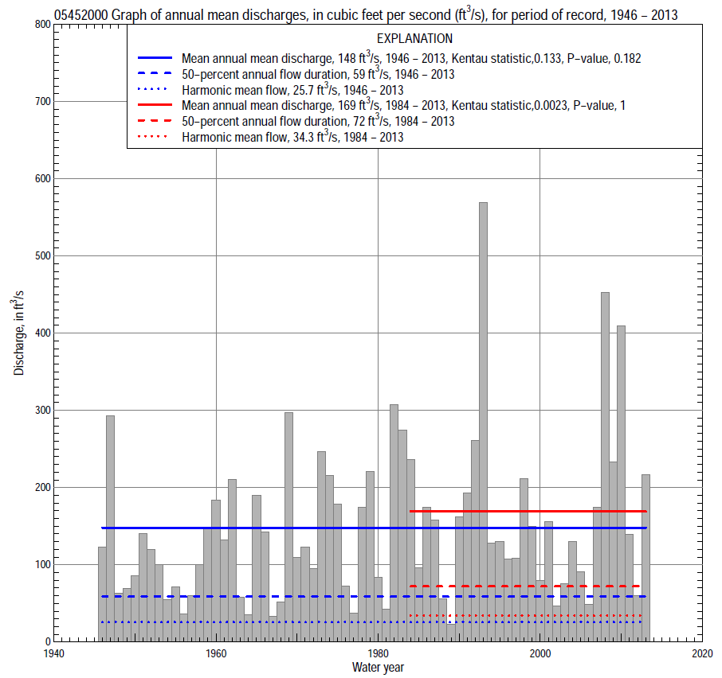

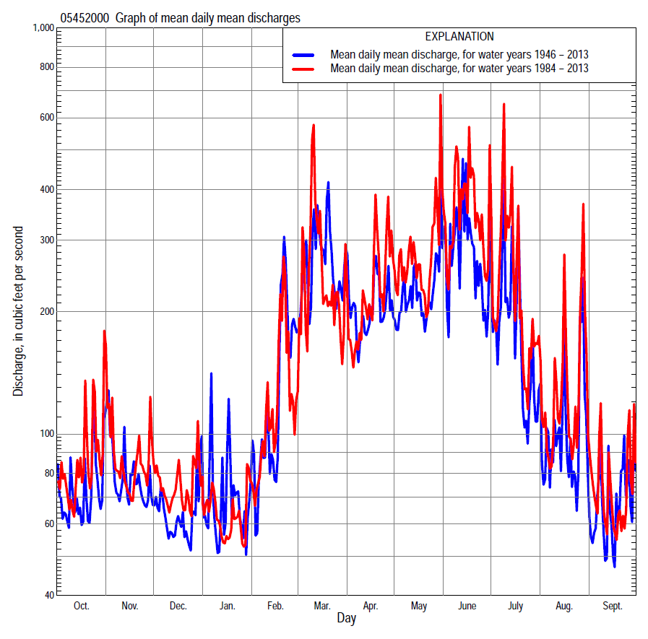

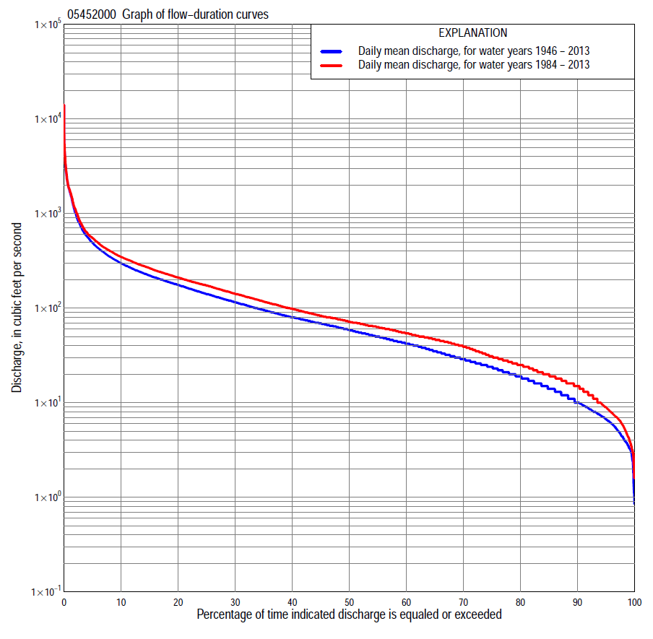

Statistics Based on the Entire Streamflow Period of Record
05452000 Monthly and annual flow durations, based on 1946–2013 period of record (68 years)
Percentage of days discharge equaled or exceeded |  |  |  |  | Discharge (cubic feet per second) |  |  |  |  |  |  |  |  | Annual flow durations
 | Oct | Nov | Dec | Jan | Feb | Mar | Apr | May | June | July | Aug | Sept | Annual | Kentau statistic | P-value
99 | 4.6 | 4.0 | 2.0 | 1.2 | 3.2 | 8.0 | 8.4 | 5.5 | 4.3 | 3.1 | 4.2 | 3.8 | 3.4 | 0.256 | 0.002
98 | 4.9 | 4.8 | 2.9 | 2.4 | 3.7 | 9.8 | 9.8 | 7.2 | 5.8 | 3.7 | 5.2 | 4.6 | 4.3 | 0.262 | 0.002
95 | 6.0 | 6.6 | 3.9 | 3.7 | 7.0 | 14 | 16 | 20 | 13 | 9.3 | 7.1 | 5.9 | 6.7 | 0.252 | 0.002
90 | 8.2 | 8.0 | 6.0 | 5.7 | 10 | 20 | 28 | 31 | 23 | 14 | 10 | 8.2 | 10 | 0.242 | 0.004
85 | 9.8 | 10 | 7.8 | 7.6 | 13 | 29 | 35 | 40 | 33 | 19 | 13 | 11 | 14 | 0.240 | 0.004
80 | 13 | 14 | 11 | 10 | 17 | 39 | 44 | 52 | 49 | 25 | 17 | 13 | 19 | 0.241 | 0.004
75 | 15 | 17 | 14 | 13 | 21 | 50 | 57 | 64 | 64 | 31 | 20 | 16 | 24 | 0.235 | 0.005
70 | 18 | 22 | 18 | 18 | 28 | 60 | 69 | 73 | 74 | 38 | 23 | 18 | 29 | 0.238 | 0.004
65 | 22 | 28 | 22 | 24 | 36 | 69 | 78 | 86 | 87 | 47 | 25 | 19 | 35 | 0.237 | 0.004
60 | 25 | 32 | 27 | 28 | 42 | 76 | 89 | 102 | 101 | 56 | 28 | 21 | 42 | 0.222 | 0.007
55 | 28 | 38 | 32 | 32 | 46 | 84 | 101 | 120 | 119 | 65 | 31 | 23 | 50 | 0.213 | 0.010
50 | 34 | 45 | 40 | 38 | 54 | 97 | 115 | 141 | 135 | 75 | 36 | 26 | 59 | 0.202 | 0.015
45 | 40 | 52 | 46 | 43 | 62 | 117 | 132 | 162 | 158 | 88 | 41 | 31 | 69 | 0.201 | 0.016
40 | 47 | 59 | 50 | 49 | 72 | 140 | 148 | 188 | 180 | 100 | 47 | 38 | 80 | 0.207 | 0.013
35 | 53 | 69 | 58 | 55 | 84 | 164 | 175 | 211 | 204 | 113 | 53 | 43 | 95 | 0.212 | 0.011
30 | 61 | 80 | 67 | 63 | 98 | 190 | 203 | 236 | 232 | 131 | 62 | 50 | 115 | 0.210 | 0.011
25 | 73 | 99 | 80 | 70 | 110 | 218 | 241 | 264 | 269 | 152 | 73 | 62 | 141 | 0.216 | 0.009
20 | 92 | 120 | 94 | 80 | 140 | 266 | 280 | 300 | 315 | 180 | 92 | 77 | 176 | 0.220 | 0.008
15 | 128 | 141 | 114 | 102 | 179 | 365 | 335 | 354 | 403 | 235 | 130 | 99 | 220 | 0.222 | 0.008
10 | 170 | 179 | 146 | 141 | 256 | 535 | 430 | 439 | 563 | 327 | 193 | 144 | 300 | 0.169 | 0.042
5 | 260 | 246 | 191 | 200 | 489 | 1,200 | 634 | 629 | 912 | 585 | 354 | 262 | 493 | 0.113 | 0.175
2 | 385 | 386 | 280 | 350 | 1,110 | 2,180 | 1,230 | 1,150 | 1,900 | 1,570 | 837 | 455 | 1,010 | 0.014 | 0.874
1 | 616 | 531 | 390 | 580 | 1,700 | 2,940 | 1,680 | 1,740 | 2,720 | 2,710 | 1,500 | 623 | 1,700 | -0.036 | 0.664

05452000 Annual exceedance probability of instantaneous peak discharges, in cubic feet per second (ft³/s), based on the Weighted Independent Estimates method,
Annual exceed-ance probability | Recur-rence interval (years) | Discharge (ft³/s) | 95-percent lower confi-dence interval (ft³/s) | 95-percent upper confi-dence interval (ft³/s)
0.500 | 2 | 4,080 | 3,390 | 4,920
0.200 | 5 | 8,480 | 6,980 | 10,300
0.100 | 10 | 12,200 | 9,860 | 15,000
0.040 | 25 | 17,600 | 13,800 | 22,500
0.020 | 50 | 21,800 | 16,600 | 28,700
0.010 | 100 | 26,100 | 19,200 | 35,600
0.005 | 200 | 32,800 | 23,100 | 46,600
0.002 | 500 | 38,000 | 25,300 | 57,100
and based on the expected moments algorithm/multiple Grubbs-Beck analysis computed using a historical period length of 95 years (1919–2013)
0.500 | 2 | 4,100 | 3,260 | 5,130
0.200 | 5 | 8,750 | 6,920 | 11,300
0.100 | 10 | 13,000 | 10,100 | 17,700
0.040 | 25 | 20,000 | 14,800 | 30,000
0.020 | 50 | 26,300 | 18,700 | 43,500
0.010 | 100 | 33,800 | 22,900 | 61,800
0.005 | 200 | 42,400 | 27,400 | 86,600
0.002 | 500 | 56,000 | 33,700 | 133,000
Kentau statistic |  | -0.126
P-value |  | 0.130
Begin year |  | 1946
End year |  | 2013
Number of peaks |  | 68

05452000 Annual exceedance probability of high discharges, based on 1946–2013 period of record (68 years)
Annual exceedance probability | Recur-rence interval (years) | Maximum average discharge (ft³/s) for indicated number of consecutive days
 |  | 1 | 3 | 7 | 15 | 30
0.990 | 1.01 | 402 | 248 | 159 | 113 | 76
0.950 | 1.05 | 699 | 462 | 290 | 195 | 132
0.900 | 1.11 | 936 | 632 | 393 | 258 | 177
0.800 | 1.25 | 1,330 | 906 | 557 | 360 | 247
0.500 | 2 | 2,550 | 1,710 | 1,030 | 662 | 457
0.200 | 5 | 4,830 | 3,020 | 1,800 | 1,180 | 809
0.100 | 10 | 6,700 | 3,960 | 2,340 | 1,580 | 1,070
0.040 | 25 | 9,460 | 5,180 | 3,060 | 2,130 | 1,430
0.020 | 50 | 11,800 | 6,110 | 3,590 | 2,570 | 1,720
0.010 | 100 | 14,300 | 7,030 | 4,130 | 3,030 | 2,010
0.005 | 200 | 17,100 | 7,960 | 4,660 | 3,520 | 2,320
0.002 | 500 | 21,200 | 9,180 | 5,370 | 4,200 | 2,740
Kentau statistic |  | -0.112 | -0.078 | -0.028 | 0.027 | 0.069
P-value |  | 0.177 | 0.352 | 0.739 | 0.747 | 0.406

 | 05452000 Annual nonexceedance probability of low discharges, based on April 1946 to March 2013 period of record (67 years)
Annual nonexceed-ance probability | Recur-rence interval (years) | Minimum average discharge (ft³/s) for indicated number of consecutive days
 |  | 1 | 3 | 7 | 14 | 30 | 60 | 90 | 120 | 183
0.01 | 100 | 0.92 | 1.0 | 1.0 | 1.1 | 1.3 | 1.7 | 2.2 | 2.5 | 3.3
0.02 | 50 | 1.3 | 1.3 | 1.4 | 1.5 | 1.8 | 2.4 | 3.0 | 3.5 | 4.6
0.05 | 20 | 2.0 | 2.1 | 2.3 | 2.5 | 3.0 | 3.8 | 4.8 | 5.5 | 7.5
0.10 | 10 | 3.0 | 3.2 | 3.4 | 3.8 | 4.5 | 5.8 | 7.1 | 8.3 | 11
0.20 | 5 | 4.8 | 5.1 | 5.5 | 6.2 | 7.3 | 9.3 | 11 | 13 | 18
0.50 | 2 | 11 | 12 | 13 | 14 | 17 | 22 | 27 | 32 | 43
0.80 | 1.25 | 23 | 25 | 27 | 30 | 36 | 48 | 59 | 71 | 94
0.90 | 1.11 | 34 | 36 | 38 | 42 | 51 | 70 | 88 | 105 | 137
0.96 | 1.04 | 48 | 51 | 55 | 59 | 73 | 102 | 131 | 158 | 200
0.98 | 1.02 | 60 | 64 | 68 | 73 | 90 | 130 | 169 | 205 | 252
0.99 | 1.01 | 73 | 77 | 82 | 87 | 108 | 159 | 210 | 256 | 308
Kentau statistic |  | 0.275 | 0.292 | 0.288 | 0.280 | 0.249 | 0.199 | 0.171 | 0.174 | 0.158
P-value |  | 0.001 | 0.000 | 0.001 | 0.001 | 0.003 | 0.017 | 0.042 | 0.038 | 0.060

05452000 Annual nonexceedance probability of seasonal low discharges, based on October 1945 to September 2013 period of record (68 years)
Annual nonexceed-ance probability | Recur-rence interval (years) | Minimum average discharge (cubic feet per second) for indicated number of consecutive days
 |  | 1 | 7 | 14 | 30 |  | 1 | 7 | 14 | 30
 |  | January-February-March |  |  |  |  | April-May-June
0.01 | 100 | 0.86 | 1.0 | 1.1 | 1.5 |  | 2.9 | 3.4 | 3.8 | 5.5
0.02 | 50 | 1.3 | 1.5 | 1.6 | 2.3 |  | 4.2 | 4.8 | 5.6 | 8.0
0.05 | 20 | 2.4 | 2.7 | 3.0 | 4.3 |  | 7.1 | 8.2 | 9.6 | 13
0.10 | 10 | 3.9 | 4.5 | 5.1 | 7.2 |  | 11 | 13 | 15 | 21
0.20 | 5 | 6.9 | 8.1 | 9.1 | 13 |  | 18 | 21 | 25 | 35
0.50 | 2 | 18 | 22 | 24 | 34 |  | 45 | 51 | 61 | 84
0.80 | 1.25 | 42 | 51 | 55 | 73 |  | 98 | 112 | 133 | 184
0.90 | 1.11 | 63 | 75 | 79 | 102 |  | 141 | 160 | 189 | 266
0.96 | 1.04 | 91 | 108 | 112 | 139 |  | 203 | 229 | 268 | 383
0.98 | 1.02 | 114 | 135 | 137 | 166 |  | 252 | 284 | 330 | 478
0.99 | 1.01 | 138 | 162 | 163 | 191 |  | 304 | 341 | 393 | 576
Kentau statistic |  | 0.176 | 0.209 | 0.194 | 0.144 |  | 0.247 | 0.222 | 0.248 | 0.241
P-value |  | 0.034 | 0.012 | 0.020 | 0.083 |  | 0.003 | 0.008 | 0.003 | 0.004
 |  | July-August-September |  |  |  |  | October-November-December
0.01 | 100 | 2.1 | 2.6 | 3.0 | 3.8 |  | 1.0 | 1.2 | 1.4 | 1.9
0.02 | 50 | 2.6 | 3.2 | 3.6 | 4.5 |  | 1.5 | 1.8 | 2.1 | 2.6
0.05 | 20 | 3.7 | 4.4 | 4.9 | 6.0 |  | 2.5 | 3.0 | 3.5 | 4.4
0.10 | 10 | 5.0 | 5.8 | 6.4 | 7.9 |  | 4.0 | 4.8 | 5.5 | 6.8
0.20 | 5 | 7.2 | 8.3 | 9.2 | 11 |  | 6.7 | 8.0 | 9.2 | 11
0.50 | 2 | 15 | 17 | 19 | 23 |  | 17 | 20 | 23 | 27
0.80 | 1.25 | 33 | 37 | 42 | 53 |  | 38 | 45 | 51 | 61
0.90 | 1.11 | 51 | 57 | 66 | 85 |  | 57 | 66 | 75 | 90
0.96 | 1.04 | 81 | 92 | 108 | 144 |  | 84 | 97 | 109 | 133
0.98 | 1.02 | 111 | 127 | 151 | 207 |  | 106 | 122 | 137 | 168
0.99 | 1.01 | 147 | 170 | 206 | 288 |  | 130 | 149 | 166 | 207
Kentau statistic |  | 0.261 | 0.229 | 0.229 | 0.179 |  | 0.190 | 0.165 | 0.165 | 0.148
P-value |  | 0.002 | 0.006 | 0.006 | 0.032 |  | 0.022 | 0.048 | 0.048 | 0.075

Statistics Based on the 1984–2013 Streamflow Period of Record
05452000 Monthly and annual flow durations, based on 1984–2013 period of record (30 years)
Percentage of days discharge equaled or exceeded |  |  |  |  | Discharge (cubic feet per second) |  |  |  |  |  |  |  |  | Annual flow durations
 | Oct | Nov | Dec | Jan | Feb | Mar | Apr | May | June | July | Aug | Sept | Annual | Kentau statistic | P-value
99 | 4.7 | 4.8 | 2.1 | 3.4 | 7.6 | 12 | 9.7 | 6.0 | 5.4 | 3.1 | 3.5 | 4.9 | 4.2 | 0.046 | 0.734
98 | 5.2 | 6.1 | 2.7 | 4.0 | 8.4 | 15 | 11 | 8.1 | 7.4 | 3.5 | 4.4 | 5.5 | 5.7 | 0.023 | 0.872
95 | 6.6 | 7.4 | 4.3 | 7.5 | 9.5 | 19 | 17 | 28 | 21 | 12 | 7.6 | 7.1 | 9.0 | 0.018 | 0.901
90 | 10 | 12 | 9.0 | 10 | 13 | 23 | 29 | 44 | 43 | 18 | 12 | 11 | 15 | 0.005 | 0.986
85 | 14 | 16 | 14 | 14 | 18 | 35 | 36 | 63 | 66 | 30 | 17 | 13 | 20 | 0.007 | 0.972
80 | 16 | 20 | 18 | 20 | 25 | 48 | 54 | 76 | 79 | 47 | 21 | 16 | 25 | 0.014 | 0.929
75 | 20 | 29 | 24 | 26 | 38 | 62 | 68 | 93 | 95 | 58 | 24 | 18 | 31 | -0.005 | 0.986
70 | 24 | 33 | 30 | 29 | 45 | 71 | 77 | 112 | 114 | 68 | 28 | 19 | 39 | -0.007 | 0.972
65 | 25 | 39 | 39 | 34 | 48 | 78 | 84 | 141 | 137 | 77 | 32 | 20 | 47 | -0.014 | 0.929
60 | 27 | 44 | 44 | 39 | 53 | 84 | 97 | 165 | 159 | 89 | 37 | 22 | 54 | -0.018 | 0.901
55 | 29 | 50 | 49 | 44 | 60 | 92 | 111 | 186 | 184 | 98 | 41 | 25 | 63 | -0.023 | 0.872
50 | 36 | 55 | 52 | 48 | 68 | 109 | 124 | 201 | 202 | 108 | 45 | 27 | 72 | 0.000 | 1.000
45 | 46 | 61 | 56 | 50 | 78 | 124 | 151 | 218 | 228 | 117 | 50 | 31 | 83 | 0.018 | 0.901
40 | 52 | 69 | 62 | 56 | 88 | 139 | 183 | 237 | 249 | 131 | 56 | 38 | 98 | 0.039 | 0.775
35 | 57 | 79 | 70 | 61 | 97 | 156 | 212 | 262 | 276 | 151 | 63 | 43 | 117 | 0.032 | 0.817
30 | 64 | 89 | 80 | 66 | 106 | 179 | 244 | 289 | 307 | 170 | 74 | 56 | 142 | 0.053 | 0.695
25 | 75 | 107 | 90 | 71 | 120 | 209 | 278 | 320 | 368 | 194 | 92 | 79 | 173 | 0.046 | 0.735
20 | 107 | 127 | 113 | 80 | 143 | 270 | 323 | 356 | 435 | 244 | 130 | 97 | 210 | 0.064 | 0.630
15 | 164 | 145 | 137 | 100 | 171 | 365 | 385 | 430 | 549 | 315 | 185 | 128 | 264 | 0.055 | 0.682
10 | 229 | 179 | 170 | 137 | 231 | 522 | 470 | 528 | 707 | 427 | 254 | 178 | 347 | 0.014 | 0.929
5 | 311 | 270 | 210 | 185 | 396 | 1,090 | 665 | 691 | 1,240 | 778 | 464 | 318 | 551 | 0.046 | 0.735
2 | 429 | 410 | 311 | 248 | 700 | 1,870 | 1,200 | 1,280 | 2,170 | 1,690 | 929 | 461 | 1,110 | 0.057 | 0.669
1 | 632 | 509 | 413 | 350 | 1,130 | 2,600 | 1,740 | 1,850 | 3,170 | 2,810 | 1,870 | 598 | 1,770 | -0.071 | 0.592

05452000 Annual exceedance probability of high discharges, based on 1984–2013 period of record (30 years)
Annual exceedance probability | Recur-rence interval (years) | Maximum average discharge (ft³/s) for indicated number of consecutive days
 |  | 1 | 3 | 7 | 15 | 30
0.990 | 1.01 | 295 | 205 | 139 | 103 | 72
0.950 | 1.05 | 550 | 393 | 259 | 183 | 133
0.900 | 1.11 | 764 | 547 | 356 | 248 | 181
0.800 | 1.25 | 1,130 | 803 | 516 | 354 | 260
0.500 | 2 | 2,370 | 1,600 | 1,010 | 685 | 496
0.200 | 5 | 4,880 | 3,010 | 1,880 | 1,290 | 894
0.100 | 10 | 7,060 | 4,090 | 2,550 | 1,780 | 1,190
0.040 | 25 | 10,400 | 5,580 | 3,490 | 2,480 | 1,590
0.020 | 50 | 13,400 | 6,760 | 4,230 | 3,070 | 1,890
0.010 | 100 | 16,700 | 7,990 | 5,010 | 3,700 | 2,210
0.005 | 200 | 20,500 | 9,260 | 5,820 | 4,380 | 2,530
0.002 | 500 | 26,100 | 11,000 | 6,950 | 5,350 | 2,960
Kentau statistic |  | -0.182 | -0.145 | -0.103 | -0.076 | -0.034
P-value |  | 0.164 | 0.269 | 0.432 | 0.568 | 0.803

 | 05452000 Annual nonexceedance probability of low discharges, based on April 1983 to March 2013 period of record (30 years)
Annual nonexceed-ance probability | Recur-rence interval (years) | Minimum average discharge (ft³/s) for indicated number of consecutive days
 |  | 1 | 3 | 7 | 14 | 30 | 60 | 90 | 120 | 183
0.01 | 100 | 1.4 | 1.5 | 1.6 | 1.7 | 2.1 | 2.8 | 3.5 | 3.7 | 4.9
0.02 | 50 | 2.0 | 2.1 | 2.2 | 2.4 | 2.9 | 3.8 | 4.6 | 5.1 | 6.6
0.05 | 20 | 3.3 | 3.5 | 3.7 | 4.0 | 4.7 | 5.9 | 7.1 | 8.0 | 10
0.10 | 10 | 4.8 | 5.3 | 5.6 | 6.1 | 7.0 | 8.5 | 10 | 12 | 15
0.20 | 5 | 7.6 | 8.3 | 8.9 | 10 | 11 | 13 | 16 | 18 | 23
0.50 | 2 | 16 | 18 | 19 | 21 | 24 | 28 | 34 | 41 | 52
0.80 | 1.25 | 31 | 33 | 36 | 39 | 45 | 57 | 69 | 83 | 108
0.90 | 1.11 | 41 | 44 | 47 | 51 | 60 | 81 | 99 | 117 | 154
0.96 | 1.04 | 54 | 56 | 61 | 66 | 79 | 114 | 142 | 166 | 223
0.98 | 1.02 | 63 | 65 | 70 | 77 | 93 | 141 | 179 | 205 | 280
0.99 | 1.01 | 72 | 74 | 79 | 86 | 107 | 171 | 218 | 246 | 341
Kentau statistic |  | 0.053 | 0.074 | 0.069 | 0.067 | 0.048 | 0.016 | -0.030 | -0.034 | -0.048
P-value |  | 0.694 | 0.580 | 0.605 | 0.617 | 0.721 | 0.915 | 0.830 | 0.803 | 0.721

05452000 Annual nonexceedance probability of seasonal low discharges, based on October 1983 to September 2013 period of record (30 years)
Annual nonexceed-ance probability | Recur-rence interval (years) | Minimum average discharge (cubic feet per second) for indicated number of consecutive days
 |  | 1 | 7 | 14 | 30 |  | 1 | 7 | 14 | 30
 |  | January-February-March |  |  |  |  | April-May-June
0.01 | 100 | 1.4 | 2.0 | 2.3 | 4.8 |  | 4.2 | 4.6 | 5.1 | 6.4
0.02 | 50 | 2.1 | 3.0 | 3.4 | 6.5 |  | 6.1 | 6.7 | 7.6 | 9.5
0.05 | 20 | 3.9 | 5.4 | 6.0 | 9.9 |  | 11 | 12 | 13 | 17
0.10 | 10 | 6.4 | 8.6 | 9.5 | 14 |  | 17 | 18 | 21 | 26
0.20 | 5 | 11 | 14 | 16 | 21 |  | 27 | 30 | 36 | 45
0.50 | 2 | 27 | 33 | 35 | 42 |  | 64 | 71 | 86 | 113
0.80 | 1.25 | 53 | 62 | 66 | 75 |  | 129 | 145 | 174 | 251
0.90 | 1.11 | 70 | 81 | 85 | 98 |  | 177 | 199 | 238 | 364
0.96 | 1.04 | 90 | 102 | 107 | 127 |  | 239 | 269 | 318 | 521
0.98 | 1.02 | 102 | 116 | 121 | 147 |  | 284 | 321 | 376 | 647
0.99 | 1.01 | 114 | 128 | 133 | 167 |  | 328 | 371 | 431 | 776
Kentau statistic |  | -0.133 | -0.048 | -0.039 | -0.039 |  | 0.138 | 0.147 | 0.163 | 0.228
P-value |  | 0.309 | 0.721 | 0.775 | 0.775 |  | 0.292 | 0.261 | 0.212 | 0.080
 |  | July-August-September |  |  |  |  | October-November-December
0.01 | 100 | 2.7 | 3.1 | 3.4 | 3.9 |  | 1.5 | 1.6 | 1.7 | 2.3
0.02 | 50 | 3.4 | 3.8 | 4.2 | 4.7 |  | 2.2 | 2.4 | 2.6 | 3.3
0.05 | 20 | 4.8 | 5.2 | 5.7 | 6.4 |  | 3.7 | 4.1 | 4.6 | 5.7
0.10 | 10 | 6.5 | 7.0 | 7.6 | 8.6 |  | 5.8 | 6.5 | 7.4 | 8.8
0.20 | 5 | 9.5 | 10 | 11 | 13 |  | 9.6 | 11 | 12 | 15
0.50 | 2 | 21 | 22 | 24 | 28 |  | 22 | 26 | 30 | 34
0.80 | 1.25 | 47 | 51 | 59 | 70 |  | 45 | 53 | 60 | 71
0.90 | 1.11 | 74 | 82 | 97 | 118 |  | 62 | 73 | 82 | 98
0.96 | 1.04 | 121 | 138 | 169 | 215 |  | 84 | 99 | 110 | 135
0.98 | 1.02 | 168 | 196 | 247 | 322 |  | 99 | 118 | 129 | 162
0.99 | 1.01 | 228 | 271 | 350 | 471 |  | 115 | 137 | 148 | 189
Kentau statistic |  | 0.041 | 0.037 | 0.037 | 0.048 |  | -0.034 | -0.028 | -0.039 | -0.067
P-value |  | 0.761 | 0.789 | 0.789 | 0.721 |  | 0.802 | 0.844 | 0.775 | 0.617

