LOCATION.--Lat 41°50'06", long 92°23'10" referenced to North American Datum of 1927, in SE 1/4 SE 1/4 SW 1/4 sec.08, T.81 N., R.13 W., Poweshiek County, IA, Hydrologic Unit 07080208, on right bank 5 ft downstream from bridge on County Highway V21, 4.0 mi northwest of Hartwick, 1.2 mi downstream from North Walnut Creek, and 6.5 mi upstream from mouth.

DRAINAGE AREA.--70.9 mi².

PERIOD OF RECORD.--Discharge records from October 1949 to current year.

GAGE.--Water-stage recorder. Datum of gage is 786.59 ft above National Geodetic Vertical Datum of 1929.

EXTREMES OUTSIDE PERIOD OF RECORD.--Flood in June 1947 reached a stage of 17.7 ft, from information by local residents, discharge not determined.

A summary of all available data for this streamgage is provided through the USGS National Water Information System web interface (NWISWeb). The following link provides access to current/historical observations, daily data, daily statistics, monthly statistics, annual statistics, peak streamflow, field measurements, field/lab water-quality samples, and the latest water-year summaries. Data can be filtered by parameter and/or dates, and can be output in various tabular and graphical formats.
http://waterdata.usgs.gov/nwis/inventory/?site_no=05452200

The USGS WaterWatch Toolkit is available at:
http://waterwatch.usgs.gov/?id=ww_toolkit
Tools for summarizing streamflow information include the duration hydrograph builder, the cumulative streamflow hydrograph builder, the streamgage statistics retrieval tool, the rating curve builder, the flood tracking chart builder, the National Weather Service Advanced Hydrologic Prediction Service (AHPS) river forecast hydrograph builder, and the raster-hydrograph builder. Entering the above number for this streamgage into these toolkit webpages will provide streamflow information specific to this streamgage.

A description of the statistics presented for this streamgage is available in the main body of the report at:
http://dx.doi.org/10.3133/ofr20151214
A link to other streamgages included in this report, a map showing the location of the streamgages, information on the programs used to compute the statistical analyses, and references are included in the main body of the report.

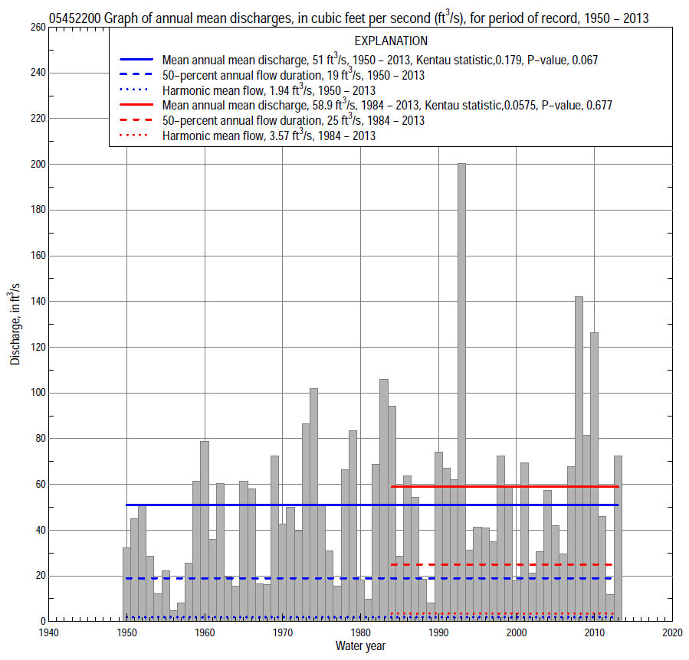

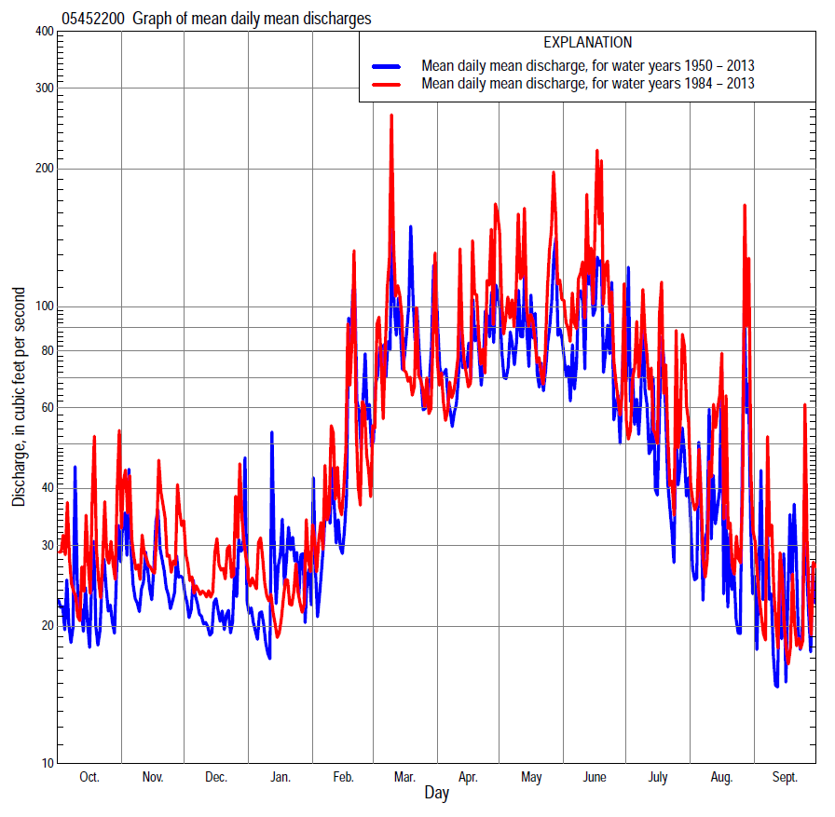

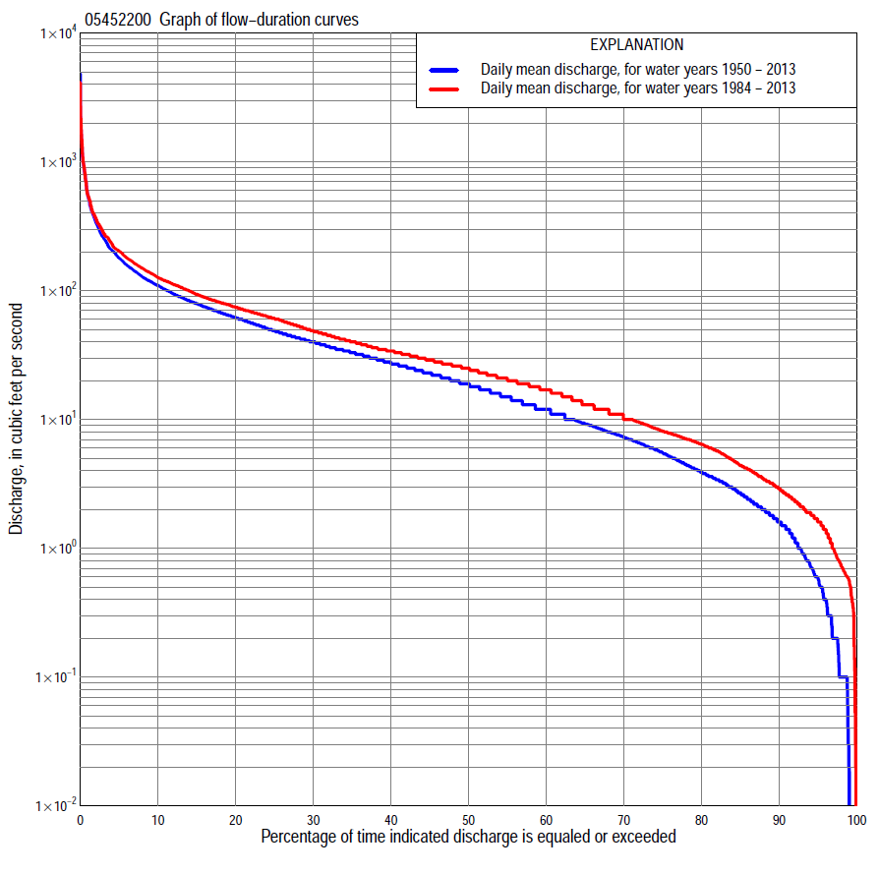

Statistics Based on the Entire Streamflow Period of Record
05452200 Monthly and annual flow durations, based on 1950–2013 period of record (64 years)
Percentage of days discharge equaled or exceeded |  |  |  |  | Discharge (cubic feet per second) |  |  |  |  |  |  |  |  | Annual flow durations
 | Oct | Nov | Dec | Jan | Feb | Mar | Apr | May | June | July | Aug | Sept | Annual | Kentau statistic | P-value
99 | 0.00 | 0.10 | 0.02 | 0.00 | 0.01 | 0.60 | 0.10 | 0.40 | 0.10 | 0.10 | 0.10 | 0.00 | 0.02 | 0.266 | 0.001
98 | 0.00 | 0.20 | 0.10 | 0.00 | 0.20 | 1.4 | 0.50 | 0.69 | 0.29 | 0.20 | 0.20 | 0.00 | 0.10 | 0.269 | 0.001
95 | 0.20 | 0.50 | 0.20 | 0.10 | 0.72 | 2.7 | 1.9 | 2.2 | 2.4 | 0.74 | 0.60 | 0.20 | 0.59 | 0.263 | 0.002
90 | 0.80 | 1.2 | 0.60 | 0.70 | 2.3 | 5.2 | 5.6 | 5.1 | 5.5 | 2.7 | 1.3 | 0.98 | 1.6 | 0.291 | 0.001
85 | 1.2 | 1.8 | 1.3 | 1.8 | 3.8 | 7.7 | 8.7 | 10 | 10 | 4.9 | 2.4 | 1.5 | 2.7 | 0.296 | 0.001
80 | 1.7 | 2.1 | 2.4 | 3.0 | 5.4 | 10 | 12 | 16 | 13 | 7.0 | 3.2 | 1.9 | 3.9 | 0.294 | 0.001
75 | 2.2 | 3.0 | 3.5 | 3.8 | 7.2 | 14 | 16 | 20 | 17 | 9.4 | 4.1 | 2.5 | 5.5 | 0.273 | 0.001
70 | 2.8 | 4.3 | 5.3 | 5.2 | 8.5 | 18 | 22 | 27 | 22 | 12 | 5.1 | 3.2 | 7.3 | 0.264 | 0.002
65 | 3.4 | 6.1 | 6.2 | 6.8 | 11 | 22 | 27 | 32 | 27 | 15 | 6.3 | 3.6 | 9.3 | 0.248 | 0.004
60 | 4.1 | 7.5 | 7.4 | 8.7 | 12 | 27 | 31 | 38 | 32 | 18 | 7.4 | 4.3 | 12 | 0.224 | 0.009
55 | 4.8 | 8.4 | 9.4 | 10 | 16 | 31 | 37 | 45 | 38 | 20 | 8.7 | 5.0 | 15 | 0.226 | 0.008
50 | 6.6 | 11 | 12 | 12 | 19 | 35 | 43 | 53 | 44 | 23 | 9.8 | 6.0 | 19 | 0.216 | 0.012
45 | 8.2 | 14 | 16 | 15 | 23 | 40 | 52 | 62 | 50 | 26 | 11 | 7.1 | 23 | 0.213 | 0.013
40 | 10 | 18 | 19 | 18 | 26 | 46 | 60 | 70 | 59 | 29 | 13 | 9.0 | 27 | 0.222 | 0.010
35 | 13 | 22 | 21 | 21 | 32 | 54 | 66 | 82 | 67 | 33 | 15 | 12 | 33 | 0.211 | 0.014
30 | 17 | 27 | 24 | 25 | 37 | 64 | 75 | 91 | 77 | 38 | 18 | 14 | 40 | 0.214 | 0.013
25 | 21 | 33 | 30 | 30 | 43 | 76 | 88 | 103 | 90 | 44 | 23 | 18 | 49 | 0.221 | 0.010
20 | 26 | 40 | 35 | 34 | 52 | 94 | 106 | 119 | 105 | 53 | 31 | 25 | 62 | 0.221 | 0.010
15 | 37 | 52 | 43 | 41 | 70 | 129 | 132 | 142 | 126 | 70 | 39 | 34 | 79 | 0.211 | 0.014
10 | 60 | 66 | 54 | 51 | 107 | 180 | 172 | 177 | 164 | 106 | 58 | 51 | 110 | 0.190 | 0.026
5 | 99 | 90 | 74 | 72 | 200 | 350 | 262 | 260 | 290 | 211 | 121 | 94 | 180 | 0.160 | 0.063
2 | 153 | 159 | 105 | 130 | 364 | 701 | 403 | 427 | 642 | 422 | 321 | 188 | 344 | 0.072 | 0.401
1 | 240 | 209 | 155 | 200 | 519 | 980 | 597 | 606 | 975 | 705 | 492 | 288 | 541 | 0.016 | 0.857

05452200 Annual exceedance probability of instantaneous peak discharges, in cubic feet per second (ft³/s), based on the Weighted Independent Estimates method,
Annual exceed-ance probability | Recur-rence interval (years) | Discharge (ft³/s) | 95-percent lower confi-dence interval (ft³/s) | 95-percent upper confi-dence interval (ft³/s)
0.500 | 2 | 2,830 | 2,410 | 3,310
0.200 | 5 | 4,560 | 3,930 | 5,290
0.100 | 10 | 5,770 | 4,930 | 6,760
0.040 | 25 | 7,450 | 6,210 | 8,950
0.020 | 50 | 8,690 | 7,050 | 10,700
0.010 | 100 | 9,910 | 7,800 | 12,600
0.005 | 200 | 11,500 | 8,770 | 15,200
0.002 | 500 | 12,800 | 9,330 | 17,700
and based on the expected moments algorithm/multiple Grubbs-Beck analysis computed using a historical period length of 64 years (1950–2013)
0.500 | 2 | 2,860 | 1,740 | 3,280
0.200 | 5 | 4,660 | 3,990 | 5,630
0.100 | 10 | 5,870 | 4,990 | 7,700
0.040 | 25 | 7,360 | 6,020 | 11,500
0.020 | 50 | 8,440 | 6,710 | 15,300
0.010 | 100 | 9,480 | 7,330 | 19,900
0.005 | 200 | 10,500 | 7,890 | 24,800
0.002 | 500 | 11,800 | 8,550 | 31,500
Kentau statistic |  | 0.092
P-value |  | 0.284
Begin year |  | 1950
End year |  | 2013
Number of peaks |  | 64

05452200 Annual exceedance probability of high discharges, based on 1950–2013 period of record (64 years)
Annual exceedance probability | Recur-rence interval (years) | Maximum average discharge (ft³/s) for indicated number of consecutive days
 |  | 1 | 3 | 7 | 15 | 30
0.990 | 1.01 | 124 | 90 | 65 | 44 | 28
0.950 | 1.05 | 250 | 167 | 111 | 76 | 50
0.900 | 1.11 | 354 | 227 | 146 | 99 | 66
0.800 | 1.25 | 528 | 324 | 202 | 136 | 92
0.500 | 2 | 1,050 | 608 | 366 | 239 | 165
0.200 | 5 | 1,930 | 1,070 | 636 | 396 | 277
0.100 | 10 | 2,550 | 1,410 | 838 | 506 | 355
0.040 | 25 | 3,360 | 1,850 | 1,110 | 647 | 454
0.020 | 50 | 3,970 | 2,180 | 1,330 | 752 | 528
0.010 | 100 | 4,560 | 2,510 | 1,550 | 856 | 600
0.005 | 200 | 5,150 | 2,850 | 1,780 | 960 | 671
0.002 | 500 | 5,920 | 3,300 | 2,090 | 1,100 | 765
Kentau statistic |  | 0.000 | -0.011 | 0.015 | 0.042 | 0.113
P-value |  | 1.000 | 0.903 | 0.867 | 0.631 | 0.188

 | 05452200 Annual nonexceedance probability of low discharges, based on April 1950 to March 2013 period of record (63 years)
Annual nonexceed-ance probability | Recur-rence interval (years) | Minimum average discharge (ft³/s) for indicated number of consecutive days
 |  | 1 | 3 | 7 | 14 | 30 | 60 | 90 | 120 | 183
0.01 | 100 | 0.00 | 0.00 | 0.00 | 0.00 | 0.00 | 0.01 | 0.07 | 0.13 | 0.33
0.02 | 50 | 0.00 | 0.00 | 0.00 | 0.00 | 0.00 | 0.04 | 0.14 | 0.23 | 0.54
0.05 | 20 | 0.00 | 0.00 | 0.00 | 0.00 | 0.04 | 0.14 | 0.36 | 0.54 | 1.1
0.10 | 10 | 0.04 | 0.05 | 0.08 | 0.10 | 0.20 | 0.38 | 0.77 | 1.1 | 2.0
0.20 | 5 | 0.34 | 0.38 | 0.44 | 0.48 | 0.71 | 1.1 | 1.8 | 2.4 | 4.0
0.50 | 2 | 2.1 | 2.3 | 2.5 | 3.0 | 3.7 | 5.5 | 6.8 | 8.6 | 13
0.80 | 1.25 | 6.4 | 6.8 | 7.7 | 8.9 | 11 | 16 | 20 | 24 | 33
0.90 | 1.11 | 10 | 10 | 12 | 13 | 16 | 23 | 31 | 38 | 52
0.96 | 1.04 | 14 | 14 | 16 | 17 | 23 | 30 | 46 | 58 | 78
0.98 | 1.02 | 16 | 17 | 19 | 20 | 27 | 34 | 58 | 73 | 100
0.99 | 1.01 | 18 | 19 | 22 | 22 | 30 | 37 | 70 | 89 | 123
Kentau statistic |  | 0.298 | 0.307 | 0.312 | 0.310 | 0.295 | 0.252 | 0.206 | 0.194 | 0.165
P-value |  | 0.001 | 0.000 | 0.000 | 0.000 | 0.001 | 0.004 | 0.017 | 0.025 | 0.056

05452200 Annual nonexceedance probability of seasonal low discharges, based on October 1949 to September 2013 period of record (64 years)
Annual nonexceed-ance probability | Recur-rence interval (years) | Minimum average discharge (cubic feet per second) for indicated number of consecutive days
 |  | 1 | 7 | 14 | 30 |  | 1 | 7 | 14 | 30
 |  | January-February-March |  |  |  |  | April-May-June
0.01 | 100 | 0.00 | 0.00 | 0.00 | 0.00 |  | 0.00 | 0.00 | 0.03 | 0.25
0.02 | 50 | 0.00 | 0.00 | 0.00 | 0.01 |  | 0.00 | 0.00 | 0.11 | 0.53
0.05 | 20 | 0.02 | 0.10 | 0.11 | 0.26 |  | 0.35 | 0.51 | 0.53 | 1.5
0.10 | 10 | 0.32 | 0.44 | 0.53 | 1.0 |  | 1.4 | 1.9 | 2.2 | 3.4
0.20 | 5 | 1.1 | 1.4 | 1.7 | 3.3 |  | 3.8 | 5.0 | 5.8 | 8.2
0.50 | 2 | 5.2 | 6.4 | 7.7 | 14 |  | 14 | 18 | 25 | 30
0.80 | 1.25 | 15 | 19 | 21 | 28 |  | 34 | 39 | 50 | 73
0.90 | 1.11 | 24 | 29 | 31 | 32 |  | 46 | 53 | 57 | 101
0.96 | 1.04 | 34 | 41 | 42 | 43 |  | 59 | 66 | 70 | 129
0.98 | 1.02 | 42 | 49 | 49 | 50 |  | 66 | 74 | 80 | 145
0.99 | 1.01 | 48 | 57 | 58 | 59 |  | 72 | 79 | 90 | 157
Kentau statistic |  | 0.204 | 0.234 | 0.239 | 0.171 |  | 0.239 | 0.215 | 0.211 | 0.237
P-value |  | 0.017 | 0.006 | 0.005 | 0.047 |  | 0.005 | 0.012 | 0.014 | 0.006
 |  | July-August-September |  |  |  |  | October-November-December
0.01 | 100 | 0.00 | 0.00 | 0.00 | 0.13 |  | 0.00 | 0.00 | 0.00 | 0.01
0.02 | 50 | 0.00 | 0.00 | 0.00 | 0.22 |  | 0.00 | 0.00 | 0.01 | 0.04
0.05 | 20 | 0.01 | 0.04 | 0.07 | 0.45 |  | 0.03 | 0.06 | 0.11 | 0.16
0.10 | 10 | 0.16 | 0.21 | 0.30 | 0.82 |  | 0.14 | 0.21 | 0.33 | 0.46
0.20 | 5 | 0.60 | 0.70 | 0.89 | 1.6 |  | 0.53 | 0.66 | 0.95 | 1.4
0.50 | 2 | 3.1 | 3.6 | 4.1 | 5.6 |  | 3.1 | 3.7 | 4.6 | 7.2
0.80 | 1.25 | 9.7 | 11 | 13 | 17 |  | 11 | 13 | 15 | 20
0.90 | 1.11 | 15 | 18 | 21 | 28 |  | 18 | 21 | 24 | 29
0.96 | 1.04 | 22 | 26 | 31 | 47 |  | 27 | 32 | 38 | 39
0.98 | 1.02 | 27 | 32 | 39 | 64 |  | 34 | 40 | 48 | 49
0.99 | 1.01 | 31 | 37 | 47 | 83 |  | 40 | 47 | 58 | 59
Kentau statistic |  | 0.238 | 0.222 | 0.237 | 0.214 |  | 0.202 | 0.215 | 0.218 | 0.192
P-value |  | 0.006 | 0.010 | 0.006 | 0.013 |  | 0.018 | 0.012 | 0.011 | 0.025

Statistics Based on the 1984–2013 Streamflow Period of Record
05452200 Monthly and annual flow durations, based on 1984–2013 period of record (30 years)
Percentage of days discharge equaled or exceeded |  |  |  |  | Discharge (cubic feet per second) |  |  |  |  |  |  |  |  | Annual flow durations
 | Oct | Nov | Dec | Jan | Feb | Mar | Apr | May | June | July | Aug | Sept | Annual | Kentau statistic | P-value
99 | 0.13 | 0.82 | 0.36 | 1.1 | 2.2 | 1.7 | 1.6 | 1.2 | 0.71 | 0.51 | 0.39 | 0.02 | 0.56 | 0.274 | 0.031
98 | 0.38 | 0.93 | 0.56 | 1.7 | 2.4 | 2.4 | 1.9 | 1.9 | 0.98 | 0.57 | 0.50 | 0.07 | 0.73 | 0.223 | 0.078
95 | 0.73 | 1.3 | 0.90 | 2.5 | 2.9 | 4.1 | 3.6 | 5.6 | 3.3 | 1.2 | 0.76 | 0.73 | 1.6 | 0.152 | 0.242
90 | 1.7 | 2.0 | 2.2 | 3.8 | 5.5 | 8.7 | 8.1 | 12 | 11 | 4.3 | 2.1 | 1.4 | 2.9 | 0.133 | 0.307
85 | 2.1 | 3.8 | 4.6 | 6.0 | 6.9 | 13 | 11 | 17 | 16 | 8.4 | 3.6 | 1.9 | 4.4 | 0.106 | 0.421
80 | 2.5 | 5.0 | 6.0 | 7.2 | 7.8 | 18 | 17 | 26 | 22 | 13 | 5.1 | 2.5 | 6.4 | 0.062 | 0.642
75 | 3.0 | 6.6 | 7.0 | 8.4 | 9.7 | 22 | 20 | 33 | 28 | 16 | 6.2 | 3.2 | 8.1 | 0.051 | 0.707
70 | 3.3 | 7.6 | 8.5 | 9.6 | 11 | 27 | 27 | 42 | 34 | 19 | 7.1 | 3.5 | 10 | 0.018 | 0.900
65 | 4.1 | 8.2 | 11 | 11 | 13 | 30 | 31 | 50 | 40 | 21 | 8.1 | 3.9 | 13 | 0.007 | 0.971
60 | 4.7 | 9.6 | 13 | 12 | 16 | 33 | 35 | 61 | 47 | 24 | 9.4 | 4.5 | 17 | -0.002 | 1.000
55 | 5.6 | 13 | 16 | 14 | 20 | 36 | 41 | 69 | 54 | 26 | 11 | 5.3 | 21 | 0.011 | 0.943
50 | 7.7 | 17 | 18 | 17 | 24 | 40 | 50 | 76 | 64 | 28 | 12 | 6.1 | 25 | 0.011 | 0.943
45 | 9.6 | 21 | 20 | 19 | 28 | 45 | 58 | 84 | 73 | 31 | 13 | 7.1 | 29 | 0.030 | 0.830
40 | 13 | 22 | 22 | 21 | 33 | 51 | 65 | 92 | 81 | 34 | 15 | 9.5 | 34 | 0.046 | 0.735
35 | 18 | 26 | 24 | 26 | 37 | 59 | 74 | 102 | 90 | 38 | 18 | 14 | 40 | 0.057 | 0.668
30 | 22 | 29 | 28 | 29 | 43 | 68 | 86 | 113 | 102 | 44 | 24 | 21 | 49 | 0.078 | 0.556
25 | 26 | 36 | 32 | 33 | 49 | 79 | 100 | 128 | 113 | 54 | 33 | 26 | 61 | 0.078 | 0.556
20 | 30 | 43 | 41 | 39 | 60 | 99 | 119 | 147 | 131 | 69 | 41 | 34 | 74 | 0.083 | 0.532
15 | 54 | 57 | 51 | 43 | 73 | 131 | 146 | 172 | 159 | 92 | 55 | 43 | 94 | 0.083 | 0.532
10 | 80 | 71 | 63 | 50 | 103 | 188 | 186 | 207 | 212 | 136 | 85 | 61 | 126 | 0.057 | 0.668
5 | 125 | 107 | 85 | 66 | 176 | 327 | 273 | 296 | 345 | 261 | 171 | 101 | 203 | 0.053 | 0.695
2 | 214 | 169 | 115 | 93 | 275 | 544 | 409 | 502 | 719 | 501 | 378 | 158 | 366 | 0.080 | 0.544
1 | 305 | 250 | 163 | 129 | 400 | 824 | 597 | 723 | 975 | 862 | 836 | 255 | 549 | 0.039 | 0.775

05452200 Annual exceedance probability of high discharges, based on 1984–2013 period of record (30 years)
Annual exceedance probability | Recur-rence interval (years) | Maximum average discharge (ft³/s) for indicated number of consecutive days
 |  | 1 | 3 | 7 | 15 | 30
0.990 | 1.01 | 85 | 75 | 62 | 44 | 31
0.950 | 1.05 | 186 | 140 | 105 | 76 | 55
0.900 | 1.11 | 275 | 192 | 138 | 100 | 73
0.800 | 1.25 | 433 | 280 | 192 | 138 | 102
0.500 | 2 | 970 | 557 | 355 | 244 | 180
0.200 | 5 | 2,010 | 1,070 | 644 | 409 | 297
0.100 | 10 | 2,850 | 1,470 | 872 | 526 | 376
0.040 | 25 | 4,050 | 2,060 | 1,200 | 677 | 474
0.020 | 50 | 5,020 | 2,540 | 1,470 | 791 | 545
0.010 | 100 | 6,040 | 3,060 | 1,750 | 906 | 615
0.005 | 200 | 7,110 | 3,610 | 2,060 | 1,020 | 682
0.002 | 500 | 8,590 | 4,390 | 2,510 | 1,170 | 768
Kentau statistic |  | -0.057 | -0.034 | -0.030 | -0.062 | -0.044
P-value |  | 0.669 | 0.803 | 0.830 | 0.643 | 0.748

 | 05452200 Annual nonexceedance probability of low discharges, based on April 1983 to March 2013 period of record (30 years)
Annual nonexceed-ance probability | Recur-rence interval (years) | Minimum average discharge (ft³/s) for indicated number of consecutive days
 |  | 1 | 3 | 7 | 14 | 30 | 60 | 90 | 120 | 183
0.01 | 100 | 0.02 | 0.02 | 0.02 | 0.02 | 0.06 | 0.36 | 0.50 | 0.78 | 1.0
0.02 | 50 | 0.04 | 0.04 | 0.04 | 0.05 | 0.12 | 0.52 | 0.73 | 1.1 | 1.4
0.05 | 20 | 0.13 | 0.14 | 0.16 | 0.18 | 0.32 | 0.90 | 1.2 | 1.8 | 2.3
0.10 | 10 | 0.35 | 0.38 | 0.43 | 0.48 | 0.72 | 1.4 | 2.0 | 2.7 | 3.7
0.20 | 5 | 0.95 | 1.1 | 1.2 | 1.3 | 1.7 | 2.5 | 3.4 | 4.5 | 6.2
0.50 | 2 | 3.8 | 4.2 | 4.7 | 5.3 | 6.0 | 6.9 | 9.0 | 11 | 16
0.80 | 1.25 | 8.3 | 9.0 | 10 | 12 | 15 | 18 | 23 | 28 | 38
0.90 | 1.11 | 11 | 11 | 13 | 15 | 20 | 28 | 36 | 43 | 58
0.96 | 1.04 | 12 | 13 | 15 | 18 | 26 | 46 | 57 | 68 | 88
0.98 | 1.02 | 13 | 14 | 16 | 19 | 29 | 62 | 76 | 92 | 115
0.99 | 1.01 | 14 | 14 | 16 | 19 | 32 | 81 | 99 | 119 | 144
Kentau statistic |  | 0.143 | 0.177 | 0.179 | 0.170 | 0.131 | 0.108 | 0.053 | 0.044 | -0.053
P-value |  | 0.276 | 0.175 | 0.169 | 0.193 | 0.318 | 0.412 | 0.695 | 0.748 | 0.695

05452200 Annual nonexceedance probability of seasonal low discharges, based on October 1983 to September 2013 period of record (30 years)
Annual nonexceed-ance probability | Recur-rence interval (years) | Minimum average discharge (cubic feet per second) for indicated number of consecutive days
 |  | 1 | 7 | 14 | 30 |  | 1 | 7 | 14 | 30
 |  | January-February-March |  |  |  |  | April-May-June
0.01 | 100 | 0.23 | 0.64 | 0.84 | 1.8 |  | 0.43 | 0.51 | 0.69 | 1.1
0.02 | 50 | 0.39 | 0.93 | 1.2 | 2.3 |  | 0.77 | 0.92 | 1.2 | 1.8
0.05 | 20 | 0.81 | 1.6 | 2.0 | 3.4 |  | 1.7 | 2.1 | 2.6 | 3.8
0.10 | 10 | 1.5 | 2.5 | 3.0 | 4.7 |  | 3.3 | 3.9 | 4.8 | 6.9
0.20 | 5 | 2.8 | 4.1 | 4.9 | 6.9 |  | 6.5 | 7.7 | 9.4 | 13
0.50 | 2 | 8.0 | 9.9 | 11 | 14 |  | 19 | 22 | 27 | 39
0.80 | 1.25 | 18 | 21 | 23 | 28 |  | 42 | 48 | 58 | 89
0.90 | 1.11 | 24 | 29 | 32 | 39 |  | 57 | 64 | 78 | 126
0.96 | 1.04 | 32 | 40 | 45 | 55 |  | 74 | 82 | 100 | 172
0.98 | 1.02 | 38 | 48 | 55 | 68 |  | 84 | 93 | 114 | 204
0.99 | 1.01 | 42 | 57 | 64 | 83 |  | 93 | 101 | 125 | 233
Kentau statistic |  | -0.147 | -0.090 | -0.071 | -0.062 |  | 0.122 | 0.108 | 0.172 | 0.223
P-value |  | 0.260 | 0.498 | 0.592 | 0.643 |  | 0.353 | 0.412 | 0.187 | 0.087
 |  | July-August-September |  |  |  |  | October-November-December
0.01 | 100 | 0.02 | 0.02 | 0.03 | 0.28 |  | 0.02 | 0.05 | 0.17 | 0.27
0.02 | 50 | 0.04 | 0.05 | 0.07 | 0.40 |  | 0.04 | 0.10 | 0.27 | 0.42
0.05 | 20 | 0.14 | 0.16 | 0.21 | 0.69 |  | 0.14 | 0.26 | 0.54 | 0.80
0.10 | 10 | 0.35 | 0.40 | 0.51 | 1.1 |  | 0.36 | 0.56 | 1.0 | 1.4
0.20 | 5 | 1.0 | 1.1 | 1.4 | 2.1 |  | 1.0 | 1.3 | 1.9 | 2.6
0.50 | 2 | 4.6 | 5.3 | 6.3 | 6.7 |  | 4.6 | 5.1 | 6.0 | 8.0
0.80 | 1.25 | 14 | 16 | 19 | 22 |  | 13 | 15 | 17 | 22
0.90 | 1.11 | 21 | 24 | 30 | 42 |  | 18 | 23 | 28 | 35
0.96 | 1.04 | 29 | 34 | 43 | 82 |  | 24 | 35 | 46 | 55
0.98 | 1.02 | 34 | 40 | 51 | 128 |  | 28 | 44 | 62 | 74
0.99 | 1.01 | 39 | 45 | 59 | 192 |  | 30 | 52 | 80 | 95
Kentau statistic |  | 0.120 | 0.117 | 0.117 | 0.094 |  | 0.166 | 0.168 | 0.099 | 0.039
P-value |  | 0.363 | 0.372 | 0.372 | 0.475 |  | 0.205 | 0.199 | 0.454 | 0.775

