LOCATION.--Lat 41°51'32.6", long 92°16'40.5" referenced to North American Datum of 1983, in SW 1/4 NW 1/4 NW 1/4 sec.05, T.81 N., R.12 W., Iowa County, IA, Hydrologic Unit 07080208, on right bank 5 ft downstream from bridge on State Highway 21, 1.7 mi south of Belle Plaine, 1.2 mi downstream from Salt Creek, and 0.9 mi downstream from Walnut Creek.

DRAINAGE AREA.--2,455 mi².

PERIOD OF RECORD.--Discharge records from September 1939 to September 1959.

GAGE.--Water-stage recorder. Datum of gage is 749.82 ft above National Geodetic Vertical Datum of 1929. Prior to March 13, 1940, non-recording gage at same site and datum.

A summary of all available data for this streamgage is provided through the USGS National Water Information System web interface (NWISWeb). The following link provides access to current/historical observations, daily data, daily statistics, monthly statistics, annual statistics, peak streamflow, field measurements, field/lab water-quality samples, and the latest water-year summaries. Data can be filtered by parameter and/or dates, and can be output in various tabular and graphical formats.
http://waterdata.usgs.gov/nwis/inventory/?site_no=05452500

The USGS WaterWatch Toolkit is available at:
http://waterwatch.usgs.gov/?id=ww_toolkit
Tools for summarizing streamflow information include the duration hydrograph builder, the cumulative streamflow hydrograph builder, the streamgage statistics retrieval tool, the rating curve builder, the flood tracking chart builder, the National Weather Service Advanced Hydrologic Prediction Service (AHPS) river forecast hydrograph builder, and the raster-hydrograph builder. Entering the above number for this streamgage into these toolkit webpages will provide streamflow information specific to this streamgage.

A description of the statistics presented for this streamgage is available in the main body of the report at:
http://dx.doi.org/10.3133/ofr20151214
A link to other streamgages included in this report, a map showing the location of the streamgages, information on the programs used to compute the statistical analyses, and references are included in the main body of the report.

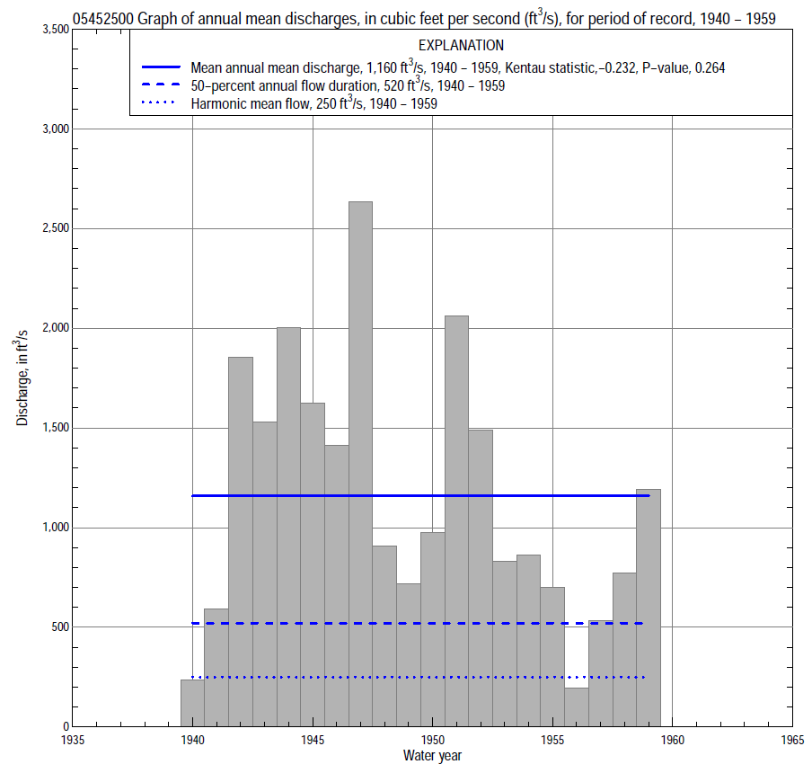

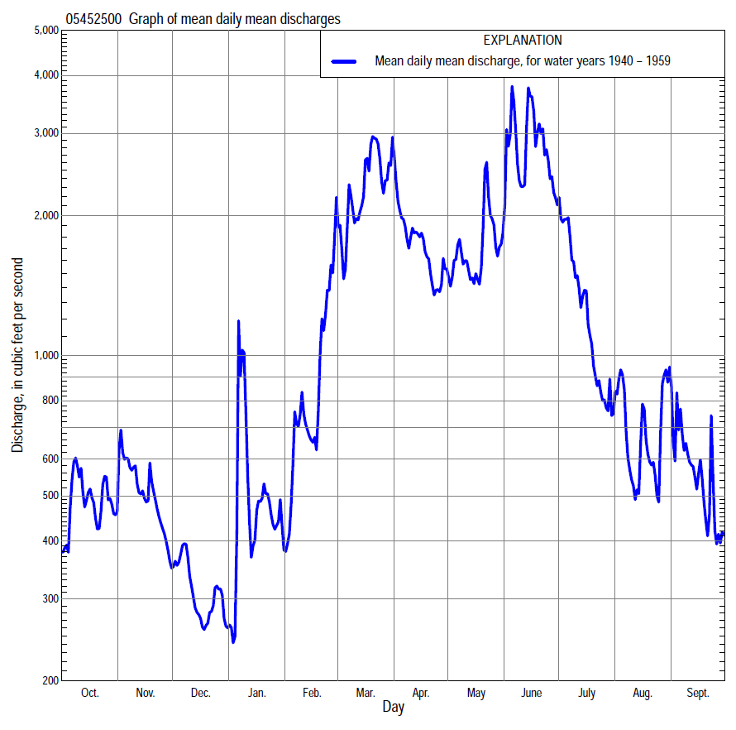

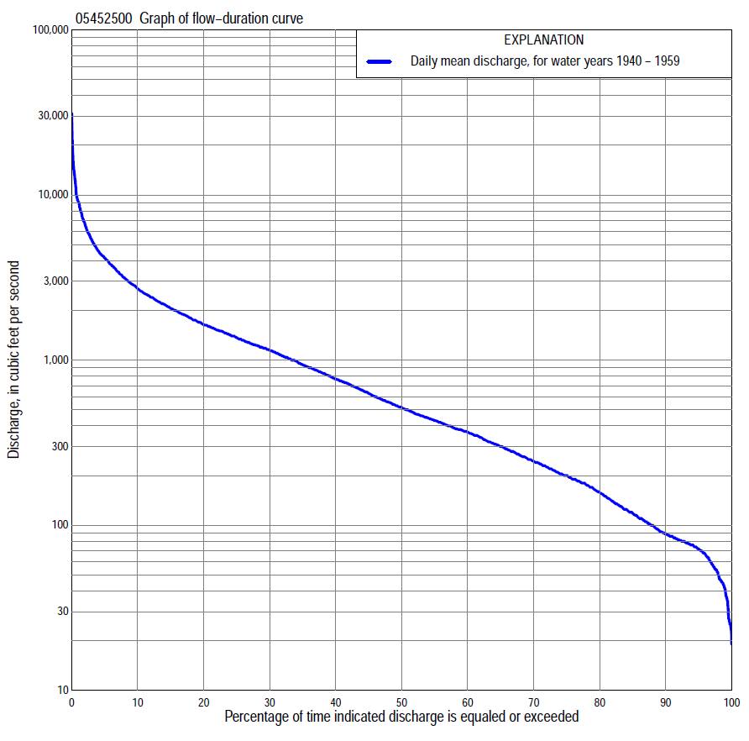

Statistics Based on the Entire Streamflow Period of Record
05452500 Monthly and annual flow durations, based on 1940–59 period of record (20 years)
Percentage of days discharge equaled or exceeded |  |  |  |  | Discharge (cubic feet per second) |  |  |  |  |  |  |  |  | Annual flow durations
 | Oct | Nov | Dec | Jan | Feb | Mar | Apr | May | June | July | Aug | Sept | Annual | Kentau statistic | P-value
99 | 58 | 60 | 45 | 24 | 27 | 100 | 146 | 184 | 81 | 56 | 76 | 60 | 41 | -0.337 | 0.041
98 | 62 | 74 | 47 | 25 | 31 | 135 | 174 | 195 | 104 | 59 | 83 | 67 | 50 | -0.342 | 0.038
95 | 68 | 78 | 60 | 37 | 37 | 186 | 204 | 238 | 154 | 94 | 96 | 78 | 72 | -0.274 | 0.098
90 | 74 | 84 | 76 | 47 | 49 | 267 | 295 | 295 | 239 | 187 | 116 | 90 | 89 | -0.274 | 0.098
85 | 81 | 88 | 80 | 55 | 100 | 350 | 428 | 353 | 371 | 257 | 139 | 102 | 120 | -0.211 | 0.206
80 | 89 | 95 | 85 | 70 | 115 | 473 | 554 | 413 | 469 | 338 | 163 | 112 | 159 | -0.263 | 0.112
75 | 102 | 110 | 91 | 80 | 150 | 630 | 690 | 473 | 660 | 417 | 198 | 140 | 200 | -0.268 | 0.105
70 | 120 | 133 | 112 | 125 | 195 | 810 | 766 | 588 | 855 | 486 | 246 | 175 | 245 | -0.258 | 0.119
65 | 135 | 157 | 145 | 160 | 230 | 950 | 885 | 762 | 1,020 | 572 | 282 | 205 | 301 | -0.232 | 0.163
60 | 154 | 185 | 170 | 190 | 260 | 1,180 | 1,010 | 1,020 | 1,190 | 665 | 323 | 228 | 368 | -0.221 | 0.183
55 | 182 | 233 | 195 | 200 | 290 | 1,340 | 1,110 | 1,160 | 1,440 | 745 | 362 | 259 | 432 | -0.205 | 0.217
50 | 253 | 280 | 220 | 240 | 350 | 1,580 | 1,220 | 1,260 | 1,690 | 868 | 415 | 317 | 520 | -0.232 | 0.163
45 | 319 | 347 | 250 | 280 | 450 | 1,800 | 1,290 | 1,370 | 1,920 | 1,040 | 461 | 405 | 633 | -0.274 | 0.098
40 | 371 | 372 | 300 | 310 | 720 | 2,010 | 1,460 | 1,510 | 2,180 | 1,190 | 537 | 495 | 770 | -0.253 | 0.127
35 | 404 | 410 | 350 | 360 | 1,000 | 2,300 | 1,610 | 1,660 | 2,420 | 1,300 | 625 | 555 | 940 | -0.247 | 0.135
30 | 448 | 508 | 400 | 420 | 1,150 | 2,680 | 1,750 | 1,860 | 2,830 | 1,440 | 712 | 628 | 1,150 | -0.232 | 0.163
25 | 562 | 640 | 442 | 500 | 1,370 | 3,010 | 2,180 | 2,040 | 3,440 | 1,630 | 810 | 719 | 1,370 | -0.200 | 0.230
20 | 732 | 770 | 480 | 560 | 1,500 | 3,440 | 2,730 | 2,280 | 4,000 | 1,880 | 945 | 853 | 1,640 | -0.168 | 0.315
15 | 1,020 | 922 | 550 | 670 | 1,760 | 3,990 | 3,070 | 2,620 | 4,760 | 2,180 | 1,090 | 1,060 | 2,060 | -0.184 | 0.270
10 | 1,340 | 1,120 | 696 | 930 | 2,280 | 4,900 | 3,620 | 3,510 | 6,470 | 2,480 | 1,460 | 1,280 | 2,710 | -0.179 | 0.284
5 | 1,790 | 1,540 | 870 | 1,600 | 3,100 | 7,800 | 5,490 | 4,400 | 9,530 | 3,970 | 2,350 | 1,750 | 4,160 | -0.100 | 0.559
2 | 2,480 | 2,580 | 1,070 | 2,500 | 4,580 | 9,850 | 6,910 | 6,200 | 15,000 | 6,420 | 3,860 | 2,610 | 6,660 | -0.053 | 0.770
1 | 2,860 | 4,080 | 1,230 | 3,500 | 5,200 | 11,600 | 8,010 | 11,800 | 20,800 | 7,160 | 4,340 | 3,380 | 9,150 | -0.032 | 0.871

05452500 Annual exceedance probability of instantaneous peak discharges, in cubic feet per second (ft³/s), based on the Weighted Independent Estimates method,
Annual exceed-ance probability | Recur-rence interval (years) | Discharge (ft³/s) | 95-percent lower confi-dence interval (ft³/s) | 95-percent upper confi-dence interval (ft³/s)
0.500 | 2 | 11,700 | 10,400 | 13,200
0.200 | 5 | 19,700 | 17,600 | 22,200
0.100 | 10 | 25,200 | 22,200 | 28,600
0.040 | 25 | 32,500 | 27,900 | 37,900
0.020 | 50 | 37,800 | 31,700 | 45,100
0.010 | 100 | 43,000 | 35,000 | 52,900
0.005 | 200 | 49,600 | 39,100 | 63,000
0.002 | 500 | 55,500 | 42,000 | 73,500
and based on the expected moments algorithm/multiple Grubbs-Beck analysis computed using a historical period length of 132 years (1882–2013)ª
0.500 | 2 | 11,700 | 10,000 | 13,600
0.200 | 5 | 19,700 | 16,900 | 23,000
0.100 | 10 | 25,400 | 21,700 | 30,100
0.040 | 25 | 33,000 | 27,600 | 40,600
0.020 | 50 | 38,900 | 31,800 | 49,800
0.010 | 100 | 44,800 | 35,700 | 60,100
0.005 | 200 | 50,800 | 39,200 | 71,700
0.002 | 500 | 58,900 | 43,600 | 89,200
Kentau statistic |  | -0.032
P-value |  | 0.871
Begin year |  | 1940
End year |  | 1959
Number of peaks |  | 20
ªAnalysis includes interval annual-peak discharges (1960–68, 1970–2013) from streamgage 05453100 Iowa River at Marengo.

05452500 Annual exceedance probability of high discharges, based on 1940–59 period of record (20 years)
[ND, not determined]
Annual exceed-ance probability | Recur-rence interval (years) | Maximum average discharge (ft³/s) for indicated number of consecutive days
 |  | 1 | 3 | 7 | 15 | 30
0.990 | 1.01 | ND | 872 | 566 | 412 | 328
0.950 | 1.05 | ND | 1,810 | 1,310 | 940 | 741
0.900 | 1.11 | ND | 2,600 | 1,960 | 1,400 | 1,100
0.800 | 1.25 | ND | 3,920 | 3,070 | 2,190 | 1,710
0.500 | 2 | ND | 7,950 | 6,390 | 4,610 | 3,570
0.200 | 5 | ND | 14,600 | 11,500 | 8,490 | 6,550
0.100 | 10 | ND | 19,400 | 14,800 | 11,100 | 8,560
0.040 | 25 | ND | 25,500 | 18,700 | 14,300 | 11,000
0.020 | 50 | ND | 29,900 | 21,300 | 16,500 | 12,700
0.010 | 100 | ND | 34,300 | 23,600 | 18,600 | 14,300
0.005 | 200 | ND | 38,600 | 25,700 | 20,500 | 15,800
0.002 | 500 | ND | 44,200 | 28,300 | 22,900 | 17,600
Kentau statistic |  | -0.021 | -0.011 | -0.053 | 0.000 | 0.011
P-value |  | 0.922 | 0.974 | 0.770 | 1.000 | 0.974

 | 05452500 Annual nonexceedance probability of low discharges, based on April 1940 to March 1959 period of record (19 years)
Annual nonexceed-ance probability | Recur-rence interval (years) | Minimum average discharge (cubic feet per second) for indicated number of consecutive days
 |  | 1 | 3 | 7 | 14 | 30 | 60 | 90 | 120 | 183
0.01 | 100 | 23 | 23 | 24 | 25 | 28 | 29 | 29 | 31 | 41
0.02 | 50 | 28 | 28 | 28 | 29 | 33 | 35 | 37 | 40 | 53
0.05 | 20 | 35 | 36 | 36 | 38 | 43 | 48 | 53 | 58 | 77
0.10 | 10 | 45 | 45 | 45 | 48 | 55 | 64 | 73 | 80 | 107
0.20 | 5 | 59 | 60 | 61 | 65 | 74 | 90 | 105 | 119 | 158
0.50 | 2 | 103 | 104 | 109 | 117 | 135 | 171 | 212 | 245 | 324
0.80 | 1.25 | 184 | 188 | 201 | 219 | 252 | 324 | 414 | 489 | 646
0.90 | 1.11 | 251 | 258 | 281 | 308 | 354 | 452 | 581 | 693 | 916
0.96 | 1.04 | 352 | 365 | 404 | 447 | 512 | 645 | 829 | 995 | 1320
0.98 | 1.02 | 440 | 458 | 514 | 572 | 655 | 811 | 1040 | 1250 | 1660
0.99 | 1.01 | 539 | 564 | 641 | 718 | 818 | 995 | 1270 | 1530 | 2040
Kentau statistic |  | -0.240 | -0.246 | -0.211 | -0.205 | -0.216 | -0.298 | -0.322 | -0.322 | -0.251
P-value |  | 0.161 | 0.151 | 0.220 | 0.234 | 0.208 | 0.080 | 0.059 | 0.059 | 0.142

05452500 Annual nonexceedance probability of seasonal low discharges, based on October 1939 to September 1959 period of record (20 years)
Annual nonexceed-ance probability | Recur-rence interval (years) | Minimum average discharge (cubic feet per second) for indicated number of consecutive days
 |  | 1 | 7 | 14 | 30 |  | 1 | 7 | 14 | 30
 |  | January-February-March |  |  |  |  | April-May-June
0.01 | 100 | 12 | 13 | 14 | 16 |  | 40 | 46 | 53 | 68
0.02 | 50 | 17 | 18 | 19 | 21 |  | 54 | 63 | 71 | 92
0.05 | 20 | 27 | 28 | 29 | 34 |  | 85 | 99 | 111 | 143
0.10 | 10 | 39 | 40 | 43 | 51 |  | 125 | 145 | 163 | 210
0.20 | 5 | 61 | 63 | 67 | 84 |  | 197 | 226 | 256 | 330
0.50 | 2 | 132 | 144 | 153 | 216 |  | 448 | 509 | 579 | 758
0.80 | 1.25 | 259 | 314 | 343 | 558 |  | 961 | 1,070 | 1,250 | 1,670
0.90 | 1.11 | 354 | 465 | 516 | 915 |  | 1,400 | 1,550 | 1,820 | 2,480
0.96 | 1.04 | 482 | 697 | 790 | 1,550 |  | 2,050 | 2,250 | 2,680 | 3,730
0.98 | 1.02 | 581 | 900 | 1,040 | 2,170 |  | 2,610 | 2,830 | 3,420 | 4,830
0.99 | 1.01 | 680 | 1,130 | 1,320 | 2,950 |  | 3,210 | 3,470 | 4,240 | 6,060
Kentau statistic |  | -0.305 | -0.311 | -0.289 | -0.305 |  | -0.221 | -0.211 | -0.200 | -0.168
P-value |  | 0.064 | 0.060 | 0.080 | 0.064 |  | 0.183 | 0.206 | 0.230 | 0.315
 |  | July-August-September |  |  |  |  | October-November-December
0.01 | 100 | 22 | 25 | 29 | 37 |  | 28 | 30 | 31 | 31
0.02 | 50 | 28 | 31 | 36 | 45 |  | 33 | 35 | 36 | 37
0.05 | 20 | 40 | 43 | 50 | 61 |  | 42 | 44 | 46 | 49
0.10 | 10 | 55 | 59 | 67 | 82 |  | 54 | 56 | 59 | 64
0.20 | 5 | 81 | 86 | 97 | 118 |  | 72 | 75 | 80 | 90
0.50 | 2 | 170 | 182 | 203 | 251 |  | 130 | 142 | 152 | 180
0.80 | 1.25 | 361 | 396 | 442 | 578 |  | 244 | 290 | 315 | 389
0.90 | 1.11 | 538 | 601 | 674 | 923 |  | 346 | 438 | 477 | 599
0.96 | 1.04 | 825 | 945 | 1,070 | 1,560 |  | 507 | 696 | 764 | 970
0.98 | 1.02 | 1,090 | 1,270 | 1,460 | 2,210 |  | 654 | 954 | 1,050 | 1,340
0.99 | 1.01 | 1,400 | 1,670 | 1,930 | 3,060 |  | 826 | 1,280 | 1,420 | 1,810
Kentau statistic |  | -0.163 | -0.147 | -0.084 | -0.063 |  | -0.226 | -0.242 | -0.253 | -0.232
P-value |  | 0.330 | 0.381 | 0.627 | 0.721 |  | 0.173 | 0.144 | 0.127 | 0.163

