LOCATION.--Lat 41°42'55.0", long 91°31'48.0" referenced to North American Datum of 1927, in SW 1/4 SW 1/4 SE 1/4 sec.22, T.80 N., R.6 W., Johnson County, IA, Hydrologic Unit 07080208, on left bank 1,200 ft downstream from Coralville Dam control house, 4.3 mi northeast of Coralville Post Office, 2.3 mi upstream from Rapid Creek, and 80.6 mi upstream from mouth.

DRAINAGE AREA.--3,115 mi².

PERIOD OF RECORD.--Discharge records from October 1992 to current year.

GAGE.--Water-stage recorder. Datum of gage is 600.00 ft above National Geodetic Vertical Datum of 1929 (levels by U.S. Army Corps of Engineers).

REMARKS.--Flow regulated by Coralville Lake (station 05453510), 1,200 ft upstream, since September 17, 1958.

A summary of all available data for this streamgage is provided through the USGS National Water Information System web interface (NWISWeb). The following link provides access to current/historical observations, daily data, daily statistics, monthly statistics, annual statistics, peak streamflow, field measurements, field/lab water-quality samples, and the latest water-year summaries. Data can be filtered by parameter and/or dates, and can be output in various tabular and graphical formats.
http://waterdata.usgs.gov/nwis/inventory/?site_no=05453520

The USGS WaterWatch Toolkit is available at:
http://waterwatch.usgs.gov/?id=ww_toolkit
Tools for summarizing streamflow information include the duration hydrograph builder, the cumulative streamflow hydrograph builder, the streamgage statistics retrieval tool, the rating curve builder, the flood tracking chart builder, the National Weather Service Advanced Hydrologic Prediction Service (AHPS) river forecast hydrograph builder, and the raster-hydrograph builder. Entering the above number for this streamgage into these toolkit webpages will provide streamflow information specific to this streamgage.

A description of the statistics presented for this streamgage is available in the main body of the report at:
http://dx.doi.org/10.3133/ofr20151214
A link to other streamgages included in this report, a map showing the location of the streamgages, information on the programs used to compute the statistical analyses, and references are included in the main body of the report.

Statistics Based on the Regulated Streamflow Period of Record
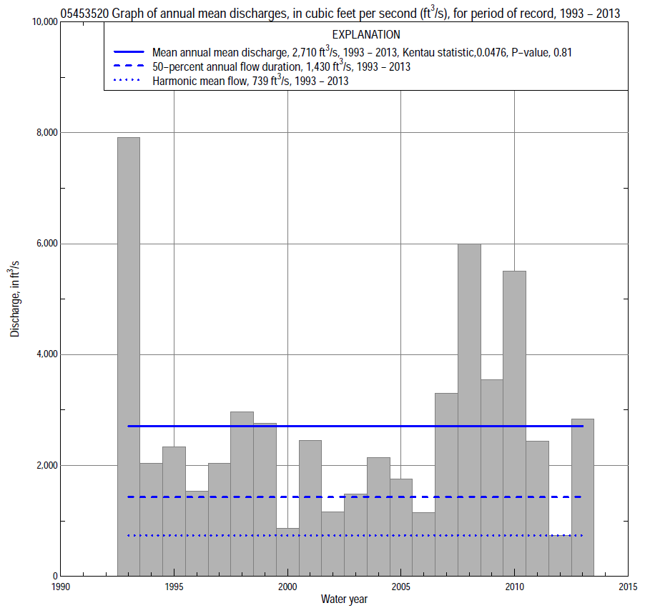

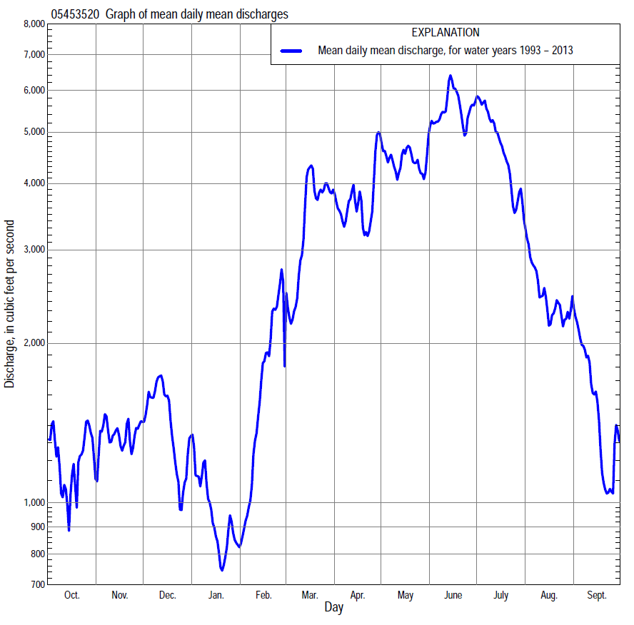

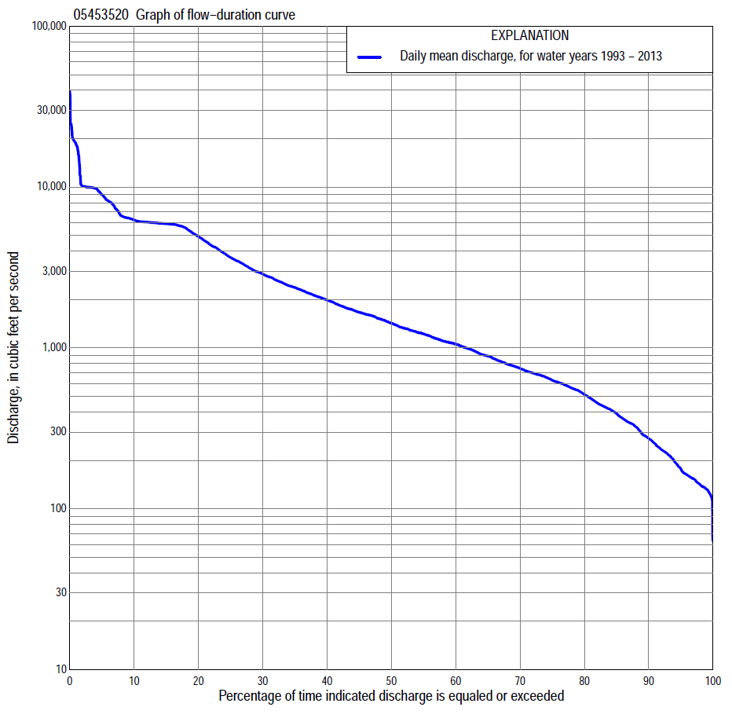

Statistics Based on the Regulated Streamflow Period of Record
05453520 Monthly and annual flow durations, based on 1993–2013 period of record (21 years)
Percentage of days discharge equaled or exceeded |  |  |  |  | Discharge (cubic feet per second) |  |  |  |  |  |  |  |  | Annual flow durations
 | Oct | Nov | Dec | Jan | Feb | Mar | Apr | May | June | July | Aug | Sept | Annual | Kentau statistic | P-value
99 | 134 | 125 | 117 | 127 | 119 | 287 | 167 | 268 | 590 | 161 | 154 | 125 | 133 | 0.033 | 0.856
98 | 136 | 132 | 120 | 134 | 154 | 304 | 303 | 277 | 606 | 246 | 158 | 130 | 141 | 0.005 | 1.000
95 | 145 | 144 | 166 | 168 | 253 | 420 | 654 | 585 | 831 | 592 | 282 | 136 | 177 | 0.010 | 0.976
90 | 159 | 188 | 224 | 215 | 346 | 696 | 762 | 1,090 | 1,340 | 957 | 417 | 151 | 274 | 0.005 | 1.000
85 | 183 | 284 | 326 | 277 | 429 | 908 | 1,040 | 1,340 | 1,750 | 1,160 | 486 | 175 | 391 | 0.019 | 0.928
80 | 213 | 425 | 425 | 353 | 560 | 1,050 | 1,210 | 1,660 | 2,070 | 1,320 | 547 | 220 | 514 | -0.010 | 0.976
75 | 234 | 490 | 523 | 412 | 644 | 1,220 | 1,390 | 2,050 | 2,450 | 1,450 | 584 | 265 | 630 | -0.043 | 0.809
70 | 256 | 554 | 625 | 463 | 742 | 1,380 | 1,530 | 2,380 | 2,810 | 1,680 | 663 | 285 | 745 | -0.062 | 0.717
65 | 317 | 632 | 716 | 546 | 825 | 1,630 | 1,800 | 2,780 | 3,340 | 1,960 | 724 | 312 | 891 | -0.076 | 0.651
60 | 362 | 690 | 819 | 599 | 889 | 1,770 | 2,140 | 3,440 | 4,120 | 2,220 | 785 | 344 | 1,060 | -0.029 | 0.880
55 | 444 | 751 | 970 | 659 | 994 | 2,000 | 2,410 | 4,030 | 5,150 | 2,660 | 855 | 378 | 1,220 | -0.029 | 0.880
50 | 580 | 851 | 1,080 | 700 | 1,090 | 2,350 | 2,620 | 4,530 | 5,730 | 3,080 | 935 | 438 | 1,430 | -0.038 | 0.833
45 | 719 | 926 | 1,180 | 763 | 1,270 | 2,770 | 3,000 | 5,570 | 5,890 | 3,950 | 1,030 | 518 | 1,670 | -0.048 | 0.786
40 | 831 | 1,070 | 1,320 | 859 | 1,470 | 3,090 | 3,440 | 5,870 | 5,930 | 4,840 | 1,130 | 612 | 1,980 | 0.024 | 0.904
35 | 1,050 | 1,220 | 1,470 | 968 | 1,750 | 3,470 | 4,000 | 5,970 | 5,990 | 5,600 | 1,240 | 765 | 2,380 | -0.014 | 0.952
30 | 1,270 | 1,440 | 1,570 | 1,060 | 1,990 | 3,860 | 4,780 | 6,060 | 6,050 | 5,880 | 1,500 | 1,000 | 2,880 | 0.010 | 0.976
25 | 1,490 | 1,740 | 1,690 | 1,200 | 2,240 | 4,400 | 5,630 | 6,130 | 6,090 | 5,970 | 1,940 | 1,320 | 3,650 | 0.057 | 0.740
20 | 1,900 | 2,000 | 1,930 | 1,330 | 2,660 | 5,300 | 6,440 | 6,320 | 6,350 | 6,550 | 2,470 | 1,730 | 4,920 | 0.086 | 0.608
15 | 2,490 | 2,400 | 2,180 | 1,540 | 3,140 | 7,630 | 7,350 | 6,470 | 6,470 | 8,120 | 4,160 | 2,210 | 5,920 | 0.067 | 0.695
10 | 3,450 | 2,770 | 2,830 | 2,120 | 3,740 | 8,950 | 9,100 | 7,030 | 8,860 | 9,750 | 6,090 | 4,410 | 6,250 | -0.048 | 0.786
5 | 4,380 | 5,840 | 5,110 | 2,780 | 5,100 | 9,800 | 9,940 | 9,970 | 18,200 | 11,900 | 10,000 | 6,060 | 8,960 | -0.010 | 0.976
2 | 6,080 | 6,050 | 5,950 | 3,690 | 7,180 | 10,000 | 10,000 | 10,100 | 19,600 | 22,800 | 19,500 | 15,000 | 10,100 | 0.033 | 0.856
1 | 6,110 | 6,080 | 6,010 | 4,260 | 7,360 | 10,200 | 10,100 | 10,100 | 27,700 | 24,700 | 20,000 | 18,900 | 18,400 | 0.038 | 0.833

05453520 Annual exceedance probability of instantaneous peak discharges, in cubic feet per second (ft³/s), based on U.S. Army Corps of Engineer regulated flow frequency studyª, analysis computed using a record length of 105 years (1904–2008)
USACE Regulated Flow Frequency Analysis
[ND; not determined]
Annual exceed-ance probability | Recur-rence interval (years) | Discharge (ft³/s) | 95-percent lower confi-dence interval (ft³/s) | 95-percent upper confi-dence interval (ft³/s)
0.500 | 2 | ND | ND | ND
0.200 | 5 | ND | ND | ND
0.100 | 10 | 10,900 | ND | ND
0.040 | 25 | 11,600 | ND | ND
0.020 | 50 | 22,200 | ND | ND
0.010 | 100 | 28,600 | ND | ND
0.005 | 200 | 35,300 | ND | ND
0.002 | 500 | 44,400 | ND | ND
ªU.S. Army Corps of Engineers, 2009, Iowa River regulated flow frequency study, Final report: Rock Island District, 65 p.
USGS Kendall's Tau Trend Analysis
Kentau statistic |  | 0.005
P-value |  | 1.000
Begin year |  | ^{b}1993
End year |  | ^{b}2013
Number of peaks |  | 21
^{b}Kendall's tau trend analysis computed using the regulated period of record which is not the same period of record used to compute the above regulated flow frequency analysis.

05453520 Annual exceedance probability of high discharges, based on 1993–2013 regulated period of recordª (21 years)
[ND, not determined]
Annual exceedance probability | Recur-rence interval (years) | Maximum average discharge (cubic feet per second) for indicated number of consecutive days
 |  | 1 | 3 | 7 | 15 | 30
0.990 | 1.01 | ND | ND | ND | ND | ND
0.950 | 1.05 | ND | ND | ND | ND | ND
0.900 | 1.11 | ND | ND | ND | ND | ND
0.800 | 1.25 | ND | ND | ND | ND | ND
0.500 | 2 | ND | ND | ND | ND | ND
0.200 | 5 | ND | ND | ND | ND | ND
0.100 | 10 | ND | ND | ND | ND | ND
0.040 | 25 | ND | ND | ND | ND | ND
0.020 | 50 | ND | ND | ND | ND | ND
0.010 | 100 | ND | ND | ND | ND | ND
0.005 | 200 | ND | ND | ND | ND | ND
0.002 | 500 | ND | ND | ND | ND | ND
Kentau statistic |  | 0.024 | 0.019 | 0.029 | 0.081 | -0.029
P-value |  | 0.904 | 0.928 | 0.880 | 0.629 | 0.880
ªContact the U.S. Army Corps of Engineers, Rock Island District, for the annual exceedance probability of high discharges.

 | 05453520 Annual nonexceedance probability of low discharges, based on April 1993 to March 2013 regulated period of record (20 years)
Annual nonexceed-ance probability | Recur-rence interval (years) | Minimum average discharge (cubic feet per second) for indicated number of consecutive days
 |  | 1 | 3 | 7 | 14 | 30 | 60 | 90 | 120 | 183
0.01 | 100 | 67 | 67 | 73 | 84 | 88 | 95 | 105 | 113 | 115
0.02 | 50 | 73 | 73 | 80 | 93 | 100 | 112 | 128 | 139 | 147
0.05 | 20 | 84 | 84 | 95 | 110 | 125 | 145 | 171 | 191 | 211
0.10 | 10 | 96 | 98 | 112 | 131 | 153 | 185 | 223 | 253 | 289
0.20 | 5 | 117 | 122 | 142 | 166 | 201 | 252 | 310 | 356 | 421
0.50 | 2 | 193 | 206 | 243 | 285 | 359 | 473 | 592 | 688 | 847
0.80 | 1.25 | 378 | 406 | 476 | 557 | 697 | 943 | 1,160 | 1,330 | 1,670
0.90 | 1.11 | 581 | 620 | 717 | 835 | 1,020 | 1,390 | 1,660 | 1,890 | 2,350
0.96 | 1.04 | 977 | 1,020 | 1,160 | 1,340 | 1,580 | 2,130 | 2,460 | 2,740 | 3,360
0.98 | 1.02 | 1,410 | 1,460 | 1,620 | 1,870 | 2,130 | 2,840 | 3,190 | 3,480 | 4,230
0.99 | 1.01 | 2,020 | 2,060 | 2,230 | 2,570 | 2,820 | 3,700 | 4,040 | 4,330 | 5,180
Kentau statistic |  | 0.221 | 0.221 | 0.147 | 0.095 | 0.084 | 0.042 | 0.032 | 0.032 | 0.063
P-value |  | 0.183 | 0.183 | 0.381 | 0.581 | 0.627 | 0.820 | 0.871 | 0.871 | 0.721

05453520 Annual nonexceedance probability of seasonal low discharges, based on October 1992 to September 2013 regulated period of record (21 years)
Annual nonexceed-ance probability | Recur-rence interval (years) | Minimum average discharge (cubic feet per second) for indicated number of consecutive days
 |  | 1 | 7 | 14 | 30 |  | 1 | 7 | 14 | 30
 |  | January-February-March |  |  |  |  | April-May-June
0.01 | 100 | 54 | 65 | 79 | 92 |  | 139 | 140 | 161 | 247
0.02 | 50 | 70 | 87 | 103 | 120 |  | 193 | 192 | 224 | 337
0.05 | 20 | 100 | 131 | 152 | 176 |  | 298 | 302 | 359 | 528
0.10 | 10 | 137 | 184 | 210 | 242 |  | 418 | 438 | 534 | 769
0.20 | 5 | 198 | 270 | 302 | 348 |  | 599 | 665 | 836 | 1,180
0.50 | 2 | 385 | 511 | 562 | 645 |  | 1,020 | 1,340 | 1,810 | 2,490
0.80 | 1.25 | 713 | 863 | 950 | 1,090 |  | 1,440 | 2,380 | 3,510 | 4,760
0.90 | 1.11 | 966 | 1,090 | 1,210 | 1,380 |  | 1,620 | 3,070 | 4,760 | 6,440
0.96 | 1.04 | 1,320 | 1,350 | 1,520 | 1,730 |  | 1,770 | 3,910 | 6,400 | 8,640
0.98 | 1.02 | 1,600 | 1,540 | 1,730 | 1,980 |  | 1,840 | 4,490 | 7,620 | 10,300
0.99 | 1.01 | 1,690 | 1,700 | 1,940 | 2,210 |  | 1,900 | 5,030 | 8,830 | 12,000
Kentau statistic |  | 0.105 | 0.057 | 0.029 | 0.000 |  | 0.243 | 0.171 | 0.086 | 0.095
P-value |  | 0.526 | 0.740 | 0.880 | 1.000 |  | 0.131 | 0.291 | 0.608 | 0.566
 |  | July-August-September |  |  |  |  | October-November-December
0.01 | 100 | 81 | 94 | 96 | 118 |  | 69 | 72 | 74 | 77
0.02 | 50 | 86 | 100 | 102 | 128 |  | 82 | 84 | 87 | 90
0.05 | 20 | 97 | 113 | 121 | 149 |  | 96 | 101 | 106 | 126
0.10 | 10 | 112 | 131 | 145 | 178 |  | 112 | 124 | 136 | 172
0.20 | 5 | 140 | 166 | 190 | 233 |  | 139 | 165 | 189 | 252
0.50 | 2 | 259 | 314 | 384 | 476 |  | 237 | 311 | 378 | 531
0.80 | 1.25 | 636 | 800 | 1,010 | 1,320 |  | 475 | 672 | 834 | 1,150
0.90 | 1.11 | 1,150 | 1,490 | 1,880 | 2,560 |  | 734 | 1,060 | 1,310 | 1,740
0.96 | 1.04 | 2,410 | 3,190 | 4,000 | 5,780 |  | 1,230 | 1,820 | 2,190 | 2,740
0.98 | 1.02 | 4,110 | 5,560 | 6,870 | 10,400 |  | 1,780 | 2,630 | 3,110 | 3,680
0.99 | 1.01 | 6,910 | 9,520 | 11,600 | 18,400 |  | 2,540 | 3,740 | 4,300 | 4,820
Kentau statistic |  | 0.162 | 0.048 | 0.010 | 0.057 |  | 0.052 | 0.010 | -0.057 | -0.057
P-value |  | 0.319 | 0.786 | 0.976 | 0.740 |  | 0.763 | 0.976 | 0.740 | 0.740

