LOCATION.--Lat 41°42'00", long 91°29'15" referenced to North American Datum of 1927, in NW 1/4 NE 1/4 NE 1/4 sec.36, T.80 N., R.6 W., Johnson County, IA, Hydrologic Unit 07080209, on left bank 80 ft upstream from bridge on State Highway 1, 3.5 mi northeast of Iowa City, and 5.0 mi upstream from mouth.

DRAINAGE AREA.--25.3 mi².

PERIOD OF RECORD.--Discharge records from October 1937 to current year. Prior to February 1938, monthly mean discharge for some periods published in WSP 1308.

GAGE.--Water-stage recorder and concrete control with sharp-crested weir. Datum of gage is 673.72 ft above National Geodetic Vertical Datum of 1929.

A summary of all available data for this streamgage is provided through the USGS National Water Information System web interface (NWISWeb). The following link provides access to current/historical observations, daily data, daily statistics, monthly statistics, annual statistics, peak streamflow, field measurements, field/lab water-quality samples, and the latest water-year summaries. Data can be filtered by parameter and/or dates, and can be output in various tabular and graphical formats.
http://waterdata.usgs.gov/nwis/inventory/?site_no=05454000

The USGS WaterWatch Toolkit is available at:
http://waterwatch.usgs.gov/?id=ww_toolkit
Tools for summarizing streamflow information include the duration hydrograph builder, the cumulative streamflow hydrograph builder, the streamgage statistics retrieval tool, the rating curve builder, the flood tracking chart builder, the National Weather Service Advanced Hydrologic Prediction Service (AHPS) river forecast hydrograph builder, and the raster-hydrograph builder. Entering the above number for this streamgage into these toolkit webpages will provide streamflow information specific to this streamgage.

A description of the statistics presented for this streamgage is available in the main body of the report at:
http://dx.doi.org/10.3133/ofr20151214
A link to other streamgages included in this report, a map showing the location of the streamgages, information on the programs used to compute the statistical analyses, and references are included in the main body of the report.

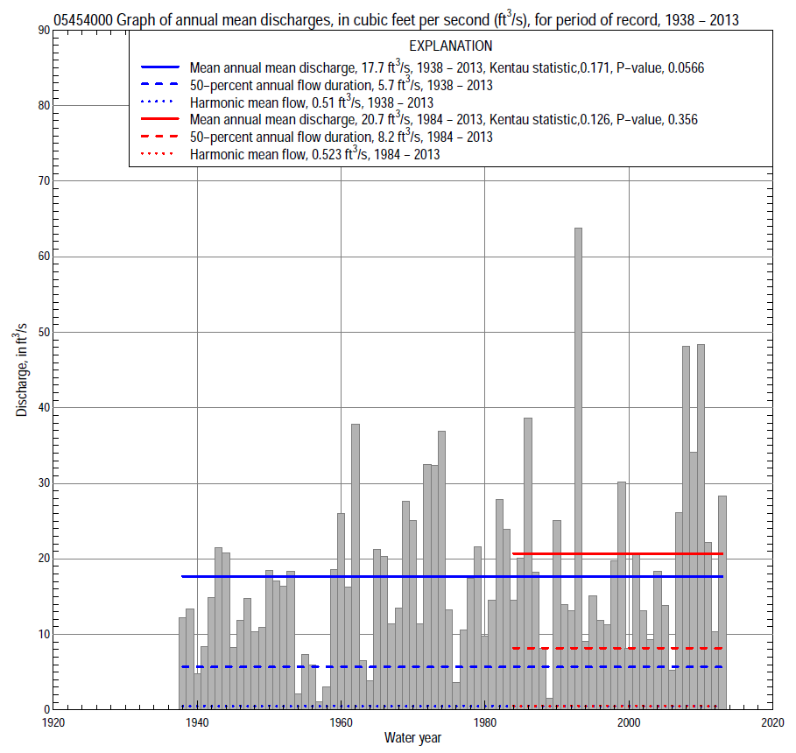

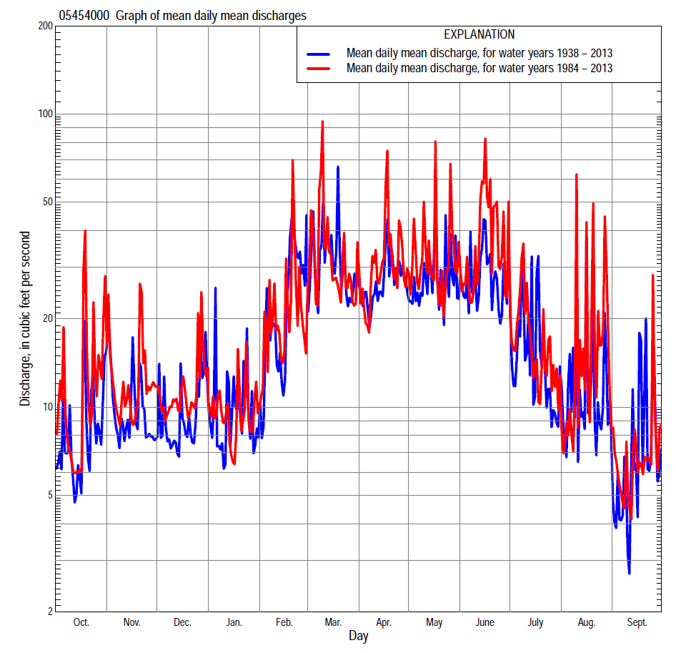

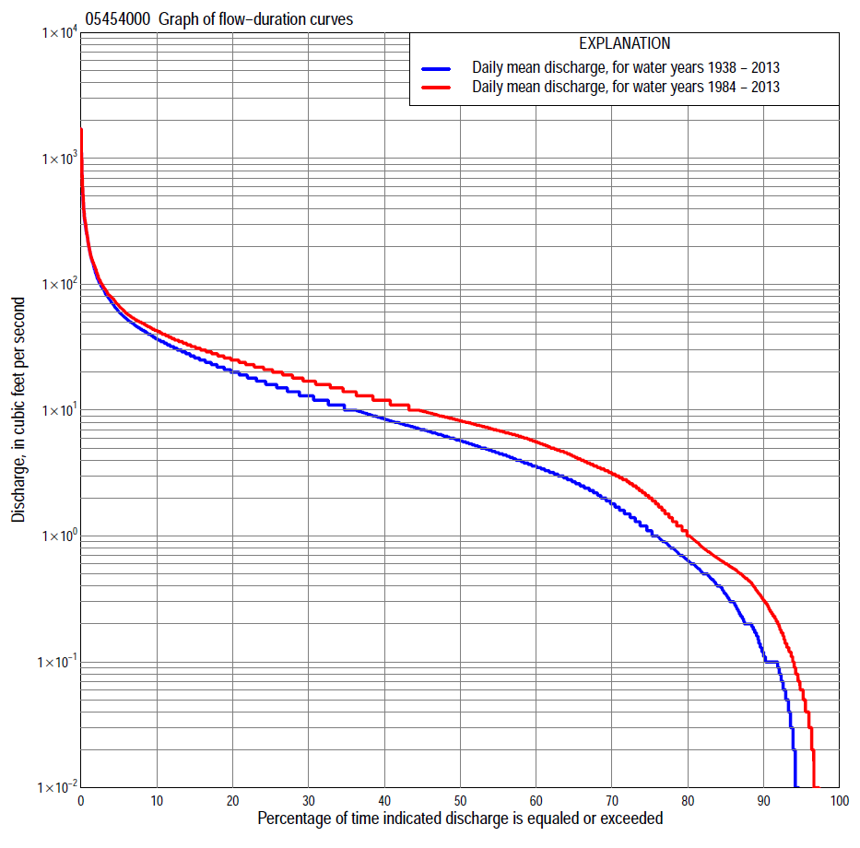

Statistics Based on the Entire Streamflow Period of Record
05454000 Monthly and annual flow durations, based on 1938–2013 period of record (76 years)
Percentage of days discharge equaled or exceeded |  |  |  |  | Discharge (cubic feet per second) |  |  |  |  |  |  |  |  | Annual flow durations
 | Oct | Nov | Dec | Jan | Feb | Mar | Apr | May | June | July | Aug | Sept | Annual | Kentau statistic | P-value
99 | 0.00 | 0.00 | 0.00 | 0.00 | 0.00 | 0.20 | 0.40 | 0.12 | 0.00 | 0.00 | 0.00 | 0.00 | 0.00 | 0.109 | 0.029
98 | 0.00 | 0.00 | 0.00 | 0.00 | 0.00 | 0.50 | 0.78 | 0.40 | 0.00 | 0.00 | 0.00 | 0.00 | 0.00 | 0.106 | 0.044
95 | 0.00 | 0.04 | 0.01 | 0.00 | 0.12 | 1.2 | 1.7 | 1.3 | 0.50 | 0.00 | 0.00 | 0.00 | 0.00 | 0.109 | 0.066
90 | 0.00 | 0.16 | 0.10 | 0.10 | 0.50 | 2.2 | 3.1 | 2.8 | 1.2 | 0.18 | 0.02 | 0.00 | 0.11 | 0.165 | 0.012
85 | 0.03 | 0.24 | 0.20 | 0.30 | 0.91 | 3.6 | 4.5 | 3.9 | 2.0 | 0.50 | 0.10 | 0.01 | 0.35 | 0.200 | 0.006
80 | 0.10 | 0.38 | 0.40 | 0.50 | 1.6 | 4.9 | 6.0 | 4.8 | 2.8 | 0.80 | 0.19 | 0.05 | 0.64 | 0.204 | 0.005
75 | 0.17 | 0.56 | 0.60 | 0.83 | 2.3 | 5.7 | 7.1 | 5.9 | 3.8 | 1.2 | 0.31 | 0.10 | 1.1 | 0.245 | 0.001
70 | 0.27 | 0.80 | 0.87 | 1.4 | 3.0 | 6.9 | 8.3 | 7.2 | 5.2 | 1.9 | 0.49 | 0.14 | 1.8 | 0.240 | 0.002
65 | 0.45 | 1.2 | 1.4 | 2.1 | 3.7 | 8.1 | 10 | 8.6 | 6.6 | 2.7 | 0.70 | 0.24 | 2.7 | 0.250 | 0.001
60 | 0.60 | 1.9 | 2.1 | 2.8 | 4.5 | 9.9 | 12 | 10 | 8.1 | 3.6 | 1.0 | 0.41 | 3.6 | 0.257 | 0.001
55 | 0.89 | 2.8 | 3.2 | 3.4 | 5.4 | 12 | 14 | 12 | 9.9 | 4.5 | 1.3 | 0.60 | 4.6 | 0.256 | 0.001
50 | 1.4 | 3.4 | 4.0 | 4.2 | 6.6 | 14 | 16 | 13 | 12 | 5.4 | 1.7 | 0.84 | 5.7 | 0.277 | 0.000
45 | 2.2 | 4.3 | 5.1 | 4.9 | 7.4 | 16 | 18 | 16 | 14 | 6.4 | 2.2 | 1.2 | 7.0 | 0.276 | 0.000
40 | 2.9 | 5.6 | 6.3 | 5.6 | 8.7 | 19 | 20 | 18 | 16 | 7.6 | 2.9 | 1.8 | 8.5 | 0.278 | 0.000
35 | 3.7 | 7.0 | 7.4 | 6.4 | 10 | 22 | 23 | 21 | 19 | 8.8 | 3.8 | 2.6 | 10 | 0.248 | 0.002
30 | 5.0 | 8.6 | 8.8 | 7.5 | 12 | 25 | 26 | 25 | 22 | 10 | 5.0 | 3.6 | 13 | 0.253 | 0.001
25 | 7.1 | 10 | 10 | 9.0 | 15 | 31 | 31 | 29 | 27 | 13 | 6.6 | 4.7 | 16 | 0.251 | 0.001
20 | 9.6 | 14 | 12 | 11 | 20 | 37 | 37 | 34 | 33 | 16 | 9.0 | 6.6 | 20 | 0.245 | 0.002
15 | 13 | 18 | 16 | 14 | 28 | 48 | 44 | 41 | 42 | 22 | 13 | 9.6 | 26 | 0.227 | 0.004
10 | 20 | 23 | 22 | 20 | 44 | 65 | 55 | 54 | 54 | 30 | 20 | 15 | 37 | 0.204 | 0.009
5 | 34 | 34 | 32 | 30 | 90 | 117 | 80 | 82 | 89 | 51 | 44 | 28 | 60 | 0.118 | 0.134
2 | 59 | 58 | 53 | 69 | 199 | 215 | 143 | 150 | 183 | 125 | 100 | 48 | 120 | 0.052 | 0.513
1 | 101 | 92 | 81 | 100 | 370 | 312 | 212 | 247 | 310 | 184 | 162 | 81 | 200 | 0.012 | 0.879

05454000 Annual exceedance probability of instantaneous peak discharges, in cubic feet per second (ft³/s), based on the Weighted Independent Estimates method,
Annual exceed-ance probability | Recur-rence interval (years) | Discharge (ft³/s) | 95-percent lower confi-dence interval (ft³/s) | 95-percent upper confi-dence interval (ft³/s)
0.500 | 2 | 1,460 | 1,220 | 1,760
0.200 | 5 | 2,710 | 2,280 | 3,210
0.100 | 10 | 3,660 | 3,050 | 4,380
0.040 | 25 | 5,030 | 4,090 | 6,180
0.020 | 50 | 6,070 | 4,790 | 7,680
0.010 | 100 | 7,110 | 5,430 | 9,310
0.005 | 200 | 8,550 | 6,280 | 11,600
0.002 | 500 | 9,740 | 6,800 | 13,900
and based on the expected moments algorithm/multiple Grubbs-Beck analysis computed using a historical period length of 76 years (1938–2013)
0.500 | 2 | 1,480 | 961 | 1,760
0.200 | 5 | 2,770 | 2,320 | 3,440
0.100 | 10 | 3,710 | 3,050 | 4,950
0.040 | 25 | 4,960 | 3,930 | 7,400
0.020 | 50 | 5,900 | 4,540 | 9,540
0.010 | 100 | 6,850 | 5,110 | 11,900
0.005 | 200 | 7,790 | 5,620 | 14,400
0.002 | 500 | 9,040 | 6,240 | 18,100
Kentau statistic |  | -0.107
P-value |  | 0.174
Begin year |  | 1938
End year |  | 2013
Number of peaks |  | 76

05454000 Annual exceedance probability of high discharges, based on 1938–2013 period of record (76 years)
Annual exceedance probability | Recur-rence interval (years) | Maximum average discharge (ft³/s) for indicated number of consecutive days
 |  | 1 | 3 | 7 | 15 | 30
0.990 | 1.01 | 40 | 25 | 15 | 8.6 | 5.3
0.950 | 1.05 | 86 | 53 | 33 | 21 | 14
0.900 | 1.11 | 127 | 77 | 49 | 32 | 22
0.800 | 1.25 | 200 | 118 | 74 | 49 | 34
0.500 | 2 | 442 | 243 | 147 | 97 | 67
0.200 | 5 | 901 | 445 | 251 | 155 | 105
0.100 | 10 | 1,260 | 586 | 314 | 185 | 122
0.040 | 25 | 1,780 | 761 | 384 | 213 | 137
0.020 | 50 | 2,180 | 887 | 430 | 229 | 144
0.010 | 100 | 2,600 | 1,010 | 470 | 241 | 149
0.005 | 200 | 3,040 | 1,120 | 505 | 250 | 152
0.002 | 500 | 3,640 | 1,270 | 545 | 260 | 156
Kentau statistic |  | 0.016 | 0.017 | 0.020 | 0.053 | 0.128
P-value |  | 0.840 | 0.830 | 0.805 | 0.498 | 0.102

 | 05454000 Annual nonexceedance probability of low discharges, based on April 1938 to March 2013 period of record (75 years)
Annual nonexceed-ance probability | Recur-rence interval (years) | Minimum average discharge (ft³/s) for indicated number of consecutive days
 |  | 1 | 3 | 7 | 14 | 30 | 60 | 90 | 120 | 183
0.01 | 100 | 0.00 | 0.00 | 0.00 | 0.00 | 0.00 | 0.00 | 0.00 | 0.00 | 0.00
0.02 | 50 | 0.00 | 0.00 | 0.00 | 0.00 | 0.00 | 0.00 | 0.01 | 0.02 | 0.04
0.05 | 20 | 0.00 | 0.00 | 0.00 | 0.00 | 0.00 | 0.00 | 0.05 | 0.08 | 0.17
0.10 | 10 | 0.00 | 0.00 | 0.00 | 0.00 | 0.00 | 0.03 | 0.12 | 0.20 | 0.41
0.20 | 5 | 0.00 | 0.00 | 0.00 | 0.00 | 0.02 | 0.14 | 0.31 | 0.49 | 1.0
0.50 | 2 | 0.12 | 0.14 | 0.18 | 0.23 | 0.44 | 1.0 | 1.5 | 2.1 | 3.8
0.80 | 1.25 | 0.89 | 1.0 | 1.3 | 1.9 | 2.4 | 4.3 | 5.6 | 7.4 | 11
0.90 | 1.11 | 1.9 | 2.1 | 2.6 | 3.6 | 4.5 | 7.7 | 10 | 13 | 18
0.96 | 1.04 | 4.1 | 4.5 | 4.8 | 6.0 | 7.6 | 13 | 19 | 22 | 29
0.98 | 1.02 | 6.7 | 6.9 | 7.0 | 7.6 | 10 | 17 | 27 | 31 | 37
0.99 | 1.01 | 8.2 | 8.3 | 8.4 | 9.1 | 13 | 21 | 37 | 40 | 46
Kentau statistic |  | 0.286 | 0.285 | 0.294 | 0.303 | 0.270 | 0.205 | 0.173 | 0.146 | 0.148
P-value |  | 0.000 | 0.000 | 0.000 | 0.000 | 0.001 | 0.009 | 0.029 | 0.065 | 0.061

05454000 Annual nonexceedance probability of seasonal low discharges, based on October 1983 to September 2013 period of record (76 years)
Annual nonexceed-ance probability | Recur-rence interval (years) | Minimum average discharge (cubic feet per second) for indicated number of consecutive days
 |  | 1 | 7 | 14 | 30 |  | 1 | 7 | 14 | 30
 |  | January-February-March |  |  |  |  | April-May-June
0.01 | 100 | 0.00 | 0.00 | 0.00 | 0.00 |  | 0.00 | 0.00 | 0.00 | 0.03
0.02 | 50 | 0.00 | 0.00 | 0.00 | 0.00 |  | 0.00 | 0.00 | 0.01 | 0.09
0.05 | 20 | 0.00 | 0.00 | 0.00 | 0.01 |  | 0.08 | 0.12 | 0.13 | 0.39
0.10 | 10 | 0.00 | 0.00 | 0.02 | 0.18 |  | 0.32 | 0.41 | 0.49 | 1.1
0.20 | 5 | 0.16 | 0.24 | 0.26 | 0.82 |  | 0.82 | 1.1 | 1.6 | 3.1
0.50 | 2 | 1.3 | 1.8 | 2.5 | 4.4 |  | 3.1 | 4.3 | 6.8 | 11
0.80 | 1.25 | 4.3 | 5.3 | 6.9 | 11 |  | 8.6 | 11 | 13 | 20
0.90 | 1.11 | 6.8 | 7.8 | 9.0 | 14 |  | 14 | 15 | 15 | 23
0.96 | 1.04 | 10 | 11 | 11 | 16 |  | 20 | 21 | 22 | 25
0.98 | 1.02 | 13 | 13 | 13 | 17 |  | 23 | 24 | 25 | 27
0.99 | 1.01 | 15 | 15 | 15 | 18 |  | 25 | 27 | 29 | 31
Kentau statistic |  | 0.227 | 0.263 | 0.258 | 0.109 |  | 0.245 | 0.225 | 0.210 | 0.176
P-value |  | 0.004 | 0.001 | 0.001 | 0.164 |  | 0.002 | 0.004 | 0.007 | 0.025
 |  | July-August-September |  |  |  |  | October-November-December
0.01 | 100 | 0.00 | 0.00 | 0.00 | 0.00 |  | 0.00 | 0.00 | 0.00 | 0.00
0.02 | 50 | 0.00 | 0.00 | 0.00 | 0.00 |  | 0.00 | 0.00 | 0.00 | 0.00
0.05 | 20 | 0.00 | 0.00 | 0.00 | 0.00 |  | 0.00 | 0.00 | 0.00 | 0.00
0.10 | 10 | 0.00 | 0.00 | 0.00 | 0.02 |  | 0.00 | 0.00 | 0.00 | 0.02
0.20 | 5 | 0.00 | 0.00 | 0.00 | 0.09 |  | 0.00 | 0.02 | 0.07 | 0.16
0.50 | 2 | 0.15 | 0.23 | 0.35 | 0.75 |  | 0.42 | 0.59 | 0.79 | 1.5
0.80 | 1.25 | 1.1 | 1.7 | 2.1 | 3.9 |  | 2.6 | 3.5 | 3.9 | 6.4
0.90 | 1.11 | 2.5 | 3.7 | 4.5 | 7.9 |  | 5.6 | 7.2 | 8.0 | 11
0.96 | 1.04 | 6.1 | 7.4 | 10 | 15 |  | 12 | 14 | 16 | 19
0.98 | 1.02 | 11 | 11 | 16 | 22 |  | 18 | 19 | 24 | 24
0.99 | 1.01 | 18 | 18 | 24 | 30 |  | 26 | 26 | 33 | 30
Kentau statistic |  | 0.245 | 0.236 | 0.247 | 0.196 |  | 0.181 | 0.172 | 0.195 | 0.182
P-value |  | 0.001 | 0.002 | 0.002 | 0.012 |  | 0.021 | 0.028 | 0.013 | 0.020

Statistics Based on the 1984–2013 Streamflow Period of Record
05454000 Monthly and annual flow durations, based on 1984–2013 period of record (30 years)
Percentage of days discharge equaled or exceeded |  |  |  |  | Discharge (cubic feet per second) |  |  |  |  |  |  |  |  | Annual flow durations
 | Oct | Nov | Dec | Jan | Feb | Mar | Apr | May | June | July | Aug | Sept | Annual | Kentau statistic | P-value
99 | 0.00 | 0.02 | 0.00 | 0.00 | 0.11 | 0.56 | 0.44 | 0.84 | 0.40 | 0.00 | 0.00 | 0.00 | 0.00 | 0.170 | 0.043
98 | 0.00 | 0.05 | 0.02 | 0.05 | 0.12 | 0.85 | 0.57 | 1.7 | 0.54 | 0.00 | 0.00 | 0.00 | 0.00 | 0.189 | 0.037
95 | 0.00 | 0.12 | 0.05 | 0.20 | 0.50 | 1.6 | 1.6 | 2.9 | 1.4 | 0.01 | 0.00 | 0.00 | 0.06 | 0.120 | 0.239
90 | 0.01 | 0.32 | 0.31 | 0.36 | 0.87 | 2.7 | 3.5 | 4.0 | 2.5 | 0.29 | 0.05 | 0.00 | 0.31 | 0.126 | 0.274
85 | 0.07 | 0.50 | 0.51 | 0.63 | 2.2 | 4.5 | 5.1 | 6.0 | 3.8 | 0.76 | 0.14 | 0.04 | 0.60 | 0.186 | 0.124
80 | 0.21 | 0.63 | 0.74 | 1.1 | 3.3 | 6.2 | 7.2 | 8.1 | 5.6 | 1.6 | 0.29 | 0.08 | 1.0 | 0.161 | 0.197
75 | 0.32 | 0.85 | 1.2 | 2.8 | 4.4 | 8.3 | 8.5 | 9.7 | 7.8 | 2.8 | 0.45 | 0.16 | 2.0 | 0.170 | 0.183
70 | 0.47 | 1.3 | 2.7 | 3.4 | 5.3 | 10 | 10 | 12 | 10 | 4.1 | 0.61 | 0.28 | 3.1 | 0.115 | 0.377
65 | 0.63 | 1.9 | 4.0 | 4.2 | 6.3 | 11 | 12 | 13 | 12 | 5.1 | 0.95 | 0.44 | 4.3 | 0.099 | 0.448
60 | 0.76 | 3.1 | 5.3 | 4.7 | 7.0 | 13 | 14 | 16 | 14 | 6.2 | 1.2 | 0.61 | 5.6 | 0.067 | 0.614
55 | 1.1 | 4.2 | 6.3 | 5.0 | 7.6 | 15 | 16 | 18 | 16 | 7.1 | 1.7 | 0.82 | 6.9 | 0.108 | 0.410
50 | 2.0 | 5.7 | 7.0 | 5.6 | 8.5 | 17 | 18 | 20 | 18 | 8.2 | 2.2 | 1.1 | 8.2 | 0.110 | 0.400
45 | 2.8 | 6.8 | 7.9 | 6.2 | 9.7 | 19 | 21 | 23 | 20 | 9.2 | 2.9 | 1.7 | 9.8 | 0.083 | 0.531
40 | 3.4 | 8.0 | 8.9 | 6.7 | 11 | 22 | 23 | 26 | 23 | 11 | 3.8 | 2.9 | 12 | 0.071 | 0.591
35 | 5.9 | 9.1 | 10 | 7.9 | 13 | 25 | 27 | 28 | 27 | 12 | 5.2 | 3.8 | 14 | 0.087 | 0.508
30 | 8.4 | 11 | 12 | 8.8 | 16 | 29 | 31 | 31 | 31 | 15 | 6.8 | 5.3 | 17 | 0.099 | 0.453
25 | 11 | 14 | 13 | 9.8 | 18 | 33 | 36 | 34 | 35 | 18 | 8.8 | 7.4 | 21 | 0.124 | 0.344
20 | 15 | 18 | 16 | 12 | 20 | 40 | 42 | 39 | 43 | 21 | 12 | 9.9 | 25 | 0.108 | 0.411
15 | 21 | 23 | 20 | 16 | 27 | 50 | 50 | 48 | 52 | 26 | 17 | 13 | 32 | 0.120 | 0.362
10 | 30 | 29 | 26 | 20 | 40 | 66 | 63 | 59 | 74 | 35 | 29 | 19 | 43 | 0.122 | 0.353
5 | 47 | 43 | 37 | 28 | 82 | 109 | 90 | 91 | 110 | 53 | 59 | 30 | 67 | 0.133 | 0.309
2 | 75 | 66 | 54 | 54 | 150 | 195 | 157 | 175 | 267 | 125 | 128 | 46 | 130 | 0.122 | 0.353
1 | 141 | 92 | 81 | 92 | 234 | 312 | 212 | 247 | 474 | 164 | 264 | 65 | 206 | 0.087 | 0.509

05454000 Annual exceedance probability of high discharges, based on 1984–2013 period of record (30 years)
Annual exceedance probability | Recur-rence interval (years) | Maximum average discharge (ft³/s) for indicated number of consecutive days
 |  | 1 | 3 | 7 | 15 | 30
0.990 | 1.01 | 37 | 28 | 19 | 12 | 7.4
0.950 | 1.05 | 77 | 53 | 35 | 24 | 17
0.900 | 1.11 | 113 | 73 | 48 | 33 | 24
0.800 | 1.25 | 177 | 108 | 68 | 48 | 37
0.500 | 2 | 404 | 221 | 133 | 92 | 70
0.200 | 5 | 879 | 439 | 249 | 164 | 113
0.100 | 10 | 1,300 | 621 | 342 | 215 | 137
0.040 | 25 | 1,940 | 890 | 474 | 283 | 161
0.020 | 50 | 2,500 | 1,120 | 583 | 333 | 175
0.010 | 100 | 3,130 | 1,370 | 699 | 383 | 186
0.005 | 200 | 3,820 | 1,640 | 822 | 433 | 195
0.002 | 500 | 4,840 | 2,040 | 998 | 499 | 205
Kentau statistic |  | 0.002 | 0.016 | 0.053 | 0.039 | 0.080
P-value |  | 1.000 | 0.915 | 0.695 | 0.775 | 0.544

 | 05454000 Annual nonexceedance probability of low discharges, based on April 1983 to March 2013 period of record (30 years)
Annual nonexceed-ance probability | Recur-rence interval (years) | Minimum average discharge (ft³/s) for indicated number of consecutive days
 |  | 1 | 3 | 7 | 14 | 30 | 60 | 90 | 120 | 183
0.01 | 100 | 0.00 | 0.00 | 0.00 | 0.00 | 0.00 | 0.00 | 0.01 | 0.01 | 0.03
0.02 | 50 | 0.00 | 0.00 | 0.00 | 0.00 | 0.00 | 0.00 | 0.02 | 0.03 | 0.07
0.05 | 20 | 0.00 | 0.00 | 0.00 | 0.00 | 0.00 | 0.00 | 0.05 | 0.08 | 0.18
0.10 | 10 | 0.00 | 0.00 | 0.00 | 0.00 | 0.01 | 0.04 | 0.12 | 0.19 | 0.43
0.20 | 5 | 0.00 | 0.00 | 0.00 | 0.01 | 0.06 | 0.17 | 0.32 | 0.51 | 1.1
0.50 | 2 | 0.33 | 0.37 | 0.43 | 0.71 | 0.78 | 1.4 | 1.7 | 2.6 | 4.7
0.80 | 1.25 | 1.8 | 1.9 | 2.4 | 3.3 | 4.0 | 6.4 | 7.6 | 10 | 14
0.90 | 1.11 | 3.6 | 3.9 | 4.7 | 5.2 | 7.6 | 12 | 15 | 18 | 23
0.96 | 1.04 | 7.0 | 7.7 | 8.5 | 9.3 | 13 | 20 | 30 | 32 | 35
0.98 | 1.02 | 11 | 12 | 12 | 13 | 17 | 26 | 44 | 45 | 43
0.99 | 1.01 | 15 | 17 | 16 | 17 | 21 | 33 | 62 | 60 | 51
Kentau statistic |  | 0.216 | 0.221 | 0.241 | 0.241 | 0.207 | 0.200 | 0.159 | 0.131 | 0.085
P-value |  | 0.095 | 0.088 | 0.062 | 0.063 | 0.112 | 0.125 | 0.225 | 0.318 | 0.521

05454000 Annual nonexceedance probability of seasonal low discharges, based on October 1983 to September 2013 period of record (30 years)
Annual nonexceed-ance probability | Recur-rence interval (years) | Minimum average discharge (cubic feet per second) for indicated number of consecutive days
 |  | 1 | 7 | 14 | 30 |  | 1 | 7 | 14 | 30
 |  | January-February-March |  |  |  |  | April-May-June
0.01 | 100 | 0.00 | 0.00 | 0.00 | 0.12 |  | 0.13 | 0.22 | 0.30 | 0.66
0.02 | 50 | 0.00 | 0.00 | 0.01 | 0.21 |  | 0.21 | 0.34 | 0.46 | 1.0
0.05 | 20 | 0.02 | 0.03 | 0.04 | 0.45 |  | 0.45 | 0.66 | 0.87 | 1.6
0.10 | 10 | 0.11 | 0.18 | 0.18 | 0.84 |  | 0.83 | 1.1 | 1.5 | 2.6
0.20 | 5 | 0.40 | 0.63 | 0.79 | 1.7 |  | 1.6 | 2.1 | 2.6 | 4.3
0.50 | 2 | 2.1 | 3.0 | 4.6 | 4.9 |  | 4.9 | 5.8 | 7.0 | 11
0.80 | 1.25 | 6.3 | 8.1 | 9.3 | 11 |  | 12 | 13 | 16 | 23
0.90 | 1.11 | 9.5 | 11 | 11 | 15 |  | 17 | 19 | 23 | 34
0.96 | 1.04 | 13 | 14 | 14 | 20 |  | 23 | 27 | 33 | 49
0.98 | 1.02 | 16 | 16 | 16 | 24 |  | 28 | 33 | 40 | 61
0.99 | 1.01 | 18 | 18 | 18 | 26 |  | 32 | 39 | 47 | 74
Kentau statistic |  | -0.032 | -0.011 | -0.011 | 0.025 |  | 0.269 | 0.232 | 0.264 | 0.324
P-value |  | 0.816 | 0.943 | 0.943 | 0.858 |  | 0.038 | 0.074 | 0.042 | 0.012
 |  | July-August-September |  |  |  |  | October-November-December
0.01 | 100 | 0.00 | 0.00 | 0.00 | 0.00 |  | 0.00 | 0.00 | 0.00 | 0.00
0.02 | 50 | 0.00 | 0.00 | 0.00 | 0.00 |  | 0.00 | 0.00 | 0.00 | 0.00
0.05 | 20 | 0.00 | 0.00 | 0.00 | 0.00 |  | 0.00 | 0.00 | 0.00 | 0.01
0.10 | 10 | 0.00 | 0.00 | 0.00 | 0.02 |  | 0.00 | 0.00 | 0.02 | 0.06
0.20 | 5 | 0.00 | 0.01 | 0.03 | 0.09 |  | 0.02 | 0.05 | 0.15 | 0.24
0.50 | 2 | 0.33 | 0.51 | 0.76 | 1.0 |  | 0.68 | 0.77 | 1.2 | 2.2
0.80 | 1.25 | 2.2 | 3.5 | 4.3 | 6.4 |  | 3.7 | 4.7 | 5.5 | 9.7
0.90 | 1.11 | 5.2 | 7.6 | 8.9 | 14 |  | 7.4 | 9.6 | 11 | 17
0.96 | 1.04 | 13 | 15 | 18 | 29 |  | 14 | 18 | 19 | 26
0.98 | 1.02 | 22 | 22 | 27 | 44 |  | 21 | 25 | 27 | 32
0.99 | 1.01 | 35 | 35 | 37 | 62 |  | 28 | 33 | 36 | 37
Kentau statistic |  | 0.179 | 0.170 | 0.154 | 0.168 |  | 0.149 | 0.129 | 0.083 | 0.039
P-value |  | 0.167 | 0.192 | 0.238 | 0.199 |  | 0.252 | 0.326 | 0.532 | 0.775

