LOCATION.--Lat 41°40'36", long 91°35'55" referenced to North American Datum of 1927, in SE 1/4 NE 1/4 SE 1/4 sec.01, T.79 N., R.7 W., Johnson County, IA, Hydrologic Unit 07080209, on left bank 15 ft upstream from bridge on 22nd Avenue, 1.1 mi west of Coralville Post Office, 1.5 mi downstream from Deer Creek, and 2.8 mi upstream from mouth.

DRAINAGE AREA.--98.1 mi².

PERIOD OF RECORD.--Discharge records from October 1952 to current year. Prior to May 1953, monthly mean discharge for some periods published in WSP 1728.

GAGE.--Water-stage recorder. Datum of gage is 647.48 ft above National Geodetic Vertical Datum of 1929 (levels by U.S. Army Corps of Engineers). Prior to January 7, 1957, non-recording gage at same site and datum.

A summary of all available data for this streamgage is provided through the USGS National Water Information System web interface (NWISWeb). The following link provides access to current/historical observations, daily data, daily statistics, monthly statistics, annual statistics, peak streamflow, field measurements, field/lab water-quality samples, and the latest water-year summaries. Data can be filtered by parameter and/or dates, and can be output in various tabular and graphical formats.
http://waterdata.usgs.gov/nwis/inventory/?site_no=05454300

The USGS WaterWatch Toolkit is available at:
http://waterwatch.usgs.gov/?id=ww_toolkit
Tools for summarizing streamflow information include the duration hydrograph builder, the cumulative streamflow hydrograph builder, the streamgage statistics retrieval tool, the rating curve builder, the flood tracking chart builder, the National Weather Service Advanced Hydrologic Prediction Service (AHPS) river forecast hydrograph builder, and the raster-hydrograph builder. Entering the above number for this streamgage into these toolkit webpages will provide streamflow information specific to this streamgage.

A description of the statistics presented for this streamgage is available in the main body of the report at:
http://dx.doi.org/10.3133/ofr20151214
A link to other streamgages included in this report, a map showing the location of the streamgages, information on the programs used to compute the statistical analyses, and references are included in the main body of the report.

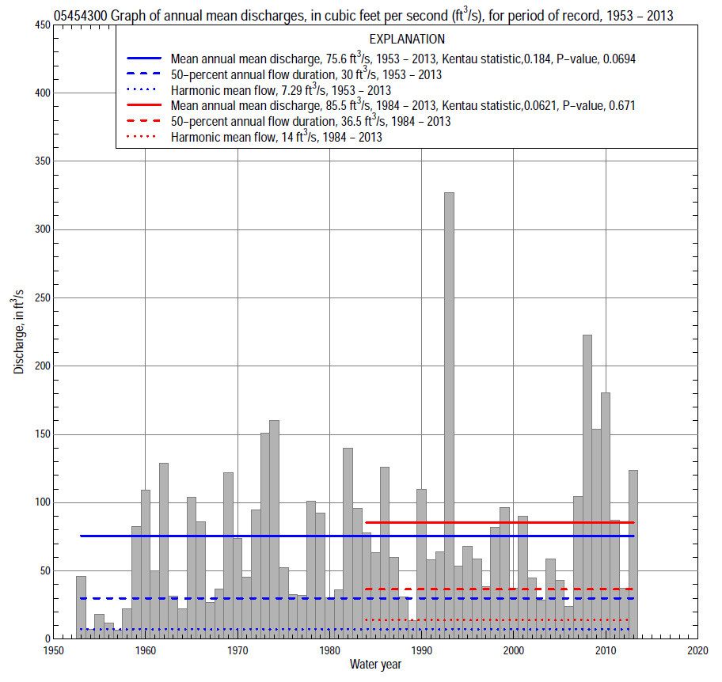

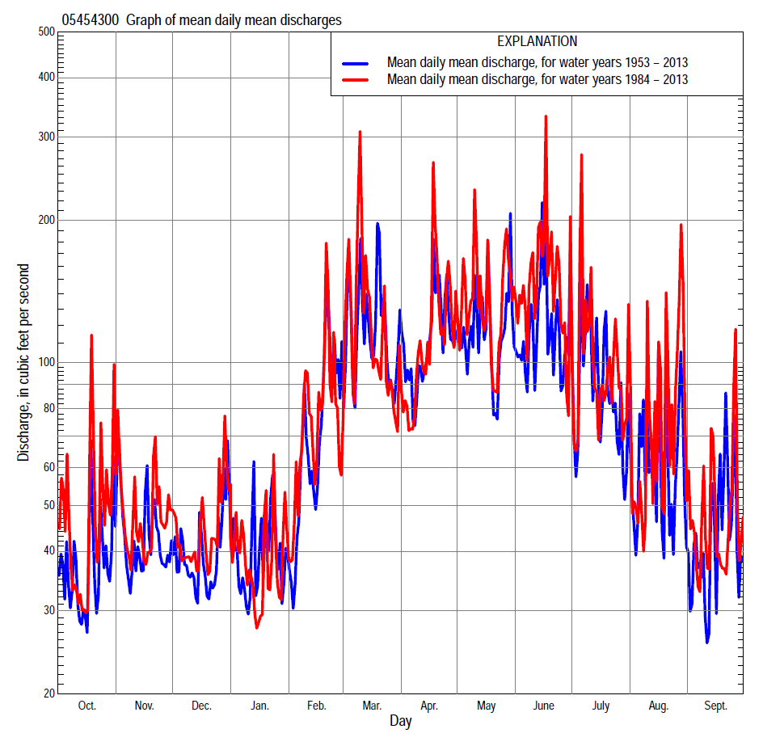

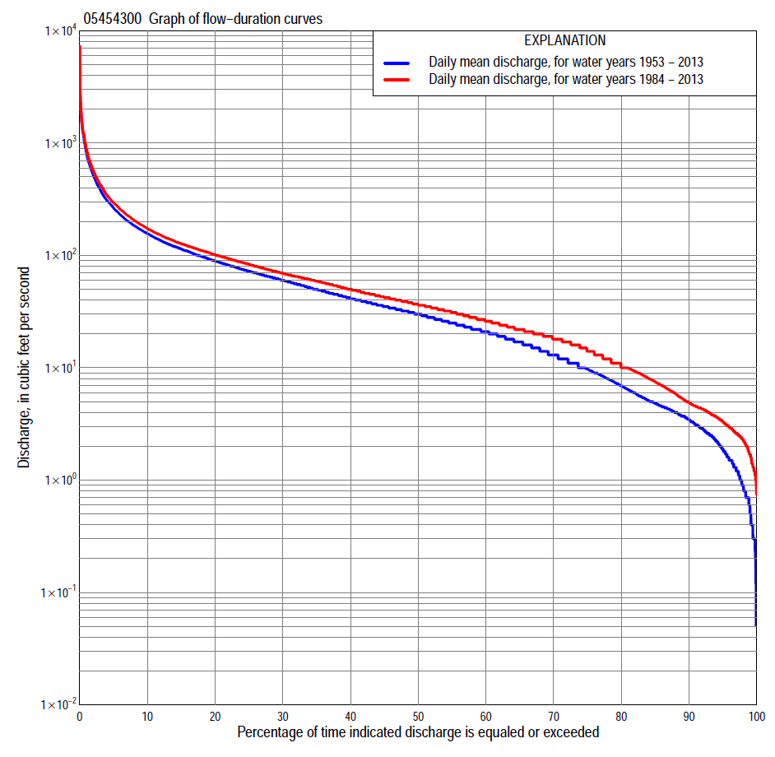

Statistics Based on the Entire Streamflow Period of Record
05454300 Monthly and annual flow durations, based on 1953–2013 period of record (61 years)
Percentage of days discharge equaled or exceeded |  |  |  |  | Discharge (cubic feet per second) |  |  |  |  |  |  |  |  | Annual flow durations
 | Oct | Nov | Dec | Jan | Feb | Mar | Apr | May | June | July | Aug | Sept | Annual | Kentau statistic | P-value
99 | 0.40 | 0.80 | 0.30 | 0.18 | 0.30 | 3.6 | 3.3 | 1.8 | 0.70 | 1.0 | 0.70 | 0.50 | 0.50 | 0.271 | 0.002
98 | 0.80 | 1.0 | 0.40 | 0.30 | 0.60 | 4.6 | 4.0 | 2.7 | 1.9 | 1.3 | 1.1 | 0.70 | 0.90 | 0.258 | 0.003
95 | 1.3 | 1.9 | 0.90 | 0.90 | 2.5 | 7.2 | 6.7 | 4.0 | 3.6 | 2.0 | 1.8 | 1.0 | 1.9 | 0.267 | 0.002
90 | 2.0 | 3.1 | 1.8 | 2.5 | 4.6 | 11 | 13 | 12 | 7.9 | 3.8 | 3.1 | 1.8 | 3.4 | 0.273 | 0.002
85 | 2.7 | 4.1 | 3.2 | 4.3 | 7.8 | 16 | 17 | 19 | 12 | 6.6 | 4.2 | 2.6 | 4.8 | 0.257 | 0.003
80 | 3.7 | 4.9 | 4.4 | 5.6 | 11 | 21 | 25 | 23 | 17 | 9.1 | 5.0 | 3.3 | 6.9 | 0.263 | 0.003
75 | 4.2 | 6.3 | 6.5 | 8.0 | 14 | 26 | 30 | 28 | 21 | 12 | 6.0 | 4.0 | 9.8 | 0.283 | 0.001
70 | 4.8 | 8.5 | 9.5 | 10 | 17 | 32 | 36 | 33 | 25 | 14 | 7.0 | 4.6 | 13 | 0.264 | 0.003
65 | 5.9 | 10 | 13 | 13 | 20 | 37 | 42 | 39 | 30 | 18 | 8.6 | 5.5 | 17 | 0.256 | 0.004
60 | 7.3 | 14 | 16 | 16 | 24 | 43 | 49 | 45 | 36 | 21 | 10 | 6.7 | 21 | 0.242 | 0.006
55 | 9.6 | 19 | 20 | 20 | 27 | 50 | 56 | 53 | 43 | 24 | 12 | 8.5 | 25 | 0.239 | 0.007
50 | 13 | 23 | 24 | 23 | 30 | 57 | 65 | 62 | 51 | 29 | 14 | 10 | 30 | 0.239 | 0.007
45 | 18 | 27 | 29 | 26 | 35 | 65 | 74 | 72 | 62 | 34 | 17 | 13 | 35 | 0.226 | 0.010
40 | 22 | 33 | 33 | 29 | 40 | 73 | 85 | 82 | 73 | 39 | 20 | 17 | 42 | 0.216 | 0.014
35 | 27 | 40 | 38 | 32 | 50 | 88 | 97 | 93 | 85 | 46 | 24 | 21 | 50 | 0.209 | 0.018
30 | 34 | 47 | 43 | 35 | 60 | 103 | 111 | 107 | 98 | 54 | 32 | 26 | 60 | 0.193 | 0.028
25 | 43 | 53 | 49 | 39 | 70 | 119 | 127 | 121 | 120 | 65 | 39 | 33 | 72 | 0.208 | 0.018
20 | 54 | 61 | 58 | 47 | 85 | 140 | 149 | 144 | 144 | 83 | 49 | 43 | 89 | 0.215 | 0.014
15 | 67 | 73 | 70 | 65 | 104 | 179 | 178 | 177 | 179 | 116 | 68 | 64 | 114 | 0.212 | 0.016
10 | 86 | 94 | 87 | 80 | 150 | 240 | 229 | 239 | 237 | 171 | 110 | 97 | 157 | 0.198 | 0.024
5 | 132 | 139 | 120 | 110 | 280 | 420 | 321 | 392 | 415 | 393 | 246 | 183 | 265 | 0.155 | 0.079
2 | 222 | 223 | 192 | 230 | 504 | 798 | 597 | 706 | 784 | 751 | 588 | 325 | 520 | 0.070 | 0.426
1 | 313 | 351 | 319 | 400 | 800 | 1,280 | 840 | 1,070 | 1,220 | 1,220 | 959 | 478 | 820 | 0.023 | 0.799

05454300 Annual exceedance probability of instantaneous peak discharges, in cubic feet per second (ft³/s), based on the Weighted Independent Estimates method,
Annual exceed-ance probability | Recur-rence interval (years) | Discharge (ft³/s) | 95-percent lower confi-dence interval (ft³/s) | 95-percent upper confi-dence interval (ft³/s)
0.500 | 2 | 1,840 | 1,510 | 2,240
0.200 | 5 | 3,530 | 2,900 | 4,310
0.100 | 10 | 5,050 | 4,100 | 6,230
0.040 | 25 | 7,420 | 5,860 | 9,390
0.020 | 50 | 9,180 | 7,050 | 12,000
0.010 | 100 | 11,000 | 8,130 | 14,800
0.005 | 200 | 13,500 | 9,640 | 19,000
0.002 | 500 | 15,500 | 10,500 | 22,900
and based on the expected moments algorithm/multiple Grubbs-Beck analysis computed using a historical period length of 61 years (1953–2013)
0.500 | 2 | 1,810 | 1,480 | 2,220
0.200 | 5 | 3,400 | 2,770 | 4,310
0.100 | 10 | 4,690 | 3,750 | 6,290
0.040 | 25 | 6,560 | 5,060 | 9,750
0.020 | 50 | 8,130 | 6,050 | 13,200
0.010 | 100 | 9,820 | 7,020 | 17,400
0.005 | 200 | 11,700 | 7,980 | 22,700
0.002 | 500 | 14,300 | 9,200 | 31,600
Kentau statistic |  | 0.025
P-value |  | 0.779
Begin year |  | 1953
End year |  | 2013
Number of peaks |  | 61

05454300 Annual exceedance probability of high discharges, based on 1953–2013 period of record (61 years)
Annual exceedance probability | Recur-rence interval (years) | Maximum average discharge (ft³/s) for indicated number of consecutive days
 |  | 1 | 3 | 7 | 15 | 30
0.990 | 1.01 | 166 | 95 | 57 | 36 | 25
0.950 | 1.05 | 304 | 185 | 113 | 75 | 52
0.900 | 1.11 | 418 | 260 | 159 | 107 | 75
0.800 | 1.25 | 612 | 387 | 235 | 160 | 112
0.500 | 2 | 1,250 | 787 | 471 | 319 | 225
0.200 | 5 | 2,490 | 1,510 | 879 | 573 | 410
0.100 | 10 | 3,540 | 2,070 | 1,180 | 750 | 542
0.040 | 25 | 5,130 | 2,850 | 1,590 | 971 | 711
0.020 | 50 | 6,500 | 3,480 | 1,910 | 1,130 | 836
0.010 | 100 | 8,020 | 4,130 | 2,230 | 1,280 | 957
0.005 | 200 | 9,700 | 4,810 | 2,560 | 1,430 | 1,080
0.002 | 500 | 12,200 | 5,760 | 3,000 | 1,620 | 1,230
Kentau statistic |  | 0.067 | 0.061 | 0.070 | 0.067 | 0.142
P-value |  | 0.451 | 0.490 | 0.429 | 0.451 | 0.107

 | 05454300 Annual nonexceedance probability of low discharges, based on April 1953 to March 2013 period of record (60 years)
Annual nonexceed-ance probability | Recur-rence interval (years) | Minimum average discharge (ft³/s) for indicated number of consecutive days
 |  | 1 | 3 | 7 | 14 | 30 | 60 | 90 | 120 | 183
0.01 | 100 | 0.00 | 0.00 | 0.00 | 0.00 | 0.11 | 0.23 | 0.51 | 0.63 | 0.81
0.02 | 50 | 0.06 | 0.07 | 0.10 | 0.12 | 0.20 | 0.40 | 0.76 | 1.0 | 1.3
0.05 | 20 | 0.28 | 0.32 | 0.41 | 0.47 | 0.49 | 0.84 | 1.4 | 1.7 | 2.5
0.10 | 10 | 0.59 | 0.66 | 0.80 | 0.90 | 1.0 | 1.6 | 2.3 | 2.9 | 4.3
0.20 | 5 | 1.2 | 1.3 | 1.6 | 1.8 | 2.2 | 3.1 | 4.2 | 5.2 | 7.9
0.50 | 2 | 4.0 | 4.2 | 4.7 | 5.3 | 7.4 | 10 | 12 | 15 | 22
0.80 | 1.25 | 10 | 11 | 12 | 14 | 18 | 26 | 32 | 38 | 54
0.90 | 1.11 | 16 | 17 | 19 | 22 | 26 | 39 | 50 | 60 | 79
0.96 | 1.04 | 24 | 26 | 30 | 34 | 36 | 58 | 81 | 95 | 115
0.98 | 1.02 | 31 | 34 | 39 | 45 | 47 | 73 | 107 | 126 | 143
0.99 | 1.01 | 38 | 42 | 49 | 56 | 57 | 88 | 138 | 159 | 171
Kentau statistic |  | 0.337 | 0.341 | 0.332 | 0.314 | 0.302 | 0.268 | 0.250 | 0.228 | 0.182
P-value |  | 0.000 | 0.000 | 0.000 | 0.000 | 0.001 | 0.003 | 0.005 | 0.010 | 0.041

05454300 Annual nonexceedance probability of seasonal low discharges, based on October 1952 to September 2013 period of record (61 years)
Annual nonexceed-ance probability | Recur-rence interval (years) | Minimum average discharge (cubic feet per second) for indicated number of consecutive days
 |  | 1 | 7 | 14 | 30 |  | 1 | 7 | 14 | 30
 |  | January-February-March |  |  |  |  | April-May-June
0.01 | 100 | 0.00 | 0.00 | 0.00 | 0.12 |  | 0.36 | 0.65 | 0.87 | 1.3
0.02 | 50 | 0.09 | 0.11 | 0.11 | 0.28 |  | 0.67 | 1.1 | 1.4 | 2.2
0.05 | 20 | 0.56 | 0.70 | 0.78 | 0.93 |  | 1.6 | 2.3 | 2.9 | 4.3
0.10 | 10 | 1.3 | 1.7 | 1.9 | 2.3 |  | 3.0 | 4.1 | 5.1 | 7.5
0.20 | 5 | 2.9 | 3.7 | 4.2 | 5.9 |  | 6.3 | 7.8 | 9.5 | 14
0.50 | 2 | 9.7 | 12 | 14 | 21 |  | 19 | 22 | 26 | 39
0.80 | 1.25 | 23 | 28 | 31 | 44 |  | 44 | 49 | 59 | 88
0.90 | 1.11 | 34 | 39 | 42 | 54 |  | 60 | 68 | 83 | 126
0.96 | 1.04 | 46 | 51 | 54 | 62 |  | 78 | 92 | 113 | 174
0.98 | 1.02 | 55 | 59 | 61 | 65 |  | 89 | 107 | 134 | 210
0.99 | 1.01 | 56 | 60 | 62 | 66 |  | 98 | 122 | 154 | 243
Kentau statistic |  | 0.213 | 0.262 | 0.278 | 0.209 |  | 0.305 | 0.285 | 0.269 | 0.258
P-value |  | 0.016 | 0.003 | 0.002 | 0.018 |  | 0.001 | 0.001 | 0.002 | 0.003
 |  | July-August-September |  |  |  |  | October-November-December
0.01 | 100 | 0.19 | 0.37 | 0.47 | 0.68 |  | 0.11 | 0.13 | 0.15 | 0.26
0.02 | 50 | 0.28 | 0.50 | 0.62 | 0.89 |  | 0.19 | 0.23 | 0.26 | 0.44
0.05 | 20 | 0.50 | 0.78 | 0.95 | 1.4 |  | 0.42 | 0.50 | 0.59 | 0.91
0.10 | 10 | 0.84 | 1.2 | 1.4 | 2.0 |  | 0.80 | 0.97 | 1.2 | 1.7
0.20 | 5 | 1.5 | 2.0 | 2.3 | 3.3 |  | 1.7 | 2.0 | 2.5 | 3.5
0.50 | 2 | 4.7 | 5.4 | 6.3 | 9.1 |  | 6.0 | 7.2 | 8.9 | 12
0.80 | 1.25 | 14 | 16 | 18 | 27 |  | 18 | 22 | 26 | 34
0.90 | 1.11 | 24 | 29 | 33 | 49 |  | 30 | 36 | 43 | 55
0.96 | 1.04 | 42 | 54 | 64 | 95 |  | 49 | 58 | 68 | 88
0.98 | 1.02 | 59 | 83 | 99 | 148 |  | 66 | 78 | 89 | 117
0.99 | 1.01 | 81 | 122 | 148 | 221 |  | 84 | 99 | 111 | 148
Kentau statistic |  | 0.297 | 0.303 | 0.305 | 0.234 |  | 0.239 | 0.225 | 0.224 | 0.221
P-value |  | 0.001 | 0.001 | 0.001 | 0.008 |  | 0.007 | 0.011 | 0.011 | 0.012

Statistics Based on the 1984–2013 Streamflow Period of Record
05454300 Monthly and annual flow durations, based on 1984–2013 period of record (30 years)
Percentage of days discharge equaled or exceeded |  |  |  |  | Discharge (cubic feet per second) |  |  |  |  |  |  |  |  | Annual flow durations
 | Oct | Nov | Dec | Jan | Feb | Mar | Apr | May | June | July | Aug | Sept | Annual | Kentau statistic | P-value
99 | 1.3 | 2.4 | 0.92 | 2.8 | 2.6 | 7.1 | 4.7 | 2.2 | 3.1 | 1.7 | 1.4 | 1.1 | 1.7 | 0.221 | 0.082
98 | 1.5 | 2.7 | 1.6 | 4.0 | 3.0 | 10 | 5.6 | 3.5 | 3.8 | 2.0 | 1.6 | 1.3 | 2.3 | 0.184 | 0.150
95 | 2.3 | 3.4 | 2.9 | 4.6 | 5.5 | 12 | 13 | 16 | 9.0 | 2.7 | 2.5 | 2.2 | 3.3 | 0.182 | 0.159
90 | 2.9 | 4.4 | 3.5 | 6.4 | 9.0 | 18 | 16 | 21 | 17 | 6.2 | 4.2 | 2.8 | 4.9 | 0.154 | 0.238
85 | 3.8 | 6.0 | 5.7 | 8.5 | 12 | 23 | 22 | 27 | 21 | 9.4 | 5.0 | 3.4 | 7.5 | 0.138 | 0.292
80 | 4.3 | 8.6 | 7.4 | 11 | 17 | 29 | 29 | 34 | 25 | 13 | 6.0 | 3.9 | 10 | 0.152 | 0.245
75 | 4.9 | 10 | 14 | 15 | 20 | 36 | 34 | 40 | 29 | 17 | 6.9 | 4.5 | 14 | 0.140 | 0.283
70 | 6.1 | 13 | 17 | 18 | 23 | 41 | 40 | 45 | 37 | 20 | 8.7 | 5.4 | 18 | 0.110 | 0.400
65 | 7.5 | 17 | 20 | 20 | 27 | 46 | 47 | 53 | 47 | 23 | 10 | 6.5 | 22 | 0.090 | 0.497
60 | 8.9 | 20 | 22 | 22 | 29 | 51 | 53 | 61 | 55 | 26 | 12 | 8.2 | 26 | 0.069 | 0.605
55 | 11 | 24 | 26 | 25 | 32 | 58 | 61 | 71 | 64 | 31 | 14 | 9.7 | 31 | 0.074 | 0.580
50 | 14 | 29 | 29 | 27 | 36 | 65 | 70 | 79 | 73 | 35 | 16 | 11 | 36 | 0.085 | 0.520
45 | 20 | 35 | 33 | 29 | 40 | 72 | 79 | 90 | 84 | 39 | 19 | 14 | 42 | 0.060 | 0.655
40 | 23 | 42 | 38 | 31 | 48 | 80 | 89 | 102 | 94 | 45 | 22 | 18 | 50 | 0.041 | 0.761
35 | 33 | 46 | 42 | 34 | 57 | 94 | 100 | 113 | 108 | 54 | 30 | 24 | 59 | 0.011 | 0.943
30 | 46 | 51 | 47 | 36 | 63 | 107 | 116 | 125 | 129 | 63 | 38 | 32 | 69 | -0.002 | 1.000
25 | 57 | 56 | 54 | 40 | 75 | 122 | 131 | 143 | 153 | 76 | 46 | 42 | 84 | 0.014 | 0.929
20 | 68 | 65 | 61 | 47 | 86 | 140 | 153 | 170 | 179 | 100 | 61 | 60 | 101 | 0.085 | 0.520
15 | 84 | 75 | 74 | 62 | 104 | 178 | 181 | 217 | 225 | 125 | 90 | 82 | 127 | 0.101 | 0.443
10 | 111 | 102 | 97 | 77 | 150 | 235 | 229 | 284 | 287 | 188 | 154 | 123 | 173 | 0.074 | 0.580
5 | 175 | 148 | 128 | 98 | 285 | 416 | 322 | 435 | 521 | 440 | 339 | 210 | 295 | 0.097 | 0.464
2 | 297 | 222 | 209 | 159 | 505 | 755 | 537 | 796 | 1,040 | 789 | 715 | 332 | 576 | 0.064 | 0.630
1 | 542 | 351 | 352 | 245 | 682 | 1,230 | 756 | 1,190 | 1,300 | 1,150 | 1,310 | 478 | 877 | 0.011 | 0.943

05454300 Annual exceedance probability of high discharges, based on 1984–2013 period of record (30 years)
Annual exceedance probability | Recur-rence interval (years) | Maximum average discharge (ft³/s) for indicated number of consecutive days
 |  | 1 | 3 | 7 | 15 | 30
0.990 | 1.01 | 225 | 142 | 98 | 68 | 46
0.950 | 1.05 | 354 | 228 | 149 | 105 | 74
0.900 | 1.11 | 457 | 295 | 188 | 132 | 96
0.800 | 1.25 | 631 | 406 | 252 | 176 | 131
0.500 | 2 | 1,220 | 764 | 452 | 310 | 237
0.200 | 5 | 2,480 | 1,480 | 846 | 555 | 425
0.100 | 10 | 3,670 | 2,110 | 1,190 | 758 | 576
0.040 | 25 | 5,670 | 3,100 | 1,740 | 1,060 | 794
0.020 | 50 | 7,580 | 4,010 | 2,240 | 1,330 | 977
0.010 | 100 | 9,910 | 5,050 | 2,820 | 1,630 | 1,180
0.005 | 200 | 12,700 | 6,270 | 3,490 | 1,960 | 1,390
0.002 | 500 | 17,400 | 8,160 | 4,550 | 2,460 | 1,710
Kentau statistic |  | 0.025 | 0.007 | 0.030 | 0.002 | 0.071
P-value |  | 0.858 | 0.972 | 0.830 | 1.000 | 0.592

 | 05454300 Annual nonexceedance probability of low discharges, based on April 1983 to March 2013 period of record (30 years)
Annual nonexceed-ance probability | Recur-rence interval (years) | Minimum average discharge (ft³/s) for indicated number of consecutive days
 |  | 1 | 3 | 7 | 14 | 30 | 60 | 90 | 120 | 183
0.01 | 100 | 0.60 | 0.60 | 0.62 | 0.66 | 0.91 | 1.2 | 1.3 | 1.4 | 2.0
0.02 | 50 | 0.76 | 0.77 | 0.81 | 0.87 | 1.2 | 1.5 | 1.8 | 2.0 | 2.7
0.05 | 20 | 1.1 | 1.1 | 1.2 | 1.3 | 1.7 | 2.2 | 2.7 | 3.1 | 4.4
0.10 | 10 | 1.5 | 1.6 | 1.8 | 1.9 | 2.5 | 3.2 | 3.9 | 4.6 | 6.5
0.20 | 5 | 2.3 | 2.5 | 2.7 | 3.0 | 3.8 | 5.0 | 6.1 | 7.5 | 11
0.50 | 2 | 5.2 | 5.6 | 6.3 | 7.0 | 8.7 | 12 | 15 | 18 | 26
0.80 | 1.25 | 12 | 13 | 15 | 17 | 20 | 29 | 36 | 43 | 59
0.90 | 1.11 | 18 | 20 | 23 | 26 | 32 | 46 | 57 | 68 | 90
0.96 | 1.04 | 29 | 32 | 36 | 43 | 52 | 77 | 94 | 107 | 138
0.98 | 1.02 | 40 | 43 | 49 | 58 | 71 | 109 | 130 | 144 | 182
0.99 | 1.01 | 53 | 57 | 64 | 78 | 95 | 148 | 175 | 187 | 232
Kentau statistic |  | 0.241 | 0.237 | 0.214 | 0.191 | 0.182 | 0.159 | 0.136 | 0.108 | 0.039
P-value |  | 0.063 | 0.069 | 0.101 | 0.143 | 0.164 | 0.225 | 0.301 | 0.412 | 0.775

05454300 Annual nonexceedance probability of seasonal low discharges, based on October 1983 to September 2013 period of record (30 years)
Annual nonexceed-ance probability | Recur-rence interval (years) | Minimum average discharge (cubic feet per second) for indicated number of consecutive days
 |  | 1 | 7 | 14 | 30 |  | 1 | 7 | 14 | 30
 |  | January-February-March |  |  |  |  | April-May-June
0.01 | 100 | 0.62 | 1.4 | 1.8 | 2.6 |  | 1.5 | 1.7 | 1.8 | 3.2
0.02 | 50 | 0.99 | 2.0 | 2.5 | 3.5 |  | 2.2 | 2.6 | 2.8 | 4.7
0.05 | 20 | 1.9 | 3.3 | 4.0 | 5.4 |  | 4.0 | 4.6 | 5.2 | 8.0
0.10 | 10 | 3.2 | 5.0 | 6.0 | 7.8 |  | 6.5 | 7.4 | 8.6 | 13
0.20 | 5 | 5.5 | 7.9 | 9.1 | 12 |  | 11 | 13 | 15 | 21
0.50 | 2 | 13 | 17 | 19 | 24 |  | 26 | 30 | 36 | 49
0.80 | 1.25 | 25 | 30 | 33 | 42 |  | 51 | 59 | 70 | 102
0.90 | 1.11 | 31 | 38 | 42 | 55 |  | 68 | 79 | 93 | 142
0.96 | 1.04 | 38 | 47 | 53 | 71 |  | 88 | 103 | 118 | 196
0.98 | 1.02 | 43 | 54 | 60 | 83 |  | 102 | 119 | 135 | 237
0.99 | 1.01 | 46 | 60 | 66 | 94 |  | 114 | 134 | 149 | 278
Kentau statistic |  | -0.044 | -0.011 | 0.018 | 0.011 |  | 0.211 | 0.200 | 0.200 | 0.264
P-value |  | 0.747 | 0.943 | 0.901 | 0.943 |  | 0.104 | 0.125 | 0.125 | 0.042
 |  | July-August-September |  |  |  |  | October-November-December
0.01 | 100 | 0.77 | 0.79 | 0.81 | 1.0 |  | 0.52 | 0.57 | 0.60 | 0.80
0.02 | 50 | 0.92 | 0.92 | 1.0 | 1.3 |  | 0.70 | 0.78 | 0.81 | 1.2
0.05 | 20 | 1.2 | 1.3 | 1.5 | 1.9 |  | 1.1 | 1.3 | 1.4 | 2.0
0.10 | 10 | 1.7 | 1.8 | 2.1 | 2.7 |  | 1.6 | 1.9 | 2.3 | 3.2
0.20 | 5 | 2.5 | 2.9 | 3.3 | 4.3 |  | 2.7 | 3.2 | 4.0 | 5.5
0.50 | 2 | 5.9 | 7.3 | 8.6 | 12 |  | 7.1 | 8.5 | 11 | 15
0.80 | 1.25 | 17 | 22 | 26 | 37 |  | 19 | 23 | 28 | 37
0.90 | 1.11 | 32 | 40 | 49 | 73 |  | 33 | 38 | 45 | 59
0.96 | 1.04 | 65 | 82 | 100 | 156 |  | 58 | 65 | 72 | 95
0.98 | 1.02 | 107 | 133 | 163 | 265 |  | 84 | 92 | 96 | 127
0.99 | 1.01 | 171 | 209 | 257 | 433 |  | 119 | 126 | 130 | 164
Kentau statistic |  | 0.186 | 0.189 | 0.172 | 0.179 |  | 0.131 | 0.126 | 0.071 | 0.025
P-value |  | 0.153 | 0.148 | 0.187 | 0.169 |  | 0.318 | 0.335 | 0.592 | 0.858

