LOCATION.--Lat 41°39'05", long 91°30'27" referenced to North American Datum of 1927, in NE 1/4 SW 1/4 NE 1/4 sec.14, T.79 N., R.6 W., Johnson County, IA, Hydrologic Unit 07080209, on right bank 60 ft downstream from bridge on Muscatine Avenue in Iowa City, 1.3 mi upstream from mouth, and 3.1 mi upstream from mouth of Ralston Creek.

DRAINAGE AREA.--2.94 mi².

PERIOD OF RECORD.--Discharge records from October 1963 to September 1995; stage-only records from October 1996 to current year.

GAGE.--Water-stage recorder. Datum of gage is 678.03 ft above National Geodetic Vertical Datum of 1929.

REMARKS.--Minor regulation from retention dam 2.0 mi upstream may affect peaks. Dam installed in 1980.

EXTREMES OUTSIDE PERIOD OF RECORD.--Flood of July 14, 1962, reached a stage of 10.5 ft, from flood profile, discharge not determined.

A summary of all available data for this streamgage is provided through the USGS National Water Information System web interface (NWISWeb). The following link provides access to current/historical observations, daily data, daily statistics, monthly statistics, annual statistics, peak streamflow, field measurements, field/lab water-quality samples, and the latest water-year summaries. Data can be filtered by parameter and/or dates, and can be output in various tabular and graphical formats.
http://waterdata.usgs.gov/nwis/inventory/?site_no=05455010

The USGS WaterWatch Toolkit is available at:
http://waterwatch.usgs.gov/?id=ww_toolkit
Tools for summarizing streamflow information include the duration hydrograph builder, the cumulative streamflow hydrograph builder, the streamgage statistics retrieval tool, the rating curve builder, the flood tracking chart builder, the National Weather Service Advanced Hydrologic Prediction Service (AHPS) river forecast hydrograph builder, and the raster-hydrograph builder. Entering the above number for this streamgage into these toolkit webpages will provide streamflow information specific to this streamgage.

A description of the statistics presented for this streamgage is available in the main body of the report at:
http://dx.doi.org/10.3133/ofr20151214
A link to other streamgages included in this report, a map showing the location of the streamgages, information on the programs used to compute the statistical analyses, and references are included in the main body of the report.

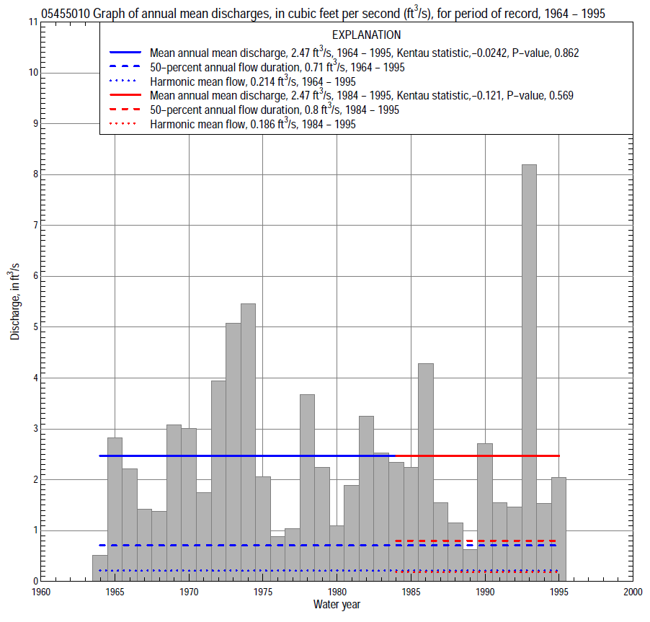

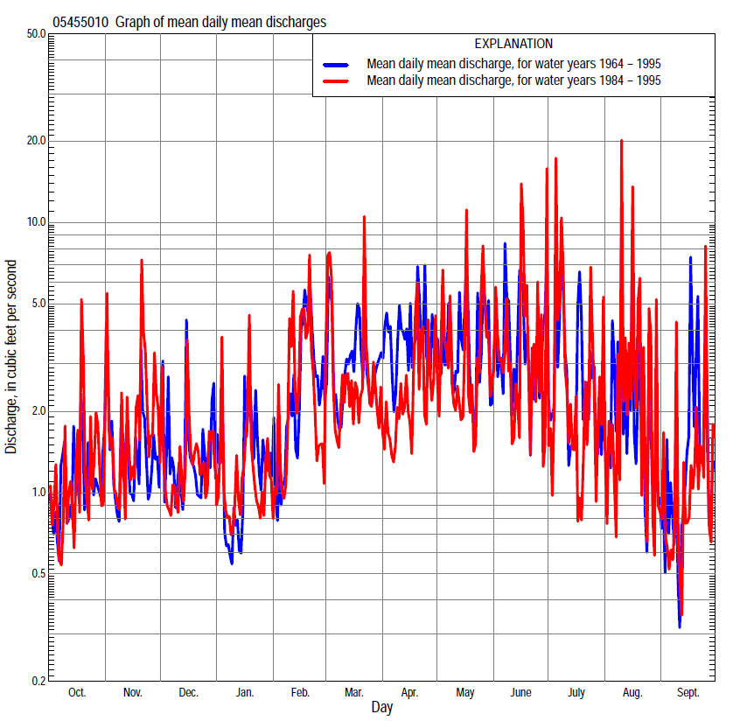

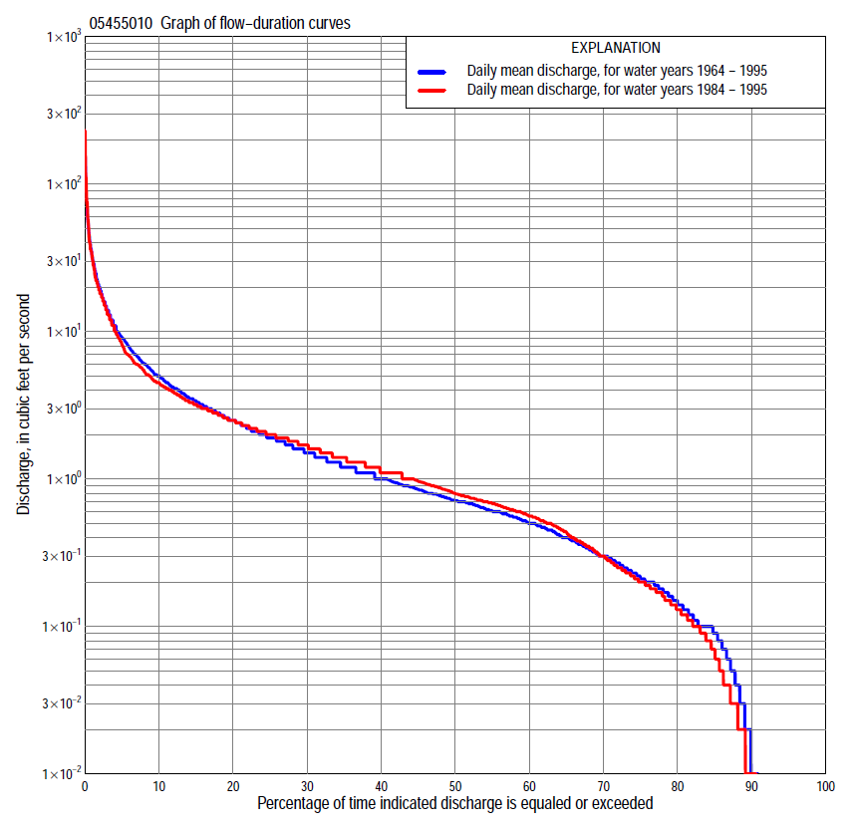

Statistics Based on the Entire Streamflow Period of Record
05455010 Monthly and annual flow durations, based on 1964–95 period of record (32 years)
[ND, not determined]
Percentage of days discharge equaled or exceeded |  |  |  |  | Discharge (cubic feet per second) |  |  |  |  |  |  |  |  | Annual flow durations
 | Oct | Nov | Dec | Jan | Feb | Mar | Apr | May | June | July | Aug | Sept | Annual | Kentau statistic | P-value
99 | 0.00 | 0.00 | 0.00 | 0.00 | 0.00 | 0.10 | 0.14 | 0.01 | 0.00 | 0.00 | 0.00 | 0.00 | 0.00 | 0.000 | ND
98 | 0.00 | 0.00 | 0.00 | 0.00 | 0.00 | 0.14 | 0.21 | 0.09 | 0.00 | 0.00 | 0.00 | 0.00 | 0.00 | 0.000 | ND
95 | 0.00 | 0.00 | 0.00 | 0.00 | 0.00 | 0.21 | 0.34 | 0.18 | 0.03 | 0.00 | 0.00 | 0.00 | 0.00 | 0.000 | ND
90 | 0.00 | 0.02 | 0.00 | 0.00 | 0.03 | 0.36 | 0.53 | 0.29 | 0.13 | 0.01 | 0.00 | 0.00 | 0.01 | 0.000 | ND
85 | 0.00 | 0.10 | 0.02 | 0.08 | 0.10 | 0.49 | 0.68 | 0.38 | 0.22 | 0.06 | 0.00 | 0.00 | 0.09 | 0.054 | 0.159
80 | 0.02 | 0.12 | 0.10 | 0.13 | 0.14 | 0.60 | 0.80 | 0.48 | 0.33 | 0.10 | 0.02 | 0.00 | 0.15 | 0.054 | 0.159
75 | 0.05 | 0.19 | 0.20 | 0.16 | 0.20 | 0.66 | 0.91 | 0.56 | 0.45 | 0.15 | 0.05 | 0.03 | 0.21 | 0.032 | 0.559
70 | 0.09 | 0.24 | 0.30 | 0.20 | 0.25 | 0.71 | 1.1 | 0.64 | 0.54 | 0.20 | 0.10 | 0.08 | 0.30 | 0.058 | 0.365
65 | 0.13 | 0.32 | 0.38 | 0.24 | 0.33 | 0.84 | 1.2 | 0.75 | 0.60 | 0.26 | 0.14 | 0.12 | 0.40 | 0.058 | 0.365
60 | 0.20 | 0.45 | 0.45 | 0.30 | 0.47 | 0.97 | 1.4 | 0.87 | 0.71 | 0.33 | 0.20 | 0.16 | 0.50 | 0.038 | 0.609
55 | 0.27 | 0.58 | 0.52 | 0.40 | 0.60 | 1.2 | 1.6 | 1.0 | 0.81 | 0.45 | 0.28 | 0.21 | 0.61 | 0.010 | 0.918
50 | 0.39 | 0.67 | 0.62 | 0.50 | 0.70 | 1.4 | 1.8 | 1.2 | 0.97 | 0.57 | 0.36 | 0.29 | 0.71 | 0.026 | 0.786
45 | 0.50 | 0.78 | 0.72 | 0.60 | 0.80 | 1.6 | 2.0 | 1.5 | 1.1 | 0.68 | 0.42 | 0.35 | 0.85 | -0.010 | 0.940
40 | 0.60 | 0.91 | 0.85 | 0.70 | 0.95 | 1.9 | 2.3 | 1.8 | 1.3 | 0.82 | 0.52 | 0.41 | 1.0 | 0.135 | 0.243
35 | 0.74 | 1.1 | 0.97 | 0.80 | 1.1 | 2.2 | 2.6 | 2.3 | 1.8 | 1.1 | 0.66 | 0.52 | 1.2 | 0.018 | 0.888
30 | 0.94 | 1.2 | 1.1 | 0.90 | 1.4 | 2.7 | 3.1 | 2.8 | 2.2 | 1.4 | 0.81 | 0.66 | 1.5 | -0.028 | 0.823
25 | 1.1 | 1.5 | 1.4 | 1.0 | 1.9 | 3.2 | 3.5 | 3.3 | 2.9 | 1.8 | 1.0 | 0.90 | 1.9 | -0.016 | 0.906
20 | 1.5 | 1.7 | 1.7 | 1.2 | 2.5 | 4.0 | 4.4 | 4.2 | 3.6 | 2.4 | 1.5 | 1.3 | 2.5 | 0.008 | 0.960
15 | 1.9 | 2.1 | 2.1 | 1.5 | 3.5 | 5.1 | 5.7 | 5.7 | 4.8 | 3.4 | 2.2 | 1.9 | 3.4 | -0.008 | 0.960
10 | 2.6 | 3.1 | 2.9 | 2.3 | 5.2 | 6.6 | 7.7 | 7.9 | 7.4 | 5.2 | 3.8 | 3.1 | 5.0 | -0.020 | 0.883
5 | 4.4 | 5.0 | 4.7 | 5.0 | 11 | 12 | 13 | 13 | 17 | 12 | 9.0 | 6.1 | 9.1 | -0.036 | 0.781
2 | 8.4 | 9.9 | 8.8 | 10 | 25 | 20 | 27 | 25 | 32 | 26 | 22 | 14 | 20 | -0.067 | 0.603
1 | 12 | 15 | 14 | 20 | 33 | 29 | 37 | 39 | 45 | 46 | 40 | 24 | 32 | -0.010 | 0.948

05455010 Annual exceedance probability of instantaneous peak discharges, in cubic feet per second (ft³/s), based on the Weighted Independent Estimates method,
Annual exceed-ance probability | Recur-rence interval (years) | Discharge (ft³/s) | 95-percent lower confi-dence interval (ft³/s) | 95-percent upper confi-dence interval (ft³/s)
0.500 | 2 | 527 | 446 | 623
0.200 | 5 | 708 | 597 | 839
0.100 | 10 | 857 | 714 | 1,030
0.040 | 25 | 1,090 | 890 | 1,340
0.020 | 50 | 1,260 | 1,010 | 1,590
0.010 | 100 | 1,430 | 1,110 | 1,840
0.005 | 200 | 1,640 | 1,230 | 2,180
0.002 | 500 | 1,800 | 1,300 | 2,490
and based on the expected moments algorithm/multiple Grubbs-Beck analysis computed using a historical period length of 17 years (1964–1980)ª
0.500 | 2 | 538 | 299 | 618
0.200 | 5 | 715 | 576 | 903
0.100 | 10 | 823 | 691 | 1,310
0.040 | 25 | 949 | 783 | 1,700
0.020 | 50 | 1,040 | 830 | 2,060
0.010 | 100 | 1,120 | 869 | 2,480
0.005 | 200 | 1,200 | 903 | 2,960
0.002 | 500 | 1,310 | 944 | 3,690
Kentau statistic |  | -0.074
P-value |  | 0.711
Begin year |  | 1964
End year |  | 1980
Number of peaks |  | 17
ªAnalysis includes only period of record prior to installation of flood retention dam.

05455010 Annual exceedance probability of high discharges, based on 1964–80 period of record (17 years)ª
Annual exceedance probability | Recur-rence interval (years) | Maximum average discharge (cubic feet per second) for indicated number of consecutive days
 |  | 1 | 3 | 7 | 15 | 30
0.990 | 1.01 | 11 | 6.0 | 3.6 | 2.3 | 1.4
0.950 | 1.05 | 19 | 12 | 6.7 | 4.3 | 2.6
0.900 | 1.11 | 26 | 16 | 8.9 | 5.7 | 3.5
0.800 | 1.25 | 36 | 22 | 12 | 7.8 | 4.9
0.500 | 2 | 66 | 38 | 20 | 13 | 8.7
0.200 | 5 | 111 | 57 | 31 | 19 | 14
0.100 | 10 | 143 | 69 | 36 | 22 | 17
0.040 | 25 | 183 | 81 | 42 | 26 | 21
0.020 | 50 | 212 | 89 | 46 | 28 | 24
0.010 | 100 | 241 | 95 | 49 | 30 | 26
0.005 | 200 | 269 | 101 | 52 | 31 | 28
0.002 | 500 | 306 | 107 | 55 | 33 | 31
Kentau statistic |  | -0.243 | -0.257 | -0.191 | -0.015 | 0.015
P-value |  | 0.187 | 0.161 | 0.303 | 0.967 | 0.967
ªAnalysis includes only period of record prior to installation of flood retention dam.

 | 05455010 Annual nonexceedance probability of low discharges, based on April 1964 to March 1995 period of record (31 years)
Annual nonexceed-ance probability | Recur-rence interval (years) | Minimum average discharge (cubic feet per second) for indicated number of consecutive days
 |  | 1 | 3 | 7 | 14 | 30 | 60 | 90 | 120 | 183
0.01 | 100 | 0.00 | 0.00 | 0.00 | 0.00 | 0.00 | 0.00 | 0.01 | 0.01 | 0.07
0.02 | 50 | 0.00 | 0.00 | 0.00 | 0.00 | 0.00 | 0.00 | 0.01 | 0.02 | 0.10
0.05 | 20 | 0.00 | 0.00 | 0.00 | 0.00 | 0.00 | 0.01 | 0.03 | 0.06 | 0.17
0.10 | 10 | 0.00 | 0.00 | 0.00 | 0.00 | 0.00 | 0.03 | 0.08 | 0.16 | 0.26
0.20 | 5 | 0.00 | 0.00 | 0.00 | 0.00 | 0.03 | 0.08 | 0.18 | 0.26 | 0.42
0.50 | 2 | 0.00 | 0.00 | 0.00 | 0.03 | 0.14 | 0.33 | 0.48 | 0.62 | 0.92
0.80 | 1.25 | 0.13 | 0.16 | 0.17 | 0.20 | 0.39 | 0.66 | 0.92 | 1.2 | 1.7
0.90 | 1.11 | 0.22 | 0.25 | 0.32 | 0.38 | 0.56 | 0.90 | 1.1 | 1.4 | 2.3
0.96 | 1.04 | 0.33 | 0.36 | 0.43 | 0.63 | 0.75 | 1.1 | 1.5 | 2.0 | 2.9
0.98 | 1.02 | 0.43 | 0.44 | 0.52 | 0.89 | 0.89 | 1.4 | 1.7 | 2.3 | 3.4
0.99 | 1.01 | 0.52 | 0.56 | 0.59 | 1.2 | 1.3 | 1.6 | 1.9 | 2.6 | 3.8
Kentau statistic |  | 0.013 | 0.022 | 0.009 | 0.041 | 0.060 | -0.041 | -0.006 | -0.062 | -0.002
P-value |  | 0.922 | 0.864 | 0.957 | 0.757 | 0.646 | 0.760 | 0.973 | 0.634 | 1.000

05455010 Annual nonexceedance probability of seasonal low discharges, based on October 1963 to September 1995 period of record (32 years)
Annual nonexceed-ance probability | Recur-rence interval (years) | Minimum average discharge (cubic feet per second) for indicated number of consecutive days
 |  | 1 | 7 | 14 | 30 |  | 1 | 7 | 14 | 30
 |  | January-February-March |  |  |  |  | April-May-June
0.01 | 100 | 0.00 | 0.00 | 0.00 | 0.00 |  | 0.00 | 0.00 | 0.02 | 0.11
0.02 | 50 | 0.00 | 0.00 | 0.00 | 0.00 |  | 0.00 | 0.00 | 0.03 | 0.14
0.05 | 20 | 0.00 | 0.00 | 0.00 | 0.02 |  | 0.00 | 0.01 | 0.06 | 0.21
0.10 | 10 | 0.00 | 0.00 | 0.00 | 0.06 |  | 0.00 | 0.04 | 0.10 | 0.30
0.20 | 5 | 0.00 | 0.00 | 0.02 | 0.13 |  | 0.10 | 0.14 | 0.20 | 0.47
0.50 | 2 | 0.15 | 0.17 | 0.19 | 0.42 |  | 0.26 | 0.54 | 0.59 | 1.1
0.80 | 1.25 | 0.39 | 0.53 | 0.68 | 1.1 |  | 0.57 | 0.90 | 1.3 | 2.6
0.90 | 1.11 | 0.57 | 0.77 | 1.1 | 1.7 |  | 0.82 | 1.0 | 1.9 | 4.2
0.96 | 1.04 | 0.80 | 1.0 | 1.6 | 2.6 |  | 1.2 | 1.2 | 2.5 | 6.9
0.98 | 1.02 | 1.0 | 1.2 | 1.9 | 3.3 |  | 1.5 | 1.5 | 3.0 | 10
0.99 | 1.01 | 1.1 | 1.3 | 2.2 | 4.1 |  | 1.9 | 1.9 | 3.4 | 13
Kentau statistic |  | 0.280 | 0.276 | 0.256 | 0.093 |  | -0.119 | -0.081 | -0.089 | -0.056
P-value |  | 0.023 | 0.027 | 0.041 | 0.466 |  | 0.346 | 0.527 | 0.486 | 0.662
 |  | July-August-September |  |  |  |  | October-November-December
0.01 | 100 | 0.00 | 0.00 | 0.00 | 0.00 |  | 0.00 | 0.00 | 0.00 | 0.00
0.02 | 50 | 0.00 | 0.00 | 0.00 | 0.01 |  | 0.00 | 0.00 | 0.00 | 0.00
0.05 | 20 | 0.00 | 0.00 | 0.00 | 0.01 |  | 0.00 | 0.00 | 0.00 | 0.00
0.10 | 10 | 0.00 | 0.00 | 0.00 | 0.03 |  | 0.00 | 0.00 | 0.00 | 0.00
0.20 | 5 | 0.00 | 0.00 | 0.00 | 0.06 |  | 0.00 | 0.00 | 0.01 | 0.07
0.50 | 2 | 0.00 | 0.01 | 0.05 | 0.24 |  | 0.09 | 0.15 | 0.18 | 0.41
0.80 | 1.25 | 0.19 | 0.24 | 0.30 | 0.73 |  | 0.31 | 0.51 | 0.63 | 1.0
0.90 | 1.11 | 0.35 | 0.57 | 0.64 | 1.2 |  | 0.48 | 0.66 | 0.94 | 1.2
0.96 | 1.04 | 0.58 | 1.2 | 1.4 | 1.9 |  | 0.71 | 0.76 | 1.3 | 1.4
0.98 | 1.02 | 0.77 | 1.7 | 2.1 | 2.5 |  | 0.88 | 0.88 | 1.5 | 1.5
0.99 | 1.01 | 1.0 | 2.3 | 3.1 | 3.1 |  | 1.0 | 1.0 | 1.6 | 1.6
Kentau statistic |  | -0.024 | 0.014 | -0.002 | 0.101 |  | 0.018 | -0.012 | 0.060 | 0.119
P-value |  | 0.837 | 0.920 | 1.000 | 0.427 |  | 0.895 | 0.935 | 0.637 | 0.347

Statistics Based on the 1984–2013 Streamflow Period of Record
05455010 Monthly and annual flow durations, based on 1984–95 period of record (12 years)
[ND, not determined]
Percentage of days discharge equaled or exceeded |  |  |  |  | Discharge (cubic feet per second) |  |  |  |  |  |  |  |  | Annual flow durations
 | Oct | Nov | Dec | Jan | Feb | Mar | Apr | May | June | July | Aug | Sept | Annual | Kentau statistic | P-value
99 | 0.00 | 0.00 | 0.00 | 0.00 | 0.00 | 0.11 | 0.10 | 0.00 | 0.00 | 0.00 | 0.00 | 0.00 | 0.00 | 0.000 | ND
98 | 0.00 | 0.00 | 0.00 | 0.07 | 0.00 | 0.14 | 0.13 | 0.01 | 0.00 | 0.00 | 0.00 | 0.00 | 0.00 | 0.000 | ND
95 | 0.00 | 0.00 | 0.00 | 0.10 | 0.02 | 0.19 | 0.20 | 0.09 | 0.00 | 0.00 | 0.00 | 0.00 | 0.00 | 0.000 | ND
90 | 0.00 | 0.04 | 0.00 | 0.15 | 0.03 | 0.42 | 0.47 | 0.19 | 0.04 | 0.00 | 0.00 | 0.00 | 0.01 | 0.000 | ND
85 | 0.00 | 0.11 | 0.03 | 0.20 | 0.12 | 0.61 | 0.66 | 0.27 | 0.09 | 0.00 | 0.00 | 0.00 | 0.07 | 0.106 | 0.385
80 | 0.03 | 0.14 | 0.28 | 0.24 | 0.20 | 0.68 | 0.74 | 0.35 | 0.17 | 0.01 | 0.00 | 0.00 | 0.13 | 0.106 | 0.385
75 | 0.05 | 0.19 | 0.36 | 0.30 | 0.25 | 0.77 | 0.87 | 0.51 | 0.24 | 0.05 | 0.02 | 0.00 | 0.20 | 0.106 | 0.385
70 | 0.08 | 0.29 | 0.44 | 0.39 | 0.48 | 0.89 | 0.96 | 0.60 | 0.35 | 0.10 | 0.07 | 0.01 | 0.30 | 0.000 | 1.000
65 | 0.11 | 0.54 | 0.52 | 0.48 | 0.59 | 1.0 | 1.1 | 0.69 | 0.55 | 0.17 | 0.10 | 0.05 | 0.43 | 0.000 | 1.000
60 | 0.17 | 0.62 | 0.61 | 0.52 | 0.66 | 1.2 | 1.2 | 0.87 | 0.65 | 0.25 | 0.16 | 0.10 | 0.56 | 0.015 | 1.000
55 | 0.20 | 0.72 | 0.72 | 0.60 | 0.74 | 1.4 | 1.3 | 1.1 | 0.84 | 0.37 | 0.21 | 0.15 | 0.68 | 0.015 | 1.000
50 | 0.26 | 0.79 | 0.85 | 0.70 | 0.82 | 1.5 | 1.5 | 1.4 | 1.1 | 0.50 | 0.30 | 0.19 | 0.80 | -0.106 | 0.583
45 | 0.38 | 1.1 | 0.94 | 0.77 | 0.94 | 1.7 | 1.6 | 1.7 | 1.3 | 0.67 | 0.37 | 0.26 | 0.97 | -0.167 | 0.408
40 | 0.52 | 1.2 | 1.0 | 0.82 | 1.0 | 1.9 | 1.8 | 2.2 | 1.6 | 0.86 | 0.50 | 0.38 | 1.1 | -0.136 | 0.546
35 | 0.82 | 1.3 | 1.1 | 0.92 | 1.2 | 2.2 | 1.9 | 2.5 | 2.0 | 1.2 | 0.66 | 0.50 | 1.4 | -0.136 | 0.546
30 | 1.1 | 1.7 | 1.3 | 1.0 | 1.5 | 2.5 | 2.2 | 2.9 | 2.4 | 1.4 | 0.87 | 0.76 | 1.7 | -0.106 | 0.654
25 | 1.5 | 2.0 | 1.7 | 1.1 | 1.8 | 3.0 | 2.4 | 3.5 | 3.0 | 1.8 | 1.3 | 1.2 | 2.0 | -0.182 | 0.395
20 | 1.8 | 2.4 | 1.9 | 1.3 | 2.3 | 3.5 | 2.8 | 4.1 | 3.6 | 2.5 | 1.9 | 1.5 | 2.5 | -0.030 | 0.942
15 | 2.2 | 3.0 | 2.3 | 1.6 | 3.2 | 4.1 | 3.4 | 5.0 | 4.7 | 3.2 | 2.8 | 2.0 | 3.2 | -0.091 | 0.723
10 | 3.0 | 4.4 | 2.8 | 2.3 | 4.6 | 5.8 | 4.3 | 6.9 | 7.2 | 5.3 | 4.4 | 3.0 | 4.5 | -0.061 | 0.834
5 | 5.1 | 6.7 | 4.0 | 3.8 | 11 | 8.6 | 7.1 | 11 | 17 | 13 | 13 | 4.5 | 8.2 | -0.045 | 0.890
2 | 11 | 13 | 6.3 | 7.8 | 25 | 20 | 18 | 19 | 35 | 30 | 27 | 10 | 18 | 0.076 | 0.782
1 | 14 | 17 | 8.9 | 9.6 | 33 | 27 | 24 | 35 | 42 | 50 | 46 | 16 | 31 | 0.106 | 0.680

(Annual nonexceedance probability of high discharges not determined because of. installation of flood retention dam.)

 | 05455010 Annual nonexceedance probability of low discharges, based on April 1983 to March 1995 period of record (12 years)
Annual nonexceed-ance probability | Recur-rence interval (years) | Minimum average discharge (cubic feet per second) for indicated number of consecutive days
 |  | 1 | 3 | 7 | 14 | 30 | 60 | 90 | 120 | 183
0.01 | 100 | 0.00 | 0.00 | 0.00 | 0.00 | 0.00 | 0.00 | 0.02 | 0.05 | 0.11
0.02 | 50 | 0.00 | 0.00 | 0.00 | 0.00 | 0.00 | 0.00 | 0.04 | 0.07 | 0.15
0.05 | 20 | 0.00 | 0.00 | 0.00 | 0.00 | 0.00 | 0.01 | 0.07 | 0.11 | 0.22
0.10 | 10 | 0.00 | 0.00 | 0.00 | 0.00 | 0.00 | 0.03 | 0.11 | 0.16 | 0.30
0.20 | 5 | 0.00 | 0.00 | 0.00 | 0.00 | 0.02 | 0.09 | 0.19 | 0.26 | 0.43
0.50 | 2 | 0.00 | 0.00 | 0.00 | 0.02 | 0.13 | 0.32 | 0.45 | 0.54 | 0.83
0.80 | 1.25 | 0.12 | 0.14 | 0.15 | 0.17 | 0.40 | 0.59 | 0.83 | 1.0 | 1.5
0.90 | 1.11 | 0.19 | 0.23 | 0.29 | 0.34 | 0.58 | 0.67 | 1.1 | 1.3 | 2.0
0.96 | 1.04 | 0.32 | 0.38 | 0.44 | 0.65 | 0.78 | 0.92 | 1.3 | 1.8 | 2.6
0.98 | 1.02 | 0.46 | 0.48 | 0.54 | 0.90 | 0.90 | 1.3 | 1.5 | 2.0 | 3.1
0.99 | 1.01 | 0.66 | 0.74 | 0.89 | 1.1 | 1.3 | 1.4 | 1.6 | 2.3 | 3.6
Kentau statistic |  | 0.076 | -0.030 | -0.076 | -0.091 | -0.091 | -0.121 | 0.000 | -0.091 | -0.030
P-value |  | 0.715 | 0.934 | 0.758 | 0.721 | 0.732 | 0.631 | 1.000 | 0.732 | 0.945

05455010 Annual nonexceedance probability of seasonal low discharges, based on October 1983 to September 1995 period of record (12 years)
Annual nonexceed-ance probability | Recur-rence interval (years) | Minimum average discharge (cubic feet per second) for indicated number of consecutive days
 |  | 1 | 7 | 14 | 30 |  | 1 | 7 | 14 | 30
 |  | January-February-March |  |  |  |  | April-May-June
0.01 | 100 | 0.00 | 0.00 | 0.00 | 0.03 |  | 0.00 | 0.00 | 0.00 | 0.06
0.02 | 50 | 0.00 | 0.00 | 0.00 | 0.04 |  | 0.00 | 0.00 | 0.01 | 0.08
0.05 | 20 | 0.00 | 0.00 | 0.01 | 0.07 |  | 0.00 | 0.00 | 0.02 | 0.14
0.10 | 10 | 0.00 | 0.01 | 0.02 | 0.12 |  | 0.00 | 0.00 | 0.05 | 0.23
0.20 | 5 | 0.04 | 0.07 | 0.08 | 0.21 |  | 0.00 | 0.04 | 0.11 | 0.40
0.50 | 2 | 0.28 | 0.32 | 0.41 | 0.54 |  | 0.22 | 0.40 | 0.44 | 1.1
0.80 | 1.25 | 0.60 | 0.76 | 1.03 | 1.2 |  | 0.51 | 1.0 | 1.2 | 2.8
0.90 | 1.11 | 0.76 | 1.04 | 1.3 | 1.7 |  | 0.78 | 1.2 | 1.9 | 4.5
0.96 | 1.04 | 0.89 | 1.3 | 1.5 | 2.4 |  | 1.2 | 1.3 | 2.6 | 7.4
0.98 | 1.02 | 1.0 | 1.5 | 1.6 | 2.9 |  | 1.6 | 1.6 | 3.2 | 10
0.99 | 1.01 | 1.0 | 1.6 | 1.7 | 3.4 |  | 2.1 | 2.1 | 3.7 | 13
Kentau statistic |  | -0.258 | -0.303 | -0.212 | -0.061 |  | 0.015 | 0.091 | 0.061 | 0.091
P-value |  | 0.271 | 0.193 | 0.373 | 0.837 |  | 1.000 | 0.732 | 0.837 | 0.732
 |  | July-August-September |  |  |  |  | October-November-December
0.01 | 100 | 0.00 | 0.00 | 0.00 | 0.00 |  | 0.00 | 0.00 | 0.00 | 0.00
0.02 | 50 | 0.00 | 0.00 | 0.00 | 0.00 |  | 0.00 | 0.00 | 0.00 | 0.00
0.05 | 20 | 0.00 | 0.00 | 0.00 | 0.01 |  | 0.00 | 0.00 | 0.00 | 0.00
0.10 | 10 | 0.00 | 0.00 | 0.00 | 0.01 |  | 0.00 | 0.00 | 0.00 | 0.01
0.20 | 5 | 0.00 | 0.00 | 0.00 | 0.03 |  | 0.00 | 0.00 | 0.00 | 0.09
0.50 | 2 | 0.00 | 0.00 | 0.02 | 0.19 |  | 0.06 | 0.11 | 0.18 | 0.43
0.80 | 1.25 | 0.18 | 0.23 | 0.38 | 0.96 |  | 0.31 | 0.48 | 0.69 | 1.0
0.90 | 1.11 | 0.47 | 0.86 | 1.0 | 2.1 |  | 0.54 | 0.72 | 1.1 | 1.4
0.96 | 1.04 | 0.97 | 2.4 | 2.5 | 4.4 |  | 0.91 | 0.99 | 1.5 | 1.7
0.98 | 1.02 | 1.5 | 4.1 | 4.3 | 7.0 |  | 1.2 | 1.2 | 1.7 | 1.8
0.99 | 1.01 | 2.1 | 6.3 | 6.8 | 10 |  | 1.3 | 1.3 | 1.9 | 1.9
Kentau statistic |  | 0.030 | -0.076 | 0.000 | 0.061 |  | 0.061 | 0.000 | -0.136 | -0.121
P-value |  | 0.927 | 0.768 | 1.000 | 0.837 |  | 0.830 | 1.000 | 0.582 | 0.631

