LOCATION.--Lat 41°28'11", long 91°42'52" referenced to North American Datum of 1927, in NW 1/4 SW 1/4 SW 1/4 sec.18, T.77 N., R.7 W., Washington County, IA, Hydrologic Unit 07080209, on right bank 30 ft upstream from bridge on State Highway 1, 0.8 mi south of Kalona, 1.1 mi upstream from Camp Creek, 4.5 mi downstream from Smith Creek, and 17.0 mi upstream from mouth.

DRAINAGE AREA.--574 mi².

PERIOD OF RECORD.--Discharge records from September 1939 to current year.

GAGE.--Water-stage recorder. Datum of gage is 633.45 ft above National Geodetic Vertical Datum of 1929 (levels by U.S. Army Corps of Engineers). Prior to December 27, 1939, non-recording gage at site 30 ft downstream at same datum.

EXTREMES OUTSIDE PERIOD OF RECORD.--Flood in June 30, 1930, reached a stage of 19.90 ft, from high-water mark, from information by local residents, discharge 18,500 ft³/s.

A summary of all available data for this streamgage is provided through the USGS National Water Information System web interface (NWISWeb). The following link provides access to current/historical observations, daily data, daily statistics, monthly statistics, annual statistics, peak streamflow, field measurements, field/lab water-quality samples, and the latest water-year summaries. Data can be filtered by parameter and/or dates, and can be output in various tabular and graphical formats.
http://waterdata.usgs.gov/nwis/inventory/?site_no=05455500

The USGS WaterWatch Toolkit is available at:
http://waterwatch.usgs.gov/?id=ww_toolkit
Tools for summarizing streamflow information include the duration hydrograph builder, the cumulative streamflow hydrograph builder, the streamgage statistics retrieval tool, the rating curve builder, the flood tracking chart builder, the National Weather Service Advanced Hydrologic Prediction Service (AHPS) river forecast hydrograph builder, and the raster-hydrograph builder. Entering the above number for this streamgage into these toolkit webpages will provide streamflow information specific to this streamgage.

A description of the statistics presented for this streamgage is available in the main body of the report at:
http://dx.doi.org/10.3133/ofr20151214
A link to other streamgages included in this report, a map showing the location of the streamgages, information on the programs used to compute the statistical analyses, and references are included in the main body of the report.

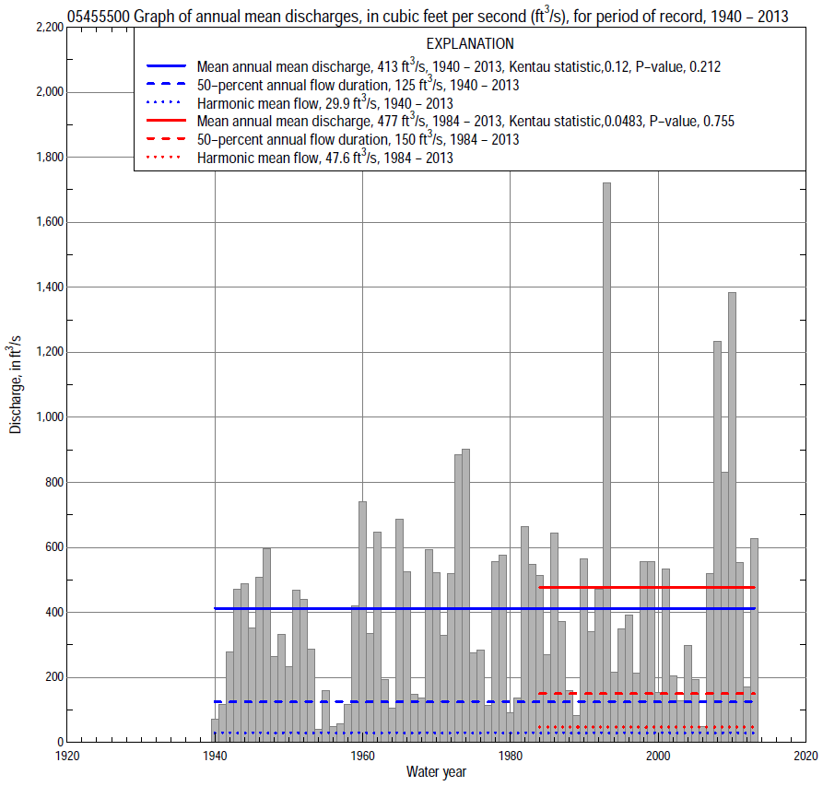

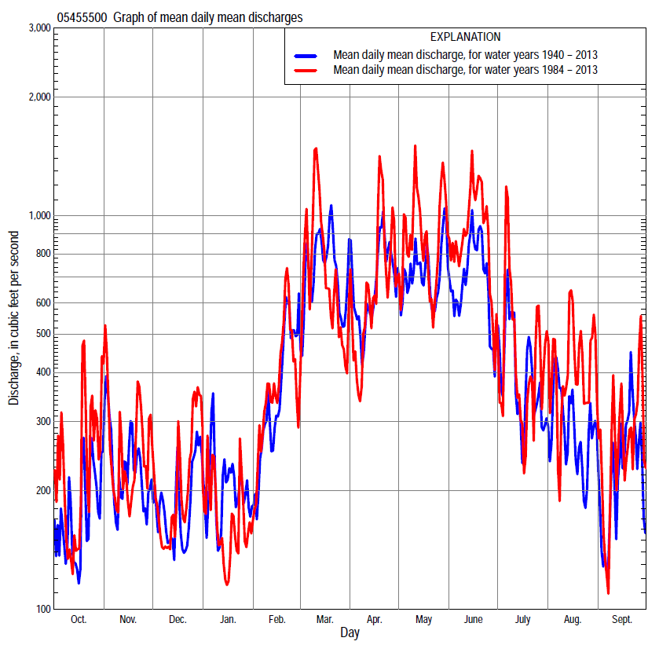

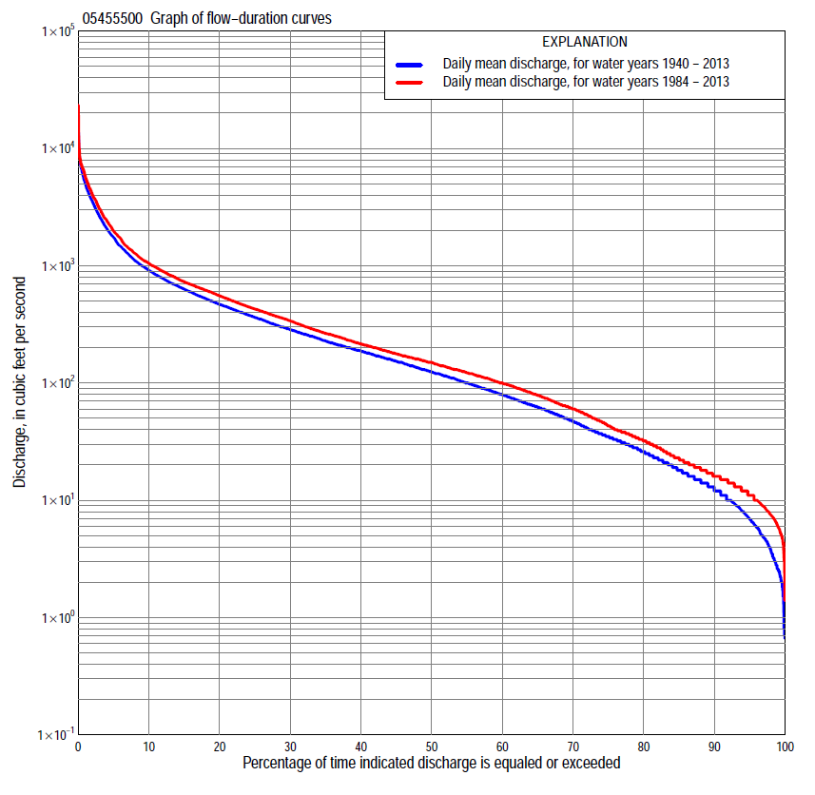

Statistics Based on the Entire Streamflow Period of Record
05455500 Monthly and annual flow durations, based on 1940–2013 period of record (74 years)
Percentage of days discharge equaled or exceeded |  |  |  |  | Discharge (cubic feet per second) |  |  |  |  |  |  |  |  | Annual flow durations
 | Oct | Nov | Dec | Jan | Feb | Mar | Apr | May | June | July | Aug | Sept | Annual | Kentau statistic | P-value
99 | 2.4 | 2.2 | 2.3 | 0.80 | 2.5 | 9.6 | 7.0 | 9.1 | 6.0 | 3.5 | 3.2 | 2.4 | 2.6 | 0.177 | 0.026
98 | 3.0 | 3.9 | 2.8 | 1.6 | 3.5 | 11 | 15 | 13 | 10 | 4.4 | 5.0 | 3.0 | 3.7 | 0.170 | 0.032
95 | 4.7 | 5.8 | 4.2 | 2.8 | 8.0 | 32 | 37 | 26 | 24 | 10 | 8.5 | 5.9 | 7.0 | 0.178 | 0.025
90 | 6.5 | 9.1 | 6.6 | 8.4 | 17 | 56 | 66 | 63 | 40 | 22 | 12 | 8.4 | 13 | 0.188 | 0.018
85 | 8.2 | 13 | 11 | 14 | 23 | 79 | 95 | 90 | 55 | 33 | 16 | 11 | 18 | 0.192 | 0.016
80 | 11 | 19 | 15 | 20 | 36 | 102 | 123 | 111 | 73 | 44 | 19 | 13 | 26 | 0.177 | 0.026
75 | 13 | 26 | 21 | 27 | 52 | 133 | 143 | 137 | 97 | 56 | 22 | 15 | 35 | 0.167 | 0.036
70 | 16 | 32 | 30 | 32 | 70 | 169 | 168 | 162 | 123 | 67 | 26 | 17 | 47 | 0.165 | 0.037
65 | 19 | 37 | 37 | 37 | 83 | 200 | 199 | 194 | 158 | 78 | 30 | 20 | 62 | 0.146 | 0.066
60 | 23 | 46 | 50 | 49 | 100 | 226 | 233 | 229 | 190 | 90 | 35 | 23 | 80 | 0.144 | 0.069
55 | 31 | 62 | 62 | 65 | 120 | 256 | 282 | 275 | 233 | 104 | 40 | 26 | 100 | 0.137 | 0.084
50 | 43 | 74 | 78 | 86 | 150 | 290 | 331 | 323 | 282 | 119 | 47 | 31 | 125 | 0.145 | 0.069
45 | 54 | 95 | 103 | 100 | 180 | 338 | 382 | 389 | 348 | 136 | 55 | 38 | 153 | 0.145 | 0.068
40 | 68 | 120 | 125 | 120 | 210 | 400 | 439 | 447 | 412 | 160 | 66 | 50 | 187 | 0.141 | 0.076
35 | 86 | 154 | 150 | 135 | 250 | 478 | 499 | 526 | 489 | 190 | 80 | 63 | 229 | 0.127 | 0.112
30 | 115 | 186 | 175 | 160 | 300 | 600 | 591 | 615 | 590 | 234 | 100 | 82 | 285 | 0.128 | 0.107
25 | 164 | 229 | 208 | 185 | 357 | 725 | 699 | 725 | 717 | 293 | 129 | 110 | 363 | 0.130 | 0.102
20 | 220 | 298 | 250 | 220 | 440 | 906 | 840 | 865 | 888 | 386 | 179 | 148 | 468 | 0.146 | 0.067
15 | 300 | 385 | 317 | 279 | 579 | 1,200 | 1,060 | 1,090 | 1,120 | 541 | 266 | 231 | 632 | 0.115 | 0.148
10 | 444 | 512 | 420 | 380 | 830 | 1,810 | 1,480 | 1,550 | 1,760 | 854 | 474 | 450 | 914 | 0.085 | 0.285
5 | 714 | 839 | 635 | 650 | 1,600 | 2,990 | 2,580 | 3,020 | 3,140 | 1,750 | 1,180 | 1,030 | 1,750 | 0.107 | 0.179
2 | 1,210 | 1,750 | 1,200 | 1,400 | 2,910 | 5,250 | 4,570 | 4,780 | 5,070 | 3,600 | 4,090 | 2,480 | 3,560 | 0.080 | 0.318
1 | 2,340 | 2,740 | 1,920 | 2,600 | 3,880 | 7,000 | 6,150 | 6,790 | 6,520 | 5,220 | 5,940 | 3,840 | 5,100 | 0.076 | 0.341

05455500 Annual exceedance probability of instantaneous peak discharges, in cubic feet per second (ft³/s), based on the Weighted Independent Estimates method,
Annual exceed-ance probability | Recur-rence interval (years) | Discharge (ft³/s) | 95-percent lower confi-dence interval (ft³/s) | 95-percent upper confi-dence interval (ft³/s)
0.500 | 2 | 6,310 | 5,390 | 7,390
0.200 | 5 | 11,200 | 9,580 | 13,200
0.100 | 10 | 15,100 | 12,700 | 18,000
0.040 | 25 | 20,600 | 16,900 | 25,200
0.020 | 50 | 24,700 | 19,600 | 31,100
0.010 | 100 | 28,800 | 22,200 | 37,400
0.005 | 200 | 34,500 | 25,600 | 46,500
0.002 | 500 | 39,100 | 27,600 | 55,400
and based on the expected moments algorithm/multiple Grubbs-Beck analysis computed using a historical period length of 84 years (1930–2013)
0.500 | 2 | 6,290 | 5,290 | 7,440
0.200 | 5 | 11,300 | 9,490 | 13,600
0.100 | 10 | 15,100 | 12,600 | 19,000
0.040 | 25 | 20,500 | 16,700 | 27,900
0.020 | 50 | 24,900 | 19,600 | 36,300
0.010 | 100 | 29,600 | 22,500 | 46,300
0.005 | 200 | 34,500 | 25,300 | 58,200
0.002 | 500 | 41,500 | 28,800 | 77,400
Kentau statistic |  | 0.076
P-value |  | 0.339
Begin year |  | 1940
End year |  | 2013
Number of peaks |  | 74

05455500 Annual exceedance probability of high discharges, based on 1940–2013 period of record (74 years)
Annual exceedance probability | Recur-rence interval (years) | Maximum average discharge (ft³/s) for indicated number of consecutive days
 |  | 1 | 3 | 7 | 15 | 30
0.990 | 1.01 | 852 | 510 | 288 | 182 | 125
0.950 | 1.05 | 1,530 | 1,030 | 622 | 412 | 285
0.900 | 1.11 | 2,060 | 1,470 | 907 | 610 | 422
0.800 | 1.25 | 2,910 | 2,190 | 1,390 | 943 | 654
0.500 | 2 | 5,460 | 4,370 | 2,850 | 1,940 | 1,350
0.200 | 5 | 9,740 | 8,010 | 5,230 | 3,460 | 2,410
0.100 | 10 | 12,900 | 10,600 | 6,880 | 4,440 | 3,100
0.040 | 25 | 17,300 | 14,000 | 8,940 | 5,600 | 3,910
0.020 | 50 | 20,600 | 16,500 | 10,400 | 6,380 | 4,460
0.010 | 100 | 24,100 | 19,000 | 11,800 | 7,100 | 4,960
0.005 | 200 | 27,700 | 21,500 | 13,200 | 7,750 | 5,410
0.002 | 500 | 32,600 | 24,700 | 14,900 | 8,520 | 5,950
Kentau statistic |  | 0.070 | 0.048 | 0.052 | 0.095 | 0.122
P-value |  | 0.383 | 0.550 | 0.514 | 0.232 | 0.126

 | 05455500 Annual nonexceedance probability of low discharges, based on April 1940 to March 2013 period of record (73 years)
Annual nonexceed-ance probability | Recur-rence interval (years) | Minimum average discharge (ft³/s) for indicated number of consecutive days
 |  | 1 | 3 | 7 | 14 | 30 | 60 | 90 | 120 | 183
0.01 | 100 | 0.60 | 0.80 | 0.88 | 1.0 | 1.1 | 1.7 | 2.3 | 2.4 | 3.6
0.02 | 50 | 0.86 | 1.1 | 1.2 | 1.3 | 1.6 | 2.4 | 3.3 | 3.6 | 5.4
0.05 | 20 | 1.5 | 1.8 | 2.0 | 2.2 | 2.8 | 4.1 | 5.6 | 6.4 | 10
0.10 | 10 | 2.3 | 2.7 | 3.0 | 3.4 | 4.4 | 6.5 | 9.0 | 11 | 17
0.20 | 5 | 4.0 | 4.5 | 5.0 | 5.6 | 7.5 | 11 | 16 | 19 | 31
0.50 | 2 | 11 | 12 | 13 | 15 | 20 | 32 | 45 | 57 | 91
0.80 | 1.25 | 29 | 30 | 33 | 38 | 52 | 90 | 123 | 159 | 237
0.90 | 1.11 | 47 | 49 | 54 | 62 | 84 | 151 | 205 | 265 | 376
0.96 | 1.04 | 78 | 83 | 90 | 104 | 138 | 259 | 347 | 447 | 594
0.98 | 1.02 | 108 | 116 | 125 | 144 | 188 | 366 | 485 | 622 | 786
0.99 | 1.01 | 143 | 157 | 168 | 193 | 247 | 498 | 653 | 830 | 999
Kentau statistic |  | 0.189 | 0.196 | 0.194 | 0.196 | 0.178 | 0.132 | 0.107 | 0.110 | 0.105
P-value |  | 0.018 | 0.015 | 0.016 | 0.014 | 0.026 | 0.098 | 0.184 | 0.172 | 0.190

05455500 Annual nonexceedance probability of seasonal low discharges, based on October 1939 to September 2013 period of record (74 years)
Annual nonexceed-ance probability | Recur-rence interval (years) | Minimum average discharge (cubic feet per second) for indicated number of consecutive days
 |  | 1 | 7 | 14 | 30 |  | 1 | 7 | 14 | 30
 |  | January-February-March |  |  |  |  | April-May-June
0.01 | 100 | 0.60 | 0.61 | 0.66 | 1.0 |  | 1.9 | 3.0 | 3.9 | 5.7
0.02 | 50 | 1.0 | 1.1 | 1.2 | 1.9 |  | 3.4 | 5.0 | 6.4 | 9.6
0.05 | 20 | 2.5 | 2.7 | 3.0 | 4.7 |  | 7.4 | 10 | 13 | 20
0.10 | 10 | 5.0 | 5.5 | 6.1 | 9.6 |  | 14 | 18 | 23 | 36
0.20 | 5 | 11 | 12 | 13 | 21 |  | 28 | 35 | 44 | 70
0.50 | 2 | 37 | 42 | 48 | 74 |  | 84 | 102 | 131 | 216
0.80 | 1.25 | 99 | 115 | 127 | 189 |  | 197 | 242 | 320 | 540
0.90 | 1.11 | 152 | 175 | 191 | 278 |  | 280 | 351 | 475 | 809
0.96 | 1.04 | 225 | 256 | 275 | 388 |  | 382 | 493 | 687 | 1,180
0.98 | 1.02 | 281 | 316 | 336 | 464 |  | 453 | 598 | 849 | 1,470
0.99 | 1.01 | 335 | 373 | 393 | 533 |  | 516 | 698 | 1,010 | 1,750
Kentau statistic |  | 0.164 | 0.167 | 0.165 | 0.081 |  | 0.167 | 0.156 | 0.177 | 0.161
P-value |  | 0.039 | 0.035 | 0.037 | 0.311 |  | 0.036 | 0.051 | 0.026 | 0.043
 |  | July-August-September |  |  |  |  | October-November-December
0.01 | 100 | 1.2 | 2.2 | 2.7 | 4.0 |  | 0.85 | 1.1 | 1.1 | 1.4
0.02 | 50 | 1.5 | 2.6 | 3.2 | 4.7 |  | 1.2 | 1.5 | 1.6 | 2.1
0.05 | 20 | 2.2 | 3.5 | 4.2 | 6.1 |  | 2.1 | 2.6 | 2.8 | 3.8
0.10 | 10 | 3.2 | 4.6 | 5.6 | 8.1 |  | 3.3 | 4.1 | 4.6 | 6.4
0.20 | 5 | 5.1 | 6.7 | 8.1 | 12 |  | 5.9 | 7.1 | 8.4 | 12
0.50 | 2 | 13 | 16 | 19 | 28 |  | 18 | 21 | 26 | 39
0.80 | 1.25 | 37 | 44 | 53 | 85 |  | 56 | 65 | 81 | 119
0.90 | 1.11 | 66 | 80 | 98 | 165 |  | 101 | 118 | 146 | 212
0.96 | 1.04 | 125 | 161 | 200 | 359 |  | 191 | 225 | 273 | 388
0.98 | 1.02 | 194 | 261 | 328 | 619 |  | 290 | 342 | 410 | 569
0.99 | 1.01 | 289 | 411 | 523 | 1,040 |  | 423 | 500 | 589 | 801
Kentau statistic |  | 0.144 | 0.145 | 0.121 | 0.078 |  | 0.155 | 0.153 | 0.159 | 0.144
P-value |  | 0.070 | 0.069 | 0.129 | 0.329 |  | 0.052 | 0.055 | 0.045 | 0.070

Statistics Based on the 1984–2013 Streamflow Period of Record
05455500 Monthly and annual flow durations, based on 1984–2013 period of record (30 years)
Percentage of days discharge equaled or exceeded |  |  |  |  | Discharge (cubic feet per second) |  |  |  |  |  |  |  |  | Annual flow durations
 | Oct | Nov | Dec | Jan | Feb | Mar | Apr | May | June | July | Aug | Sept | Annual | Kentau statistic | P-value
99 | 4.3 | 6.7 | 6.9 | 8.8 | 5.8 | 20 | 19 | 13 | 16 | 6.9 | 4.7 | 2.6 | 5.9 | 0.163 | 0.210
98 | 4.8 | 9.1 | 8.0 | 9.4 | 8.4 | 31 | 25 | 27 | 21 | 8.4 | 5.9 | 4.9 | 7.5 | 0.117 | 0.370
95 | 6.1 | 13 | 10 | 12 | 13 | 39 | 43 | 74 | 38 | 12 | 9.6 | 7.3 | 11 | 0.062 | 0.642
90 | 8.1 | 17 | 13 | 17 | 22 | 55 | 69 | 96 | 54 | 21 | 14 | 9.0 | 16 | -0.009 | 0.957
85 | 12 | 24 | 16 | 21 | 38 | 86 | 113 | 118 | 74 | 31 | 17 | 11 | 23 | 0.009 | 0.957
80 | 14 | 29 | 24 | 28 | 54 | 128 | 132 | 142 | 102 | 47 | 20 | 13 | 32 | -0.007 | 0.972
75 | 16 | 34 | 33 | 38 | 68 | 159 | 154 | 170 | 140 | 61 | 23 | 15 | 43 | -0.055 | 0.681
70 | 19 | 38 | 43 | 49 | 83 | 186 | 176 | 212 | 186 | 70 | 26 | 17 | 60 | -0.046 | 0.734
65 | 22 | 49 | 58 | 64 | 100 | 222 | 201 | 279 | 225 | 83 | 30 | 19 | 79 | -0.069 | 0.605
60 | 28 | 71 | 72 | 83 | 120 | 248 | 232 | 361 | 283 | 96 | 35 | 21 | 100 | -0.048 | 0.721
55 | 38 | 86 | 95 | 95 | 145 | 274 | 271 | 424 | 359 | 111 | 39 | 24 | 122 | -0.060 | 0.656
50 | 55 | 110 | 112 | 102 | 170 | 310 | 335 | 480 | 413 | 127 | 45 | 30 | 150 | -0.083 | 0.532
45 | 68 | 136 | 129 | 120 | 190 | 360 | 395 | 558 | 474 | 148 | 52 | 38 | 177 | -0.080 | 0.544
40 | 84 | 157 | 148 | 130 | 224 | 418 | 449 | 637 | 546 | 174 | 62 | 56 | 215 | -0.057 | 0.668
35 | 112 | 174 | 165 | 140 | 260 | 484 | 528 | 721 | 633 | 212 | 81 | 75 | 265 | -0.023 | 0.872
30 | 163 | 197 | 195 | 162 | 300 | 590 | 640 | 814 | 739 | 263 | 109 | 98 | 338 | -0.007 | 0.972
25 | 217 | 245 | 225 | 190 | 360 | 699 | 754 | 938 | 897 | 325 | 153 | 128 | 427 | 0.021 | 0.887
20 | 284 | 332 | 290 | 220 | 437 | 872 | 870 | 1,090 | 1,070 | 417 | 231 | 198 | 553 | 0.048 | 0.721
15 | 395 | 427 | 374 | 274 | 565 | 1,160 | 1,100 | 1,370 | 1,470 | 638 | 402 | 332 | 728 | 0.074 | 0.580
10 | 559 | 585 | 484 | 340 | 800 | 1,860 | 1,460 | 1,950 | 2,250 | 997 | 826 | 670 | 1,040 | 0.044 | 0.748
5 | 853 | 963 | 691 | 500 | 1,600 | 3,080 | 2,340 | 3,400 | 3,980 | 1,820 | 2,430 | 1,430 | 1,970 | 0.117 | 0.372
2 | 1,880 | 1,750 | 1,140 | 930 | 2,980 | 5,710 | 4,570 | 5,220 | 6,520 | 4,370 | 5,460 | 2,790 | 4,060 | 0.101 | 0.443
1 | 3,870 | 2,580 | 2,150 | 1,270 | 3,880 | 7,460 | 5,530 | 7,190 | 7,190 | 5,940 | 6,740 | 3,850 | 5,730 | 0.055 | 0.682

05455500 Annual exceedance probability of high discharges, based on 1984–2013 period of record (30 years)
Annual exceedance probability | Recur-rence interval (years) | Maximum average discharge (ft³/s) for indicated number of consecutive days
 |  | 1 | 3 | 7 | 15 | 30
0.990 | 1.01 | 986 | 553 | 390 | 281 | 194
0.950 | 1.05 | 1,660 | 1,080 | 738 | 530 | 384
0.900 | 1.11 | 2,180 | 1,510 | 1,020 | 729 | 536
0.800 | 1.25 | 3,020 | 2,230 | 1,480 | 1,050 | 782
0.500 | 2 | 5,610 | 4,470 | 2,910 | 2,020 | 1,490
0.200 | 5 | 10,300 | 8,380 | 5,400 | 3,630 | 2,580
0.100 | 10 | 14,100 | 11,300 | 7,280 | 4,800 | 3,320
0.040 | 25 | 19,600 | 15,300 | 9,870 | 6,340 | 4,230
0.020 | 50 | 24,200 | 18,500 | 11,900 | 7,530 | 4,870
0.010 | 100 | 29,200 | 21,700 | 14,000 | 8,720 | 5,490
0.005 | 200 | 34,600 | 25,000 | 16,200 | 9,920 | 6,080
0.002 | 500 | 42,600 | 29,500 | 19,100 | 11,500 | 6,810
Kentau statistic |  | 0.071 | 0.021 | 0.030 | 0.080 | 0.103
P-value |  | 0.592 | 0.887 | 0.830 | 0.544 | 0.432

 | 05455500 Annual nonexceedance probability of low discharges, based on April 1983 to March 2013 period of record (30 years)
Annual nonexceed-ance probability | Recur-rence interval (years) | Minimum average discharge (ft³/s) for indicated number of consecutive days
 |  | 1 | 3 | 7 | 14 | 30 | 60 | 90 | 120 | 183
0.01 | 100 | 1.1 | 1.6 | 2.1 | 2.2 | 3.3 | 4.2 | 5.1 | 5.5 | 5.9
0.02 | 50 | 1.5 | 2.0 | 2.6 | 2.7 | 4.0 | 5.2 | 6.4 | 7.1 | 8.2
0.05 | 20 | 2.3 | 2.9 | 3.6 | 3.9 | 5.4 | 7.3 | 9.2 | 11 | 14
0.10 | 10 | 3.4 | 4.0 | 4.9 | 5.4 | 7.3 | 10 | 13 | 16 | 21
0.20 | 5 | 5.5 | 6.2 | 7.3 | 8.1 | 11 | 15 | 20 | 25 | 36
0.50 | 2 | 14 | 15 | 17 | 19 | 24 | 36 | 49 | 64 | 100
0.80 | 1.25 | 37 | 38 | 42 | 48 | 62 | 97 | 135 | 178 | 272
0.90 | 1.11 | 62 | 64 | 70 | 81 | 106 | 172 | 237 | 312 | 458
0.96 | 1.04 | 107 | 114 | 125 | 142 | 194 | 328 | 445 | 581 | 795
0.98 | 1.02 | 153 | 167 | 184 | 209 | 294 | 509 | 683 | 879 | 1,140
0.99 | 1.01 | 211 | 238 | 264 | 297 | 434 | 766 | 1,010 | 1,290 | 1,560
Kentau statistic |  | 0.207 | 0.184 | 0.140 | 0.136 | 0.085 | 0.030 | -0.021 | -0.048 | -0.099
P-value |  | 0.112 | 0.158 | 0.284 | 0.301 | 0.521 | 0.830 | 0.887 | 0.721 | 0.454

05455500 Annual nonexceedance probability of seasonal low discharges, based on October 1983 to September 2013 period of record (30 years)
Annual nonexceed-ance probability | Recur-rence interval (years) | Minimum average discharge (cubic feet per second) for indicated number of consecutive days
 |  | 1 | 7 | 14 | 30 |  | 1 | 7 | 14 | 30
 |  | January-February-March |  |  |  |  | April-May-June
0.01 | 100 | 2.1 | 2.6 | 3.1 | 4.7 |  | 6.6 | 7.9 | 8.3 | 12
0.02 | 50 | 3.3 | 4.1 | 4.7 | 7.0 |  | 9.7 | 12 | 12 | 18
0.05 | 20 | 6.2 | 7.7 | 8.8 | 12 |  | 17 | 20 | 22 | 33
0.10 | 10 | 10 | 13 | 15 | 20 |  | 26 | 31 | 36 | 54
0.20 | 5 | 19 | 23 | 26 | 34 |  | 44 | 51 | 63 | 96
0.50 | 2 | 50 | 61 | 67 | 86 |  | 106 | 126 | 166 | 265
0.80 | 1.25 | 113 | 134 | 147 | 188 |  | 225 | 277 | 387 | 650
0.90 | 1.11 | 163 | 189 | 207 | 268 |  | 318 | 402 | 576 | 992
0.96 | 1.04 | 229 | 260 | 285 | 377 |  | 442 | 580 | 850 | 1,510
0.98 | 1.02 | 280 | 311 | 342 | 460 |  | 537 | 723 | 1,070 | 1,940
0.99 | 1.01 | 330 | 361 | 398 | 544 |  | 633 | 873 | 1,310 | 2,410
Kentau statistic |  | -0.115 | -0.129 | -0.101 | -0.145 |  | 0.126 | 0.113 | 0.145 | 0.200
P-value |  | 0.381 | 0.326 | 0.443 | 0.269 |  | 0.335 | 0.392 | 0.269 | 0.125
 |  | July-August-September |  |  |  |  | October-November-December
0.01 | 100 | 1.5 | 2.7 | 2.9 | 4.5 |  | 1.7 | 1.9 | 2.0 | 2.5
0.02 | 50 | 1.9 | 3.1 | 3.4 | 5.1 |  | 2.2 | 2.5 | 2.6 | 3.6
0.05 | 20 | 2.7 | 4.1 | 4.5 | 6.5 |  | 3.3 | 3.8 | 4.2 | 6.2
0.10 | 10 | 3.8 | 5.3 | 5.9 | 8.4 |  | 4.8 | 5.7 | 6.6 | 9.8
0.20 | 5 | 6.0 | 7.8 | 8.7 | 12 |  | 7.8 | 9.4 | 11 | 17
0.50 | 2 | 16 | 19 | 22 | 32 |  | 21 | 26 | 32 | 49
0.80 | 1.25 | 52 | 62 | 74 | 113 |  | 63 | 76 | 94 | 135
0.90 | 1.11 | 102 | 126 | 156 | 253 |  | 117 | 138 | 165 | 229
0.96 | 1.04 | 221 | 293 | 376 | 673 |  | 233 | 266 | 303 | 396
0.98 | 1.02 | 377 | 531 | 700 | 1,350 |  | 372 | 413 | 450 | 564
0.99 | 1.01 | 622 | 937 | 1,270 | 2,640 |  | 572 | 618 | 644 | 771
Kentau statistic |  | 0.154 | 0.122 | 0.099 | 0.057 |  | 0.048 | 0.023 | -0.016 | -0.080
P-value |  | 0.239 | 0.353 | 0.454 | 0.669 |  | 0.721 | 0.872 | 0.915 | 0.544

