LOCATION.--Lat 41°25'25.6", long 91°28'42.7" referenced to North American Datum of 1983, in NW 1/4 NE 1/4 NW 1/4 sec.06, T.76 N., R.5 W., Louisa County, IA, Hydrologic Unit 07080209, on left bank 30 ft downstream from tri-county bridge on County Highway W66, 5 mi southwest of Lone Tree, 6.2 mi downstream from English River, and 46.6 mi upstream from mouth.

DRAINAGE AREA.--4,293 mi².

PERIOD OF RECORD.--Discharge records from October 1956 to current year.

GAGE.--Water-stage recorder. Datum of gage is 588.16 ft above National Geodetic Vertical Datum of 1929. Prior to December 28, 1956, non-recording gage at same site and datum.

REMARKS.--Flow regulated by Coralville Lake (station 05453510), 36.1 mi upstream, since September 17, 1958.

EXTREMES OUTSIDE PERIOD OF RECORD.--Flood of May 25, 1944, reached a stage of 19.94 ft, from information by U.S. Army Corps of Engineers, discharge not determined.

A summary of all available data for this streamgage is provided through the USGS National Water Information System web interface (NWISWeb). The following link provides access to current/historical observations, daily data, daily statistics, monthly statistics, annual statistics, peak streamflow, field measurements, field/lab water-quality samples, and the latest water-year summaries. Data can be filtered by parameter and/or dates, and can be output in various tabular and graphical formats.
http://waterdata.usgs.gov/nwis/inventory/?site_no=05455700

The USGS WaterWatch Toolkit is available at:
http://waterwatch.usgs.gov/?id=ww_toolkit
Tools for summarizing streamflow information include the duration hydrograph builder, the cumulative streamflow hydrograph builder, the streamgage statistics retrieval tool, the rating curve builder, the flood tracking chart builder, the National Weather Service Advanced Hydrologic Prediction Service (AHPS) river forecast hydrograph builder, and the raster-hydrograph builder. Entering the above number for this streamgage into these toolkit webpages will provide streamflow information specific to this streamgage.

A description of the statistics presented for this streamgage is available in the main body of the report at:
http://dx.doi.org/10.3133/ofr20151214
A link to other streamgages included in this report, a map showing the location of the streamgages, information on the programs used to compute the statistical analyses, and references are included in the main body of the report.

Statistics Based on the Regulated Streamflow Period of Record
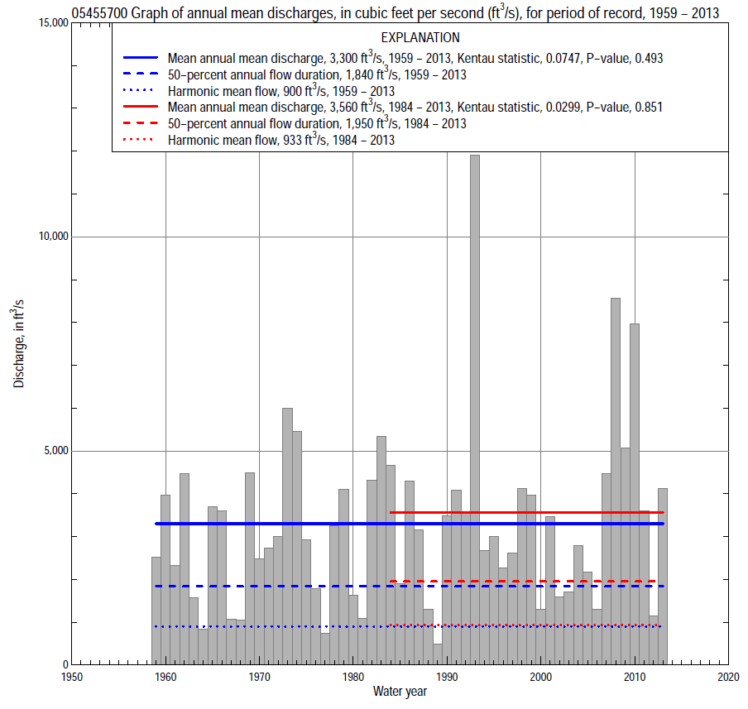

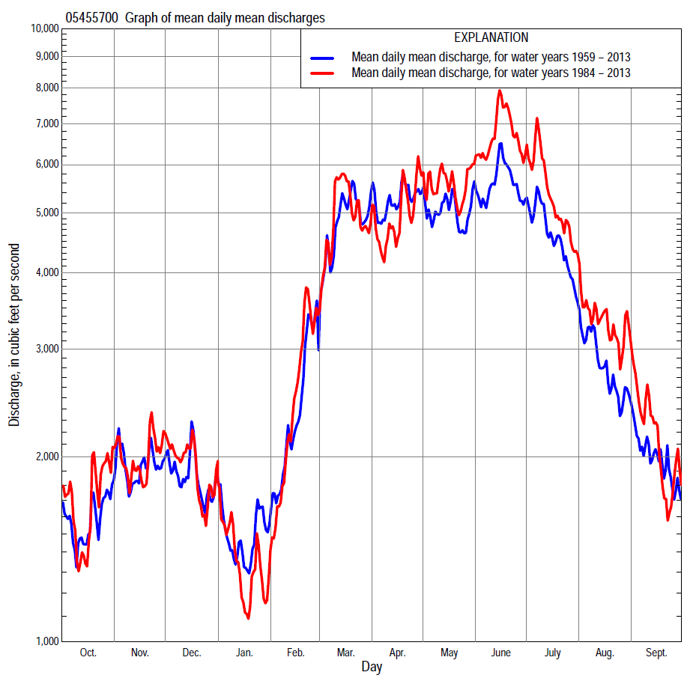

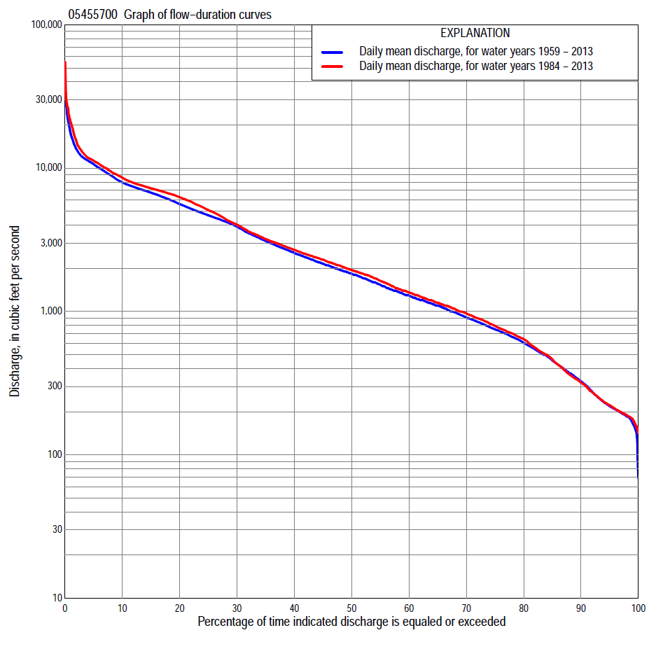

Statistics Based on the Regulated Streamflow Period of Record
05455700 Monthly and annual flow durations, based on 1959–2013 regulated period of record (55 years)
Percentage of days discharge equaled or exceeded |  |  |  |  | Discharge (cubic feet per second) |  |  |  |  |  |  |  |  | Annual flow durations
 | Oct | Nov | Dec | Jan | Feb | Mar | Apr | May | June | July | Aug | Sept | Annual | Kentau statistic | P-value
99 | 179 | 177 | 160 | 152 | 162 | 275 | 330 | 226 | 147 | 94 | 154 | 186 | 166 | 0.051 | 0.586
98 | 185 | 184 | 175 | 160 | 215 | 371 | 418 | 294 | 207 | 168 | 192 | 195 | 186 | 0.030 | 0.749
95 | 192 | 197 | 192 | 184 | 300 | 555 | 734 | 540 | 441 | 263 | 253 | 208 | 218 | 0.023 | 0.811
90 | 208 | 225 | 258 | 230 | 440 | 790 | 1,060 | 800 | 720 | 582 | 347 | 232 | 327 | 0.084 | 0.372
85 | 224 | 336 | 380 | 308 | 583 | 1,080 | 1,370 | 1,130 | 1,160 | 854 | 482 | 256 | 455 | 0.079 | 0.400
80 | 262 | 417 | 487 | 370 | 727 | 1,310 | 1,660 | 1,540 | 1,510 | 1,040 | 587 | 312 | 605 | 0.077 | 0.408
75 | 327 | 561 | 600 | 445 | 878 | 1,680 | 1,920 | 1,880 | 1,930 | 1,310 | 672 | 357 | 750 | 0.060 | 0.523
70 | 422 | 677 | 724 | 525 | 1,000 | 1,960 | 2,230 | 2,270 | 2,360 | 1,530 | 736 | 401 | 908 | 0.065 | 0.486
65 | 520 | 806 | 890 | 660 | 1,140 | 2,350 | 2,600 | 2,780 | 2,840 | 1,800 | 807 | 471 | 1,100 | 0.053 | 0.571
60 | 630 | 920 | 1,020 | 749 | 1,260 | 2,700 | 2,870 | 3,330 | 3,460 | 2,110 | 873 | 526 | 1,290 | 0.055 | 0.561
55 | 773 | 1,070 | 1,170 | 860 | 1,400 | 3,180 | 3,300 | 4,020 | 4,210 | 2,530 | 991 | 606 | 1,530 | 0.044 | 0.637
50 | 907 | 1,200 | 1,300 | 950 | 1,580 | 3,600 | 3,660 | 4,630 | 4,760 | 3,100 | 1,160 | 700 | 1,840 | 0.036 | 0.700
45 | 1,020 | 1,350 | 1,460 | 1,100 | 1,800 | 4,100 | 4,310 | 5,220 | 5,340 | 4,000 | 1,340 | 810 | 2,150 | 0.044 | 0.637
40 | 1,200 | 1,610 | 1,650 | 1,200 | 2,020 | 4,720 | 5,140 | 5,690 | 5,960 | 4,500 | 1,550 | 1,090 | 2,560 | 0.053 | 0.571
35 | 1,380 | 1,950 | 1,890 | 1,300 | 2,250 | 5,410 | 6,150 | 6,250 | 6,600 | 5,180 | 1,940 | 1,360 | 3,100 | 0.056 | 0.552
30 | 1,670 | 2,250 | 2,140 | 1,550 | 2,510 | 6,170 | 7,090 | 6,840 | 6,950 | 5,900 | 2,520 | 1,770 | 3,900 | 0.075 | 0.420
25 | 2,050 | 2,540 | 2,450 | 1,800 | 3,000 | 7,340 | 8,250 | 7,290 | 7,340 | 6,380 | 3,820 | 2,220 | 4,690 | 0.119 | 0.204
20 | 2,480 | 3,040 | 2,800 | 2,080 | 3,530 | 8,530 | 9,340 | 7,640 | 7,890 | 6,970 | 4,850 | 3,030 | 5,610 | 0.131 | 0.161
15 | 3,180 | 4,070 | 3,360 | 2,480 | 4,300 | 9,550 | 10,400 | 8,200 | 9,090 | 7,650 | 5,440 | 4,450 | 6,740 | 0.127 | 0.172
10 | 4,070 | 4,770 | 4,300 | 3,170 | 5,670 | 10,500 | 11,200 | 9,770 | 11,200 | 9,420 | 6,420 | 5,090 | 7,970 | 0.089 | 0.342
5 | 5,220 | 6,320 | 5,770 | 5,140 | 8,400 | 11,900 | 12,200 | 11,700 | 14,000 | 12,500 | 9,730 | 6,900 | 10,700 | 0.033 | 0.727
2 | 7,530 | 7,620 | 7,480 | 7,100 | 9,960 | 14,800 | 14,700 | 15,300 | 20,600 | 20,000 | 17,000 | 11,400 | 13,500 | 0.024 | 0.799
1 | 9,680 | 8,400 | 7,980 | 9,350 | 11,700 | 16,700 | 16,100 | 18,600 | 22,700 | 27,000 | 24,500 | 19,000 | 17,400 | 0.007 | 0.948

05455700 Annual exceedance probability of instantaneous peak discharges, in cubic feet per second (ft³/s), based on U.S. Army Corps of Engineers regulated flow frequency studyª, analysis computed using a record length of 105 years (1904–2008)
USACE Regulated Flow Frequency Analysis
[ND, not determined]
Annual exceed-ance probability | Recur-rence interval (years) | Discharge (ft³/s) | 95-percent lower confi-dence interval (ft³/s) | 95-percent upper confi-dence interval (ft³/s)
0.500 | 2 | ND | ND | ND
0.200 | 5 | ND | ND | ND
0.100 | 10 | 21,800 | ND | ND
0.040 | 25 | 30,200 | ND | ND
0.020 | 50 | 33,100 | ND | ND
0.010 | 100 | 53,400 | ND | ND
0.005 | 200 | 62,900 | ND | ND
0.002 | 500 | 76,100 | ND | ND
ªU.S. Army Corps of Engineers, 2009, Iowa River regulated flow frequency study, Final report: Rock Island District, 65 p.
USGS Kendall's Tau Trend Analysis
Kentau statistic |  | -0.039
P-value |  | 0.679
Begin year |  | ^{b}1959
End year |  | ^{b}2013
Number of peaks |  | 55
^{b}Kendall's tau trend analysis computed using the regulated period of record which is not the same period of record used to compute the above regulated flow frequency analysis.

05455700 Annual exceedance probability of high discharges, based on 1959–2013 regulated period of recordª (55 years)
[ND, not determined]
Annual exceedance probability | Recur-rence interval (years) | Maximum average discharge (cubic feet per second) for indicated number of consecutive days
 |  | 1 | 3 | 7 | 15 | 30
0.990 | 1.01 | ND | ND | ND | ND | ND
0.950 | 1.05 | ND | ND | ND | ND | ND
0.900 | 1.11 | ND | ND | ND | ND | ND
0.800 | 1.25 | ND | ND | ND | ND | ND
0.500 | 2 | ND | ND | ND | ND | ND
0.200 | 5 | ND | ND | ND | ND | ND
0.100 | 10 | ND | ND | ND | ND | ND
0.040 | 25 | ND | ND | ND | ND | ND
0.020 | 50 | ND | ND | ND | ND | ND
0.010 | 100 | ND | ND | ND | ND | ND
0.005 | 200 | ND | ND | ND | ND | ND
0.002 | 500 | ND | ND | ND | ND | ND
Kentau statistic |  | -0.034 | -0.009 | 0.028 | 0.038 | 0.034
P-value |  | 0.717 | 0.931 | 0.772 | 0.684 | 0.717
ªContact the U.S. Army Corps of Engineers, Rock Island District, for the annual exceedance probability of high discharges.

 | 05455700 Annual nonexceedance probability of low discharges, based on April 1959 to March 2013 regulated period of record (54 years)
Annual nonexceed-ance probability | Recur-rence interval (years) | Minimum average discharge (cubic feet per second) for indicated number of consecutive days
 |  | 1 | 3 | 7 | 14 | 30 | 60 | 90 | 120 | 183
0.01 | 100 | 420 | 455 | 494 | 510 | 545 | 585 | 617 | 669 | 781
0.02 | 50 | 512 | 551 | 597 | 616 | 658 | 714 | 767 | 833 | 983
0.05 | 20 | 681 | 726 | 784 | 811 | 866 | 955 | 1,050 | 1,150 | 1,370
0.10 | 10 | 867 | 918 | 987 | 1,030 | 1,100 | 1,230 | 1,380 | 1,500 | 1,810
0.20 | 5 | 1,140 | 1,200 | 1,290 | 1,340 | 1,450 | 1,650 | 1,880 | 2,060 | 2,490
0.50 | 2 | 1,870 | 1,930 | 2,050 | 2,170 | 2,390 | 2,810 | 3,280 | 3,620 | 4,370
0.80 | 1.25 | 2,880 | 2,950 | 3,090 | 3,350 | 3,810 | 4,630 | 5,420 | 6,030 | 7,170
0.90 | 1.11 | 3,540 | 3,600 | 3,760 | 4,120 | 4,790 | 5,920 | 6,890 | 7,720 | 9,060
0.96 | 1.04 | 4,350 | 4,400 | 4,560 | 5,070 | 6,050 | 7,610 | 8,770 | 9,890 | 11,400
0.98 | 1.02 | 4,920 | 4,960 | 5,130 | 5,760 | 7,010 | 8,900 | 10,200 | 11,500 | 13,100
0.99 | 1.01 | 5,470 | 5,510 | 5,670 | 6,430 | 7,960 | 10,200 | 11,600 | 13,100 | 14,800
Kentau statistic |  | 0.122 | 0.101 | 0.100 | 0.117 | 0.097 | 0.057 | 0.036 | 0.022 | 0.020
P-value |  | 0.194 | 0.283 | 0.289 | 0.216 | 0.303 | 0.551 | 0.709 | 0.823 | 0.835

05455700 Annual nonexceedance probability of seasonal low discharges, based on October 1958 to September 2013 regulated period of record (55 years)
Annual nonexceed-ance probability | Recur-rence interval (years) | Minimum average discharge (cubic feet per second) for indicated number of consecutive days
 |  | 1 | 7 | 14 | 30 |  | 1 | 7 | 14 | 30
 |  | January-February-March |  |  |  |  | April-May-June
0.01 | 100 | 78 | 88 | 96 | 111 |  | 99 | 108 | 120 | 161
0.02 | 50 | 100 | 112 | 122 | 143 |  | 141 | 154 | 176 | 239
0.05 | 20 | 141 | 161 | 175 | 208 |  | 234 | 258 | 302 | 417
0.10 | 10 | 192 | 220 | 240 | 289 |  | 358 | 399 | 476 | 661
0.20 | 5 | 276 | 317 | 346 | 425 |  | 580 | 657 | 800 | 1,110
0.50 | 2 | 541 | 620 | 680 | 864 |  | 1,330 | 1,560 | 1,960 | 2,660
0.80 | 1.25 | 1,030 | 1,160 | 1,290 | 1,700 |  | 2,720 | 3,330 | 4,260 | 5,510
0.90 | 1.11 | 1,420 | 1,580 | 1,770 | 2,380 |  | 3,790 | 4,750 | 6,100 | 7,640
0.96 | 1.04 | 1,990 | 2,180 | 2,450 | 3,380 |  | 5,210 | 6,740 | 8,660 | 10,400
0.98 | 1.02 | 2,460 | 2,660 | 3,010 | 4,220 |  | 6,310 | 8,310 | 10,700 | 12,500
0.99 | 1.01 | 2,970 | 3,170 | 3,610 | 5,130 |  | 7,400 | 9,930 | 12,700 | 14,400
Kentau statistic |  | 0.106 | 0.137 | 0.127 | 0.046 |  | 0.195 | 0.154 | 0.139 | 0.130
P-value |  | 0.254 | 0.143 | 0.172 | 0.622 |  | 0.036 | 0.098 | 0.135 | 0.163
 |  | July-August-September |  |  |  |  | October-November-December
0.01 | 100 | 99 | 109 | 110 | 129 |  | 84 | 84 | 84 | 87
0.02 | 50 | 108 | 119 | 123 | 147 |  | 99 | 101 | 102 | 111
0.05 | 20 | 127 | 141 | 150 | 182 |  | 129 | 135 | 141 | 162
0.10 | 10 | 150 | 169 | 184 | 229 |  | 165 | 176 | 190 | 227
0.20 | 5 | 194 | 220 | 246 | 313 |  | 226 | 247 | 276 | 342
0.50 | 2 | 364 | 420 | 497 | 660 |  | 432 | 494 | 578 | 747
0.80 | 1.25 | 851 | 995 | 1,230 | 1,700 |  | 881 | 1,040 | 1,260 | 1,640
0.90 | 1.11 | 1,460 | 1,710 | 2,160 | 3,040 |  | 1,310 | 1,580 | 1,930 | 2,470
0.96 | 1.04 | 2,780 | 3,290 | 4,230 | 6,040 |  | 2,050 | 2,500 | 3,080 | 3,840
0.98 | 1.02 | 4,420 | 5,240 | 6,790 | 9,800 |  | 2,770 | 3,400 | 4,200 | 5,110
0.99 | 1.01 | 6,890 | 8,170 | 10,700 | 15,500 |  | 3,660 | 4,500 | 5,570 | 6,600
Kentau statistic |  | 0.098 | 0.071 | 0.056 | 0.026 |  | -0.016 | -0.010 | -0.003 | -0.010
P-value |  | 0.296 | 0.450 | 0.552 | 0.783 |  | 0.867 | 0.919 | 0.977 | 0.919

Statistics Based on the 1984–2013 Regulated Streamflow Period of Record
05455700 Monthly and annual flow durations, based on 1984–2013 regulated period of record (30 years)
Percentage of days discharge equaled or exceeded |  |  |  |  | Discharge (cubic feet per second) |  |  |  |  |  |  |  |  | Annual flow durations
 | Oct | Nov | Dec | Jan | Feb | Mar | Apr | May | June | July | Aug | Sept | Annual | Kentau statistic | P-value
99 | 153 | 191 | 160 | 158 | 230 | 340 | 297 | 232 | 274 | 167 | 153 | 192 | 178 | 0.032 | 0.817
98 | 180 | 195 | 170 | 169 | 240 | 471 | 348 | 303 | 335 | 184 | 176 | 195 | 190 | 0.009 | 0.957
95 | 192 | 206 | 182 | 185 | 310 | 629 | 724 | 646 | 620 | 259 | 227 | 205 | 222 | -0.007 | 0.972
90 | 208 | 226 | 205 | 257 | 437 | 960 | 979 | 1,040 | 812 | 395 | 285 | 225 | 319 | -0.011 | 0.943
85 | 236 | 337 | 351 | 340 | 583 | 1,290 | 1,310 | 1,400 | 1,300 | 849 | 443 | 244 | 465 | 0.009 | 0.957
80 | 282 | 492 | 500 | 478 | 720 | 1,630 | 1,700 | 1,870 | 1,620 | 1,270 | 577 | 288 | 642 | -0.014 | 0.929
75 | 328 | 641 | 746 | 600 | 902 | 1,890 | 1,910 | 2,360 | 2,180 | 1,560 | 684 | 336 | 794 | -0.025 | 0.858
70 | 372 | 761 | 895 | 711 | 1,030 | 2,200 | 2,180 | 2,800 | 2,640 | 1,850 | 761 | 368 | 969 | -0.016 | 0.915
65 | 467 | 851 | 1,000 | 760 | 1,190 | 2,520 | 2,580 | 3,190 | 3,370 | 2,110 | 845 | 416 | 1,150 | -0.021 | 0.887
60 | 520 | 959 | 1,120 | 864 | 1,370 | 2,900 | 2,840 | 3,850 | 4,360 | 2,490 | 905 | 474 | 1,360 | -0.028 | 0.844
55 | 676 | 1,070 | 1,240 | 950 | 1,600 | 3,330 | 3,110 | 4,560 | 5,460 | 2,990 | 1,060 | 528 | 1,640 | -0.044 | 0.748
50 | 891 | 1,170 | 1,400 | 1,050 | 1,900 | 3,630 | 3,500 | 5,310 | 6,280 | 3,800 | 1,240 | 642 | 1,950 | -0.030 | 0.830
45 | 1,010 | 1,310 | 1,530 | 1,150 | 2,100 | 4,130 | 3,900 | 5,980 | 6,730 | 4,830 | 1,380 | 715 | 2,300 | -0.021 | 0.887
40 | 1,150 | 1,480 | 1,780 | 1,220 | 2,300 | 4,590 | 4,600 | 6,780 | 7,070 | 5,650 | 1,620 | 883 | 2,690 | -0.005 | 0.986
35 | 1,350 | 2,000 | 1,940 | 1,360 | 2,500 | 5,140 | 5,480 | 7,140 | 7,360 | 6,190 | 1,950 | 1,270 | 3,200 | -0.002 | 1.000
30 | 1,570 | 2,280 | 2,200 | 1,580 | 2,820 | 5,940 | 6,380 | 7,420 | 7,740 | 6,610 | 2,490 | 1,800 | 4,030 | 0.034 | 0.803
25 | 1,940 | 2,530 | 2,450 | 1,790 | 3,200 | 7,030 | 7,180 | 7,740 | 8,490 | 7,120 | 3,950 | 2,180 | 5,100 | 0.108 | 0.412
20 | 2,420 | 2,970 | 2,770 | 2,100 | 3,640 | 8,880 | 8,400 | 8,180 | 9,660 | 7,690 | 5,390 | 2,890 | 6,270 | 0.085 | 0.521
15 | 3,350 | 3,610 | 3,230 | 2,400 | 4,320 | 9,950 | 9,260 | 9,030 | 11,000 | 9,120 | 6,390 | 4,670 | 7,240 | 0.117 | 0.372
10 | 4,770 | 5,460 | 4,210 | 2,800 | 5,540 | 10,900 | 11,000 | 10,400 | 13,400 | 10,700 | 7,980 | 6,390 | 8,580 | 0.113 | 0.392
5 | 6,790 | 6,760 | 6,310 | 3,490 | 7,770 | 11,900 | 12,100 | 12,000 | 17,700 | 15,200 | 12,600 | 7,820 | 11,300 | 0.074 | 0.580
2 | 9,640 | 7,990 | 7,230 | 4,720 | 9,610 | 14,300 | 14,800 | 15,200 | 22,600 | 27,000 | 23,800 | 17,500 | 15,400 | 0.110 | 0.402
1 | 10,500 | 8,850 | 7,980 | 6,000 | 11,300 | 16,300 | 16,700 | 19,100 | 31,100 | 29,500 | 28,600 | 20,800 | 20,800 | 0.078 | 0.556

05455700 Annual exceedance probability of high discharges, based on 1984–2013 regulated period of recordª (30 years)
[ND, not determined]
Annual exceedance probability | Recur-rence interval (years) | Maximum average discharge (cubic feet per second) for indicated number of consecutive days
 |  | 1 | 3 | 7 | 15 | 30
0.990 | 1.01 | ND | ND | ND | ND | ND
0.950 | 1.05 | ND | ND | ND | ND | ND
0.900 | 1.11 | ND | ND | ND | ND | ND
0.800 | 1.25 | ND | ND | ND | ND | ND
0.500 | 2 | ND | ND | ND | ND | ND
0.200 | 5 | ND | ND | ND | ND | ND
0.100 | 10 | ND | ND | ND | ND | ND
0.040 | 25 | ND | ND | ND | ND | ND
0.020 | 50 | ND | ND | ND | ND | ND
0.010 | 100 | ND | ND | ND | ND | ND
0.005 | 200 | ND | ND | ND | ND | ND
0.002 | 500 | ND | ND | ND | ND | ND
Kentau statistic |  | 0.021 | 0.028 | 0.062 | 0.108 | 0.067
P-value |  | 0.886 | 0.844 | 0.643 | 0.412 | 0.617
ªContact the U.S. Army Corps of Engineers, Rock Island District, for the annual exceedance probability of high discharges.

 | 05455700 Annual nonexceedance probability of low discharges, based on April 1983 to March 2013 regulated period of record (30 years)
Annual nonexceed-ance probability | Recur-rence interval (years) | Minimum average discharge (cubic feet per second) for indicated number of consecutive days
 |  | 1 | 3 | 7 | 14 | 30 | 60 | 90 | 120 | 183
0.01 | 100 | 89 | 90 | 92 | 94 | 105 | 105 | 113 | 117 | 139
0.02 | 50 | 99 | 102 | 103 | 107 | 123 | 128 | 142 | 150 | 183
0.05 | 20 | 119 | 124 | 125 | 134 | 156 | 174 | 200 | 218 | 273
0.10 | 10 | 143 | 149 | 154 | 166 | 196 | 230 | 272 | 303 | 387
0.20 | 5 | 182 | 190 | 201 | 220 | 263 | 324 | 394 | 448 | 582
0.50 | 2 | 316 | 330 | 360 | 401 | 485 | 637 | 801 | 938 | 1,230
0.80 | 1.25 | 613 | 640 | 712 | 804 | 957 | 1,290 | 1,620 | 1,930 | 2,460
0.90 | 1.11 | 910 | 949 | 1,060 | 1,200 | 1,410 | 1,880 | 2,350 | 2,790 | 3,490
0.96 | 1.04 | 1,440 | 1,500 | 1,680 | 1,900 | 2,160 | 2,850 | 3,480 | 4,120 | 4,980
0.98 | 1.02 | 1,980 | 2,050 | 2,290 | 2,600 | 2,890 | 3,740 | 4,490 | 5,280 | 6,220
0.99 | 1.01 | 2,670 | 2,760 | 3,080 | 3,480 | 3,790 | 4,790 | 5,640 | 6,590 | 7,570
Kentau statistic |  | 0.076 | 0.062 | 0.034 | 0.021 | 0.011 | -0.007 | -0.030 | -0.080 | -0.071
P-value |  | 0.568 | 0.643 | 0.803 | 0.887 | 0.943 | 0.972 | 0.830 | 0.544 | 0.592

05455700 Annual nonexceedance probability of seasonal low discharges, based on October 1983 to September 2013 regulated period of record (30 years)
Annual nonexceed-ance probability | Recur-rence interval (years) | Minimum average discharge (cubic feet per second) for indicated number of consecutive days
 |  | 1 | 7 | 14 | 30 |  | 1 | 7 | 14 | 30
 |  | January-February-March |  |  |  |  | April-May-June
0.01 | 100 | 84 | 92 | 97 | 105 |  | 138 | 139 | 145 | 203
0.02 | 50 | 109 | 122 | 129 | 142 |  | 192 | 194 | 207 | 288
0.05 | 20 | 159 | 183 | 196 | 219 |  | 304 | 315 | 348 | 475
0.10 | 10 | 220 | 258 | 278 | 314 |  | 449 | 475 | 540 | 727
0.20 | 5 | 319 | 379 | 412 | 473 |  | 699 | 762 | 894 | 1,190
0.50 | 2 | 619 | 737 | 807 | 945 |  | 1,520 | 1,750 | 2,170 | 2,810
0.80 | 1.25 | 1,130 | 1,300 | 1,430 | 1,700 |  | 2,980 | 3,660 | 4,750 | 6,030
0.90 | 1.11 | 1,500 | 1,690 | 1,860 | 2,210 |  | 4,100 | 5,210 | 6,880 | 8,670
0.96 | 1.04 | 2,010 | 2,180 | 2,390 | 2,850 |  | 5,600 | 7,380 | 9,940 | 12,400
0.98 | 1.02 | 2,400 | 2,530 | 2,770 | 3,310 |  | 6,760 | 9,130 | 12,400 | 15,500
0.99 | 1.01 | 2,790 | 2,870 | 3,130 | 3,750 |  | 7,930 | 10,900 | 15,000 | 18,700
Kentau statistic |  | -0.018 | -0.021 | -0.039 | -0.044 |  | 0.218 | 0.186 | 0.159 | 0.228
P-value |  | 0.901 | 0.887 | 0.775 | 0.748 |  | 0.094 | 0.154 | 0.225 | 0.080
 |  | July-August-September |  |  |  |  | October-November-December
0.01 | 100 | 101 | 107 | 108 | 113 |  | 82 | 83 | 84 | 90
0.02 | 50 | 110 | 119 | 120 | 129 |  | 100 | 101 | 102 | 114
0.05 | 20 | 127 | 139 | 144 | 163 |  | 130 | 133 | 140 | 164
0.10 | 10 | 151 | 165 | 177 | 208 |  | 164 | 172 | 186 | 227
0.20 | 5 | 195 | 215 | 240 | 293 |  | 220 | 240 | 266 | 339
0.50 | 2 | 387 | 432 | 515 | 673 |  | 414 | 476 | 551 | 737
0.80 | 1.25 | 1,020 | 1,160 | 1,450 | 1,980 |  | 851 | 1,010 | 1,200 | 1,640
0.90 | 1.11 | 1,910 | 2,210 | 2,800 | 3,850 |  | 1,290 | 1,550 | 1,850 | 2,500
0.96 | 1.04 | 4,130 | 4,840 | 6,190 | 8,540 |  | 2,060 | 2,490 | 2,980 | 3,960
0.98 | 1.02 | 7,190 | 8,540 | 10,900 | 15,000 |  | 2,830 | 3,430 | 4,090 | 5,350
0.99 | 1.01 | 12,300 | 14,800 | 18,900 | 25,700 |  | 3,820 | 4,610 | 5,470 | 7,020
Kentau statistic |  | 0.124 | 0.094 | 0.071 | 0.034 |  | -0.053 | -0.039 | -0.062 | -0.113
P-value |  | 0.344 | 0.475 | 0.592 | 0.803 |  | 0.695 | 0.775 | 0.643 | 0.392

