LOCATION.--Lat 42°44'14.06", long 92°28'11.66" referenced to North American Datum of 1927, in NW 1/4 NE 1/4 SW 1/4 sec.35, T.92 N., R.14 W., Bremer County, IA, Hydrologic Unit 07080201, on downstream side of bridge on County Highway V14, at northern edge of Waverly, and 194.9 mi upstream from mouth.

DRAINAGE AREA.--1,547 mi².

PERIOD OF RECORD.--Discharge records from August 2000 to current year.

GAGE.--Water-stage recorder. Datum of gage is 900.40 ft above National Geodetic Vertical Datum of 1929.

REMARKS.--Flow affected by power plant 1.4 mi downstream.

A summary of all available data for this streamgage is provided through the USGS National Water Information System web interface (NWISWeb). The following link provides access to current/historical observations, daily data, daily statistics, monthly statistics, annual statistics, peak streamflow, field measurements, field/lab water-quality samples, and the latest water-year summaries. Data can be filtered by parameter and/or dates, and can be output in various tabular and graphical formats.
http://waterdata.usgs.gov/nwis/inventory/?site_no=05458300

The USGS WaterWatch Toolkit is available at:
http://waterwatch.usgs.gov/?id=ww_toolkit
Tools for summarizing streamflow information include the duration hydrograph builder, the cumulative streamflow hydrograph builder, the streamgage statistics retrieval tool, the rating curve builder, the flood tracking chart builder, the National Weather Service Advanced Hydrologic Prediction Service (AHPS) river forecast hydrograph builder, and the raster-hydrograph builder. Entering the above number for this streamgage into these toolkit webpages will provide streamflow information specific to this streamgage.

A description of the statistics presented for this streamgage is available in the main body of the report at:
http://dx.doi.org/10.3133/ofr20151214
A link to other streamgages included in this report, a map showing the location of the streamgages, information on the programs used to compute the statistical analyses, and references are included in the main body of the report.

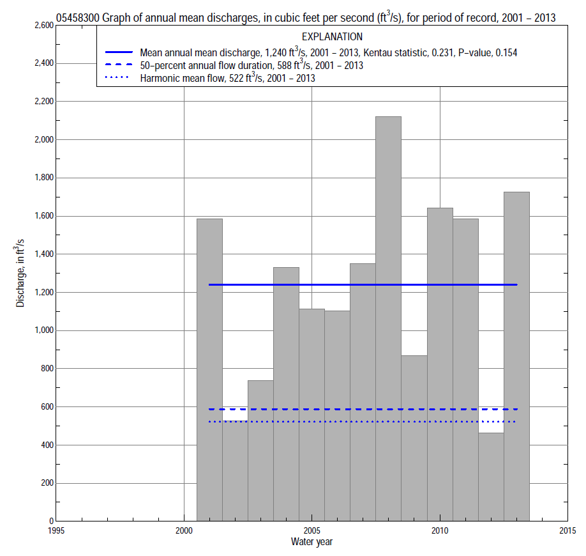

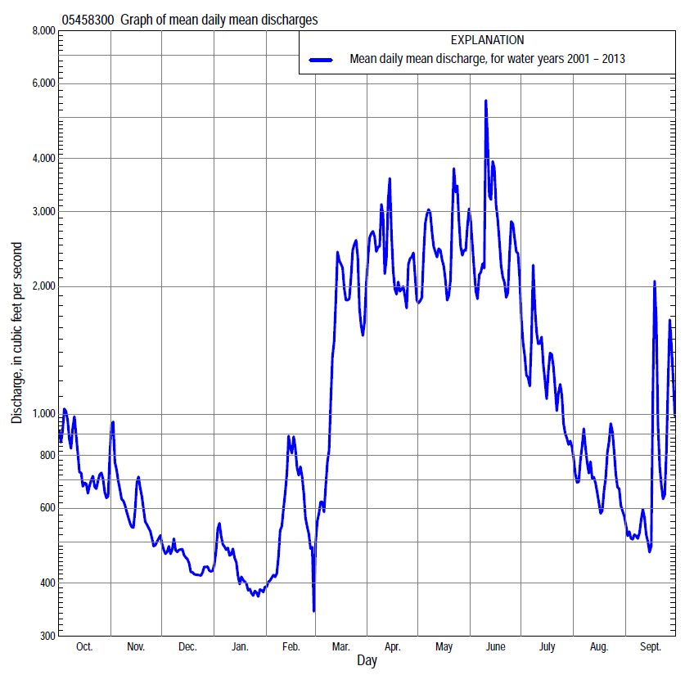

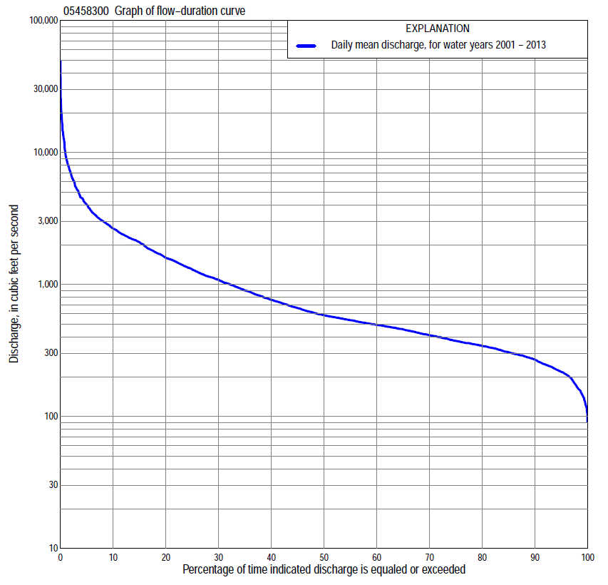

Statistics Based on the Entire Streamflow Period of Record
05458300 Monthly and annual flow durations, based on 2001–13 period of record (13 years)
Percentage of days discharge equaled or exceeded |  |  |  |  | Discharge (cubic feet per second) |  |  |  |  |  |  |  |  | Annual flow durations
 | Oct | Nov | Dec | Jan | Feb | Mar | Apr | May | June | July | Aug | Sept | Annual | Kentau statistic | P-value
99 | 140 | 162 | 107 | 114 | 144 | 158 | 354 | 394 | 500 | 224 | 191 | 149 | 144 | -0.051 | 0.855
98 | 158 | 173 | 120 | 121 | 148 | 171 | 360 | 410 | 515 | 260 | 205 | 159 | 166 | 0.000 | 1.000
95 | 198 | 201 | 187 | 144 | 172 | 227 | 434 | 515 | 597 | 297 | 242 | 185 | 217 | 0.038 | 0.903
90 | 243 | 256 | 248 | 197 | 220 | 298 | 472 | 785 | 810 | 353 | 328 | 274 | 269 | 0.000 | 1.000
85 | 282 | 300 | 275 | 211 | 231 | 366 | 514 | 914 | 920 | 414 | 354 | 290 | 306 | -0.013 | 1.000
80 | 320 | 310 | 290 | 225 | 240 | 428 | 578 | 1,020 | 1,010 | 469 | 389 | 309 | 342 | -0.026 | 0.951
75 | 345 | 332 | 303 | 245 | 250 | 462 | 670 | 1,120 | 1,090 | 527 | 422 | 328 | 373 | -0.026 | 0.951
70 | 360 | 353 | 328 | 275 | 266 | 486 | 766 | 1,220 | 1,170 | 607 | 446 | 343 | 414 | -0.051 | 0.855
65 | 380 | 369 | 342 | 289 | 299 | 518 | 1,030 | 1,320 | 1,300 | 656 | 481 | 363 | 459 | -0.077 | 0.760
60 | 406 | 393 | 357 | 300 | 330 | 563 | 1,130 | 1,470 | 1,430 | 720 | 499 | 384 | 496 | 0.051 | 0.855
55 | 432 | 412 | 376 | 314 | 346 | 609 | 1,410 | 1,630 | 1,540 | 827 | 521 | 398 | 539 | 0.179 | 0.428
50 | 463 | 455 | 424 | 359 | 372 | 679 | 1,590 | 1,820 | 1,690 | 952 | 547 | 419 | 588 | 0.192 | 0.392
45 | 496 | 481 | 484 | 410 | 400 | 753 | 1,770 | 2,040 | 1,810 | 1,070 | 572 | 445 | 668 | 0.231 | 0.300
40 | 525 | 511 | 509 | 434 | 436 | 874 | 2,080 | 2,250 | 2,040 | 1,150 | 603 | 490 | 770 | 0.256 | 0.246
35 | 571 | 545 | 536 | 460 | 467 | 1,020 | 2,320 | 2,400 | 2,190 | 1,230 | 648 | 520 | 907 | 0.282 | 0.200
30 | 666 | 594 | 560 | 501 | 505 | 1,220 | 2,560 | 2,600 | 2,390 | 1,420 | 712 | 561 | 1,090 | 0.333 | 0.127
25 | 755 | 698 | 576 | 539 | 577 | 1,440 | 2,810 | 2,860 | 2,770 | 1,550 | 805 | 629 | 1,310 | 0.282 | 0.200
20 | 934 | 794 | 600 | 576 | 751 | 1,820 | 3,090 | 3,100 | 3,240 | 1,780 | 938 | 738 | 1,600 | 0.231 | 0.300
15 | 1,210 | 936 | 640 | 620 | 811 | 2,440 | 3,720 | 3,600 | 3,810 | 2,060 | 1,120 | 937 | 2,100 | 0.256 | 0.246
10 | 1,810 | 1,070 | 686 | 800 | 948 | 3,830 | 4,900 | 4,480 | 4,810 | 2,420 | 1,330 | 1,320 | 2,660 | 0.179 | 0.428
5 | 2,810 | 1,360 | 760 | 977 | 1,880 | 6,070 | 7,300 | 7,740 | 7,630 | 3,260 | 1,740 | 2,380 | 4,030 | 0.179 | 0.428
2 | 3,520 | 2,430 | 889 | 1,090 | 3,140 | 11,500 | 9,850 | 10,800 | 12,500 | 4,540 | 2,170 | 4,490 | 6,900 | 0.077 | 0.760
1 | 4,530 | 2,930 | 939 | 1,420 | 4,020 | 13,300 | 16,500 | 14,100 | 19,000 | 6,610 | 3,690 | 8,330 | 9,580 | 0.051 | 0.855

05458300 Annual exceedance probability of instantaneous peak discharges, in cubic feet per second (ft³/s), based on the Weighted Independent Estimates method,
Annual exceed-ance probability | Recur-rence interval (years) | Discharge (ft³/s) | 95-percent lower confi-dence interval (ft³/s) | 95-percent upper confi-dence interval (ft³/s)
0.500 | 2 | 9,780 | 8,400 | 11,400
0.200 | 5 | 18,100 | 15,700 | 21,000
0.100 | 10 | 24,200 | 20,700 | 28,300
0.040 | 25 | 32,800 | 27,300 | 39,300
0.020 | 50 | 38,900 | 31,500 | 48,000
0.010 | 100 | 44,900 | 35,200 | 57,300
0.005 | 200 | 53,000 | 40,100 | 70,100
0.002 | 500 | 59,700 | 43,000 | 82,700
and based on the expected moments algorithm/multiple Grubbs-Beck analysis computed using a historical period length of 109 years (1905–2013)
0.500 | 2 | 9,750 | 5,960 | 13,900
0.200 | 5 | 18,000 | 12,100 | 24,900
0.100 | 10 | 24,300 | 16,300 | 33,800
0.040 | 25 | 32,800 | 21,800 | 47,400
0.020 | 50 | 39,400 | 25,700 | 59,900
0.010 | 100 | 46,200 | 29,600 | 74,800
0.005 | 200 | 53,100 | 33,200 | 92,700
0.002 | 500 | 62,600 | 37,800 | 122,000
Kentau statistic |  | 0.103
P-value |  | 0.669
Begin year |  | 2001
End year |  | 2013
Number of peaks |  | 13

05458300 Annual exceedance probability of high discharges, based on 2001–2013 period of record (13 years)
[ND, not determined]
Annual exceed-ance probability | Recur-rence interval (years) | Maximum average discharge (ft³/s) for indicated number of consecutive days
 |  | 1 | 3 | 7 | 15 | 30
0.990 | 1.01 | ND | ND | 913 | 693 | 641
0.950 | 1.05 | ND | ND | 1,750 | 1,350 | 1,150
0.900 | 1.11 | ND | ND | 2,440 | 1,890 | 1,550
0.800 | 1.25 | ND | ND | 3,590 | 2,770 | 2,160
0.500 | 2 | ND | ND | 7,210 | 5,410 | 3,890
0.200 | 5 | ND | ND | 13,700 | 9,770 | 6,510
0.100 | 10 | ND | ND | 18,800 | 12,900 | 8,290
0.040 | 25 | ND | ND | 25,900 | 17,000 | 10,500
0.020 | 50 | ND | ND | 31,600 | 20,100 | 12,200
0.010 | 100 | ND | ND | 37,500 | 23,100 | 13,700
0.005 | 200 | ND | ND | 43,800 | 26,200 | 15,300
0.002 | 500 | ND | ND | 52,500 | 30,200 | 17,300
Kentau statistic |  | 0.103 | 0.103 | 0.128 | 0.103 | 0.128
P-value |  | 0.669 | 0.669 | 0.583 | 0.669 | 0.583

 | 05458300 Annual nonexceedance probability of low discharges, based on April 2001 to March 2013 period of record (12 years)
Annual nonexceed-ance probability | Recur-rence interval (years) | Minimum average discharge (cubic feet per second) for indicated number of consecutive days
 |  | 1 | 3 | 7 | 14 | 30 | 60 | 90 | 120 | 183
0.01 | 100 | 67 | 73 | 79 | 85 | 96 | 101 | 110 | 116 | 117
0.02 | 50 | 82 | 89 | 96 | 102 | 113 | 120 | 131 | 138 | 139
0.05 | 20 | 108 | 118 | 125 | 132 | 144 | 154 | 169 | 178 | 182
0.10 | 10 | 135 | 147 | 155 | 162 | 175 | 190 | 208 | 219 | 230
0.20 | 5 | 173 | 187 | 195 | 205 | 218 | 238 | 263 | 278 | 303
0.50 | 2 | 255 | 273 | 283 | 297 | 314 | 349 | 389 | 417 | 500
0.80 | 1.25 | 343 | 361 | 375 | 396 | 426 | 476 | 536 | 589 | 804
0.90 | 1.11 | 386 | 404 | 421 | 446 | 487 | 545 | 617 | 690 | 1,020
0.96 | 1.04 | 429 | 444 | 465 | 497 | 553 | 619 | 704 | 802 | 1,300
0.98 | 1.02 | 454 | 467 | 490 | 527 | 594 | 665 | 759 | 877 | 1,520
0.99 | 1.01 | 474 | 484 | 511 | 552 | 631 | 706 | 808 | 946 | 1,730
Kentau statistic |  | -0.061 | -0.091 | -0.121 | -0.061 | 0.030 | -0.030 | -0.030 | 0.030 | 0.000
P-value |  | 0.837 | 0.732 | 0.631 | 0.837 | 0.945 | 0.945 | 0.945 | 0.945 | 1.000

05458300 Annual nonexceedance probability of seasonal low discharges, based on October 2000 to September 2013 period of record (13 years)
Annual nonexceed-ance probability | Recur-rence interval (years) | Minimum average discharge (cubic feet per second) for indicated number of consecutive days
 |  | 1 | 7 | 14 | 30 |  | 1 | 7 | 14 | 30
 |  | January-February-March |  |  |  |  | April-May-June
0.01 | 100 | 83 | 90 | 101 | 111 |  | 181 | 194 | 218 | 320
0.02 | 50 | 97 | 105 | 116 | 126 |  | 211 | 230 | 257 | 374
0.05 | 20 | 120 | 132 | 141 | 152 |  | 266 | 296 | 329 | 471
0.10 | 10 | 145 | 159 | 168 | 179 |  | 325 | 369 | 410 | 578
0.20 | 5 | 180 | 198 | 207 | 219 |  | 415 | 478 | 536 | 740
0.50 | 2 | 265 | 291 | 302 | 321 |  | 658 | 769 | 901 | 1,180
0.80 | 1.25 | 379 | 410 | 434 | 467 |  | 1,040 | 1,210 | 1,530 | 1,880
0.90 | 1.11 | 452 | 483 | 521 | 568 |  | 1,310 | 1,510 | 2,010 | 2,390
0.96 | 1.04 | 539 | 569 | 629 | 698 |  | 1,680 | 1,910 | 2,710 | 3,080
0.98 | 1.02 | 601 | 629 | 709 | 797 |  | 1,970 | 2,210 | 3,300 | 3,630
0.99 | 1.01 | 660 | 685 | 788 | 898 |  | 2,270 | 2,520 | 3,930 | 4,200
Kentau statistic |  | -0.090 | -0.051 | -0.077 | 0.000 |  | 0.064 | 0.205 | 0.154 | 0.179
P-value |  | 0.714 | 0.855 | 0.760 | 1.000 |  | 0.807 | 0.360 | 0.502 | 0.428
 |  | July-August-September |  |  |  |  | October-November-December
0.01 | 100 | 105 | 137 | 150 | 174 |  | 67 | 82 | 103 | 124
0.02 | 50 | 123 | 155 | 168 | 190 |  | 85 | 103 | 124 | 146
0.05 | 20 | 153 | 186 | 198 | 219 |  | 117 | 141 | 162 | 185
0.10 | 10 | 184 | 217 | 229 | 248 |  | 151 | 181 | 201 | 225
0.20 | 5 | 228 | 260 | 273 | 291 |  | 200 | 237 | 255 | 280
0.50 | 2 | 329 | 362 | 380 | 400 |  | 309 | 362 | 376 | 404
0.80 | 1.25 | 453 | 490 | 523 | 562 |  | 426 | 492 | 510 | 549
0.90 | 1.11 | 525 | 570 | 616 | 677 |  | 484 | 555 | 580 | 630
0.96 | 1.04 | 607 | 664 | 731 | 830 |  | 539 | 614 | 652 | 716
0.98 | 1.02 | 663 | 730 | 816 | 951 |  | 571 | 648 | 696 | 772
0.99 | 1.01 | 713 | 794 | 900 | 1,080 |  | 596 | 674 | 732 | 821
Kentau statistic |  | -0.256 | -0.128 | -0.154 | -0.205 |  | -0.103 | -0.026 | -0.026 | 0.000
P-value |  | 0.246 | 0.583 | 0.502 | 0.360 |  | 0.669 | 0.951 | 0.951 | 1.000

