LOCATION.--Lat 42°38'54", long 92°27'54" referenced to North American Datum of 1927, in NW 1/4 NW 1/4 SE 1/4 sec.35, T.91 N., R.14 W., Bremer County, IA, Hydrologic Unit 07080201, on left bank 300 ft downstream from bridge on County Highway C50 in Janesville, 3.6 mi upstream from West Fork Cedar River, and 182.6 mi upstream from mouth.

DRAINAGE AREA.--1,661 mi².

PERIOD OF RECORD.--Discharge records from October 1904 to September 1906, October 1914 to September 1927, October 1932 to September 1942, October 1945 to current year. Prior to May 1946, monthly mean discharge for some periods published in WSP 1308. Prior to October 1906, published as "Red Cedar River at Janesville".

GAGE.--Water-stage recorder. Datum of gage is 868.26 ft above National Geodetic Vertical Datum of 1929. Prior to July 26, 1919, non-recording gage at site 1,000 ft downstream at datum 4.0 ft lower; July 26, 1919, to September 30, 1927, November 14, 1932, to September 30, 1942, and April 26, 1946, to November 10, 1949, non-recording gage at county bridge 300 ft upstream at same datum.

REMARKS.--Minor diurnal fluctuations during periods of low flow due to operations of power plant located 10.0 mi upstream.

EXTREMES OUTSIDE PERIOD OF RECORD.--Flood of March 17, 1945, reached a stage of 16.2 ft, from high-water mark, at site 300 ft upstream at current datum, discharge 34,300 ft³/s. Flood of March 16, 1929, reached a stage of about 16 ft, from information by city of Waterloo, at current datum, discharge not determined.

A summary of all available data for this streamgage is provided through the USGS National Water Information System web interface (NWISWeb). The following link provides access to current/historical observations, daily data, daily statistics, monthly statistics, annual statistics, peak streamflow, field measurements, field/lab water-quality samples, and the latest water-year summaries. Data can be filtered by parameter and/or dates, and can be output in various tabular and graphical formats.
http://waterdata.usgs.gov/nwis/inventory/?site_no=05458500

The USGS WaterWatch Toolkit is available at:
http://waterwatch.usgs.gov/?id=ww_toolkit
Tools for summarizing streamflow information include the duration hydrograph builder, the cumulative streamflow hydrograph builder, the streamgage statistics retrieval tool, the rating curve builder, the flood tracking chart builder, the National Weather Service Advanced Hydrologic Prediction Service (AHPS) river forecast hydrograph builder, and the raster-hydrograph builder. Entering the above number for this streamgage into these toolkit webpages will provide streamflow information specific to this streamgage.

A description of the statistics presented for this streamgage is available in the main body of the report at:
http://dx.doi.org/10.3133/ofr20151214
A link to other streamgages included in this report, a map showing the location of the streamgages, information on the programs used to compute the statistical analyses, and references are included in the main body of the report.

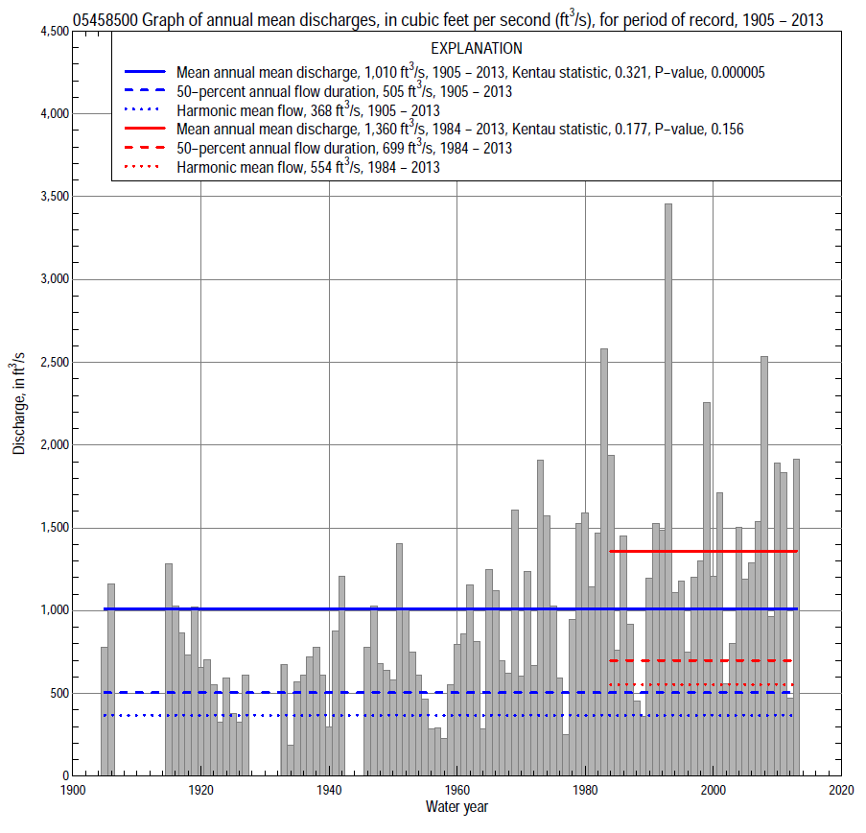

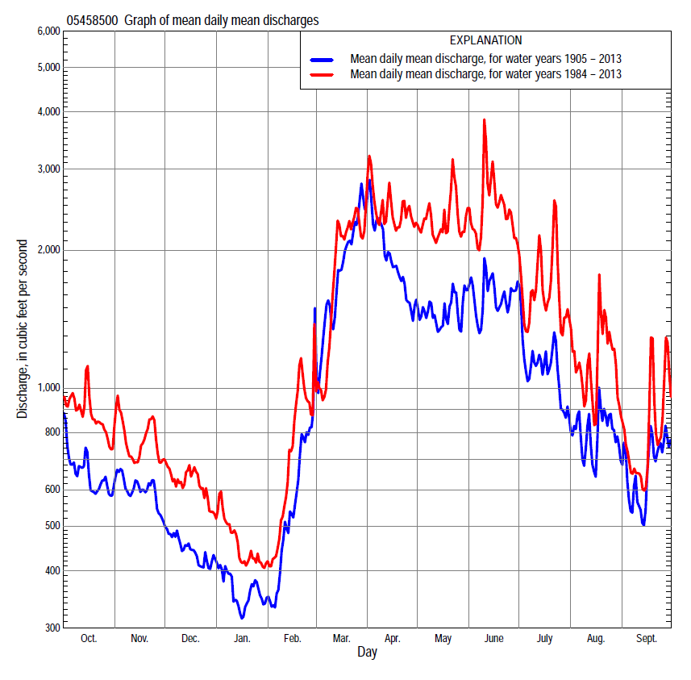

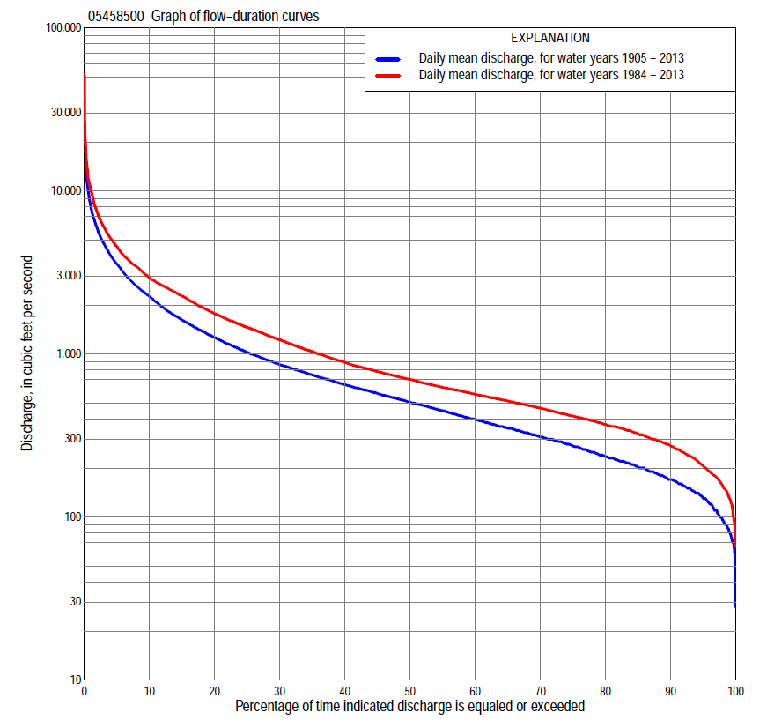

Statistics Based on the Entire Streamflow Period of Record
05458500 Monthly and annual flow durations, based on 1905–06, 1915–27, 1933–42, 1946–2013 period of record (93 years)
Percentage of days discharge equaled or exceeded |  |  |  |  | Discharge (cubic feet per second) |  |  |  |  |  |  |  |  | Annual flow durations
 | Oct | Nov | Dec | Jan | Feb | Mar | Apr | May | June | July | Aug | Sept | Annual | Kentau statistic | P-value
99 | 96 | 88 | 70 | 77 | 60 | 120 | 210 | 145 | 111 | 90 | 88 | 81 | 81 | 0.450 | 0.000
98 | 108 | 118 | 80 | 84 | 66 | 146 | 231 | 168 | 143 | 111 | 119 | 114 | 97 | 0.455 | 0.000
95 | 140 | 150 | 100 | 90 | 97 | 204 | 312 | 228 | 179 | 156 | 140 | 141 | 132 | 0.439 | 0.000
90 | 165 | 175 | 130 | 110 | 130 | 260 | 383 | 306 | 240 | 195 | 169 | 173 | 170 | 0.416 | 0.000
85 | 190 | 191 | 155 | 130 | 156 | 320 | 452 | 370 | 306 | 240 | 200 | 200 | 202 | 0.397 | 0.000
80 | 212 | 215 | 170 | 145 | 190 | 420 | 530 | 444 | 378 | 282 | 230 | 233 | 235 | 0.380 | 0.000
75 | 236 | 235 | 200 | 160 | 210 | 491 | 605 | 525 | 452 | 330 | 254 | 270 | 273 | 0.361 | 0.000
70 | 261 | 260 | 220 | 180 | 230 | 550 | 695 | 605 | 546 | 389 | 291 | 300 | 310 | 0.343 | 0.000
65 | 288 | 294 | 242 | 200 | 250 | 652 | 772 | 670 | 631 | 444 | 331 | 326 | 352 | 0.335 | 0.000
60 | 318 | 334 | 280 | 220 | 272 | 750 | 856 | 747 | 726 | 505 | 368 | 351 | 399 | 0.305 | 0.000
55 | 348 | 371 | 308 | 250 | 300 | 835 | 969 | 820 | 820 | 580 | 405 | 377 | 450 | 0.318 | 0.000
50 | 383 | 410 | 332 | 274 | 320 | 932 | 1,100 | 915 | 930 | 665 | 447 | 406 | 505 | 0.313 | 0.000
45 | 420 | 460 | 360 | 302 | 361 | 1,100 | 1,270 | 1,020 | 1,060 | 746 | 498 | 435 | 572 | 0.315 | 0.000
40 | 472 | 512 | 395 | 335 | 400 | 1,290 | 1,470 | 1,140 | 1,220 | 840 | 540 | 467 | 648 | 0.318 | 0.000
35 | 524 | 570 | 440 | 360 | 450 | 1,500 | 1,680 | 1,280 | 1,400 | 950 | 587 | 505 | 744 | 0.313 | 0.000
30 | 598 | 635 | 500 | 400 | 513 | 1,770 | 1,970 | 1,480 | 1,600 | 1,070 | 637 | 563 | 860 | 0.309 | 0.000
25 | 695 | 707 | 553 | 450 | 580 | 2,180 | 2,390 | 1,720 | 1,840 | 1,220 | 721 | 642 | 1,020 | 0.310 | 0.000
20 | 840 | 808 | 620 | 500 | 680 | 2,620 | 2,730 | 2,060 | 2,210 | 1,410 | 845 | 731 | 1,270 | 0.317 | 0.000
15 | 1,050 | 957 | 708 | 590 | 820 | 3,400 | 3,310 | 2,470 | 2,620 | 1,720 | 1,040 | 880 | 1,620 | 0.306 | 0.000
10 | 1,360 | 1,270 | 863 | 668 | 1,060 | 4,520 | 4,130 | 3,160 | 3,440 | 2,250 | 1,420 | 1,220 | 2,260 | 0.301 | 0.000
5 | 2,140 | 1,680 | 1,100 | 920 | 1,930 | 6,290 | 6,260 | 4,510 | 4,800 | 3,470 | 2,560 | 2,120 | 3,550 | 0.286 | 0.000
2 | 3,270 | 2,480 | 1,650 | 1,380 | 3,480 | 9,150 | 9,790 | 6,860 | 7,760 | 6,040 | 5,180 | 3,610 | 5,800 | 0.251 | 0.000
1 | 4,300 | 3,220 | 2,150 | 1,600 | 4,960 | 12,000 | 13,500 | 9,220 | 10,800 | 8,330 | 7,850 | 4,970 | 7,990 | 0.159 | 0.024

05458500 Annual exceedance probability of instantaneous peak discharges, in cubic feet per second (ft³/s), based on the Weighted Independent Estimates method,
Annual exceed-ance probability | Recur-rence interval (years) | Discharge (ft³/s) | 95-percent lower confi-dence interval (ft³/s) | 95-percent upper confi-dence interval (ft³/s)
0.500 | 2 | 10,500 | 9,050 | 12,300
0.200 | 5 | 19,300 | 16,700 | 22,300
0.100 | 10 | 25,700 | 22,000 | 29,900
0.040 | 25 | 34,300 | 28,600 | 41,000
0.020 | 50 | 40,400 | 32,800 | 49,700
0.010 | 100 | 46,300 | 36,500 | 58,900
0.005 | 200 | 54,400 | 41,300 | 71,600
0.002 | 500 | 60,800 | 44,000 | 84,000
and based on the expected moments algorithm/multiple Grubbs-Beck analysis computed using a historical period length of 109 years (1905–2013)
0.500 | 2 | 10,500 | 8,860 | 12,400
0.200 | 5 | 19,300 | 16,500 | 22,900
0.100 | 10 | 25,900 | 21,900 | 31,400
0.040 | 25 | 34,600 | 28,500 | 44,500
0.020 | 50 | 41,400 | 33,000 | 55,800
0.010 | 100 | 48,200 | 37,000 | 68,500
0.005 | 200 | 55,100 | 40,600 | 82,900
0.002 | 500 | 64,400 | 44,800 | 105,000
Kentau statistic |  | 0.059
P-value |  | 0.411
Begin year |  | 1905
End year |  | 2013
Number of peaks |  | 92

05458500 Annual exceedance probability of high discharges, based on 1905-06, 1915-27, 1933-42, 1946-2013 period of record (68 years)
Annual exceed-ance probability | Recur-rence interval (years) | Maximum average discharge (ft³/s) for indicated number of consecutive days
 |  | 1 | 3 | 7 | 15 | 30
0.990 | 1.01 | 1,200 | 1,050 | 864 | 638 | 483
0.950 | 1.05 | 2,350 | 2,040 | 1,600 | 1,190 | 895
0.900 | 1.11 | 3,280 | 2,830 | 2,180 | 1,610 | 1,210
0.800 | 1.25 | 4,820 | 4,130 | 3,110 | 2,290 | 1,710
0.500 | 2 | 9,470 | 7,970 | 5,820 | 4,200 | 3,060
0.200 | 5 | 17,200 | 14,200 | 10,200 | 7,110 | 5,040
0.100 | 10 | 22,900 | 18,600 | 13,200 | 9,080 | 6,320
0.040 | 25 | 30,300 | 24,200 | 17,200 | 11,500 | 7,860
0.020 | 50 | 35,900 | 28,500 | 20,100 | 13,300 | 8,940
0.010 | 100 | 41,500 | 32,600 | 23,100 | 15,000 | 9,950
0.005 | 200 | 47,100 | 36,700 | 26,000 | 16,600 | 10,900
0.002 | 500 | 54,500 | 42,000 | 29,800 | 18,700 | 12,100
KENTAU statistic |  | 0.261 | 0.279 | 0.301 | 0.346 | 0.371
P-level |  | 0.000 | 0.000 | 0.000 | 0.000 | 0.000

05458500 Annual nonexceedance probability of low discharges, based on April 1905 to March 1906, April 1915 to March 1927, April 1933 to March 1942, April 1946 to March 2013 period of record (89 years)
Annual nonexceed-ance probability | Recur-rence interval (years) | Minimum average discharge (ft³/s) for indicated number of consecutive days
 |  | 1 | 3 | 7 | 14 | 30 | 60 | 90 | 120 | 183
0.01 | 100 | 31 | 38 | 40 | 44 | 51 | 61 | 66 | 76 | 83
0.02 | 50 | 38 | 46 | 48 | 53 | 61 | 72 | 79 | 90 | 99
0.05 | 20 | 52 | 61 | 64 | 70 | 79 | 93 | 102 | 116 | 130
0.10 | 10 | 68 | 78 | 82 | 88 | 100 | 116 | 129 | 146 | 165
0.20 | 5 | 93 | 104 | 109 | 117 | 131 | 152 | 170 | 192 | 221
0.50 | 2 | 162 | 175 | 185 | 197 | 217 | 252 | 289 | 322 | 389
0.80 | 1.25 | 270 | 286 | 302 | 322 | 352 | 413 | 485 | 541 | 690
0.90 | 1.11 | 346 | 365 | 385 | 410 | 451 | 532 | 634 | 709 | 932
0.96 | 1.04 | 444 | 469 | 494 | 527 | 582 | 696 | 841 | 945 | 1,290
0.98 | 1.02 | 518 | 549 | 578 | 616 | 685 | 827 | 1,010 | 1,140 | 1,590
0.99 | 1.01 | 593 | 630 | 663 | 708 | 791 | 963 | 1,190 | 1,340 | 1,920
Kentau statistic |  | 0.553 | 0.548 | 0.546 | 0.545 | 0.536 | 0.496 | 0.477 | 0.453 | 0.443
P-value |  | 0.000 | 0.000 | 0.000 | 0.000 | 0.000 | 0.000 | 0.000 | 0.000 | 0.000

05458500 Annual nonexceedance probability of seasonal low discharges, based on October 1904 to September 1906, October 1914 to September 1927, October 1932 to September 1942, October 1945 to September 2013 period of record (93 years)
Annual nonexceed-ance probability | Recur-rence interval (years) | Minimum average discharge (cubic feet per second) for indicated number of consecutive days
 |  | 1 | 7 | 14 | 30 |  | 1 | 7 | 14 | 30
 |  | January-February-March |  |  |  |  | April-May-June
0.01 | 100 | 43 | 45 | 48 | 53 |  | 57 | 84 | 92 | 111
0.02 | 50 | 52 | 54 | 58 | 64 |  | 72 | 103 | 113 | 137
0.05 | 20 | 68 | 72 | 76 | 85 |  | 102 | 141 | 154 | 189
0.10 | 10 | 86 | 92 | 97 | 108 |  | 138 | 186 | 202 | 250
0.20 | 5 | 113 | 122 | 129 | 144 |  | 197 | 259 | 282 | 352
0.50 | 2 | 190 | 208 | 218 | 250 |  | 384 | 477 | 529 | 672
0.80 | 1.25 | 310 | 345 | 364 | 426 |  | 730 | 863 | 992 | 1,280
0.90 | 1.11 | 396 | 445 | 472 | 560 |  | 1,010 | 1,170 | 1,380 | 1,780
0.96 | 1.04 | 510 | 580 | 619 | 747 |  | 1,420 | 1,600 | 1,950 | 2,530
0.98 | 1.02 | 598 | 685 | 736 | 899 |  | 1,770 | 1,950 | 2,440 | 3,170
0.99 | 1.01 | 689 | 794 | 857 | 1,060 |  | 2,140 | 2,330 | 2,980 | 3,890
Kentau statistic |  | 0.362 | 0.377 | 0.389 | 0.341 |  | 0.382 | 0.336 | 0.333 | 0.335
P-value |  | 0.000 | 0.000 | 0.000 | 0.000 |  | 0.000 | 0.000 | 0.000 | 0.000
 |  | July-August-September |  |  |  |  | October-November-December
0.01 | 100 | 47 | 68 | 78 | 95 |  | 39 | 57 | 61 | 70
0.02 | 50 | 57 | 80 | 91 | 108 |  | 48 | 67 | 72 | 83
0.05 | 20 | 77 | 103 | 114 | 132 |  | 66 | 87 | 93 | 106
0.10 | 10 | 99 | 129 | 140 | 160 |  | 86 | 109 | 117 | 133
0.20 | 5 | 133 | 168 | 180 | 203 |  | 118 | 144 | 155 | 175
0.50 | 2 | 233 | 278 | 295 | 331 |  | 208 | 243 | 264 | 300
0.80 | 1.25 | 401 | 459 | 488 | 565 |  | 350 | 410 | 450 | 521
0.90 | 1.11 | 529 | 594 | 639 | 762 |  | 451 | 539 | 595 | 699
0.96 | 1.04 | 707 | 780 | 852 | 1,060 |  | 584 | 721 | 801 | 961
0.98 | 1.02 | 851 | 930 | 1,030 | 1,330 |  | 686 | 870 | 972 | 1,180
0.99 | 1.01 | 1,000 | 1,090 | 1,220 | 1,630 |  | 789 | 1,030 | 1,160 | 1,430
Kentau statistic |  | 0.407 | 0.366 | 0.345 | 0.319 |  | 0.377 | 0.385 | 0.385 | 0.345
P-value |  | 0.000 | 0.000 | 0.000 | 0.000 |  | 0.000 | 0.000 | 0.000 | 0.000

Statistics Based on the 1984–2013 Streamflow Period of Record
05458500 Monthly and annual flow durations, based on 1984–2013 period of record (30 years)
Percentage of days discharge equaled or exceeded |  |  |  |  | Discharge (cubic feet per second) |  |  |  |  |  |  |  |  | Annual flow durations
 | Oct | Nov | Dec | Jan | Feb | Mar | Apr | May | June | July | Aug | Sept | Annual | Kentau statistic | P-value
99 | 145 | 163 | 84 | 90 | 130 | 179 | 316 | 300 | 201 | 164 | 121 | 135 | 130 | 0.057 | 0.668
98 | 149 | 173 | 96 | 100 | 147 | 219 | 334 | 357 | 222 | 180 | 127 | 144 | 155 | 0.069 | 0.605
95 | 178 | 190 | 181 | 135 | 183 | 300 | 371 | 431 | 258 | 226 | 176 | 181 | 205 | 0.080 | 0.544
90 | 255 | 261 | 250 | 198 | 230 | 430 | 434 | 566 | 437 | 284 | 237 | 292 | 273 | 0.071 | 0.592
85 | 280 | 296 | 298 | 225 | 245 | 492 | 528 | 671 | 624 | 402 | 339 | 320 | 323 | 0.028 | 0.844
80 | 326 | 349 | 327 | 255 | 265 | 540 | 670 | 796 | 813 | 487 | 392 | 347 | 370 | 0.009 | 0.957
75 | 362 | 385 | 355 | 290 | 290 | 588 | 765 | 940 | 949 | 590 | 433 | 369 | 416 | -0.023 | 0.872
70 | 396 | 430 | 380 | 304 | 310 | 671 | 841 | 1,100 | 1,060 | 685 | 493 | 393 | 465 | -0.055 | 0.682
65 | 443 | 472 | 405 | 320 | 345 | 747 | 1,030 | 1,220 | 1,190 | 756 | 532 | 410 | 515 | -0.037 | 0.789
60 | 469 | 509 | 439 | 341 | 370 | 819 | 1,220 | 1,350 | 1,340 | 841 | 565 | 433 | 566 | -0.057 | 0.669
55 | 504 | 552 | 480 | 362 | 407 | 914 | 1,470 | 1,480 | 1,460 | 931 | 596 | 459 | 624 | -0.016 | 0.915
50 | 534 | 598 | 539 | 410 | 440 | 1,000 | 1,660 | 1,600 | 1,630 | 1,040 | 625 | 482 | 699 | -0.007 | 0.972
45 | 567 | 640 | 580 | 450 | 490 | 1,170 | 1,920 | 1,770 | 1,820 | 1,130 | 680 | 509 | 780 | 0.016 | 0.915
40 | 648 | 711 | 618 | 480 | 523 | 1,310 | 2,200 | 1,970 | 2,030 | 1,240 | 724 | 554 | 888 | 0.044 | 0.748
35 | 734 | 767 | 650 | 520 | 560 | 1,520 | 2,500 | 2,220 | 2,270 | 1,380 | 788 | 612 | 1,030 | 0.055 | 0.682
30 | 847 | 842 | 693 | 550 | 600 | 1,710 | 2,750 | 2,430 | 2,510 | 1,530 | 866 | 663 | 1,220 | 0.064 | 0.630
25 | 1,010 | 943 | 740 | 590 | 700 | 2,030 | 3,100 | 2,710 | 2,830 | 1,720 | 993 | 723 | 1,460 | 0.097 | 0.464
20 | 1,180 | 1,070 | 830 | 620 | 814 | 2,550 | 3,490 | 3,120 | 3,290 | 1,970 | 1,210 | 816 | 1,770 | 0.131 | 0.318
15 | 1,400 | 1,240 | 910 | 660 | 944 | 3,060 | 4,070 | 3,710 | 4,020 | 2,340 | 1,510 | 979 | 2,270 | 0.136 | 0.301
10 | 1,800 | 1,440 | 1,000 | 735 | 1,280 | 4,130 | 5,260 | 4,690 | 4,910 | 3,240 | 2,150 | 1,560 | 2,930 | 0.179 | 0.169
5 | 2,720 | 1,940 | 1,330 | 998 | 2,420 | 6,020 | 7,260 | 6,860 | 7,380 | 5,130 | 3,760 | 2,520 | 4,560 | 0.200 | 0.125
2 | 3,980 | 2,760 | 1,900 | 1,200 | 4,480 | 9,820 | 10,300 | 10,000 | 11,100 | 9,060 | 6,910 | 3,870 | 7,370 | 0.205 | 0.116
1 | 5,100 | 3,050 | 2,580 | 1,540 | 5,630 | 13,200 | 14,400 | 13,000 | 14,400 | 11,700 | 10,700 | 5,720 | 10,200 | 0.154 | 0.239

05458500 Annual exceedance probability of high discharges, based on 1984–2013 period of record (30 years)
Annual exceed-ance probability | Recur-rence interval (years) | Maximum average discharge (ft³/s) for indicated number of consecutive days
 |  | 1 | 3 | 7 | 15 | 30
0.990 | 1.01 | 1,730 | 1,510 | 1,310 | 1,020 | 850
0.950 | 1.05 | 2,840 | 2,530 | 2,120 | 1,690 | 1,390
0.900 | 1.11 | 3,720 | 3,330 | 2,740 | 2,200 | 1,790
0.800 | 1.25 | 5,180 | 4,640 | 3,750 | 3,000 | 2,390
0.500 | 2 | 9,930 | 8,730 | 6,780 | 5,280 | 4,010
0.200 | 5 | 19,500 | 16,300 | 12,200 | 8,990 | 6,410
0.100 | 10 | 27,900 | 22,600 | 16,700 | 11,700 | 8,030
0.040 | 25 | 41,300 | 32,000 | 23,100 | 15,400 | 10,100
0.020 | 50 | 53,400 | 40,000 | 28,600 | 18,300 | 11,600
0.010 | 100 | 67,400 | 48,900 | 34,500 | 21,200 | 13,100
0.005 | 200 | 83,600 | 58,700 | 41,100 | 24,300 | 14,500
0.002 | 500 | 109,000 | 73,300 | 50,700 | 28,500 | 16,500
Kentau statistic |  | 0.147 | 0.172 | 0.149 | 0.218 | 0.182
P-value |  | 0.261 | 0.187 | 0.254 | 0.094 | 0.164

 | 05458500 Annual nonexceedance probability of low discharges, based on April 1983 to March 2013 period of record (30 years)
Annual nonexceed-ance probability | Recur-rence interval (years) | Minimum average discharge (ft³/s) for indicated number of consecutive days
 |  | 1 | 3 | 7 | 14 | 30 | 60 | 90 | 120 | 183
0.01 | 100 | 63 | 68 | 72 | 77 | 83 | 92 | 110 | 116 | 123
0.02 | 50 | 77 | 84 | 89 | 95 | 103 | 113 | 132 | 140 | 150
0.05 | 20 | 102 | 112 | 120 | 128 | 137 | 152 | 172 | 184 | 201
0.10 | 10 | 130 | 143 | 153 | 162 | 174 | 193 | 215 | 232 | 258
0.20 | 5 | 169 | 186 | 198 | 210 | 226 | 251 | 277 | 301 | 344
0.50 | 2 | 260 | 281 | 298 | 317 | 341 | 383 | 429 | 472 | 574
0.80 | 1.25 | 369 | 386 | 406 | 430 | 465 | 530 | 626 | 696 | 913
0.90 | 1.11 | 428 | 438 | 460 | 485 | 528 | 606 | 746 | 833 | 1,140
0.96 | 1.04 | 489 | 490 | 512 | 539 | 589 | 682 | 884 | 992 | 1,430
0.98 | 1.02 | 520 | 521 | 542 | 570 | 625 | 728 | 979 | 1,100 | 1,640
0.99 | 1.01 | 544 | 545 | 567 | 594 | 654 | 766 | 1,070 | 1,200 | 1,840
Kentau statistic |  | 0.030 | 0.021 | 0.002 | 0.057 | 0.034 | 0.002 | -0.025 | -0.053 | -0.099
P-value |  | 0.830 | 0.887 | 1.000 | 0.669 | 0.803 | 1.000 | 0.858 | 0.695 | 0.454

05458500 Annual nonexceedance probability of seasonal low discharges, based on October 1983 to September 2013 period of record (30 years)
Annual nonexceed-ance probability | Recur-rence interval (years) | Minimum average discharge (cubic feet per second) for indicated number of consecutive days
 |  | 1 | 7 |  | 14 |  | 30 |  | 1 | 7 | 14 | 30
 |  | January-February-March |  |  |  |  |  |  | April-May-June
0.01 | 100 | 70 | 83 | 88 |  | 97 |  |  | 126 | 133 | 135 | 169
0.02 | 50 | 85 | 99 | 105 |  | 115 |  |  | 156 | 167 | 172 | 216
0.05 | 20 | 112 | 129 | 136 |  | 149 |  |  | 214 | 232 | 243 | 308
0.10 | 10 | 140 | 160 | 170 |  | 185 |  |  | 280 | 306 | 327 | 418
0.20 | 5 | 182 | 205 | 218 |  | 237 |  |  | 383 | 424 | 463 | 595
0.50 | 2 | 285 | 318 | 338 |  | 366 |  |  | 668 | 758 | 869 | 1,120
0.80 | 1.25 | 418 | 467 | 496 |  | 536 |  |  | 1,110 | 1,290 | 1,550 | 2,000
0.90 | 1.11 | 499 | 560 | 594 |  | 641 |  |  | 1,410 | 1,660 | 2,070 | 2,640
0.96 | 1.04 | 592 | 671 | 710 |  | 765 |  |  | 1,800 | 2,150 | 2,760 | 3,500
0.98 | 1.02 | 655 | 747 | 790 |  | 851 |  |  | 2,100 | 2,520 | 3,310 | 4,160
0.99 | 1.01 | 713 | 820 | 866 |  | 932 |  |  | 2,390 | 2,890 | 3,870 | 4,840
Kentau statistic |  | -0.021 | -0.048 | -0.016 |  | -0.007 |  |  | 0.156 | 0.154 | 0.168 | 0.177
P-value |  | 0.886 | 0.721 | 0.915 |  | 0.972 |  |  | 0.232 | 0.239 | 0.199 | 0.175
 |  | July-August-September |  |  |  |  |  |  | October-November-December
0.01 | 100 | 118 | 124 | 134 |  | 137 |  |  | 64 | 75 | 84 | 109
0.02 | 50 | 133 | 140 | 149 |  | 155 |  |  | 82 | 95 | 106 | 132
0.05 | 20 | 160 | 169 | 178 |  | 187 |  |  | 114 | 134 | 148 | 174
0.10 | 10 | 189 | 201 | 209 |  | 223 |  |  | 150 | 177 | 193 | 220
0.20 | 5 | 234 | 250 | 259 |  | 281 |  |  | 202 | 239 | 260 | 286
0.50 | 2 | 358 | 389 | 404 |  | 454 |  |  | 328 | 389 | 420 | 454
0.80 | 1.25 | 566 | 625 | 668 |  | 777 |  |  | 479 | 565 | 610 | 682
0.90 | 1.11 | 728 | 810 | 888 |  | 1,050 |  |  | 562 | 660 | 713 | 825
0.96 | 1.04 | 962 | 1,080 | 1,220 |  | 1,480 |  |  | 648 | 756 | 821 | 994
0.98 | 1.02 | 1,160 | 1,310 | 1,520 |  | 1,870 |  |  | 701 | 814 | 888 | 1,110
0.99 | 1.01 | 1,370 | 1,560 | 1,860 |  | 2,320 |  |  | 745 | 863 | 944 | 1,230
Kentau statistic |  | 0.046 | 0.034 | 0.034 |  | 0.011 |  |  | -0.018 | -0.039 | -0.062 | -0.108
P-value |  | 0.735 | 0.803 | 0.803 |  | 0.943 |  |  | 0.901 | 0.775 | 0.643 | 0.412

