LOCATION.--Lat 42°37'46", long 92°32'36" referenced to North American Datum of 1927, in SW 1/4 SW 1/4 SE 1/4 sec.06, T.90 N., R.14 W., Black Hawk County, IA, Hydrologic Unit 07080204, on left bank 100 ft downstream from bridge on County Highway C55 in Finchford, 3.2 mi upstream from Shell Rock River, and 5.4 mi upstream from mouth.

DRAINAGE AREA.--846 mi².

PERIOD OF RECORD.--Discharge records from October 1945 to current year. Prior to October 1955, published as "West Fork Shell Rock River at Finchford".

GAGE.--Water-stage recorder. Datum of gage is 867.54 ft above National Geodetic Vertical Datum of 1929. Prior to June 10, 1955, non-recording gage at same site and datum.

REMARKS.--An authorized diversion of 2,100 acre-ft is made into Big Marsh, 16 mi upstream, each year between September 1 and November 15. Net effect on daily flows at gage is unknown.

EXTREMES OUTSIDE PERIOD OF RECORD.--Flood in March 1929 reached a stage of about 14 ft, from information by local resident, discharge about 12,800 ft³/s.

A summary of all available data for this streamgage is provided through the USGS National Water Information System web interface (NWISWeb). The following link provides access to current/historical observations, daily data, daily statistics, monthly statistics, annual statistics, peak streamflow, field measurements, field/lab water-quality samples, and the latest water-year summaries. Data can be filtered by parameter and/or dates, and can be output in various tabular and graphical formats.
http://waterdata.usgs.gov/nwis/inventory/?site_no=05458900

The USGS WaterWatch Toolkit is available at:
http://waterwatch.usgs.gov/?id=ww_toolkit
Tools for summarizing streamflow information include the duration hydrograph builder, the cumulative streamflow hydrograph builder, the streamgage statistics retrieval tool, the rating curve builder, the flood tracking chart builder, the National Weather Service Advanced Hydrologic Prediction Service (AHPS) river forecast hydrograph builder, and the raster-hydrograph builder. Entering the above number for this streamgage into these toolkit webpages will provide streamflow information specific to this streamgage.

A description of the statistics presented for this streamgage is available in the main body of the report at:
http://dx.doi.org/10.3133/ofr20151214
A link to other streamgages included in this report, a map showing the location of the streamgages, information on the programs used to compute the statistical analyses, and references are included in the main body of the report.

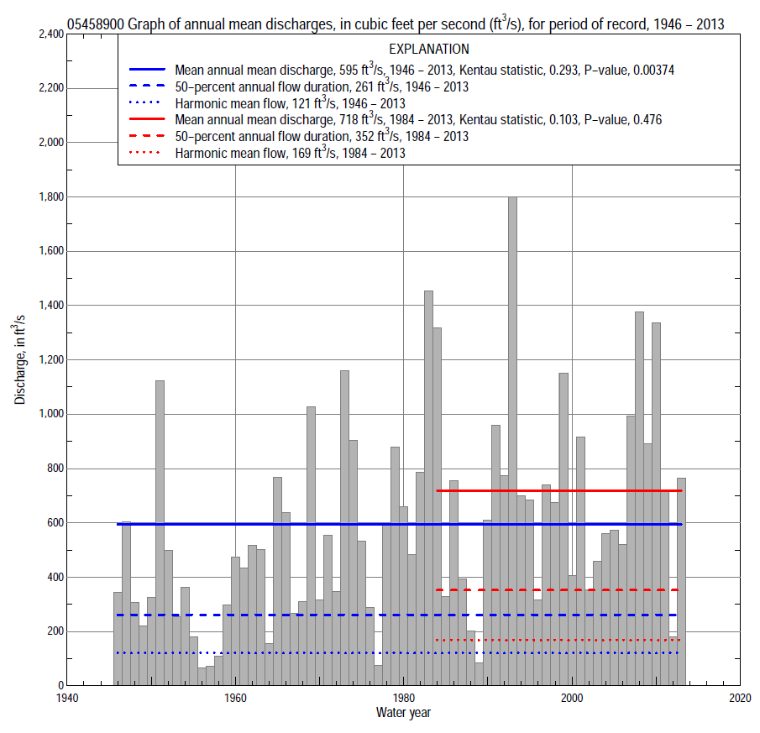

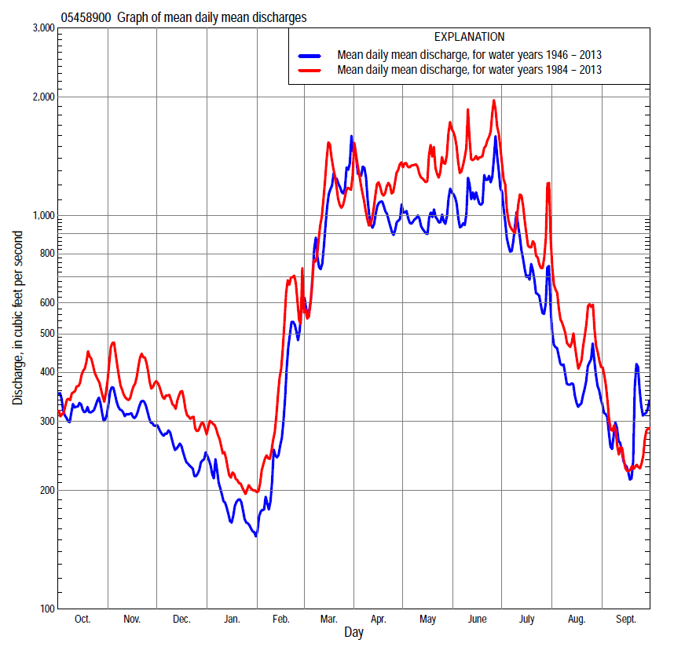

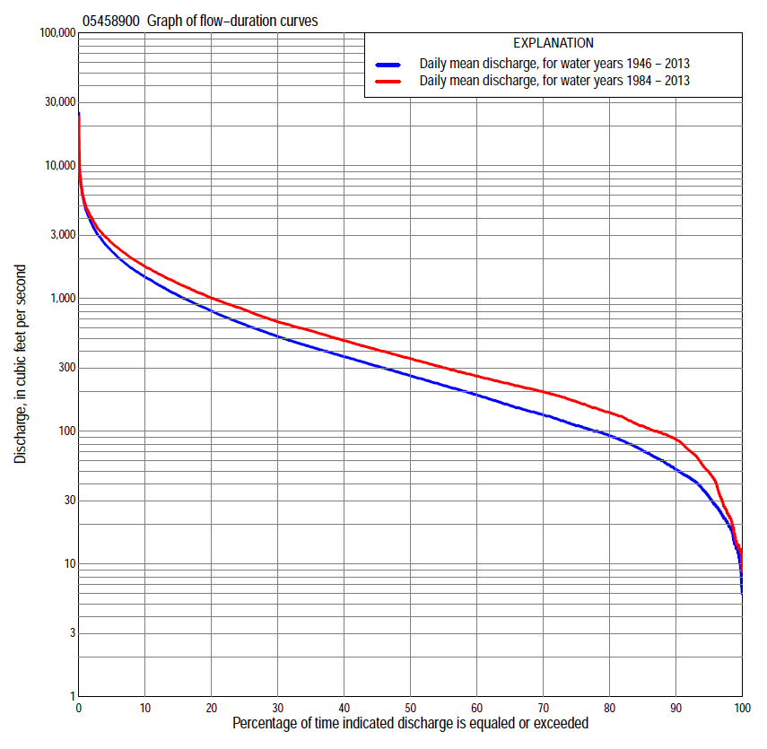

Statistics Based on the Entire Streamflow Period of Record
05458900 Monthly and annual flow durations, based on 1946–2013 period of record (68 years)
Percentage of days discharge equaled or exceeded |  |  |  |  | Discharge (cubic feet per second) |  |  |  |  |  |  |  |  | Annual flow durations
 | Oct | Nov | Dec | Jan | Feb | Mar | Apr | May | June | July | Aug | Sept | Annual | Kentau statistic | P-value
99 | 14 | 20 | 12 | 8.6 | 6.5 | 41 | 79 | 55 | 36 | 24 | 15 | 14 | 14 | 0.342 | 0.000
98 | 18 | 22 | 13 | 9.8 | 10 | 53 | 93 | 69 | 46 | 29 | 20 | 18 | 19 | 0.331 | 0.000
95 | 22 | 28 | 25 | 14 | 19 | 80 | 123 | 107 | 76 | 56 | 34 | 24 | 32 | 0.329 | 0.000
90 | 37 | 45 | 43 | 28 | 38 | 105 | 170 | 145 | 119 | 89 | 49 | 31 | 52 | 0.312 | 0.000
85 | 46 | 62 | 54 | 41 | 46 | 130 | 239 | 200 | 170 | 120 | 75 | 46 | 72 | 0.309 | 0.000
80 | 56 | 77 | 66 | 50 | 56 | 172 | 293 | 273 | 222 | 149 | 97 | 61 | 93 | 0.314 | 0.000
75 | 68 | 98 | 89 | 58 | 68 | 211 | 331 | 315 | 281 | 175 | 109 | 70 | 110 | 0.311 | 0.000
70 | 81 | 113 | 106 | 69 | 81 | 245 | 400 | 358 | 342 | 215 | 126 | 85 | 133 | 0.308 | 0.000
65 | 100 | 135 | 120 | 80 | 92 | 297 | 451 | 396 | 406 | 258 | 145 | 95 | 156 | 0.290 | 0.000
60 | 130 | 160 | 138 | 93 | 100 | 353 | 527 | 450 | 465 | 303 | 158 | 106 | 187 | 0.284 | 0.001
55 | 141 | 184 | 150 | 103 | 110 | 418 | 596 | 522 | 523 | 348 | 176 | 120 | 220 | 0.280 | 0.001
50 | 168 | 208 | 166 | 114 | 130 | 490 | 673 | 603 | 602 | 403 | 198 | 135 | 261 | 0.281 | 0.001
45 | 199 | 238 | 188 | 128 | 160 | 580 | 796 | 690 | 709 | 468 | 218 | 157 | 309 | 0.303 | 0.000
40 | 225 | 266 | 220 | 145 | 200 | 700 | 907 | 797 | 856 | 542 | 247 | 177 | 364 | 0.326 | 0.000
35 | 251 | 308 | 252 | 165 | 230 | 851 | 1,020 | 918 | 1,020 | 642 | 281 | 202 | 431 | 0.331 | 0.000
30 | 301 | 362 | 295 | 196 | 266 | 1,010 | 1,200 | 1,060 | 1,200 | 756 | 326 | 235 | 517 | 0.345 | 0.000
25 | 368 | 410 | 342 | 240 | 320 | 1,210 | 1,400 | 1,240 | 1,420 | 920 | 389 | 285 | 638 | 0.329 | 0.000
20 | 481 | 470 | 387 | 278 | 390 | 1,460 | 1,610 | 1,450 | 1,650 | 1,100 | 478 | 351 | 805 | 0.320 | 0.000
15 | 652 | 568 | 450 | 330 | 473 | 1,830 | 1,920 | 1,770 | 2,050 | 1,350 | 603 | 440 | 1,050 | 0.310 | 0.000
10 | 801 | 703 | 560 | 450 | 690 | 2,520 | 2,370 | 2,230 | 2,670 | 1,760 | 827 | 574 | 1,450 | 0.297 | 0.000
5 | 1,120 | 982 | 714 | 596 | 1,200 | 3,780 | 3,180 | 3,060 | 3,980 | 2,670 | 1,570 | 1,040 | 2,260 | 0.243 | 0.003
2 | 1,820 | 1,440 | 981 | 820 | 2,300 | 5,700 | 4,560 | 4,350 | 5,920 | 3,990 | 2,510 | 1,770 | 3,620 | 0.176 | 0.034
1 | 2,290 | 1,840 | 1,190 | 1,150 | 4,080 | 7,300 | 5,720 | 5,900 | 7,770 | 5,420 | 3,650 | 2,720 | 4,790 | 0.104 | 0.212

05458900 Annual exceedance probability of instantaneous peak discharges, in cubic feet per second (ft³/s), based on the Weighted Independent Estimates method,
Annual exceed-ance probability | Recur-rence interval (years) | Discharge (ft³/s) | 95-percent lower confi-dence interval (ft³/s) | 95-percent upper confi-dence interval (ft³/s)
0.500 | 2 | 6,190 | 5,180 | 7,410
0.200 | 5 | 11,900 | 10,000 | 14,000
0.100 | 10 | 16,000 | 13,400 | 19,000
0.040 | 25 | 21,900 | 17,900 | 26,800
0.020 | 50 | 26,100 | 20,700 | 32,900
0.010 | 100 | 30,200 | 23,200 | 39,300
0.005 | 200 | 35,900 | 26,500 | 48,600
0.002 | 500 | 40,200 | 28,300 | 57,200
and based on the expected moments algorithm/multiple Grubbs-Beck analysis computed using a historical period length of 85 years (1929–2013)
0.500 | 2 | 6,160 | 4,430 | 7,420
0.200 | 5 | 11,700 | 9,630 | 14,700
0.100 | 10 | 15,800 | 12,800 | 21,000
0.040 | 25 | 21,400 | 16,800 | 30,900
0.020 | 50 | 25,700 | 19,600 | 39,500
0.010 | 100 | 30,100 | 22,300 | 48,900
0.005 | 200 | 34,500 | 24,700 | 59,400
0.002 | 500 | 40,400 | 27,700 | 75,000
Kentau statistic |  | -0.010
P-value |  | 0.907
Begin year |  | 1946
End year |  | 2013
Number of peaks |  | 68

05458900 Annual exceedance probability of high discharges, based on 1946–2013 period of record (68 years)
Annual exceedance probability | Recur-rence interval (years) | Maximum average discharge (ft³/s) for indicated number of consecutive days
 |  | 1 | 3 | 7 | 15 | 30
0.990 | 1.01 | 354 | 321 | 266 | 212 | 160
0.950 | 1.05 | 880 | 806 | 665 | 515 | 394
0.900 | 1.11 | 1,370 | 1,250 | 1,030 | 783 | 600
0.800 | 1.25 | 2,260 | 2,050 | 1,650 | 1,240 | 946
0.500 | 2 | 5,230 | 4,590 | 3,580 | 2,590 | 1,930
0.200 | 5 | 10,600 | 8,740 | 6,510 | 4,550 | 3,260
0.100 | 10 | 14,500 | 11,500 | 8,350 | 5,750 | 4,020
0.040 | 25 | 19,500 | 14,900 | 10,400 | 7,070 | 4,800
0.020 | 50 | 23,200 | 17,200 | 11,800 | 7,910 | 5,260
0.010 | 100 | 26,800 | 19,300 | 13,000 | 8,640 | 5,640
0.005 | 200 | 30,200 | 21,200 | 14,000 | 9,270 | 5,950
0.002 | 500 | 34,600 | 23,500 | 15,200 | 9,980 | 6,290
Kentau statistic |  | 0.024 | 0.058 | 0.106 | 0.139 | 0.156
P-value |  | 0.779 | 0.491 | 0.202 | 0.095 | 0.060

 | 05458900 Annual nonexceedance probability of low discharges, based on April 1946 to March 2013 period of record (67 years)
Annual nonexceed-ance probability | Recur-rence interval (years) | Minimum average discharge (ft³/s) for indicated number of consecutive days
 |  | 1 | 3 | 7 | 14 | 30 | 60 | 90 | 120 | 183
0.01 | 100 | 5.0 | 5.1 | 5.3 | 5.6 | 6.3 | 7.4 | 9.0 | 11 | 12
0.02 | 50 | 7.1 | 7.3 | 7.5 | 8.0 | 9.0 | 11 | 13 | 15 | 17
0.05 | 20 | 12 | 12 | 13 | 13 | 15 | 18 | 21 | 25 | 29
0.10 | 10 | 18 | 18 | 19 | 20 | 23 | 27 | 33 | 38 | 45
0.20 | 5 | 28 | 29 | 30 | 33 | 36 | 44 | 53 | 61 | 74
0.50 | 2 | 61 | 64 | 66 | 71 | 80 | 98 | 121 | 141 | 175
0.80 | 1.25 | 116 | 120 | 126 | 134 | 152 | 194 | 245 | 292 | 373
0.90 | 1.11 | 155 | 159 | 167 | 178 | 202 | 264 | 338 | 410 | 531
0.96 | 1.04 | 203 | 206 | 217 | 230 | 264 | 355 | 463 | 573 | 750
0.98 | 1.02 | 236 | 240 | 253 | 268 | 308 | 421 | 558 | 701 | 923
0.99 | 1.01 | 268 | 272 | 286 | 302 | 349 | 486 | 652 | 831 | 1,100
Kentau statistic |  | 0.320 | 0.344 | 0.345 | 0.333 | 0.309 | 0.310 | 0.302 | 0.278 | 0.254
P-value |  | 0.000 | 0.000 | 0.000 | 0.000 | 0.000 | 0.000 | 0.000 | 0.001 | 0.002

05458900 Annual nonexceedance probability of seasonal low discharges, based on October 1945 to September 2013 period of record (68 years)
Annual nonexceed-ance probability | Recur-rence interval (years) | Minimum average discharge (cubic feet per second) for indicated number of consecutive days
 |  | 1 | 7 | 14 | 30 |  | 1 | 7 | 14 | 30
 |  | January-February-March |  |  |  |  | April-May-June
0.01 | 100 | 5.6 | 5.9 | 6.2 | 7.1 |  | 21 | 23 | 26 | 33
0.02 | 50 | 8.0 | 8.4 | 8.8 | 10 |  | 30 | 33 | 36 | 46
0.05 | 20 | 13 | 14 | 15 | 17 |  | 48 | 53 | 58 | 74
0.10 | 10 | 20 | 22 | 23 | 26 |  | 71 | 79 | 87 | 110
0.20 | 5 | 33 | 35 | 37 | 42 |  | 113 | 125 | 139 | 177
0.50 | 2 | 77 | 84 | 89 | 102 |  | 252 | 280 | 319 | 412
0.80 | 1.25 | 164 | 181 | 192 | 224 |  | 506 | 569 | 670 | 899
0.90 | 1.11 | 234 | 259 | 278 | 327 |  | 703 | 793 | 955 | 1,310
0.96 | 1.04 | 333 | 371 | 401 | 478 |  | 969 | 1,100 | 1,360 | 1,930
0.98 | 1.02 | 411 | 461 | 501 | 602 |  | 1,180 | 1,340 | 1,690 | 2,460
0.99 | 1.01 | 492 | 554 | 606 | 735 |  | 1,390 | 1,580 | 2,030 | 3,020
Kentau statistic |  | 0.317 | 0.336 | 0.333 | 0.317 |  | 0.341 | 0.326 | 0.327 | 0.331
P-value |  | 0.000 | 0.000 | 0.000 | 0.000 |  | 0.000 | 0.000 | 0.000 | 0.000
 |  | July-August-September |  |  |  |  | October-November-December
0.01 | 100 | 11 | 11 | 12 | 14 |  | 6.6 | 7.8 | 8.5 | 10
0.02 | 50 | 13 | 14 | 15 | 18 |  | 9.3 | 11 | 12 | 14
0.05 | 20 | 20 | 21 | 22 | 26 |  | 15 | 18 | 19 | 23
0.10 | 10 | 27 | 29 | 31 | 36 |  | 23 | 27 | 29 | 35
0.20 | 5 | 40 | 43 | 46 | 54 |  | 38 | 43 | 47 | 56
0.50 | 2 | 83 | 89 | 97 | 116 |  | 87 | 99 | 108 | 129
0.80 | 1.25 | 168 | 183 | 203 | 254 |  | 181 | 208 | 228 | 275
0.90 | 1.11 | 240 | 265 | 296 | 384 |  | 254 | 296 | 325 | 396
0.96 | 1.04 | 350 | 392 | 442 | 598 |  | 354 | 421 | 462 | 569
0.98 | 1.02 | 445 | 503 | 571 | 798 |  | 433 | 521 | 573 | 710
0.99 | 1.01 | 550 | 628 | 719 | 1,030 |  | 512 | 625 | 688 | 859
Kentau statistic |  | 0.259 | 0.254 | 0.250 | 0.225 |  | 0.263 | 0.255 | 0.249 | 0.231
P-value |  | 0.002 | 0.002 | 0.003 | 0.007 |  | 0.002 | 0.002 | 0.003 | 0.005

Statistics Based on the 1984–2013 Streamflow Period of Record
05458900 Monthly and annual flow durations, based on 1984–2013 period of record (30 years)
Percentage of days discharge equaled or exceeded |  |  |  |  | Discharge (cubic feet per second) |  |  |  |  |  |  |  |  | Annual flow durations
 | Oct | Nov | Dec | Jan | Feb | Mar | Apr | May | June | July | Aug | Sept | Annual | Kentau statistic | P-value
99 | 13 | 21 | 11 | 13 | 17 | 42 | 124 | 97 | 52 | 30 | 14 | 13 | 15 | 0.030 | 0.830
98 | 14 | 23 | 13 | 14 | 21 | 53 | 135 | 120 | 69 | 32 | 15 | 15 | 23 | 0.028 | 0.844
95 | 23 | 39 | 50 | 33 | 45 | 135 | 153 | 195 | 111 | 60 | 36 | 24 | 49 | 0.046 | 0.735
90 | 54 | 89 | 68 | 56 | 62 | 200 | 210 | 284 | 228 | 129 | 60 | 34 | 87 | 0.007 | 0.972
85 | 74 | 106 | 104 | 71 | 82 | 217 | 296 | 344 | 336 | 185 | 111 | 73 | 109 | -0.028 | 0.844
80 | 89 | 118 | 120 | 88 | 95 | 250 | 347 | 392 | 416 | 252 | 146 | 88 | 138 | -0.030 | 0.830
75 | 99 | 142 | 140 | 100 | 106 | 297 | 419 | 477 | 480 | 294 | 162 | 94 | 167 | -0.048 | 0.721
70 | 131 | 170 | 155 | 110 | 129 | 344 | 508 | 569 | 543 | 339 | 186 | 103 | 198 | -0.064 | 0.630
65 | 140 | 190 | 170 | 121 | 150 | 403 | 574 | 649 | 602 | 376 | 201 | 120 | 226 | -0.076 | 0.568
60 | 169 | 210 | 200 | 140 | 190 | 461 | 635 | 744 | 720 | 430 | 221 | 134 | 260 | -0.069 | 0.605
55 | 192 | 230 | 232 | 153 | 210 | 518 | 711 | 855 | 860 | 492 | 244 | 149 | 300 | -0.067 | 0.617
50 | 211 | 257 | 260 | 170 | 233 | 587 | 833 | 936 | 1,010 | 568 | 273 | 166 | 352 | -0.039 | 0.775
45 | 222 | 295 | 295 | 190 | 251 | 676 | 918 | 1,060 | 1,170 | 647 | 305 | 185 | 410 | 0.034 | 0.803
40 | 239 | 359 | 330 | 230 | 280 | 840 | 1,010 | 1,180 | 1,320 | 739 | 337 | 198 | 481 | 0.076 | 0.568
35 | 266 | 421 | 354 | 255 | 313 | 940 | 1,190 | 1,300 | 1,490 | 858 | 389 | 219 | 571 | 0.099 | 0.454
30 | 344 | 450 | 376 | 280 | 365 | 1,080 | 1,370 | 1,500 | 1,660 | 1,000 | 439 | 254 | 668 | 0.103 | 0.432
25 | 485 | 529 | 410 | 300 | 410 | 1,260 | 1,580 | 1,730 | 1,970 | 1,160 | 526 | 289 | 821 | 0.117 | 0.372
20 | 656 | 611 | 472 | 340 | 475 | 1,520 | 1,800 | 2,010 | 2,310 | 1,350 | 616 | 338 | 1,000 | 0.122 | 0.353
15 | 773 | 685 | 566 | 440 | 619 | 1,820 | 2,040 | 2,360 | 2,830 | 1,630 | 760 | 427 | 1,300 | 0.166 | 0.205
10 | 889 | 800 | 660 | 530 | 866 | 2,330 | 2,520 | 2,880 | 3,530 | 2,200 | 1,060 | 505 | 1,740 | 0.154 | 0.239
5 | 1,180 | 1,080 | 823 | 616 | 1,450 | 3,140 | 3,240 | 3,690 | 4,520 | 2,940 | 2,000 | 810 | 2,620 | 0.191 | 0.143
2 | 1,820 | 1,570 | 1,090 | 751 | 2,500 | 5,260 | 4,430 | 5,570 | 5,990 | 4,520 | 3,400 | 1,400 | 3,990 | 0.136 | 0.301
1 | 2,260 | 1,820 | 1,200 | 1,020 | 4,140 | 6,570 | 5,010 | 7,750 | 7,770 | 6,010 | 4,060 | 1,860 | 5,090 | 0.133 | 0.309

05458900 Annual exceedance probability of high discharges, based on 1984–2013 period of record (30 years)
Annual exceedance probability | Recur-rence interval (years) | Maximum average discharge (ft³/s) for indicated number of consecutive days
 |  | 1 | 3 | 7 | 15 | 30
0.990 | 1.01 | 628 | 561 | 482 | 377 | 306
0.950 | 1.05 | 1,190 | 1,100 | 955 | 745 | 596
0.900 | 1.11 | 1,650 | 1,550 | 1,340 | 1,040 | 823
0.800 | 1.25 | 2,450 | 2,310 | 1,970 | 1,510 | 1,180
0.500 | 2 | 5,060 | 4,660 | 3,820 | 2,850 | 2,150
0.200 | 5 | 10,200 | 8,790 | 6,800 | 4,850 | 3,510
0.100 | 10 | 14,400 | 11,900 | 8,880 | 6,160 | 4,350
0.040 | 25 | 20,800 | 16,200 | 11,500 | 7,740 | 5,320
0.020 | 50 | 26,200 | 19,600 | 13,500 | 8,840 | 5,970
0.010 | 100 | 32,200 | 23,000 | 15,300 | 9,860 | 6,550
0.005 | 200 | 38,700 | 26,600 | 17,200 | 10,800 | 7,090
0.002 | 500 | 48,200 | 31,300 | 19,600 | 12,000 | 7,730
Kentau statistic |  | 0.099 | 0.120 | 0.122 | 0.117 | 0.140
P-value |  | 0.454 | 0.363 | 0.354 | 0.372 | 0.284

 | 05458900 Annual nonexceedance probability of low discharges, based on April 1983 to March 2013 period of record (30 years)
Annual nonexceed-ance probability | Recur-rence interval (years) | Minimum average discharge (ft³/s) for indicated number of consecutive days
 |  | 1 | 3 | 7 | 14 | 30 | 60 | 90 | 120 | 183
0.01 | 100 | 7.6 | 8.1 | 8.6 | 9.3 | 10 | 11 | 13 | 14 | 14
0.02 | 50 | 11 | 12 | 13 | 14 | 15 | 16 | 19 | 21 | 22
0.05 | 20 | 20 | 21 | 22 | 24 | 26 | 29 | 34 | 37 | 40
0.10 | 10 | 30 | 32 | 34 | 36 | 40 | 45 | 54 | 59 | 66
0.20 | 5 | 48 | 51 | 54 | 57 | 62 | 73 | 88 | 96 | 112
0.50 | 2 | 95 | 100 | 105 | 111 | 123 | 153 | 188 | 210 | 258
0.80 | 1.25 | 150 | 155 | 163 | 172 | 194 | 254 | 322 | 378 | 475
0.90 | 1.11 | 178 | 181 | 191 | 201 | 229 | 306 | 395 | 478 | 603
0.96 | 1.04 | 202 | 204 | 215 | 226 | 261 | 356 | 468 | 585 | 739
0.98 | 1.02 | 215 | 215 | 227 | 238 | 278 | 384 | 510 | 651 | 822
0.99 | 1.01 | 222 | 223 | 236 | 247 | 291 | 405 | 543 | 707 | 889
Kentau statistic |  | 0.009 | 0.011 | 0.000 | -0.007 | -0.030 | -0.048 | -0.080 | -0.048 | -0.071
P-value |  | 0.957 | 0.943 | 1.000 | 0.972 | 0.830 | 0.721 | 0.544 | 0.721 | 0.592

05458900 Annual nonexceedance probability of seasonal low discharges, based on October 1983 to September 2013 period of record (30 years)
Annual nonexceed-ance probability | Recur-rence interval (years) | Minimum average discharge (cubic feet per second) for indicated number of consecutive days
 |  | 1 | 7 | 14 | 30 |  | 1 | 7 | 14 | 30
 |  | January-February-March |  |  |  |  | April-May-June
0.01 | 100 | 11 | 13 | 13 | 14 |  | 39 | 41 | 44 | 54
0.02 | 50 | 15 | 18 | 18 | 20 |  | 54 | 57 | 61 | 75
0.05 | 20 | 24 | 28 | 29 | 33 |  | 85 | 90 | 98 | 121
0.10 | 10 | 36 | 42 | 43 | 48 |  | 123 | 132 | 145 | 182
0.20 | 5 | 56 | 64 | 67 | 75 |  | 187 | 203 | 226 | 287
0.50 | 2 | 118 | 133 | 142 | 158 |  | 377 | 415 | 482 | 634
0.80 | 1.25 | 224 | 250 | 264 | 291 |  | 668 | 749 | 916 | 1,260
0.90 | 1.11 | 300 | 332 | 350 | 381 |  | 861 | 973 | 1,230 | 1,730
0.96 | 1.04 | 396 | 438 | 457 | 490 |  | 1,090 | 1,240 | 1,620 | 2,350
0.98 | 1.02 | 466 | 516 | 535 | 566 |  | 1,250 | 1,440 | 1,910 | 2,830
0.99 | 1.01 | 534 | 591 | 608 | 637 |  | 1,400 | 1,610 | 2,190 | 3,310
Kentau statistic |  | 0.014 | 0.018 | 0.021 | 0.016 |  | 0.143 | 0.126 | 0.145 | 0.191
P-value |  | 0.929 | 0.901 | 0.887 | 0.915 |  | 0.276 | 0.335 | 0.269 | 0.143
 |  | July-August-September |  |  |  |  | October-November-December
0.01 | 100 | 12 | 12 | 13 | 14 |  | 7.2 | 8.4 | 9.5 | 12
0.02 | 50 | 16 | 17 | 18 | 19 |  | 11 | 13 | 14 | 18
0.05 | 20 | 24 | 26 | 27 | 30 |  | 21 | 23 | 26 | 31
0.10 | 10 | 35 | 37 | 40 | 44 |  | 34 | 38 | 41 | 49
0.20 | 5 | 53 | 56 | 61 | 68 |  | 58 | 63 | 68 | 81
0.50 | 2 | 114 | 121 | 132 | 155 |  | 131 | 144 | 156 | 182
0.80 | 1.25 | 227 | 245 | 269 | 336 |  | 236 | 269 | 296 | 343
0.90 | 1.11 | 317 | 346 | 380 | 494 |  | 296 | 346 | 386 | 448
0.96 | 1.04 | 443 | 491 | 540 | 733 |  | 357 | 432 | 488 | 570
0.98 | 1.02 | 543 | 610 | 672 | 940 |  | 393 | 486 | 555 | 651
0.99 | 1.01 | 649 | 737 | 811 | 1,170 |  | 422 | 532 | 613 | 723
Kentau statistic |  | -0.018 | -0.009 | -0.007 | -0.011 |  | -0.039 | -0.034 | -0.011 | -0.039
P-value |  | 0.901 | 0.957 | 0.972 | 0.943 |  | 0.775 | 0.803 | 0.943 | 0.775

