LOCATION.--Lat 43°09'54", long 93°11'33" referenced to North American Datum of 1927, in NE 1/4 SE 1/4 NW 1/4 sec.03, T.96 N., R.20 W., Cerro Gordo County, IA, Hydrologic Unit 07080203, on right bank 650 ft upstream from bridge on 13th Street in Mason City, 0.1 mi downstream from Calmus Creek, 1.0 mi upstream from Willow Creek, and 20.2 mi upstream from mouth.

DRAINAGE AREA.--526 mi².

PERIOD OF RECORD.--Discharge records from October 1932 to current year. Prior to January 1933, monthly mean discharge published in WSP 1308. Prior to October 1959, published as "Lime Creek at Mason City."

GAGE.--Water-stage recorder and concrete control. Datum of gage is 1,069.59 ft above National Geodetic Vertical Datum of 1929. Prior to October 15, 1934, non-recording gage at datum 6.47 ft lower; October 15 to November 6, 1934, non-recording gage at different datum; November 7, 1934, to March 22, 1935, non-recording gage at same datum.

A summary of all available data for this streamgage is provided through the USGS National Water Information System web interface (NWISWeb). The following link provides access to current/historical observations, daily data, daily statistics, monthly statistics, annual statistics, peak streamflow, field measurements, field/lab water-quality samples, and the latest water-year summaries. Data can be filtered by parameter and/or dates, and can be output in various tabular and graphical formats.
http://waterdata.usgs.gov/nwis/inventory/?site_no=05459500

The USGS WaterWatch Toolkit is available at:
http://waterwatch.usgs.gov/?id=ww_toolkit
Tools for summarizing streamflow information include the duration hydrograph builder, the cumulative streamflow hydrograph builder, the streamgage statistics retrieval tool, the rating curve builder, the flood tracking chart builder, the National Weather Service Advanced Hydrologic Prediction Service (AHPS) river forecast hydrograph builder, and the raster-hydrograph builder. Entering the above number for this streamgage into these toolkit webpages will provide streamflow information specific to this streamgage.

A description of the statistics presented for this streamgage is available in the main body of the report at:
http://dx.doi.org/10.3133/ofr20151214
A link to other streamgages included in this report, a map showing the location of the streamgages, information on the programs used to compute the statistical analyses, and references are included in the main body of the report.

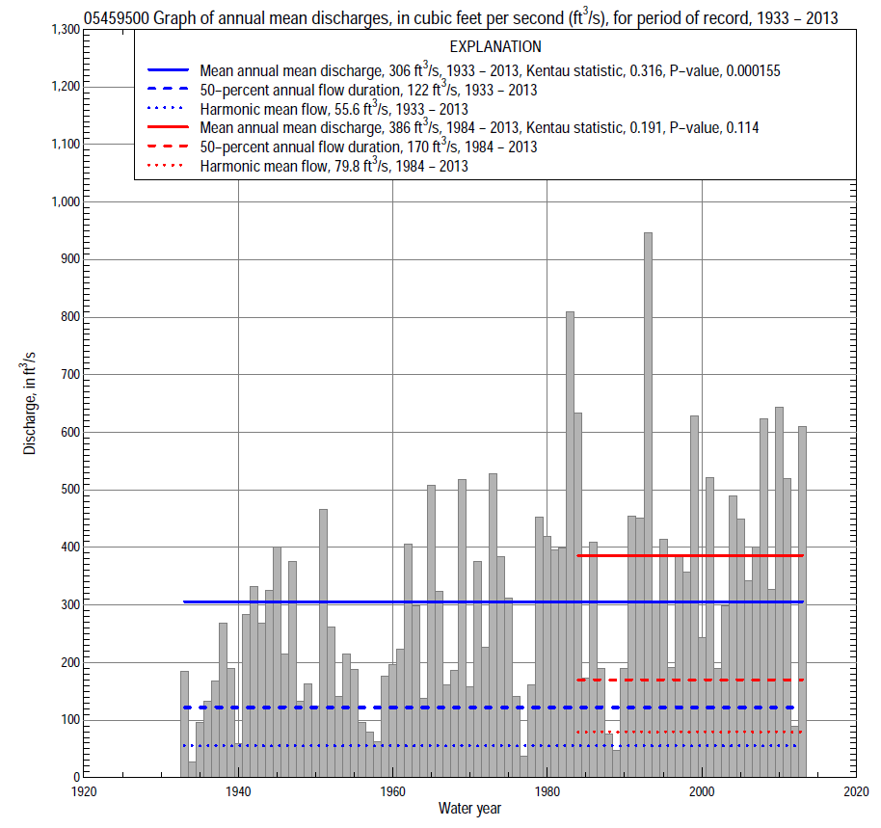

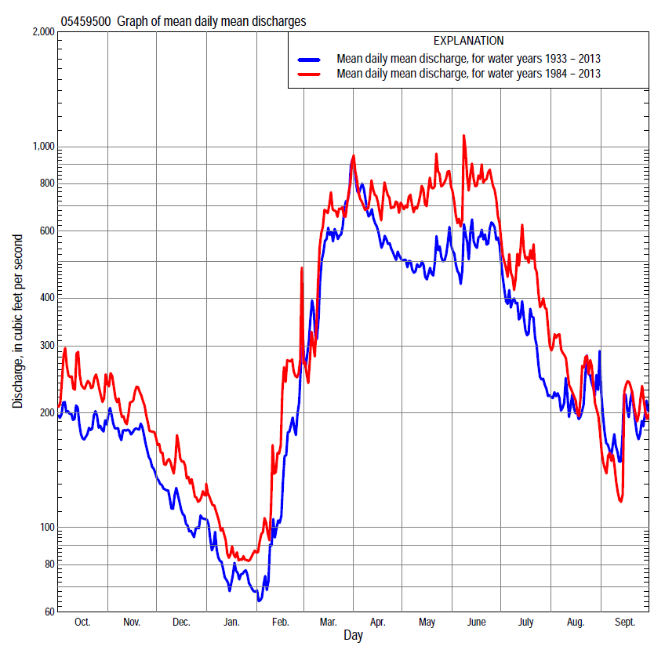

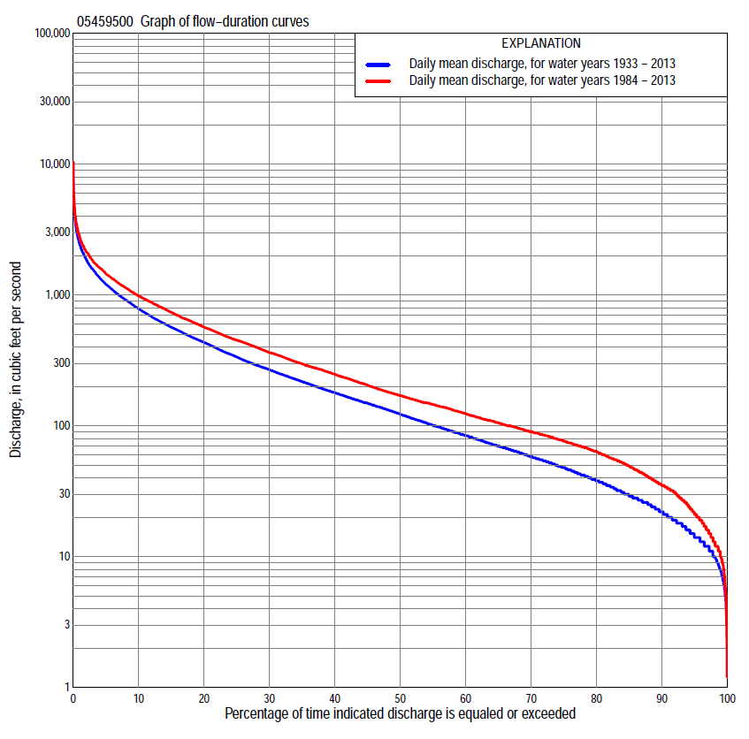

Statistics Based on the Entire Streamflow Period of Record
05459500 Monthly and annual flow durations, based on 1933–2013 period of record (81 years)
Percentage of days discharge equaled or exceeded |  |  |  |  | Discharge (cubic feet per second) |  |  |  |  |  |  |  |  | Annual flow durations
 | Oct | Nov | Dec | Jan | Feb | Mar | Apr | May | June | July | Aug | Sept | Annual | Kentau statistic | P-value
99 | 8.0 | 10 | 5.3 | 5.5 | 6.8 | 11 | 42 | 24 | 14 | 7.0 | 4.8 | 8.0 | 7.7 | 0.336 | 0.000
98 | 11 | 13 | 10 | 7.9 | 7.6 | 14 | 55 | 34 | 18 | 8.1 | 6.1 | 9.6 | 10 | 0.340 | 0.000
95 | 16 | 18 | 13 | 10 | 10 | 21 | 69 | 50 | 28 | 16 | 13 | 13 | 14 | 0.341 | 0.000
90 | 21 | 22 | 18 | 13 | 13 | 39 | 96 | 77 | 51 | 28 | 18 | 18 | 22 | 0.331 | 0.000
85 | 25 | 28 | 23 | 16 | 18 | 54 | 129 | 100 | 70 | 40 | 27 | 23 | 29 | 0.321 | 0.000
80 | 30 | 33 | 27 | 19 | 22 | 70 | 154 | 120 | 99 | 55 | 36 | 32 | 38 | 0.315 | 0.000
75 | 37 | 40 | 30 | 24 | 27 | 90 | 187 | 145 | 123 | 69 | 46 | 40 | 48 | 0.311 | 0.000
70 | 43 | 46 | 36 | 27 | 32 | 112 | 225 | 168 | 147 | 84 | 54 | 48 | 58 | 0.325 | 0.000
65 | 48 | 55 | 42 | 32 | 36 | 144 | 255 | 195 | 174 | 103 | 62 | 56 | 70 | 0.320 | 0.000
60 | 54 | 64 | 50 | 37 | 40 | 183 | 292 | 216 | 213 | 124 | 73 | 63 | 84 | 0.307 | 0.000
55 | 62 | 76 | 59 | 42 | 48 | 221 | 341 | 250 | 257 | 150 | 85 | 69 | 101 | 0.318 | 0.000
50 | 75 | 96 | 68 | 48 | 55 | 262 | 400 | 292 | 311 | 180 | 97 | 77 | 122 | 0.321 | 0.000
45 | 93 | 121 | 80 | 56 | 64 | 313 | 464 | 342 | 366 | 219 | 108 | 86 | 149 | 0.341 | 0.000
40 | 116 | 150 | 94 | 66 | 72 | 368 | 531 | 400 | 435 | 255 | 123 | 95 | 179 | 0.350 | 0.000
35 | 155 | 174 | 115 | 75 | 80 | 444 | 599 | 462 | 508 | 295 | 140 | 112 | 218 | 0.356 | 0.000
30 | 204 | 199 | 138 | 88 | 93 | 533 | 704 | 550 | 599 | 349 | 162 | 130 | 269 | 0.358 | 0.000
25 | 252 | 230 | 154 | 100 | 110 | 662 | 824 | 646 | 692 | 418 | 197 | 157 | 336 | 0.356 | 0.000
20 | 301 | 270 | 175 | 116 | 146 | 834 | 967 | 763 | 855 | 508 | 255 | 201 | 435 | 0.332 | 0.000
15 | 377 | 342 | 204 | 140 | 190 | 1,050 | 1,120 | 908 | 1,050 | 614 | 353 | 294 | 567 | 0.324 | 0.000
10 | 496 | 436 | 247 | 167 | 275 | 1,400 | 1,380 | 1,150 | 1,350 | 804 | 558 | 443 | 786 | 0.304 | 0.000
5 | 702 | 571 | 320 | 237 | 507 | 1,930 | 1,900 | 1,580 | 1,890 | 1,200 | 946 | 732 | 1,210 | 0.269 | 0.000
2 | 1,020 | 806 | 498 | 380 | 1,040 | 2,690 | 2,820 | 2,270 | 2,620 | 1,850 | 1,490 | 1,230 | 1,870 | 0.202 | 0.008
1 | 1,270 | 984 | 634 | 496 | 1,670 | 3,410 | 3,640 | 2,810 | 3,410 | 2,580 | 1,910 | 1,840 | 2,430 | 0.134 | 0.077

05459500 Annual exceedance probability of instantaneous peak discharges, in cubic feet per second (ft³/s), based on the Weighted Independent Estimates method,
Annual exceed-ance probability | Recur-rence interval (years) | Discharge (ft³/s) | 95-percent lower confi-dence interval (ft³/s) | 95-percent upper confi-dence interval (ft³/s)
0.500 | 2 | 3,250 | 2,800 | 3,780
0.200 | 5 | 5,570 | 4,780 | 6,490
0.100 | 10 | 7,270 | 6,130 | 8,610
0.040 | 25 | 9,530 | 7,740 | 11,700
0.020 | 50 | 11,300 | 8,840 | 14,400
0.010 | 100 | 13,100 | 9,860 | 17,300
0.005 | 200 | 14,900 | 10,800 | 20,600
0.002 | 500 | 17,400 | 11,900 | 25,300
and based on the expected moments algorithm/multiple Grubbs-Beck analysis computed using a historical period length of 81 years (1933–2013)
0.500 | 2 | 3,290 | 2,810 | 3,840
0.200 | 5 | 5,650 | 4,840 | 6,700
0.100 | 10 | 7,380 | 6,260 | 9,050
0.040 | 25 | 9,700 | 8,020 | 12,700
0.020 | 50 | 11,500 | 9,270 | 16,100
0.010 | 100 | 13,400 | 10,400 | 19,900
0.005 | 200 | 15,300 | 11,500 | 24,400
0.002 | 500 | 17,900 | 12,900 | 31,400
Kentau statistic |  | 0.010
P-value |  | 0.903
Begin year |  | 1933
End year |  | 2013
Number of peaks |  | 81

05459500 Annual exceedance probability of high discharges, based on 1933–2013 period of record (81 years)
Annual exceedance probability | Recur-rence interval (years) | Maximum average discharge (ft³/s) for indicated number of consecutive days
 |  | 1 | 3 | 7 | 15 | 30
0.990 | 1.01 | 435 | 371 | 260 | 172 | 127
0.950 | 1.05 | 784 | 668 | 502 | 353 | 264
0.900 | 1.11 | 1,050 | 897 | 692 | 499 | 374
0.800 | 1.25 | 1,480 | 1,260 | 995 | 735 | 551
0.500 | 2 | 2,710 | 2,290 | 1,840 | 1,400 | 1,040
0.200 | 5 | 4,650 | 3,920 | 3,100 | 2,360 | 1,730
0.100 | 10 | 6,020 | 5,050 | 3,930 | 2,980 | 2,160
0.040 | 25 | 7,780 | 6,520 | 4,920 | 3,690 | 2,640
0.020 | 50 | 9,100 | 7,610 | 5,610 | 4,170 | 2,960
0.010 | 100 | 10,400 | 8,690 | 6,260 | 4,600 | 3,250
0.005 | 200 | 11,700 | 9,760 | 6,870 | 5,000 | 3,500
0.002 | 500 | 13,400 | 11,200 | 7,630 | 5,480 | 3,800
Kentau statistic |  | 0.056 | 0.068 | 0.121 | 0.169 | 0.201
P-value |  | 0.463 | 0.370 | 0.111 | 0.026 | 0.008

 | 05459500 Annual nonexceedance probability of low discharges, based on April 1933 to March 2013 period of record (80 years)
Annual nonexceed-ance probability | Recur-rence interval (years) | Minimum average discharge (ft³/s) for indicated number of consecutive days
 |  | 1 | 3 | 7 | 14 | 30 | 60 | 90 | 120 | 183
0.01 | 100 | 1.7 | 2.1 | 2.5 | 2.9 | 3.4 | 4.4 | 5.2 | 6.1 | 6.4
0.02 | 50 | 2.4 | 2.9 | 3.5 | 4.0 | 4.6 | 6.0 | 7.0 | 8.2 | 8.9
0.05 | 20 | 4.1 | 4.8 | 5.6 | 6.2 | 7.2 | 9.1 | 11 | 13 | 14
0.10 | 10 | 6.4 | 7.2 | 8.2 | 9.1 | 10 | 13 | 16 | 18 | 22
0.20 | 5 | 11 | 12 | 13 | 14 | 16 | 20 | 24 | 28 | 35
0.50 | 2 | 24 | 26 | 27 | 30 | 34 | 43 | 54 | 63 | 84
0.80 | 1.25 | 46 | 50 | 53 | 57 | 66 | 87 | 113 | 137 | 191
0.90 | 1.11 | 62 | 67 | 72 | 78 | 92 | 122 | 163 | 202 | 287
0.96 | 1.04 | 81 | 90 | 97 | 106 | 126 | 171 | 237 | 302 | 436
0.98 | 1.02 | 94 | 106 | 116 | 127 | 153 | 211 | 299 | 390 | 567
0.99 | 1.01 | 106 | 122 | 134 | 148 | 181 | 254 | 367 | 488 | 713
Kentau statistic |  | 0.362 | 0.363 | 0.370 | 0.378 | 0.382 | 0.320 | 0.311 | 0.282 | 0.243
P-value |  | 0.000 | 0.000 | 0.000 | 0.000 | 0.000 | 0.000 | 0.000 | 0.000 | 0.001

05459500 Annual nonexceedance probability of seasonal low discharges, based on October 1932 to September 2013 period of record (81 years)
Annual nonexceed-ance probability | Recur-rence interval (years) | Minimum average discharge (cubic feet per second) for indicated number of consecutive days
 |  | 1 | 7 | 14 | 30 |  | 1 | 7 | 14 | 30
 |  | January-February-March |  |  |  |  | April-May-June
0.01 | 100 | 3.4 | 3.9 | 4.1 | 4.9 |  | 7.0 | 8.7 | 10 | 15
0.02 | 50 | 4.4 | 5.0 | 5.4 | 6.3 |  | 10 | 12 | 14 | 21
0.05 | 20 | 6.5 | 7.4 | 7.8 | 9.2 |  | 17 | 20 | 23 | 34
0.10 | 10 | 9.2 | 10 | 11 | 13 |  | 26 | 31 | 36 | 51
0.20 | 5 | 14 | 15 | 16 | 19 |  | 42 | 50 | 58 | 82
0.50 | 2 | 29 | 32 | 34 | 40 |  | 103 | 122 | 143 | 197
0.80 | 1.25 | 58 | 66 | 71 | 84 |  | 233 | 274 | 326 | 440
0.90 | 1.11 | 83 | 96 | 104 | 123 |  | 344 | 406 | 491 | 654
0.96 | 1.04 | 119 | 141 | 153 | 183 |  | 511 | 606 | 743 | 978
0.98 | 1.02 | 149 | 181 | 197 | 236 |  | 650 | 777 | 963 | 1,260
0.99 | 1.01 | 182 | 225 | 246 | 296 |  | 802 | 964 | 1,210 | 1,570
Kentau statistic |  | 0.289 | 0.310 | 0.317 | 0.278 |  | 0.381 | 0.376 | 0.372 | 0.352
P-value |  | 0.000 | 0.000 | 0.000 | 0.000 |  | 0.000 | 0.000 | 0.000 | 0.000
 |  | July-August-September |  |  |  |  | October-November-December
0.01 | 100 | 1.9 | 3.7 | 4.2 | 5.2 |  | 2.6 | 3.7 | 4.7 | 5.9
0.02 | 50 | 3.0 | 5.2 | 5.8 | 7.2 |  | 3.7 | 5.1 | 6.3 | 7.8
0.05 | 20 | 5.5 | 8.4 | 9.3 | 11 |  | 6.1 | 8.0 | 9.6 | 12
0.10 | 10 | 9.1 | 13 | 14 | 17 |  | 9.4 | 12 | 14 | 17
0.20 | 5 | 16 | 20 | 22 | 27 |  | 15 | 19 | 22 | 27
0.50 | 2 | 40 | 45 | 49 | 61 |  | 37 | 44 | 50 | 61
0.80 | 1.25 | 81 | 90 | 100 | 130 |  | 81 | 99 | 112 | 136
0.90 | 1.11 | 109 | 124 | 139 | 189 |  | 118 | 148 | 168 | 205
0.96 | 1.04 | 143 | 171 | 193 | 276 |  | 171 | 223 | 257 | 317
0.98 | 1.02 | 166 | 206 | 236 | 350 |  | 215 | 289 | 336 | 418
0.99 | 1.01 | 187 | 242 | 279 | 429 |  | 262 | 362 | 427 | 536
Kentau statistic |  | 0.317 | 0.304 | 0.307 | 0.287 |  | 0.290 | 0.292 | 0.293 | 0.288
P-value |  | 0.000 | 0.000 | 0.000 | 0.000 |  | 0.000 | 0.000 | 0.000 | 0.000

Statistics Based on the 1984–2013 Streamflow Period of Record
05459500 Monthly and annual flow durations, based on 1984–2013 period of record (30 years)
Percentage of days discharge equaled or exceeded |  |  |  |  | Discharge (cubic feet per second) |  |  |  |  |  |  |  |  | Annual flow durations
 | Oct | Nov | Dec | Jan | Feb | Mar | Apr | May | June | July | Aug | Sept | Annual | Kentau statistic | P-value
99 | 8.9 | 14 | 5.3 | 8.7 | 12 | 15 | 56 | 46 | 18 | 8.3 | 3.5 | 8.5 | 10 | 0.000 | 1.000
98 | 14 | 17 | 9.6 | 11 | 13 | 21 | 59 | 65 | 23 | 15 | 5.9 | 9.6 | 13 | 0.014 | 0.929
95 | 19 | 23 | 20 | 14 | 17 | 48 | 74 | 100 | 40 | 22 | 12 | 16 | 21 | 0.041 | 0.762
90 | 30 | 33 | 29 | 19 | 28 | 71 | 109 | 123 | 71 | 35 | 23 | 28 | 35 | 0.034 | 0.803
85 | 38 | 43 | 39 | 28 | 33 | 97 | 144 | 150 | 150 | 61 | 37 | 42 | 49 | 0.011 | 0.943
80 | 46 | 55 | 49 | 35 | 38 | 115 | 185 | 192 | 207 | 84 | 67 | 53 | 64 | -0.007 | 0.972
75 | 53 | 67 | 57 | 40 | 46 | 136 | 233 | 236 | 254 | 117 | 83 | 60 | 77 | -0.009 | 0.957
70 | 65 | 80 | 65 | 46 | 54 | 155 | 262 | 308 | 298 | 169 | 93 | 69 | 90 | -0.016 | 0.915
65 | 78 | 98 | 73 | 53 | 64 | 184 | 325 | 372 | 341 | 205 | 103 | 74 | 105 | -0.039 | 0.775
60 | 92 | 116 | 82 | 59 | 70 | 210 | 400 | 420 | 386 | 236 | 114 | 81 | 124 | -0.032 | 0.817
55 | 103 | 138 | 98 | 70 | 76 | 250 | 470 | 492 | 450 | 276 | 124 | 86 | 146 | -0.002 | 1.000
50 | 118 | 162 | 116 | 82 | 80 | 288 | 539 | 563 | 521 | 304 | 135 | 91 | 170 | 0.028 | 0.844
45 | 146 | 179 | 135 | 90 | 92 | 335 | 629 | 617 | 595 | 355 | 149 | 98 | 205 | 0.085 | 0.521
40 | 190 | 200 | 150 | 99 | 100 | 383 | 737 | 675 | 655 | 405 | 164 | 107 | 248 | 0.122 | 0.354
35 | 238 | 224 | 160 | 106 | 110 | 448 | 821 | 756 | 771 | 459 | 185 | 119 | 297 | 0.149 | 0.254
30 | 277 | 254 | 174 | 113 | 130 | 520 | 905 | 846 | 905 | 523 | 219 | 137 | 364 | 0.177 | 0.175
25 | 315 | 281 | 189 | 127 | 158 | 650 | 1,000 | 973 | 1,040 | 597 | 269 | 150 | 451 | 0.172 | 0.187
20 | 375 | 339 | 211 | 141 | 200 | 850 | 1,130 | 1,130 | 1,220 | 685 | 324 | 173 | 567 | 0.163 | 0.212
15 | 449 | 397 | 237 | 155 | 291 | 1,110 | 1,290 | 1,370 | 1,440 | 840 | 447 | 266 | 737 | 0.182 | 0.164
10 | 584 | 454 | 277 | 178 | 431 | 1,500 | 1,490 | 1,650 | 1,750 | 1,070 | 668 | 387 | 983 | 0.214 | 0.101
5 | 825 | 555 | 342 | 228 | 713 | 2,040 | 2,000 | 2,200 | 2,230 | 1,410 | 991 | 691 | 1,450 | 0.237 | 0.069
2 | 1,170 | 699 | 452 | 333 | 1,360 | 2,760 | 3,160 | 3,010 | 3,020 | 2,200 | 1,330 | 895 | 2,140 | 0.232 | 0.074
1 | 1,440 | 887 | 560 | 360 | 1,910 | 4,000 | 3,490 | 3,990 | 4,040 | 2,760 | 1,650 | 1,580 | 2,750 | 0.202 | 0.120

05459500 Annual exceedance probability of high discharges, based on 1984–2013 period of record (30 years)
Annual exceedance probability | Recur-rence interval (years) | Maximum average discharge (ft³/s) for indicated number of consecutive days
 |  | 1 | 3 | 7 | 15 | 30
0.990 | 1.01 | 515 | 437 | 320 | 216 | 180
0.950 | 1.05 | 870 | 745 | 585 | 434 | 352
0.900 | 1.11 | 1,140 | 978 | 788 | 607 | 487
0.800 | 1.25 | 1,560 | 1,340 | 1,110 | 883 | 697
0.500 | 2 | 2,780 | 2,390 | 2,000 | 1,640 | 1,260
0.200 | 5 | 4,760 | 4,060 | 3,350 | 2,710 | 2,030
0.100 | 10 | 6,220 | 5,260 | 4,260 | 3,380 | 2,490
0.040 | 25 | 8,180 | 6,860 | 5,390 | 4,140 | 3,020
0.020 | 50 | 9,710 | 8,090 | 6,200 | 4,650 | 3,360
0.010 | 100 | 11,300 | 9,340 | 6,980 | 5,110 | 3,660
0.005 | 200 | 12,900 | 10,600 | 7,740 | 5,520 | 3,930
0.002 | 500 | 15,100 | 12,300 | 8,710 | 6,010 | 4,250
Kentau statistic |  | 0.138 | 0.154 | 0.205 | 0.218 | 0.209
P-value |  | 0.292 | 0.239 | 0.116 | 0.094 | 0.108

 | 05459500 Annual nonexceedance probability of low discharges, based on April 1983 to March 2013 period of record (30 years)
Annual nonexceed-ance probability | Recur-rence interval (years) | Minimum average discharge (ft³/s) for indicated number of consecutive days
 |  | 1 | 3 | 7 | 14 | 30 | 60 | 90 | 120 | 183
0.01 | 100 | 1.0 | 1.7 | 2.8 | 3.3 | 5.6 | 6.9 | 7.9 | 8.5 | 7.9
0.02 | 50 | 2.0 | 3.0 | 4.4 | 5.1 | 8.0 | 10 | 11 | 12 | 12
0.05 | 20 | 4.5 | 6.2 | 8.4 | 9.4 | 13 | 16 | 18 | 20 | 21
0.10 | 10 | 8.7 | 11 | 14 | 15 | 19 | 23 | 27 | 30 | 34
0.20 | 5 | 17 | 20 | 23 | 25 | 29 | 35 | 43 | 47 | 56
0.50 | 2 | 41 | 45 | 48 | 52 | 57 | 69 | 87 | 100 | 129
0.80 | 1.25 | 68 | 73 | 77 | 83 | 94 | 117 | 152 | 181 | 246
0.90 | 1.11 | 78 | 85 | 89 | 97 | 114 | 145 | 192 | 234 | 322
0.96 | 1.04 | 86 | 95 | 100 | 109 | 135 | 175 | 237 | 296 | 410
0.98 | 1.02 | 89 | 99 | 105 | 115 | 147 | 194 | 266 | 338 | 469
0.99 | 1.01 | 90 | 101 | 108 | 119 | 157 | 210 | 292 | 376 | 521
Kentau statistic |  | -0.002 | -0.005 | 0.007 | 0.025 | 0.032 | 0.011 | -0.016 | -0.002 | -0.030
P-value |  | 1.000 | 0.986 | 0.972 | 0.858 | 0.817 | 0.943 | 0.915 | 1.000 | 0.830

05459500 Annual nonexceedance probability of seasonal low discharges, based on October 1983 to September 2013 period of record (30 years)
Annual nonexceed-ance probability | Recur-rence interval (years) | Minimum average discharge (cubic feet per second) for indicated number of consecutive days
 |  | 1 | 7 | 14 | 30 |  | 1 | 7 | 14 | 30
 |  | January-February-March |  |  |  |  | April-May-June
0.01 | 100 | 5.0 | 6.5 | 7.2 | 8.5 |  | 9.2 | 11 | 12 | 17
0.02 | 50 | 6.8 | 8.6 | 9.5 | 11 |  | 14 | 17 | 19 | 26
0.05 | 20 | 10 | 13 | 14 | 16 |  | 27 | 31 | 35 | 48
0.10 | 10 | 15 | 18 | 20 | 22 |  | 44 | 52 | 59 | 78
0.20 | 5 | 22 | 26 | 29 | 32 |  | 78 | 90 | 103 | 136
0.50 | 2 | 45 | 52 | 56 | 62 |  | 193 | 225 | 264 | 343
0.80 | 1.25 | 80 | 95 | 102 | 114 |  | 392 | 467 | 569 | 733
0.90 | 1.11 | 103 | 126 | 136 | 152 |  | 528 | 639 | 796 | 1,030
0.96 | 1.04 | 133 | 166 | 180 | 204 |  | 691 | 850 | 1,090 | 1,400
0.98 | 1.02 | 154 | 197 | 214 | 245 |  | 802 | 999 | 1,300 | 1,680
0.99 | 1.01 | 174 | 227 | 247 | 286 |  | 903 | 1,140 | 1,500 | 1,950
Kentau statistic |  | -0.064 | -0.046 | -0.030 | 0.002 |  | 0.113 | 0.113 | 0.140 | 0.166
P-value |  | 0.630 | 0.735 | 0.830 | 1.000 |  | 0.392 | 0.392 | 0.284 | 0.205
 |  | July-August-September |  |  |  |  | October-November-December
0.01 | 100 | 1.0 | 3.0 | 3.7 | 6.1 |  | 2.0 | 3.2 | 5.2 | 7.3
0.02 | 50 | 2.1 | 4.9 | 5.8 | 8.9 |  | 3.5 | 5.3 | 7.9 | 11
0.05 | 20 | 5.4 | 9.4 | 11 | 15 |  | 7.4 | 10 | 14 | 18
0.10 | 10 | 11 | 16 | 18 | 23 |  | 13 | 17 | 22 | 27
0.20 | 5 | 23 | 28 | 30 | 38 |  | 25 | 31 | 36 | 44
0.50 | 2 | 64 | 67 | 72 | 87 |  | 59 | 72 | 80 | 94
0.80 | 1.25 | 112 | 125 | 138 | 172 |  | 103 | 132 | 146 | 173
0.90 | 1.11 | 133 | 159 | 180 | 233 |  | 123 | 166 | 186 | 223
0.96 | 1.04 | 147 | 194 | 227 | 310 |  | 140 | 199 | 229 | 281
0.98 | 1.02 | 153 | 215 | 256 | 366 |  | 148 | 218 | 256 | 320
0.99 | 1.01 | 156 | 232 | 282 | 419 |  | 153 | 232 | 279 | 354
Kentau statistic |  | -0.009 | -0.007 | 0.023 | -0.021 |  | 0.021 | 0.016 | -0.011 | 0.000
P-value |  | 0.957 | 0.972 | 0.872 | 0.887 |  | 0.886 | 0.915 | 0.943 | 1.000

