LOCATION.--Lat 42°57'55", long 92°52'15" referenced to North American Datum of 1927, in SE 1/4 SE 1/4 SE 1/4 sec.08, T.94 N., R.17 W., Floyd County, IA, Hydrologic Unit 07080202, on left wingwall of dam at Marble Rock, 7.7 mi downstream from Beaver Creek, and 1.1 mi upstream from Ackley Creek.

DRAINAGE AREA.--1,318 mi².

PERIOD OF RECORD.--September 1942 to September 1953. Prior to September 1942, see Shell Rock River at Greene (05461000).

GAGE.--Non-recording gage and concrete control. Datum of gage is 961.17 ft above North American Vertical Datum of 1929. October 1, 1942 to March 12, 1945, and June 6, 1946, to June 19, 1950, water-stage recorder, and March 13, 1945, to June 5, 1946, non-recording gage, all at same site and datum.

A summary of all available data for this streamgage is provided through the USGS National Water Information System web interface (NWISWeb). The following link provides access to current/historical observations, daily data, daily statistics, monthly statistics, annual statistics, peak streamflow, field measurements, field/lab water-quality samples, and the latest water-year summaries. Data can be filtered by parameter and/or dates, and can be output in various tabular and graphical formats.
http://waterdata.usgs.gov/nwis/inventory/?site_no=05460500

The USGS WaterWatch Toolkit is available at:
http://waterwatch.usgs.gov/?id=ww_toolkit
Tools for summarizing streamflow information include the duration hydrograph builder, the cumulative streamflow hydrograph builder, the streamgage statistics retrieval tool, the rating curve builder, the flood tracking chart builder, the National Weather Service Advanced Hydrologic Prediction Service (AHPS) river forecast hydrograph builder, and the raster-hydrograph builder. Entering the above number for this streamgage into these toolkit webpages will provide streamflow information specific to this streamgage.

A description of the statistics presented for this streamgage is available in the main body of the report at:
http://dx.doi.org/10.3133/ofr20151214
A link to other streamgages included in this report, a map showing the location of the streamgages, information on the programs used to compute the statistical analyses, and references are included in the main body of the report.

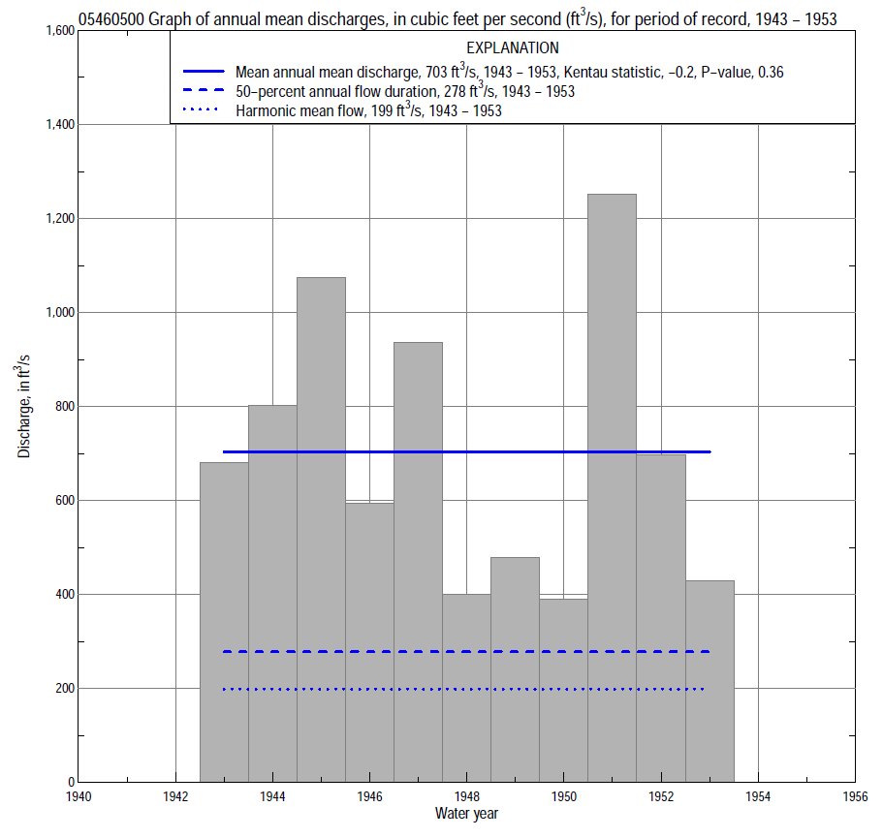

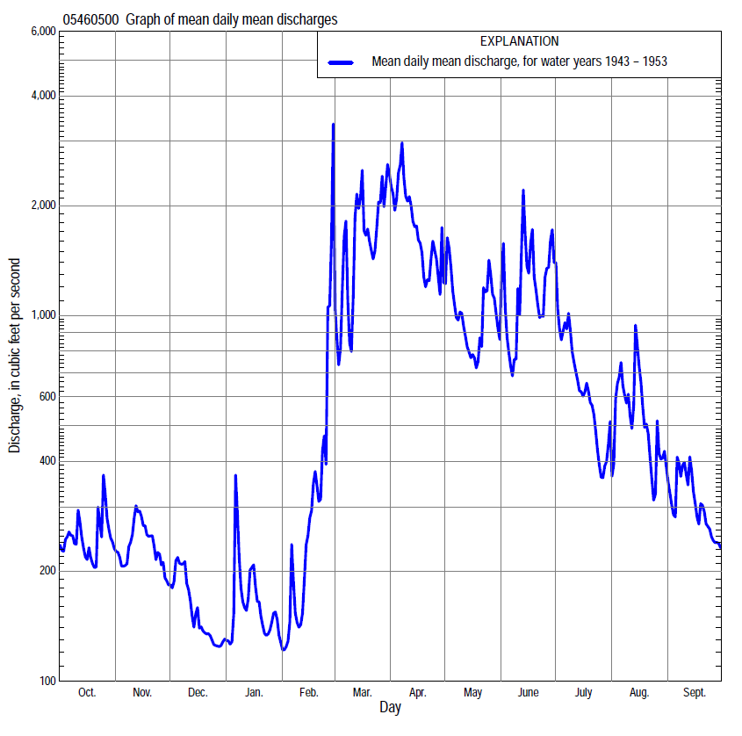

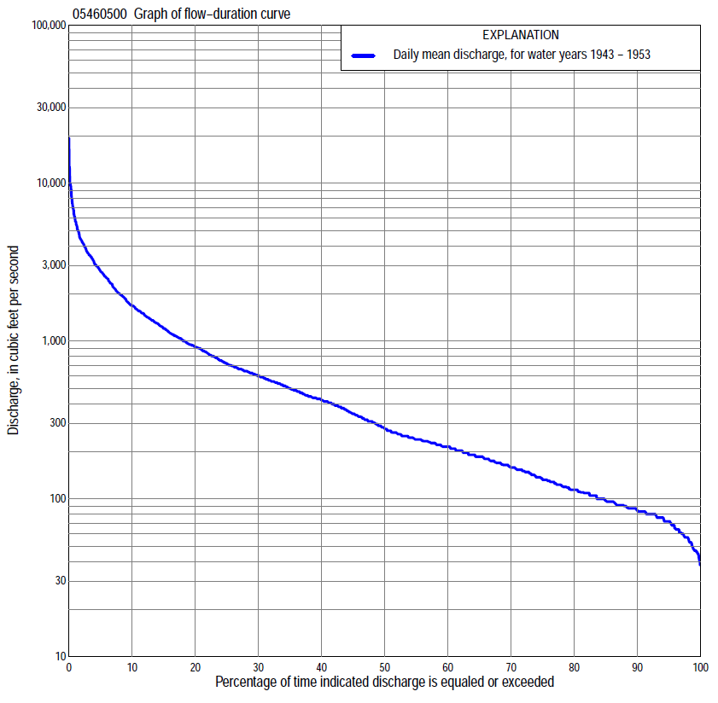

Statistics Based on the Entire Streamflow Period of Record
05460500 Monthly and annual flow durations, based on 1943–53 period of record (11 years)
Percentage of days discharge equaled or exceeded |  |  |  |  | Discharge (cubic feet per second) |  |  |  |  |  |  |  |  | Annual flow durations
 | Oct | Nov | Dec | Jan | Feb | Mar | Apr | May | June | July | Aug | Sept | Annual | Kentau statistic | P-value
99 | 57 | 54 | 53 | 40 | 41 | 49 | 263 | 169 | 114 | 87 | 64 | 53 | 47 | -0.345 | 0.161
98 | 57 | 61 | 55 | 47 | 43 | 150 | 332 | 190 | 132 | 100 | 72 | 57 | 56 | -0.273 | 0.276
95 | 64 | 76 | 61 | 50 | 46 | 196 | 406 | 232 | 142 | 119 | 76 | 72 | 72 | -0.255 | 0.310
90 | 80 | 80 | 72 | 65 | 50 | 250 | 461 | 250 | 164 | 132 | 91 | 83 | 83 | -0.236 | 0.350
85 | 91 | 87 | 76 | 76 | 58 | 339 | 520 | 284 | 226 | 153 | 105 | 87 | 97 | -0.182 | 0.482
80 | 109 | 96 | 83 | 80 | 70 | 430 | 590 | 354 | 284 | 185 | 123 | 100 | 114 | -0.236 | 0.350
75 | 114 | 111 | 88 | 83 | 83 | 590 | 645 | 430 | 344 | 216 | 148 | 122 | 132 | -0.309 | 0.213
70 | 122 | 114 | 92 | 87 | 88 | 655 | 700 | 478 | 398 | 263 | 164 | 128 | 158 | -0.382 | 0.119
65 | 137 | 132 | 98 | 91 | 96 | 700 | 783 | 520 | 445 | 300 | 176 | 135 | 185 | -0.364 | 0.138
60 | 158 | 148 | 105 | 96 | 105 | 844 | 865 | 554 | 478 | 354 | 196 | 155 | 214 | -0.309 | 0.213
55 | 174 | 164 | 114 | 105 | 110 | 972 | 961 | 609 | 537 | 414 | 214 | 174 | 238 | -0.236 | 0.350
50 | 185 | 179 | 128 | 110 | 130 | 1,100 | 1,060 | 662 | 581 | 478 | 238 | 185 | 278 | -0.236 | 0.350
45 | 196 | 190 | 140 | 123 | 170 | 1,290 | 1,200 | 713 | 664 | 537 | 290 | 214 | 346 | -0.236 | 0.350
40 | 208 | 202 | 153 | 137 | 200 | 1,400 | 1,350 | 764 | 813 | 590 | 346 | 226 | 425 | -0.273 | 0.276
35 | 215 | 214 | 165 | 165 | 244 | 1,590 | 1,600 | 834 | 1,000 | 640 | 398 | 263 | 503 | -0.200 | 0.436
30 | 238 | 232 | 185 | 185 | 280 | 1,900 | 1,850 | 939 | 1,200 | 703 | 490 | 310 | 609 | -0.200 | 0.436
25 | 277 | 263 | 202 | 220 | 330 | 2,140 | 2,100 | 1,070 | 1,420 | 806 | 637 | 355 | 723 | -0.200 | 0.436
20 | 317 | 340 | 224 | 233 | 414 | 2,600 | 2,510 | 1,410 | 1,680 | 939 | 783 | 425 | 929 | -0.273 | 0.276
15 | 400 | 430 | 245 | 246 | 630 | 2,960 | 3,040 | 1,740 | 2,240 | 1,130 | 1,070 | 520 | 1,220 | -0.200 | 0.436
10 | 500 | 469 | 260 | 297 | 900 | 3,500 | 3,770 | 2,510 | 2,980 | 1,380 | 1,420 | 662 | 1,680 | -0.200 | 0.436
5 | 620 | 626 | 410 | 375 | 1,200 | 4,530 | 4,930 | 3,610 | 5,120 | 2,060 | 1,960 | 1,100 | 2,770 | -0.182 | 0.482
2 | 918 | 813 | 469 | 453 | 2,000 | 7,270 | 7,490 | 4,550 | 6,250 | 2,770 | 2,610 | 1,340 | 4,340 | -0.127 | 0.640
1 | 1,240 | 994 | 532 | 664 | 6,390 | 9,610 | 12,600 | 4,970 | 7,980 | 3,860 | 3,680 | 1,510 | 5,750 | -0.055 | 0.876

05460500 Annual exceedance probability of instantaneous peak discharges, in cubic feet per second (ft³/s), based on the Weighted Independent Estimates method,
Annual exceed-ance probability | Recur-rence interval (years) | Discharge (ft³/s) | 95-percent lower confi-dence interval (ft³/s) | 95-percent upper confi-dence interval (ft³/s)
0.500 | 2 | 9,790 | 8,270 | 11,600
0.200 | 5 | 15,900 | 13,400 | 18,900
0.100 | 10 | 19,900 | 16,600 | 23,900
0.040 | 25 | 26,000 | 21,100 | 32,000
0.020 | 50 | 30,400 | 24,100 | 38,500
0.010 | 100 | 34,700 | 26,600 | 45,300
0.005 | 200 | 40,800 | 30,100 | 55,200
0.002 | 500 | 45,500 | 32,000 | 64,500
and based on the expected moments algorithm/multiple Grubbs-Beck analysis computed using a historical period length of 49 years (1916–1964)
0.500 | 2 | 9,830 | 7,530 | 12,400
0.200 | 5 | 15,800 | 12,400 | 20,000
0.100 | 10 | 20,100 | 15,600 | 26,100
0.040 | 25 | 25,600 | 19,600 | 35,700
0.020 | 50 | 29,800 | 22,300 | 44,600
0.010 | 100 | 34,100 | 24,900 | 55,200
0.005 | 200 | 38,500 | 27,400 | 67,700
0.002 | 500 | 44,300 | 30,300 | 87,700
Kentau statistic |  | 0.114
P-value |  | 0.487
Begin year |  | 1933
End year |  | 1953
Number of peaks |  | 21

05460500 Annual exceedance probability of high discharges, based on 1943–53 period of record (11 years)
Annual exceed-ance probability | Recur-rence interval (years) | Maximum average discharge (ft³/s) for indicated number of consecutive days
 |  | 1 | 3 | 7 | 15 | 30
0.990 | 1.01 | 3,350 | 2,760 | 2,330 | 1,730 | 1,250
0.950 | 1.05 | 4,250 | 3,390 | 2,670 | 1,990 | 1,510
0.900 | 1.11 | 4,860 | 3,830 | 2,920 | 2,180 | 1,680
0.800 | 1.25 | 5,750 | 4,490 | 3,320 | 2,470 | 1,950
0.500 | 2 | 8,110 | 6,300 | 4,540 | 3,320 | 2,670
0.200 | 5 | 11,800 | 9,290 | 6,800 | 4,840 | 3,850
0.100 | 10 | 14,400 | 11,600 | 8,730 | 6,100 | 4,750
0.040 | 25 | 18,100 | 15,000 | 11,800 | 8,010 | 6,050
0.020 | 50 | 21,100 | 17,800 | 14,500 | 9,710 | 7,130
0.010 | 100 | 24,300 | 20,900 | 17,800 | 11,700 | 8,320
0.005 | 200 | 27,700 | 24,400 | 21,600 | 13,900 | 9,630
0.002 | 500 | 32,500 | 29,600 | 27,700 | 17,400 | 11,600
Kentau statistic |  | -0.182 | -0.055 | -0.091 | -0.200 | -0.091
P-value |  | 0.482 | 0.876 | 0.756 | 0.436 | 0.756

 | 05460500 Annual nonexceedance probability of low discharges, based on April 1943 to March 1953 period of record (10 years)
Annual nonexceed-ance probability | Recur-rence interval (years) | Minimum average discharge (cubic feet per second) for indicated number of consecutive days
 |  | 1 | 3 | 7 | 14 | 30 | 60 | 90 | 120 | 183
0.01 | 100 | 31 | 33 | 38 | 38 | 38 | 44 | 44 | 44 | 44
0.02 | 50 | 32 | 34 | 39 | 40 | 40 | 48 | 48 | 49 | 51
0.05 | 20 | 34 | 36 | 41 | 43 | 45 | 55 | 56 | 58 | 64
0.10 | 10 | 37 | 39 | 44 | 47 | 50 | 63 | 66 | 69 | 78
0.20 | 5 | 42 | 45 | 49 | 53 | 60 | 74 | 81 | 86 | 102
0.50 | 2 | 60 | 63 | 67 | 74 | 88 | 107 | 125 | 138 | 173
0.80 | 1.25 | 99 | 102 | 106 | 116 | 140 | 163 | 205 | 238 | 305
0.90 | 1.11 | 137 | 141 | 145 | 154 | 186 | 207 | 273 | 326 | 417
0.96 | 1.04 | 207 | 210 | 213 | 218 | 259 | 272 | 376 | 468 | 589
0.98 | 1.02 | 278 | 280 | 283 | 283 | 326 | 328 | 469 | 599 | 741
0.99 | 1.01 | 370 | 370 | 372 | 372 | 405 | 405 | 575 | 754 | 915
Kentau statistic |  | -0.378 | -0.333 | -0.289 | -0.111 | -0.111 | -0.200 | -0.244 | -0.289 | -0.244
P-value |  | 0.152 | 0.211 | 0.283 | 0.721 | 0.721 | 0.474 | 0.371 | 0.283 | 0.371

05460500 Annual nonexceedance probability of seasonal low discharges, based on October 1942 to September 1953 period of record (11 years)
Annual nonexceed-ance probability | Recur-rence interval (years) | Minimum average discharge (cubic feet per second) for indicated number of consecutive days
 |  | 1 | 7 | 14 | 30 |  | 1 | 7 | 14 | 30
 |  | January-February-March |  |  |  |  | April-May-June
0.01 | 100 | 31 | 31 | 31 | 31 |  | 67 | 75 | 78 | 93
0.02 | 50 | 34 | 35 | 35 | 35 |  | 79 | 89 | 94 | 112
0.05 | 20 | 39 | 41 | 41 | 43 |  | 102 | 115 | 124 | 150
0.10 | 10 | 44 | 47 | 48 | 52 |  | 127 | 145 | 159 | 193
0.20 | 5 | 52 | 57 | 59 | 65 |  | 166 | 191 | 212 | 265
0.50 | 2 | 76 | 85 | 91 | 107 |  | 280 | 325 | 364 | 487
0.80 | 1.25 | 118 | 134 | 145 | 185 |  | 475 | 551 | 608 | 907
0.90 | 1.11 | 152 | 173 | 189 | 252 |  | 628 | 726 | 788 | 1,260
0.96 | 1.04 | 204 | 232 | 253 | 357 |  | 846 | 974 | 1,030 | 1,800
0.98 | 1.02 | 250 | 283 | 308 | 452 |  | 1,030 | 1,180 | 1,220 | 2,270
0.99 | 1.01 | 303 | 341 | 369 | 561 |  | 1,220 | 1,400 | 1,420 | 2,800
Kentau statistic |  | -0.109 | -0.055 | -0.091 | -0.236 |  | -0.273 | -0.164 | -0.091 | -0.091
P-value |  | 0.696 | 0.876 | 0.756 | 0.350 |  | 0.276 | 0.533 | 0.756 | 0.756
 |  | July-August-September |  |  |  |  | October-November-December
0.01 | 100 | 28 | 35 | 44 | 51 |  | 30 | 36 | 42 | 47
0.02 | 50 | 34 | 41 | 50 | 57 |  | 33 | 39 | 45 | 52
0.05 | 20 | 45 | 52 | 60 | 68 |  | 39 | 45 | 52 | 60
0.10 | 10 | 57 | 64 | 72 | 82 |  | 45 | 52 | 60 | 70
0.20 | 5 | 76 | 84 | 92 | 105 |  | 54 | 62 | 71 | 85
0.50 | 2 | 131 | 141 | 151 | 183 |  | 81 | 94 | 104 | 129
0.80 | 1.25 | 220 | 238 | 266 | 363 |  | 127 | 152 | 162 | 207
0.90 | 1.11 | 287 | 314 | 368 | 547 |  | 165 | 203 | 210 | 272
0.96 | 1.04 | 377 | 424 | 530 | 882 |  | 220 | 282 | 282 | 370
0.98 | 1.02 | 449 | 515 | 679 | 1,230 |  | 267 | 344 | 344 | 457
0.99 | 1.01 | 524 | 615 | 855 | 1,680 |  | 320 | 415 | 415 | 555
Kentau statistic |  | -0.291 | -0.309 | -0.309 | -0.382 |  | -0.327 | -0.382 | -0.309 | -0.236
P-value |  | 0.241 | 0.213 | 0.213 | 0.119 |  | 0.184 | 0.119 | 0.213 | 0.350

