LOCATION.--Lat 42°34'19.2", long 92°37'05.8" referenced to North American Datum of 1983, in NW 1/4 SE 1/4 SE 1/4 sec.28, T.90 N., R.15 W., Butler County, IA, Hydrologic Unit 07080205, on right bank 5 ft downstream from bridge on County Highway T55, 0.2 mi north of New Hartford, and 9.9 mi upstream from mouth.

DRAINAGE AREA.--347 mi².

PERIOD OF RECORD.--Discharge records from October 1945 to current year. Prior to April 1948, monthly mean discharge for some periods published in WSP 1308.

GAGE.--Water-stage recorder. Datum of gage is 882.44 ft above National Geodetic Vertical Datum of 1929. Prior to July 14, 1959, non-recording gage at same site and datum.

A summary of all available data for this streamgage is provided through the USGS National Water Information System web interface (NWISWeb). The following link provides access to current/historical observations, daily data, daily statistics, monthly statistics, annual statistics, peak streamflow, field measurements, field/lab water-quality samples, and the latest water-year summaries. Data can be filtered by parameter and/or dates, and can be output in various tabular and graphical formats.
http://waterdata.usgs.gov/nwis/inventory/?site_no=05463000

The USGS WaterWatch Toolkit is available at:
http://waterwatch.usgs.gov/?id=ww_toolkit
Tools for summarizing streamflow information include the duration hydrograph builder, the cumulative streamflow hydrograph builder, the streamgage statistics retrieval tool, the rating curve builder, the flood tracking chart builder, the National Weather Service Advanced Hydrologic Prediction Service (AHPS) river forecast hydrograph builder, and the raster-hydrograph builder. Entering the above number for this streamgage into these toolkit webpages will provide streamflow information specific to this streamgage.

A description of the statistics presented for this streamgage is available in the main body of the report at:
http://dx.doi.org/10.3133/ofr20151214
A link to other streamgages included in this report, a map showing the location of the streamgages, information on the programs used to compute the statistical analyses, and references are included in the main body of the report.

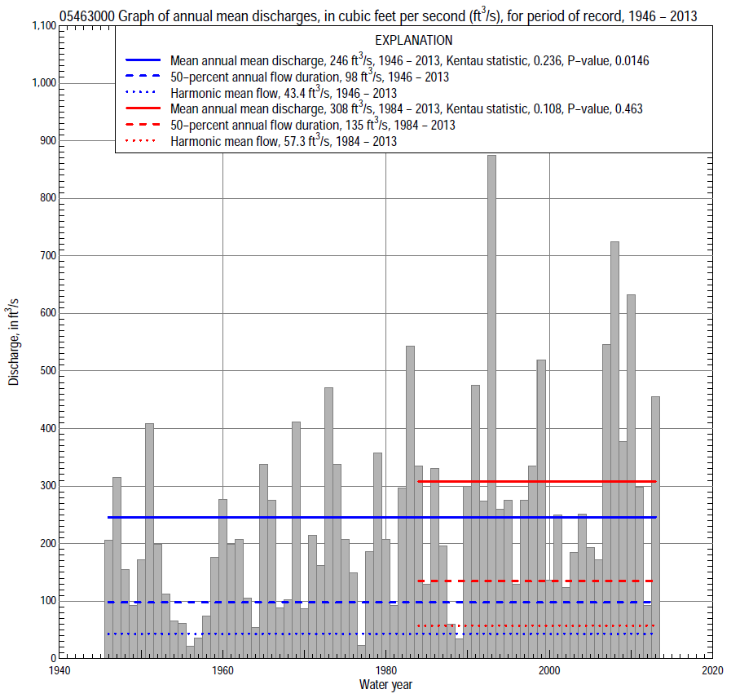

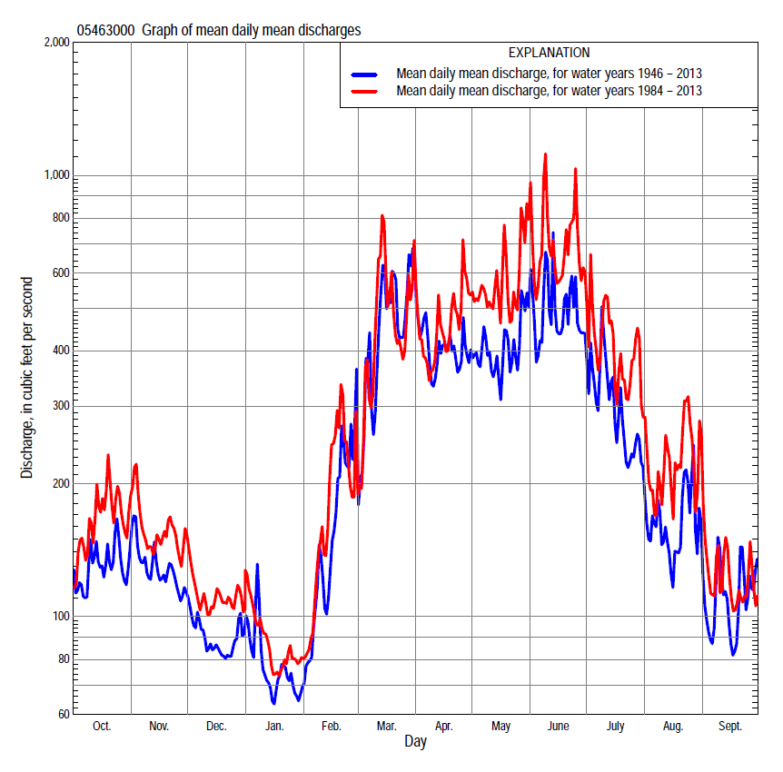

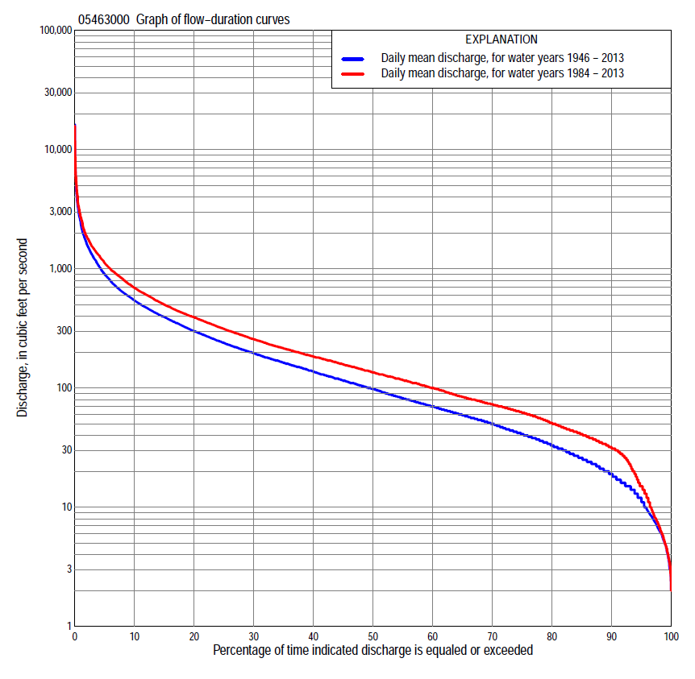

Statistics Based on the Entire Streamflow Period of Record
05463000 Monthly and annual flow durations, based on 1946–2013 period of record (68 years)
Percentage of days discharge equaled or exceeded |  |  |  |  | Discharge (cubic feet per second) |  |  |  |  |  |  |  |  | Annual flow durations
 | Oct | Nov | Dec | Jan | Feb | Mar | Apr | May | June | July | Aug | Sept | Annual | Kentau statistic | P-value
99 | 4.6 | 8.6 | 4.5 | 2.9 | 4.0 | 20 | 27 | 19 | 10 | 4.7 | 4.0 | 4.7 | 4.9 | 0.300 | 0.000
98 | 6.0 | 10 | 5.7 | 3.2 | 5.0 | 23 | 31 | 22 | 13 | 6.7 | 5.6 | 5.5 | 6.4 | 0.299 | 0.000
95 | 11 | 14 | 8.4 | 5.6 | 6.4 | 30 | 41 | 35 | 24 | 17 | 10 | 8.4 | 12 | 0.295 | 0.000
90 | 16 | 19 | 12 | 7.8 | 13 | 39 | 66 | 51 | 44 | 33 | 19 | 15 | 19 | 0.289 | 0.000
85 | 20 | 23 | 17 | 12 | 15 | 54 | 79 | 65 | 57 | 45 | 26 | 20 | 26 | 0.287 | 0.001
80 | 24 | 28 | 20 | 15 | 19 | 64 | 98 | 79 | 82 | 58 | 34 | 26 | 33 | 0.290 | 0.000
75 | 29 | 36 | 26 | 18 | 25 | 85 | 118 | 105 | 104 | 70 | 41 | 29 | 41 | 0.303 | 0.000
70 | 36 | 42 | 30 | 23 | 29 | 109 | 141 | 129 | 124 | 82 | 47 | 33 | 50 | 0.298 | 0.000
65 | 42 | 47 | 38 | 26 | 34 | 126 | 162 | 154 | 147 | 97 | 53 | 37 | 59 | 0.293 | 0.000
60 | 49 | 55 | 44 | 31 | 40 | 147 | 185 | 178 | 172 | 112 | 58 | 42 | 70 | 0.301 | 0.000
55 | 56 | 63 | 52 | 36 | 51 | 169 | 211 | 202 | 198 | 128 | 64 | 47 | 82 | 0.291 | 0.000
50 | 63 | 76 | 58 | 43 | 61 | 200 | 238 | 224 | 230 | 145 | 72 | 52 | 98 | 0.295 | 0.000
45 | 70 | 87 | 64 | 52 | 78 | 235 | 273 | 256 | 274 | 164 | 80 | 58 | 115 | 0.303 | 0.000
40 | 81 | 108 | 72 | 63 | 90 | 274 | 312 | 299 | 317 | 188 | 89 | 66 | 138 | 0.312 | 0.000
35 | 89 | 127 | 85 | 75 | 103 | 320 | 352 | 347 | 373 | 210 | 100 | 74 | 163 | 0.318 | 0.000
30 | 107 | 152 | 99 | 84 | 118 | 388 | 406 | 399 | 446 | 245 | 112 | 85 | 196 | 0.324 | 0.000
25 | 136 | 171 | 120 | 100 | 146 | 446 | 471 | 458 | 531 | 292 | 129 | 100 | 239 | 0.320 | 0.000
20 | 176 | 196 | 140 | 118 | 185 | 550 | 548 | 540 | 640 | 369 | 156 | 119 | 300 | 0.293 | 0.000
15 | 232 | 227 | 161 | 135 | 250 | 704 | 661 | 665 | 829 | 480 | 198 | 151 | 395 | 0.289 | 0.000
10 | 315 | 284 | 200 | 170 | 360 | 954 | 894 | 881 | 1,090 | 647 | 284 | 241 | 542 | 0.279 | 0.001
5 | 456 | 400 | 278 | 231 | 600 | 1,730 | 1,340 | 1,380 | 1,760 | 1,120 | 564 | 417 | 900 | 0.216 | 0.009
2 | 773 | 610 | 394 | 359 | 1,100 | 3,280 | 1,950 | 2,140 | 2,870 | 1,890 | 1,270 | 728 | 1,610 | 0.187 | 0.024
1 | 1,150 | 740 | 505 | 500 | 1,600 | 4,380 | 2,760 | 2,960 | 4,570 | 2,690 | 2,120 | 1,060 | 2,460 | 0.090 | 0.280

05463000 Annual exceedance probability of instantaneous peak discharges, in cubic feet per second (ft³/s), based on the Weighted Independent Estimates method,
Annual exceed-ance probability | Recur-rence interval (years) | Discharge (ft³/s) | 95-percent lower confi-dence interval (ft³/s) | 95-percent upper confi-dence interval (ft³/s)
0.500 | 2 | 3,930 | 3,140 | 4,910
0.200 | 5 | 8,340 | 6,750 | 10,300
0.100 | 10 | 11,900 | 9,550 | 14,800
0.040 | 25 | 17,200 | 13,500 | 21,900
0.020 | 50 | 21,000 | 16,000 | 27,500
0.010 | 100 | 24,800 | 18,200 | 33,600
0.005 | 200 | 30,500 | 21,500 | 43,100
0.002 | 500 | 34,500 | 23,100 | 51,500
and based on the expected moments algorithm/multiple Grubbs-Beck analysis computed using a historical period length of 68 years (1946–2013)
0.500 | 2 | 3,900 | 3,070 | 4,910
0.200 | 5 | 8,200 | 6,500 | 10,600
0.100 | 10 | 11,800 | 9,230 | 16,100
0.040 | 25 | 17,100 | 12,900 | 25,700
0.020 | 50 | 21,500 | 15,700 | 35,400
0.010 | 100 | 26,300 | 18,400 | 47,600
0.005 | 200 | 31,500 | 21,000 | 63,100
0.002 | 500 | 38,800 | 24,300 | 89,800
Kentau statistic |  | -0.007
P-value |  | 0.933
Begin year |  | 1946
End year |  | 2013
Number of peaks |  | 68

05463000 Annual exceedance probability of high discharges, based on 1946–2013 period of record (68 years)
Annual exceedance probability | Recur-rence interval (years) | Maximum average discharge (ft³/s) for indicated number of consecutive days
 |  | 1 | 3 | 7 | 15 | 30
0.990 | 1.01 | 176 | 150 | 119 | 89 | 68
0.950 | 1.05 | 485 | 394 | 292 | 207 | 155
0.900 | 1.11 | 790 | 626 | 450 | 312 | 230
0.800 | 1.25 | 1,360 | 1,040 | 728 | 494 | 360
0.500 | 2 | 3,310 | 2,420 | 1,620 | 1,070 | 756
0.200 | 5 | 6,760 | 4,710 | 3,100 | 2,010 | 1,390
0.100 | 10 | 9,210 | 6,260 | 4,110 | 2,670 | 1,820
0.040 | 25 | 12,200 | 8,120 | 5,350 | 3,480 | 2,330
0.020 | 50 | 14,300 | 9,400 | 6,220 | 4,050 | 2,690
0.010 | 100 | 16,300 | 10,600 | 7,020 | 4,590 | 3,030
0.005 | 200 | 18,200 | 11,600 | 7,770 | 5,100 | 3,340
0.002 | 500 | 20,400 | 12,900 | 8,680 | 5,730 | 3,720
Kentau statistic |  | 0.020 | 0.048 | 0.104 | 0.113 | 0.134
P-value |  | 0.816 | 0.568 | 0.210 | 0.174 | 0.106

 | 05463000 Annual nonexceedance probability of low discharges, based on April 1946 to March 2013 period of record (67 years)
Annual nonexceed-ance probability | Recur-rence interval (years) | Minimum average discharge (ft³/s) for indicated number of consecutive days
 |  | 1 | 3 | 7 | 14 | 30 | 60 | 90 | 120 | 183
0.01 | 100 | 1.3 | 1.4 | 1.5 | 1.7 | 2.0 | 2.8 | 3.5 | 4.4 | 5.2
0.02 | 50 | 1.9 | 2.1 | 2.2 | 2.4 | 2.8 | 3.8 | 4.9 | 6.0 | 7.2
0.05 | 20 | 3.3 | 3.5 | 3.7 | 4.1 | 4.7 | 6.2 | 7.8 | 9.4 | 12
0.10 | 10 | 5.3 | 5.5 | 5.9 | 6.3 | 7.3 | 9.3 | 12 | 14 | 17
0.20 | 5 | 8.8 | 9.2 | 10 | 10 | 12 | 15 | 19 | 22 | 28
0.50 | 2 | 21 | 22 | 23 | 25 | 28 | 35 | 44 | 52 | 65
0.80 | 1.25 | 45 | 47 | 50 | 53 | 60 | 77 | 95 | 114 | 144
0.90 | 1.11 | 64 | 66 | 70 | 75 | 85 | 112 | 139 | 169 | 213
0.96 | 1.04 | 88 | 92 | 98 | 106 | 120 | 165 | 206 | 253 | 317
0.98 | 1.02 | 107 | 112 | 120 | 131 | 148 | 209 | 262 | 325 | 406
0.99 | 1.01 | 126 | 132 | 142 | 156 | 176 | 257 | 323 | 406 | 504
Kentau statistic |  | 0.282 | 0.285 | 0.292 | 0.289 | 0.284 | 0.275 | 0.276 | 0.258 | 0.233
P-value |  | 0.001 | 0.001 | 0.000 | 0.001 | 0.001 | 0.001 | 0.001 | 0.002 | 0.005

05463000 Annual nonexceedance probability of seasonal low discharges, based on October 1945 to September 2013 period of record (68 years)
Annual nonexceed-ance probability | Recur-rence interval (years) | Minimum average discharge (cubic feet per second) for indicated number of consecutive days
 |  | 1 | 7 | 14 | 30 |  | 1 | 7 | 14 | 30
 |  | January-February-March |  |  |  |  | April-May-June
0.01 | 100 | 1.5 | 1.7 | 1.8 | 2.3 |  | 5.8 | 7.3 | 7.9 | 11
0.02 | 50 | 2.2 | 2.5 | 2.6 | 3.3 |  | 8.5 | 11 | 11 | 15
0.05 | 20 | 3.9 | 4.3 | 4.5 | 5.5 |  | 15 | 18 | 19 | 25
0.10 | 10 | 6.1 | 6.8 | 7.2 | 8.6 |  | 23 | 27 | 30 | 38
0.20 | 5 | 11 | 12 | 12 | 15 |  | 38 | 44 | 49 | 62
0.50 | 2 | 27 | 30 | 32 | 38 |  | 90 | 101 | 118 | 151
0.80 | 1.25 | 62 | 70 | 75 | 91 |  | 185 | 207 | 251 | 343
0.90 | 1.11 | 93 | 104 | 112 | 140 |  | 254 | 288 | 358 | 511
0.96 | 1.04 | 139 | 156 | 169 | 217 |  | 344 | 395 | 506 | 766
0.98 | 1.02 | 177 | 199 | 217 | 285 |  | 410 | 477 | 624 | 985
0.99 | 1.01 | 219 | 246 | 268 | 362 |  | 475 | 558 | 744 | 1,220
Kentau statistic |  | 0.248 | 0.268 | 0.267 | 0.238 |  | 0.358 | 0.337 | 0.334 | 0.349
P-value |  | 0.003 | 0.001 | 0.001 | 0.004 |  | 0.000 | 0.000 | 0.000 | 0.000
 |  | July-August-September |  |  |  |  | October-November-December
0.01 | 100 | 2.3 | 3.0 | 3.4 | 3.9 |  | 2.2 | 2.5 | 2.8 | 3.9
0.02 | 50 | 3.4 | 4.2 | 4.6 | 5.3 |  | 3.1 | 3.6 | 4.0 | 5.4
0.05 | 20 | 5.7 | 6.7 | 7.3 | 8.5 |  | 5.2 | 6.0 | 6.7 | 8.6
0.10 | 10 | 8.8 | 9.9 | 11 | 13 |  | 8.0 | 9.2 | 10 | 13
0.20 | 5 | 14 | 16 | 17 | 20 |  | 13 | 15 | 17 | 20
0.50 | 2 | 33 | 36 | 39 | 46 |  | 31 | 36 | 40 | 47
0.80 | 1.25 | 68 | 74 | 81 | 101 |  | 67 | 78 | 85 | 100
0.90 | 1.11 | 94 | 105 | 117 | 149 |  | 97 | 113 | 122 | 145
0.96 | 1.04 | 128 | 148 | 169 | 220 |  | 138 | 162 | 175 | 210
0.98 | 1.02 | 154 | 183 | 213 | 281 |  | 171 | 202 | 217 | 264
0.99 | 1.01 | 179 | 220 | 259 | 347 |  | 205 | 244 | 261 | 322
Kentau statistic |  | 0.277 | 0.272 | 0.258 | 0.229 |  | 0.234 | 0.258 | 0.265 | 0.239
P-value |  | 0.001 | 0.001 | 0.002 | 0.006 |  | 0.005 | 0.002 | 0.001 | 0.004

Statistics Based on the 1984–2013 Streamflow Period of Record
05463000 Monthly and annual flow durations, based on 1984–2013 period of record (30 years)
Percentage of days discharge equaled or exceeded |  |  |  |  | Discharge (cubic feet per second) |  |  |  |  |  |  |  |  | Annual flow durations
 | Oct | Nov | Dec | Jan | Feb | Mar | Apr | May | June | July | Aug | Sept | Annual | Kentau statistic | P-value
99 | 4.6 | 9.2 | 4.1 | 3.4 | 7.0 | 20 | 43 | 18 | 17 | 7.8 | 3.3 | 4.0 | 4.9 | 0.041 | 0.762
98 | 6.2 | 13 | 4.5 | 4.5 | 10 | 24 | 51 | 33 | 22 | 9.2 | 4.1 | 4.5 | 6.8 | 0.055 | 0.681
95 | 8.2 | 15 | 9.0 | 5.9 | 13 | 50 | 68 | 55 | 38 | 20 | 8.2 | 6.2 | 15 | 0.062 | 0.643
90 | 27 | 26 | 19 | 13 | 27 | 72 | 80 | 87 | 80 | 43 | 20 | 26 | 32 | 0.037 | 0.789
85 | 31 | 40 | 32 | 25 | 32 | 100 | 104 | 138 | 115 | 73 | 46 | 29 | 41 | -0.002 | 1.000
80 | 36 | 44 | 41 | 31 | 35 | 115 | 127 | 170 | 139 | 98 | 54 | 33 | 51 | 0.005 | 0.986
75 | 40 | 50 | 46 | 36 | 41 | 128 | 152 | 195 | 166 | 115 | 60 | 37 | 62 | 0.023 | 0.872
70 | 44 | 66 | 52 | 42 | 60 | 140 | 175 | 217 | 192 | 134 | 65 | 41 | 73 | 0.005 | 0.986
65 | 56 | 76 | 58 | 47 | 72 | 160 | 199 | 240 | 233 | 150 | 72 | 46 | 84 | 0.028 | 0.844
60 | 63 | 83 | 62 | 54 | 81 | 177 | 223 | 282 | 284 | 167 | 78 | 50 | 100 | 0.025 | 0.858
55 | 71 | 93 | 66 | 64 | 94 | 208 | 252 | 330 | 326 | 187 | 86 | 55 | 117 | 0.018 | 0.901
50 | 81 | 109 | 74 | 71 | 100 | 237 | 277 | 368 | 374 | 204 | 95 | 63 | 135 | 0.021 | 0.886
45 | 89 | 126 | 84 | 78 | 110 | 270 | 316 | 402 | 435 | 231 | 104 | 68 | 158 | 0.034 | 0.803
40 | 103 | 156 | 96 | 83 | 117 | 308 | 355 | 443 | 501 | 260 | 115 | 75 | 184 | 0.051 | 0.708
35 | 129 | 175 | 120 | 95 | 131 | 350 | 419 | 502 | 593 | 304 | 130 | 84 | 215 | 0.085 | 0.521
30 | 153 | 191 | 135 | 110 | 154 | 395 | 477 | 580 | 683 | 361 | 151 | 97 | 257 | 0.087 | 0.509
25 | 186 | 210 | 150 | 120 | 178 | 445 | 540 | 658 | 800 | 428 | 182 | 114 | 313 | 0.117 | 0.372
20 | 232 | 228 | 170 | 130 | 210 | 566 | 647 | 772 | 947 | 517 | 231 | 144 | 392 | 0.133 | 0.309
15 | 299 | 264 | 198 | 144 | 278 | 716 | 806 | 959 | 1,170 | 647 | 300 | 205 | 500 | 0.133 | 0.309
10 | 374 | 310 | 228 | 171 | 400 | 945 | 1,080 | 1,220 | 1,500 | 893 | 445 | 301 | 693 | 0.179 | 0.169
5 | 599 | 434 | 309 | 225 | 670 | 1,550 | 1,460 | 1,750 | 2,250 | 1,430 | 911 | 460 | 1,120 | 0.216 | 0.097
2 | 1,030 | 630 | 421 | 293 | 1,090 | 3,160 | 1,950 | 2,510 | 3,690 | 2,590 | 1,680 | 728 | 1,870 | 0.209 | 0.108
1 | 1,450 | 740 | 520 | 414 | 1,600 | 4,110 | 2,740 | 4,070 | 5,400 | 3,330 | 2,620 | 912 | 2,710 | 0.182 | 0.164

05463000 Annual exceedance probability of high discharges, based on 1984–2013 period of record (30 years)
Annual exceedance probability | Recur-rence interval (years) | Maximum average discharge (ft³/s) for indicated number of consecutive days
 |  | 1 | 3 | 7 | 15 | 30
0.990 | 1.01 | 320 | 260 | 215 | 172 | 143
0.950 | 1.05 | 660 | 539 | 409 | 308 | 245
0.900 | 1.11 | 956 | 776 | 571 | 418 | 324
0.800 | 1.25 | 1,470 | 1,180 | 843 | 599 | 454
0.500 | 2 | 3,210 | 2,490 | 1,720 | 1,170 | 849
0.200 | 5 | 6,580 | 4,830 | 3,360 | 2,210 | 1,550
0.100 | 10 | 9,350 | 6,630 | 4,680 | 3,050 | 2,110
0.040 | 25 | 13,400 | 9,090 | 6,580 | 4,270 | 2,920
0.020 | 50 | 16,700 | 11,000 | 8,150 | 5,270 | 3,580
0.010 | 100 | 20,300 | 13,000 | 9,830 | 6,360 | 4,290
0.005 | 200 | 24,100 | 15,000 | 11,600 | 7,530 | 5,060
0.002 | 500 | 29,500 | 17,800 | 14,200 | 9,220 | 6,160
Kentau statistic |  | 0.120 | 0.138 | 0.136 | 0.122 | 0.140
P-value |  | 0.363 | 0.292 | 0.301 | 0.354 | 0.284

 | 05463000 Annual nonexceedance probability of low discharges, based on April 1983 to March 2013 period of record (30 years)
Annual nonexceed-ance probability | Recur-rence interval (years) | Minimum average discharge (ft³/s) for indicated number of consecutive days
 |  | 1 | 3 | 7 | 14 | 30 | 60 | 90 | 120 | 183
0.01 | 100 | 1.3 | 1.5 | 1.7 | 2.0 | 2.2 | 3.4 | 4.3 | 4.8 | 4.9
0.02 | 50 | 2.3 | 2.6 | 2.9 | 3.3 | 3.7 | 5.3 | 6.5 | 7.4 | 7.6
0.05 | 20 | 4.7 | 5.3 | 5.8 | 6.5 | 7.4 | 10 | 12 | 13 | 14
0.10 | 10 | 8.3 | 9.2 | 10 | 11 | 13 | 16 | 19 | 21 | 24
0.20 | 5 | 15 | 16 | 18 | 19 | 22 | 26 | 32 | 35 | 41
0.50 | 2 | 35 | 37 | 40 | 42 | 48 | 57 | 70 | 79 | 98
0.80 | 1.25 | 58 | 61 | 65 | 69 | 78 | 98 | 124 | 146 | 188
0.90 | 1.11 | 69 | 71 | 75 | 82 | 90 | 121 | 155 | 187 | 245
0.96 | 1.04 | 77 | 79 | 84 | 91 | 100 | 143 | 186 | 233 | 307
0.98 | 1.02 | 81 | 83 | 87 | 96 | 104 | 155 | 205 | 262 | 347
0.99 | 1.01 | 84 | 86 | 90 | 99 | 107 | 164 | 220 | 287 | 381
Kentau statistic |  | 0.046 | 0.046 | 0.025 | 0.025 | 0.025 | -0.002 | 0.011 | -0.002 | -0.016
P-value |  | 0.735 | 0.735 | 0.858 | 0.858 | 0.858 | 1.000 | 0.943 | 1.000 | 0.915

05463000 Annual nonexceedance probability of seasonal low discharges, based on October 1983 to September 2013 period of record (30 years)
Annual nonexceed-ance probability | Recur-rence interval (years) | Minimum average discharge (cubic feet per second) for indicated number of consecutive days
 |  | 1 | 7 |  | 14 |  | 30 |  | 1 | 7 | 14 | 30
 |  | January-February-March |  |  |  |  |  |  | April-May-June
0.01 | 100 | 1.7 | 2.3 | 2.4 |  | 3.1 |  |  | 11 | 14 | 14 | 18
0.02 | 50 | 2.8 | 3.7 | 3.9 |  | 5.0 |  |  | 16 | 19 | 20 | 25
0.05 | 20 | 5.5 | 7.1 | 7.6 |  | 9.5 |  |  | 27 | 31 | 34 | 41
0.10 | 10 | 9.6 | 12 | 13 |  | 16 |  |  | 41 | 46 | 51 | 63
0.20 | 5 | 17 | 21 | 23 |  | 27 |  |  | 64 | 72 | 81 | 102
0.50 | 2 | 44 | 52 | 56 |  | 63 |  |  | 136 | 150 | 179 | 239
0.80 | 1.25 | 88 | 98 | 105 |  | 113 |  |  | 244 | 271 | 344 | 502
0.90 | 1.11 | 115 | 125 | 134 |  | 142 |  |  | 312 | 350 | 460 | 711
0.96 | 1.04 | 145 | 154 | 162 |  | 170 |  |  | 388 | 444 | 605 | 1,000
0.98 | 1.02 | 164 | 170 | 179 |  | 186 |  |  | 439 | 509 | 710 | 1,230
0.99 | 1.01 | 180 | 184 | 192 |  | 199 |  |  | 483 | 568 | 809 | 1,460
Kentau statistic |  | -0.044 | -0.025 | -0.016 |  | -0.007 |  |  | 0.182 | 0.172 | 0.182 | 0.251
P-value |  | 0.748 | 0.858 | 0.915 |  | 0.972 |  |  | 0.164 | 0.187 | 0.164 | 0.054
 |  | July-August-September |  |  |  |  |  |  | October-November-December
0.01 | 100 | 1.8 | 2.5 |  | 2.8 |  | 3.4 |  | 1.8 | 2.3 | 2.8 | 4.7
0.02 | 50 | 2.9 | 3.8 |  | 4.2 |  | 5.0 |  | 2.9 | 3.8 | 4.4 | 6.9
0.05 | 20 | 5.7 | 6.9 |  | 7.5 |  | 8.8 |  | 5.8 | 7.3 | 8.5 | 12
0.10 | 10 | 9.9 | 11 |  | 12 |  | 14 |  | 10 | 13 | 14 | 18
0.20 | 5 | 18 | 20 |  | 21 |  | 24 |  | 18 | 22 | 25 | 30
0.50 | 2 | 47 | 49 |  | 53 |  | 62 |  | 46 | 54 | 59 | 66
0.80 | 1.25 | 96 | 106 |  | 117 |  | 140 |  | 89 | 101 | 110 | 125
0.90 | 1.11 | 128 | 148 |  | 168 |  | 206 |  | 115 | 129 | 140 | 163
0.96 | 1.04 | 164 | 203 |  | 238 |  | 300 |  | 142 | 158 | 171 | 208
0.98 | 1.02 | 188 | 244 |  | 293 |  | 376 |  | 158 | 175 | 189 | 238
0.99 | 1.01 | 209 | 284 |  | 347 |  | 455 |  | 171 | 189 | 204 | 266
Kentau statistic |  | 0.046 | 0.025 |  | 0.009 |  | 0.011 |  | -0.011 | -0.025 | -0.002 | 0.002
P-value |  | 0.735 | 0.858 |  | 0.957 |  | 0.943 |  | 0.943 | 0.858 | 1.000 | 1.000

