LOCATION.--Lat 42°24'28", long 92°27'47" referenced to North American Datum of 1927, in SE 1/4 SW 1/4 NE 1/4 sec.27, T.88 N., R.14 W., Black Hawk County, IA, Hydrologic Unit 07080205, on left bank 35 ft downstream from bridge on State Highway 58, 0.2 mi northwest of Chicago and Great Western Railway tracks, at western edge of Hudson, 4.5 mi upstream from Prescotts Creek, and 12.5 mi upstream from mouth.

DRAINAGE AREA.--303 mi².

PERIOD OF RECORD.--Discharge records from April 1952 to September 1995, October 2001 to current year.

GAGE.--Water-stage recorder. Datum of gage is 865.03 ft above National Geodetic Vertical Datum of 1929.

A summary of all available data for this streamgage is provided through the USGS National Water Information System web interface (NWISWeb). The following link provides access to current/historical observations, daily data, daily statistics, monthly statistics, annual statistics, peak streamflow, field measurements, field/lab water-quality samples, and the latest water-year summaries. Data can be filtered by parameter and/or dates, and can be output in various tabular and graphical formats.
http://waterdata.usgs.gov/nwis/inventory/?site_no=05463500

The USGS WaterWatch Toolkit is available at:
http://waterwatch.usgs.gov/?id=ww_toolkit
Tools for summarizing streamflow information include the duration hydrograph builder, the cumulative streamflow hydrograph builder, the streamgage statistics retrieval tool, the rating curve builder, the flood tracking chart builder, the National Weather Service Advanced Hydrologic Prediction Service (AHPS) river forecast hydrograph builder, and the raster-hydrograph builder. Entering the above number for this streamgage into these toolkit webpages will provide streamflow information specific to this streamgage.

A description of the statistics presented for this streamgage is available in the main body of the report at:
http://dx.doi.org/10.3133/ofr20151214
A link to other streamgages included in this report, a map showing the location of the streamgages, information on the programs used to compute the statistical analyses, and references are included in the main body of the report.

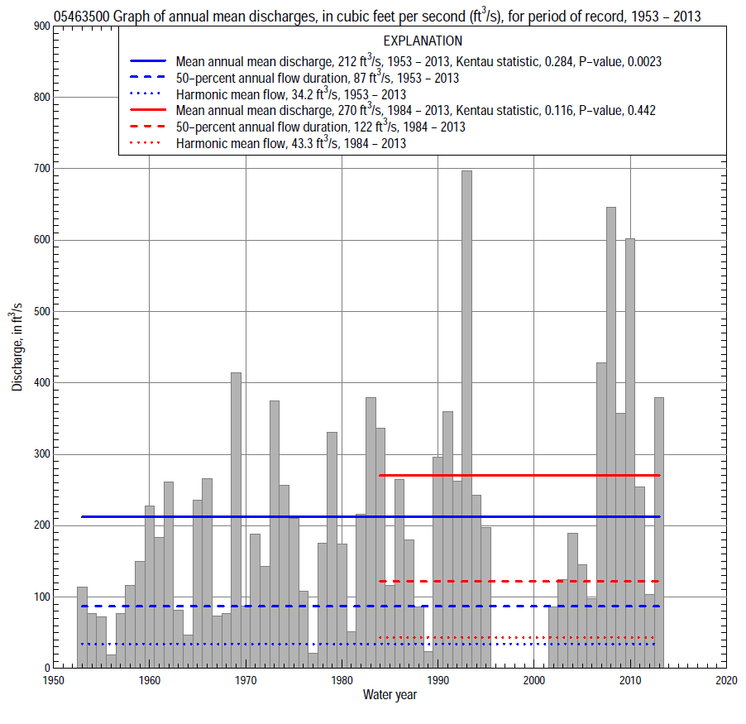

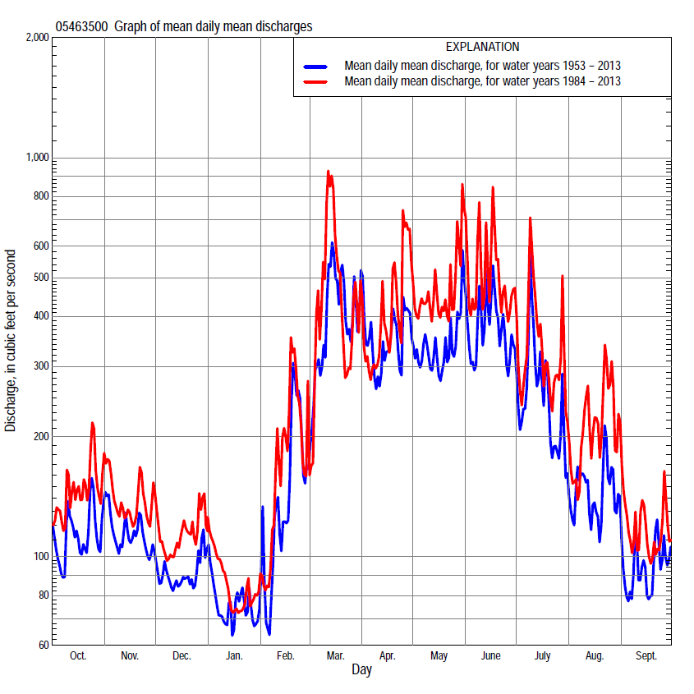

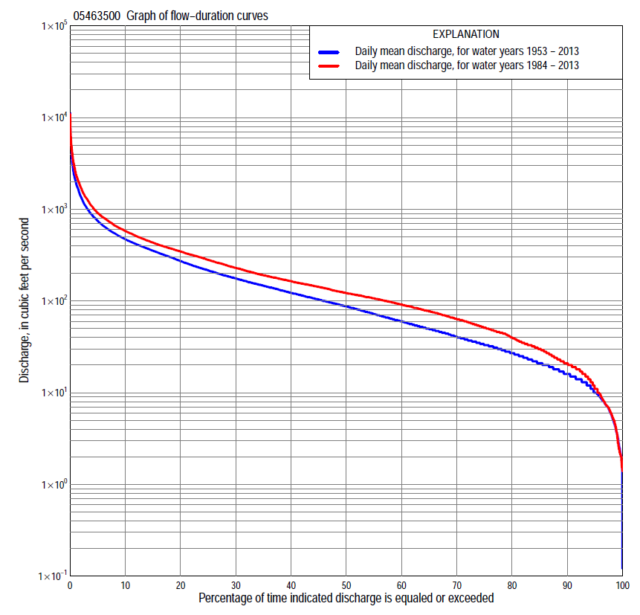

Statistics Based on the Entire Streamflow Period of Record
05463500 Monthly and annual flow durations, based on 1953–95, 2002–13 period of record (55 years)
Percentage of days discharge equaled or exceeded |  |  |  |  | Discharge (cubic feet per second) |  |  |  |  |  |  |  |  | Annual flow durations
 | Oct | Nov | Dec | Jan | Feb | Mar | Apr | May | June | July | Aug | Sept | Annual | Kentau statistic | P-value
99 | 3.7 | 7.2 | 2.6 | 2.0 | 2.9 | 15 | 14 | 14 | 9.2 | 3.7 | 2.2 | 3.5 | 3.5 | 0.246 | 0.008
98 | 6.8 | 8.0 | 4.3 | 2.2 | 4.1 | 16 | 17 | 16 | 13 | 4.4 | 3.6 | 4.3 | 5.7 | 0.244 | 0.009
95 | 9.6 | 12 | 7.0 | 4.4 | 6.6 | 22 | 26 | 28 | 20 | 17 | 8.8 | 8.5 | 10 | 0.253 | 0.006
90 | 14 | 15 | 10 | 7.4 | 13 | 33 | 37 | 41 | 34 | 26 | 16 | 14 | 16 | 0.251 | 0.007
85 | 16 | 17 | 14 | 9.8 | 16 | 45 | 62 | 56 | 48 | 33 | 21 | 17 | 21 | 0.249 | 0.007
80 | 20 | 21 | 18 | 14 | 19 | 56 | 84 | 73 | 68 | 42 | 26 | 20 | 27 | 0.254 | 0.006
75 | 22 | 27 | 21 | 18 | 23 | 67 | 103 | 94 | 88 | 51 | 31 | 22 | 33 | 0.271 | 0.004
70 | 26 | 33 | 26 | 22 | 28 | 83 | 118 | 114 | 105 | 61 | 34 | 26 | 41 | 0.261 | 0.005
65 | 33 | 39 | 31 | 26 | 34 | 105 | 134 | 140 | 122 | 73 | 38 | 30 | 50 | 0.270 | 0.004
60 | 39 | 48 | 37 | 32 | 45 | 126 | 152 | 160 | 143 | 89 | 42 | 33 | 60 | 0.275 | 0.003
55 | 46 | 60 | 44 | 36 | 57 | 145 | 171 | 181 | 174 | 105 | 49 | 37 | 72 | 0.291 | 0.002
50 | 50 | 71 | 49 | 44 | 64 | 170 | 194 | 205 | 207 | 124 | 54 | 42 | 87 | 0.305 | 0.001
45 | 56 | 84 | 59 | 55 | 73 | 202 | 222 | 235 | 246 | 142 | 62 | 48 | 104 | 0.319 | 0.001
40 | 72 | 97 | 79 | 66 | 84 | 235 | 258 | 280 | 296 | 161 | 72 | 53 | 122 | 0.317 | 0.001
35 | 84 | 111 | 97 | 76 | 96 | 278 | 295 | 326 | 343 | 182 | 85 | 59 | 147 | 0.318 | 0.001
30 | 103 | 132 | 112 | 85 | 113 | 330 | 345 | 365 | 391 | 212 | 98 | 68 | 176 | 0.317 | 0.001
25 | 124 | 154 | 125 | 94 | 140 | 393 | 395 | 412 | 450 | 252 | 113 | 81 | 216 | 0.314 | 0.001
20 | 157 | 178 | 148 | 105 | 169 | 475 | 453 | 478 | 530 | 316 | 141 | 105 | 273 | 0.302 | 0.001
15 | 205 | 218 | 170 | 120 | 220 | 594 | 550 | 576 | 621 | 389 | 210 | 145 | 355 | 0.286 | 0.002
10 | 285 | 266 | 200 | 170 | 330 | 873 | 722 | 718 | 784 | 526 | 306 | 226 | 474 | 0.275 | 0.003
5 | 415 | 362 | 280 | 247 | 600 | 1,700 | 1,100 | 1,000 | 1,220 | 967 | 574 | 416 | 753 | 0.229 | 0.014
2 | 683 | 516 | 412 | 371 | 1,200 | 3,050 | 1,850 | 1,610 | 2,080 | 1,770 | 1,200 | 632 | 1,360 | 0.188 | 0.044
1 | 937 | 654 | 522 | 500 | 1,710 | 4,010 | 2,940 | 2,210 | 2,960 | 2,540 | 1,790 | 834 | 2,050 | 0.142 | 0.127

05463500 Annual exceedance probability of instantaneous peak discharges, in cubic feet per second (ft³/s), based on the Weighted Independent Estimates method,
Annual exceed-ance probability | Recur-rence interval (years) | Discharge (ft³/s) | 95-percent lower confi-dence interval (ft³/s) | 95-percent upper confi-dence interval (ft³/s)
0.500 | 2 | 3,160 | 2,450 | 4,070
0.200 | 5 | 7,310 | 5,760 | 9,280
0.100 | 10 | 11,100 | 8,690 | 14,100
0.040 | 25 | 16,700 | 12,900 | 21,800
0.020 | 50 | 20,900 | 15,600 | 27,900
0.010 | 100 | 24,900 | 17,900 | 34,500
0.005 | 200 | 31,000 | 21,400 | 45,000
0.002 | 500 | 35,400 | 23,100 | 54,100
and based on the expected moments algorithm/multiple Grubbs-Beck analysis computed using a historical period length of 62 years (1952–2013)
0.500 | 2 | 3,040 | 2,270 | 4,010
0.200 | 5 | 6,890 | 5,220 | 9,340
0.100 | 10 | 10,300 | 7,700 | 14,800
0.040 | 25 | 15,500 | 11,100 | 24,800
0.020 | 50 | 19,900 | 13,700 | 35,100
0.010 | 100 | 24,800 | 16,200 | 48,300
0.005 | 200 | 30,100 | 18,500 | 65,000
0.002 | 500 | 37,800 | 21,400 | 94,000
Kentau statistic |  | 0.117
P-value |  | 0.206
Begin year |  | 1952
End year |  | 2013
Number of peaks |  | 56

05463500 Annual exceedance probability of high discharges, based on 1953–95, 2002–2013 period of record (55 years)
Annual exceedance probability | Recur-rence interval (years) | Maximum average discharge (ft³/s) for indicated number of consecutive days
 |  | 1 | 3 | 7 | 15 | 30
0.990 | 1.01 | 180 | 145 | 109 | 84 | 55
0.950 | 1.05 | 439 | 344 | 249 | 184 | 128
0.900 | 1.11 | 681 | 525 | 374 | 271 | 193
0.800 | 1.25 | 1,120 | 844 | 592 | 418 | 302
0.500 | 2 | 2,610 | 1,890 | 1,300 | 876 | 631
0.200 | 5 | 5,330 | 3,710 | 2,530 | 1,640 | 1,130
0.100 | 10 | 7,390 | 5,040 | 3,430 | 2,180 | 1,450
0.040 | 25 | 10,100 | 6,730 | 4,600 | 2,860 | 1,830
0.020 | 50 | 12,100 | 7,970 | 5,470 | 3,350 | 2,080
0.010 | 100 | 14,100 | 9,180 | 6,320 | 3,830 | 2,300
0.005 | 200 | 16,100 | 10,300 | 7,150 | 4,290 | 2,500
0.002 | 500 | 18,700 | 11,800 | 8,220 | 4,880 | 2,740
Kentau statistic |  | -0.011 | 0.013 | 0.025 | 0.037 | 0.032
P-value |  | 0.901 | 0.891 | 0.784 | 0.681 | 0.718

 | 05463500 Annual nonexceedance probability of low discharges, based on April 1952 to March 1995, April 2002 to March 2013 period of record (54 years)
Annual nonexceed-ance probability | Recur-rence interval (years) | Minimum average discharge (cubic feet per second) for indicated number of consecutive days
 |  | 1 | 3 | 7 | 14 | 30 | 60 | 90 | 120 | 183
0.01 | 100 | 0.30 | 0.37 | 0.55 | 0.98 | 1.5 | 2.3 | 3.1 | 3.4 | 4.1
0.02 | 50 | 0.59 | 0.70 | 0.96 | 1.5 | 2.2 | 3.2 | 4.3 | 4.7 | 5.8
0.05 | 20 | 1.5 | 1.7 | 2.0 | 2.8 | 3.7 | 5.2 | 6.9 | 7.8 | 9.5
0.10 | 10 | 3.1 | 3.3 | 3.7 | 4.6 | 5.8 | 8.0 | 10 | 12 | 15
0.20 | 5 | 6.5 | 6.7 | 7.2 | 8.0 | 9.6 | 13 | 16 | 19 | 24
0.50 | 2 | 20 | 20 | 20 | 21 | 24 | 31 | 38 | 46 | 59
0.80 | 1.25 | 40 | 41 | 43 | 45 | 52 | 67 | 84 | 101 | 134
0.90 | 1.11 | 51 | 53 | 58 | 64 | 75 | 99 | 123 | 148 | 201
0.96 | 1.04 | 61 | 65 | 74 | 89 | 108 | 145 | 182 | 217 | 303
0.98 | 1.02 | 66 | 72 | 85 | 107 | 135 | 183 | 233 | 275 | 391
0.99 | 1.01 | 70 | 77 | 94 | 125 | 162 | 225 | 288 | 338 | 488
Kentau statistic |  | 0.306 | 0.312 | 0.297 | 0.291 | 0.289 | 0.251 | 0.249 | 0.244 | 0.234
P-value |  | 0.001 | 0.001 | 0.002 | 0.002 | 0.002 | 0.008 | 0.008 | 0.009 | 0.013

05463500 Annual nonexceedance probability of seasonal low discharges, based on April 1952 to September 1995, October 2001 to September 2013 period of record (55–56 years)
Annual nonexceed-ance probability | Recur-rence interval (years) | Minimum average discharge (cubic feet per second) for indicated number of consecutive days
 |  | 1 | 7 | 14 | 30 |  | 1 | 7 | 14 | 30
 |  | January-February-March |  |  |  |  | April-May-June
0.01 | 100 | 0.33 | 0.57 | 0.99 | 1.8 |  | 5.1 | 6.2 | 6.8 | 8.7
0.02 | 50 | 0.66 | 1.0 | 1.6 | 2.8 |  | 7.2 | 8.7 | 9.6 | 12
0.05 | 20 | 1.7 | 2.3 | 3.1 | 4.9 |  | 12 | 14 | 16 | 20
0.10 | 10 | 3.7 | 4.5 | 5.5 | 8.0 |  | 18 | 22 | 24 | 32
0.20 | 5 | 8.4 | 9.2 | 10 | 14 |  | 30 | 35 | 40 | 53
0.50 | 2 | 28 | 29 | 30 | 37 |  | 71 | 83 | 97 | 131
0.80 | 1.25 | 64 | 68 | 71 | 85 |  | 156 | 182 | 215 | 302
0.90 | 1.11 | 85 | 97 | 105 | 125 |  | 227 | 267 | 316 | 454
0.96 | 1.04 | 107 | 132 | 153 | 184 |  | 332 | 390 | 466 | 686
0.98 | 1.02 | 120 | 156 | 189 | 232 |  | 419 | 494 | 591 | 886
0.99 | 1.01 | 129 | 178 | 226 | 281 |  | 512 | 605 | 726 | 1,110
Kentau statistic |  | 0.247 | 0.277 | 0.281 | 0.240 |  | 0.331 | 0.297 | 0.300 | 0.305
P-value |  | 0.008 | 0.003 | 0.003 | 0.010 |  | 0.000 | 0.001 | 0.001 | 0.001
 |  | July-August-September |  |  |  |  | October-November-December
0.01 | 100 | 2.0 | 2.4 | 2.8 | 3.5 |  | 1.5 | 1.9 | 2.2 | 3.2
0.02 | 50 | 2.7 | 3.3 | 3.7 | 4.6 |  | 2.2 | 2.7 | 3.1 | 4.5
0.05 | 20 | 4.4 | 5.1 | 5.7 | 6.9 |  | 3.8 | 4.6 | 5.3 | 7.2
0.10 | 10 | 6.6 | 7.4 | 8.2 | 10 |  | 6.1 | 7.2 | 8.3 | 11
0.20 | 5 | 11 | 12 | 13 | 16 |  | 11 | 12 | 14 | 17
0.50 | 2 | 25 | 27 | 30 | 36 |  | 27 | 30 | 34 | 41
0.80 | 1.25 | 56 | 60 | 66 | 83 |  | 61 | 68 | 75 | 90
0.90 | 1.11 | 82 | 91 | 101 | 129 |  | 90 | 99 | 110 | 132
0.96 | 1.04 | 122 | 139 | 156 | 205 |  | 132 | 146 | 161 | 195
0.98 | 1.02 | 155 | 181 | 206 | 276 |  | 166 | 184 | 202 | 248
0.99 | 1.01 | 192 | 230 | 264 | 362 |  | 202 | 225 | 246 | 306
Kentau statistic |  | 0.273 | 0.260 | 0.255 | 0.216 |  | 0.203 | 0.208 | 0.212 | 0.211
P-value |  | 0.003 | 0.005 | 0.006 | 0.019 |  | 0.029 | 0.025 | 0.023 | 0.024

Statistics Based on the 1984–2013 Streamflow Period of Record
05463500 Monthly and annual flow durations, based on 1984–95, 2002–13 period of record (24 years)
Percentage of days discharge equaled or exceeded |  |  |  |  | Discharge (cubic feet per second) |  |  |  |  |  |  |  |  | Annual flow durations
 | Oct | Nov | Dec | Jan | Feb | Mar | Apr | May | June | July | Aug | Sept | Annual | Kentau statistic | P-value
99 | 2.6 | 8.4 | 2.1 | 2.2 | 6.0 | 17 | 19 | 14 | 12 | 3.9 | 1.6 | 2.2 | 3.6 | 0.123 | 0.413
98 | 3.9 | 11 | 2.4 | 4.6 | 6.4 | 21 | 21 | 21 | 14 | 4.5 | 2.1 | 3.3 | 5.8 | 0.116 | 0.441
95 | 7.9 | 14 | 7.8 | 6.0 | 14 | 39 | 28 | 62 | 32 | 13 | 5.8 | 6.1 | 11 | 0.116 | 0.441
90 | 14 | 17 | 11 | 14 | 19 | 61 | 51 | 102 | 58 | 30 | 13 | 10 | 21 | 0.098 | 0.519
85 | 20 | 20 | 19 | 21 | 26 | 74 | 96 | 126 | 86 | 45 | 24 | 18 | 30 | 0.087 | 0.568
80 | 24 | 34 | 26 | 26 | 33 | 98 | 116 | 149 | 99 | 57 | 32 | 22 | 40 | 0.080 | 0.602
75 | 33 | 46 | 33 | 32 | 51 | 114 | 134 | 163 | 110 | 71 | 37 | 26 | 51 | 0.069 | 0.655
70 | 44 | 53 | 44 | 36 | 63 | 130 | 150 | 180 | 124 | 92 | 45 | 30 | 63 | 0.022 | 0.901
65 | 50 | 65 | 46 | 46 | 70 | 145 | 166 | 205 | 141 | 117 | 50 | 32 | 77 | 0.036 | 0.823
60 | 54 | 75 | 54 | 58 | 78 | 165 | 186 | 236 | 195 | 138 | 58 | 37 | 91 | 0.036 | 0.823
55 | 65 | 88 | 72 | 65 | 86 | 192 | 206 | 279 | 244 | 153 | 66 | 43 | 107 | 0.069 | 0.655
50 | 77 | 103 | 93 | 70 | 96 | 217 | 234 | 312 | 298 | 171 | 76 | 53 | 122 | 0.109 | 0.472
45 | 83 | 118 | 104 | 77 | 106 | 246 | 267 | 348 | 347 | 193 | 90 | 59 | 142 | 0.083 | 0.585
40 | 90 | 133 | 113 | 83 | 117 | 276 | 305 | 381 | 391 | 216 | 102 | 69 | 164 | 0.080 | 0.602
35 | 108 | 147 | 121 | 90 | 139 | 317 | 355 | 420 | 439 | 247 | 116 | 85 | 191 | 0.120 | 0.427
30 | 126 | 161 | 139 | 100 | 154 | 357 | 395 | 481 | 500 | 295 | 140 | 109 | 229 | 0.123 | 0.413
25 | 170 | 173 | 156 | 112 | 180 | 407 | 449 | 557 | 579 | 336 | 184 | 138 | 280 | 0.163 | 0.275
20 | 196 | 192 | 180 | 120 | 206 | 485 | 520 | 647 | 656 | 409 | 236 | 170 | 346 | 0.130 | 0.385
15 | 271 | 236 | 195 | 150 | 265 | 607 | 654 | 754 | 800 | 510 | 319 | 231 | 433 | 0.087 | 0.568
10 | 365 | 299 | 244 | 190 | 380 | 872 | 841 | 899 | 1,070 | 749 | 498 | 332 | 579 | 0.112 | 0.457
5 | 537 | 407 | 318 | 247 | 610 | 1,970 | 1,290 | 1,300 | 1,670 | 1,220 | 894 | 492 | 912 | 0.134 | 0.372
2 | 872 | 606 | 477 | 299 | 1,310 | 3,270 | 2,110 | 2,180 | 2,960 | 2,050 | 1,730 | 661 | 1,700 | 0.188 | 0.206
1 | 1,110 | 710 | 545 | 369 | 1,700 | 4,510 | 4,040 | 3,470 | 3,820 | 3,120 | 2,540 | 724 | 2,520 | 0.181 | 0.224

05463500 Annual exceedance probability of high discharges, based on 1984–95, 2002–2013 period of record (24 years)
Annual exceedance probability | Recur-rence interval (years) | Maximum average discharge (ft³/s) for indicated number of consecutive days
 |  | 1 | 3 | 7 | 15 | 30
0.990 | 1.01 | 199 | 183 | 153 | 126 | 97
0.950 | 1.05 | 448 | 391 | 307 | 239 | 184
0.900 | 1.11 | 678 | 575 | 440 | 331 | 254
0.800 | 1.25 | 1,100 | 903 | 669 | 486 | 370
0.500 | 2 | 2,650 | 2,030 | 1,440 | 980 | 714
0.200 | 5 | 5,960 | 4,260 | 2,940 | 1,890 | 1,280
0.100 | 10 | 8,880 | 6,130 | 4,200 | 2,610 | 1,700
0.040 | 25 | 13,300 | 8,860 | 6,040 | 3,650 | 2,240
0.020 | 50 | 17,100 | 11,100 | 7,580 | 4,500 | 2,650
0.010 | 100 | 21,300 | 13,600 | 9,250 | 5,400 | 3,070
0.005 | 200 | 26,000 | 16,200 | 11,100 | 6,360 | 3,480
0.002 | 500 | 32,700 | 19,800 | 13,700 | 7,720 | 4,030
Kentau statistic |  | 0.120 | 0.133 | 0.101 | 0.106 | 0.087
P-value |  | 0.361 | 0.307 | 0.441 | 0.420 | 0.507

 | 05463500 Annual nonexceedance probability of low discharges, based on April 1983 to March 1995, April 2002 to March 2013 period of record (23 years)
Annual nonexceed-ance probability | Recur-rence interval (years) | Minimum average discharge (cubic feet per second) for indicated number of consecutive days
 |  | 1 | 3 | 7 | 14 | 30 | 60 | 90 | 120 | 183
0.01 | 100 | 0.93 | 0.99 | 1.1 | 1.2 | 1.6 | 2.3 | 2.7 | 2.9 | 3.2
0.02 | 50 | 1.6 | 1.6 | 1.8 | 2.0 | 2.6 | 3.5 | 4.2 | 4.6 | 5.3
0.05 | 20 | 3.1 | 3.3 | 3.6 | 4.0 | 5.0 | 6.5 | 8.0 | 8.9 | 10
0.10 | 10 | 5.5 | 5.8 | 6.3 | 6.9 | 8.4 | 11 | 13 | 15 | 18
0.20 | 5 | 10 | 11 | 12 | 13 | 15 | 19 | 23 | 27 | 33
0.50 | 2 | 27 | 28 | 30 | 32 | 37 | 46 | 58 | 68 | 87
0.80 | 1.25 | 56 | 57 | 60 | 65 | 76 | 93 | 116 | 138 | 186
0.90 | 1.11 | 74 | 75 | 79 | 86 | 102 | 126 | 155 | 184 | 254
0.96 | 1.04 | 95 | 95 | 99 | 110 | 132 | 165 | 201 | 237 | 336
0.98 | 1.02 | 108 | 108 | 111 | 125 | 151 | 192 | 232 | 271 | 391
0.99 | 1.01 | 120 | 118 | 121 | 138 | 169 | 216 | 260 | 302 | 441
Kentau statistic |  | 0.186 | 0.194 | 0.174 | 0.162 | 0.115 | 0.154 | 0.067 | 0.059 | 0.067
P-value |  | 0.224 | 0.205 | 0.256 | 0.291 | 0.460 | 0.316 | 0.673 | 0.712 | 0.673

05463500 Annual nonexceedance probability of seasonal low discharges, based on October 1983 to September 1995, October 2001 to September 2013 period of record (24 years)
Annual nonexceed-ance probability | Recur-rence interval (years) | Minimum average discharge (cubic feet per second) for indicated number of consecutive days
 |  | 1 | 7 | 14 | 30 |  | 1 | 7 | 14 | 30
 |  | January-February-March |  |  |  |  | April-May-June
0.01 | 100 | 1.2 | 1.5 | 1.7 | 3.2 |  | 7.2 | 8.4 | 8.6 | 13
0.02 | 50 | 2.1 | 2.5 | 2.9 | 5.0 |  | 11 | 12 | 13 | 18
0.05 | 20 | 4.3 | 5.2 | 6.0 | 9.0 |  | 18 | 21 | 22 | 31
0.10 | 10 | 7.7 | 9.3 | 11 | 15 |  | 28 | 32 | 36 | 48
0.20 | 5 | 15 | 18 | 20 | 25 |  | 47 | 52 | 60 | 79
0.50 | 2 | 40 | 46 | 50 | 57 |  | 108 | 121 | 141 | 192
0.80 | 1.25 | 86 | 93 | 99 | 108 |  | 214 | 242 | 288 | 424
0.90 | 1.11 | 116 | 122 | 128 | 140 |  | 289 | 330 | 395 | 619
0.96 | 1.04 | 150 | 152 | 158 | 175 |  | 383 | 443 | 531 | 902
0.98 | 1.02 | 170 | 171 | 176 | 198 |  | 450 | 526 | 630 | 1,130
0.99 | 1.01 | 185 | 186 | 191 | 217 |  | 514 | 606 | 724 | 1,380
Kentau statistic |  | 0.004 | 0.000 | 0.007 | 0.029 |  | 0.178 | 0.145 | 0.196 | 0.239
P-value |  | 1.000 | 1.000 | 0.980 | 0.862 |  | 0.234 | 0.333 | 0.189 | 0.107
 |  | July-August-September |  |  |  |  | October-November-December
0.01 | 100 | 1.3 | 1.5 | 1.7 | 2.1 |  | 1.1 | 1.5 | 1.6 | 2.5
0.02 | 50 | 2.0 | 2.3 | 2.5 | 3.1 |  | 1.9 | 2.5 | 2.7 | 4.0
0.05 | 20 | 3.8 | 4.2 | 4.6 | 5.6 |  | 4.0 | 5.1 | 5.7 | 7.7
0.10 | 10 | 6.5 | 7.0 | 7.7 | 9.3 |  | 7.4 | 9.0 | 10 | 13
0.20 | 5 | 12 | 13 | 14 | 17 |  | 14 | 17 | 19 | 23
0.50 | 2 | 35 | 37 | 41 | 49 |  | 39 | 43 | 50 | 57
0.80 | 1.25 | 88 | 97 | 107 | 132 |  | 80 | 86 | 98 | 117
0.90 | 1.11 | 136 | 154 | 171 | 215 |  | 105 | 113 | 127 | 156
0.96 | 1.04 | 208 | 243 | 272 | 354 |  | 133 | 142 | 158 | 203
0.98 | 1.02 | 269 | 322 | 363 | 484 |  | 149 | 159 | 175 | 234
0.99 | 1.01 | 334 | 410 | 465 | 634 |  | 162 | 174 | 190 | 262
Kentau statistic |  | 0.116 | 0.105 | 0.123 | 0.123 |  | 0.065 | 0.072 | 0.051 | 0.029
P-value |  | 0.442 | 0.487 | 0.413 | 0.413 |  | 0.673 | 0.637 | 0.747 | 0.862

