LOCATION.--Lat 42°29'44", long 92°20'03" referenced to North American Datum of 1927, in SE 1/4 NW 1/4 NW 1/4 sec.25, T.89 N., R.13 W., Black Hawk County, IA, Hydrologic Unit 07080205, on left bank near end of East 7th Street, 0.3 mi upstream from bridge on 11th Street in Waterloo, 1.1 mi downstream from Black Hawk Creek, and 162.3 mi upstream from mouth.

DRAINAGE AREA.--5,146 mi².

PERIOD OF RECORD.--Discharge records from October 1940 to current year. Prior to April 1941, monthly mean discharge for some periods published in WSP 1308.

GAGE.--Water-stage recorder. Datum of gage is 824.14 ft above National Geodetic Vertical Datum of 1929.

REMARKS.--Minor diurnal fluctuations during periods of low flow due to operations of power plant located 30.3 mi upstream.

EXTREMES OUTSIDE PERIOD OF RECORD.--Flood of March 16, 1929, reached a stage of about 20.0 ft, determined by U.S. Army Corps of Engineers, from information by city of Waterloo, discharge about 65,000 ft³/s. Flood of April 2, 1933, reached a stage of about 19.5 ft, from information by city of Waterloo, discharge about 61,000 ft³/s.

A summary of all available data for this streamgage is provided through the USGS National Water Information System web interface (NWISWeb). The following link provides access to current/historical observations, daily data, daily statistics, monthly statistics, annual statistics, peak streamflow, field measurements, field/lab water-quality samples, and the latest water-year summaries. Data can be filtered by parameter and/or dates, and can be output in various tabular and graphical formats.
http://waterdata.usgs.gov/nwis/inventory/?site_no=05464000

The USGS WaterWatch Toolkit is available at:
http://waterwatch.usgs.gov/?id=ww_toolkit
Tools for summarizing streamflow information include the duration hydrograph builder, the cumulative streamflow hydrograph builder, the streamgage statistics retrieval tool, the rating curve builder, the flood tracking chart builder, the National Weather Service Advanced Hydrologic Prediction Service (AHPS) river forecast hydrograph builder, and the raster-hydrograph builder. Entering the above number for this streamgage into these toolkit webpages will provide streamflow information specific to this streamgage.

A description of the statistics presented for this streamgage is available in the main body of the report at:
http://dx.doi.org/10.3133/ofr20151214
A link to other streamgages included in this report, a map showing the location of the streamgages, information on the programs used to compute the statistical analyses, and references are included in the main body of the report.

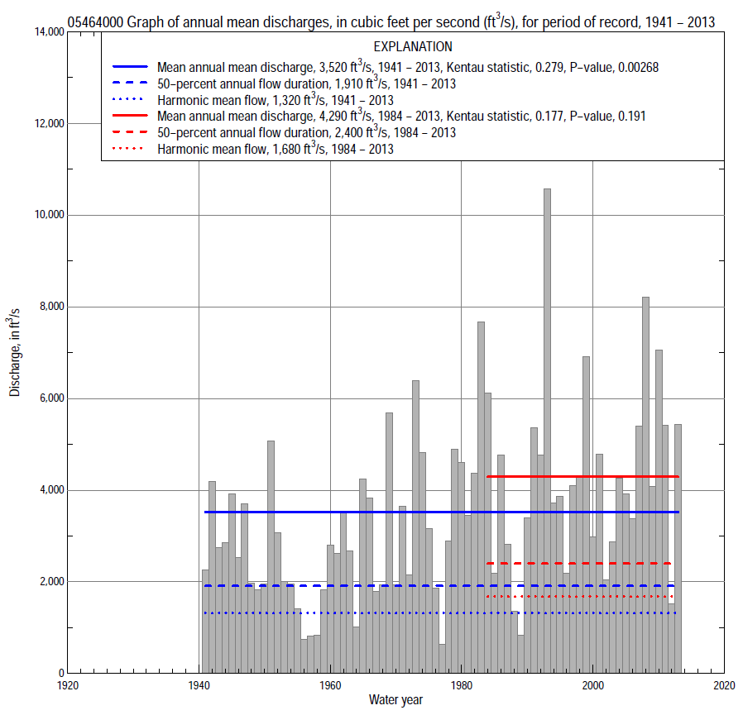

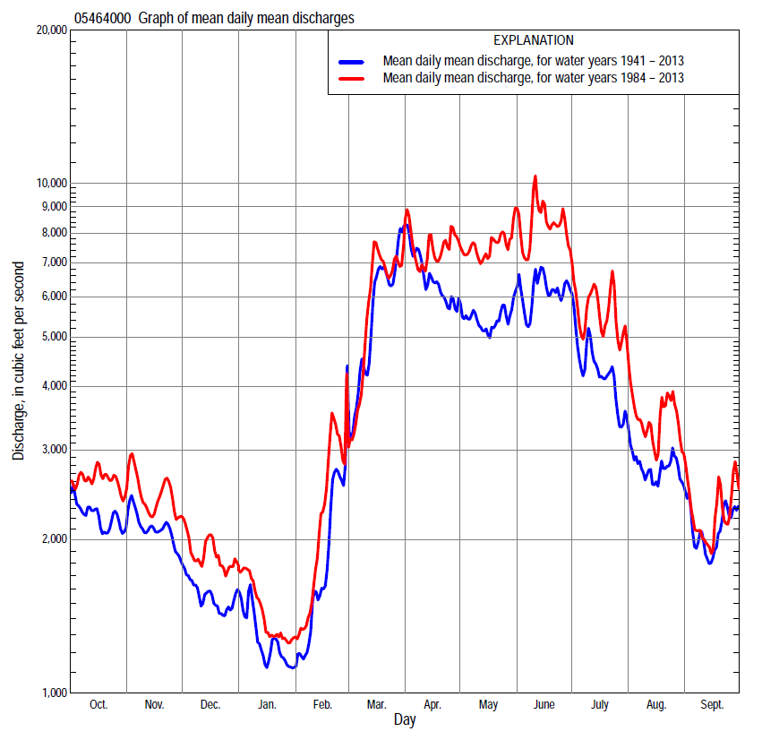

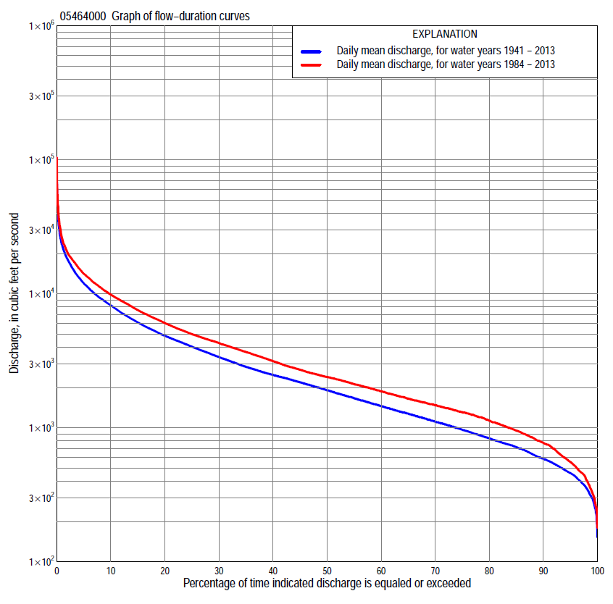

Statistics Based on the Entire Streamflow Period of Record
05464000 Monthly and annual flow durations, based on 1941–2013 period of record (73 years)
Percentage of days discharge equaled or exceeded |  |  |  |  | Discharge (cubic feet per second) |  |  |  |  |  |  |  |  | Annual flow durations
 | Oct | Nov | Dec | Jan | Feb | Mar | Apr | May | June | July | Aug | Sept | Annual | Kentau statistic | P-value
99 | 345 | 345 | 240 | 230 | 192 | 449 | 686 | 591 | 468 | 411 | 339 | 373 | 300 | 0.229 | 0.004
98 | 358 | 375 | 260 | 255 | 267 | 525 | 762 | 707 | 524 | 471 | 416 | 396 | 352 | 0.245 | 0.002
95 | 417 | 431 | 364 | 300 | 315 | 697 | 1,000 | 962 | 818 | 618 | 505 | 464 | 460 | 0.265 | 0.001
90 | 528 | 545 | 442 | 386 | 450 | 824 | 1,420 | 1,260 | 1,120 | 852 | 600 | 552 | 587 | 0.259 | 0.001
85 | 631 | 618 | 520 | 474 | 540 | 962 | 1,790 | 1,540 | 1,500 | 1,020 | 717 | 658 | 717 | 0.263 | 0.001
80 | 730 | 750 | 600 | 530 | 600 | 1,330 | 2,200 | 1,930 | 1,810 | 1,200 | 834 | 773 | 834 | 0.254 | 0.001
75 | 778 | 869 | 693 | 591 | 672 | 1,600 | 2,480 | 2,230 | 2,090 | 1,420 | 962 | 884 | 966 | 0.257 | 0.001
70 | 862 | 992 | 778 | 640 | 726 | 1,900 | 2,750 | 2,450 | 2,460 | 1,730 | 1,110 | 987 | 1,110 | 0.242 | 0.002
65 | 964 | 1,150 | 926 | 725 | 770 | 2,220 | 3,090 | 2,710 | 2,810 | 2,010 | 1,220 | 1,070 | 1,270 | 0.233 | 0.004
60 | 1,080 | 1,270 | 1,040 | 800 | 825 | 2,590 | 3,520 | 2,990 | 3,230 | 2,260 | 1,360 | 1,150 | 1,450 | 0.231 | 0.004
55 | 1,280 | 1,420 | 1,130 | 880 | 881 | 2,940 | 3,920 | 3,330 | 3,590 | 2,500 | 1,520 | 1,220 | 1,660 | 0.268 | 0.001
50 | 1,400 | 1,550 | 1,200 | 950 | 998 | 3,370 | 4,520 | 3,820 | 4,030 | 2,820 | 1,690 | 1,320 | 1,910 | 0.269 | 0.001
45 | 1,550 | 1,700 | 1,300 | 1,030 | 1,110 | 3,820 | 5,030 | 4,190 | 4,490 | 3,170 | 1,880 | 1,440 | 2,190 | 0.283 | 0.000
40 | 1,730 | 1,870 | 1,390 | 1,100 | 1,300 | 4,420 | 5,800 | 4,650 | 5,210 | 3,570 | 2,070 | 1,570 | 2,480 | 0.306 | 0.000
35 | 2,020 | 2,060 | 1,540 | 1,200 | 1,500 | 5,020 | 6,580 | 5,230 | 5,920 | 3,980 | 2,260 | 1,760 | 2,850 | 0.298 | 0.000
30 | 2,300 | 2,320 | 1,700 | 1,370 | 1,730 | 5,820 | 7,470 | 5,980 | 6,730 | 4,510 | 2,490 | 2,000 | 3,380 | 0.306 | 0.000
25 | 2,650 | 2,570 | 1,930 | 1,600 | 1,950 | 7,040 | 8,500 | 6,760 | 7,810 | 5,070 | 2,810 | 2,290 | 4,030 | 0.321 | 0.000
20 | 3,270 | 2,900 | 2,280 | 1,800 | 2,290 | 8,720 | 9,550 | 7,880 | 8,900 | 5,860 | 3,450 | 2,640 | 4,860 | 0.309 | 0.000
15 | 4,050 | 3,550 | 2,510 | 2,050 | 2,900 | 10,900 | 11,000 | 9,240 | 10,300 | 7,080 | 4,120 | 3,180 | 6,120 | 0.297 | 0.000
10 | 4,900 | 4,400 | 3,010 | 2,390 | 3,840 | 13,800 | 13,400 | 11,400 | 13,000 | 9,010 | 5,310 | 4,300 | 8,190 | 0.287 | 0.000
5 | 6,730 | 5,770 | 4,000 | 3,120 | 6,000 | 18,600 | 18,300 | 15,400 | 18,100 | 13,000 | 9,810 | 6,920 | 12,000 | 0.234 | 0.004
2 | 9,730 | 7,830 | 5,430 | 4,700 | 10,700 | 25,500 | 25,900 | 20,700 | 25,300 | 20,400 | 16,700 | 10,000 | 18,100 | 0.150 | 0.061
1 | 11,600 | 9,740 | 6,140 | 6,280 | 16,700 | 30,700 | 35,800 | 25,500 | 33,200 | 25,900 | 20,400 | 13,900 | 23,200 | 0.090 | 0.263

05464000 Annual exceedance probability of instantaneous peak discharges, in cubic feet per second (ft³/s), based on the Weighted Independent Estimates method,
Annual exceed-ance probability | Recur-rence interval (years) | Discharge (ft³/s) | 95-percent lower confi-dence interval (ft³/s) | 95-percent upper confi-dence interval (ft³/s)
0.500 | 2 | 25,800 | 22,400 | 29,700
0.200 | 5 | 43,200 | 37,500 | 49,900
0.100 | 10 | 55,000 | 47,100 | 64,300
0.040 | 25 | 71,100 | 59,200 | 85,400
0.020 | 50 | 82,800 | 67,100 | 102,000
0.010 | 100 | 94,100 | 73,900 | 120,000
0.005 | 200 | 110,000 | 83,200 | 145,000
0.002 | 500 | 123,000 | 88,900 | 170,000
and based on the expected moments algorithm/multiple Grubbs-Beck analysis computed using a historical period length of 85 years (1929–2013)
0.500 | 2 | 25,900 | 21,700 | 30,100
0.200 | 5 | 43,600 | 37,400 | 51,800
0.100 | 10 | 56,600 | 47,900 | 69,400
0.040 | 25 | 74,000 | 61,200 | 96,200
0.020 | 50 | 87,500 | 70,700 | 120,000
0.010 | 100 | 101,000 | 79,800 | 148,000
0.005 | 200 | 116,000 | 88,500 | 181,000
0.002 | 500 | 135,000 | 99,300 | 233,000
Kentau statistic |  | 0.008
P-value |  | 0.924
Begin year |  | 1941
End year |  | 2013
Number of peaks |  | 73

05464000 Annual exceedance probability of high discharges, based on 1941–2013 period of record (73 years)
[ND, not determined]
Annual exceed-ance probability | Recur-rence interval (years) | Maximum average discharge (ft³/s) for indicated number of consecutive days
 |  | 1 | 3 | 7 | 15 | 30
0.990 | 1.01 | ND | 2,340 | 2,000 | 1,610 | 1,320
0.950 | 1.05 | ND | 4,930 | 4,130 | 3,310 | 2,720
0.900 | 1.11 | ND | 7,090 | 5,870 | 4,670 | 3,820
0.800 | 1.25 | ND | 10,700 | 8,720 | 6,870 | 5,560
0.500 | 2 | ND | 21,300 | 16,900 | 13,000 | 10,200
0.200 | 5 | ND | 37,800 | 29,200 | 21,800 | 16,400
0.100 | 10 | ND | 49,000 | 37,300 | 27,400 | 20,000
0.040 | 25 | ND | 62,500 | 46,800 | 33,700 | 23,900
0.020 | 50 | ND | 72,100 | 53,500 | 38,000 | 26,300
0.010 | 100 | ND | 81,100 | 59,600 | 41,900 | 28,500
0.005 | 200 | ND | 89,700 | 65,300 | 45,400 | 30,300
0.002 | 500 | ND | 100,000 | 72,200 | 49,600 | 32,400
Kentau statistic |  | 0.023 | 0.055 | 0.101 | 0.161 | 0.187
P-value |  | 0.779 | 0.496 | 0.207 | 0.045 | 0.019

 | 05464000 Annual nonexceedance probability of low discharges, based on April 1941 to March 2013 period of record (72 years)
Annual nonexceed-ance probability | Recur-rence interval (years) | Minimum average discharge (ft³/s) for indicated number of consecutive days
 |  | 1 | 3 | 7 | 14 | 30 | 60 | 90 | 120 | 183
0.01 | 100 | 157 | 163 | 166 | 176 | 193 | 212 | 220 | 236 | 248
0.02 | 50 | 185 | 193 | 199 | 210 | 230 | 253 | 266 | 286 | 307
0.05 | 20 | 235 | 248 | 259 | 273 | 297 | 328 | 351 | 380 | 421
0.10 | 10 | 289 | 307 | 323 | 341 | 370 | 410 | 446 | 487 | 554
0.20 | 5 | 369 | 393 | 417 | 441 | 478 | 535 | 593 | 653 | 765
0.50 | 2 | 573 | 611 | 653 | 693 | 755 | 870 | 999 | 1,120 | 1,380
0.80 | 1.25 | 863 | 915 | 973 | 1,040 | 1,150 | 1,380 | 1,640 | 1,880 | 2,390
0.90 | 1.11 | 1,060 | 1,110 | 1,180 | 1,250 | 1,410 | 1,740 | 2,100 | 2,430 | 3,150
0.96 | 1.04 | 1,300 | 1,350 | 1,420 | 1,520 | 1,730 | 2,200 | 2,720 | 3,190 | 4,180
0.98 | 1.02 | 1,480 | 1,530 | 1,590 | 1,700 | 1,970 | 2,560 | 3,190 | 3,780 | 5,000
0.99 | 1.01 | 1,650 | 1,700 | 1,750 | 1,880 | 2,190 | 2,920 | 3,680 | 4,390 | 5,840
Kentau statistic |  | 0.267 | 0.248 | 0.287 | 0.299 | 0.300 | 0.262 | 0.256 | 0.230 | 0.204
P-value |  | 0.001 | 0.002 | 0.000 | 0.000 | 0.000 | 0.001 | 0.002 | 0.004 | 0.011

05464000 Annual nonexceedance probability of seasonal low discharges, based on October 1940 to September 2013 period of record (73 years)
Annual nonexceed-ance probability | Recur-rence interval (years) | Minimum average discharge (cubic feet per second) for indicated number of consecutive days
 |  | 1 | 7 | 14 | 30 |  | 1 | 7 | 14 | 30
 |  | January-February-March |  |  |  |  | April-May-June
0.01 | 100 | 159 | 170 | 180 | 200 |  | 313 | 342 | 355 | 430
0.02 | 50 | 190 | 204 | 215 | 236 |  | 391 | 429 | 449 | 544
0.05 | 20 | 246 | 267 | 279 | 303 |  | 543 | 597 | 632 | 770
0.10 | 10 | 308 | 337 | 351 | 379 |  | 721 | 794 | 851 | 1,040
0.20 | 5 | 402 | 443 | 461 | 498 |  | 1,000 | 1,110 | 1,210 | 1,480
0.50 | 2 | 654 | 731 | 766 | 846 |  | 1,820 | 2,030 | 2,280 | 2,840
0.80 | 1.25 | 1,040 | 1,170 | 1,250 | 1,450 |  | 3,180 | 3,570 | 4,160 | 5,240
0.90 | 1.11 | 1,300 | 1,490 | 1,610 | 1,920 |  | 4,180 | 4,710 | 5,610 | 7,110
0.96 | 1.04 | 1,650 | 1,900 | 2,090 | 2,610 |  | 5,530 | 6,250 | 7,630 | 9,750
0.98 | 1.02 | 1,910 | 2,220 | 2,460 | 3,190 |  | 6,570 | 7,460 | 9,260 | 11,900
0.99 | 1.01 | 2,180 | 2,540 | 2,860 | 3,820 |  | 7,650 | 8,710 | 11,000 | 14,200
Kentau statistic |  | 0.231 | 0.243 | 0.246 | 0.208 |  | 0.314 | 0.307 | 0.304 | 0.301
P-value |  | 0.004 | 0.002 | 0.002 | 0.009 |  | 0.000 | 0.000 | 0.000 | 0.000
 |  | July-August-September |  |  |  |  | October-November-December
0.01 | 100 | 260 | 297 | 311 | 339 |  | 167 | 198 | 205 | 228
0.02 | 50 | 298 | 336 | 352 | 384 |  | 200 | 237 | 248 | 276
0.05 | 20 | 366 | 407 | 425 | 467 |  | 259 | 309 | 328 | 364
0.10 | 10 | 442 | 486 | 508 | 561 |  | 325 | 390 | 419 | 466
0.20 | 5 | 559 | 609 | 637 | 711 |  | 426 | 514 | 559 | 624
0.50 | 2 | 889 | 960 | 1,020 | 1,160 |  | 705 | 861 | 953 | 1,080
0.80 | 1.25 | 1,450 | 1,570 | 1,700 | 2,020 |  | 1,150 | 1,410 | 1,580 | 1,850
0.90 | 1.11 | 1,890 | 2,060 | 2,270 | 2,760 |  | 1,470 | 1,820 | 2,050 | 2,430
0.96 | 1.04 | 2,520 | 2,790 | 3,120 | 3,910 |  | 1,910 | 2,370 | 2,670 | 3,240
0.98 | 1.02 | 3,050 | 3,420 | 3,880 | 4,950 |  | 2,250 | 2,800 | 3,160 | 3,890
0.99 | 1.01 | 3,630 | 4,110 | 4,740 | 6,160 |  | 2,610 | 3,250 | 3,660 | 4,580
Kentau statistic |  | 0.244 | 0.234 | 0.230 | 0.224 |  | 0.222 | 0.206 | 0.218 | 0.221
P-value |  | 0.002 | 0.004 | 0.004 | 0.005 |  | 0.006 | 0.010 | 0.007 | 0.006

Statistics Based on the 1984–2013 Streamflow Period of Record
05464000 Monthly and annual flow durations, based on 1984–2013 period of record (30 years)
Percentage of days discharge equaled or exceeded |  |  |  |  | Discharge (cubic feet per second) |  |  |  |  |  |  |  |  | Annual flow durations
 | Oct | Nov | Dec | Jan | Feb | Mar | Apr | May | June | July | Aug | Sept | Annual | Kentau statistic | P-value
99 | 350 | 366 | 230 | 260 | 300 | 430 | 1,000 | 851 | 494 | 403 | 307 | 401 | 333 | -0.025 | 0.858
98 | 355 | 380 | 260 | 270 | 323 | 535 | 1,040 | 999 | 578 | 455 | 320 | 437 | 405 | -0.034 | 0.803
95 | 452 | 557 | 474 | 459 | 474 | 776 | 1,230 | 1,480 | 885 | 638 | 498 | 472 | 555 | -0.028 | 0.844
90 | 700 | 813 | 582 | 560 | 619 | 1,430 | 1,570 | 2,180 | 1,500 | 896 | 685 | 772 | 771 | -0.018 | 0.901
85 | 792 | 974 | 724 | 637 | 700 | 1,660 | 2,270 | 2,480 | 2,240 | 1,390 | 1,040 | 904 | 951 | -0.032 | 0.817
80 | 921 | 1,160 | 900 | 742 | 757 | 1,870 | 2,520 | 2,810 | 2,830 | 1,930 | 1,280 | 1,010 | 1,130 | -0.037 | 0.789
75 | 1,030 | 1,250 | 1,040 | 820 | 815 | 2,110 | 2,870 | 3,320 | 3,380 | 2,240 | 1,490 | 1,080 | 1,310 | -0.034 | 0.803
70 | 1,270 | 1,380 | 1,140 | 897 | 880 | 2,500 | 3,420 | 3,880 | 3,770 | 2,510 | 1,640 | 1,170 | 1,480 | -0.076 | 0.568
65 | 1,360 | 1,480 | 1,230 | 978 | 982 | 2,790 | 3,800 | 4,260 | 4,220 | 2,870 | 1,830 | 1,250 | 1,650 | -0.080 | 0.544
60 | 1,450 | 1,570 | 1,310 | 1,040 | 1,100 | 2,990 | 4,460 | 4,780 | 4,700 | 3,230 | 1,990 | 1,330 | 1,870 | -0.057 | 0.668
55 | 1,550 | 1,680 | 1,390 | 1,100 | 1,250 | 3,340 | 4,880 | 5,180 | 5,380 | 3,630 | 2,110 | 1,430 | 2,120 | 0.025 | 0.858
50 | 1,650 | 1,870 | 1,500 | 1,170 | 1,400 | 3,750 | 5,640 | 5,710 | 6,050 | 3,980 | 2,250 | 1,490 | 2,400 | 0.037 | 0.789
45 | 1,810 | 2,070 | 1,610 | 1,300 | 1,600 | 4,280 | 6,500 | 6,300 | 6,820 | 4,390 | 2,390 | 1,580 | 2,710 | 0.064 | 0.630
40 | 2,070 | 2,330 | 1,790 | 1,400 | 1,740 | 4,680 | 7,180 | 6,850 | 7,490 | 4,790 | 2,570 | 1,710 | 3,150 | 0.117 | 0.372
35 | 2,310 | 2,560 | 2,080 | 1,600 | 1,820 | 5,220 | 8,070 | 7,460 | 8,350 | 5,240 | 2,800 | 1,890 | 3,680 | 0.122 | 0.354
30 | 2,710 | 2,820 | 2,320 | 1,760 | 1,950 | 5,880 | 8,810 | 8,380 | 9,320 | 5,780 | 3,200 | 2,100 | 4,300 | 0.140 | 0.284
25 | 3,470 | 3,150 | 2,440 | 1,910 | 2,200 | 6,590 | 9,860 | 9,260 | 10,300 | 6,420 | 3,620 | 2,340 | 5,000 | 0.168 | 0.199
20 | 4,030 | 3,550 | 2,600 | 2,050 | 2,830 | 8,450 | 10,800 | 10,500 | 11,800 | 7,420 | 4,070 | 2,620 | 6,050 | 0.168 | 0.199
15 | 4,520 | 3,970 | 3,000 | 2,210 | 3,550 | 10,600 | 12,500 | 12,500 | 13,500 | 8,950 | 4,680 | 3,080 | 7,560 | 0.177 | 0.175
10 | 5,430 | 4,610 | 3,350 | 2,530 | 4,970 | 13,600 | 15,200 | 14,900 | 17,200 | 11,800 | 6,580 | 4,760 | 9,880 | 0.209 | 0.108
5 | 7,770 | 5,790 | 4,410 | 3,230 | 7,290 | 17,600 | 19,100 | 19,400 | 22,400 | 16,400 | 11,400 | 7,070 | 14,100 | 0.209 | 0.108
2 | 10,900 | 7,740 | 5,570 | 4,090 | 11,200 | 23,400 | 27,300 | 27,300 | 30,500 | 24,400 | 18,700 | 9,940 | 20,300 | 0.177 | 0.175
1 | 12,400 | 9,170 | 6,140 | 4,720 | 15,500 | 32,000 | 35,800 | 38,000 | 40,300 | 32,600 | 23,600 | 14,100 | 25,700 | 0.191 | 0.143

05464000 Annual exceedance probability of high discharges, based on 1984–2013 period of record (30 years)
Annual exceed-ance probability | Recur-rence interval (years) | Maximum average discharge (ft³/s) for indicated number of consecutive days
 |  | 1 | 3 | 7 | 15 | 30
0.990 | 1.01 | 3,860 | 3,760 | 3,500 | 2,830 | 2,430
0.950 | 1.05 | 6,620 | 6,370 | 5,730 | 4,770 | 4,020
0.900 | 1.11 | 8,790 | 8,400 | 7,420 | 6,210 | 5,180
0.800 | 1.25 | 12,400 | 11,700 | 10,100 | 8,460 | 6,940
0.500 | 2 | 23,400 | 21,800 | 18,100 | 14,700 | 11,600
0.200 | 5 | 43,800 | 39,900 | 31,700 | 24,600 | 18,500
0.100 | 10 | 60,300 | 54,400 | 42,300 | 31,500 | 23,100
0.040 | 25 | 84,600 | 75,400 | 57,300 | 40,600 | 28,800
0.020 | 50 | 105,000 | 92,800 | 69,500 | 47,500 | 32,900
0.010 | 100 | 127,000 | 112,000 | 82,600 | 54,500 | 37,000
0.005 | 200 | 152,000 | 132,000 | 96,600 | 61,500 | 41,000
0.002 | 500 | 187,000 | 162,000 | 116,000 | 70,800 | 46,100
Kentau statistic |  | 0.177 | 0.182 | 0.191 | 0.191 | 0.182
P-value |  | 0.175 | 0.164 | 0.143 | 0.143 | 0.164

 | 05464000 Annual nonexceedance probability of low discharges, based on April 1983 to March 2013 period of record (30 years)
Annual nonexceed-ance probability | Recur-rence interval (years) | Minimum average discharge (ft³/s) for indicated number of consecutive days
 |  | 1 | 3 | 7 | 14 | 30 | 60 | 90 | 120 | 183
0.01 | 100 | 183 | 197 | 206 | 225 | 248 | 259 | 271 | 286 | 287
0.02 | 50 | 220 | 237 | 254 | 277 | 304 | 321 | 339 | 361 | 372
0.05 | 20 | 287 | 310 | 338 | 368 | 403 | 433 | 466 | 501 | 540
0.10 | 10 | 359 | 386 | 427 | 464 | 507 | 555 | 605 | 658 | 734
0.20 | 5 | 461 | 494 | 551 | 598 | 652 | 729 | 811 | 891 | 1,030
0.50 | 2 | 709 | 749 | 830 | 898 | 983 | 1,140 | 1,320 | 1,470 | 1,810
0.80 | 1.25 | 1,020 | 1,060 | 1,130 | 1,220 | 1,350 | 1,640 | 1,970 | 2,220 | 2,860
0.90 | 1.11 | 1,210 | 1,230 | 1,290 | 1,390 | 1,550 | 1,910 | 2,360 | 2,660 | 3,480
0.96 | 1.04 | 1,420 | 1,430 | 1,450 | 1,550 | 1,740 | 2,200 | 2,780 | 3,140 | 4,170
0.98 | 1.02 | 1,520 | 1,530 | 1,540 | 1,650 | 1,860 | 2,380 | 3,050 | 3,460 | 4,630
0.99 | 1.01 | 1,590 | 1,600 | 1,610 | 1,730 | 1,960 | 2,540 | 3,300 | 3,740 | 5,030
Kentau statistic |  | -0.057 | -0.048 | -0.002 | -0.007 | 0.025 | -0.048 | -0.057 | -0.090 | -0.080
P-value |  | 0.668 | 0.721 | 1.000 | 0.972 | 0.858 | 0.721 | 0.669 | 0.498 | 0.544

05464000 Annual nonexceedance probability of seasonal low discharges, based on October 1983 to September 2013 period of record (30 years)
Annual nonexceed-ance probability | Recur-rence interval (years) | Minimum average discharge (cubic feet per second) for indicated number of consecutive days
 |  | 1 | 7 | 14 | 30 |  | 1 | 7 | 14 | 30
 |  | January-February-March |  |  |  |  | April-May-June
0.01 | 100 | 211 | 240 | 258 | 267 |  | 389 | 392 | 397 | 482
0.02 | 50 | 252 | 286 | 306 | 321 |  | 509 | 519 | 532 | 646
0.05 | 20 | 325 | 369 | 394 | 418 |  | 743 | 772 | 806 | 979
0.10 | 10 | 404 | 459 | 489 | 525 |  | 1,020 | 1,070 | 1,140 | 1,390
0.20 | 5 | 521 | 591 | 629 | 682 |  | 1,450 | 1,550 | 1,680 | 2,060
0.50 | 2 | 821 | 930 | 991 | 1,090 |  | 2,600 | 2,870 | 3,270 | 4,070
0.80 | 1.25 | 1,240 | 1,410 | 1,510 | 1,650 |  | 4,220 | 4,770 | 5,730 | 7,280
0.90 | 1.11 | 1,520 | 1,720 | 1,850 | 2,030 |  | 5,230 | 5,970 | 7,380 | 9,520
0.96 | 1.04 | 1,870 | 2,100 | 2,280 | 2,480 |  | 6,400 | 7,380 | 9,390 | 12,300
0.98 | 1.02 | 2,120 | 2,380 | 2,600 | 2,810 |  | 7,180 | 8,340 | 10,800 | 14,400
0.99 | 1.01 | 2,360 | 2,660 | 2,910 | 3,120 |  | 7,900 | 9,220 | 12,200 | 16,300
Kentau statistic |  | -0.057 | -0.025 | -0.021 | -0.011 |  | 0.172 | 0.172 | 0.191 | 0.186
P-value |  | 0.668 | 0.858 | 0.887 | 0.943 |  | 0.187 | 0.187 | 0.143 | 0.154
 |  | July-August-September |  |  |  |  | October-November-December
0.01 | 100 | 309 | 336 | 346 | 367 |  | 170 | 207 | 221 | 262
0.02 | 50 | 355 | 385 | 397 | 425 |  | 214 | 262 | 282 | 331
0.05 | 20 | 441 | 473 | 489 | 533 |  | 297 | 363 | 399 | 461
0.10 | 10 | 535 | 571 | 593 | 656 |  | 390 | 476 | 529 | 606
0.20 | 5 | 681 | 724 | 755 | 849 |  | 528 | 644 | 724 | 823
0.50 | 2 | 1,100 | 1,160 | 1,230 | 1,430 |  | 875 | 1,070 | 1,210 | 1,380
0.80 | 1.25 | 1,800 | 1,930 | 2,080 | 2,490 |  | 1,320 | 1,610 | 1,820 | 2,100
0.90 | 1.11 | 2,340 | 2,550 | 2,780 | 3,380 |  | 1,590 | 1,930 | 2,160 | 2,530
0.96 | 1.04 | 3,130 | 3,450 | 3,820 | 4,720 |  | 1,890 | 2,290 | 2,540 | 3,020
0.98 | 1.02 | 3,790 | 4,220 | 4,720 | 5,890 |  | 2,080 | 2,520 | 2,770 | 3,340
0.99 | 1.01 | 4,510 | 5,080 | 5,740 | 7,230 |  | 2,250 | 2,730 | 2,980 | 3,630
Kentau statistic |  | -0.039 | -0.011 | 0.002 | 0.034 |  | -0.034 | -0.094 | -0.094 | -0.080
P-value |  | 0.775 | 0.943 | 1.000 | 0.803 |  | 0.803 | 0.475 | 0.475 | 0.544

